Technical Datasheet Input Module with Modbus TCP over Ethernet Interface

This IO module communicates via Ethernet Port. The port can drive distances up to max 80 meters without the use of any repeater (this is as per the ethernet LAN guidelines).
The Modbus TCP Digital IO module is sturdy, low power usage and easy to use.

16 Port DI Module: -
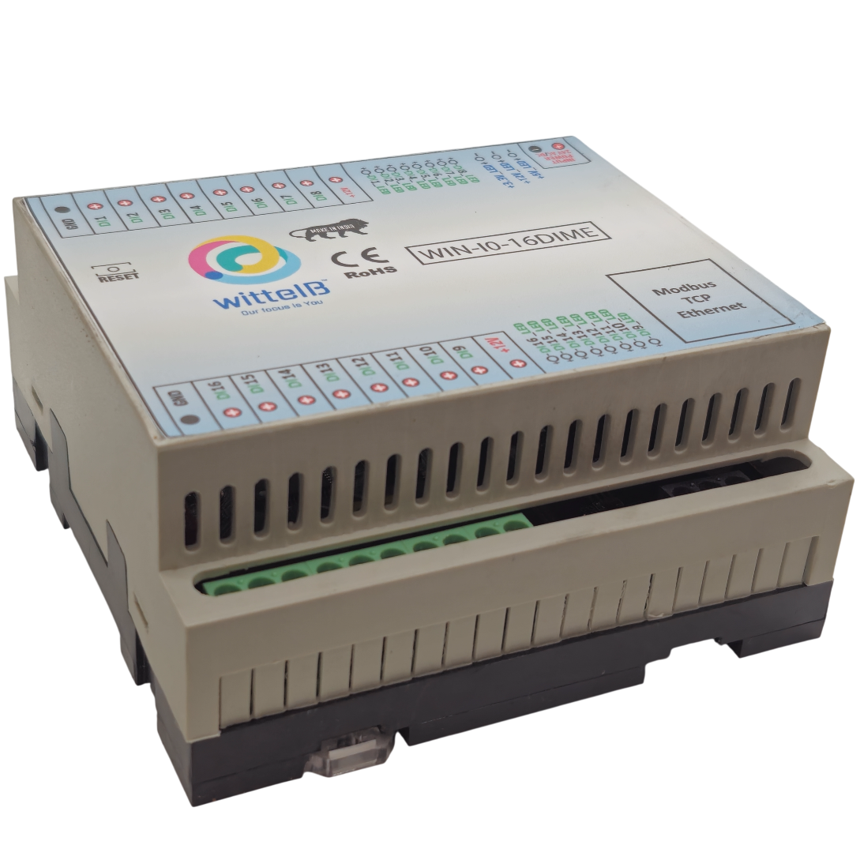

The IO modules are mounted on DIN rail mountable casing and with exposed connectors and LED indicators. The DIP switch for Slave ID and Baud rate are placed inside the enclosure.
The design of the modules incorporates ‘resettable Fuses’ to safeguard against sudden High Voltage spikes. the board also has ‘reverse polarity’ protection both for input and power connector.
the communication port also has signal isolation and additional jumper for ‘end of line’120 ohms termination resistance which may or may not be used.
Specifications
General –

I/O Connectors 2 Pin 5.08 mm pitch pluggable screw Terminal Block and maximum 2.5 sq mm cable connector
Dimensions 110 mm B x 110 mm L x 50 mm H
Power Input Power – 12 VDC or 24 V AC/DC
Typical – 12V DC @ 120mA
Operating Temperature 0 – 60° C (32 ~ 140°F)
Storage Temperature -20 - 70° C (-4 ~ 158°F)
Storage Humidity 5 ~ 95 % RH, non – Condensing
Certifications  

DI Inputs –

Channels 16
Sense Voltage 4 – 30 VDC
Sense Logic Logic ‘0’ = <1 VDC, Logic ‘1’ = >3.3 VDC
Isolation Optically isolated
Response Time 2 msec, Max 6 msec

Configuration Settings: -

Communication Speed 10/100 Base-T Ethernet Compatible Interface
Data Bits 8
Parity None
CRC 1
Stop bit Yes
Slave ID Configurable through Web portal
Function code DI 0x02 Read discrete Input
DI Register Address 0,1,2,3,4,5,6,7,8,9,10,11,12,13,14,15.

Configuration Guide – Ethernet Modbus TCP/IP IO Module:-
- Open a web browser (Google Chrome, Microsoft Edge, Firefox, etc.).
- In the browser’s address bar, type the default IP address:
192.168.0.160
- Press Enter. A message will appear saying:
“Please go to http://192.168.0.160/setup.”
- Copy this link (http://192.168.0.160/setup) and paste it into a new browser tab.
- Press Enter again to open the Setup / Configuration Page of the device.

To Reset the Device to Default Settings
- Place the jumper on the designated Reset position on the device.
- Press the Reset button once.
- The module will reboot and revert to its default IP address: 192.168.0.160.

To Change the IP Address
- On the Setup / Configuration Page, enter the new IP address you wish to assign.
- Click Submit to save the new settings.
- The device will automatically apply the new IP address.
Note:
- Ensure your PC’s IP address is in the same network range (for example, 192.168.0.xxx) when accessing the module.
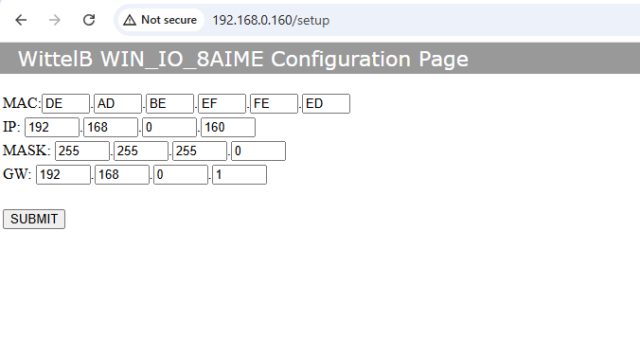
- After changing the IP, you must use the new address to log in again.
16 DIME

DI
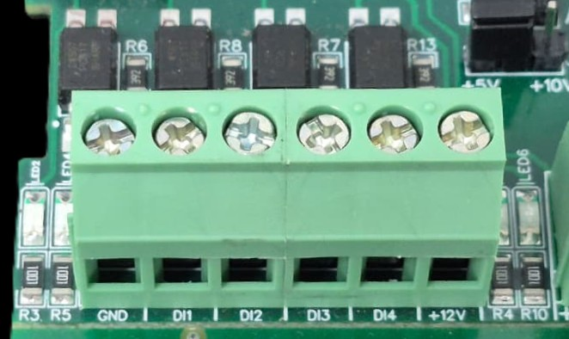
I/p device
I/p device
I/p device
I/p device
- Operation: The module provides four isolated input channels (DI1–DI4) for sensing external signals or dry contacts. These inputs are opto-isolated for circuit protection.
- Terminal Layout:
  - GND: Common Ground reference.
  - DI1 – DI4: Individual Digital Input channels.
  - +12V: Internal reference voltage for sourcing "Dry Contact" switches.
- Wiring Options:
  - Dry Contact: Connect a switch between the +12V terminal and any DI pin.
  - External Voltage: Connect the external signal to a DI pin and the external ground to the GND terminal.
- Voltage Rating: The input circuitry is rated for a maximum of 80VDC. Ensure external signals do not exceed this limit to prevent damage to the isolation ICs.

ID | Function  Description | Register  Description | Modbus  Function Code | Protocol | Data Type
1 | DI 1(With & Without Potential) | 10001 | 0X01 | TCP/IP | 1 Bit Boolean
2 | DI 2(With & Without Potential) | 10002 | 0X01 | TCP/IP | 1 Bit Boolean
3 | DI 3(With & Without Potential) | 10003 | 0X01 | TCP/IP | 1 Bit Boolean
4 | DI 4(With & Without Potential) | 10004 | 0X01 | TCP/IP | 1 Bit Boolean
5 | DI 5(With & Without Potential) | 10005 | 0x01 | TCP/IP | 1 Bit Boolean
6 | DI 6(With & Without Potential) | 10006 | 0X01 | TCP/IP | 1 Bit Boolean
7 | DI 7(With & Without Potential) | 10007 | 0X01 | TCP/IP | 1 Bit Boolean
8 | DI 8(With & Without Potential) | 10008 | 0X01 | TCP/IP | 1 Bit Boolean
9 | DI 9(With & Without Potential) | 10009 | 0X01 | TCP/IP | 1 Bit Boolean
10 | DI 10(With & Without Potential) | 10010 | 0X01 | TCP/IP | 1 Bit Boolean
11 | DI 11(With & Without Potential) | 10011 | 0X01 | TCP/IP | 1 Bit Boolean
12 | DI 12(With & Without Potential) | 10012 | 0X01 | TCP/IP | 1 Bit Boolean
13 | DI 13(With & Without Potential) | 10013 | 0X01 | TCP/IP | 1 Bit Boolean
14 | DI 14(With & Without Potential) | 10014 | 0X01 | TCP/IP | 1 Bit Boolean
15 | DI 7(With & Without Potential) | 10015 | 0X01 | TCP/IP | 1 Bit Boolean
16 | DI 8(With & Without Potential) | 10016 | 0X01 | TCP/IP | 1 Bit Boolean

Product Image:
I/P Power 24 V DC
12V DI1 Di2 DI3 DI4 DI5 DI6 DI7 DI8 GND
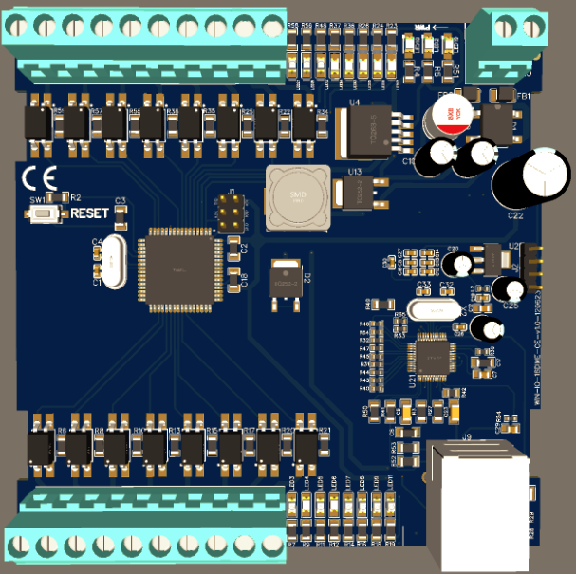
Modbus TCP Port
GND DI16 Di5 DI14 DI13 DI12 DI11 DI10 DI9 12V

For more details: http://www.youtube.com/@wittelb

Contact us: -
Augmatic Technologies Pvt. Ltd.,
Plot no 6, Shah Industrial Estate II,
Kotambi,
Vadodara – 391510.
Email – Sales@wittelb.com
Support: support@wittelb.raiseaticket.com / +91 94038 92805

