Technical Datasheet of WIN-IO-16UI8UOM Module (Modbus RTU)

1. Overview
The Universal Input (UI) and Universal Output (UO) board support communication exclusively over Modbus RTU, enabling seamless control and monitoring of inputs/outputs. The board provide configurable input and output selection via RTU, ensuring flexibility across various applications.
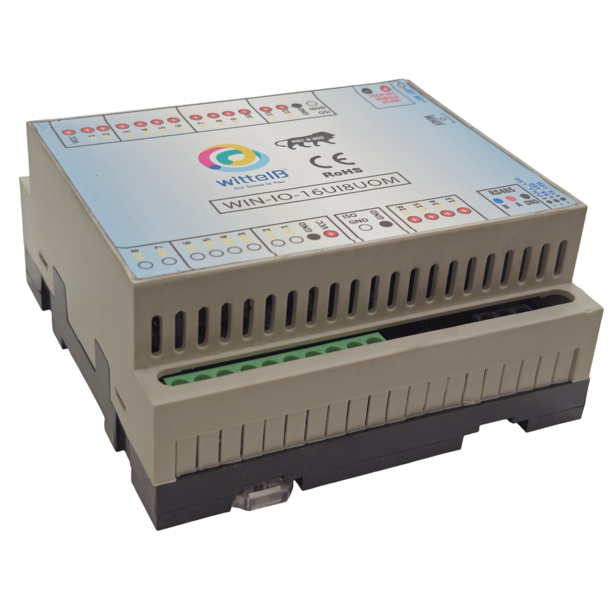

The module acts as an input/output device between the Modbus RTU Serial.
Digital IO module is study, low power usage and easy to use.
The IO modules are mounted on DIN rail mountable casing and with exposed connectors and LED indicators.

Specifications

Category | UIUO Module
Input Type | Analog Input (10V)  Analog Input (5V)  Digital Input  NTC Sensor Input.  (Configurable via RS485)
Output Types | Analog Output (AO),  Digital Output (DO).  (configurable via RS485)
Connectors | Single port handling multiple input/output types

General –
Dimensions 110 mm L x 110 mm B x 50 mm H
Power Input Power – 9 – 24 V DC or 24 V AC/DC
Typical – 24V DC @ 700mA
Operating Temperature 0 – 60° C (32 ~ 140°F)
Storage Temperature -20 - 70° C (-4 ~ 158°F)
Storage Humidity 5 ~ 95 % RH, non – Condensing
Certifications 

UI (Universal Inputs) –
Digital Input channels 16
Sense Voltage 3.3 – 12 VDC (Depends on the selected type of Input)
Digital Sensing Logic Logic ‘0’ = <1 VDC, Logic ‘1’ = >3.3 VDC
Isolation Optically isolated
Response Time 2 msec, Max 6 msec

Analog Input channels 8
Input Signal 0 – 5VDC / 0 – 10VDC / NTC (Web page selectable)
Accuracy ± 2% Full scale
Input Resolution 10 bits
Isolation Optically Isolated
External Loop Voltage + 15 VDC min
AI input impedance 120Ω
UO (Universal Outputs) –

Digital Output channels 8
Output Type P-Channel MOSFET
Channel Voltage 12 VDC
Channel Current 20A
Channel Power 240 W (max)
Operating Time 2.8ns.
Turn Off delay Time 33.5ns.
Operating Temperature -55℃~+150℃

Analog Output channels 8
Analog Resolution 10 bits (0 to 10VDC)
Accuracy ± 2% Full scale
Isolation Optically Isolated
Conversion Time 15 msec

Additional Features: -
Input power reverse polarity safety
ESD Safety IEC 61000-4-2, ± 30KV contact, ± 30KV air

Configuration Of UIUO module:-
The UI/UO module supports flexible I/O configuration.
Each of the 16 UI (Universal Input) UI1 to UI8 ports can be independently configured as Analog Input, NTC Sensor Input, Digital Input and UI9 to UI16 must be configure as Digital Input. Similarly, each of the 8 UO (Universal Output) ports can be independently configured as, Analog Output, Digital Output.
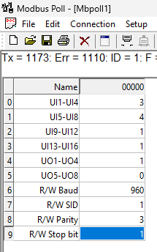
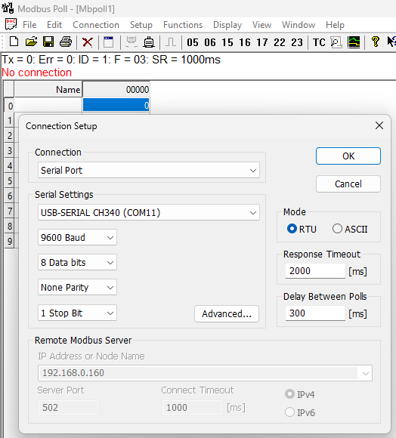
All the configuration can be done through the RS485 as Mbpoll.
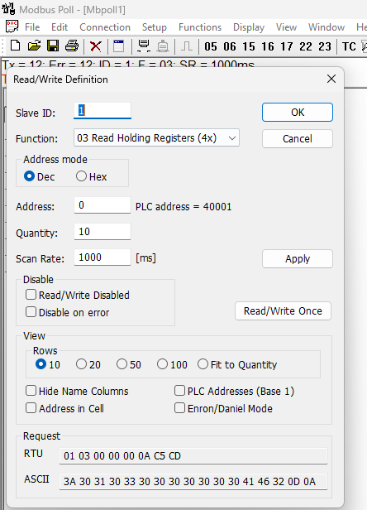
Image1 Image2 Image3

The following are step by step guide for configuration:
- Connect the mbpoll with default addresses as Baud-9600, SID-1, Parity-None, Data bit-8 as shown in image 1 & 2.
- Click on setup, then Read/Write definition there func code should be 03.
- Address 0 and quantity 10 for setup mode.
- 40001 to 40006 registers for setup UI/UO modes.
- 40007 to 40010 registers for soft setting SID/Baud/Parity/Data bit.

Setup mode of UIUO module:-
- Refer Above Image 3 for Setup mode
- For Universal Input enter 1 as DI, 2 as 10v, 3 as NTC, 4 as 5v
- For UI setup Fun code 03 and Modbus register from 40001 to 40004
- At 40001 reg UI1 to UI4 channels will be set, enter 1/2/3/4 as required in reg 40001
- At 40002 reg UI5 to UI8 channels will be set, enter 1/2/3/4 as required in reg 40002
- At 40003 reg UI9 to UI12 channels will be set, must enter 1 in reg 40003
- At 40004 reg UI13 to UI16 channels will be set, must enter 1 in reg 40004
- For example, to set Channel 1 to 4 of UI as NTC Sensor input then in reg 40001 enter 3.
Note: Always press reset button in the device after doing configuration for UI/UO Status, then only changes in configuration will take place.

- For Universal Output enter 0 as AO, 1 as DO
- For UO setup Fun code 03 and Modbus register from 40005 to 40006
- At 40005 reg UO1 to UO4 channels will be set, enter 1/2 as required in reg 40005
- At 40006 reg UO5 to UO8 channels will be set, enter 1/2 as required in reg 40006
- For example, to set Channel 1 to 4 of UO as Digital output (DO) then in reg 40005 enter 1.
Note: Always press reset button in the device after doing configuration for UI/UO Status, then only changes in configuration will take place.

Read/Write mode of UIUO module:-
- For Universal Input
- For Universal Input Read Mode Fun code 03 and Modbus registers from 40011 to 40026.
- For DI the data will be 1/0 at selected registers.
- For AI data will be 0-1023 resolution at selected registers.
- For NTC data will be temperature ex-27.6 as 276 at selected registers.

Note: The data of UI port can be fetched from the mentioned Modbus registers, irrespective of DI, AI, NTC, selection. The Desired Inputs are as follows:
INPUT TYPE | Input Value
DI | 0 V(0) , 12VDC (1)
AI(5V) | 0 to 5VDC (0-1023)
AI(10V) | 0 to 10VDC (0-1023)
NTC | NTC sensor(Temperature in °C)

- For Universal Output
- For Universal Output Write Mode Fun code 03 and Modbus registers from 40027 to 40034.
- For DO the data will be write 1/0 at selected registers.
- For AO the data will be write 0 to 1023 resolution at selected registers.

Note: Similarly, the data of the UO port can be set in the same register as mentioned Modbus register. For DO, It should be sent 0 or 1 (12VDC). And for AO a 10-bit resolution value must be sent (i.e. from 0 to 1023) to set output of 0 to 10VDC.

OUTPUT Type | Output Value
DO | 0 (0V) , 1 (12VDC)
AO | 0 to 10VDC (0-1023)


UIUO Status:-

- Here UI1 to UI4 selected as NTC(3), UI5 to UI8 selected as AI(5v) and UI9 to UI16 selected as DI(1).
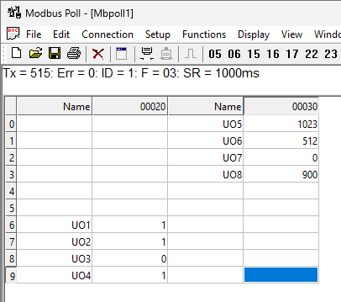
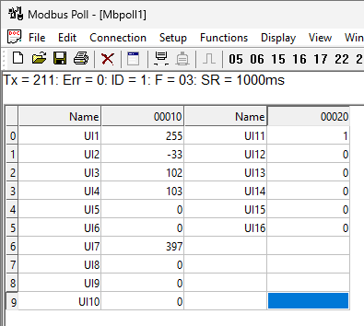
- And UO1 to Uo4 selected as DO(1) , UO5 to UO8 selected as AO(0).
Image1 Image2

- In image1 shows the UI data as selected channels.
- At UI1 there is NTC sensor providing value as 255(25.5 °C)
- At UI7 there is AI sensor providing value as 397 resolution.
- At UI11 there is DI sensor providing value as 1(HIGH)
- In image2 shows the UO data as selected channels.
- At UO1 to UO4 there is DO provided value as 1/0.
- At UO5 to UO8 there is AO provided value as 0-1023.

Modbus Soft Setting Configuration:-

Here is an example of receiving data on Mb poll software.
- Open Mb-poll software connect using configuration setting (Default baud rate is 9600 and slave id is 1).
- After connecting you will get data as shown below image1.
- As you can see in the image1 below, the resistor 40007 – 960 represents the present baud rate (9600) of the board and the resistor 40008 – 1 represents the present slave id of the board.
- To change the baud rate and slave id Jumper should be in single/removed as shown in image3 below, then you must enter a value on the 40007 register for the baud rate and on the 40008 register for the slave id as shown in the image2 below, in single register we can Read & Write the values.
- Now you can see data. In below image2 set 115200 baud rate and slave ID 10.
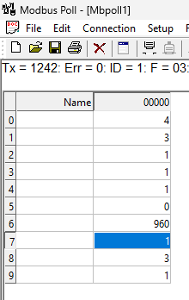
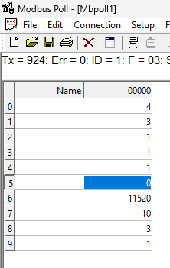
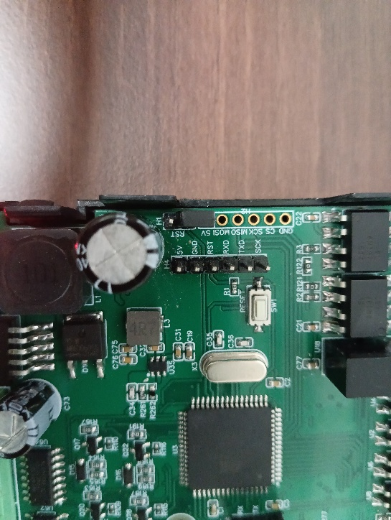

Open

Image1 Image2 Image3

- As you can see in the image1/2 above, the registers 40001 to 40004 shows the UI setup, registers 40005 to 40006 shows the UO setup and registers 40007 to 40010 represents the Modbus soft setting Baud/SID/Parity/Data bit.

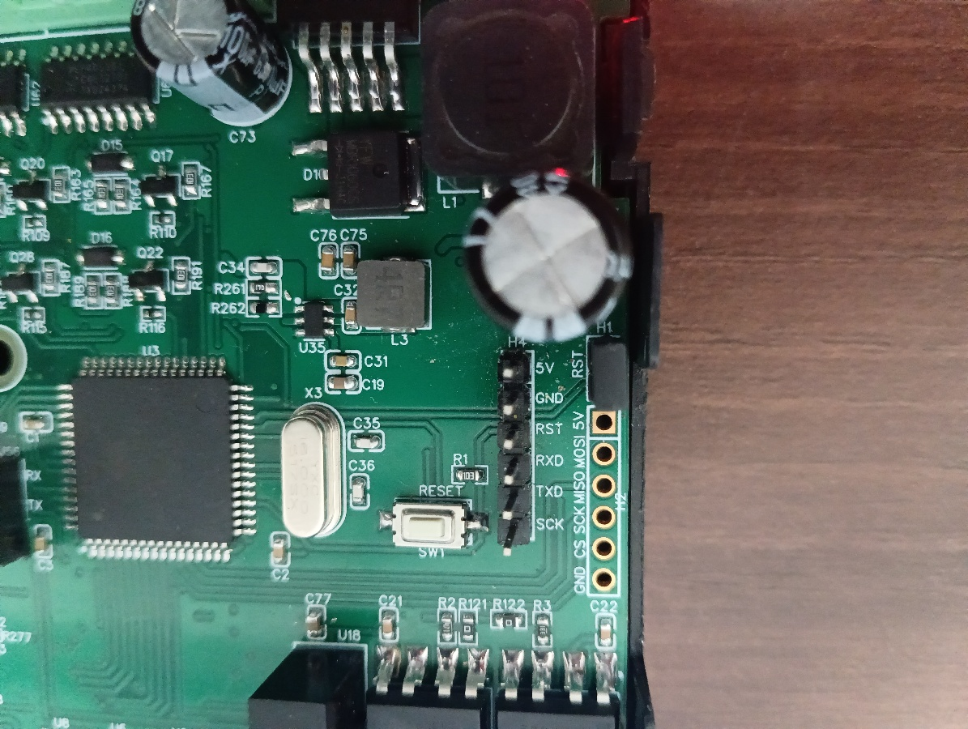
Closed

Image4

Hard reset Setting
Somehow you forgot the baud rate or slave id of the board then Place the jumper (as shown in the above image4) from the board reboot the system or press the reset button (given on the board). Then you will get the default baud rate of 9600 and slave id 1.

MODBUS REGISTERS TABLE FOR UIUO PORTS:-
ID | Function  Description | Register  Description | Modbus Function Code | Data  Type
1 | SET UI1 TO UI4 | 40001 | 0x03 | Boolean
2 | SET UI5 TO UI8 | 40002 | 0x03 | Boolean
3 | SET UI9 TO UI12 | 40003 | 0x03 | Boolean
4 | SET UI13 TO UI16 | 40004 | 0x03 | Boolean
5 | SET UO1 TO UO4 | 40005 | 0x03 | Boolean
6 | SET UO5 TO UO8 | 40006 | 0x03 | Boolean
7 | R/W BAUD | 40007 | 0x03 | Boolean
8 | R/W SID | 40008 | 0x03 | Boolean
9 | R/W PARITY | 40009 | 0x03 | Boolean
10 | R/W STOP BIT | 40010 | 0x03 | Boolean
11 | UI 1 (DI/AI/NTC) | 40011 | 0x03 | Boolean
12 | UI 2 ( DI/AI/NTC ) | 40012 | 0x03 | Boolean
13 | UI 3 ( DI/AI/NTC ) | 40013 | 0x03 | Boolean
14 | UI 4 ( DI/AI/NTC ) | 40014 | 0x03 | Boolean
15 | UI 5 ( DI/AI/NTC ) | 40015 | 0x03 | Boolean
16 | UI 6 ( DI/AI/NTC ) | 40016 | 0x03 | Boolean
17 | UI 7 ( DI/AI/NTC ) | 40017 | 0x03 | Boolean
18 | UI 8 ( DI/AI/NTC ) | 40018 | 0x03 | Boolean
19 | UI 9 (DI) | 40019 | 0x03 | Boolean
20 | UI 10 (DI) | 40020 | 0x03 | Boolean
21 | UI 11 (DI) | 40021 | 0x03 | Boolean
22 | UI 12 (DI) | 40022 | 0x03 | Boolean
23 | UI 13 (DI) | 40023 | 0x03 | Boolean
24 | UI 14 (DI) | 40024 | 0x03 | Boolean
25 | UI 15 (DI) | 40025 | 0x03 | Boolean
26 | UI 16 (DI) | 40026 | 0x03 | Boolean
27 | UO1( DO/AO ) | 40027 | 0x03 | Boolean
28 | UO2( DO/AO ) | 40028 | 0x03 | Boolean
29 | UO3( DO/AO ) | 40029 | 0x03 | Boolean
30 | UO4( DO/AO ) | 40030 | 0x03 | Boolean
31 | UO5( DO/AO ) | 40031 | 0x03 | Boolean
32 | UO6( DO/AO ) | 40032 | 0x03 | Boolean
33 | UO7( DO/AO ) | 40033 | 0x03 | Boolean
34 | UO8( DO/AO ) | 40034 | 0x03 | Boolean

DI

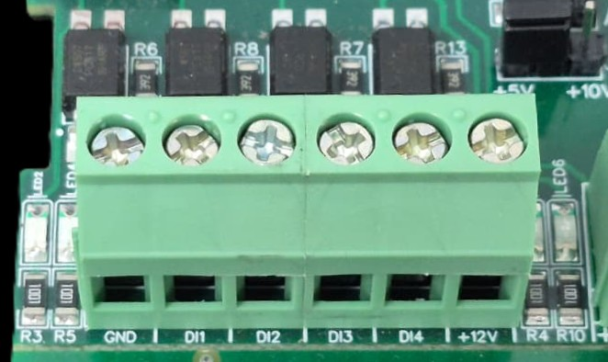

I/p device
I/p device
I/p device

I/p device

- Operation: The module provides four isolated input channels (DI1–DI4) for sensing external signals or dry contacts. These inputs are opto-isolated for circuit protection.
- Terminal Layout:
  - GND: Common Ground reference.
  - DI1 – DI4: Individual Digital Input channels.
  - +12V: Internal reference voltage for sourcing "Dry Contact" switches.
- Wiring Options:
  - Dry Contact: Connect a switch between the +12V terminal and any DI pin.
  - External Voltage: Connect the external signal to a DI pin and the external ground to the GND terminal.
- Voltage Rating: The input circuitry is rated for a maximum of 80VDC. Ensure external signals do not exceed this limit to prevent damage to the isolation ICs.

AI-NTC
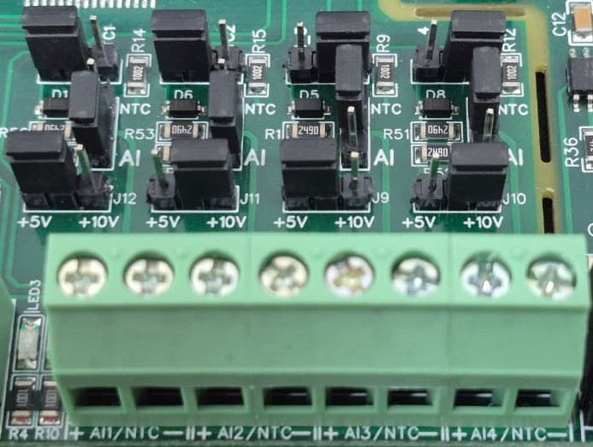
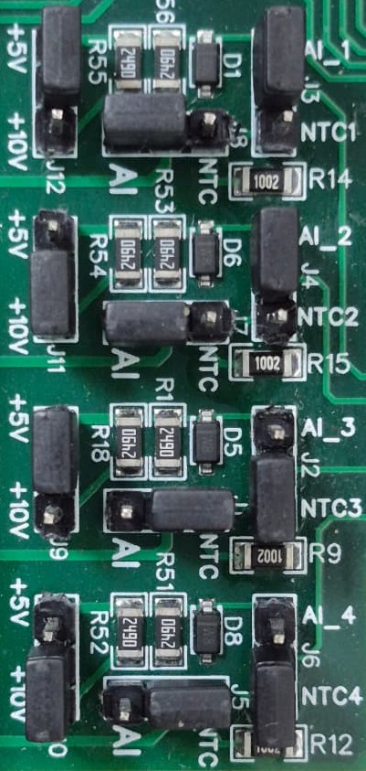
Sensor
Sensor
Sensor
Sensor

- Analog Input & NTC Operation: Each channel provides two terminals: + (Positive) and - (Negative/Common). These are used to interface with either standard external analog sensors or NTC thermistors.
- Channel Configuration (Visual Guide): Each of the four channels features two dedicated jumpers to independently select the operating mode (AI or NTC) and the reference voltage range (5V or 10V). Refer to the color-coded boxes in the board diagram to configure your desired scenario:
  - Red Box (AI Mode, 5V Range): Set the mode jumper to AI and the voltage jumper to +5V.
  - Green Box (AI Mode, 10V Range): Set the mode jumper to AI and the voltage jumper to +10V.
  - Blue Box (NTC Mode, 5V Range): Set the mode jumper to NTC and the voltage jumper to +5V.
  - Yellow Box (NTC Mode, 10V Range): Set the mode jumper to NTC and the voltage jumper to +10V.
- Sensor Wiring Connections:
  - The sensor or thermistor's positive signal wire should be connected to the + terminal of the desired channel (labelled AI1/NTC, AI2/NTC, etc.).
  - The sensor's common or ground wire should be connected to the corresponding - terminal.
- Crucial Setup Recommendation: Always ensure that both the mode jumper (NTC vs. AI) and the voltage jumper strictly match the hardware you are connecting. Incorrectly setting an NTC to an AI mode, or mismatching the voltage limits, will result in inaccurate temperature or signal readings.

AO

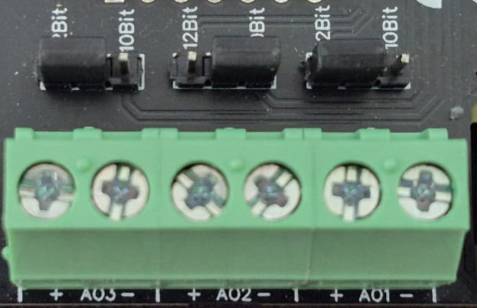
O/p device
O/p device
O/p device

- Analog Output (AO) Operation: Each channel provides two terminals: + (Positive) and - (Negative/Common). These are used to send variable analog signals to external output (O/p) devices, such as variable frequency drives or proportional valves.
- Channel Configuration (Visual Guide): Each of the three AO channels features a dedicated jumper to set the output bit resolution. Refer to the color-coded boxes in the board diagram to configure your desired resolution:
  - Green & Yellow Box (12-bit): Set the resolution jumper to 12Bit.
  - Blue Box (10-bit): Set the resolution jumper to 10Bit.
- Output Device Wiring Connections:
  - The external device's positive signal wire should be connected to the + terminal of the desired channel (AO1, AO2, or AO3).
  - The device's common or ground wire should be connected to the corresponding - terminal..
- Crucial Setup Recommendation: Always ensure that the hardware jumper setting (10-bit or 12-bit) matches the output scaling configured in your main control software. A mismatch between software resolution and hardware configuration will result in incorrect output signal levels.

DO

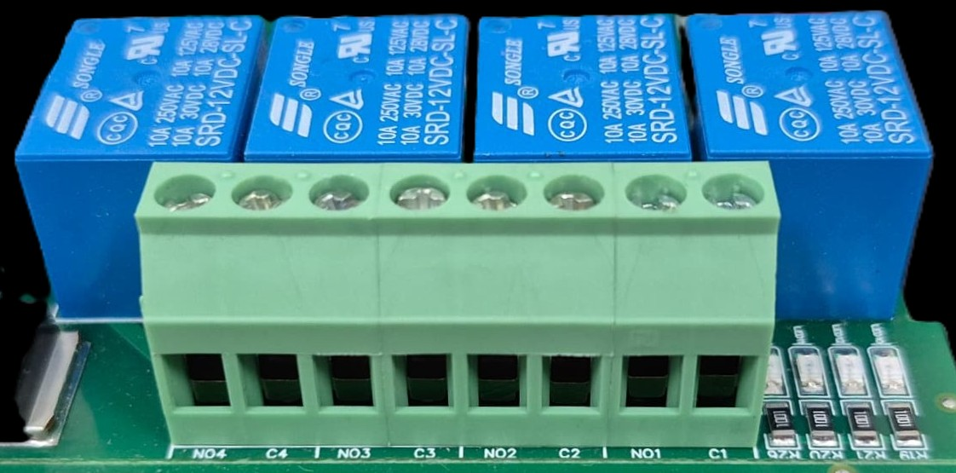




L
O
A
D
N

P
L
O
A
D
N

P
L
O
A
D
N

P
L
O
A
D
N

P

- Digital Output (DO) operation: Each channel provides two terminals: C (Common) and NO (Normally Open). When the relay coil is energized, terminal C is internally connected to NO, allowing current to flow. When the relay is de-energized, the connection between C and NO remains open, and the load stays OFF.
- Load Wiring Connections:
  - AC Load Connection: The AC Live (Phase) wire should be connected to terminal C. The load is connected between terminal NO and Neutral (N).
  - DC Load Connection: The positive supply (+V) should be connected to terminal C. The load is connected between terminal NO and Ground (GND).
- Crucial Safety Recommendation and Rating: It is strongly recommended to switch the Live (Phase) conductor in AC applications to ensure the load is safely de-energized when the relay is off.
Note: Ensure that the connected load does not exceed the relay’s contact rating of 10A @ 250VAC (or 10A @ 125VAC) or 10A @ 30VDC (or 10A @ 28VDC).

Wiring Diagram:-
The Port number and Sequence of UI and UO are as mentioned in the wiring diagrams shown below. Also the position of default reset button is as shown in the diagram.

1-12 UI

GND
12v Ref
Input
9-24 VDC
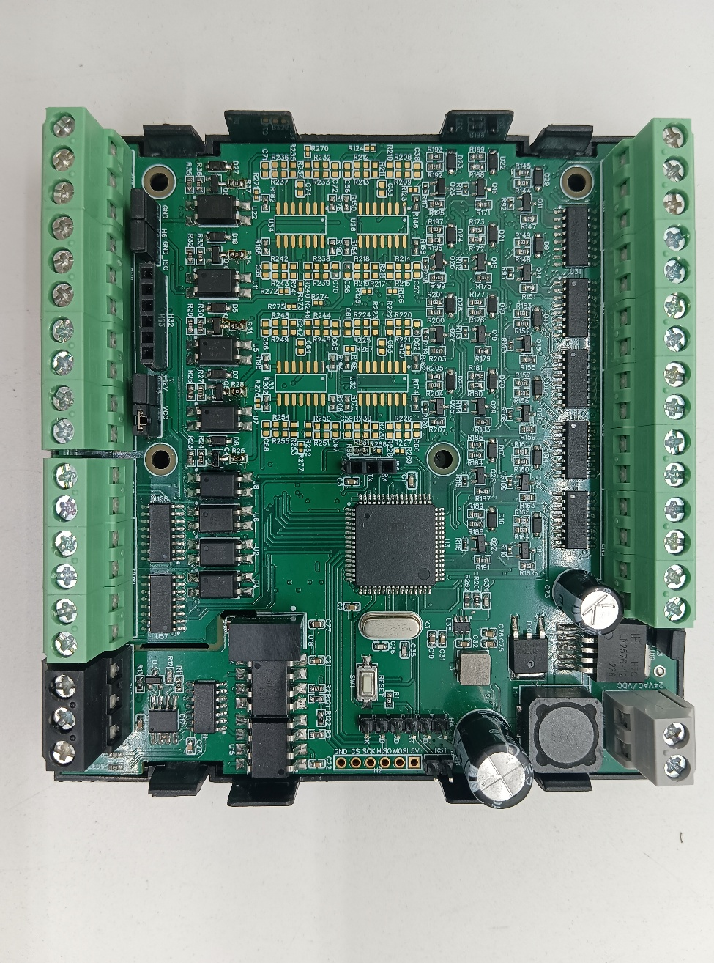
Jumper
Reset
Modbus
RS485
16-13 UI

GND
8-1 UO

Contact us: -
Augmatic Technologies Pvt. Ltd.,
Plot no 6, Shah Industrial Estate II,
Kotambi,
Vadodara – 391510.
Email – Sales@wittelb.com
Support: support@wittelb.raiseaticket.com / +91 94038 92805

