32 channel NPN based DO

The IO modules communicate via RS485. The port can drive distances up to max 200 meters without the use of any repeater (this feature however also depends on the signal strength of the Modbus Master Device).
The RS485 Digital IO module is sturdy, has low power usage and is easy to use.

32 Port DO Module: -
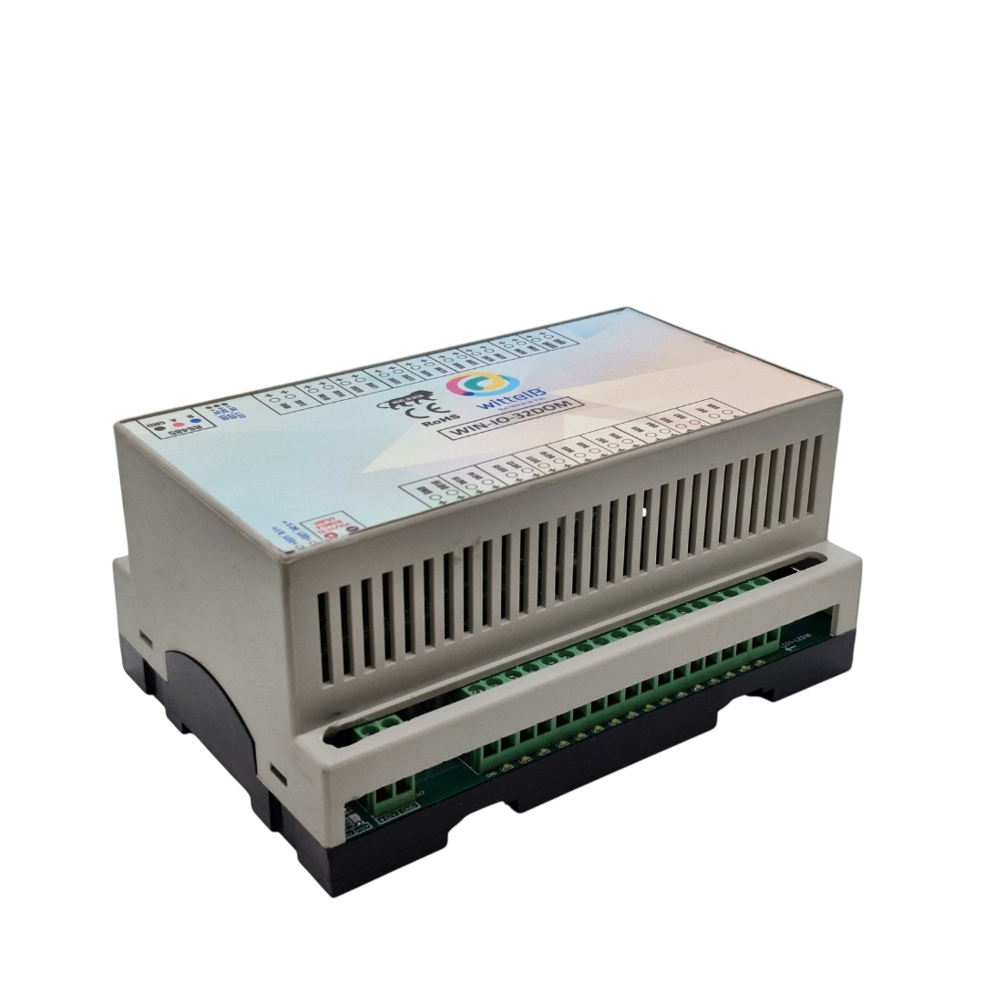

The IO modules are mounted on DIN rail mountable casing and with exposed connectors and LED indicators. Baud rate and slave ID can be changed by software setting.
The design of the modules incorporates ‘resettable Fuses’ to safeguard against reverse polarity connection both for Power and Communication port.

Specifications
General –

I/O Connectors 5.08 mm pitch pluggable screw Terminal Block
Dimensions 157 mm L x 110 mm B x 73 mm H
Power Input Power –24 V DC options
Typical – 12V DC @ 150mA
Operating Temperature 0 – 60° C (32 ~ 140°F)
Storage Temperature -20 - 70° C (-4 ~ 158°F)
Storage Humidity 5 ~ 95 % RH, non – Condensing
Output mode Collector NPN output
Response speed 0.01 seconds (10ms)
Application design Industrial-grade anti-interference design, stable
Certifications 

Additional Features: -
Communication ports are isolated
Input power reverse polarity safety
ESD Safety IEC 61000-4-2, ± 30KV contact, ± 30KV air
EFT IEC 61000-4-4, 50A (5/50ms)
400V isolation.
CRC Error check.
No configuration needed on the IO board

Configuration Settings: -

Communication Speed 9600 – 115200 Kbps (Software selectable)
Data Bits 8
Parity None
Stop bit 1
CRC Yes
Slave ID Software selectable
Function code 0x01
DO Register Address 0 to 31

ID | Function | Register | Protocol | Data
 | Description | Description |  | Type
1 | DO 1 | 1 | RS485 | 1 Bit Boolean
2 | DO 2 | 2 | RS485 | 1 Bit Boolean
3 | DO 3 | 3 | RS485 | 1 Bit Boolean
4 | DO 4 | 4 | RS485 | 1 Bit Boolean
5 | DO 5 | 5 | RS485 | 1 Bit Boolean
6 | DO 6 | 6 | RS485 | 1 Bit Boolean
7 | DO 7 | 7 | RS485 | 1 Bit Boolean
8 | DO 8 | 8 | RS485 | 1 Bit Boolean
9 | DO 9 | 9 | RS485 | 1 Bit Boolean
10 | DO 10 | 10 | RS485 | 1 Bit Boolean
11 | DO 11 | 11 | RS485 | 1 Bit Boolean
12 | DO 12 | 12 | RS485 | 1 Bit Boolean
13 | DO 13 | 13 | RS485 | 1 Bit Boolean
14 | DO 14 | 14 | RS485 | 1 Bit Boolean
15 | DO 15 | 15 | RS485 | 1 Bit Boolean
16 | DO 16 | 16 | RS485 | 1 Bit Boolean
17 | DO 17 | 17 | RS485 | 1 Bit Boolean
18 | DO 18 | 18 | RS485 | 1 Bit Boolean
19 | DO 19 | 19 | RS485 | 1 Bit Boolean
20 | DO 20 | 20 | RS485 | 1 Bit Boolean
21 | DO 21 | 21 | RS485 | 1 Bit Boolean
22 | DO 22 | 22 | RS485 | 1 Bit Boolean
23 | DO 23 | 23 | RS485 | 1 Bit Boolean
24 | DO 24 | 24 | RS485 | 1 Bit Boolean
25 | DO 25 | 25 | RS485 | 1 Bit Boolean
26 | DO 26 | 26 | RS485 | 1 Bit Boolean
27 | DO 27 | 27 | RS485 | 1 Bit Boolean
28 | DO 28 | 28 | RS485 | 1 Bit Boolean
29 | DO 29 | 29 | RS485 | 1 Bit Boolean
30 | DO 30 | 30 | RS485 | 1 Bit Boolean
31 | DO 31 | 31 | RS485 | 1 Bit Boolean
32 | DO 32 | 32 | RS485 | 1 Bit Boolean

DO
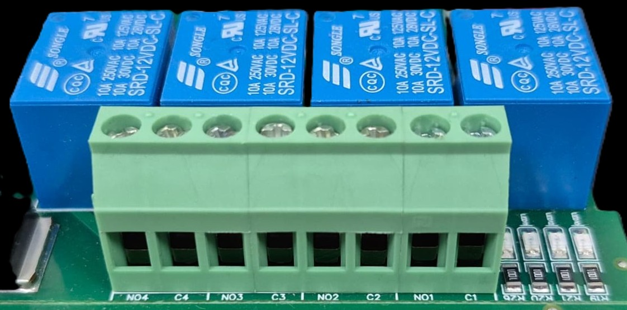




L
O
A
D
N

P
L
O
A
D
N

P
L
O
A
D
N

P
L
O
A
D
N

P

- Digital Output (DO) operation: Each channel provides two terminals: C (Common) and NO (Normally Open). When the relay coil is energized, terminal C is internally connected to NO, allowing current to flow. When the relay is de-energized, the connection between C and NO remains open, and the load stays OFF.
- Load Wiring Connections:
  - AC Load Connection: The AC Live (Phase) wire should be connected to terminal C. The load is connected between terminal NO and Neutral (N).
  - DC Load Connection: The positive supply (+V) should be connected to terminal C. The load is connected between terminal NO and Ground (GND).
- Crucial Safety Recommendation and Rating: It is strongly recommended to switch the Live (Phase) conductor in AC applications to ensure the load is safely de-energized when the relay is off.
Note: Ensure that the connected load does not exceed the relay’s contact rating of 10A @ 250VAC (or 10A @ 125VAC) or 10A @ 30VDC (or 10A @ 28VDC).

Recommended Cable Electrical Characteristics: -
22 AWG Cable Shielded Twisted pair should be used
Tinned Copper Recommended
Nominal Conductor DCR 14.7 ohm / 1000 ft
Nominal Capacitance 11 pf / feet (conductor to conductor)
High Frequency Non-Insertion Loss 0.5db / 100f

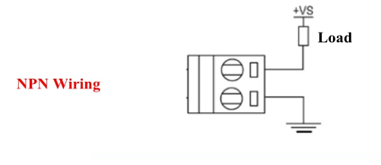
Application design as above
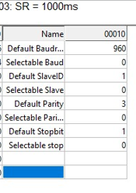
This is default Modbus setting that is Baud rate is 9600, Slave ID is 1.
Baud rate is multiple of 10(960*10=9600)
To change baud rate and slave ID , at the selectable register the required value of Baud rate and Slave ID, Make a power cycle (Power ON/OFF the product) and Connect Modbus with changed parameters.

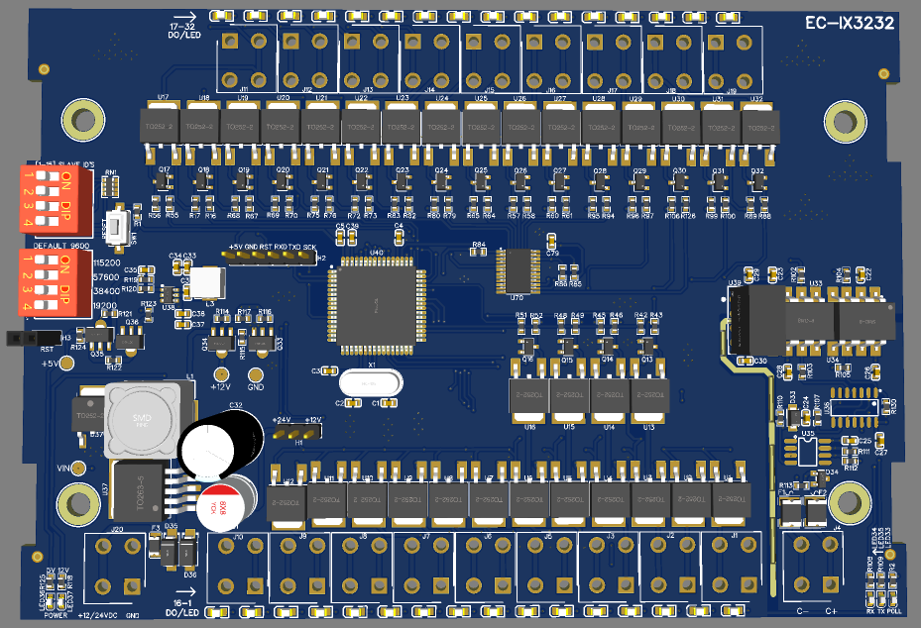
DIGITAL OUTPUT (DO) (MOSFET)
17|18|19|20|21|22|23|24|25|26|27|28|29|30|31|32
16|15|14|13|12|11|10|09|08|07|06|05|04|03|02|01
DIGITAL OUTPUT (DO) (MOSFET)
Common
GND
12/24V DC
Inut Supply
MODBUS
RS485
Polling
LED
RESET
DIP Switch: Baud rate & Slave ID
Power
LED
Default Setting
Common
GND

Contact us: -
Augmatic Technologies Pvt. Ltd.,
Plot no 6, Shah Industrial Estate II,
Kotambi,
Vadodara – 391510.
Email – Sales@wittelb.com
Support: support@wittelb.raiseaticket.com / +91 94038 92805

