Technical Datasheet Input / Output Modules with Modbus TCP Protocol with Ethernet Interface

The IO module communicates via Ethernet Interface. The module is designed to allow interface with other Modbus TCP/IP compatible devices. The module acts as an input/output device between the Modbus TCP/IP Network and the Gateway.
Digital IO module is sturdy, low power usage and is easy to use.

4 Port AI Module with Modbus TCP Ethernet Port: -
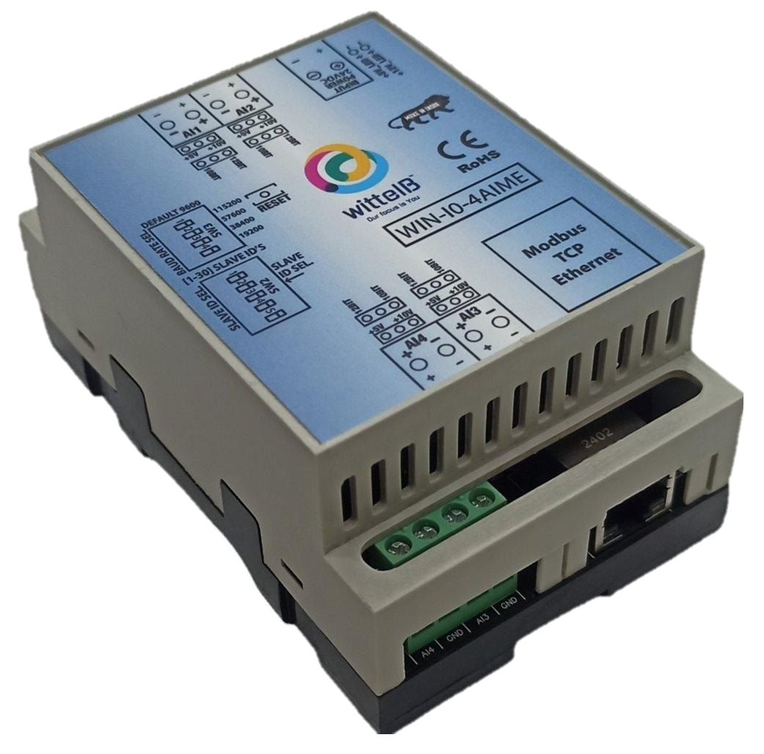

The IO modules are mounted on DIN rail mountable casing and with exposed connectors and LED indicators.
The design of the modules incorporates ‘resettable Fuses’ to safeguard against sudden High Voltage spikes. The board also has ‘reverse polarity’ protection for input Power connector.
The communication port also has signal isolation and additional Jumper for ‘end of line’ 120 ohms termination resistance which may or may not be used.
Specifications

General: –
I/O Connectors 2 Pin 5.08 mm pitch pluggable screw terminals.
Dimensions 70 mm L x 110 mm B x 50 mm H
Power Input Power – 12 – 24 VDC or 24 V AC/DC
Typical – 12V DC @ 1Amp
Operating Temperature 0 – 60° C (32 ~ 140°F)
Storage Temperature | -20 - 70° C (-4 ~ 158°F)
Storage Humidity | 5 ~ 95 % RH, non – Condensing
Certifications  
AI Inputs: –
Channels | 4
Input Signal | 4 – 20 mA / 0 – 5 V / 0 – 10 V (jumper selectable)
Accuracy | ± 2 % of Full scale
Input Resolution | 10-bit /12-bit resolution (optional)
Isolation | Optically Isolated
External Loop Voltage | + 12 VDC min
AI input impedance | 120Ω

Additional Features: -
Input power reverse polarity safety
ESD Safety IEC 61000-4-2, ± 30KV contact, ± 30KV air EFT IEC 61000-4-4, 50A (5/50ms)
750V isolation.
CRC Error check.
Web based Configuration needed for the IO board

Configuration Settings: -
Communication Speed 10/100 Base-T Ethernet compatible Interface
Data Bits |  |  | 8
Parity |  |  | None
Stop bit |  |  | 1
CRC |  |  | Yes
Slave ID |  |  | (Web Selectable)
Function Code AI 0x03 Read Holding Registers
AI Register Address 10 Bit -1,2,3,4 / 12 Bit - 5,6,7,8.

ID | Function Description | Register Description | Modbus  Function Code | Protocol | Data Type
1 | AI 1 – 10 Bit | 40001 | 0X03 | RS485 | 16 Bit Unsigned int
2 | AI 2 – 10 Bit | 40002 | 0X03 | RS485 | 16 Bit Unsigned int
3 | AI 3 – 10 Bit | 40003 | 0X03 | RS485 | 16 Bit Unsigned int
4 | AI 4 – 10 Bit | 40004 | 0X03 | RS485 | 16 Bit Unsigned int
5 | AI 5 – 12 Bit | 40005 | 0X03 | RS485 | 16 Bit Unsigned int
6 | AI 6 – 12 Bit | 40006 | 0X03 | RS485 | 16 Bit Unsigned int
7 | AI 7 – 12 Bit | 40007 | 0X03 | RS485 | 16 Bit Unsigned int
8 | AI 8 – 12 Bit | 40008 | 0X03 | RS485 | 16 Bit Unsigned int

Note: -

For MODBUS communications, a shielded and twisted pair cable is used. One example of such cable is Belden 3105A.

Recommended Cable Electrical Characteristics: -

22 AWG Cable Shielded and twisted pair should be used.
Tinned Copper Recommended
Nominal Conductor DCR 14.7 ohm / 1000 ft
Nominal Capacitance 11 pf / feet (conductor to conductor)
High Frequency Non-Insertion Loss 0.5db / 100ft

Configuration Guide – Ethernet Modbus TCP/IP IO Module:-
- Open a web browser (Google Chrome, Microsoft Edge, Firefox, etc.).
- In the browser’s address bar, type the default IP address:
192.168.0.160
- Press Enter. A message will appear saying:
“Please go to http://192.168.0.160/setup.”
- Copy this link (http://192.168.0.160/setup) and paste it into a new browser tab.
- Press Enter again to open the Setup / Configuration Page of the device.

To Reset the Device to Default Settings
- Place the jumper on the designated Reset position on the device.
- Press the Reset button once.
- The module will reboot and revert to its default IP address: 192.168.0.160.

To Change the IP Address
- On the Setup / Configuration Page, enter the new IP address you wish to assign.
- Click Submit to save the new settings.
- The device will automatically apply the new IP address.
Note:
- Ensure your PC’s IP address is in the same network range (for example, 192.168.0.xxx) when accessing the module.
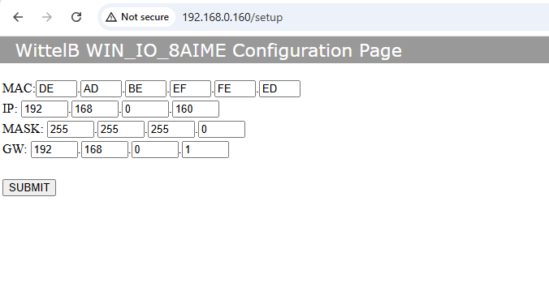
- After changing the IP, you must use the new address to log in again.
4 AIME

AI
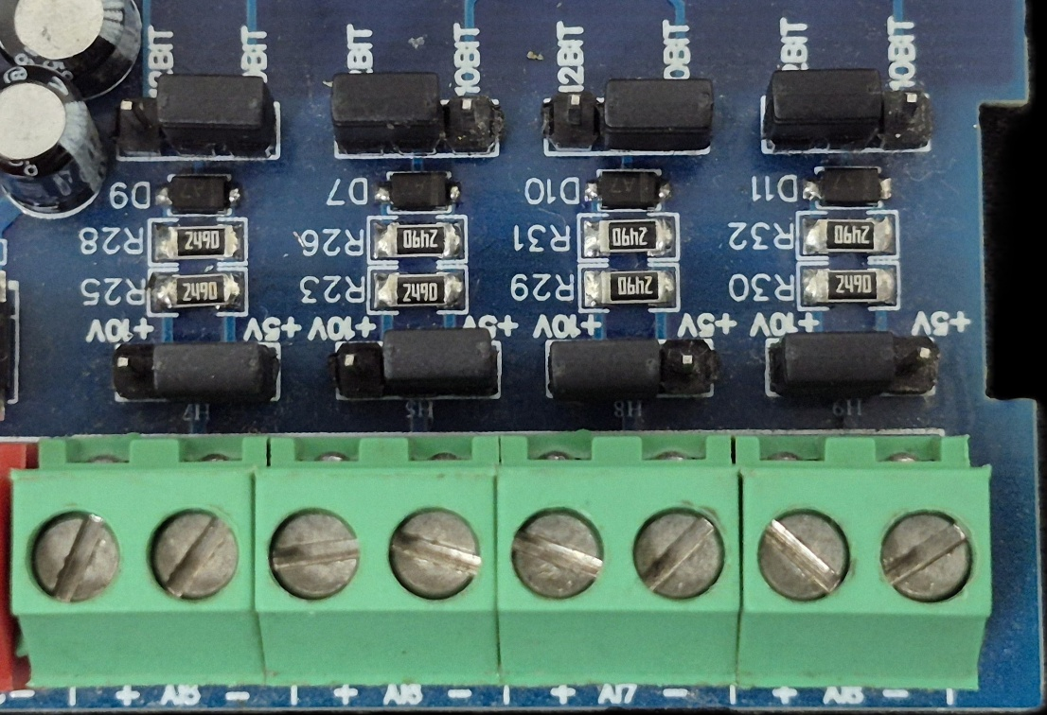
Sensor
Sensor
Sensor
Sensor

- Analog Input (AI) Operation: Each channel provides two terminals: + (Positive) and - (Negative/Common). These are used to read external analog sensor signals.
- Channel Configuration (Visual Guide): Each of the four AI channels features two dedicated jumpers to independently set the voltage range and bit resolution. Refer to the color-coded boxes in the board diagram to configure your desired scenario:
  - Red Box (5V, 10-bit): Set the voltage jumper to +5V and the resolution jumper to 10 BIT.
  - Green Box (5V, 12-bit): Set the voltage jumper to +5V and the resolution jumper to 12 BIT.
  - Blue Box (10V, 10-bit): Set the voltage jumper to +10V and the resolution jumper to 10 BIT.
  - Yellow Box (10V, 12-bit): Set the voltage jumper to +10V and the resolution jumper to 12 BIT.
- Sensor Wiring Connections:
  - The analog sensor's positive signal wire should be connected to the + terminal of the desired channel.
  - The sensor's common or ground wire should be connected to the corresponding - terminal.
- Crucial Setup Recommendation: Always ensure that the voltage jumper setting strictly matches the maximum output range of your connected sensor (either 5V or 10V) to guarantee accurate analog-to-digital conversion and prevent data clipping.
AI 3
AI 4

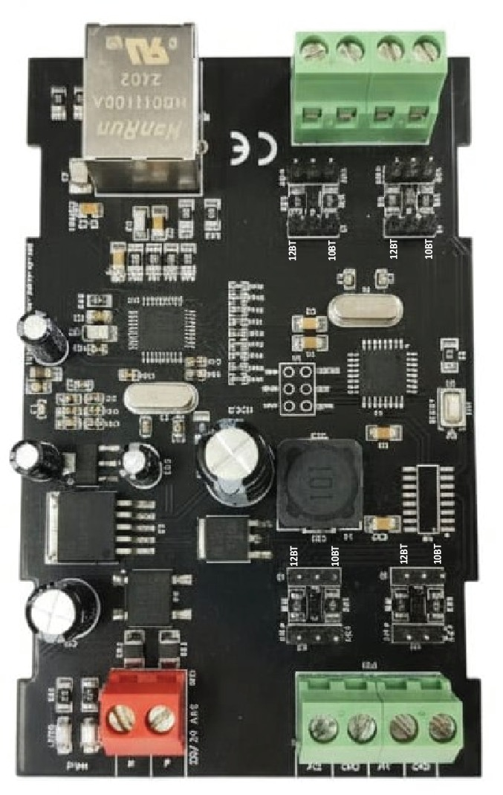
AI 2
AI 1

Input
12
-
24

VDC

Modbus
TCP
Ethernet

Jumper

10
/ 12
Bit

Jumper

V / 10V
5

NOTE:–
By default, the Jumper setting on the board is 10 V and 10 Bit.

Contact us: -
Augmatic Technologies Pvt. Ltd.,
Plot no 6, Shah Industrial Estate II,
Kotambi,
Vadodara – 391510.
Email – Sales@wittelb.com
Support: support@wittelb.raiseaticket.com / +91 94038 92805

