Technical Datasheet Input / Output Modules with Modbus RTU Protocol with RS485 Interface

The IO modules communicate via RS485. The port can drive distances up to max 700 meters without the use of any repeater (this feature however also depends on the signal strength of the Modbus Master Device).

The RS485 Digital IO module is sturdy, low power usage and easy to use.

4 Port AO Module Voltage (0-10V): -

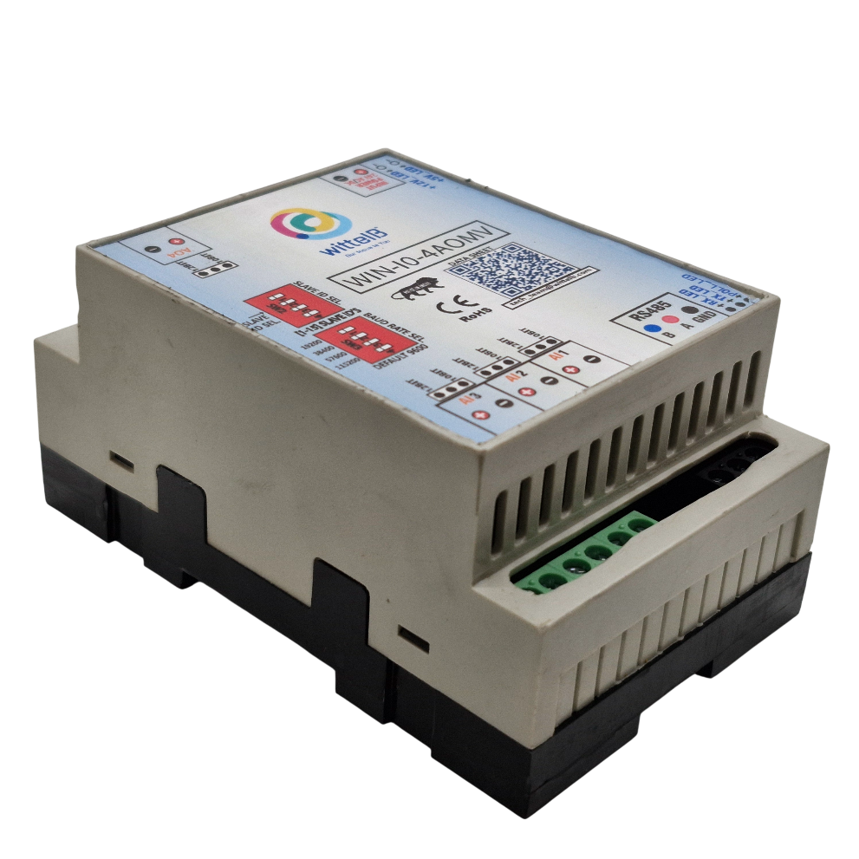

The IO modules are mounted on DIN rail mountable casing and with exposed connectors and LED indicators. The DIP switch for Slave ID and Baud rate are placed inside the enclosure.
The design of the modules incorporates ‘resettable Fuses’ to safeguard against sudden High Voltage spikes. The board also has ‘reverse polarity’ protection both for input Power connector.
The communication port also has signal isolation and additional Jumper for ‘end of line’ 120 ohms termination resistance which may or may not be used.
Specifications

General: –

I/O Connectors 2 Pin 5.08 mm pitch pluggable screw terminals.
Dimensions 70 mm x 110 mm x 50 mm
Power Input Power: 9–36 V DC or 24 V AC/DC
Typical: 12V DC 1Amp
Operating Temperature 0 – 60° C (32 ~ 140°F)
Storage Temperature -20 - 70° C (-4 ~ 158°)
Storage Humidity 5 ~ 95 % RH, non – Condensing
Certifications  

AO Outputs: –
Channels | 4
Inputs Resolution | 10 Bit (12 Bit Optional)
Signal Range | 0 – 10V
Accuracy | ± 2% Full scale
Linearity Error | 0.1 %
Conversion Time | 20 msec

Additional Features: -
Communication port isolated
Input power reverse polarity safety
ESD Safety IEC 61000-4-2, ± 30KV contact, ± 30KV air EFT IEC 61000-4-4, 50A (5/50ms)
750V isolation.
CRC Error check.
No configuration needed on the IO board

Configuration Settings: -

Communication Speed 9600 Kbps (DIP SW selectable)
Data Bits | 8
Parity | None
Stop bit | 1
CRC | Yes
Slave ID | 1 – 15 (DIP SW selectable)
Function code AO | 0x10 Write Multiple registers
AO Register Address | 10 Bit -0,1,2,3 / 12 Bit – 4,5,6,7.

ID | Function Description | Register Description | Modbus  Function Code | Protocol | Data Type
1 | AO 1 – 10 Bit | 40001 | 0X10 | RS485 | 16 Bit Unsigned int
2 | AO 2 – 10 Bit | 40002 | 0X10 | RS485 | 16 Bit Unsigned int
3 | AO 3 – 10 Bit | 40003 | 0X10 | RS485 | 16 Bit Unsigned int
4 | AO 4 – 10 Bit | 40004 | 0X10 | RS485 | 16 Bit Unsigned int
5 | AO 1 - 12 Bit | 40005 | 0x10 | RS485 | 16 Bit Unsigned int
6 | AO 2 - 12 Bit | 40006 | 0x10 | RS485 | 16 Bit Unsigned int
7 | AO 3 - 12 Bit | 40007 | 0x10 | RS485 | 16 Bit Unsigned int
8 | AO 4 - 12 Bit | 40008 | 0x10 | RS485 | 16 Bit Unsigned int

Note: -
For MODBUS communications, a shielded and twisted pair cable is used. One example of such cable is Belden 3105A.

Recommended Cable Electrical Characteristics: -

22 AWG Cable Shielded and twisted pair should be used.
Tinned Copper Recommended
Nominal Conductor DCR 14.7 ohm / 1000 ft
Nominal Capacitance 11 pf / feet (conductor to conductor)
High Frequency Non-Insertion Loss 0.5db / 10

BAUD RATE DESCRIPTION:-

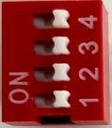

L
SB

M
SB

- For Baud rate Selection, DIP SW is used as per the diagram.
- Pulling up the switch will make Baud rate active.
- If no selection is made 9600 will be default Baud rate.
- When u change the Baud rate in the Module power ‘ON’ condition, pls press the reset button to get Change to affect

Baud Rate | DIP SWITCH
 | 1 | 2 | 3 | 4
9600 | OFF | OFF | OFF | OFF
115200 | ON | OFF | OFF | OFF
57600 | OFF | ON | OFF | OFF
38400 | OFF | OFF | ON | OFF
19200 | OFF | OFF | OFF | ON

SLAVE ID DESCRIPTION:-

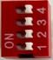

MSB

LSB

- For Slave ID Selection SW is used to Set The SLAVE ID .
- For Slave ID DIP Switch LSB is “1” follow through “4” is MSB.
- Slave ID Confirmed through below Device ID table .
- IF Eg. Slave ID 1 is Needed to be selected Switch number 1 should pulled up other three should be selected down side. So”1 0 0 0” will be selected as Slave ID 1

Slave ID |  | DIP SWITCH |  |  | OUTPUT  (Binary) | OUTPUT  (Decimal)
 | 1 | 2 | 3 | 4
0 | OFF(0) | OFF(0) | OFF(0) | OFF(0) | 0 0 0 1 | 1
1 | ON(1) | OFF(0) | OFF(0) | OFF(0) | 0 0 0 1 | 1
2 | OFF(0) | ON(1) | OFF(0) | OFF(0) | 0 0 1 0 | 2
3 | ON(1) | ON(1) | OFF(0) | OFF(0) | 0 0 1 1 | 3
4 | OFF(0) | OFF(0) | ON(1) | OFF(0) | 0 1 0 0 | 4
5 | ON(1) | OFF(0) | ON(1) | OFF(0) | 0 1 0 1 | 5
6 | OFF(0) | ON(1) | ON(1) | OFF(0) | 0 1 1 0 | 6
7 | ON(1) | ON(1) | ON(1) | OFF(0) | 0 1 1 1 | 7
8 | OFF(0) | OFF(0) | OFF(0) | ON(1) | 1 0 0 0 | 8
9 | ON(1) | OFF(0) | OFF(0) | ON(1) | 1 0 0 1 | 9
10 | OFF(0) | ON(1) | OFF(0) | ON(1) | 1 0 1 0 | 10
11 | ON(1) | ON(1) | OFF(0) | ON(1) | 1 0 1 1 | 11
12 | OFF(0) | OFF(0) | ON(1) | ON(1) | 1 1 0 0 | 12
13 | ON(1) | OFF(0) | ON(1) | ON(1) | 1 1 0 1 | 13
14 | OFF(0) | ON(1) | ON(1) | ON(1) | 1 1 1 0 | 14
15 | ON(1) | ON(1) | ON(1) | ON(1) | 1 1 1 1 | 15

AO
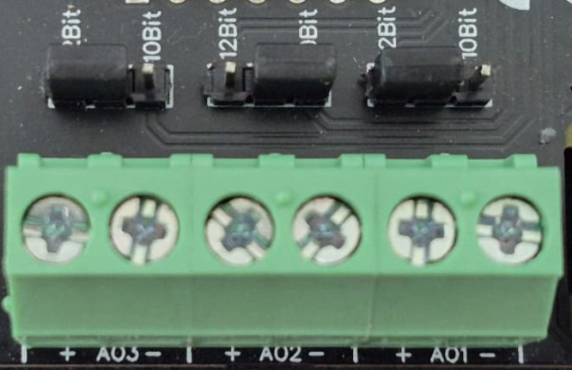

O/p device
O/p device

O/p device

- Analog Output (AO) Operation: Each channel provides two terminals: + (Positive) and - (Negative/Common). These are used to send variable analog signals to external output (O/p) devices, such as variable frequency drives or proportional valves.
- Channel Configuration (Visual Guide): Each of the three AO channels features a dedicated jumper to set the output bit resolution. Refer to the color-coded boxes in the board diagram to configure your desired resolution:
  - Green & Yellow Box (12-bit): Set the resolution jumper to 12Bit.
  - Blue Box (10-bit): Set the resolution jumper to 10Bit.
- Output Device Wiring Connections:
  - The external device's positive signal wire should be connected to the + terminal of the desired channel (AO1, AO2, or AO3).
  - The device's common or ground wire should be connected to the corresponding - terminal..
- Crucial Setup Recommendation: Always ensure that the hardware jumper setting (10-bit or 12-bit) matches the output scaling configured in your main control software. A mismatch between software resolution and hardware configuration will result in incorrect output signal levels.

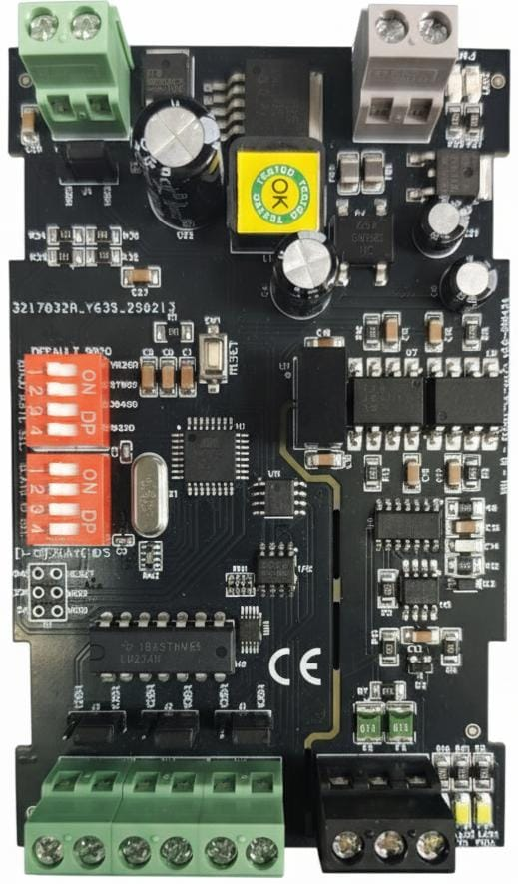

36 vvvvvvvvvvvvvV
9-36

AC/DC

AO
-
1

(0
-
10
V
)

Baud Rate

DIP SW

1.11520000000000

2.57600

3.38400

4.19200

Slave ID
DIP SW

1

-

15

AO
-

4
AO
-

AO
3
-

2

0
-
10
V 10 bit / 12 bit

Modbus
RTU

RS485

10
-
bit
–

12
-
bit
Jumper
selection

Contact us: -
Augmatic Technologies Pvt. Ltd.,
Plot no 6, Shah Industrial Estate II,
Kotambi,
Vadodara – 391510.
Email – Sales@wittelb.com
Support: support@wittelb.raiseaticket.com / +91 94038 92805

