Technical Datasheet WIN-IO-4DOAOM

The IO modules communicate via RS485. The port can drive distances up to max 700 meters without the use of any repeater (this feature however also depends on the signal strength of the Modbus Master Device).
The RS485 Digital IO module is sturdy, low power usage and easy to use.
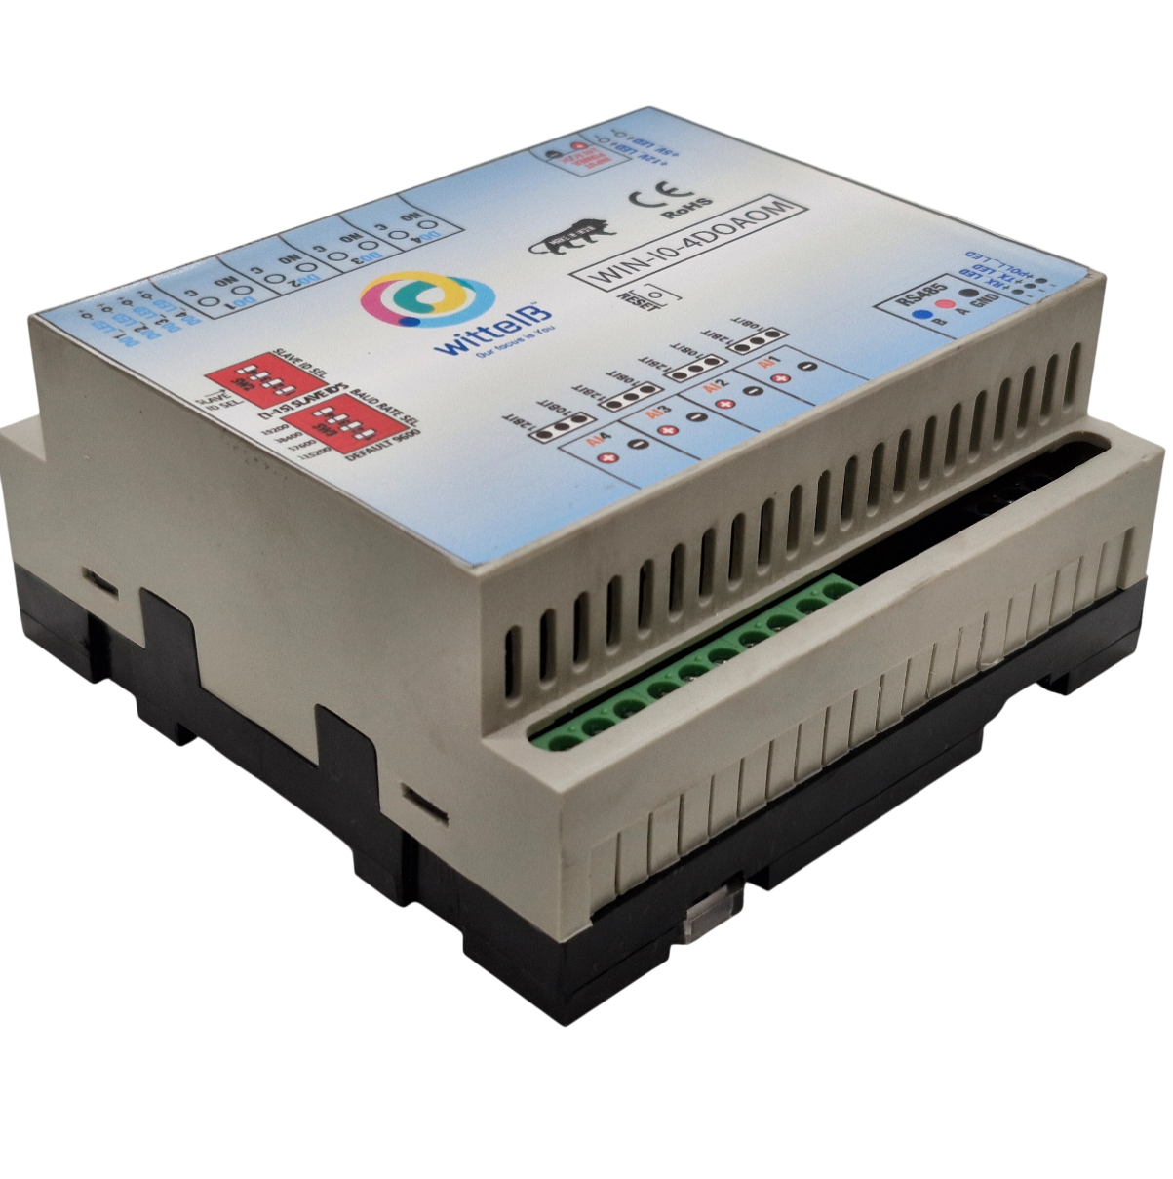
4Port DO-4-AO Module: -

The IO modules are mounted on DIN rail mountable casing and with exposed connectors and LED indicators.

The design of the modules incorporates ‘resettable Fuses’ to safeguard against reverse polarity connection both for Power and Communication port.

Specifications
General –
I/O Connectors 12 Pin 5.08 mm pitch pluggable screw Terminal Block, 2 Pin 5.08 mm pitch pluggable screw terminals.
Power Input Power – 12 - 24 VDC or 24 V AC/DC
Typical – 12V DC @ 120mA
Operating Temperature 0 – 60° C (32 ~ 140°F)
Storage Temperature -20 - 70° C (-4 ~ 158°F)
Storage Humidity 5 ~ 95 % RH, non – Condensing

Certifications 

DO with Relay Output –
Channels 4
Contact Form 1A, 1C
Contact Material Ag Alloy
Contact Capacity 10A @ 240VAC, 10A @ 28VDC
Coil Voltage 5 – 48 VDC
Coil Power 0.36 W
Insulation Resistance 250MΩ
Electrical Life 1 x 10^5
Mechanical Life 1 x 10^7
Operating Time 7 msec, Max 15 msec
Release Time 2 msec, Max 6 msec

AO Outputs –
Channels 4 AO Channel
Input Signal Modbus RS485
Output Resolution 4 – 20 mA (10Bit)
Accuracy ± 2% Full scale

Configuration Settings: -
Communication Speed 9600 – 115200.
Data Bits 8
Parity None
Stop bit 1
CRC Yes
Slave Id Soft Setting
Function code DO 0x05 and 0x0F (5 Single coil & 15 multiple coil)
DO Register Address 0,1,2,3.
Function code AO 0x03 Read Holding Register.
AO Register Address 0,1,2,3,4,5,6,7.
Function code Soft Serial 0x03 Read Holding Register

ID | Function  Description | Register  Description | Modbus Function Code | Protocol | Data  Type
0 | DO1 | 00001 | 0X05,0X0F | RS485 | 1 Bit Boolean
1 | DO2 | 00002 | 0X05,0X0F | RS485 | 1 Bit Boolean
2 | DO3 | 00003 | 0X05,0X0F | RS485 | 1 Bit Boolean
3 | DO4 | 00004 | 0X05,0X0F | RS485 | 1 Bit Boolean
1 | AO 1 - 10 Bit | 40001 | 0x03 | RS485 | 16 Bit Unsigned int
2 | AO 2 - 10 Bit | 40002 | 0x03 | RS485 | 16 Bit Unsigned int
3 | AO 3 - 10 Bit | 40003 | 0x03 | Rs485 | 16 Bit Unsigned int
4 | AO 4 - 10 Bit | 40004 | 0x03 | Rs485 | 16 Bit Unsigned int
5 | AO1 - 12 Bit | 40005 | 0x03 | RS485 | 16 Bit Unsigned int
6 | AO2 - 12 Bit | 40006 | 0x03 | RS485 | 16 Bit Unsigned int
7 | AO3 - 12 Bit | 40007 | 0x03 | RS485 | 16 Bit Unsigned int
8 | AO4 - 12 Bit | 40008 | 0x03 | RS485 | 16 Bit Unsigned int
10 | Display Baud Rate (Default:960) | 40011 | 0x03 | RS485 | 16 Bit Unsigned int
11 | Enter New Baud Rate | 40012 | 0x03 | RS485 | 16 Bit Unsigned int
12 | Display Slave ID (Default:1) | 40013 | 0x03 | RS485 | 16 Bit Unsigned int
13 | Enter New Slave ID | 40014 | 0x03 | RS485 | 16 Bit Unsigned int
14 | Display Parity  (Default: None-3, Odd-1, Even-2) | 40015 | 0x03 | RS485 | 16 Bit Unsigned int
15 | Enter New Parity | 40016 | 0x03 | RS485 | 16 Bit Unsigned int
16 | Display Stop Bit  (start-2/stop bit-1) | 40017 | 0x03 | RS485 | 16 Bit Unsigned int
17 | Enter New Start/ Stop Bit | 40018 | 0x03 | RS485 | 16 Bit Unsigned int
Additional Features: -
All inputs and communication ports isolated
Input power reverse polarity safety
ESD Safety IEC 61000-4-2, ± 30KV contact, ± 30KV air
EFT IEC 61000-4-4, 50A (5/50ms)
750V isolation.
CRC Error check.
No configuration needed on the IO board

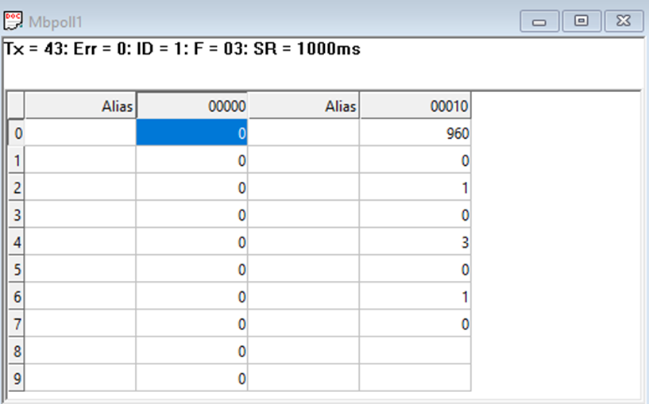

Note:

- In register 40015- you will able to see the current parity and you can change it in register 40016
- In register 40017- you will able to see the current stop bit and you can change it in register 40018
- If you want to enter the baud rate 9600/19200/38400/57600/115200etc.
Enter it as 960/1920/5760/11520etc.
- After that press the reset button or reboot the system.

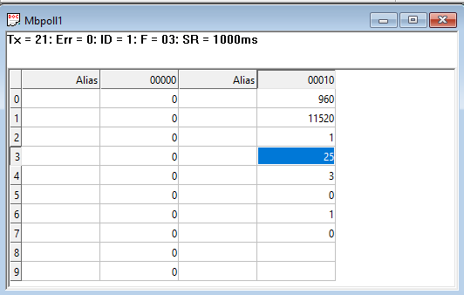

As you can see in the image above, the resistor 40011 – 960 represents the present bund rate (9600) of the board and 40013 – 1 represents the present slave id of the board.

To change the baud rate and slave id you have to enter a value on the 40012 resistor for the baud rate and 40014 for the slave id as shown in the image below.
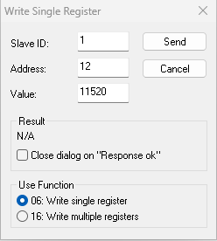
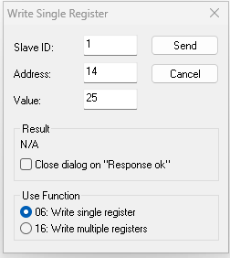


Note:
1. If you want to enter the baud rate 9600/19200/38400/57600/115200etc.
Enter it like this 960/1920/5760/11520etc.
2. After that press the reset button or reboot the system.
3. Then you will get the present value of 11520 at 40011 baud rate(115200) and 25 at 40013 slave id.
4. You can Change Parity Bit , stop bit Of the device with same way.
Recommended Cable Electrical Characteristics: -
22 AWG Cable Shielded and twisted pair should be used.
Tinned Copper Recommended
Nominal Conductor DCR 14.7 ohm / 1000 ft
Nominal Capacitance 11 pf / feet (conductor to conductor)
High Frequency Non-Insertion Loss 0.5db / 100ft

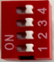
Default Setting DIP Switch

NOTE – By default the Jumper setting on the board is 10 V and 10 Bit. – By default, Baud rate DIP Switch 1 is set to ON, toggling it OFF and Pressing reset button will bring the device to default RS485 Configuration i.e. Baud rate - 9600, Stop bit - 1, Parity - None, Data Bit - 8. Keep the indicated DIP switch to ON position for Setting desired configuration.

DO

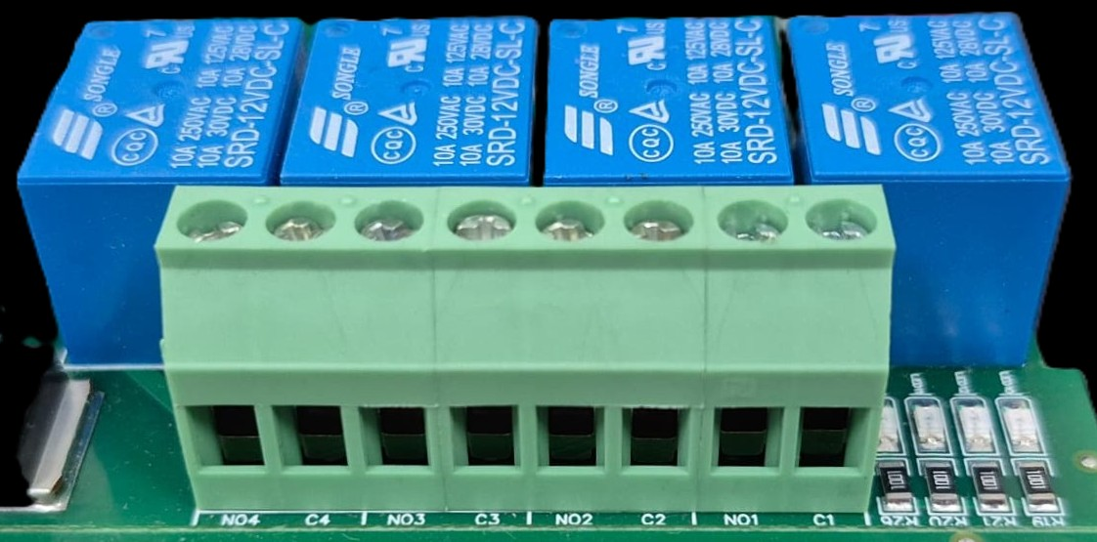





L
O
A
D
N

P
L
O
A
D
N

P
L
O
A
D
N

P
L
O
A
D
N

P

- Digital Output (DO) operation: Each channel provides two terminals: C (Common) and NO (Normally Open). When the relay coil is energized, terminal C is internally connected to NO, allowing current to flow. When the relay is de-energized, the connection between C and NO remains open, and the load stays OFF.
- Load Wiring Connections:
  - AC Load Connection: The AC Live (Phase) wire should be connected to terminal C. The load is connected between terminal NO and Neutral (N).
  - DC Load Connection: The positive supply (+V) should be connected to terminal C. The load is connected between terminal NO and Ground (GND).
- Crucial Safety Recommendation and Rating: It is strongly recommended to switch the Live (Phase) conductor in AC applications to ensure the load is safely de-energized when the relay is off.
Note: Ensure that the connected load does not exceed the relay’s contact rating of 10A @ 250VAC (or 10A @ 125VAC) or 10A @ 30VDC (or 10A @ 28VDC).

AO

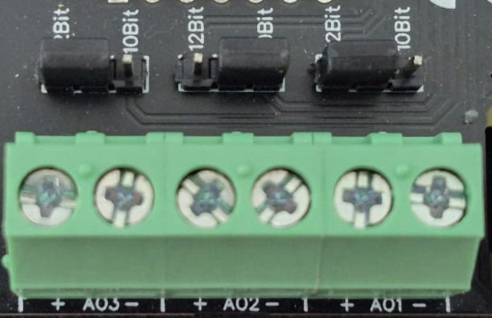
O/p device

O/p device

O/p device

- Analog Output (AO) Operation: Each channel provides two terminals: + (Positive) and - (Negative/Common). These are used to send variable analog signals to external output (O/p) devices, such as variable frequency drives or proportional valves.
- Channel Configuration (Visual Guide): Each of the three AO channels features a dedicated jumper to set the output bit resolution. Refer to the color-coded boxes in the board diagram to configure your desired resolution:
  - Green & Yellow Box (12-bit): Set the resolution jumper to 12Bit.
  - Blue Box (10-bit): Set the resolution jumper to 10Bit.
- Output Device Wiring Connections:
  - The external device's positive signal wire should be connected to the + terminal of the desired channel (AO1, AO2, or AO3).
  - The device's common or ground wire should be connected to the corresponding - terminal..
- Crucial Setup Recommendation: Always ensure that the hardware jumper setting (10-bit or 12-bit) matches the output scaling configured in your main control software. A mismatch between software resolution and hardware configuration will result in incorrect output signal levels.

Reset Button
Default Setting DIP Switch
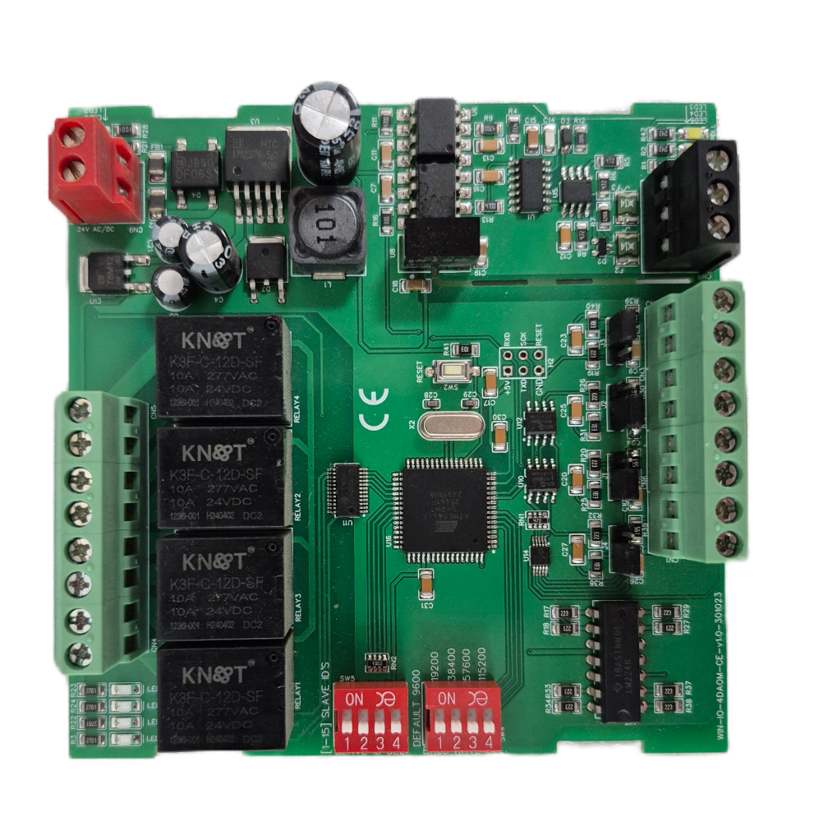

Input112-24 VDC
Modbus RS 485
DO4 DO3 DO2 DO1
AO1 AO2 AO3 AO4

Contact Information
Augmatic Technologies Pvt. Ltd.,
Plot no 6, Shah Industrial Estate II,
Kotambi,
Vadodara – 391510.
Email – Sales@wittelb.com
Support E.: support@wittelb.raiseaticket.com / M.: 9403892805

