Technical Datasheet Input / Output Modules with Modbus TCP Protocol with Ethernet Interface

The IO module communicates via Ethernet Interface. The module is designed to allow interface with other Modbus TCP/IP compatible devices. The module acts as an input/output device between the Modbus TCP/IP Network and the Gateway.
Digital IO module is sturdy, has low power usage and is easy to use.

Port DO Module with Modbus TCP Ethernet : -
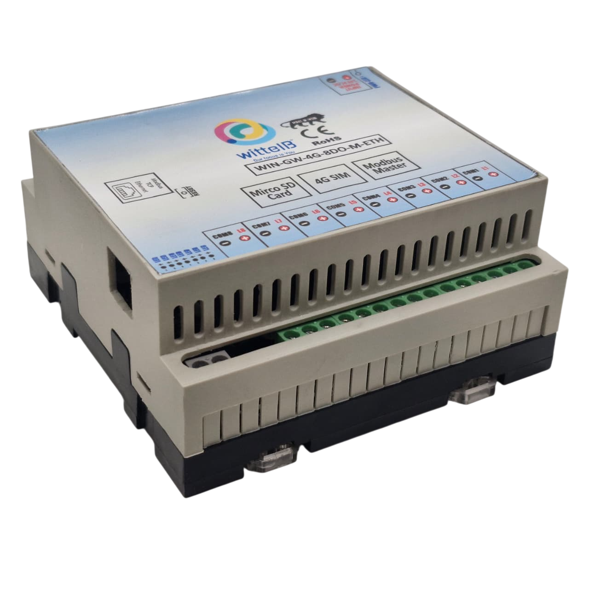

The IO modules enclosures are DIN rail Mountable. It’s a closed Enclosure with openings for connectors and LED indicators.
The design of the modules incorporates ‘resettable Fuses’ to safeguard against sudden High Voltage spikes. the board also has ‘reverse polarity’ protection both for input and power connector.
the communication port also has signal isolation and additional jumper for ‘end of line’120 ohms termination resistance which may or may not be used.
Specifications
General –
I/O Connectors 2 Pin 5.08 mm pitch pluggable screw Terminal Block with max 2.5 sq mm wire connection.
Dimensions 110 mm B x 110 mm L x 50 mm H
Power Input Power – 12 – 24 VDC or 24 V AC/DC
Typical – 12V DC @ 500mA
Operating Temperature 0 – 60° C (32 ~ 140°F)
Storage Temperature -20 - 70° C (-4 ~ 158°F)
Storage Humidity 5 ~ 95 % RH, non – Condensing
Certifications 

Relay Output –

Channels 8
Contact Form 1A, 1C
Contact Material Ag Alloy
Contact Capacity 10A @ 240VAC, 10A @ 28VDC
Coil Voltage 5 – 48 VDC
Coil Power 0.36 W
Insulation Resistance 250MΩ
Electrical Life 1 x 10^5
Mechanical Life 1 x 10^7
Operating Time 7 msec, Max 15 msec
Release Time 2 msec, Max 6 msec

Configuration Settings: -

Communication Speed 10/100 Base-T Ethernet compatible Interface
Data Bits 8
Parity None
Stop bit 1
CRC Yes
Slave ID Configured through web App (Details provided with Product)
Function code DO 0x05 and 0x0F (5 Single coil & 15 multiple coil)
DO Register Address 0,1,2,3,4,5,6,7,8

Configuration Guide – Ethernet Modbus TCP/IP IO Module:-
- Open a web browser (Google Chrome, Microsoft Edge, Firefox, etc.).
- In the browser’s address bar, type the default IP address:
192.168.0.160
- Press Enter. A message will appear saying:
“Please go to http://192.168.0.160/setup.”
- Copy this link (http://192.168.0.160/setup) and paste it into a new browser tab.
- Press Enter again to open the Setup / Configuration Page of the device.

To Reset the Device to Default Settings
- Place the jumper on the designated Reset position on the device.
- Press the Reset button once.
- The module will reboot and revert to its default IP address: 192.168.0.160.

To Change the IP Address
- On the Setup / Configuration Page, enter the new IP address you wish to assign.
- Click Submit to save the new settings.
- The device will automatically apply the new IP address.
Note:
- Ensure your PC’s IP address is in the same network range (for example, 192.168.0.xxx) when accessing the module.
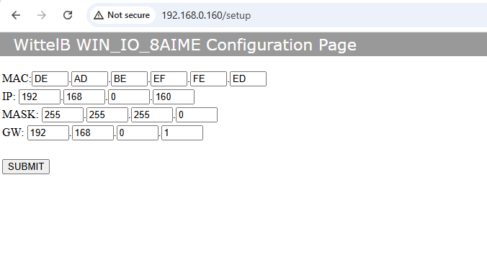
- After changing the IP, you must use the new address to log in again.
8 DOME

DO

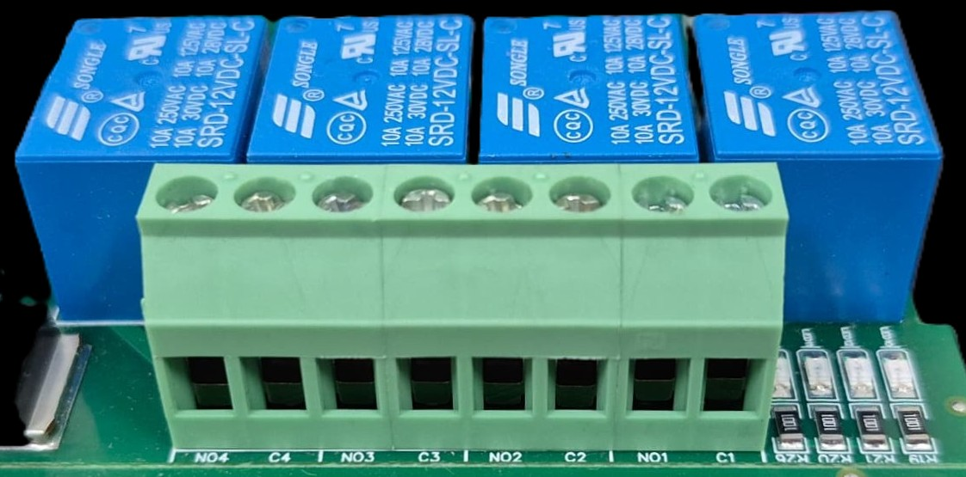





L
O
A
D
N

P
L
O
A
D
N

P
L
O
A
D
N

P
L
O
A
D
N

P

- Digital Output (DO) operation: Each channel provides two terminals: C (Common) and NO (Normally Open). When the relay coil is energized, terminal C is internally connected to NO, allowing current to flow. When the relay is de-energized, the connection between C and NO remains open, and the load stays OFF.
- Load Wiring Connections:
  - AC Load Connection: The AC Live (Phase) wire should be connected to terminal C. The load is connected between terminal NO and Neutral (N).
  - DC Load Connection: The positive supply (+V) should be connected to terminal C. The load is connected between terminal NO and Ground (GND).
- Crucial Safety Recommendation and Rating: It is strongly recommended to switch the Live (Phase) conductor in AC applications to ensure the load is safely de-energized when the relay is off.
Note: Ensure that the connected load does not exceed the relay’s contact rating of 10A @ 250VAC (or 10A @ 125VAC) or 10A @ 30VDC (or 10A @ 28VDC).

Module Details –
I/P Power 24 V DC
DO1 DO2 DO3 DO4
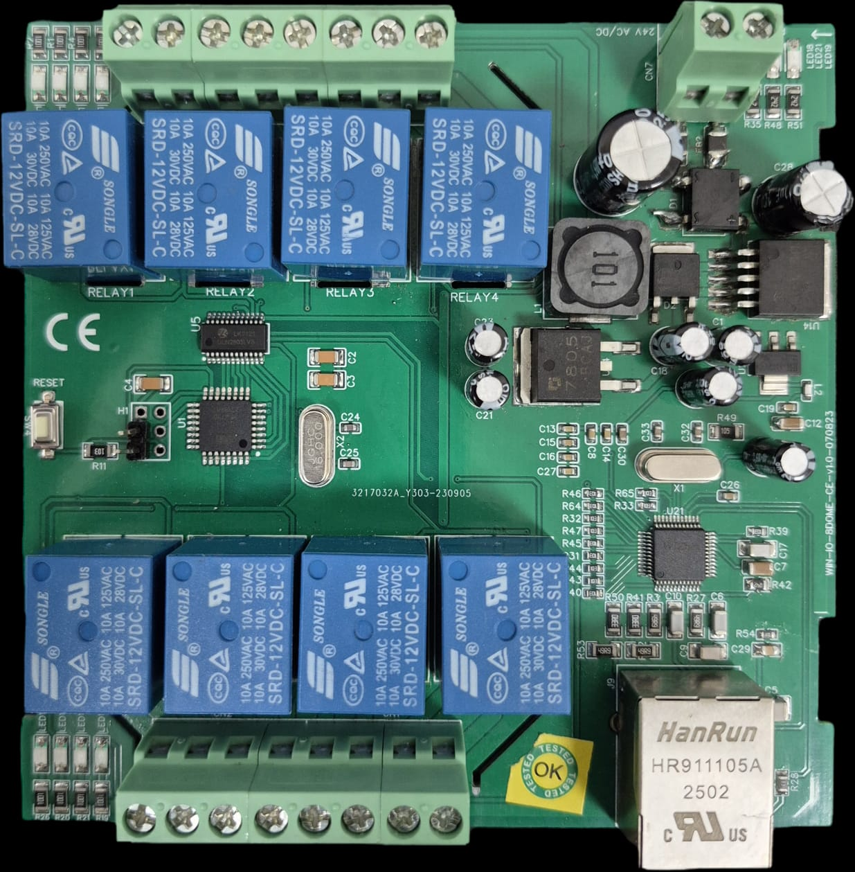

RESET SW

Modbus TCP Port
DO8 DO7 DO6 DO5

For more details: http://www.youtube.com/@wittelb

Contact us: -
Augmatic Technologies Pvt. Ltd.,
Plot no 6, Shah Industrial Estate II,
Kotambi,
Vadodara – 391510.
Email – Sales@wittelb.com
Support: support@wittelb.raiseaticket.com / +91 94038 92805

