Technical Datasheet of WIN-IO-8UI8UOM-E Module (Modbus TCP/IP)
1. Overview
The Universal Input (UI) and Universal Output (UO) board support communication exclusively over Modbus TCP/IP, enabling seamless control and monitoring of inputs/outputs. The board provide configurable input and output selection via TCP/IP web pages, ensuring flexibility across various applications. The module acts as an input/output device between the Modbus TCP/IP Network and the Gateway.
Digital IO module is sturdy, low power usage and easy to use.
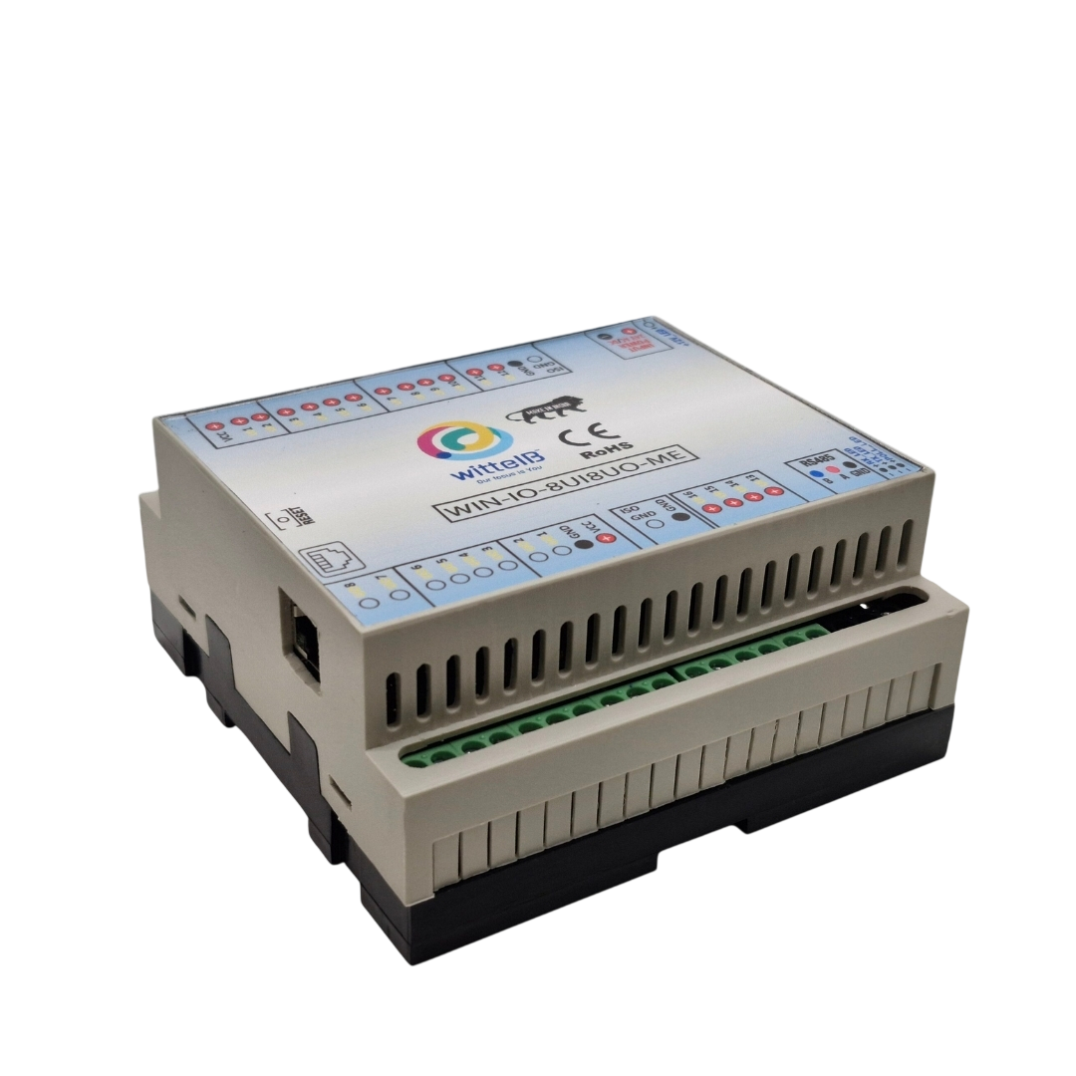
The IO modules are mounted on DIN rail mountable casing and with exposed connectors and LED indicators.

Specifications
Category | UIUO Module
Input Type | Analog Input (10V)  Analog Input (5V),  Digital Input ,  NTC Sensor Input.  (Configurable via TCP/IP web page)
Output Types | Analog Output (AO),  Digital Output (DO).  (configurable via TCP/IP web pages)
Connectors | Single port handling multiple input/output types

General –
Dimensions 110 mm L x 110 mm B x 50 mm H
Power Input Power – 15 – 40 V DC or 24 V AC/DC
Typical – 24V DC @ 150mA
Operating Temperature 0 – 60° C (32 ~ 140°F)
Storage Temperature -20 - 70° C (-4 ~ 158°F)
Storage Humidity 5 ~ 95 % RH, non – Condensing
Certifications 

UI (Universal Inputs) –
Digital Channels 8
Sense Voltage 3.3 – 12 VDC (Depends on the selected type of Input)
Digital Sensing Logic Logic ‘0’ = <1 VDC, Logic ‘1’ = >3.3 VDC
Isolation Optically isolated
Response Time 2 msec, Max 6 msec

Analog Channels 8 (Can sense Analog Voltage, NTC)
Input Signal 0 – 5VDC / 0 – 10VDC / NTC (Web page selectable)
Accuracy ± 2% Full scale
Input Resolution 10 bits
Isolation Optically Isolated
External Loop Voltage + 15 VDC min
AI input impedance 120Ω
UO (Universal Outputs) –

Channels 8
Analog Output Resolution 10 bits (0 to 10VDC)
Channels 8
Digital Output NPN Transistor based switching

Additional Features: -
Input power reverse polarity safety
ESD Safety IEC 61000-4-2, ± 30KV contact, ± 30KV air

Configuration Of UIUO module

The UIUO module can be configured as Analog Input, NTC Sensor Input or Digital Input for each of the 8 UI. Similarly each of the 8 UO ports can be configured as Analog Output or Digital Output.
All the configuration can be done through Web page hosted at the default IP address (i.e. 192.168.1.177) or at the changed IP address.

The following are step by step guide for configuration:
- Connect the Module to +24VDC POWER SUPPLY.
- Connect the Board to the PC via an Ethernet Cable.
- Use the default setting for PC as TCP/IPv4 (i.e., Address -192.168.1.56).
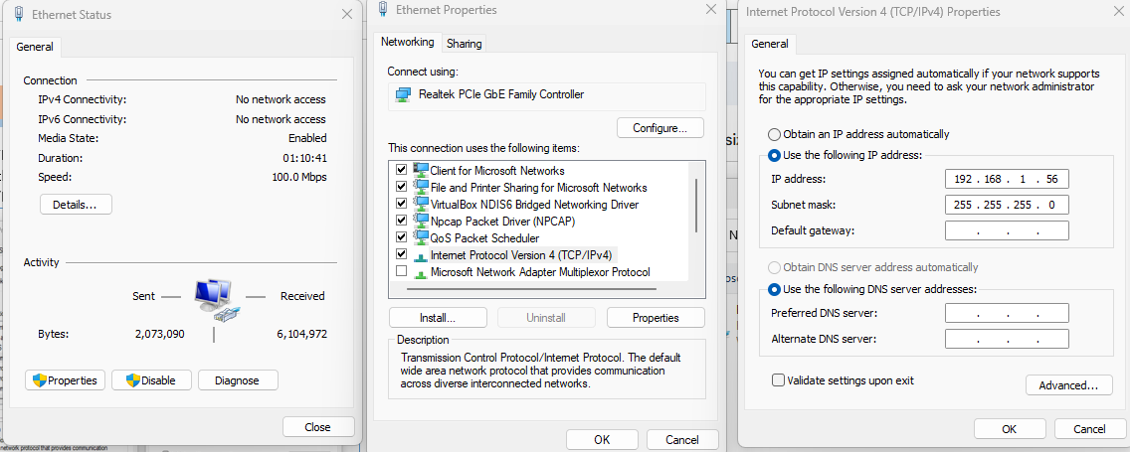
- 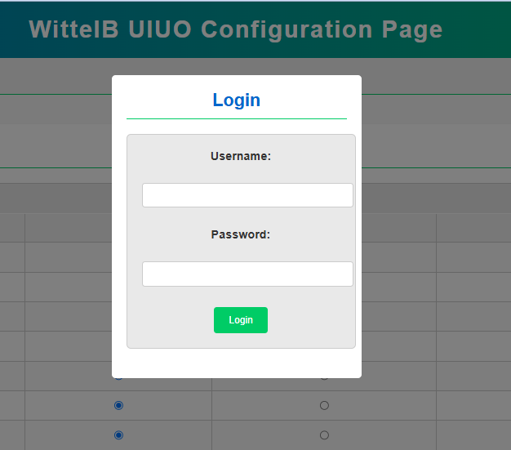Now, open web browser and type 192.168.1.177/ (default IP address) and Press ‘Enter’. A login page will appear as shown below.
- Default Login Credentials are :
Username: admin
Password: admin

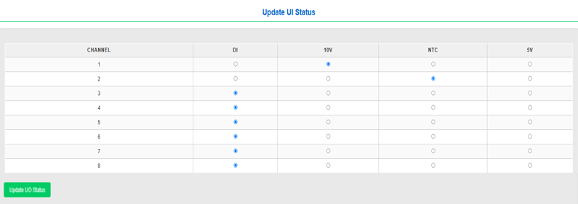
- After successful login, The UIUO Configuration page will be visible. It has three tables. The first and second table named as ‘Update UI Status’ and ‘Update UO Status’ which have selectable radio button for doing the configuration of respective channels as shown below.

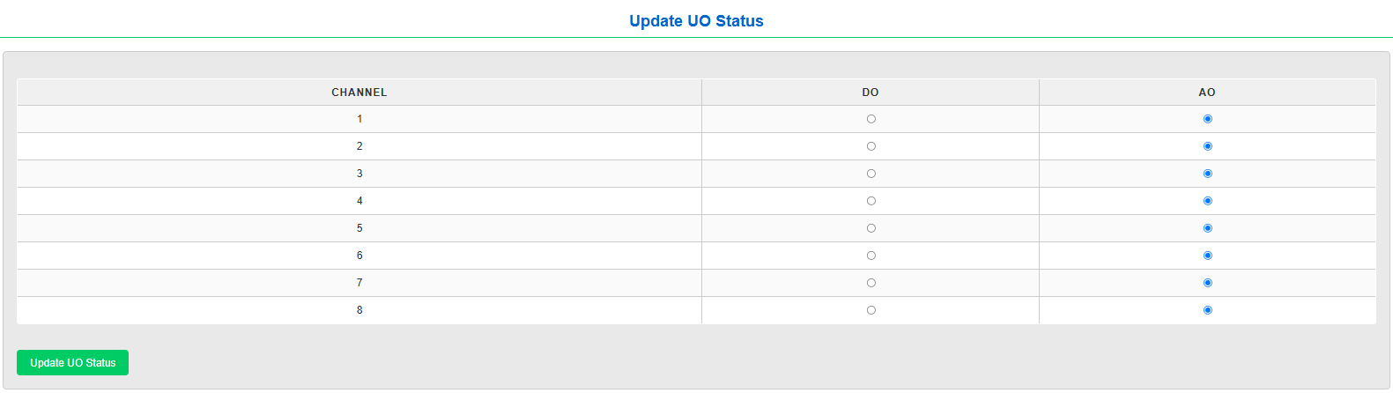

- For example, to set Channel 1 of UI as NTC Sensor input, the radio button in front of Channel 1 must be selected as NTC and then “Update UI Status” button need to be pressed. This will make the Channel 1 of UI port as NTC sensor input port.

Note: Always restart the device after doing configuration for UI/UO Status, then only changes in configuration will take place.

- 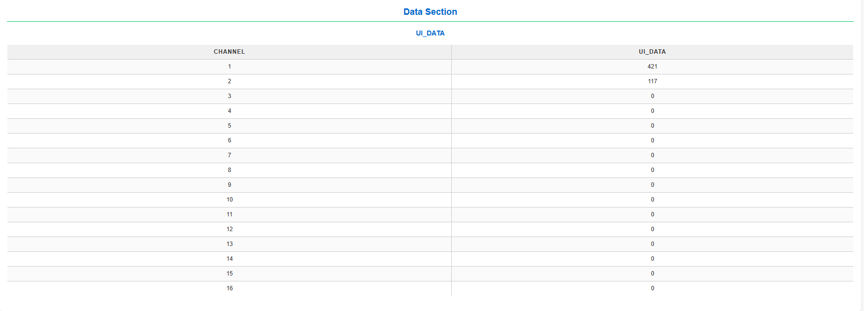The third table “UI_DATA” is for viewing the UI port data locally on the web page.

- User can select all the desired configuration at once and then press the Update button for UI or UO to update the Port status in the module.

- User can change the IP and Mac Address for the TCP from the second tab “MODBUS TCP CONFIGURATION” in the web page and press the “Save Configuration” button and restart the device to set the new IP, as shown below.
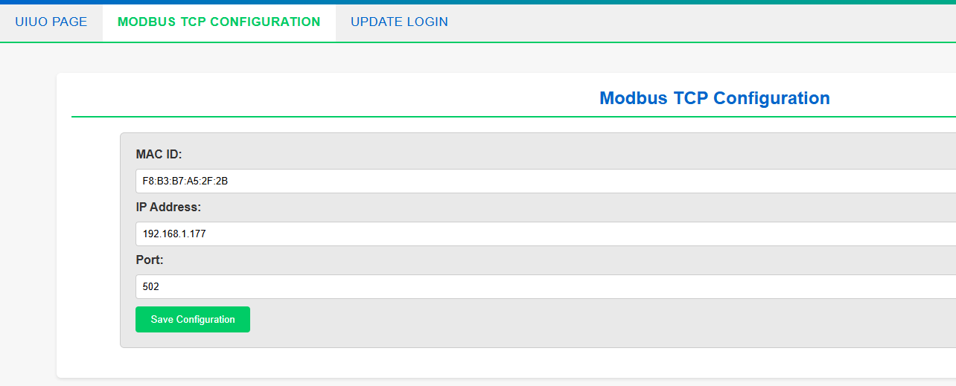

Note: To reset the IP address to default IP, the user need to press and hold the reset button located near the Ethernet port for 5 seconds.

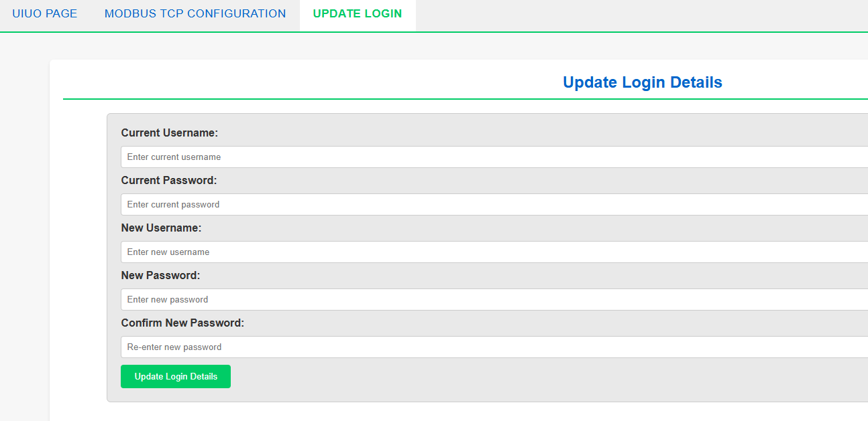
- On the third tab “UPDATE LOGIN” page, the user can change the Username and Password, to enhance the security of UIUO module, as show below.

- After all the configuration, User can now connect the UIUO module to Modbus TCP master at the set IP address or default IP address(192.168.1.177).

- Here we have shown a connecting with Modbus Poll software for demonstration in the below images.
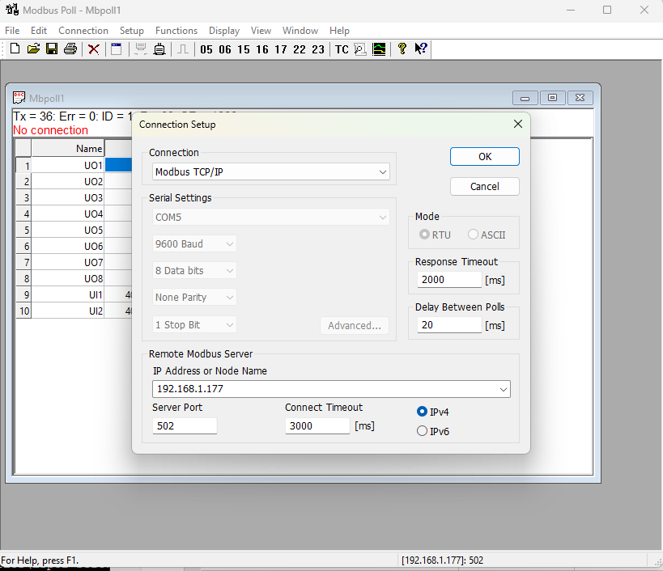
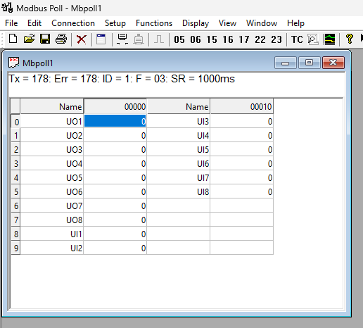

- The data of UI port can be fetched from the mentioned Modbus register in the table below, irrespective of DI, AI, NTC selection. The Desired Inputs are as follows:

INPUT TYPE | Input Value
DI | 0 V(0) , 12VDC (1)
AI(5V) | 0 to 5VDC (0-1023)
AI(10V) | 0 to 10VDC (0-1023)
NTC | NTC sensor(Temperature in °C)

- Similarly, the data of the UO port can be set in the same register as mentioned in the table below. For DO, It should be sent 0 or 1 (12VDC). And for AO a 10-bit resolution value must be sent (i.e. from 0 to 1023) to set output of 0 to 10VDC.

OUTPUT Type | Output Value
DO | 0 (0V) , 1 (12VDC)
AO | 0 to 10VDC (0-1023)

MODBUS COILS TABLE FOR UIUO PORTS:-
ID | Function  Description | Register  Description | Modbus Function Code | Data  Type
1 | UO 1 (DO) | 00001 | 0x01 | Boolean
2 | UO 2 ( DO ) | 00002 | 0x01 | Boolean
3 | UO 3 ( DO ) | 00003 | 0x01 | Boolean
4 | UO 4 ( DO ) | 00004 | 0x01 | Boolean
5 | UO 5 ( DO ) | 00005 | 0x01 | Boolean
6 | UO 6 ( DO ) | 00006 | 0x01 | Boolean
7 | UO 7 ( DO ) | 00007 | 0x01 | Boolean
8 | UO 8 ( DO ) | 00008 | 0x01 | Boolean
9 | UI 1 (DI) | 00009 | 0x01 | Boolean
10 | UI 2 (DI) | 00010 | 0x01 | Boolean
11 | UI 3 (DI) | 00011 | 0x01 | Boolean
12 | UI 4 (DI) | 00012 | 0x01 | Boolean
13 | UI 5 (DI) | 00013 | 0x01 | Boolean
14 | UI 6 (DI) | 00014 | 0x01 | Boolean
15 | UI 7 (DI) | 00015 | 0x01 | Boolean
16 | UI 8 (DI) | 00016 | 0x01 | Boolean

MODBUS REGISTERS TABLE FOR UIUO PORTS:-
1 | UO 1 (AO) | 40001 | 0X03 | 16 Bit Unsigned int
2 | UO 2 (AO) | 40002 | 0X03 | 16 Bit Unsigned int
3 | UO 3 (AO) | 40003 | 0X03 | 16 Bit Unsigned int
4 | UO 4 (AO) | 40004 | 0X03 | 16 Bit Unsigned int
5 | UO 5 (AO) | 40005 | 0X03 | 16 Bit Unsigned int
6 | UO 6 (AO) | 40006 | 0X03 | 16 Bit Unsigned int
7 | UO 7 (AO) | 40007 | 0X03 | 16 Bit Unsigned int
9 | UI 1 (AI,NTC) | 40009 | 0x03 | 16 Bit Unsigned int
10 | UI 2 (AI,NTC) | 40010 | 0x03 | 16 Bit Unsigned int
11 | UI 3 (AI,NTC) | 40011 | 0x03 | 16 Bit Unsigned int
12 | UI 4 (AI,NTC) | 40012 | 0x03 | 16 Bit Unsigned int
13 | UI 5 (AI,NTC) | 40013 | 0X03 | 16 Bit Unsigned int
14 | UI 6 (AI,NTC) | 40014 | 0X03 | 16 Bit Unsigned int
15 | UI 7 (AI,NTC) | 40015 | 0X03 | 16 Bit Unsigned int
16 | UI 8 (AI,NTC) | 40016 | 0X03 | 16 Bit Unsigned int

DI

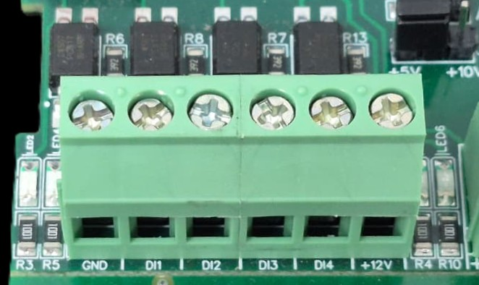

I/p device
I/p device
I/p device
I/p device

- Operation: The module provides four isolated input channels (DI1–DI4) for sensing external signals or dry contacts. These inputs are opto-isolated for circuit protection.
- Terminal Layout:
  - GND: Common Ground reference.
  - DI1 – DI4: Individual Digital Input channels.
  - +12V: Internal reference voltage for sourcing "Dry Contact" switches.
- Wiring Options:
  - Dry Contact: Connect a switch between the +12V terminal and any DI pin.
  - External Voltage: Connect the external signal to a DI pin and the external ground to the GND terminal.
- Voltage Rating: The input circuitry is rated for a maximum of 80VDC. Ensure external signals do not exceed this limit to prevent damage to the isolation ICs.

DO

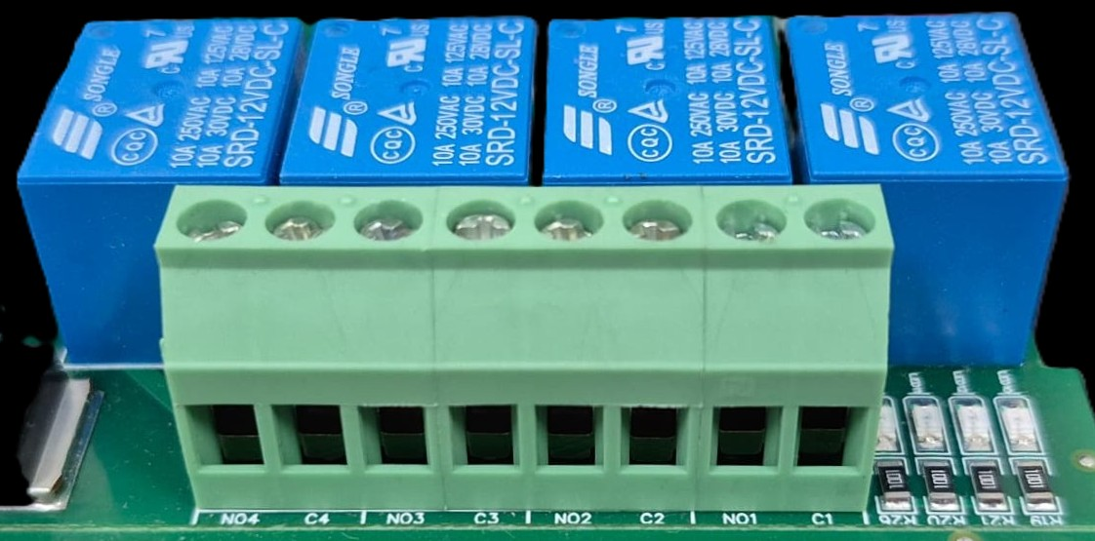





L
O
A
D
N

P
L
O
A
D
N

P
L
O
A
D
N

P
L
O
A
D
N

P

- Digital Output (DO) operation: Each channel provides two terminals: C (Common) and NO (Normally Open). When the relay coil is energized, terminal C is internally connected to NO, allowing current to flow. When the relay is de-energized, the connection between C and NO remains open, and the load stays OFF.
- Load Wiring Connections:
  - AC Load Connection: The AC Live (Phase) wire should be connected to terminal C. The load is connected between terminal NO and Neutral (N).
  - DC Load Connection: The positive supply (+V) should be connected to terminal C. The load is connected between terminal NO and Ground (GND).
- Crucial Safety Recommendation and Rating: It is strongly recommended to switch the Live (Phase) conductor in AC applications to ensure the load is safely de-energized when the relay is off.
Note: Ensure that the connected load does not exceed the relay’s contact rating of 10A @ 250VAC (or 10A @ 125VAC) or 10A @ 30VDC (or 10A @ 28VDC).

AI-NTC

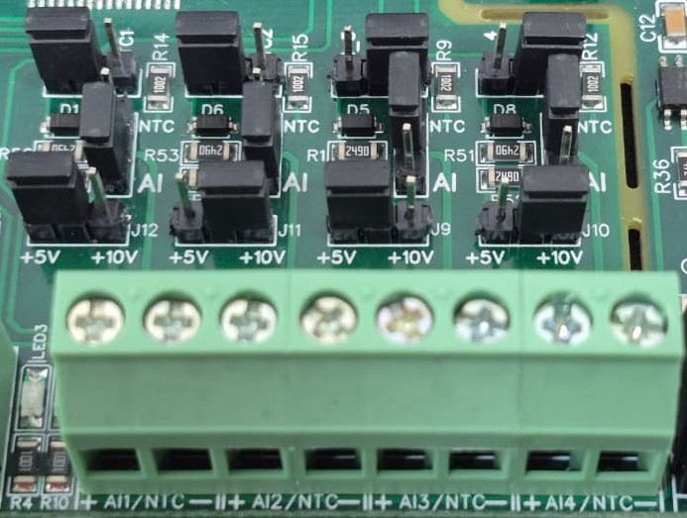
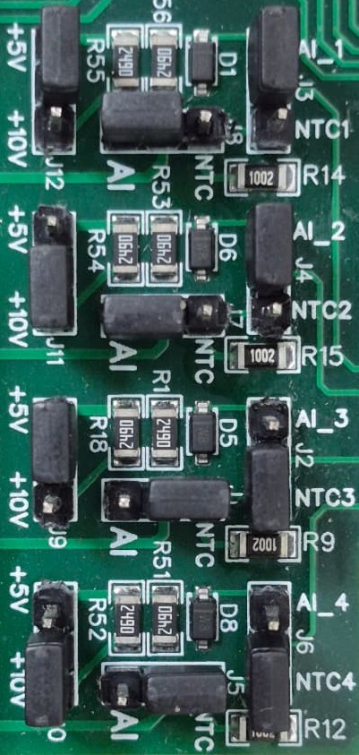
Sensor
Sensor
Sensor
Sensor

- Analog Input & NTC Operation: Each channel provides two terminals: + (Positive) and - (Negative/Common). These are used to interface with either standard external analog sensors or NTC thermistors.
- Channel Configuration (Visual Guide): Each of the four channels features two dedicated jumpers to independently select the operating mode (AI or NTC) and the reference voltage range (5V or 10V). Refer to the color-coded boxes in the board diagram to configure your desired scenario:
  - Red Box (AI Mode, 5V Range): Set the mode jumper to AI and the voltage jumper to +5V.
  - Green Box (AI Mode, 10V Range): Set the mode jumper to AI and the voltage jumper to +10V.
  - Blue Box (NTC Mode, 5V Range): Set the mode jumper to NTC and the voltage jumper to +5V.
  - Yellow Box (NTC Mode, 10V Range): Set the mode jumper to NTC and the voltage jumper to +10V.
- Sensor Wiring Connections:
  - The sensor or thermistor's positive signal wire should be connected to the + terminal of the desired channel (labelled AI1/NTC, AI2/NTC, etc.).
  - The sensor's common or ground wire should be connected to the corresponding - terminal.
- Crucial Setup Recommendation: Always ensure that both the mode jumper (NTC vs. AI) and the voltage jumper strictly match the hardware you are connecting. Incorrectly setting an NTC to an AI mode, or mismatching the voltage limits, will result in inaccurate temperature or signal readings.
AO

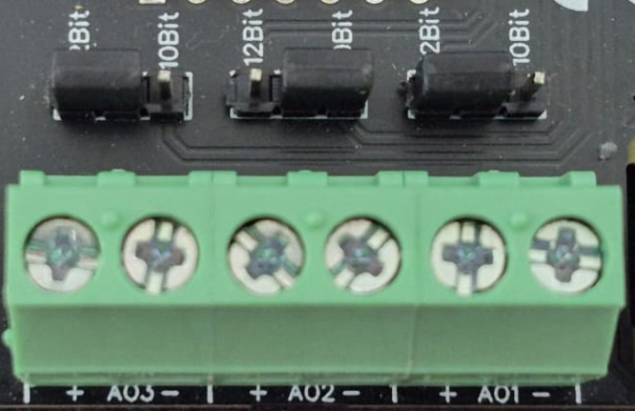
O/p device
O/p device
O/p device

- Analog Output (AO) Operation: Each channel provides two terminals: + (Positive) and - (Negative/Common). These are used to send variable analog signals to external output (O/p) devices, such as variable frequency drives or proportional valves.
- Channel Configuration (Visual Guide): Each of the three AO channels features a dedicated jumper to set the output bit resolution. Refer to the color-coded boxes in the board diagram to configure your desired resolution:
  - Green & Yellow Box (12-bit): Set the resolution jumper to 12Bit.
  - Blue Box (10-bit): Set the resolution jumper to 10Bit.
- Output Device Wiring Connections:
  - The external device's positive signal wire should be connected to the + terminal of the desired channel (AO1, AO2, or AO3).
  - The device's common or ground wire should be connected to the corresponding - terminal..
- Crucial Setup Recommendation: Always ensure that the hardware jumper setting (10-bit or 12-bit) matches the output scaling configured in your main control software. A mismatch between software resolution and hardware configuration will result in incorrect output signal level

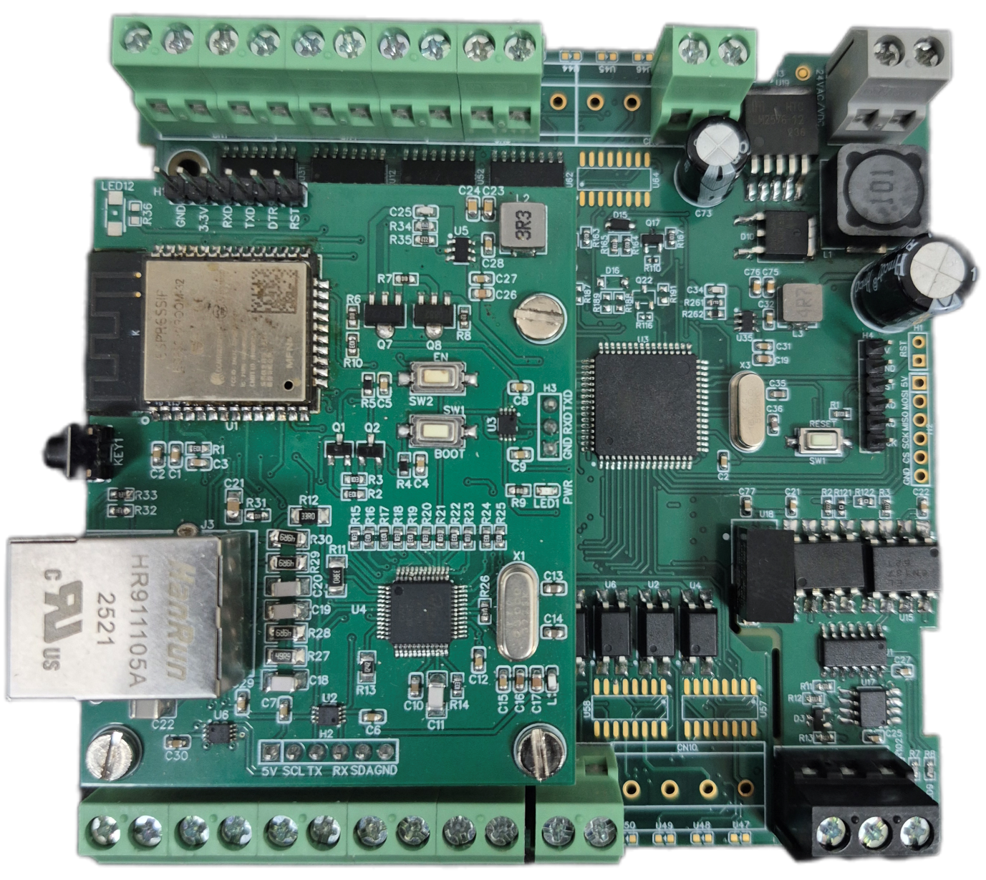
UI Pins
1 2 3 4 5 6 7 8
24V AC/DC
GND | DI_GND

+24V DI Ref.

Reset Button

Ethernet Port

VCC
DI_GND | GND
8 | 7 | 6 | 5 | 4 | 3 | 2 | 1
Universal Output Pins
Modbus RS485

Contact us: -
Augmatic Technologies Pvt. Ltd.,
Plot no 6, Shah Industrial Estate II,
Kotambi,
Vadodara – 391510.
Email – Sales@wittelb.com
Support: support@wittelb.raiseaticket.com / +91 94038 92805

