Technical Datasheet RS485 Isolator-Repeat Converter

An RS485-to-RS485 isolator-Repeater is a specialized communication interface module designed to electrically isolate two independent RS485 networks while still allowing seamless bidirectional data transfer between them. RS485 is widely used in industrial automation, Modbus RTU systems, building management, and long-distance data communication. However, RS485 networks are often exposed to problems such as noise, voltage differences between grounds, and lightning surges.
To overcome these issues, an RS485 isolator provides galvanic isolation, ensuring high reliability, safety, and long-term stability.

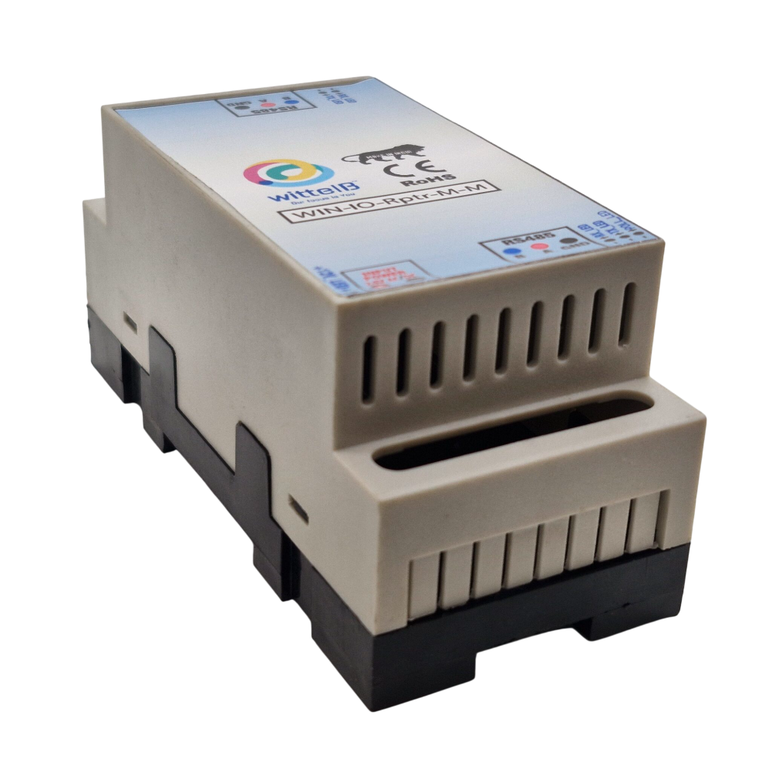

(RS485-Repeater)

Note – This image is for representation only. Actual product detail may slightly vary.

Specifications -
General –
I/O Connectors 2 Pin 5.08 mm pitch pluggable screw Terminal Block
Dimensions 110 mm L x 50 mm B x 50 mm H
Power Input Power – 12 – 24 DC
Typical – 12V DC @ 80mA
Operating Temperature 0 – 60° C (32 ~ 140°F)
Storage Temperature -20 - 70° C (-4 ~ 158°F)


Storage Humidity 5 ~ 95 % RH, non – Condensing.

Certifications

Additional Features: -
All inputs and communication port isolated
Input power reverse polarity safety
ESD Safety IEC 61000-4-2,  30KV contact,  30KV air EFT IEC 61000-4-4, 50A (5/50ms) 750V– 5KV isolation.
CRC Error check.
No configuration needed on the IO board

Features:-
- Galvanic Isolation: (typically 750V – 5 kV isolation)
- Bidirectional half-duplex RS485 communication.
- Opto coupler isolation: between input and output signals.
- Isolated DC-DC power module: to supply the RS485 side.
- Protection from ground loops & lightning surges.
- Improves stability for long-distance communication.
- Works with Modbus RTU, DMX, industrial RS485 devices.
- It support wide range of baudrate 9600-2Mbps.
- Transmission Distance up to 1200meters(at 9600 baud)
- 300 meter at high speed like 115200 baud-rate.

Typical Components on the Board:-
- RS485 Transceiver (e.g., MAX485 / SP485 / ADM485) on both sides
- Digital isolator / Optocoupler for TX/RX signals
- Isolated DC-DC converter (e.g., 5V → 5V isolated)
- TVS diodes / protection circuitry • Terminal blocks for both RS485 ports.
- Status LEDs (Power, TX, RX).

Application:-

- Industrial Atomation:
  - PLC communication.
  - VFDs ,meter, sensor.
  - SCADA system.
  - Modbus Network.

- Long-Distance Communication Lines:
  - Between buildings.
  - Across large factory.

- Safety-Critical Application:
  - Protective expensive equipment.
  - Preventing ground Potential difference.

- Noise Heavy Environments:
  - High-Power motors.
  - Inductive loads.
  - Lightning-prone outdoor installation.

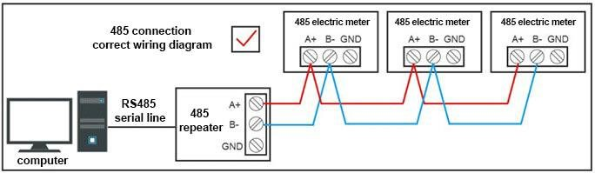

(
Wiring Diagrams
)

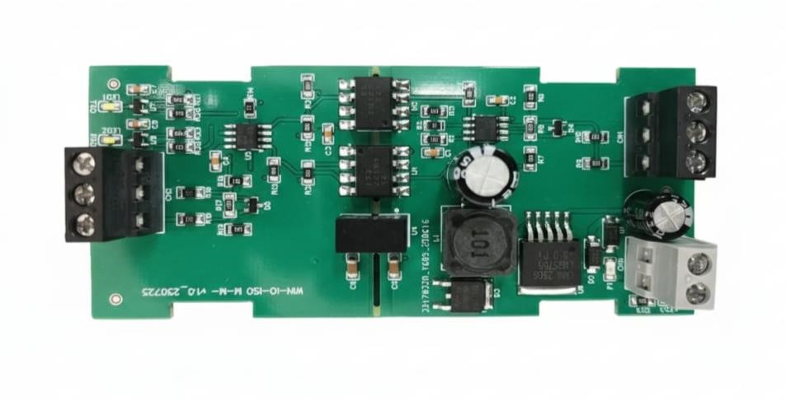

(
PCB Design
)

Modnus
RS485

12
-
24
Volt

Modnus
RS485

Contact us: -
Augmatic Technologies Pvt. Ltd.,
Plot no 6, Shah Industrial Estate II, Kotambi,
Vadodara – 391510.
Email – Sales@wittelb.com
Support: support@wittelb.raiseaticket.com / +91 94038 92805

