Temperature & Humidity Sensor with RS485 with WiFi

1. Product Overview
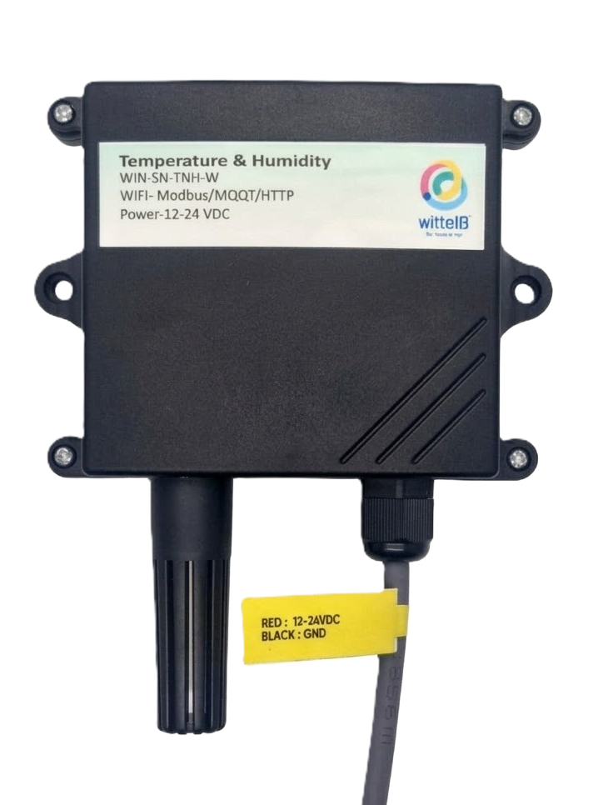
WIN-SN-TNH-M-W is a versatile and reliable solution for anyone needing precise temperature and humidity monitoring with robust communication capabilities. It measures temperature and humidity in various environments, from industrial facilities to greenhouses and smart homes. This board stands out because it can communicate its readings through an isolated RS485 interface. This type of communication is robust, making it ideal for long-distance data transmission and resistant to electrical interference, ensuring accurate and reliable measurements.

One of the key advantages of the WIN-SN-TNH-M-W is its flexibility in sensors compatibility. It supports a variety of sensors that are listed in Table 1 each suited for different ranges of temperature and humidity. Additionally, it features dual connectivity with Modbus RS485 as well as WiFi data transfer in a single device.
This manual provides instructions for installation and use of the sensor board to measure temperature and humidity in the environment. The sensor board offers data output in Modbus RTU (RS485) and can be powered by DC power supply.
 | Sensor Name | Temperature  Measuring Range | Humidity  Measuring range | Operating Temperature | Measuring Accuracy
☒ | AHT21 | -40°C ~ 120°C. | 0~100% RH. | -40°C ~ 120°C. | 0.3°C, 2.0 %RH
☐ | AHT20 | -40°C ~ 85°C. | 0~80% RH. | -40°C ~ 85°C. | 0.3°C, 2.0 %RH
☐ | SHT21 | -40°C ~ 125°C. | 0~80% RH. | -40°C ~ 125°C. | 0.3°C, 2.0 %RH
☐ | SHT25 | -40°C ~ 125°C. | 0~80% RH. | -40°C ~ 125°C. | 0.2°C, 1.8 %RH

 | Product Configuration
☒ | TnH + RS485 + WiFi

2. Sensor Specifications
- Wide temperature range: −40 °C to +125 °C
- Full humidity range: 0 % to 100 % RH
- Power supply DC: 12-24V@1A.
- Product dimension: 85*85*36 mm.

- Certifications:

3. Power Supply Connection
DC Connection
- Use 5V@ 1A, Power supply.
- Don’t make loose connection.
4. Configuration Settings
- Communication Speed 9600 – 115200 Kbps (SW Selectable)
- Data Bits 8
- Parity None
- CRC Yes
- Slave ID 1, DIP (SW Selectable)
- Function Code 0X03 (Read Holding Register)
Recommended Cable Electrical Characteristics
22 AWG Cable Shielded and twisted pair should be used.
Tinned Copper Recommended
Nominal Conductor DCR 14.7 ohm / 1000 ft
Nominal Capacitance 11 pf / feet (conductor to conductor)
High Frequency Non-Insertion Loss 0.5db / 100ft

5. Modbus RS485 Data Storage register
ID | Function  Description | Register  Description | Modbus Function Code | Protocol | Data  Type
1 | Temperature | 40001 | 0x03 | RS485 | 16-bit int
2 | Humidity | 40002 | 0x03 | RS485 | 16-bit int
1 | Display Baud Rate (Default: 960) | 40011 | 0x03 | RS485 | 16-bit int
2 | Enter New Baud Rate | 40012 | 0x03 | RS485 | 16-bit int
3 | Display Slave ID (Default: 1) | 40013 | 0x03 | RS485 | 16-bit int
4 | Enter New Slave ID | 40014 | 0x03 | RS485 | 16-bit int
5 | Display Parity (Default: None-3 And for Odd-1, Even-2) | 40015 | 0x03 | RS485 | 16-bit int
6 | Enter New Parity | 40016 | 0x03 | RS485 | 16-bit int
7 | Display Stop Bit (start-2/stop bit-1) | 40017 | 0x03 | RS485 | 16-bit int
8 | Enter New Start/ Stop Bit | 40018 | 0x03 | RS485 | 16-bit int

6. Modbus Configuration

Here is an example of receiving data on Mb poll software.
- Open Mb-poll software connects using configuration setting (Default baud rate is 9600 and slave id is 1).
- After connecting you will get data as shown below.
Important Note
- If you want to enter the baud rate 9600/19200/38400/57600/115200etc, enter it like this 960/1920/3840/5760/11520etc.
- After that press the reset button or reboot the system.
- Then you will get the present value of 11520 at 40011 baud rate (115200) and 2 at 40013 slave id.
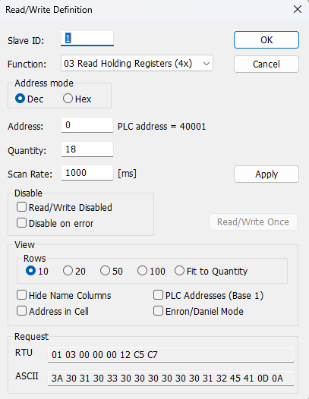
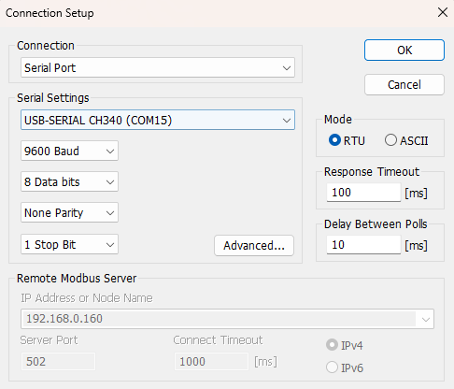

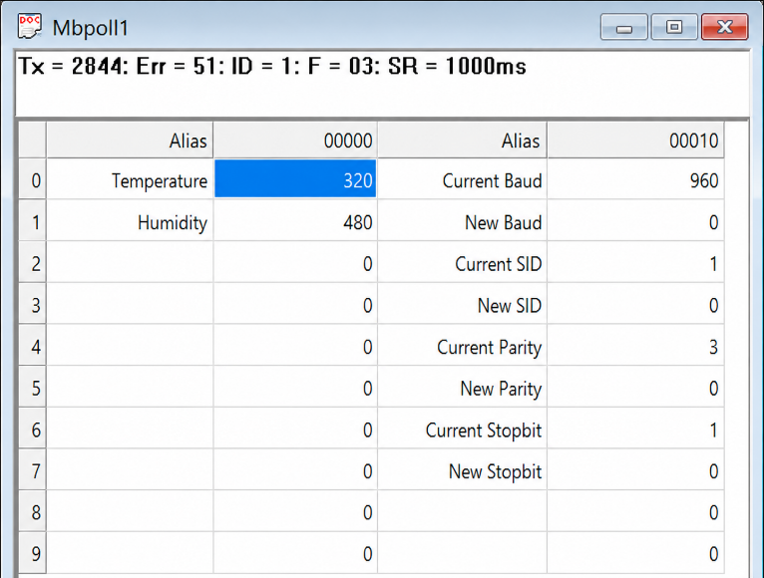
- Above image Shows sensor data over Modbus with default Modbus settings
- At register 40001 shows Temperature Values, register 40002 shows Humidity Values.
- The value 320 indicates 32.0 temperature and 480 indicates 48.0 humidity.
- As you can see in the image above, the resistor 40011 – 960 represents the present bund rate (9600) of the board and 40013 – 1 represents the present slave id of the board.
- To change the baud rate and slave id Jumper should be in single/removed then, you must enter a value on the 40012 resistors for the baud rate and 40014 for the slave id as shown in the image below and restart the board.
- Now you can see data below image set 115200 baud rate and slave ID 10.
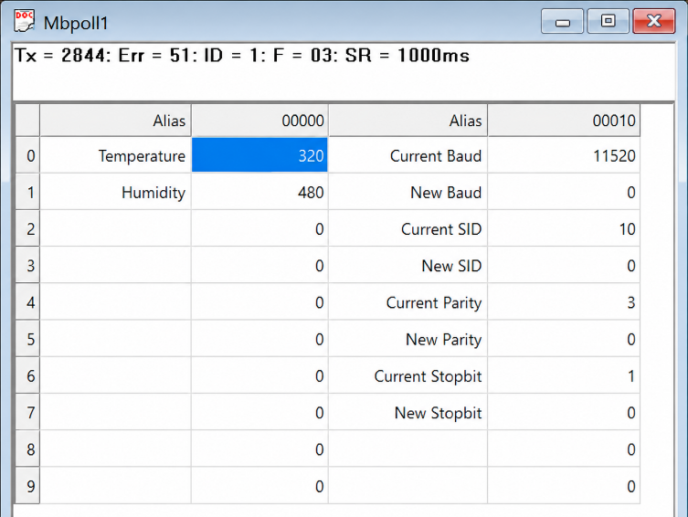
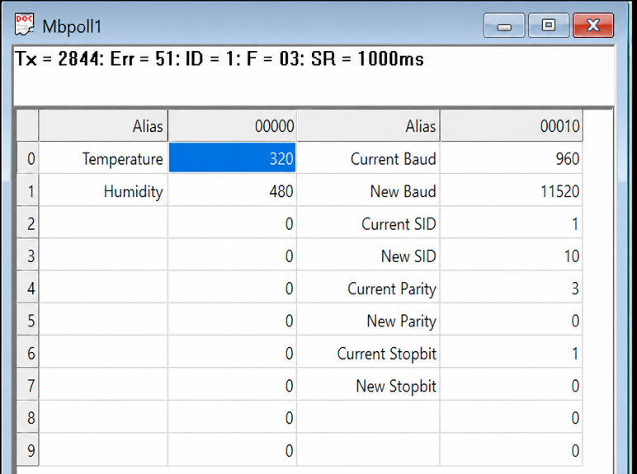

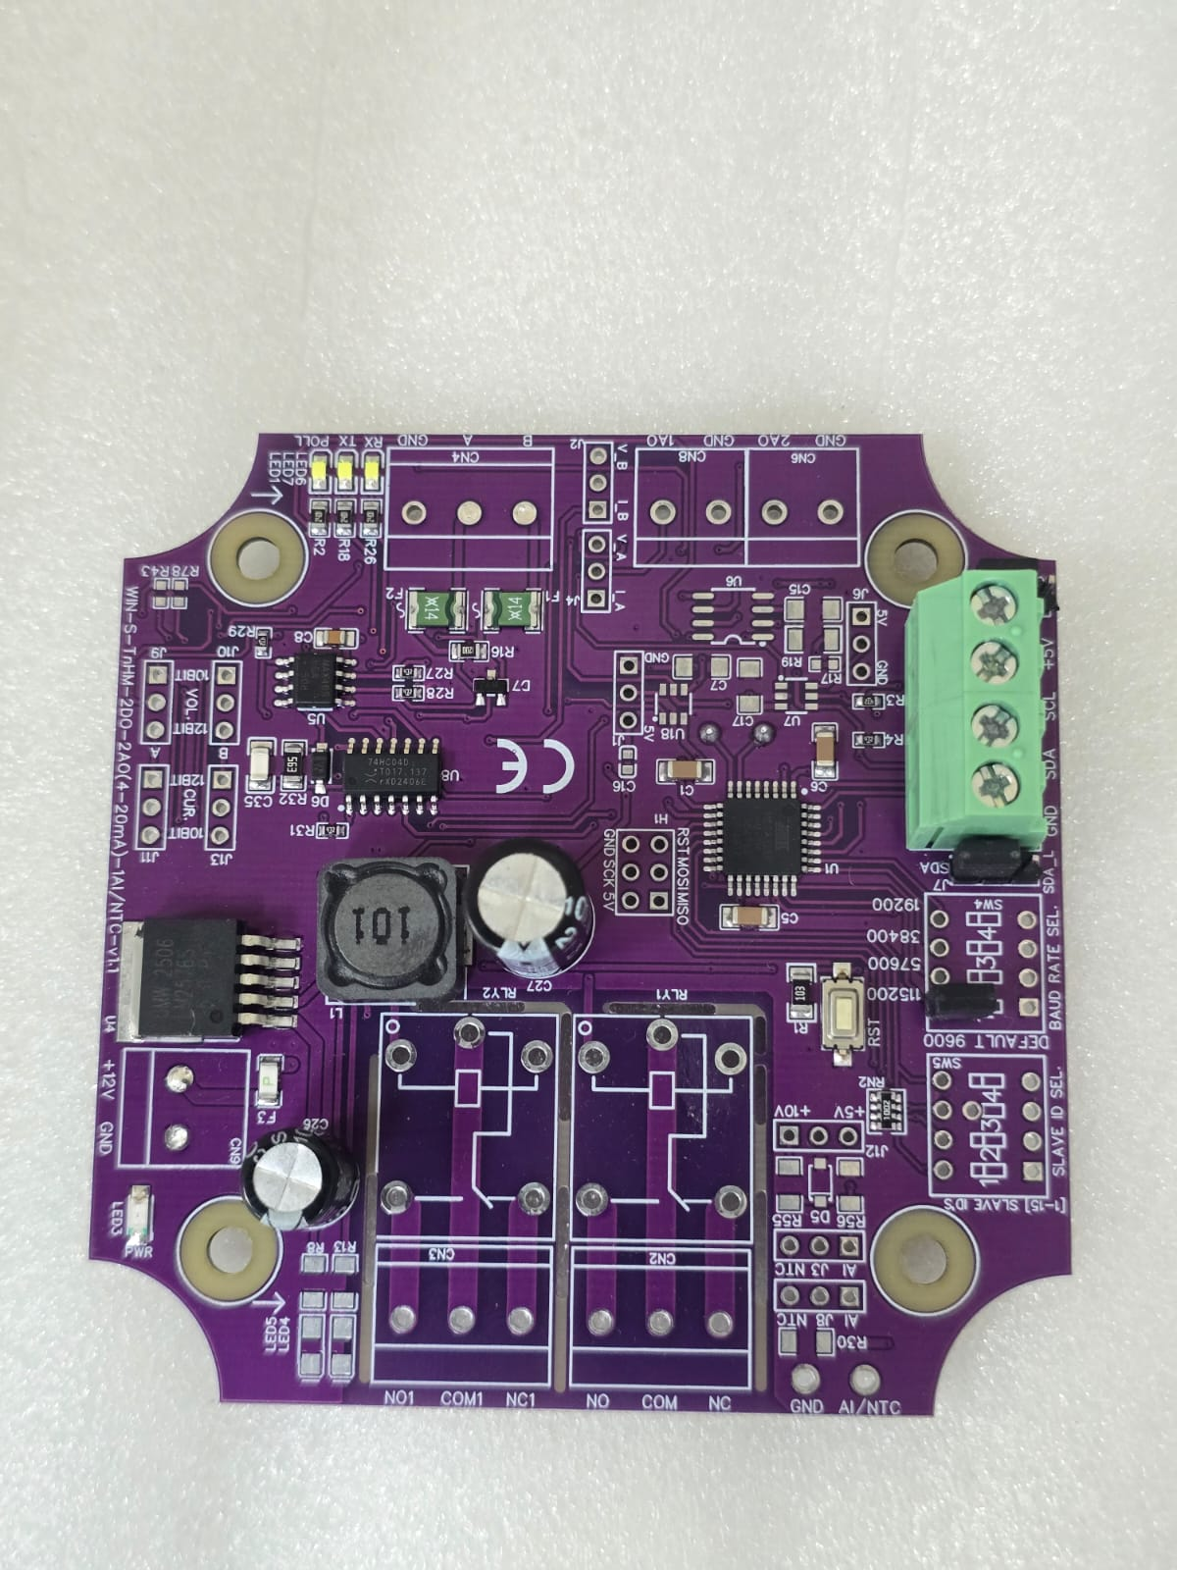
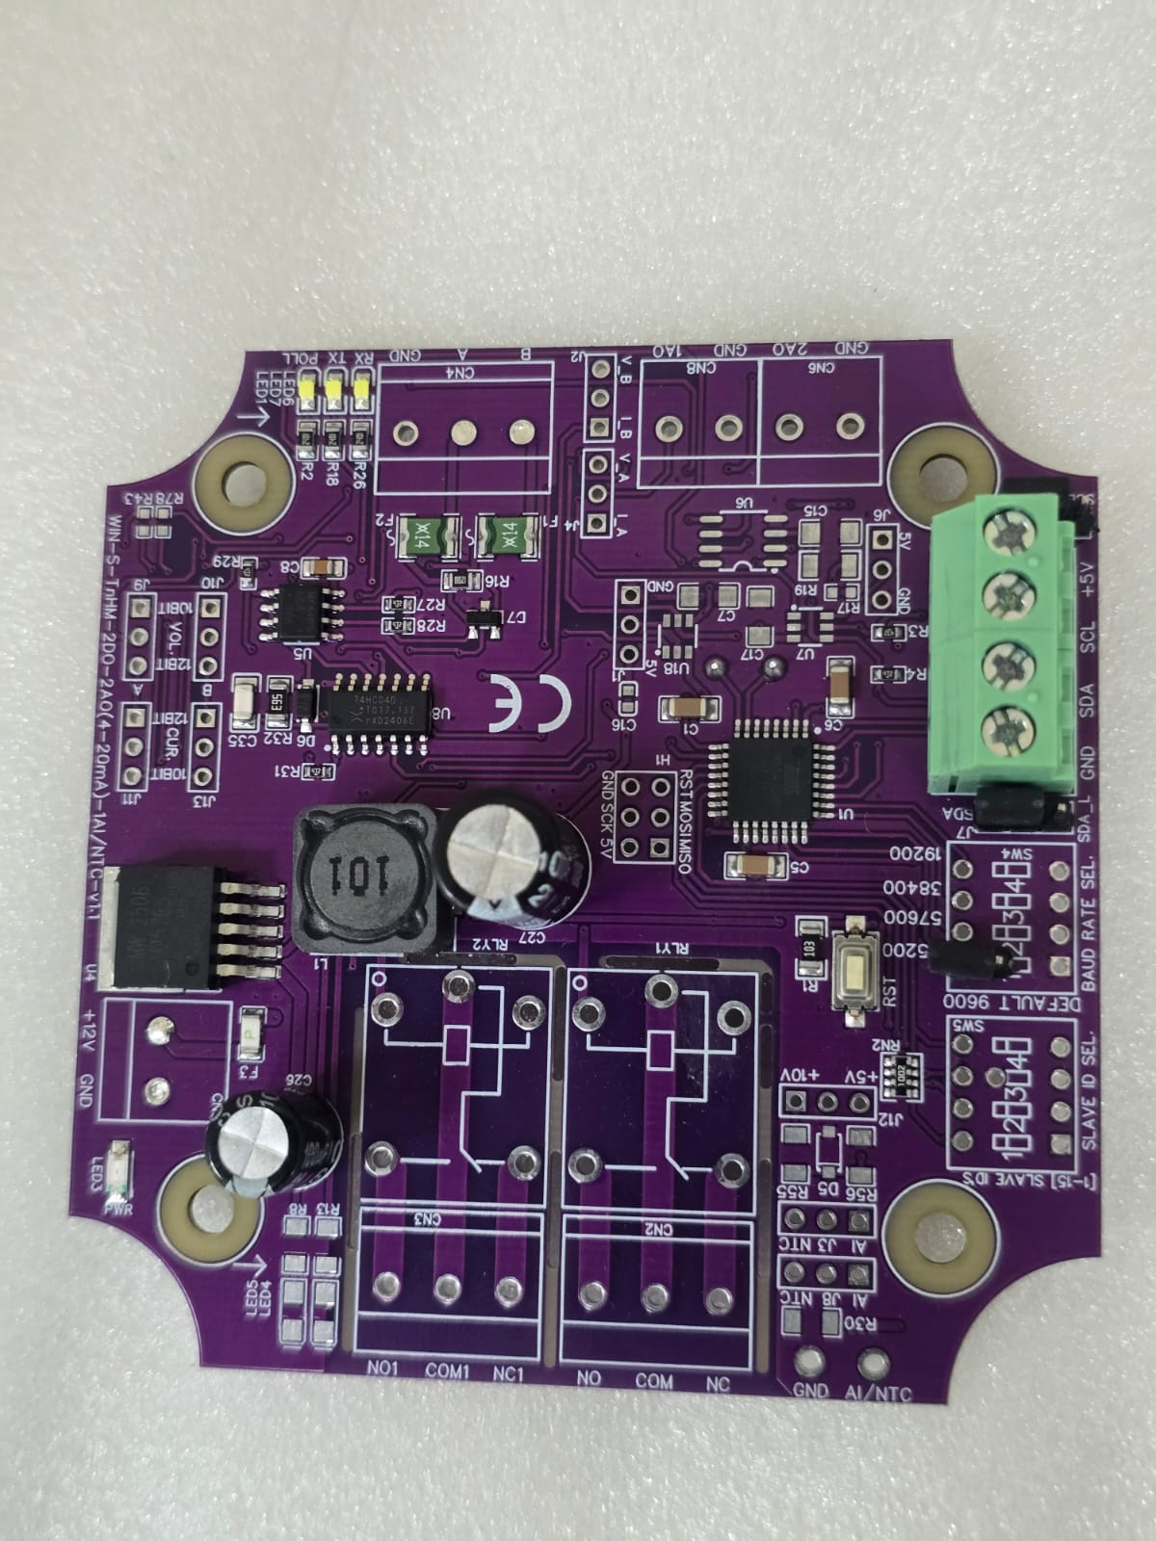

Closed
Open/Remove

Image1.1 Image1.2

Hard reset Setting
- Somehow, you forgot the baud rate or slave id of the board then Place the jumper (as shown in image 1.2) from the board reboot the system or press the reset button (given on the board). Then you will get the default baud rate of 9600 and slave id 1.

Web Portal Configuration Guide
The embedded web portal provides a unified, single-page interface for configuring both local Wi-Fi credentials and sensor IP addressing. This streamlines setup and enables seamless remote sensor data monitoring.
  - Initial Wi-Fi Connection & IP Setup
- First, connect your mobile device or PC directly to the Display's local hotspot. Search for the Wi-Fi network named WIN-SN-TnH-M-W and enter the password 12345678.
- Open your web browser and navigate to 192.168.4.1 to access the initial configuration portal.
- Enter your local Wi-Fi network credentials to connect the device to your facility's network.
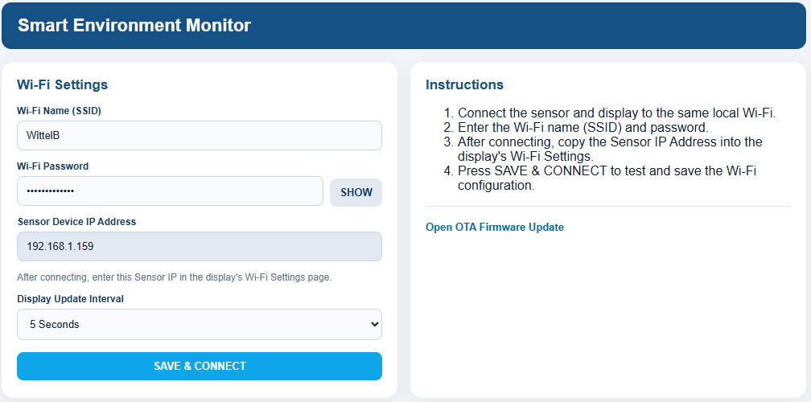
  - Accessing the Smart Environment Monitor Settings
- Ensure your PC or mobile device is connected to your standard local network (the same network the device just joined).
- Enter the assigned IP Address into your web browser to open the unified configuration portal.
- Sensor Device IP Address: After connecting to your local Wi-Fi (e.g., WittelB), the interface generates a specific Sensor Device IP Address (e.g., 192.168.1.159). Copy this IP address and enter it into the display unit's Wi-Fi settings page to link the sensor and display.
- Display Update Interval (Polling Frequency): Use the dropdown menu to set the data sharing and polling frequency between the sensors and the display. You can configure an update interval ranging from a minimum of 5 seconds (Default) up to a maximum of 60 minutes.
- Click SAVE & CONNECT to test and save your configuration settings.

Contact Information
Augmatic Technologies Pvt. Ltd.,
Plot no 6, Shah Industrial Estate II,
Kotambi,
Vadodara – 391510.
Email – Sales@wittelb.com
Support: support@wittelb.raiseaticket.com / +91 94038 92805

