LUMINOUS INTENSITY SENSOR
1. Product Overview
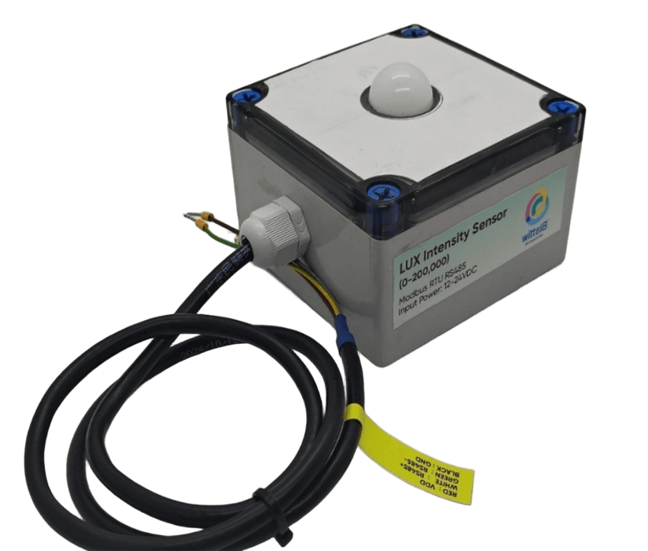
WIN-SN-PAR-M is a compact, high-precision horticultural sensor designed for applications requiring accurate Photosynthetic Photon Flux Density (PPFD) monitoring in a small form factor. Utilizing an advanced internal calibration algorithm, the device precisely converts ambient Lux measurements into actionable PPFD values ($μ$mol/m².s), ensuring highly reliable data for optimized plant growth. Its RS485 communication interface simplifies integration into smart agriculture and embedded IoT systems. The sensor's long-term stability ensures consistent performance in harsh greenhouse or outdoor environments, making it a cost-effective solution for long-term deployment.

Fig.1 - Product Image (Similar form factor shown for reference)

- Superior sensor performance.
- Operating range -20°C to 60°C and 0% to 70% RH for humidity
- Fully calibrated and processed digital, RS485 Output
- Wide Input voltage options 12-24V DC / 230V AC (optional)
- Excellent long-term stability
- Advanced PPFD Conversion: Internal engine calculates PPFD (up to ~3,700 μmol/m².s).
- Configurable Working Modes: Built-in selectable multiplication factors via Modbus to ensure accurate PPFD conversion based on the specific light source.
Measuring Parameter | Measuring Range | Operating Temperature
PPFD | up to 3,700 μmol/m².s | -20°C ~ 60°C.

2. Sensor Specifications
- Wide temperature range: −40 °C to +125 °C
- Full humidity range: 0 % to 100 % RH
- Power supply DC: 12-24V@1A.
- Product dimension: 100*100*60 mm.

- Certifications:

3. Power Supply Connection
DC Connection
- Use 12-24V@ 1A, Power supply.
- Don’t make loose connection.

4. Configuration Settings
- Communication Speed 9600 – 115200 Kbps (SW Selectable)
- Data Bits 8
- Parity None
- CRC Yes
- Slave ID 1, DIP (SW Selectable)
- Function Code 0X03 (Read Holding Register)

Recommended Cable Electrical Characteristics
22 AWG Cable Shielded and twisted pair should be used.
Tinned Copper Recommended
Nominal Conductor DCR 14.7 ohm / 1000 ft
Nominal Capacitance 11 pf / feet (conductor to conductor)
High Frequency Non-Insertion Loss 0.5db / 100ft

6. Modbus RS485 Data Storage register

ID | Function  Description | Register  Description | Modbus Function Code | Protocol | Data  Type
1 | PPFD (μmol/m².s) | 40003 | 0x03 | RS485 | 32 bit unsigned big endian
 |  | 40004
2 | Current Light Mode | 40005 | 0x03 | RS485 | 16-bit int
3 | Enter New Light Mode | 40006 | 0x03 | RS485 | 16-bit int
1 | Display Baud Rate (Default: 960) | 40011 | 0x03 | RS485 | 16-bit int
2 | Enter New Baud Rate | 40012 | 0x03 | RS485 | 16-bit int
3 | Display Slave ID (Default: 1) | 40013 | 0x03 | RS485 | 16-bit int
4 | Enter New Slave ID | 40014 | 0x03 | RS485 | 16-bit int
5 | Display Parity (Default: None-3 And for Odd-1, Even-2) | 40015 | 0x03 | RS485 | 16-bit int
6 | Enter New Parity | 40016 | 0x03 | RS485 | 16-bit int
7 | Display Stop Bit (start-2/stop bit-1) | 40017 | 0x03 | RS485 | 16-bit int
8 | Enter New Start/ Stop Bit | 40018 | 0x03 | RS485 | 16-bit int

7. Modbus Configuration
Here is an example of receiving data on Mb poll software.
- Open Mb-poll software connect using configuration setting (Default baud rate is 9600 and slave id is 1).
- After connecting you will get data as shown below.

Important Note
- If you want to enter the baud rate 9600/19200/38400/57600/115200etc, enter it like this 960/1920/3840/5760/11520etc.
- After that press the reset button or reboot the system.
- Then you will get the present value of 11520 at 40011 baud rate (115200) and 2 at 40013 slave id.
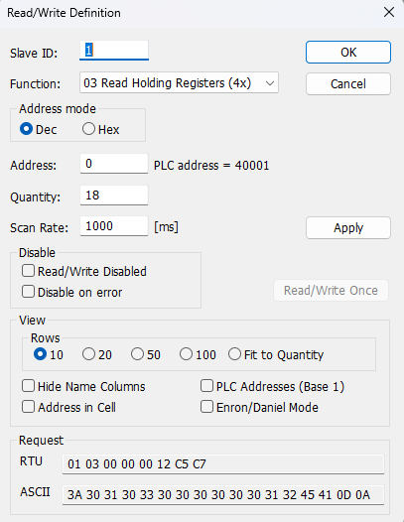
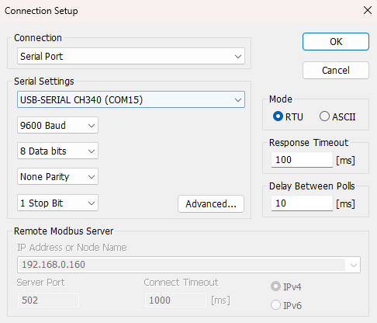

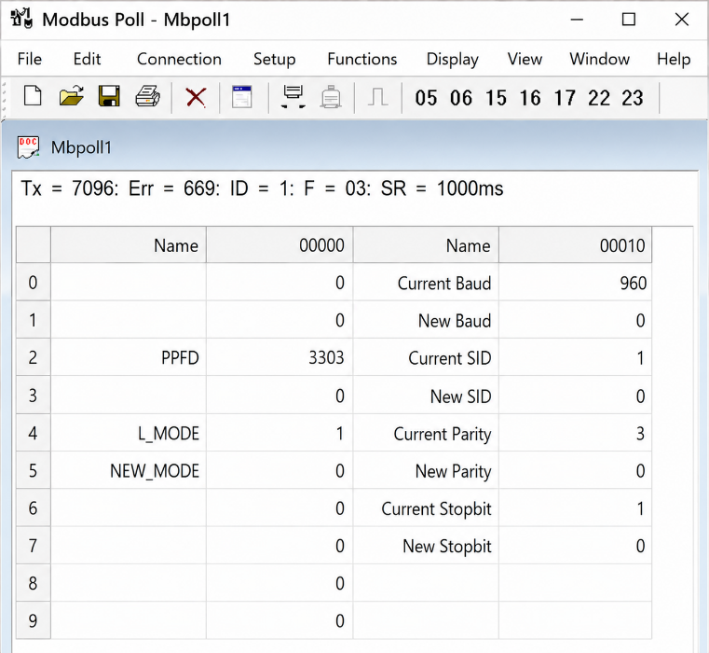

- Above image Shows sensor data over Modbus with default Modbus settings
- As you can see in the image above, the resistor 40011 – 960 represents the present bund rate (9600) of the board and 40013 – 1 represents the present slave id of the board.
- To change the baud rate and slave id Jumper should be in single/removed then you must enter a value on the 40012 resistors for the baud rate and 40014 for the slave id as shown in the image below and restart the board.
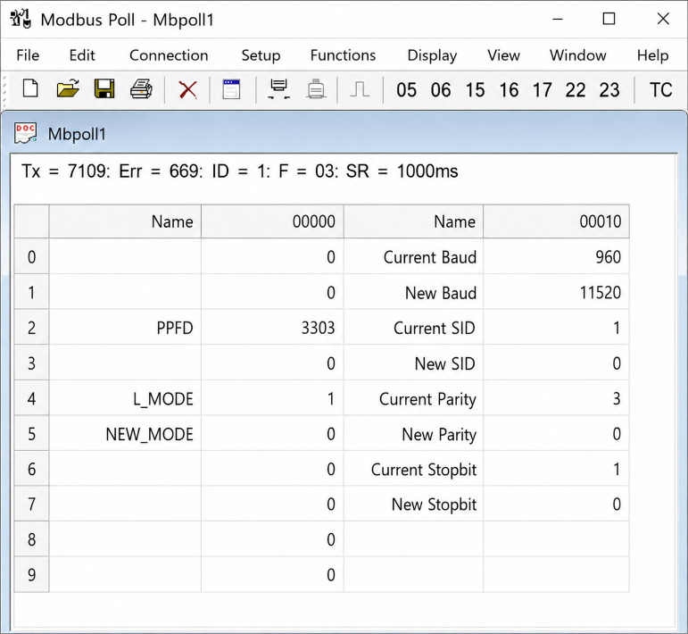
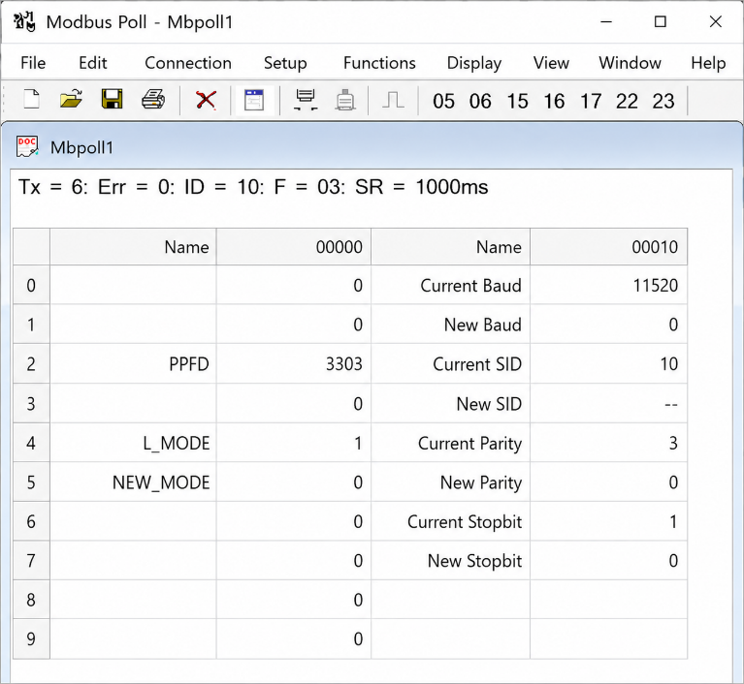
- Now you can see data below image set 115200 baud rate and slave ID 10.

- Make the register 40003 and 40004 as 32 bits unsigned big endian then at the register 40003 shows PPFD values.
- Resistor 40005 will show Current Light Mode for PPFD multiplication factor.
- To set the PPFD light mode, enter the 1-5 value in register 40006. The new value is applied after reset, and the updated PPFD value is reflected in register 40005.
  - 1: Full spectrum LED (0.0150 multiplication factor)
  - 2: Cool white light (0.0142 multiplication factor)
  - 3: HPS(High Pressure Sodium) (0.0122 multiplication factor)
  - 4: Sunlight (0.0185 multiplication factor)
  - 5: Custom Factor (As per client request)

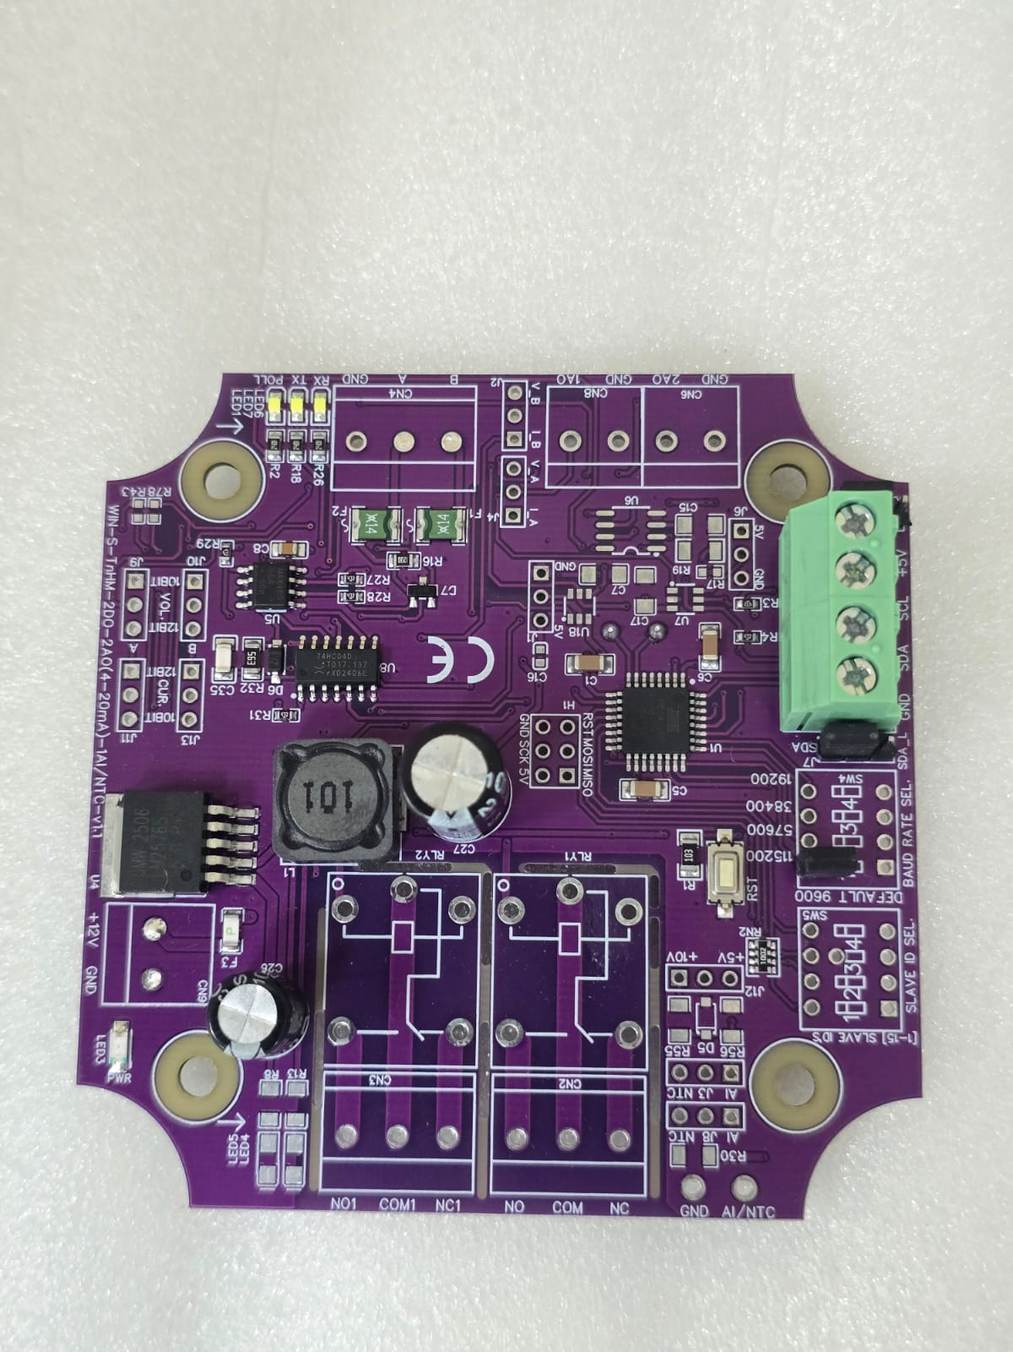
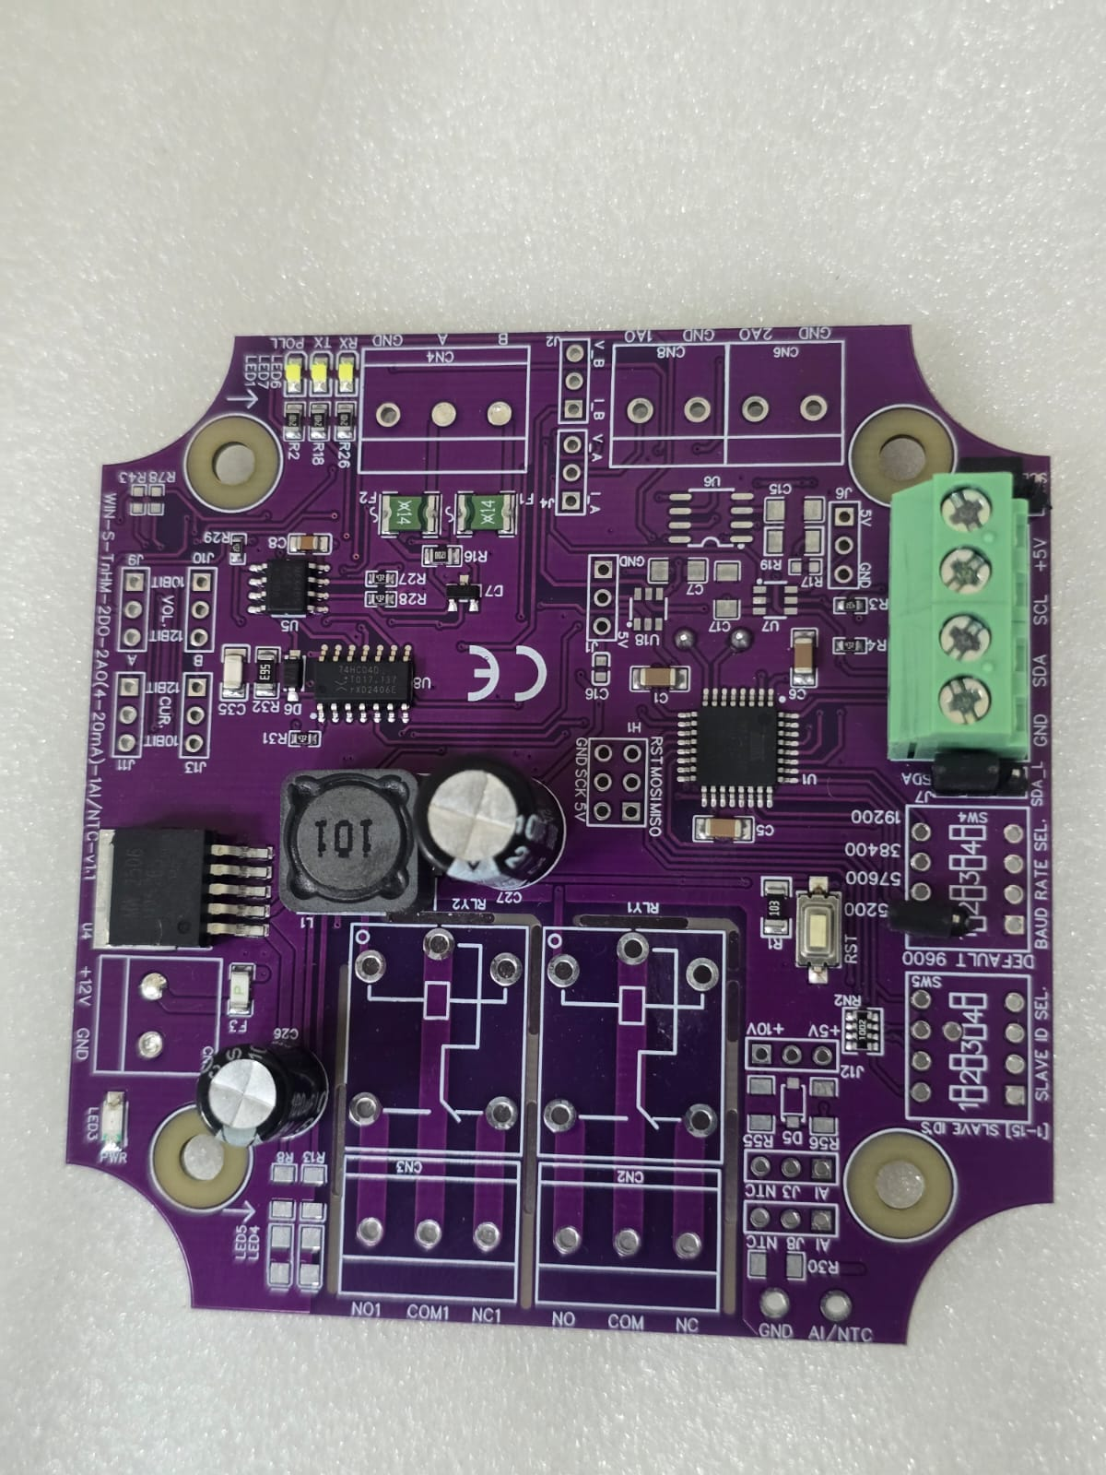

Closed
Open/Remove

Image1.1 Image1.2

Hard reset Setting
- Somehow you forgot the baud rate or slave id of the board then Place the jumper (as shown in the image 1.2) from the board reboot the system or press the reset button (given on the board). Then you will get the default baud rate of 9600 and slave id 1.

Contact Information
Augmatic Technologies Pvt. Ltd.,
Plot no 6, Shah Industrial Estate II,
Kotambi,
Vadodara – 391510.
Email – Sales@wittelb.com
Support E.: support@wittelb.raiseaticket.com / M.: 9403892805

