Technical Datasheet of WIN-PIHAT-QCTL-EC200-4G-GNSS
1. Overview
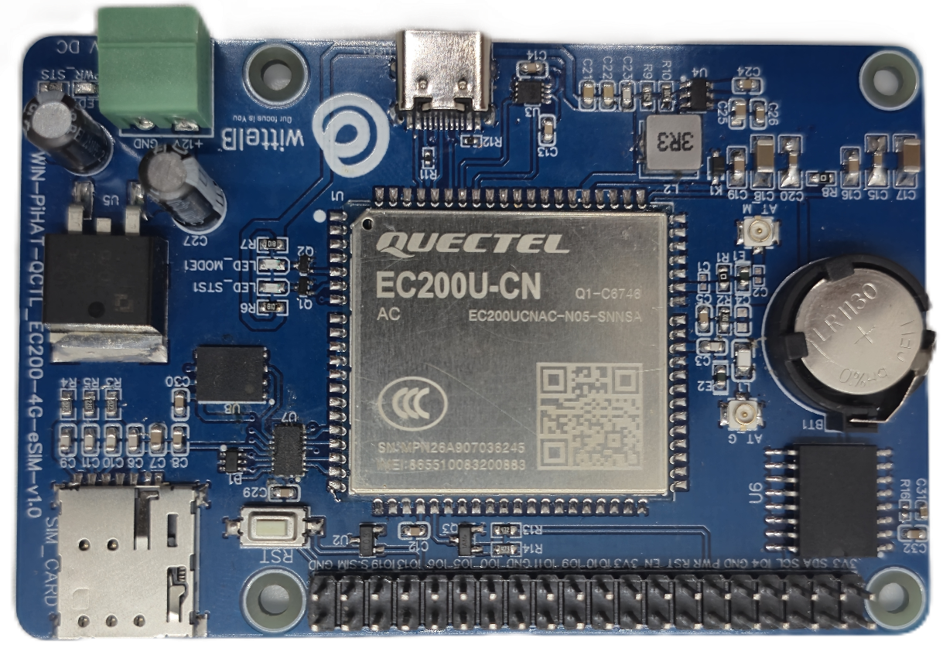
The PiHAT QCTL EC200 is an advanced LTE Cat 1 cellular expansion board for Raspberry Pi, offering reliable 4G data transmission and a fully integrated GNSS engine for accurate tracking. The module ensures seamless network connectivity by providing both Physical SIM and eSIM options, along with an onboard Real-Time Clock (RTC) for precise offline timestamping in remote industrial environments.
PiHAT features a versatile communication architecture supporting high-speed AT command and data transfers over both UART and USB Type-C interfaces. Its plug-and-play design provides hardware-level flexibility while maintaining a compact and robust solution for IoT telemetry, fleet management, and embedded automation applications.
Specifications
General :–

Dimensions 56 mm L x 85 mm W
Power Input Power – 12/24V DC
Operating Temperature 0 – 60° C (32 ~ 140°F)
Storage Temperature -20 - 70° C (-4 ~ 158°F)
Storage Humidity 5 ~ 95 % RH, non – Condensing
Certifications 

PiHAT EC200 (Cellular & Tracking) :–

Module Core Quectel EC200 (LTE Cat 1)
Network Support 4G LTE Data & SMS
SIM Interfaces Dual Support (Physical SIM & eSIM)
Location Services Dedicated GNSS Engine (Hardware GPS/GLONASS)
Communication USB Type-C & Standard UART
Timekeeping Onboard RTC with Battery Backup (CR1220)
Configuration :-

The cellular modem operates as a USB/UART-driven communication module and is interfaced to the Raspberry Pi GPIO header through dedicated power and reset control traces. Modem control and telemetry are performed via software running on the Raspberry Pi. Specific GPIO pins are configured as digital outputs to drive the onboard power-management IC and SIM routing logic.

When the Power pin (PWR) is pulsed HIGH, the onboard circuitry boots the baseband processor, bringing the module ONLINE to establish a network connection. When the Reset pin (RST) is pulled to an active LOW state, the baseband performs a hard hardware reboot to clear any unresponsive states. Additionally, driving the SIM Select pin toggles the active data lines between the physical Nano-SIM slot and the onboard eSIM.

The following are step by step guides for configuration:
- Connect the Module to +12/24V DC POWER SUPPLY.
- Connect the Board to the Raspberry Pi via header pins and the USB Type-C data cable.

Sr. No. | Control Function | Pi GPIO | Header Pin number
1 | Power Key (PWR) | 17 | 11
2 | Hardware Reset (RST) | 27 | 13
3 | Module Enable (EN) | 22 | 15
4 | SIM Select (EC200 Board) | 26 | 37

Sr. No. | Communication  EC200 | Pi GPIO | Header Pin number
1 | SDA | 02 | 03
2 | SCL | 03 | 05
3 | RXD | 14 | 08
4 | TXD | 15 | 10

Module Power & Signal Characteristics :-
- Power Starvation: The cellular radio amplifier can draw massive peak currents (up to 2.0A) during network registration and data transmission.
- Example: Relying solely on the Raspberry Pi's USB or GPIO header for power will cause voltage brownouts, resulting in unexpected module reboots or "Zombie" ports. Always connect a dedicated external power supply to the board's terminal block.
- GNSS Limitations: The GNSS engine requires a dedicated antenna and a direct line of sight to the sky to download satellite almanac data and calculate a 3D fix.
- Example: Operating the PiHAT deep indoors or inside a metal enclosure will result in indefinite "Searching" states. Ensure the GNSS antenna is routed outside or utilize LBS (Cell Tower Triangulation) as a software fallback.
- Boot Logic: The PWR (Power) GPIO pin operates as a momentary hardware toggle switch, not an absolute ON/OFF switch.
- Example: Pulsing the PWR pin while the module is already ON will initiate a shutdown sequence. To avoid accidental power-downs during error recovery, rely on the RST (Reset) pin for forced reboots.

Sample Code & Examples :-
Download the official Python example script—including the fully integrated MQTT telemetry loops—from our repository here:

- QCTL_EC200_MASTER(4G+GNSS).py

Hardware Interface & Connector Layout:
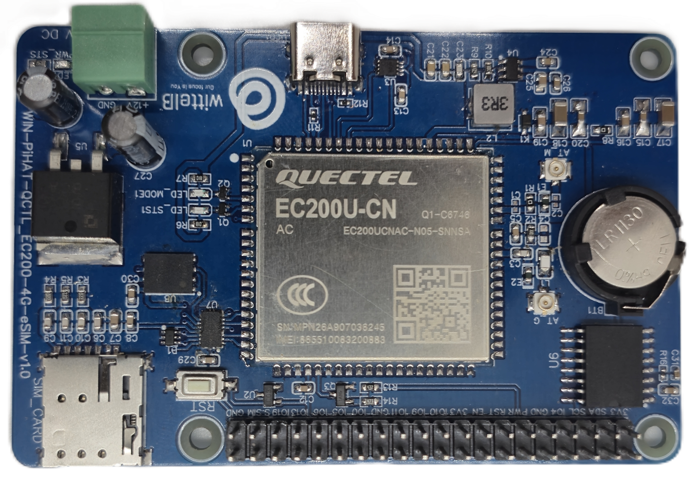
1
2
39
40
Antenna
GNSS
eSIM
12/24V DC Supply
Type C DATA
Antenna
Main
40 pin GPIO Headers
RESET
Button
Physical SIM

Contact us: -
Augmatic Technologies Pvt. Ltd.,
Plot no 6, Shah Industrial Estate II,
Kotambi,
Vadodara – 391510.
Email – Sales@wittelb.com
Support: support@wittelb.raiseaticket.com / +91 94038 92805

