Technical Datasheet of WIN-PIHAT-SIMCOM-A7672-4G-ESIM-V1.0
Overview :-
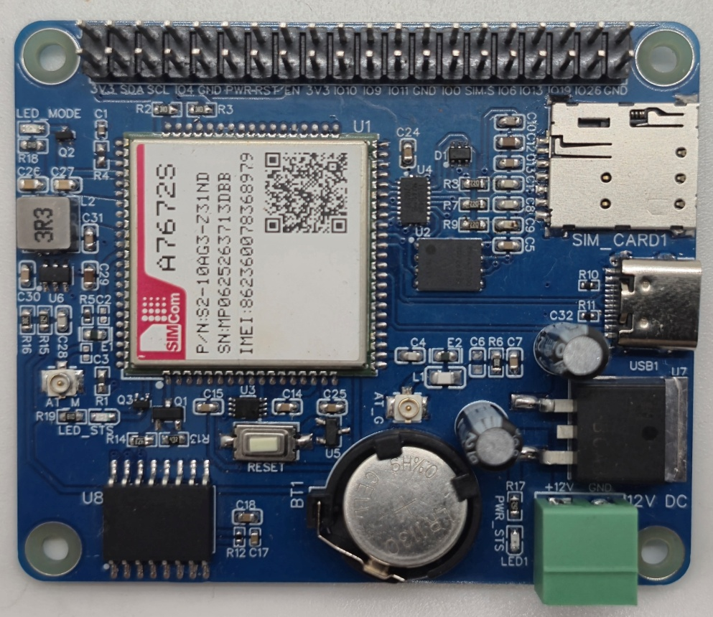
The PiHAT A7672S is a cost-effective LTE expansion board tailored for Raspberry Pi, offering optimized 4G telemetry and built-in GNSS capabilities alongside cellular triangulation (LBS). The hardware maximizes network redundancy by featuring both Physical & eSIM support, while an onboard Real-Time Clock (RTC) ensures accurate localized timestamping for secure data logging.
PiHAT features a highly adaptable communication interface that supports reliable data transmission through both standard UART and USB Type-C. Its streamlined telemetry design allows for scalable connectivity, delivering a compact and reliable solution for stationary IoT endpoints, smart metering, and industrial monitoring.
Specifications
General :–

Dimensions 56 mm L x 65 mm W
Power Input Power – 12/24V DC
Operating Temperature 0 – 60° C (32 ~ 140°F)
Storage Temperature -20 - 70° C (-4 ~ 158°F)
Storage Humidity 5 ~ 95 % RH, non – Condensing
Certifications 

PiHAT EC200 (Cellular & Tracking) :–

Module Core SIMCom A7672S (LTE Cat 1)
Network Support 4G LTE Data & SMS
SIM Interfaces Dual Support (Physical SIM & eSIM)
Location Services Cellular Triangulation (LBS / Raw Cell ID)
Communication USB Type-C & Standard UART
Timekeeping Onboard RTC with Battery Backup (CR1220)

Configuration :-

The cellular modem operates as a USB/UART-driven communication module and is interfaced to the Raspberry Pi GPIO header through dedicated power and reset control traces. Modem control and telemetry are performed via software running on the Raspberry Pi. Specific GPIO pins are configured as digital outputs to drive the onboard power-management IC and SIM routing logic.

When the Power pin (PWR) is pulsed HIGH, the onboard circuitry boots the baseband processor, bringing the module ONLINE to establish a network connection. When the Reset pin (RST) is pulled to an active LOW state, the baseband performs a hard hardware reboot to clear any unresponsive states. Additionally, driving the SIM Select pin toggles the active data lines between the physical Nano-SIM slot and the onboard eSIM.

The following are step by step guides for configuration:
- Connect the Module to +12/24V DC POWER SUPPLY.
- Connect the Board to the Raspberry Pi via header pins and the USB Type-C data cable.

Sr. No. | Control Function | Pi GPIO | Header Pin number
1 | Power Key (PWR) | 17 | 11
2 | Hardware Reset (RST) | 27 | 13
3 | Module Enable (EN) | 22 | 15
4 | SIM Select (A7672S Board) | 05 | 29

Sr. No. | Communication  A7672S | Pi GPIO | Header Pin number
1 | SDA | 02 | 03
2 | SCL | 03 | 05
3 | RXD | 14 | 08
4 | TXD | 15 | 10

Module Power & Signal Characteristics :-
- Power Starvation: The cellular radio amplifier can draw massive peak currents (up to 2.0A) during network registration and data transmission.
- Example: Relying solely on the Raspberry Pi's USB or GPIO header for power will cause voltage brownouts, resulting in unexpected module reboots or "Zombie" ports. Always connect a dedicated external power supply to the board's terminal block.
- GNSS Limitations: The GNSS engine requires a dedicated antenna and a direct line of sight to the sky to download satellite almanac data and calculate a 3D fix.
- Example: Operating the PiHAT deep indoors or inside a metal enclosure will result in indefinite "Searching" states. Ensure the GNSS antenna is routed outside or utilize LBS (Cell Tower Triangulation) as a software fallback.
- Boot Logic: The PWR (Power) GPIO pin operates as a momentary hardware toggle switch, not an absolute ON/OFF switch.
- Example: Pulsing the PWR pin while the module is already ON will initiate a shutdown sequence. To avoid accidental power-downs during error recovery, rely on the RST (Reset) pin for forced reboots.

Sample Code & Examples :-
Download the official Python example scripts—including the fully integrated GNSS and MQTT telemetry loops—from our repository here:

- SIMCOM_A7672S

Hardware Interface & Connector Layout:
2
1
40
39
TypeC DATA
eSIM
Antenna
GNSS
Antenna
Main
RESET
Button
Physical SIM
40 pin GPIO Headers
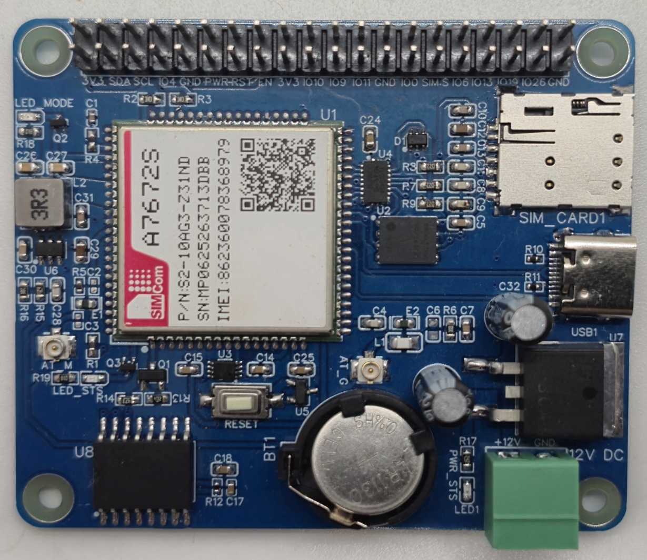
12/24V DC Supply

Contact us: -
Augmatic Technologies Pvt. Ltd.,
Plot no 6, Shah Industrial Estate II,
Kotambi,
Vadodara – 391510.
Email – Sales@wittelb.com
Support: support@wittelb.raiseaticket.com / +91 94038 92805

