Technical Datasheet TnH Sensor Modules with AOV/AOC

The WIN-SN-TNH-AOC-AOV (Outdoor Edition) is a robust sensor housed in a weather-resistant louvered enclosure, designed to accurately measure Temperature and Humidity in outdoor environments.

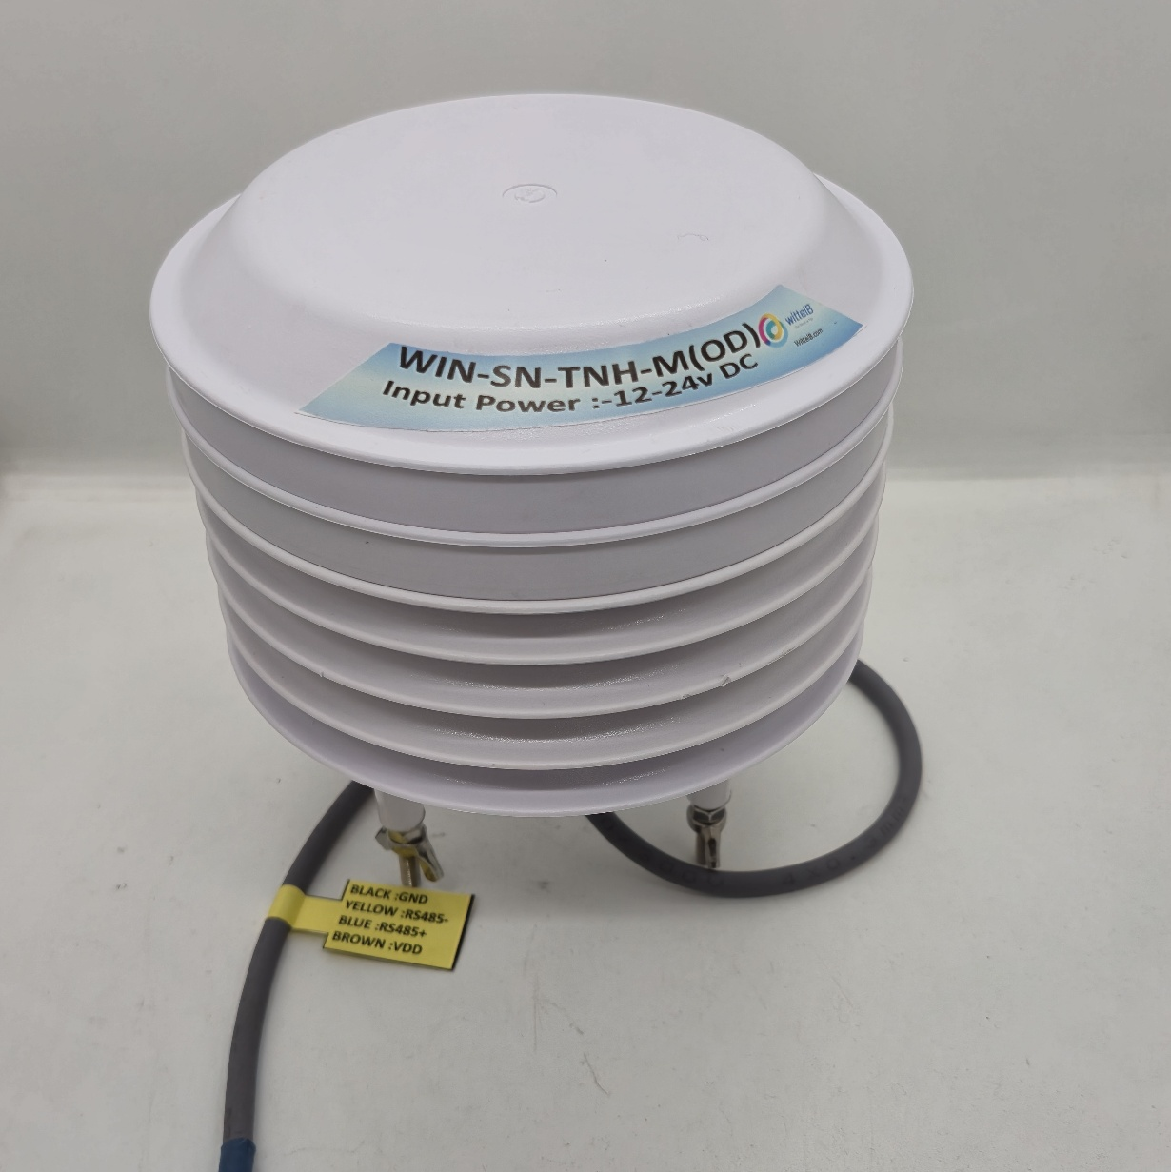
TnH Sensor Module: -

The device outputs precise analog signals with selectable 10-bit or 12-bit resolution, supporting both 0-10V and 4-20mA ranges for easy integration with industrial systems. Powered by a standard 12-24V DC supply, it features onboard resettable fuses to protect against reverse polarity on both the power and analog signal terminals. This resilient design makes it ideal for greenhouse climate control and general environmental monitoring.
Specifications
General –

Dimensions 158mm L x 139 mm D
Power Input Power – 12 - 24 V DC
Operating Temperature 0 – 60° C (32 ~ 140°F)
Storage Temperature -20 - 70° C (-4 ~ 158°F)
Storage Humidity 5 ~ 95 % RH, non – Condensing
Certifications 
Technical Specifications: -
Measured Parameters Temperature and Humidity
Output Type Analog Output 10-bit / 12-bit resolution
Output Range AOV 0-10V / AOC 4-20mA

 | Sensor Name | Temperature  Measuring Range | Humidity  Measuring range | Operating Temperature | Measuring Accuracy
☐ | AHT20 | -20°C ~ 85°C. | 0~100% RH. | -40°C ~ 120°C. | 0.3°C, 2.0 %RH
☐ | AHT21 | -40°C ~ 120°C. | 0~100% RH. | -40°C ~ 120°C. | 0.3°C, 2.0 %RH

Applications
- Outdoor air quality monitoring.
- Climate control in greenhouses.
- Environmental monitoring systems.
- Smart home system.
Precautions
- Read all instructions before using the sensor board.
- Keep the sensor board away from water or moisture to prevent damage.
- Do not disassemble or modify the sensor board.
- Use only the specified power sources and mentioned.

Wire diagram:

ID | AO | Wire Colour | Parameter
1 | AO1 | Brown | Temperature +
2 | AO1 | Black | Temperature -
3 | AO2 | Yellow | Humidity +
4 | AO2 | White | Humidity -

Wire diagram:

Analog Output | Parameter | Range
AO1 | Temperature | -40°C ~ 85°0043
AO2 | Humidity | 0 ~ 130 g/m³

Contact us: -
Augmatic Technologies Pvt. Ltd.,
Plot no 6, Shah Industrial Estate II,
Kotambi,
Vadodara – 391510.
Email – Sales@wittelb.com
Support: support@wittelb.raiseaticket.com / +91 94038 92805

