Technical Datasheet Input / Output Modules with Modbus RTU Protocol with RS485 Interface

The IO modules communicate via RS485. The port can drive distances up to max 700 meters without the use of any repeater (this feature however also depends on the signal strength of the Modbus Master Device).
The RS485 Digital IO module is sturdy, low power usage and easy to use.
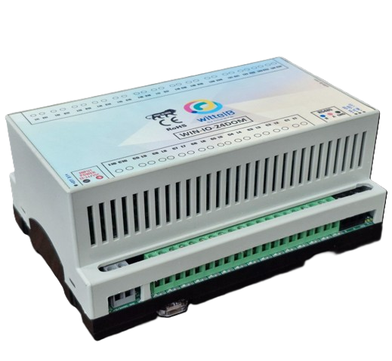
24 Port DO Module: -

The IO modules are mounted on DIN rail mountable casing and with exposed connectors and LED indicators. The DIP switch for Slave ID and Baud rate are placed inside the enclosure.

The design of the modules incorporates ‘resettable Fuses’ to safeguard against reverse polarity connection both for Power and Communication port.

Specifications
General –

I/O Connectors 12 Pin 5.08 mm pitch pluggable screw Terminal Block
Dimensions 157 mm L x 110 mm B x 75 mm H
BPower Input Power – 15-40 VDC or 24 V AC / DC options
Typical – 12V DC @ 150mA
Operating Temperature 0 – 60° C (32 ~ 140°F)
Storage Temperature -20 - 70° C (-4 ~ 158°F)
Storage Humidity 5 ~ 95 % RH, non – Condensing
Certifications 

Relay Output –
Channels 24
Contact Form 1A, 1C
Contact Material Ag Alloy
Contact Capacity 10A @ 240VAC, 10A @ 28VDC
Coil Voltage 5 – 48 VDC
Coil Power 0.36 W
Insulation Resistance 250MΩ
Electrical Life 1 x 10^5
Mechanical Life 1 x 10^7
Operating Time 7 msec, Max 15 msec
Release Time 2 msec, Max 6 msec

Additional Features: -
Communication ports are isolated
Input power reverse polarity safety
ESD Safety IEC 61000-4-2, ± 30KV contact, ± 30KV air
EFT IEC 61000-4-4, 50A (5/50ms)
400V isolation.
CRC Error check.
No configuration needed on the IO board

Configuration Settings: -

Communication Speed 9600 – 115200 Kbps (soft settings)
Data Bits 8
Parity None =3
Stop bit 1
CRC Yes
Slave ID Soft Settings selectable (1-247)
Function code 0x05 and 0x0F (5 Single coil & 15 multiple coil)
DO Register Address 0,1,2,3,4,5,6,7,8,9,10,11,12,13,14,15,16,17,18,19,20,
21,22,23.
ID | Function  Description | Register  Description | Modbus Function Code | Protocol | Data  Type
1 | DO 1 | 00001 | 0X05,0X0F | RS485 | 1 Bit Boolean
2 | DO 2 | 00002 | 0X05,0X0F | RS485 | 1 Bit Boolean
3 | DO 3 | 00003 | 0X05,0X0F | RS485 | 1 Bit Boolean
4 | DO 4 | 00004 | 0X05,0X0F | RS485 | 1 Bit Boolean
5 | DO 5 | 00005 | 0X05,0X0F | RS485 | 1 Bit Boolean
6 | DO 6 | 00005 | 0X05,0X0F | RS485 | 1 Bit Boolean
7 | DO 7 | 00007 | 0X05,0X0F | RS485 | 1 Bit Boolean
8 | DO 8 | 00008 | 0X05,0X0F | RS485 | 1 Bit Boolean
9 | DO 9 | 00009 | 0X05,0X0F | RS485 | 1 Bit Boolean
10 | DO 10 | 00010 | 0X05,0X0F | RS485 | 1 Bit Boolean
11 | DO 11 | 00011 | 0X05,0X0F | RS485 | 1 Bit Boolean
12 | DO 12 | 00012 | 0X05,0X0F | RS485 | 1 Bit Boolean
13 | DO 13 | 00013 | 0X05,0X0F | RS485 | 1 Bit Boolean
14 | DO 14 | 00014 | 0X05,0X0F | RS485 | 1 Bit Boolean
15 | DO 15 | 00015 | 0X05,0X0F | RS485 | 1 Bit Boolean
16 | DO 16 | 00016 | 0X05,0X0F | RS485 | 1 Bit Boolean
17 | DO 17 | 00017 | 0X05,0X0F | RS485 | 1 Bit Boolean
18 | DO 18 | 00018 | 0X05,0X0F | RS485 | 1 Bit Boolean
19 | DO 19 | 00019 | 0X05,0X0F | RS485 | 1 Bit Boolean
20 | DO 20 | 00020 | 0X05,0X0F | RS485 | 1 Bit Boolean
21 | DO 21 | 00021 | 0X05,0X0F | RS485 | 1 Bit Boolean
22 | DO 22 | 00022 | 0X05,0X0F | RS485 | 1 Bit Boolean
23 | DO 23 | 00023 | 0X05,0X0F | RS485 | 1 Bit Boolean
24 | DO 24 | 00024 | 0X05,0X0F | RS485 | 1 Bit Boolean

Note: -
For MODBUS communications, a shielded and twisted pair cable is used. One example of such cable is Belden 3105A.

Recommended Cable Electrical Characteristics: -
22 AWG Cable Shielded Twisted pair should be used
Tinned Copper Recommended
Nominal Conductor DCR 14.7 ohm / 1000 ft
Nominal Capacitance 11 pf / feet (conductor to conductor)
High Frequency Non-Insertion Loss 0.5db / 100f

Soft Settings Configuration: -
- Connect The Modbus A and B to cable.
Here is an example of receiving data on Mb poll software.
- Open Mb-poll software connect using configuration setting (Default Baudrate is 9600 and slave id is 1).
- After connecting you will get data as shown below.

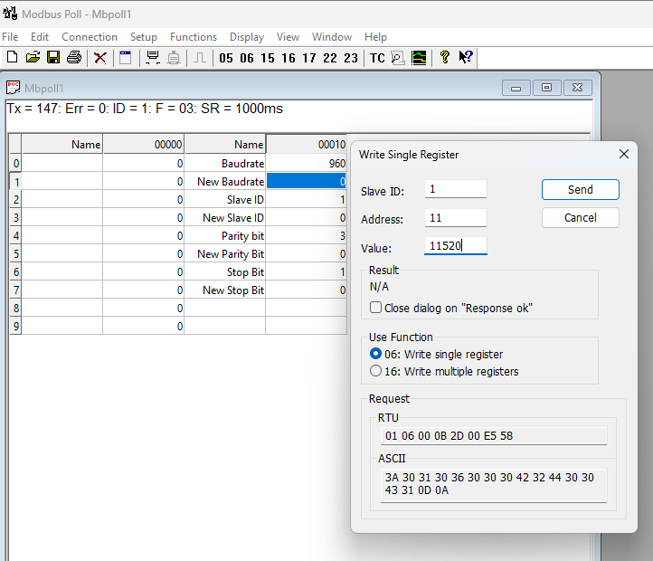

As you can see in the image above, the resistor 40010 – 960 represents the present bund rate (9600) of the board and 40012 – 1 represents the present slave id of the board.
To change the baud rate and slave id you must enter a value on the 40011 resistors for the baud rate and 40013 for the slave id as shown in the image below.
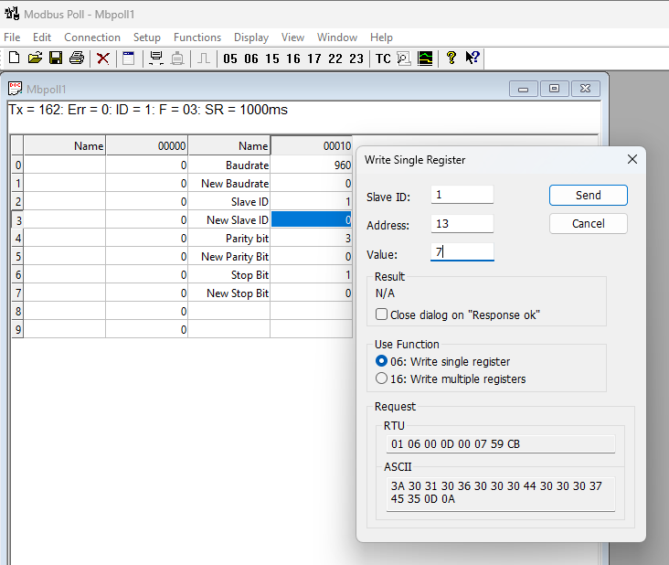

Hard Reset Setting
If the configured baud rate or slave ID of the board is unknown or forgotten, follow the procedure below to restore the default settings:
- Short the reset jumper on the board (as shown in the reference image).
- Reboot the system by either:
  - Power cycling the device, or
  - Pressing and holding the RESET button for at least 5 seconds.
- After reset, the device will revert to the default communication settings.
- Default Communication settings :9600 Baud rate , 1 is slave ID
Contact us: -
Augmatic Technologies Pvt. Ltd.,
Plot no 6, Shah Industrial Estate II,
Kotambi,
Vadodara – 391510.
Email – Sales@wittelb.com
Support: support@wittelb.raiseaticket.com / +91 94038 92805

