Technical Datasheet Input / Output Modules with Modbus RTU Protocol with RS485 Interface

The IO modules communicate via RS485. The port can drive distances up to max 700 meters without the use of any repeater (this feature however also depends on the signal strength of the Modbus Master Device).
The RS485 Digital IO module is sturdy, low power usage and easy to use.

Port AI Module: -
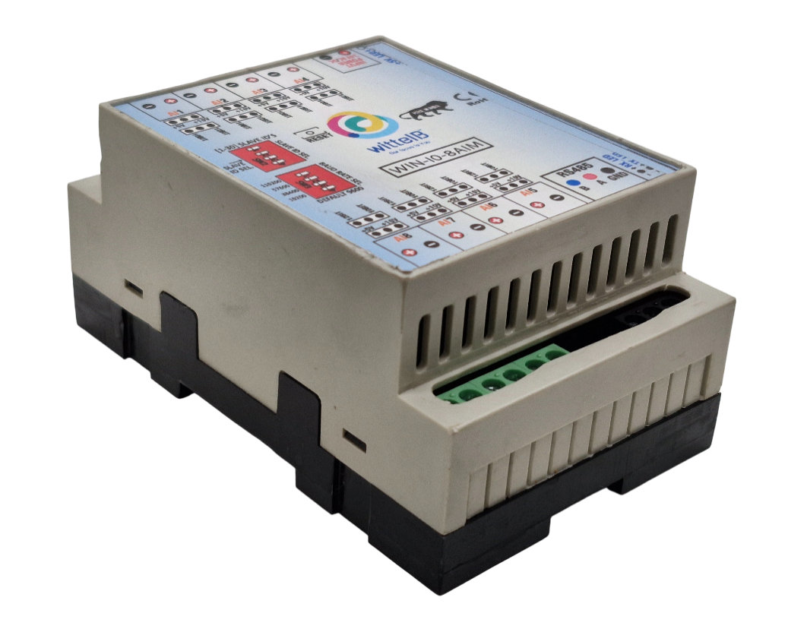

The IO modules are mounted on DIN rail mountable casing and with exposed connectors and LED indicators. The DIP switch for Slave ID and Baud rate are placed inside the enclosure.

The design of the modules incorporates ‘resettable Fuses’ to safeguard against sudden High Voltage spikes. The board also has ‘reverse polarity’ protection both for input Power connector.

The communication port also has signal isolation and additional Jumper for ‘end of line’ 120 ohms termination resistance which may or may not be used.

Specifications

General
I/O Connectors 2 Pin 5.08 mm pitch pluggable screw terminals.
Dimensions 70 mm L x 110 mm B x 50 mm H
Power Input Power – 12 – 24 VDC
Typical – 12V DC @ 1 Amp
Operating Temperature 0 – 60° C (32 ~ 140°F)
Storage Temperature | -20 - 70° C (-4 ~ 158°F))
Storage Humidity | 5 ~ 95 % RH, non – Condensing
Certifications  
AI Inputs –
Channels | 8
Input Signal | 4 – 20 mA / 0 – 5 V / 0 – 10 V / 0 – 5 V (jumper sel)
Accuracy | ± 2 % of Full scale
Input Resolution | 10-bit /12-bit resolution (optional)
Isolation | Optically Isolated
External Loop Voltage | + 12 VDC min
AI input impedance | 120Ω

Additional Features: -
Communication port isolated
Input power reverse polarity safety
ESD Safety IEC 61000-4-2, ± 30KV contact, ± 30KV airEFT IEC 61000-4-4, 50A (5/50ms)
750V isolation.
CRC Error check.
No configuration needed on the IO board

Configuration Settings: -

Communication Speed 9600 – 19200 Kbps (DIP SW Selectable)
Data Bits |  |  | 8
Parity |  |  | None
Stop bit |  |  | 1
CRC |  |  | Yes
Slave ID |  |  | 1 – 15 (DIP SW Selectable)
Function Code AI 0x09 Read Holding Registers
AI Register Address 10 Bit - 0,1,2,3,4,5,6,7 / 12 Bit – 8,9,10,11,12,13,14,15

ID | Function Description | Register Description | Modbus  Function Code | Protocol | Data Type
1 | AI 1 – 10 Bit | 40001 | 0X03 | RS485 | 16 Bit Unsigned int
2 | AI 2 – 10 Bit | 40002 | 0X03 | RS485 | 16 Bit Unsigned int
3 | AI 3 – 10 Bit | 40003 | 0X03 | RS485 | 16 Bit Unsigned int
4 | AI 4 – 10 Bit | 40004 | 0X03 | RS485 | 16 Bit Unsigned int
5 | AI 5 – 10 Bit | 40005 | 0X03 | RS485 | 16 Bit Unsigned int
6 | AI 6 – 10 Bit | 40006 | 0X03 | RS485 | 16 Bit Unsigned int
7 | AI 7 – 10 Bit | 40007 | 0X03 | RS485 | 16 Bit Unsigned int
8 | AI 8 – 10 Bit | 40008 | 0X03 | RS485 | 16 Bit Unsigned int
9 | AI – 1 12 Bit | 40009 | 0x03 | RS485 | 16 Bit Unsigned int
10 | AI – 2 12 Bit | 40010 | 0x03 | RS485 | 16 Bit Unsigned int
11 | AI – 3 12 Bit | 40011 | 0x03 | RS485 | 16 Bit Unsigned int
12 | AI – 4 12 Bit | 40012 | 0x03 | RS485 | 16 Bit Unsigned int
13 | AI – 5 12 Bit | 40013 | 0x03 | RS485 | 16 Bit Unsigned int
14 | AI – 6 12 Bit | 40014 | 0x03 | RS485 | 16 Bit Unsigned int
15 | AI – 7 12 Bit | 40015 | 0x03 | RS485 | 16 Bit Unsigned int
16 | AI – 8 12 Bit | 40016 | 0x03 | RS485 | 16 Bit Unsigned int

Note: -
For MODBUS communications, a shielded and twisted pair cable is used. One example of such cable is Belden 3105A.

Recommended Cable Electrical Characteristics: -
22 AWG Cable Shielded and twisted pair should be used.
Tinned Copper Recommended
Nominal Conductor DCR 14.7 ohm / 1000 ft
Nominal Capacitance 11 pf / feet (conductor to conductor)
High Frequency Non-Insertion Loss 0.5db / 100ft

NOTE – By default the Jumper setting on the board is 10 V and 10 Bit.

BAUD RATE DESCRIPTION

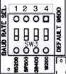
LSB
MSB

- For Baud rate Selection, DIP SW is used as per the diagram.
- Pulling up the switch will make Baud rate active. `
- If no selection is made 9600 will be default Baud rate.
- When u change the Baud rate in the Module power ‘ON’ condition, please press the reset button to get Change to affect.

Baud Rate | DIP SWITCH
Baud Rate | 1 | 2 | 3 | 4
9600 | - | OFF | OFF | OFF
57600 | - | ON | OFF | OFF
38400 | - | OFF | ON | OFF
19200 | - | OFF | OFF | ON

SLAVE ID DESCRIPTION

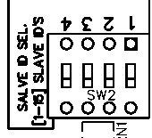

MSB

LSB

For Slave ID Selection SW is used to Set The SLAVE ID .
For Slave ID DIP Switch LSB is “1” follow through “4” is MSB.
Slave ID Confirmed through below Device ID table .
IF Eg. Slave ID 1 is Needed to be selected Switch number 1 should pulled up other three should be selected down side. So”1 0 0 0” will be selected as Slave ID 1.

Slave ID | DIP SWITCH |  |  |  | OUTPUT  (Binary) | OUTPUT  (Decimal)
Slave ID | 1 | 2 | 3 | 4 | OUTPUT  (Binary) | OUTPUT  (Decimal)
0 | OFF(0) | OFF(0) | OFF(0) | OFF(0) | 0 0 0 1 | 1
1 | ON(1) | OFF(0) | OFF(0) | OFF(0) | 0 0 0 1 | 1
2 | OFF(0) | ON(1) | OFF(0) | OFF(0) | 0 0 1 0 | 2
3 | ON(1) | ON(1) | OFF(0) | OFF(0) | 0 0 1 1 | 3
4 | OFF(0) | OFF(0) | ON(1) | OFF(0) | 0 1 0 0 | 4
5 | ON(1) | OFF(0) | ON(1) | OFF(0) | 0 1 0 1 | 5
6 | OFF(0) | ON(1) | ON(1) | OFF(0) | 0 1 1 0 | 6
7 | ON(1) | ON(1) | ON(1) | OFF(0) | 0 1 1 1 | 7
8 | OFF(0) | OFF(0) | OFF(0) | ON(1) | 1 0 0 0 | 8
9 | ON(1) | OFF(0) | OFF(0) | ON(1) | 1 0 0 1 | 9
10 | OFF(0) | ON(1) | OFF(0) | ON(1) | 1 0 1 0 | 10
11 | ON(1) | ON(1) | OFF(0) | ON(1) | 1 0 1 1 | 11
12 | OFF(0) | OFF(0) | ON(1) | ON(1) | 1 1 0 0 | 12
13 | ON(1) | OFF(0) | ON(1) | ON(1) | 1 1 0 1 | 13
14 | OFF(0) | ON(1) | ON(1) | ON(1) | 1 1 1 0 | 14
15 | ON(1) | ON(1) | ON(1) | ON(1) | 1 1 1 1 | 15

AI
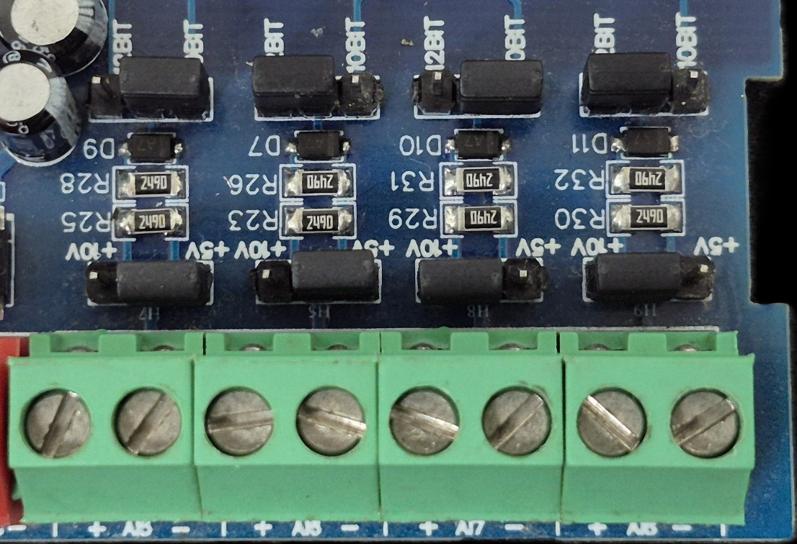
Sensor
Sensor
Sensor
Sensor

- Analog Input (AI) Operation: Each channel provides two terminals: + (Positive) and - (Negative/Common). These are used to read external analog sensor signals.
- Channel Configuration (Visual Guide): Each of the four AI channels features two dedicated jumpers to independently set the voltage range and bit resolution. Refer to the color-coded boxes in the board diagram to configure your desired scenario:
  - Red Box (5V, 10-bit): Set the voltage jumper to +5V and the resolution jumper to 10 BIT.
  - Green Box (5V, 12-bit): Set the voltage jumper to +5V and the resolution jumper to 12 BIT.
  - Blue Box (10V, 10-bit): Set the voltage jumper to +10V and the resolution jumper to 10 BIT.
  - Yellow Box (10V, 12-bit): Set the voltage jumper to +10V and the resolution jumper to 12 BIT.
- Sensor Wiring Connections:
  - The analog sensor's positive signal wire should be connected to the + terminal of the desired channel.
  - The sensor's common or ground wire should be connected to the corresponding - terminal.
- Crucial Setup Recommendation: Always ensure that the voltage jumper setting strictly matches the maximum output range of your connected sensor (either 5V or 10V) to guarantee accurate analog-to-digital conversion and prevent data clipping.
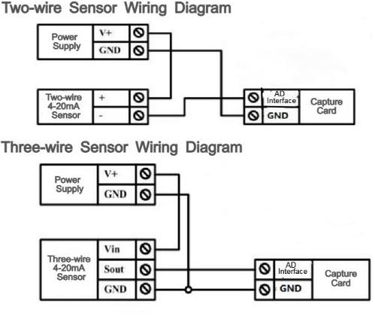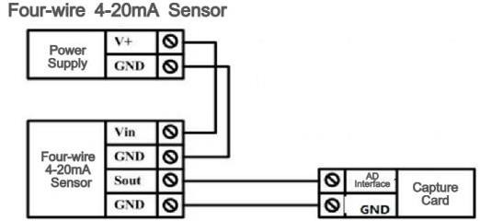

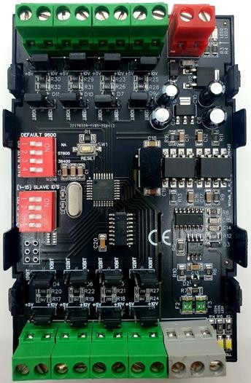

AI5 AI6 AI7 AI8

AI
4

AI
36

AI
27

AI
1

Input
12
-
24

VDC

Modbus
RS 485

LSB

M
SB

LSB

Baud Rate

Slave ID

M
SB

Jumper

5
V / 10V

Jumper

10
/ 12
Bit

Jumper

10
/ 12
Bit

Jumper

5
V / 10V

Contact Information
Augmatic Technologies Pvt. Ltd.,
Plot no 6, Shah Industrial Estate II,
Kotambi,
Vadodara – 391510.
Email – Sales@wittelb.com
Support E.: support@wittelb.raiseaticket.com / M.: 9403892805

