Technical Datasheet of 4AI With 16-&-24BIT Resolution
1. Overview
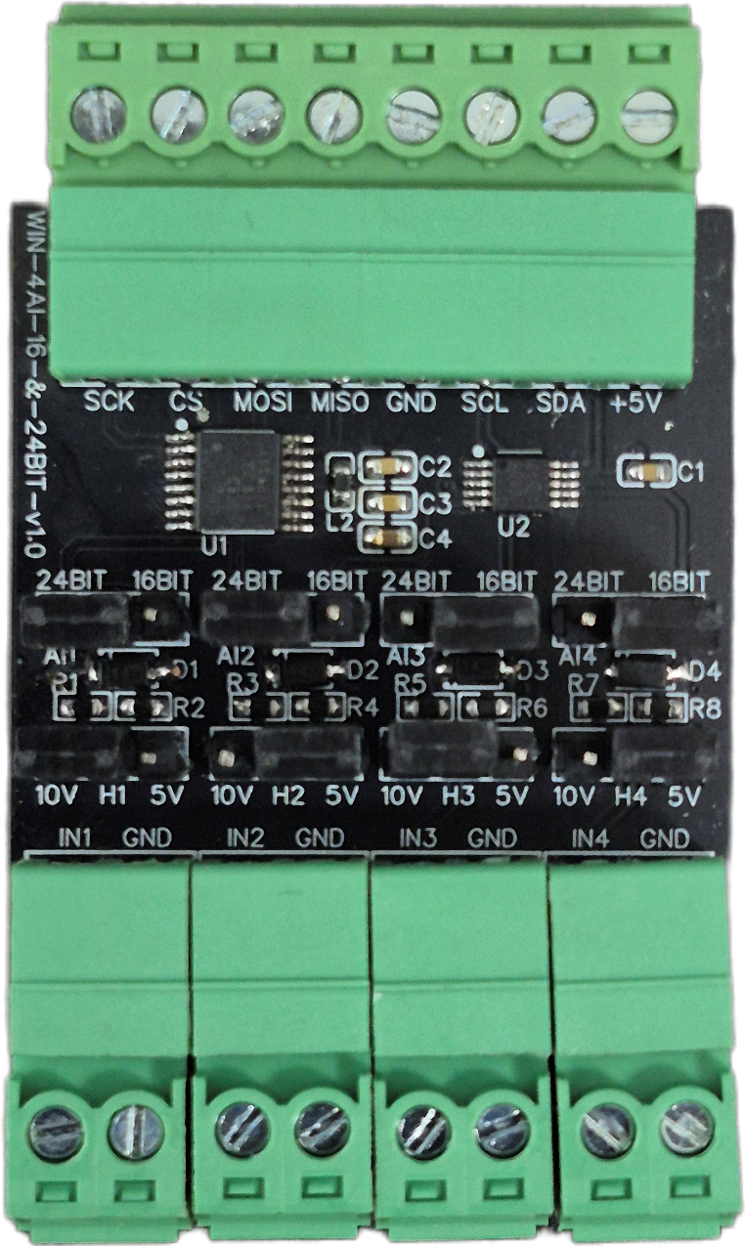
The 4AI Expansion Board is a high-precision analog-to-digital data acquisition module designed for Raspberry Pi, offering configurable input support for 4-20mA, 0-5V, and 0-10V signals. The board ensures versatile measurement capabilities by providing field-selectable 16-bit or 24-bit resolution, allowing developers to seamlessly switch between standard data acquisition and high-precision sensing to suit the requirements of diverse industrial environments.

This board features a versatile signal-handling architecture supporting multiple industrial input standards. Its plug-and-play design provides hardware-level flexibility through dedicated jumper configuration, while maintaining a compact and robust solution for process monitoring, industrial automation, and real-time sensor data logging applications.
Specifications
General :–
Dimensions 61 mm L x 37 mm W
Power Input Power – 5V/3.3 VDC
Operating Temperature 0 – 60° C (32 ~ 140°F)
Storage Temperature -20 - 70° C (-4 ~ 158°F)
Storage Humidity 5 ~ 95 % RH, non – Condensing
Certifications 

4AI Expansion Board Specifications :–
Input Channels 4 Independent Analog Inputs
ADC Resolution Jumper Selectable (16-bit / 24-bit)
Supported Inputs 4-20mA, 0-5V, 0-10V
Communication SPI (SCK, CS, MOSI, MISO) & I2C (SCL, SDA)
Supply Voltage 3.3V/5V DC
Configuration Hardware Jumper-based Input/Range Selection

Diagnostic Note on Floating Pins:
The routing jumpers (AI1-AI4) physically disconnect the analog signal from the unused ADC. If software attempts to read a channel from an ADC that does not currently have the jumper routed to it, the ADC pin will "float" and read ambient room static (often settling randomly near 0.5V or reading raw negative noise). This is normal hardware behavior, and floating values should be ignored by the system controller.


AI Configuration :-
Analog Input (AI) Operation: Each channel provides two terminals: + (Positive) and - (Negative/Common). These are used to read external analog sensor signals.
Channel Configuration (Visual Guide): Each of the four AI channels features two dedicated jumpers to independently set the voltage range and bit resolution. Refer to the color-coded boxes in the board diagram to configure your desired scenario:
- Red Box (10V, 24-bit): Set the voltage jumper to +10V and the resolution jumper to 24-BIT.
- Green Box (5V, 24-bit): Set the voltage jumper to +5V and the resolution jumper to 24-BIT.
- Blue Box (10V, 16-bit): Set the voltage jumper to +10V and the resolution jumper to 16-BIT.
- Yellow Box (5V, 16-bit): Set the voltage jumper to +5V and the resolution jumper to 16-BIT.
Sensor Wiring Connections:
- The analog sensor's positive signal wire should be connected to the + terminal of the desired channel.
- The sensor's common or ground wire should be connected to the corresponding - terminal.
Crucial Setup Recommendation: Always ensure that the voltage jumper setting strictly matches the maximum output range of your connected sensor (either 5V or 10V) to guarantee accurate analog-to-digital conversion and prevent data clipping.

Sample Code & Examples :-
Download the official Arduino example sketch—featuring pre-configured initialization routines for seamlessly reading both 16-bit and 24-bit high-precision analog data—from our repository here:

- WIN-4AI-16-24BIT-v1.0.ino

Hardware Interface & Connector Layout:

GND
+5V
SPI
PINS
I2C
PINS

AI4

AI3

AI2

AI1
16 & 24BIT
Resolution
5 & 10V
Jumper Select

Contact us: -
Augmatic Technologies Pvt. Ltd.,
Plot no 6, Shah Industrial Estate II,
Kotambi,
Vadodara – 391510.
Email – Sales@wittelb.com
Support: support@wittelb.raiseaticket.com / +91 94038 92805

