Q.1] WAP TO FIND LARGEST AMONG 2 NUMBERS
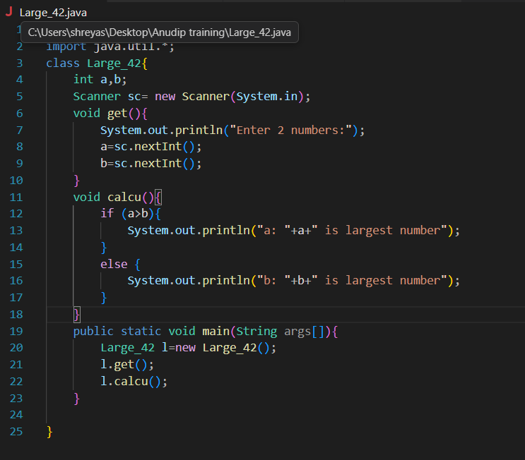

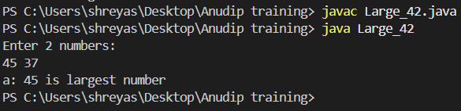

Q.2]WAP A PROGRAM TO CHECK WHETHER A PERSON IS ELIGIBLE TO VOTE OR NOT
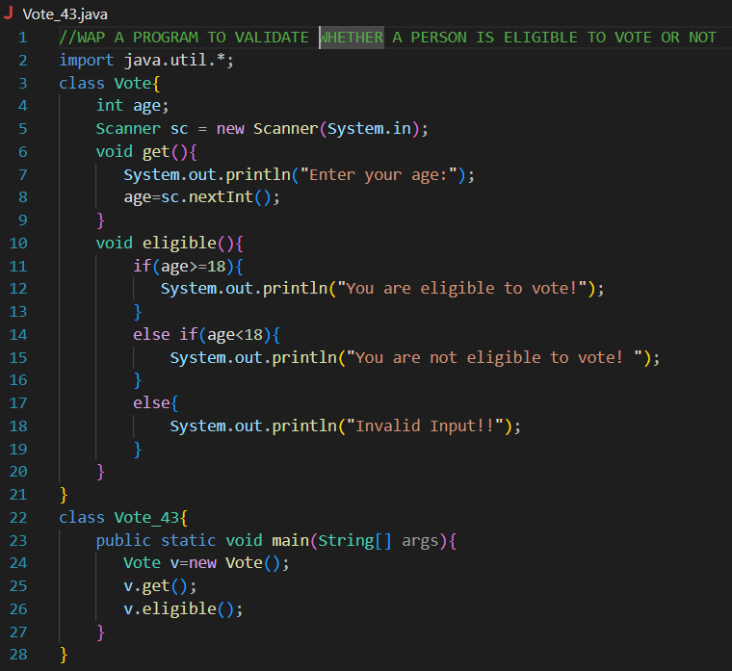

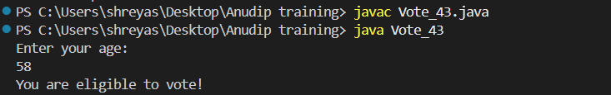

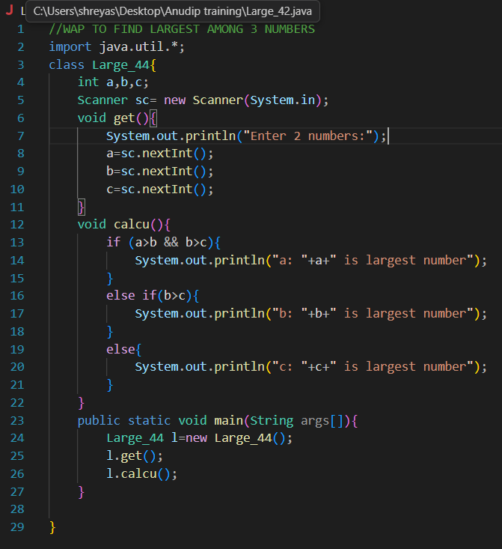
Q.3] WAP TO FIND LARGEST OF 3 NUMBERS

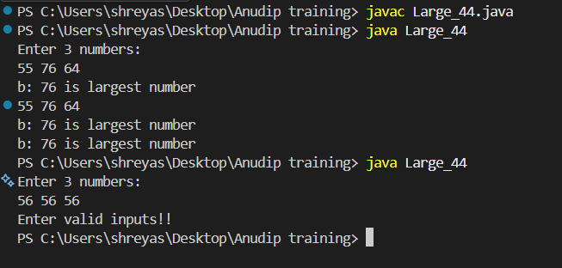

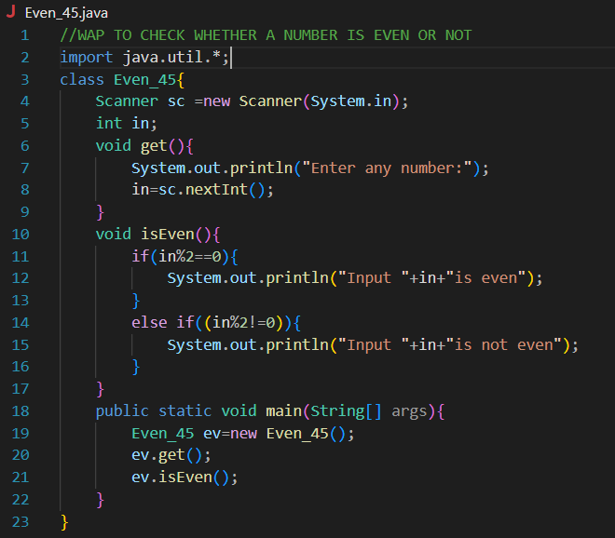
Q.4] WAP TO CHECK WHETHER A NUMBER IS EVEN OR NOT

