Create Table Employee with fields-
Emp_id PRIMARY KEY,
Emp_name(not null),
city(deafault mumbai),
salary (check constraint salary>30000)
Insert atleast 5 records.
Display all records.

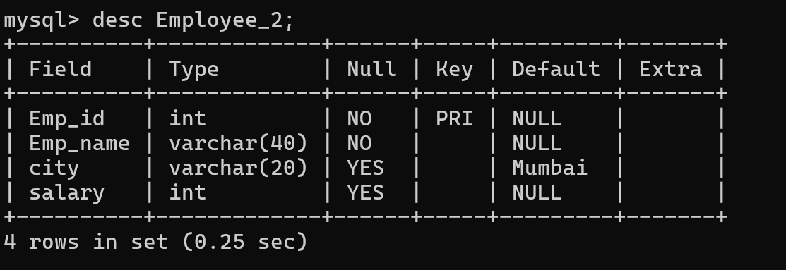
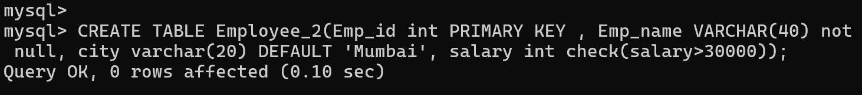

Insert atleast 5 records
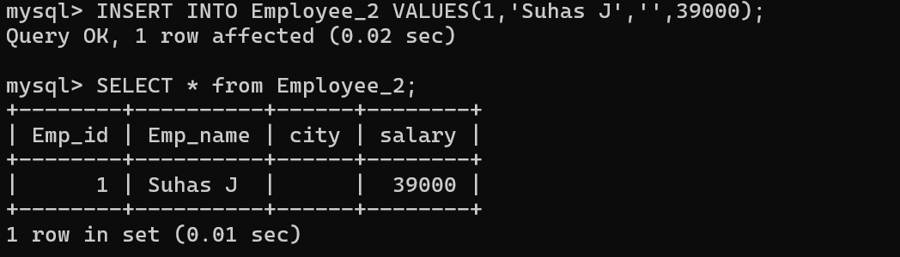

DEFAULT value
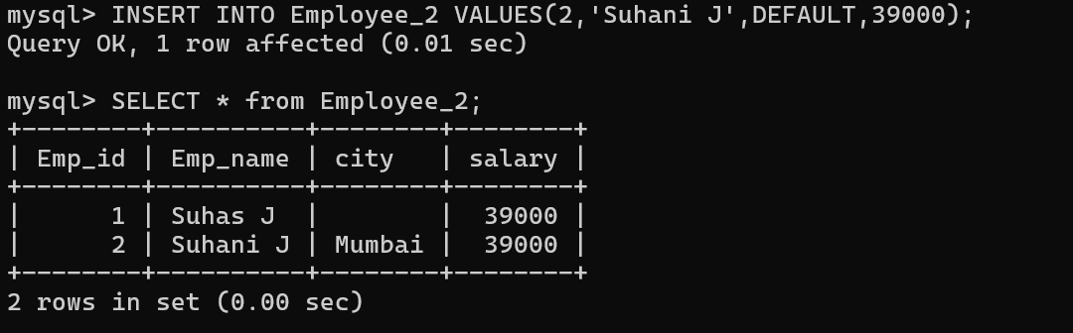
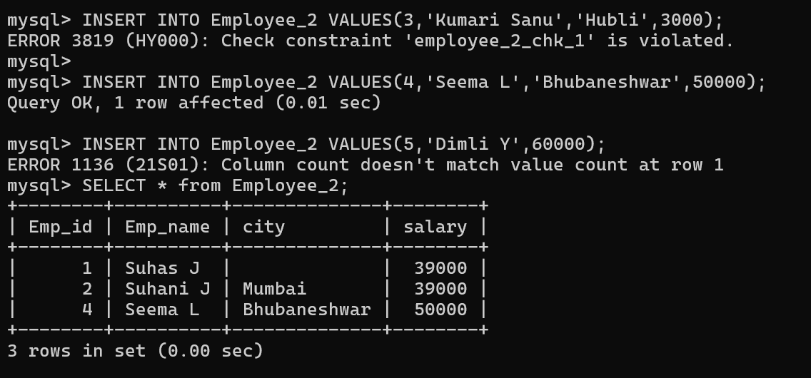
Salary check constraint violated

DISPLAYING ALL RECORDS
