Technical Write-Up
Shreyas · Part 1

Architecture
LangGraph, checkpointedStreamlit UIFastAPIExtractorgemma3:4bValidatorRouterCustomer rules YAMLSQLite checkpointsSQLite: shipments, fields,runsqwen3:8b text-to-SQLRead-only guard
Stages pass typed objects. State is checkpointed after each step, so a crashed run resumes by run ID. Results the UI shows live in separate SQLite tables.

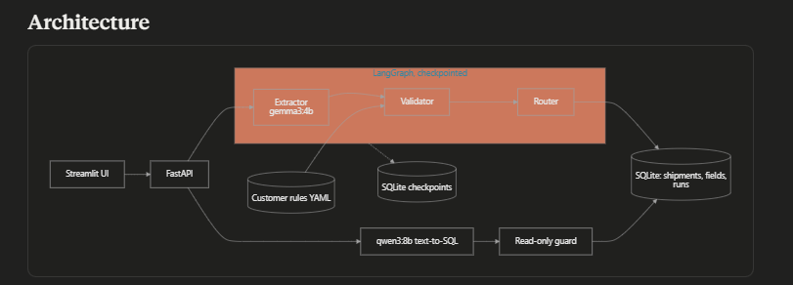

Three failures I hit
- SQL model used a phrase as a value. "How many were auto-approved?" became decision = 'auto-approved', but the stored value is auto_approve. Zero rows, no error. I put the exact enum values and field names in the prompt and added tests. Another query guessed consignee instead of consignee_name and had the same fix.
- Hosted providers failed three ways. Gemini gave 503, then 429 (free quota, limit 20). Groq gave a 403 edge block. Each time the pipeline failed loudly: error stored, nothing approved, earlier output kept. I moved to local Ollama.
- Value with no support in the document. Every value needs a quote found in the text. Otherwise retry once, then null it. Tested with a fixture, not seen live.
Known gap: Tesseract isn't installed, so image-only files fail loudly instead of being checked.
And hwo I solved it was by using local vision supported model using ollama

Observability (50 customers)
One ID follows a document through every step, row, and answer. Runs already store per-agent timing and token counts. For production I'd add a trace ID from the email arriving, plus Langfuse or OpenTelemetry. The dashboard would show volume, decision mix, uncertain fields, human overrides of approvals, failures, p50/p95 latency, and cost per document. Proposed, not built.

Cost
Local inference costs nothing per call. Each run used about 488 input and 461 output tokens. At an assumed $1 and $5 per million tokens (illustration only), that's about $0.003 per document.Cost grows with page count, image size, and the retry. Controls: three-page cap, one retry. I'd add a per-document cost ceiling.

Latency
7.68 s and 6.46 s end to end on the two sample runs. The slowest step is the vision model call; validation and routing are near zero. To speed up: shrink images, send only needed pages, run pages in parallel, cache by file hash(as it was run on RTX 5050 8GB VRAM)

With a week instead of a day
- Real customer-labeled documents (everything so far is synthetic)
- OCR for image-only files, then rerun evals
- Damaged test documents to measure caught rate
- Email trigger and cross-document checks
- Compare a stronger hosted model on the same test set

