CryptoShift Team Playbook
  - Four roles, a 36-hour build plan, technical stack, architecture diagrams, and mentor-ready handoffs
Quant-A-Maze 3.0 | PQC-01 | Verification-Gated Cryptographic Migration Across Banking Applications
This playbook turns the project brief and current workspace notes into an executable team plan. It is written for a four-person student team and a 36-hour hackathon. The goal is to finish one credible end-to-end slice, not four separate prototypes.
Project status note: the conversation log reports a Python 3.12 environment, QpiAI Opt and Quantum packages, CLI commands, local simulations, and a sample six-service schedule. Treat those as reported prior results until each is checked from the current code and sanitized evidence. This guide recommends work organization; it does not assert unverified implementation status.

How to use this playbook
Start with the one-page project model and architecture. Assign one owner to each workstream and agree on the shared data contracts before coding. Follow the time-boxed plan. If time is lost, keep the inventory, deterministic plan, verification record, and truthful report; drop the optional dashboard or quantum experiment first. Every person contributes to integration and rehearsal.

Contents
1. The project in plain language
2. What success means for the challenge
3. Architecture and evidence flow
4. Team roles at a glance
5. Member 1: discovery and dataset
6. Member 2: migration planning and optimization
7. Member 3: protocol verification and rollback
8. Member 4: product integration and demo
9. Technical stack and why each choice fits
10. Shared contracts and integration rules
11. The 36-hour step-by-step plan
12. Definition of done and evidence checklist
13. Team communication and failure handling
14. What to tell the mentor
15. Common mistakes to avoid
16. Sources and implementation references

1. The project in plain language
CryptoShift helps an engineering team prepare for a post-quantum cryptography migration. It examines a bounded set of source, configuration, and dependency files; records where cryptographic behavior may be present; infers what each use is doing; and creates a dependency-aware migration plan. A verification gate checks that a proposed wave has evidence, compatibility checks, observable traces, measured overhead, an accountable approver, and a rollback path.
The core challenge is not “find RSA and replace it.” RSA and elliptic-curve algorithms can appear in key establishment, digital signatures, certificates, or legacy protocol behavior. The correct PQC candidate depends on the operation. ML-KEM is a key-establishment mechanism. ML-DSA and SLH-DSA are signature schemes. A credible inventory records purpose separately from the text clue and labels uncertain cases for human review.
The quantum threat is a reason to plan, not a reason to claim that today’s banking systems can already be broken by practical quantum computers. A future fault-tolerant machine could threaten some widely used public-key mechanisms. Long-lived sensitive information may face “harvest now, decrypt later” risk. The project demonstrates how to move from discovery to a governed migration decision; it does not make a bank quantum-safe.

One-sentence product explanation
“CryptoShift turns cryptographic clues into an evidence-backed inventory, dependency-aware migration waves, and a verification record with rollback criteria, while keeping a human responsible for every security decision.”

2. What success means for the challenge
The challenge asks for a practical migration approach. Treat its deliverables as a single chain. The inventory is the starting evidence. The plan consumes the inventory and dependency data. The before/after traces and compatibility tests show what the plan changes. The rollback record addresses operational risk. Detection metrics quantify how well the discovery rules performed on a labelled sample. Protocol correctness, overhead, and feasibility explain whether the proposed wave is plausible.
Challenge evidence | What the team should show | Primary owner
Cryptographic inventory | Finding with file/service evidence, operation-purpose hypothesis, confidence, and review state. | Member 1
Dependency-aware sequence | A graph and ordered waves; explain one prerequisite and any blocker. | Member 2
Before/after protocol traces | Comparable baseline and candidate traces; mark simulated/mock traces explicitly. | Member 3
Compatibility tests | Expected outcomes for old/new client and server combinations, plus negative behavior. | Member 3
Rollback plan | Known-good configuration, stop trigger, restore action, owner, and re-check. | Member 3
Precision and recall | Labelled-set size and provenance, unit of analysis, TP/FP/FN, calculation, limitations. | Member 1
Correctness and overhead | Correct operation role and observed size/timing method in a named environment. | Member 3
Feasible dependencies | What libraries, peers, service owners, maintenance windows, and approvals are prerequisites. | Member 2

A feature is not complete merely because a file exists. A feature is complete when a teammate can run it, its output is tied to a pinned input, and the demo accurately describes the result. For example, a local QpiAI simulator run does not prove cloud execution or quantum advantage. A mocked trace does not prove a real protocol handshake. Keep those labels visible.

3. Architecture and evidence flow
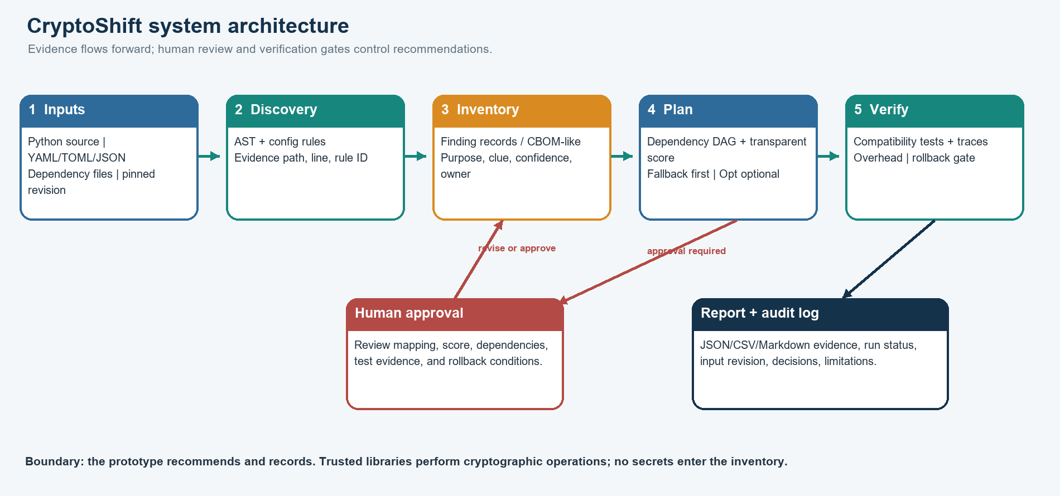
Figure 1. CryptoShift architecture. Evidence flows through discovery, inventory, planning, and verification; a human approval gate controls progression.
The architecture is intentionally layered. The scanner should not also decide security policy. A planner should not silently rewrite source code. A dashboard should not manufacture a “verified” status from a successful scan. Each layer consumes a structured record and emits a structured result that can be reviewed independently.

3.1 What each layer owns
- Input scope records the repository or sample name, pinned commit/revision, supported languages, included directories, exclusions, and scan date.
- Discovery identifies candidate cryptographic use. Python AST rules, configuration parsers, and dependency-file checks produce source evidence; they do not prove runtime use.
- Classification proposes the operation purpose and candidate family, with rationale and confidence. “Unknown” is valid and should create a review task.
- Inventory normalizes evidence into stable finding IDs, links components to dependencies, and preserves provenance.
- Planning uses dependencies, capacity, maintenance windows, risk factors, and verification prerequisites to produce ordered waves. The transparent baseline is always available.
- Verification records expected and observed results, compatibility, traces, timing/size, approval, and rollback status.
- Reporting presents counts and limitations, not stronger claims than the evidence supports.
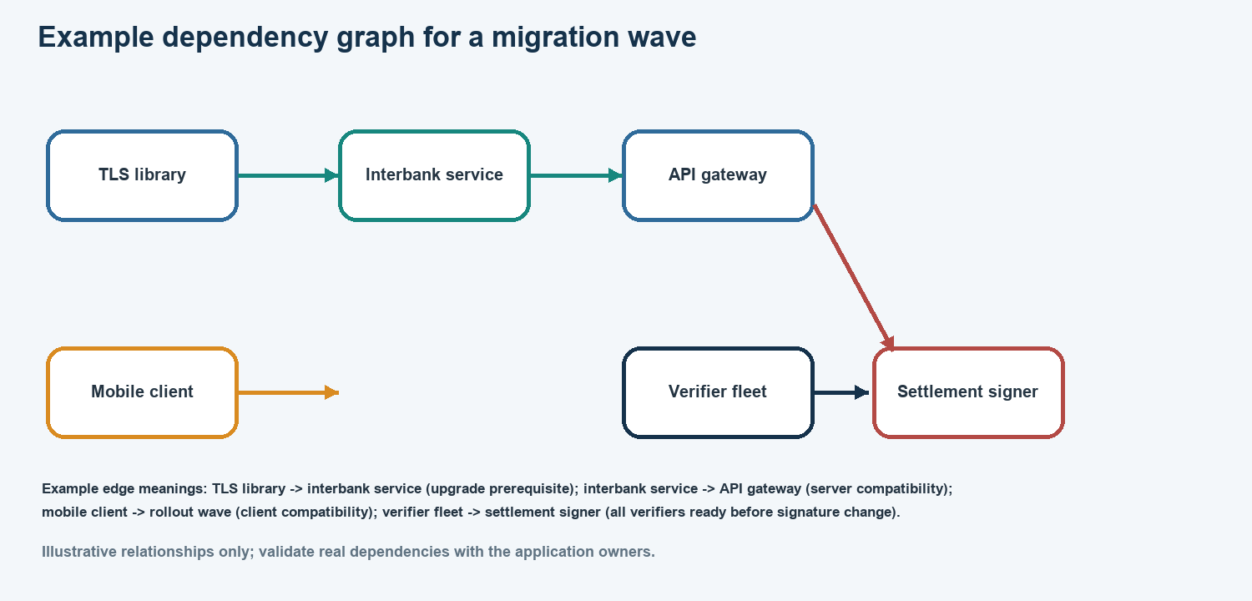
Figure 2. Illustrative dependency graph. These relationships are examples; owners must validate real prerequisites before scheduling a migration.

3.2 Team workstreams
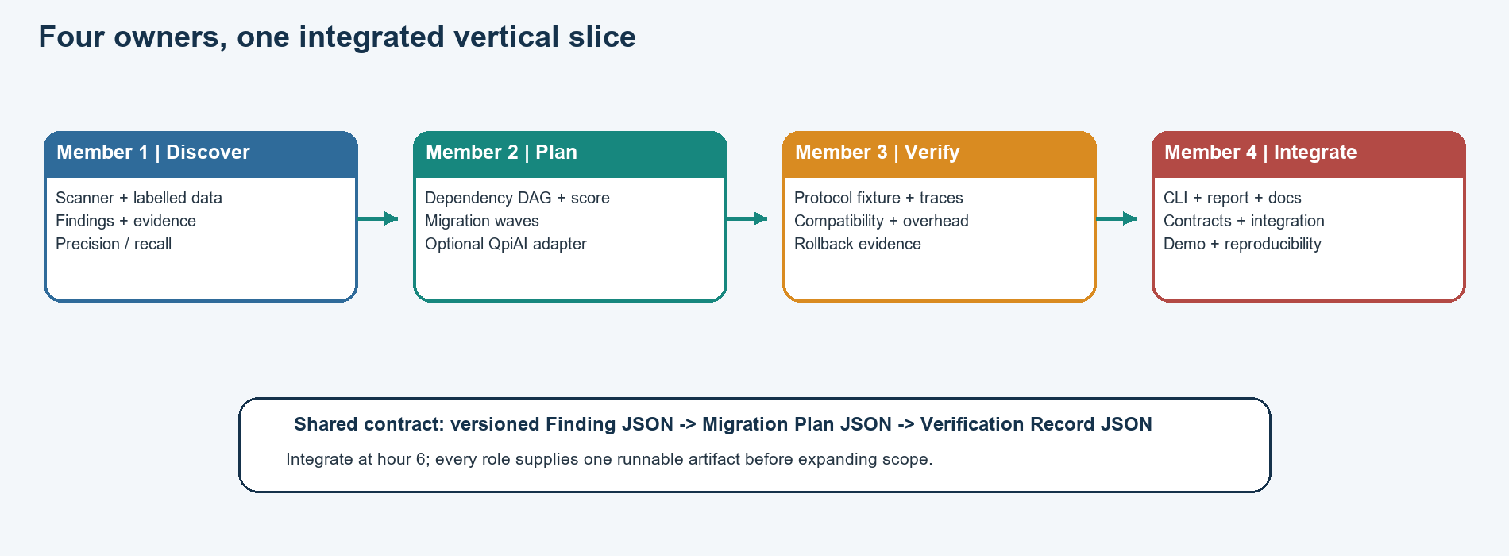
Figure 3. Four owners feed one vertical slice. The shared JSON contracts keep independent work mergeable.
Give each person a clear code and evidence boundary, but define shared interfaces early. Every member should produce one small end-to-end artifact before broadening their assigned component. For example, the scanner begins with one known finding; the planner begins with three dependency-linked tasks; the verifier begins with one baseline and one candidate trace; the integrator begins with a command that runs the skeleton workflow.

4. Team roles at a glance
Member / role | Owns | Must deliver by hour 30 | Core stack
1. Discovery and data lead | Scanner, rule semantics, dataset provenance, labels, detection metrics. | Evidence-linked findings; labelled subset; reproducible TP/FP/FN and precision/recall; false-positive review notes. | Python ast/pathlib/re; config parsers; CSV/JSON; pytest for unit checks.
2. Migration planner | Dependency model, transparent scoring, deterministic scheduler, optional QpiAI Opt comparison. | Dependency graph; valid ordered waves; objective/constraints; baseline schedule; Opt result only if actually run. | Python dataclasses; deterministic graph/topological logic or NetworkX; existing QpiAI Opt adapter optionally.
3. Verification and rollback lead | Protocol fixture/traces, compatibility matrix, correctness, overhead, rollback. | Comparable traces; positive/negative checks; stated measurement method; gate status; actionable rollback record. | Python; trusted crypto/TLS library already supported, or explicitly labelled mock; JSONL/CSV trace logs.
4. Integration and demo lead | CLI, report/dashboard, packaging, documentation, clean run, demo story. | One-command path; stable schema integration; README/runbook; demo checklist; source-controlled evidence without secrets. | Current Python CLI; Markdown/JSON; optional Streamlit only after core path works; Git/GitHub.

How the team should work together
Member 4 is the integration owner, not the only person allowed to integrate. Every member owns their own branch and commits small changes that can be merged quickly. The integration owner maintains the shared schema, calls out incompatibilities early, and keeps the “golden path” runnable. The other members maintain module-level checks and return integrated code by the agreed checkpoints.
The project files in the current workspace already suggest modules for scanning, rules, models, dependencies, scoring, proposals, protocol demo, verification, rollback, metrics, reporting, and QpiAI optimization. Confirm the current call graph before moving files. Keep one canonical implementation. The existing project notes report a root `cryptoshift/` package and thin `src/cryptoshift/optimization/` re-exports; avoid relocating modules during the hackathon unless a broken import makes it necessary.

5. Member 1: discovery and dataset

Mission
Make it easy to see what the scanner found and why. Member 1 is responsible for high-quality evidence, not for maximizing the number of hits. A concise finding linked to a source location, operation hypothesis, and uncertainty is more useful than a large unreviewed list.

Step-by-step tasks
- Agree with the team on the finding record: ID, source revision, path, line/key, evidence type, matched rule, algorithm clue, operation purpose, confidence, component, dependency references, and review status.
- Map the current scanner code. Identify supported file types and existing rule coverage. Keep existing useful behavior; document unsupported languages and dynamic cases.
- Implement or refine Python AST rules for syntax-aware imports and calls. Use narrow context checks for aliasing and assignment where time allows. Use text patterns for configuration and dependency files, but keep each evidence type distinct.
- Normalize path and line information. Do not store source lines that may contain credentials; provide a location and a safe explanatory excerpt only when it contains no secrets.
- Choose a small public-data sample. Pin exact revisions, record licenses and file scope, and avoid uploading private or secret-bearing code to external models.
- Create labels independently from scanner output. Record the unit counted and whether code is active-looking, test/demo, vendored, generated, or unknown. Ask a second teammate to review ambiguous labels.
- Split evaluation by repository/project where possible. Do not randomly split neighboring files from one repository into tuning and holdout sets.
- Calculate TP, FP, FN, precision, and recall. Show raw counts and the denominator. Keep synthetic fixtures outside the real-data score.
- Review the top false positives and false negatives with Member 2 and Member 4; propose only bounded rule changes and keep an evaluation change log.

Technical stack and implementation choices
Use Python 3.12 from the existing project virtual environment. The Python `ast` module exposes a parsed representation of Python syntax and source locations, making it suitable for finding supported Python API patterns. Combine it with `pathlib` for file traversal, `re` for targeted configuration clues, `json`/`csv` for exports, and `tomllib` for TOML on supported Python versions. Add PyYAML only if the project really scans YAML; parse it safely and never evaluate untrusted file content.
Prefer standard-library dataclasses for the compact MVP data model. If schema validation becomes a source of bugs, use a single explicit validator or add Pydantic only after agreeing that the dependency is worth it. Avoid adding a large static-analysis framework within the 36-hour window unless a small experiment proves that it improves the target language coverage.
Use pytest as the development test runner if it is already available or can be added to the development environment. Write small deterministic checks for known positive cases, negative cases, path/line stability, and duplicate suppression. The pytest documentation describes conventional test discovery and readable assertion failures; keep the suite small enough to run repeatedly during integration.

Deliverables and acceptance checks
- `findings.json` or equivalent contains no secret values and every finding has a stable ID and evidence location.
- Supported languages and file types are listed; unsupported files are not presented as scanned.
- A small labelled real-public sample has source URLs/revisions and license notes; synthetic cases are stored separately.
- Every metric can be recomputed from published counts and a documented unit of analysis.
- At least one false positive and one false negative are explained so the mentor sees the limits of static discovery.

Handoff to Member 2
Provide finding IDs, candidate operation purposes, confidence, service/component names, and dependency clues. Do not hand over only a count or a flat list of algorithm names. Mark uncertain mappings explicitly so Member 2 can model an investigation task rather than inventing a migration action.

6. Member 2: migration planning and optimization

Mission
Turn findings and dependency clues into a plan that can be explained. Member 2 owns the sequence and the assumptions. A useful planner says which work goes first, what it depends on, why the order is feasible, and what remains blocked. A solver score without visible constraints or rationale is not a migration plan.

Step-by-step tasks
- Agree on component IDs with Member 1. Model services, clients, libraries, gateways, certificate/trust components, vendor endpoints, and test environments as nodes only when they matter to the sample.
- Create directed edges for prerequisites and compatibility. State the edge meaning in one sentence, such as “the client trust-store parser must support the new certificate before the signer changes.”
- Check that the graph is acyclic or report cycles as real planning blockers. A dependency cycle should not be silently broken to make scheduling work.
- Define a transparent baseline scheduler. Start with a stable topological order, then pack tasks into waves subject to capacity, maintenance-window, and verification-prerequisite limits.
- Use interpretable risk inputs such as exposure, data lifetime, business criticality, dependency centrality, readiness, and uncertainty. Keep risk priority separate from investigation urgency so low-confidence exposure is not buried.
- Write down the objective and every weight. Use normalized factors and explain whether higher scores mean earlier attention, more risk, or greater cost.
- Only after the deterministic planner is reproducible, try the QpiAI Opt adapter on the same small problem. Record whether it is a local solve, its status, objective, schedule, and runtime conditions.
- Compare schedules on the same input and state whether the result matches, differs, or is infeasible. Do not call one superior unless the objective and constraints make the comparison valid.
- Keep QpiAI Quantum/QCloud optional. If the project has a meaningful supported local simulation tied to the same scheduling formulation, describe it as a simulator result. Otherwise mark it not attempted and deliver the fallback.
- Provide a plan object with ordered waves, dependencies, blockers, and human approval state. Member 3 must be able to consume it without depending on an optimization SDK.

Technical stack and implementation choices
Use Python dataclasses or the agreed JSON schema for migration tasks and plans. The first scheduler can be implemented with a deterministic graph traversal and stable tie-breaking. NetworkX is an optional convenience for DAG validation, topological order, and generation layers; its documentation warns that topological sorting is meaningful only for directed acyclic graphs. Keep NetworkX optional if the existing scheduler is already small and clear.
Keep QpiAI packages behind an adapter. The core CLI and plan format must work without credentials or optional packages. Based on the prior project log, the environment reportedly contains `qpiai-opt` and `qpiai-quantum`; treat those versions and authentication outcomes as historical until verified. Local Opt solve, QCloud local simulation, remote platform execution, and physical QPU execution are distinct modes. This hackathon plan uses only local modes unless the team has separate explicit authorization for a remote action.

Example objective and constraint story
For a small instance, define binary assignment x[i,w] indicating whether task i is scheduled in wave w. Require each task to appear in exactly one wave. For every prerequisite edge i -> j, require wave(i) <= wave(j). Enforce maximum services or minutes per wave. If a task requires verification, it cannot be marked complete until Member 3 supplies the gate record. An example objective may minimize weighted completion time plus a stated rollout-change cost. The weights are demonstration assumptions, not a bank policy or a probability of attack.
If converting the problem into a QUBO, document how constraints are penalized, how the penalty is chosen, what variables are encoded, and how the returned bitstring is checked for feasibility. A low energy is not automatically a valid schedule; decode and validate every solution against the original constraints.

Deliverables and acceptance checks
- A diagram or JSON graph shows the dependency relationships and their evidence or assumptions.
- The baseline produces a deterministic schedule for the sample and flags cycles/infeasible capacity.
- Every score factor and weight is visible; no “AI score” obscures the reason for order.
- An Opt/QCloud result is included only if it ran; it is labeled with package version, mode, and input.
- The output keeps the plan feasible and provides a fallback if optional SDKs or credentials are absent.

Handoff to Member 3
Provide the planned waves, expected peer combinations, algorithm role, compatibility assumptions, and an explicit list of checks that must pass before the pilot state. Member 3 returns gate status and evidence references. If verification fails, Member 2 updates the plan as blocked or revised; do not force the task to appear complete.

7. Member 3: protocol verification and rollback

Mission
Prove that the planned change has the expected behavior in a controlled setting and define how the team stops safely. Member 3 owns what was observed, what was not tested, and what rollback means for the fixture. This role does not certify production cryptographic security.

Step-by-step tasks
- Choose one narrow protocol or operation flow that the team can actually exercise. Confirm whether a trusted library or system protocol implementation supports the needed behavior. If not, define a deterministic mock and label it unmistakably.
- Agree with Member 2 on the exact intended role: key establishment versus signature or verification. Never test a signature path as if it were a KEM path.
- Capture a baseline trace with the existing fixture/configuration. Record version, selected parameters, outcome, message or artifact size, and timing method where available.
- Capture the candidate trace under as similar an environment as possible. Include client/server version and whether the peer was legacy or PQC-capable.
- Build a compatibility matrix: old client/old server, new/new, old/new, and new/old. For each pair, state expected success, explicit fallback, or rejection.
- Add negative checks. A modified signed message should not verify. An unsupported peer should fail or follow a deliberate compatibility policy. A downgrade must not happen silently.
- Measure overhead with repeated trials if the implementation permits. Report hardware, library/version, parameter, warm-up, trial count, median and spread; otherwise say “not measured.”
- Write the rollback record before calling a wave ready. Define the known-good version/configuration, trigger, owner, restore steps, and post-rollback check.
- Produce one machine-readable verification record with pass/fail/blocked states. Member 4 uses that record to render the report; never hand off only a screenshot.
- Review the final claims: a passing fixture check demonstrates the named behavior under the named setup, not protocol security in general.

Technical stack and implementation choices
Use Python and a vetted, currently supported library or protocol stack already available to the team. Do not implement ML-KEM, ML-DSA, SLH-DSA, TLS, or cryptographic primitives from scratch for a hackathon. JSON Lines or CSV is sufficient for trace evidence. Keep raw private keys, API credentials, session secrets, and personal banking data out of trace files.
A trace record can contain: `run_id`, `finding_id`, `scenario`, `client_version`, `server_version`, `offered`, `selected`, `result`, `duration_ms`, `message_bytes`, `library`, `environment`, `timestamp`, `mode`, and `notes`. Keep duration units and size units explicit. If the only artifact is a toy trace, call it a model trace in the output and presentation.

Deliverables and acceptance checks
- Baseline and candidate outputs use the same trace schema and comparable setup.
- The compatibility matrix includes both success and failure behavior.
- The report states actual measurements or explicitly says they were not measured.
- The rollback steps can be executed on the disposable fixture and have a clear trigger.
- A failing verification state blocks the migration plan from advancing to pilot.

Handoff to Member 4
Provide the verification JSON, baseline/candidate trace references, matrix, rollback steps, and a one-sentence statement of what each check proves. Include any blocked/failed result and its reason. Member 4 must not remove inconvenient failures from the dashboard or final talk.

8. Member 4: product integration and demo

Mission
Make the project runnable, coherent, and understandable. Member 4 owns the CLI path, report experience, runbook, and demo rehearsal. This person protects integration time and keeps all four roles connected through versioned contracts. The user-facing result can be a CLI and readable report; a web dashboard is optional.

Step-by-step tasks
- Inspect existing CLI behavior and preserve working commands. Add only the minimum command path needed for the vertical slice; do not replace the interface late in the build.
- Define where sample input lives and how the demo selects a pinned revision or synthetic fixture. Label synthetic inputs in both filename and UI/report.
- Wire scanner output to inventory, plan, and verification report through JSON contracts. Add clear errors when optional packages or credentials are missing.
- Create one local command or short sequence that starts from a clean checkout and produces the full evidence pack without manual editing.
- If time allows after the complete CLI works, add a Streamlit dashboard for findings, dependencies, wave schedule, and verification status. Reuse the same JSON output; do not embed project logic only in UI callbacks.
- Create a report that summarizes source scope, supported file types, finding counts, uncertain cases, wave order, verification results, overhead, and rollback. Include exact data provenance and limitations.
- Maintain a setup guide and demo runbook: environment creation, dependency install, command, expected output, credential handling, and failure fallback.
- Integrate branches continuously. Resolve conflicts in a shared session; ask the owning member to explain intended behavior before changing their logic.
- Run a clean-checkout rehearsal by hour 30. Keep a fallback demo path with the deterministic scheduler if QpiAI or network setup is unavailable.
- Capture actual terminal outputs or report artifacts only after review; remove local usernames, absolute paths, secrets, and unrelated environment details before sharing.

Technical stack and implementation choices
Keep the current Python CLI, which the project log reports as `cryptoshift_cli.py` with commands such as `check-auth`, `schedule`, and `demo`; confirm command names against the current CLI before putting them in final instructions. Use Markdown for documentation and JSON/CSV for machine-readable results. Streamlit is a reasonable optional Python dashboard when the core flow is stable; its official documentation supports local installation in a Python environment and a simple first-app workflow. Do not add a backend service, database, React frontend, or deployment cloud unless the existing project genuinely requires it.
For version control, use Git feature branches or short-lived work branches and one integration branch. Keep `.env`, `qcloud.env`, `.venv`, caches, rendered artifacts, and local reports with credentials excluded. Add only non-sensitive reproducible evidence. A private GitHub repository is the safe default for this student project until the team reviews licenses and content for public release.

Deliverables and acceptance checks
- A clean setup path runs without needing a live API key for the baseline demo.
- The CLI/report shows provenance and status labels and does not overstate completion.
- Each table or chart in the UI can be traced to the JSON result and source revision.
- The project can be demoed in five minutes without network access, using the fallback path.
- The final README includes limitations, scope, setup, commands, and source/license attribution.

9. Technical stack and why each choice fits
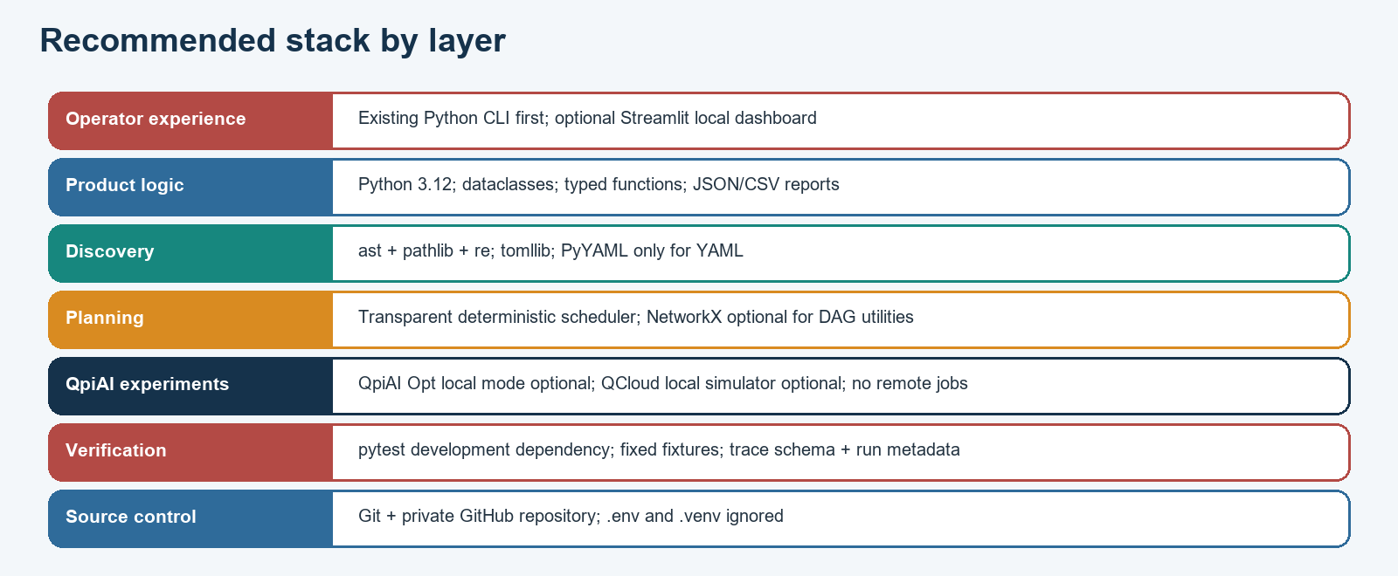
Figure 4. Recommended stack by layer. Keep the deterministic Python path central; optional tools must not block it.
Layer | Recommended choice | Use it for | Avoid during this hackathon
Language/runtime | Existing Python 3.12 virtual environment | Reuse the current modules and team knowledge. | Global package installs or major framework rewrites.
Static scanning | `ast`, `pathlib`, `re`; parse only supported formats | Python AST for source syntax; regex for targeted config clues; explicit file traversal. | Treating a text match as proof of live runtime use.
Configuration | `tomllib`; PyYAML only if YAML is in scope | Parse dependency/config metadata with clear evidence paths. | Loading executable or untrusted serialized objects.
Data model | Dataclasses + JSON/CSV | Small, reviewable finding/plan/trace records. | Multiple incompatible schemas or heavy database.
Dependency planning | Deterministic scheduler; optional NetworkX | Cycle detection, topological order, stable wave packing. | Optimization without feasibility validation.
QpiAI experiments | Existing Opt adapter local mode; local simulator only if useful | Compare optimization on the same small scheduling input. | Platform submission, paid task, QPU, or quantum-advantage claims.
UI/report | CLI + Markdown/JSON; optional Streamlit | Reliable demo first, dashboard only if spare time. | Dashboard-only business logic or cloud deployment.
Verification | pytest dev dependency + fixtures | Repeatable scanner, planner, CLI, and trace behavior checks. | Only manual screenshots without machine-readable evidence.
Version control | Git, private GitHub by default | Shared branches, review, tagged evidence. | Committing `.env`, virtualenv, caches, or unlicensed corpora.

9.1 Core install versus optional extras
Keep core dependencies small so the fallback works on a clean laptop. The standard-library scanner and scheduler should not import QpiAI packages at module import time. Load optional adapters only when the corresponding command is selected. Separate development requirements such as pytest from core runtime packages. If a dashboard is not built, do not install Streamlit merely because it is recommended here.

9.2 Data flow versus tool branding
Select tools because they support a specific step. Python AST supports source discovery. A graph utility supports dependency reasoning. pytest supports repeatable checks. QpiAI Opt can evaluate a defined local scheduling model if its current API and account setup permit. QpiAI Quantum’s local simulator can support a bounded experiment if it is genuinely tied to the same task. None of those tools automatically proves correct migration or security.

9.3 Secret and data handling
- Keep all API keys in ignored local configuration or an approved secret store; never paste them into code, docs, screenshots, or chat.
- Rotate any key that has appeared in a conversation or committed file; ignore the old value entirely.
- Use public source repositories only within license permissions; cite pinned revisions and do not upload code to external LLMs without authorization.
- Run secret scanning on staged files before every commit. Inspect filenames and checks, not key values.
- Keep demo records synthetic and explicitly labelled; do not use real account, card, transaction, or customer data.

10. Shared contracts and integration rules
The fastest way to lose hackathon time is to discover at hour 20 that everyone used different names for a service, finding, confidence, and status. Define the contracts in the first two hours. Keep them small. Store example JSON fixtures in version control and let each owner implement against those fixtures.

10.1 Finding record
A minimal finding record should include: `schema_version`, `finding_id`, `source_id`, `revision`, `path`, `line_start`, `line_end`, `evidence_kind`, `rule_id`, `algorithm_clue`, `operation_purpose`, `confidence`, `rationale`, `component_id`, `dependency_ids`, `review_status`, and `secret_redacted`. Use `unknown` where evidence is insufficient. Confidence should be a documented category or numeric scale with an explanation; do not invent precision that the rule cannot support.

10.2 Migration plan record
A plan record should include: `plan_id`, `input_revision`, `finding_ids`, `dependency_edges`, `score_model`, `score_weights`, `waves`, `capacity_constraints`, `blocked_items`, `solver_name`, `solver_version`, `execution_mode`, `status`, and `assumptions`. A deterministic result should be reproducible from the same input. If QpiAI did not run, say `fallback` or `not_attempted`; do not leave solver fields ambiguous.

10.3 Verification record
A verification record should include: `run_id`, `finding_id`, `plan_id`, `scenario`, `expected`, `observed`, `result`, `trace_path`, `library`, `version`, `environment`, `message_bytes`, `duration_ms`, `rollback_trigger`, `rollback_steps`, `approver_role`, and `notes`. Never include credentials or raw secrets. If a value was not measured, use `null` plus a note instead of zero.

10.4 Definition of ready for integration
- Every module imports without requiring optional credentials at import time.
- Inputs and outputs follow the current schema or the owner has proposed a versioned change.
- A tiny local example produces machine-readable output.
- The owner can explain one expected failure and how it appears in the output.
- The change includes a short README note or docstring where the interface would otherwise be unclear.

10.5 Branch and merge rhythm
Use small branches named for the work, such as `inventory-evidence`, `wave-planner`, `trace-gate`, or `demo-report`. Merge an early skeleton by hour 6, not a large feature late in the build. Rebase only when the team understands what history changes. Avoid force pushes on a shared branch. Keep the main branch runnable; merge a feature only when the end-to-end path still starts.

11. The 36-hour step-by-step plan
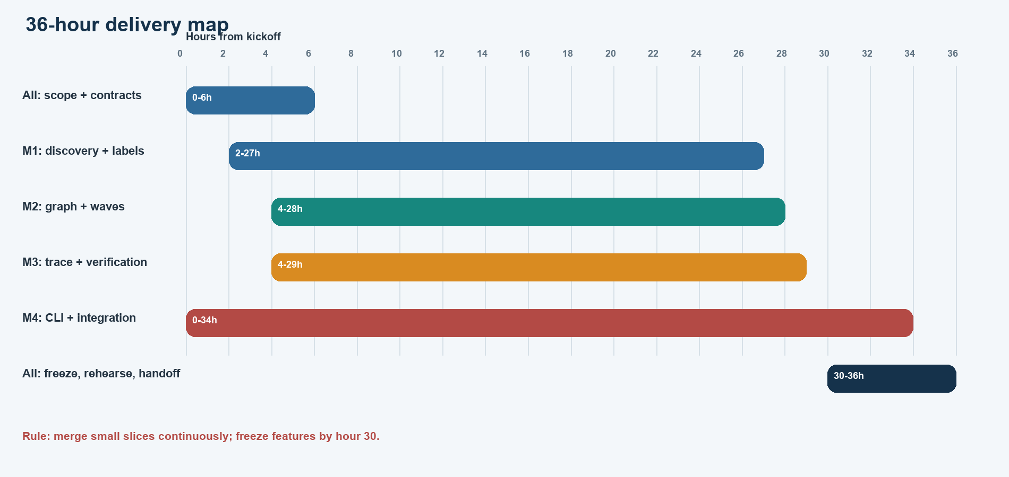
Figure 5. Work overlaps deliberately. The integration owner starts immediately, while domain owners produce narrow vertical slices and evidence.

Hour 0-2: agree the mission
Read the exact challenge rubric together. Agree on a one-sentence product statement, a single demo dataset, one target language/config scope, and a measurable definition of success. Confirm all four names and owners. Assign a notetaker who records decisions and unresolved assumptions. Create a shared branch plan and the three JSON contracts. Do not spend these hours installing optional tools or designing a perfect dashboard.

Hour 2-6: build the skeleton
Member 1 scans a fixture and returns one finding with source evidence. Member 2 consumes a three-node dependency graph and returns a valid order. Member 3 creates one baseline/candidate trace pair or a labelled mock pair. Member 4 wires one CLI command to call the modules and writes a short quickstart. Integrate at hour 6. If a module is still only a design slide, reduce its scope until it runs.

Hour 6-12: make the vertical slice real
Expand scanner coverage only for known file types and call patterns. Add source pinning and the first labels. Validate graph cycles and capacity. Add the first verification failure case and rollback trigger. Member 4 turns the command output into a readable report. Stop adding fields if they do not support a deliverable or a reviewer decision.

Hour 12-18: connect the four outputs
Run the full workflow on the same selected input. Fix schema mismatch before feature additions. Add a second service dependency and one config finding. Add the compatibility matrix. Measure one honest overhead dimension if the chosen implementation can do it. Record package versions and execution mode. At hour 18, the team should be able to show the main demo path even if its presentation is rough.

Hour 18-24: evaluate and challenge assumptions
Member 1 reviews false positives and false negatives with another teammate and freezes the evaluation split. Member 2 compares the baseline schedule with QpiAI Opt only if setup works in local mode; otherwise document the fallback. Member 3 tests invalid/unsupported behavior and checks trace comparability. Member 4 produces an interim report and rehearses the demo once. Ask: “What evidence would make us change this recommendation?”

Hour 24-30: freeze scope and prepare proof
Freeze features by hour 30. Capture actual outputs from a clean run. Recompute metrics and verify counts. Check that no secret, raw key, private path, or unlicensed data is present. Replace unsupported claims with “not measured” or “not implemented.” Prepare one slide or screen for architecture, one for evidence, one for schedule, one for verification, and one for limits.

Hour 30-34: rehearse and repair
Run the demo from a clean checkout or separate environment. A teammate who did not write the main command follows the runbook. Repair only defects that block correctness or clarity. Prepare a deterministic fallback path if login, network, QpiAI, or a UI component fails. Keep the recorded successful output as evidence, but do not pretend it occurred live if the demo uses cached output.

Hour 34-36: present and hand off
Assign speaking sections: Member 4 introduces the user journey, Member 1 explains evidence and evaluation, Member 2 explains dependencies and wave ordering, Member 3 explains tests and rollback. Rehearse handoffs and likely questions. End with what is implemented, what is measured, what remains blocked, and the next concrete step for production-quality discovery.

Time-box summary
Checkpoint | Expected state | Stop condition
Hour 2 | Scope, contracts, roles, dataset candidate selected. | No coding until IDs and interfaces are agreed.
Hour 6 | A tiny runnable flow exists across all four workstreams. | If not, cut to one finding / one plan / one test.
Hour 18 | Integrated workflow runs on the same input. | No isolated feature expansion until integration works.
Hour 24 | Metrics and verification evidence have actual counts/results. | Mark incomplete evidence clearly.
Hour 30 | Feature freeze; only correctness/demo fixes remain. | No new optional SDK, UI, or dataset source.
Hour 36 | Rehearsed, reproducible demo and honest handoff. | Use fallback if external services fail.

12. Definition of done and evidence checklist
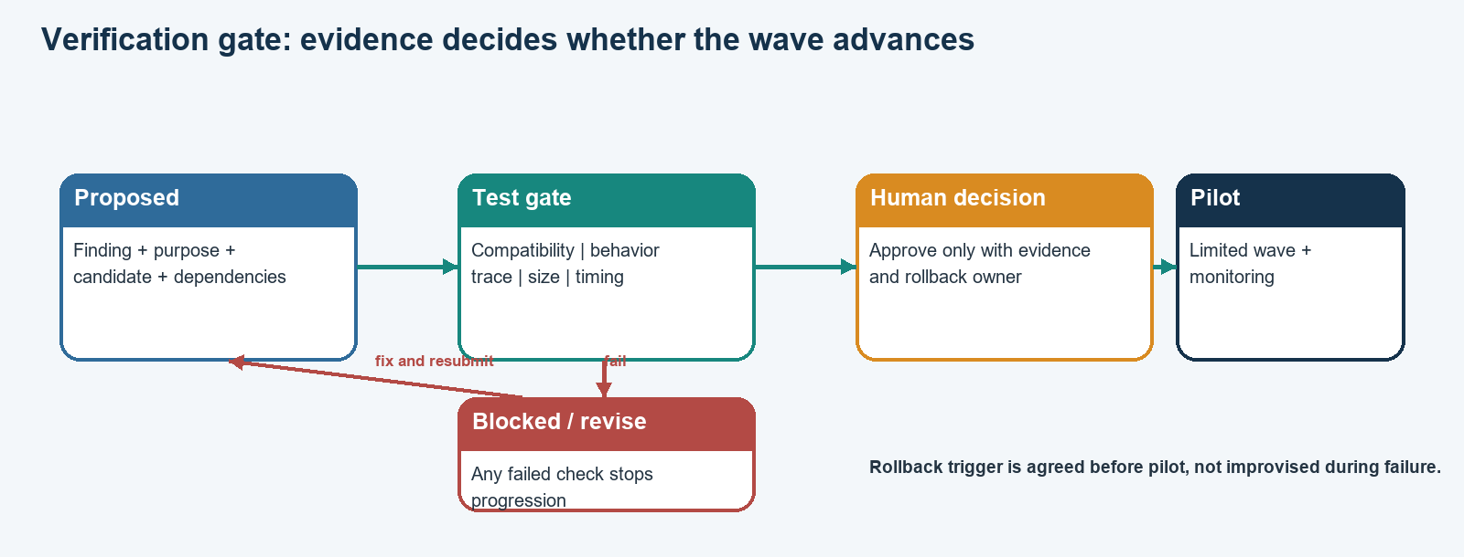
Figure 6. A failed check routes the change back for revision; pilot approval needs evidence and an owner.

12.1 Product done
- A beginner can create the project environment and run the local baseline using the README.
- The CLI can scan the agreed sample and produce findings with path/line/config-key evidence.
- Every finding distinguishes an algorithm clue from an operation-purpose hypothesis.
- The migration planner emits a dependency-feasible ordered schedule and shows its assumptions.
- A verification gate consumes plan and trace evidence; a failure blocks pilot status.
- A rollback record contains a trigger, steps, owner, and post-restore check.
- Synthetic data and mock traces are identified wherever they appear.
- The dashboard, if any, can be skipped without breaking the core demo.

12.2 Evaluation done
- Data provenance: URL, pinned revision, license, collection date, file scope, excluded paths.
- Labels: schema, unit of analysis, annotation process, disagreement resolution, and uncertain class.
- Metrics: raw TP/FP/FN counts; precision and recall formulas; deduplication/matching rule.
- Leakage control: split by repository/project where feasible; state when sample size is too small.
- Overhead: named environment, library/version, repeated trials when possible, measured dimensions, and limitations.
- Protocol evidence: baseline/candidate traces or an explicit “mock” label and exact behavior tested.

12.3 Presentation done
- The first sentence states the operational problem and intended user.
- The architecture slide uses the same component names as the code and docs.
- The team can explain why ML-KEM and signature standards serve different jobs.
- A live or recorded demo shows evidence, schedule, gate behavior, and rollback.
- The final slide lists implemented, run successfully, fallback, blocked, and not attempted status separately.
- No unsupported “quantum advantage,” “production-ready,” “100% coverage,” or “bank is quantum-safe” claims.

13. Team communication and failure handling

13.1 Daily stand-up during the hackathon
Every two to three hours, spend five minutes answering four prompts: What artifact is now runnable? What interface changed? What is blocked? What is the next smallest deliverable? Do not report only effort or hours. Point to a commit, file, command, graph, label sheet, trace, or report.

13.2 Integration rules
- All branch changes are small and committed; one person reviews the output contract before merge.
- When a module fails, keep the deterministic fallback path working and mark the optional component blocked.
- No new data source is added after hour 24 unless it fixes a material evaluation gap and the labels can be completed.
- No one copies API keys into source, prompts, screenshots, issue comments, or documentation.
- A disagreement about a security mapping defaults to “unknown / needs review” until evidence resolves it.
- The team records decisions with date/time, chosen option, rejected assumption, and owner.

13.3 Failure matrix
Failure | Response | Demo message
QpiAI key missing or auth unavailable | Run the deterministic local scheduler; leave key status as missing/blocked. | “Optional solver did not run; this schedule is from the baseline.”
QCloud local example fails | Skip it and retain the optimizer comparison only if it ran. | “No QCloud result is claimed; the core migration plan is unaffected.”
Dataset is too small for stable metrics | Report counts and call the evaluation a pilot. | “This sample measures rule behavior, not production-wide recall.”
Trace implementation cannot support PQC | Use a clearly marked model trace or focus on scanner/planner proof. | “This trace demonstrates workflow shape; it is not a live PQC handshake.”
Dependency graph contains a cycle | Report the cycle and block scheduling until a human resolves it. | “The plan is infeasible under these stated prerequisites.”
Dashboard fails | Use CLI output and saved local report. | “The core workflow is the CLI; the UI is optional.”

14. What to tell the mentor

14.1 A two-minute team explanation
“Banks use public-key cryptography for secure connections, certificates, and digital signatures. A future sufficiently capable quantum computer could threaten some current public-key systems, so organizations need a long migration runway. The difficult part is discovering where cryptography is used across code, config, libraries, certificates, services, and vendor dependencies, then changing it without breaking peers or losing a rollback path.
“CryptoShift is a Python-first decision-support prototype. We scan a bounded, pinned scope and attach evidence to each finding. We keep algorithm clues separate from purpose: ML-KEM is for key establishment, while ML-DSA and SLH-DSA are signature standards. We turn findings into a dependency-aware schedule, then use a verification gate for compatibility, protocol behavior, overhead, human approval, and rollback.
“We evaluate detection against a labelled sample and show counts, precision, recall, and limitations. Our data and traces are clearly labelled as public, synthetic, real implementation, or mocked. The tool does not claim complete bank-wide discovery or production security. Optional QpiAI tools only support a bounded scheduling experiment; our deterministic planner is the fallback.”

14.2 Who presents what
Speaker | Talk track | Proof artifact
Member 4 opens | User problem, workflow, and what is in scope. | CLI/demo landing page and architecture diagram.
Member 1 | How findings are supported by evidence and how the dataset was labelled. | Finding detail and metric counts.
Member 2 | Why tasks are ordered in waves and how dependencies constrain timing. | Dependency graph and schedule comparison.
Member 3 | How compatibility and correctness are checked and how rollback works. | Before/after traces, negative test, gate record.
Member 4 closes | Implemented status, limitations, next deployment steps. | Reproducible report and README.

14.3 Questions to be ready for
Mentor question | Strong answer shape
How complete is discovery? | Name supported file types and sample size; identify native, dynamic, vendor, and runtime gaps.
Why these replacements? | Explain operation role, not just the legacy algorithm name; show standards references and peer support assumptions.
How are labels independent? | Describe annotation process, repository-level split, ambiguity handling, and actual TP/FP/FN.
What did QpiAI do? | State exact adapter, package version if verified, local mode, same problem input, solver status, and no quantum advantage claim.
What did you measure? | Name environment, method, repetitions, metric, and limitations; say “not measured” when appropriate.
What happens when rollout fails? | Show pre-agreed gate failure, stop trigger, rollback steps, owner, and re-verification.
Can this be used in a real bank today? | No; it is a prototype. A production program requires broad discovery, expert review, interoperability, compliance, secure key management, and operational rollout controls.

15. Common mistakes to avoid
- Starting with QCloud circuits before the deterministic scheduling problem is defined.
- Scanning only for “RSA” and treating every hit as a KEM migration.
- Claiming 100% detection from a tiny sample or using paper scores as project results.
- Mixing synthetic fixtures with real-data evaluation without disclosure.
- Putting the whole workflow in a dashboard before the CLI and data contracts work.
- Treating a low objective value as proof of a valid schedule without checking constraints.
- Calling a local simulator a QPU result or implying that PQC requires quantum hardware.
- Showing credentials, absolute local paths, raw source secrets, or user-specific logs in screenshots.
- Writing a rollback section after the demo instead of using rollback as a gate condition.
- Letting the final presentation say more than the code and evidence demonstrate.

16. Sources and implementation references
Use primary standards and official project documentation when deciding implementation details. The recommendations below describe tool fit; verify current versions and APIs at implementation time.
- NIST FIPS 203: ML-KEM: https://csrc.nist.gov/pubs/fips/203/final - Key-encapsulation mechanism standard.
- NIST FIPS 204: ML-DSA: https://csrc.nist.gov/pubs/fips/204/final - Module-lattice digital signature standard.
- NIST FIPS 205: SLH-DSA: https://csrc.nist.gov/pubs/fips/205/final - Stateless hash-based signature standard.
- NIST NCCoE migration to PQC: https://www.nccoe.nist.gov/applied-cryptography/migration-to-pqc - Discovery, interoperability, and migration project materials.
- Python ast module: https://docs.python.org/3.11/library/ast.html - Python source syntax tree reference.
- pytest getting started: https://docs.pytest.org/en/stable/getting-started.html - Test discovery and basic assertion workflow.
- NetworkX DAG algorithms: https://networkx.org/documentation/stable/reference/algorithms/dag.html - Cycle and topological-order utilities.
- Streamlit installation: https://docs.streamlit.io/get-started/installation - Optional local Python dashboard setup.
- QpiAI Opt SDK: https://github.com/qpiai/qpiai-opt - Use the current official API and local mode instructions.
- QpiAI Quantum SDK: https://github.com/qpiai/quantum-sdk - Use the current official SDK and simulator guidance.
- QpiAI QCloud docs: https://docs.qcloud.qpiai.tech/ - Authentication and current platform documentation.

Final guidance
The team succeeds when four people produce one coherent chain of evidence. Begin with a narrow scope, define the record formats, and integrate early. Keep the deterministic path usable. Make uncertainty visible. Verify the operation that the system actually performs. Report only measured results. A careful, reproducible migration-planning prototype is a stronger mentor demonstration than a larger collection of disconnected features.

