CryptoShift Team Roles and Architecture
  - A practical four-person work plan for the PQC-01 MVP
Quant-A-Maze 3.0 | Verification-Gated Cryptographic Migration Across Banking Applications
This guide assigns one documentation, dataset, and Bloq-tools lead, two product developers, and one full-stack developer. It defines the deliverables, handoffs, architecture, and a 36-hour build rhythm for a single runnable prototype. The current repository already contains Python scanning, planning, verification, reporting, and optimization modules; this plan extends and integrates that work instead of requiring a disruptive rewrite.
Use this as the current team assignment. Keep the deterministic local product path as the MVP. Treat Bloq as a separate optional experiment and never make the core application depend on it.

Project outcome and scope
CryptoShift should let a user inspect a selected demo repository, review evidence-backed cryptographic findings, understand dependencies, view a migration sequence, check verification status, inspect rollback conditions, and export a traceable report. It is a local decision-support prototype, not a production bank migration system or a cryptographic certification tool.
- Static matches are candidate evidence, not proof of runtime use.
- Only report measured metrics from actual runs; label synthetic fixtures, modeled traces, simulators, and unrun integrations clearly.
- ML-KEM serves key establishment. ML-DSA and SLH-DSA serve digital signatures. Make mappings depend on evidence and operation purpose.
- Use supported cryptographic libraries and protocol fixtures; never implement cryptographic primitives from scratch.

Team at a glance
Member | Ownership | Primary output | Core tools
1. Documentation, datasets, and Bloq tools | Documentation, data provenance/labels, evaluation evidence, optional Bloq experiment records. | Accurate runbook and evidence pack; sourced and labelled data; truthful demo and limitation notes. | Markdown, CSV/JSON, GitHub Issues, Mermaid/diagrams.net, Bloq notebook only for approved synthetic data.
2. Discovery and inventory developer | Scanner rules, finding schema use, inventory evidence, scanner tests. | Evidence-linked findings, stable inventory output, positive/negative scanner tests. | Existing Python package, ast/pathlib, config parsers as needed, JSON/CSV, pytest.
3. Planning and verification developer | Dependencies, migration waves, compatibility checks, gate states, rollback records. | Explainable plan and machine-readable verification record; tests for blockers and failures. | Python, existing scheduler/optimization modules, deterministic graph logic, pytest, JSON/JSONL.
4. Full-stack application developer | Local UI, orchestration, report presentation/export, integration path. | One local user journey from input selection through report download. | Existing Python stack; Streamlit if no working UI exists; Git; JSON/CSV/Markdown exports.

Current project context
The README describes an existing Python-first prototype with `src/cryptoshift/` modules for scanning, rules, models, dependencies, scoring, proposals, verification, protocol demos, rollback, metrics, reporting, and `optimization/`. It also describes a synthetic demo bank app, labelled evaluation fixtures, QpiAI optimization experiments, and reports. Confirm current behavior before presenting it; repository notes are not a substitute for rerunning a command.
The repository now has newly prepared folders such as `src/cryptoshift/ui/`, `planning/`, and `verification/`, while established modules are still flat files such as `scanner.py` and `verification.py`. Do not move working modules into the new folders during the hackathon unless imports are deliberately migrated and the full test path stays green. Treat the existing source paths as canonical until the team explicitly decides otherwise.

Architecture and information flow
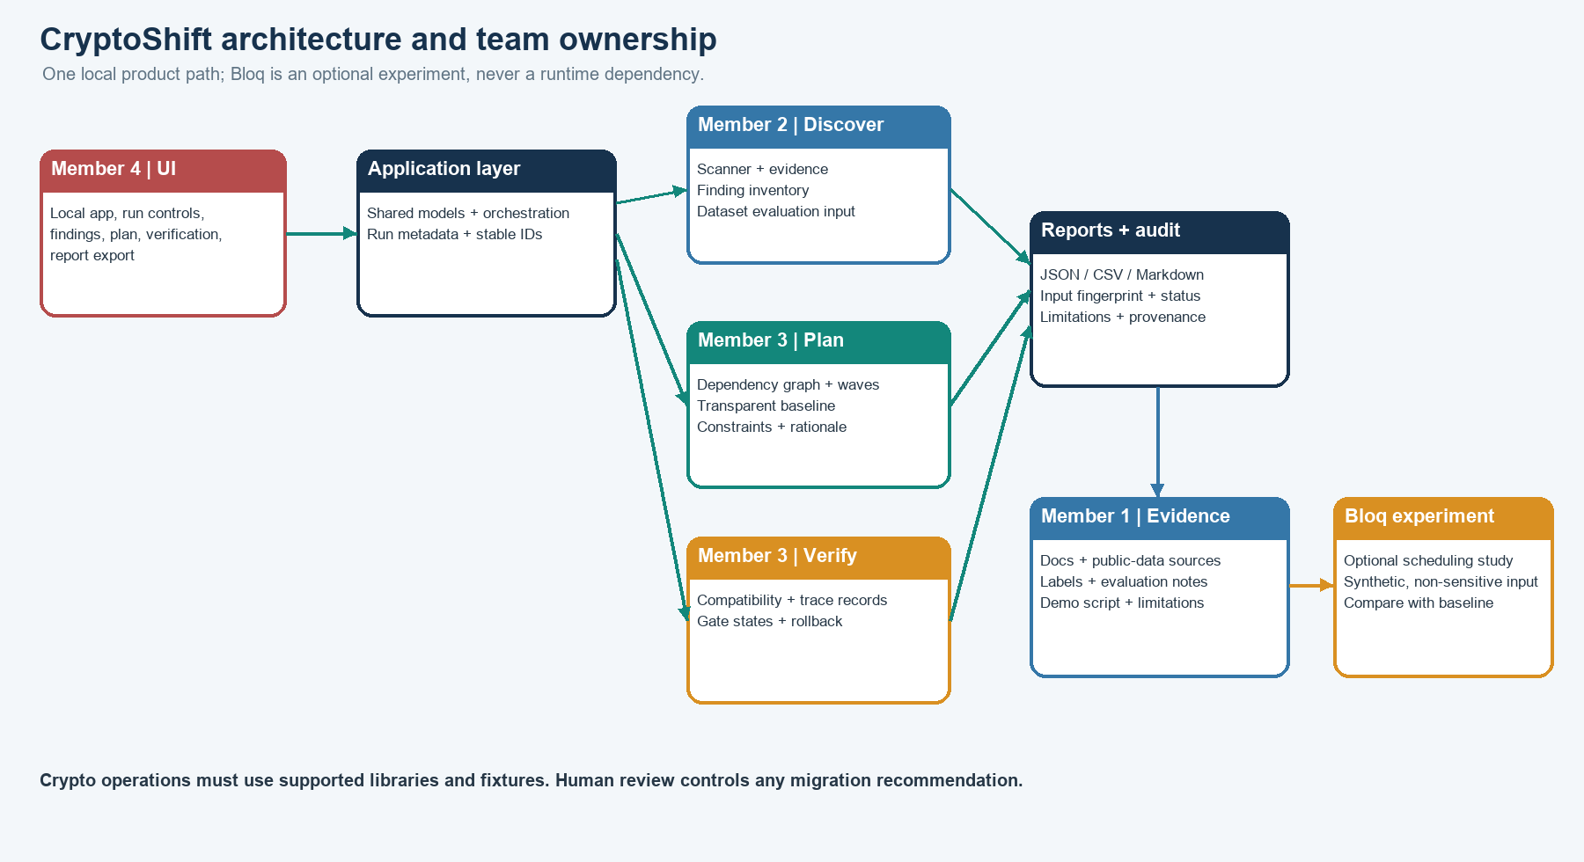
Figure 1. The local application uses shared run records and a human-controlled verification gate. The optional Bloq experiment is outside the runtime path.

End-to-end user workflow
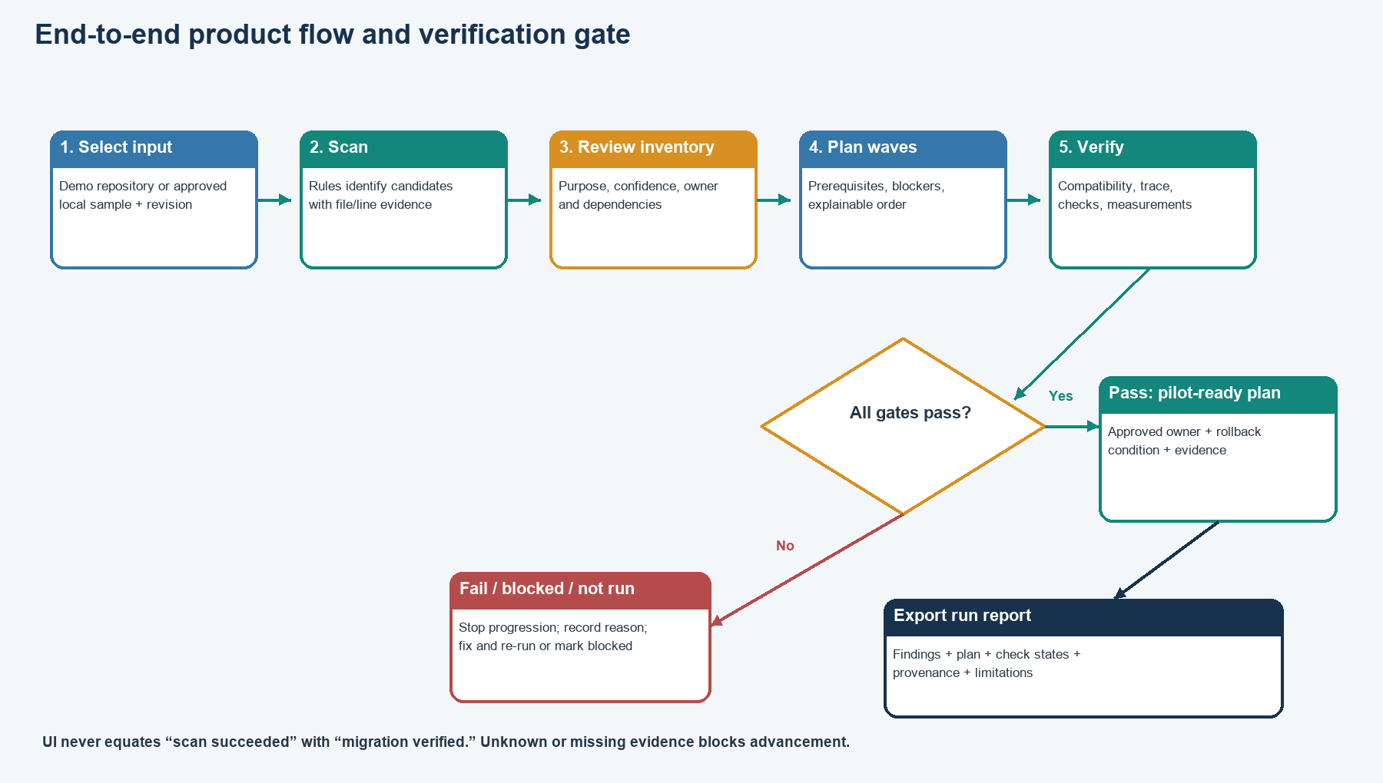
Figure 2. A failed or missing check stops advancement. A scan alone never marks a migration verified.

Shared interfaces and handoffs
Record | Required content | Producer → consumer
Run metadata | Run ID, timestamp, input path/revision or fingerprint, tool version, scope, exclusions. | Member 4 creates context; all modules attach it; Member 1 documents reproducibility.
Finding | Stable ID, file/line or config key, evidence, rule, algorithm clue, operation-purpose hypothesis, confidence, component, review state. | Member 2 → Member 3 and Member 4; Member 1 verifies labeling/provenance.
Plan | Components, dependencies and evidence, ordered waves, constraints, blockers, rationale, baseline/optional experiment metadata. | Member 3 → Member 4 and Member 1.
Verification record | Check ID, expected/observed result, pass/fail/blocked/not-run, trace reference, method, timestamp, rollback trigger/owner. | Member 3 → Member 4 and Member 1.
Report | Run metadata, findings, plan, verification, data provenance, measured results, limitations. | Member 4 renders; Member 1 reviews claim accuracy.

Member 1 Documentation, datasets, and Bloq tools

Mission
Maintain the single source of truth about how to install, run, evaluate, and present the product. Curate data and evidence; do not promise capabilities that have not been demonstrated.

Step-by-step tasks
- At kickoff, record scope, supported inputs, acceptance criteria, the existing commands, and agreed record fields. Confirm every statement against the current README and a real run.
- Identify suitable public code/data for cryptographic-use discovery. Record repository/source URL, license, retrieval date, selected files, exclusions, and provenance. Do not assume a labelled public benchmark exists.
- Coordinate with Member 2 on the exact labeling unit and finding categories. Maintain reviewed labels with rationale; keep public data, processed data, and synthetic fixtures separate.
- Define the evaluation procedure with Member 2: split by repository where feasible, avoid tuning on held-out data, and calculate TP/FP/FN, precision, and recall only from actual labels and scanner outputs.
- Maintain setup instructions, architecture and data-flow diagrams, dataset notes, demo script, change/evidence log, known limitations, and mentor-ready explanation. Update them after integration checkpoints.
- Inspect Bloq availability and document account-supported algorithms/backends before planning any run. If used, maintain a notebook/run record for a small synthetic, non-sensitive schedule and compare it against Member 3’s deterministic baseline.
- Capture actual command lines, environment versions, test results, screenshots, report paths, and whether each feature was measured, simulated, mocked, blocked, or not run.
- Before the presentation, verify the demo sequence from a clean terminal and make sure docs and slides describe the same code and outputs.

Tools and deliverables
Tools: Markdown, GitHub Issues/Projects, CSV/JSON, Mermaid or diagrams.net, spreadsheet review for labels, and Bloq’s notebook/experiment interface only for approved synthetic inputs. Deliver: setup and runbook; sourced dataset register and labeling notes; evidence log; evaluation-method document; demo script; limitations page; and any actual Bloq experiment record.
Boundary: this role does not own product feature coding. It can review interfaces and data but should not become the team’s unplanned spare developer. Never place keys or private traces into docs, datasets, screenshots, or Bloq.

Member 2 Cryptographic discovery and inventory developer

Mission
Make every candidate finding reviewable by showing where it came from and why the scanner emitted it.

Step-by-step tasks
- Agree with the team on the existing canonical finding model in `src/cryptoshift/models.py`; extend it only when the whole workflow needs a field.
- Inspect existing `scanner.py` and `rules.py`; run and preserve working behavior before considering changes. Keep the existing flat module paths during this sprint unless a tested import migration is needed.
- Define a bounded set of supported file types and rules. Use Python AST for Python syntax and safe standard/config parsers for supported manifests. Treat regex clues as candidates, not semantic proof.
- For each finding, preserve source path and line/config key, matched rule, evidence reference, algorithm clue, operation purpose, confidence, component, source revision, and human-review status.
- Handle parse errors, unsupported formats, duplicate matches, exclusions, and unknown purpose explicitly. Never silently discard uncertainty.
- Add or refine unit fixtures for positive, negative, ambiguous, and malformed cases. Coordinate the labelled evaluation set with Member 1.
- Provide a stable finding inventory to Member 3 and Member 4. Run the evaluator against labels and provide counts needed for actual metrics.

Tools and deliverables
Tools: current Python version and packaging from `pyproject.toml`; standard-library `ast`, `pathlib`, and `tomllib`; existing package dependencies; pytest if present. Deliver: runnable scan operation, finding/inventory output, rule rationale, tests, and a short false-positive/false-negative review.

Member 3 Migration planning, verification, and rollback developer

Mission
Turn evidence and dependencies into a feasible, explainable sequence, then stop progression unless verification evidence satisfies the agreed gate.

Step-by-step tasks
- Inspect `dependencies.py`, `scoring.py`, `verification.py`, `rollback.py`, and `optimization/` before changing them. Map actual functions to workflow steps.
- Build on the existing deterministic fallback scheduler. Model service dependencies, wave capacity, maintenance-time constraints, verifier readiness, and explicit unknowns.
- Detect cycles, missing dependency nodes, infeasible waves, and blocked components. Provide human-readable reasons.
- Make scoring factors visible and explainable. Keep the baseline available even if any optional solver fails.
- Use correctly scoped algorithms: ML-KEM only for key establishment; ML-DSA or SLH-DSA for digital signatures when the operation and evidence support that mapping.
- Define compatibility checks, expected outcomes, gate statuses, trace references, and a rollback record with trigger, restore action, owner, and re-check. Use the existing modeled/mock trace only with its label intact.
- If Bloq is available and time permits, formulate a small scheduling comparison using synthetic data only. Record notebook, formulation, constraints, backend, actual status, and output. Do not claim quantum advantage from a toy run.
- Provide plan and verification JSON records to Member 4; provide assumptions, measurements, failure cases, and experiment details to Member 1.

Tools and deliverables
Tools: existing Python planning and optimization code, deterministic graph/topological logic, current QpiAI modules if already used, Bloq only for the optional comparison, pytest, JSON/JSONL. Deliver: dependency-aware migration waves, rationale, compatibility matrix, machine-readable verification result, rollback record, and tests for cycle/block/failure cases.

Member 4 Full-stack application developer

Mission
Make the capabilities usable as one local application. Own the user-facing workflow, integration, error handling, and report downloads; keep all UI claims tied to backend records.

Step-by-step tasks
- Inspect the current CLI, packaging, README, and dependencies. Preserve the current CLI entry point and avoid a framework rewrite.
- Choose the smallest UI approach compatible with the repository. If there is no UI, Streamlit is a practical Python-first choice for a 36-hour prototype; do not introduce a separate frontend/backend stack unless the team already has one working.
- Define one orchestration path that calls existing scanner, planner, verification, and reporting modules. Do not duplicate algorithms inside UI callbacks.
- Implement a clear screen flow: overview/input selection; findings; dependencies; migration plan; verification and rollback; run history and exports; limitations.
- Show evidence, confidence, assumptions, input fingerprint, run time, and honest statuses. Distinguish passed, failed, blocked, and not-run. Do not translate a successful scan into “verified.”
- Handle no findings, malformed input, scan failure, cycles, missing optional tools, verification failures, and export errors with visible explanations.
- Provide JSON/CSV/Markdown downloads that reuse actual run records. Include data provenance and limitations in generated reports.
- Integrate continuously with Members 2 and 3. Add an end-to-end test around the golden demo path and keep the local app runnable without secrets or external services.
- Give Member 1 exact install/run commands and UI screenshots only after they match the working product.

Tools and deliverables
Tools: Python package and CLI already in the project; Streamlit if no UI framework exists; existing models; pytest; JSON/CSV/Markdown export; Git. Deliver: locally runnable UI, integrated user workflow, truthful status views, report downloads, error handling, and end-to-end verification.

Recommended 36-hour build rhythm
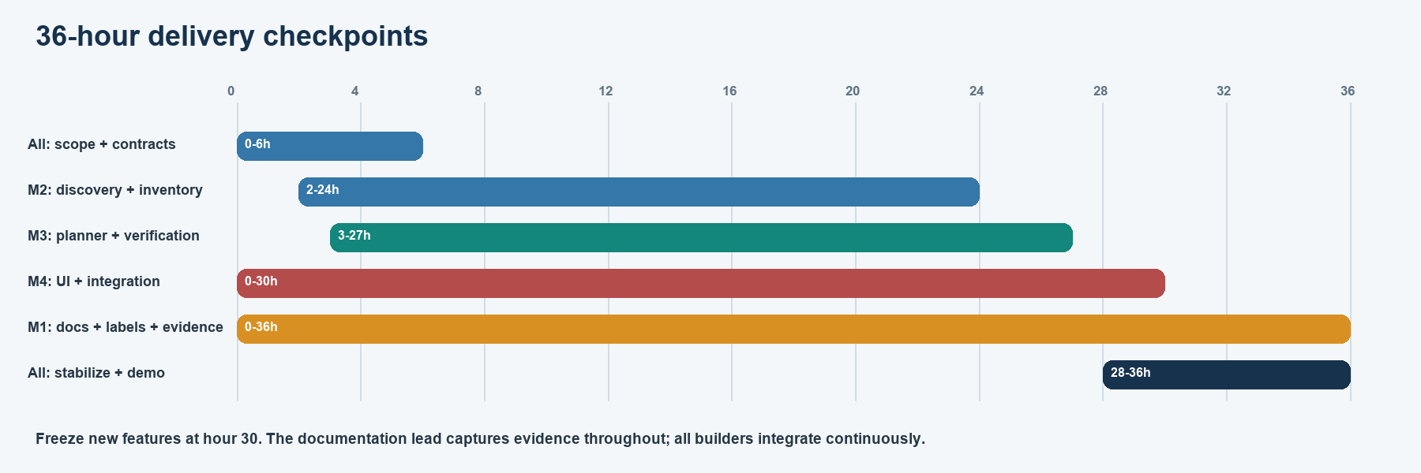
Figure 3. The timeline overlaps work intentionally. Integration begins immediately, and documentation captures evidence from the start.
Checkpoint | Build goal | Evidence expected
Hours 0–2 | Agree on scope, demo input, shared records, branch rules, acceptance criteria. | Written contracts, current baseline status, owner list.
Hours 2–6 | Each developer makes one thin runnable slice; Member 4 wires the first UI shell. | One finding, one plan, one verification record, one screen.
Hours 6–12 | Run scanner → inventory → plan → verification → report for one demo service. | Golden-path command and visible records.
Hours 12–20 | Expand supported rules, dependencies, checks, rollback, exports. | Automated tests and interim report.
Hours 20–27 | Evaluate labelled cases, challenge assumptions, optional Bloq comparison if ready. | Actual TP/FP/FN; no fabricated metrics; recorded experiment status.
Hours 27–30 | Freeze new features; repair only core-path failures. | Release candidate and issue list.
Hours 30–36 | Rehearse from setup docs, capture evidence, present and hand off. | Reproducible demo, final report, known limitations.

Definition of done
- A teammate can install/run from documented steps and reach the local interface or documented CLI.
- One demo input completes the end-to-end path and produces traceable scan, plan, verification, and report records.
- Findings have path/line or config evidence and uncertainty; dependencies and plan ordering are explainable.
- Verification blocks on missing or failed evidence and records a rollback action and owner.
- Metrics are computed from labelled inputs and real outputs; dataset provenance and limitations are documented.
- Synthetic inputs, modeled traces, Bloq/QpiAI simulations, actual hardware runs, and unrun work are clearly distinguished.
- Secrets remain local and untracked; no external experiment receives source, keys, or banking data.

Technical and safety notes
The current README describes a synthetic banking fixture set, modeled protocol traces, a deterministic scheduler, QpiAI adapters, and local simulator evidence. Treat those as repository claims until the team reruns and confirms them. Bloq is an optional platform for quantum experiments and editable notebooks; it is not the local app host or a required runtime dependency. The planner baseline and UI must still work without Bloq.
A credential was previously pasted into conversation history. Rotate exposed credentials with their provider, then store any replacement locally. Never copy a key into this guide, source files, screenshots, Git, a public dataset, or a Bloq notebook.

References
- Current CryptoShift README and pyproject.toml: Project files: README.md and pyproject.toml
- NIST FIPS 203 — ML-KEM: https://csrc.nist.gov/pubs/fips/203/final
- NIST FIPS 204 — ML-DSA: https://csrc.nist.gov/pubs/fips/204/final
- NIST FIPS 205 — SLH-DSA: https://csrc.nist.gov/pubs/fips/205/final
- NIST Migration to Post-Quantum Cryptography: https://www.nccoe.nist.gov/applied-cryptography/migration-to-pqc
- Bloq Quantum product overview: https://www.bloq.in/product
- Bloq Quantum documentation: https://www.bloq.in/docs
- Python AST documentation: https://docs.python.org/3.12/library/ast.html
- Streamlit installation: https://docs.streamlit.io/get-started/installation

