VISVESVARAYA TECHNOLOGICAL UNIVERSITY
“JnanaSangama”, Belgaum -590014, Karnataka.

LAB REPORT
on
Artificial Intelligence (23CS5PCAIN)
Submitted by
Shreyas R Achar(1BM23CS320)
in partial fulfillment for the award of the degree of
BACHELOR OF ENGINEERING
in
COMPUTER SCIENCE AND ENGINEERING

B.M.S. COLLEGE OF ENGINEERING
(Autonomous Institution under VTU)
BENGALURU-560019
Aug 2025 to Dec 2025

B.M.S. College of Engineering,
Bull Temple Road, Bangalore 560019
(Affiliated To Visvesvaraya Technological University, Belgaum)
Department of Computer Science and Engineering

CERTIFICATE
This is to certify that the Lab work entitled “Artificial Intelligence (23CS5PCAIN)” carried out by Shreyas R Achar (1BM23CS320), who is bonafide student of B.M.S. College of Engineering. It is in partial fulfillment for the award of Bachelor of Engineering in Computer Science and Engineering of the Visvesvaraya Technological University, Belgaum. The Lab report has been approved as it satisfies the academic requirements in respect of an Artificial Intelligence (23CS5PCAIN) work prescribed for the said degree.

Lab faculty Incharge Name  Assistant Professor  Department of CSE, BMSCE | Dr. Kavitha Sooda  Professor & HOD  Department of CSE, BMSCE

Index
Sl.  No. | Date | Experiment Title | Page No.
1 | 30-9-2024 | Implement Tic –Tac –Toe Game  Implement vacuum cleaner agent | 4-10
2 | 7-10-2024 | Implement 8 puzzle problems using Depth First Search (DFS)  Implement Iterative deepening search algorithm | 11-19
3 | 14-10-2024 | Implement A* search algorithm | 20-23
4 | 21-10-2024 | Implement Hill Climbing search algorithm to solve N-Queens problem | 24-27
5 | 28-10-2024 | Simulated Annealing to Solve 8-Queens problem | 28-30
6 | 11-11-2024 | Create a knowledge base using propositional logic and show that the given query entails the knowledge base or not. | 30-34
7 | 2-12-2024 | Implement unification in first order logic | 35-39
8 | 2-12-2024 | Create a knowledge base consisting of first order logic statements and prove the given query using forward reasoning. | 40-47
9 | 16-12-2024 | Create a knowledge base consisting of first order logic statements and prove the given query using Resolution | 48-53
10 | 16-12-2024 | Implement Alpha-Beta Pruning. | 54-55

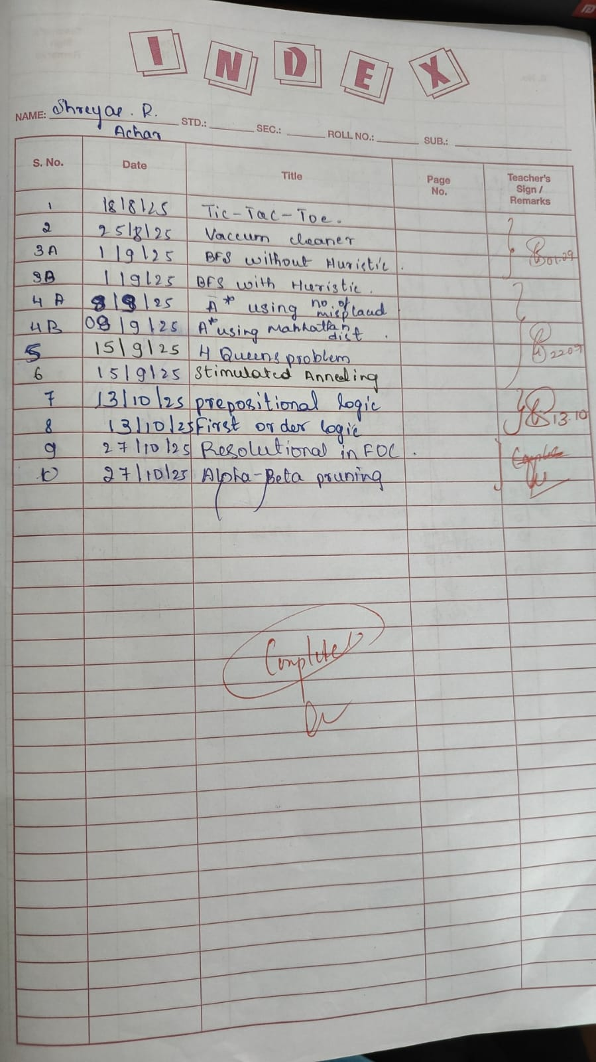
Github Link:
https://github.com/shreyasacharya1/ai_lab

Program 1
Implement Tic –Tac –Toe Game
Implement vacuum cleaner agent

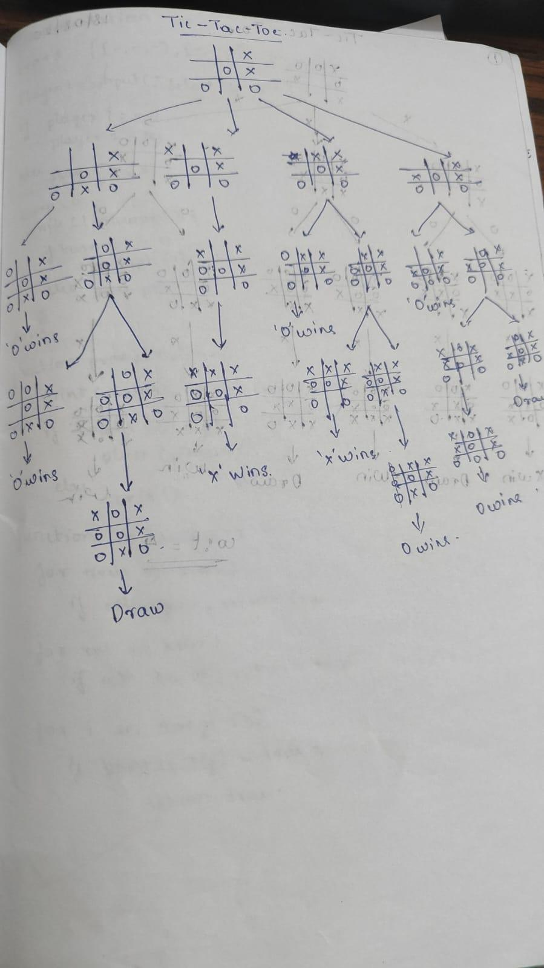
Algorithm:
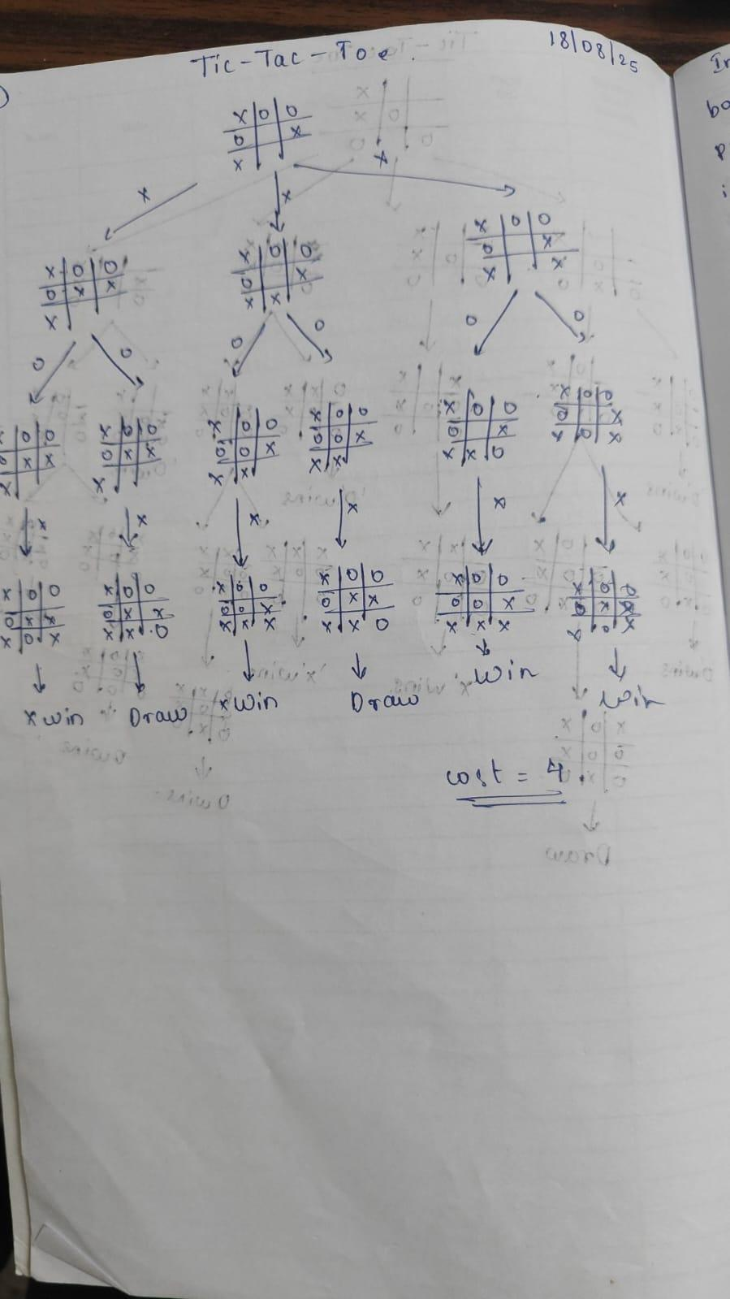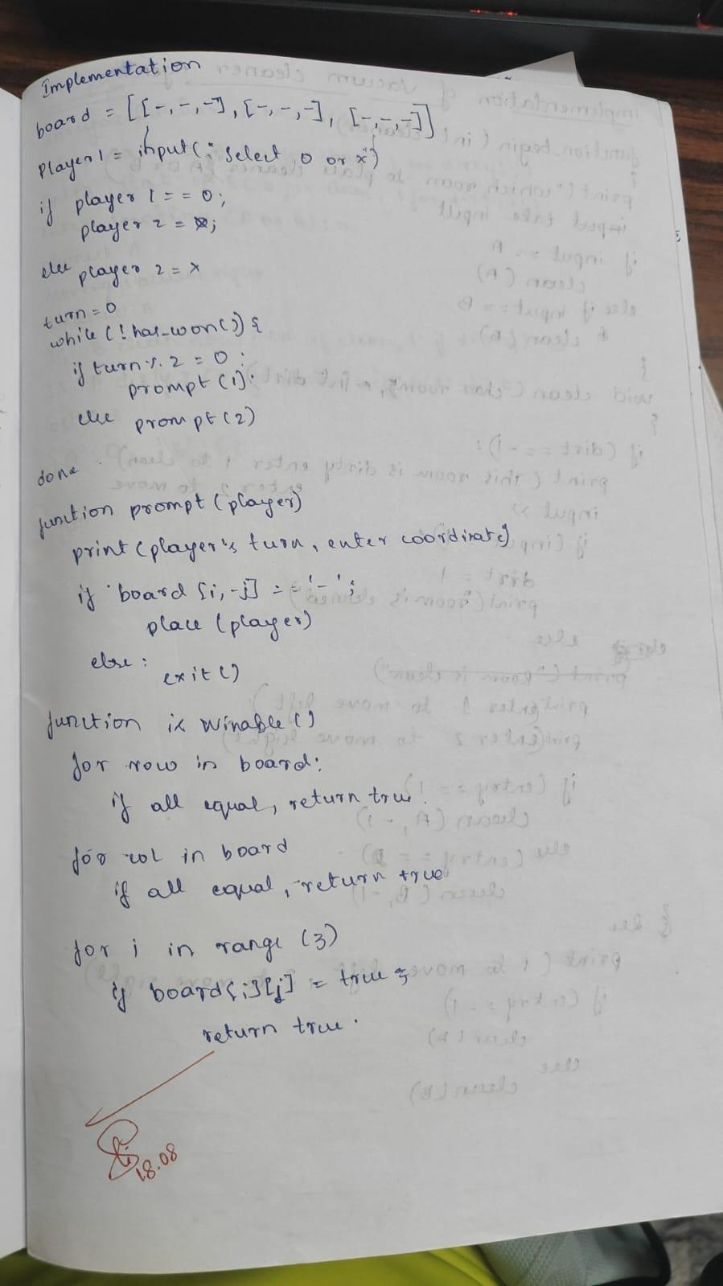

Code:
Implement Tic –Tac –Toe Game
code
def print_board(board):
for row in board:
print("|".join(row))
print("-" * 5)

def check_win(board, player):
for row in board:
if all([cell == player for cell in row]):
return True
for col in range(3):
if all([board[row][col] == player for row in range(3)]):
return True
if board[0][0] == board[1][1] == board[2][2] == player:
return True
if board[0][2] == board[1][1] == board[2][0] == player:
return True
return False

def check_draw(board):
for row in board:
if " " in row:
return False
return True

def play_game():
board = [[" " for _ in range(3)] for _ in range(3)]
players = ["X", "O"]
current_player = 0

while True:
print_board(board)
player = players[current_player]
try:
row = int(input(f"Player {player}, enter row (0-2): "))
col = int(input(f"Player {player}, enter column (0-2): "))
if not (0 <= row <= 2 and 0 <= col <= 2):
print("Invalid input. Row and column must be between 0 and 2.")
continue
except ValueError:
print("Invalid input. Please enter a number.")
continue

if board[row][col] == " ":
board[row][col] = player
if check_win(board, player):
print_board(board)
print(f"Player {player} wins!")
break
elif check_draw(board):
print_board(board)
print("It's a draw!")
break
else:
current_player = (current_player + 1) % 2
else:
print("That spot is already taken! Try again.")

play_game()

Implement vacuum cleaner agent
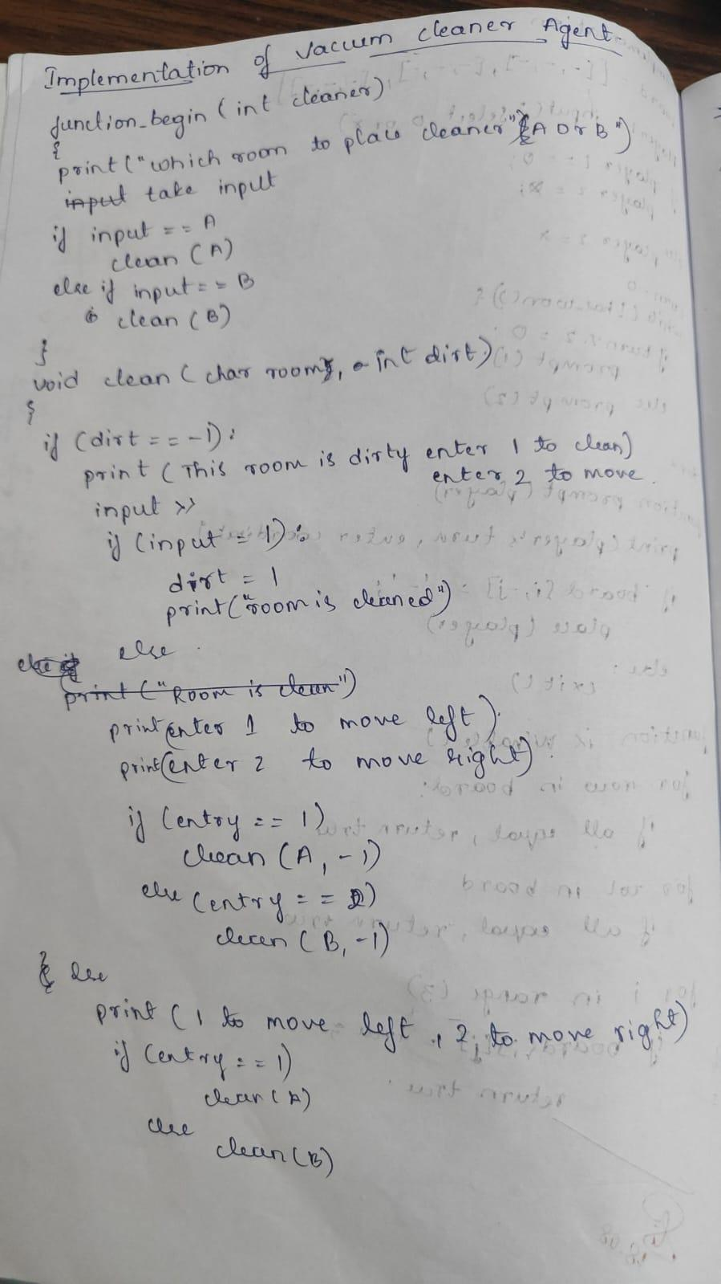
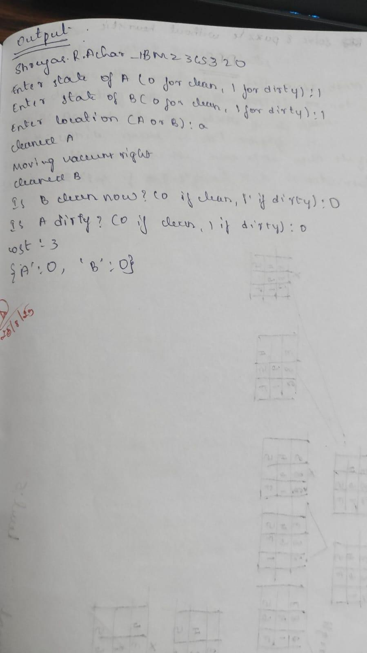

Code:
print("Shreyas.R.Achar_1BM23CS320")
def vacuum_cleaner_agent():
state_A = int(input("Enter state of A (0 for clean, 1 for dirty): "))
state_B = int(input("Enter state of B (0 for clean, 1 for dirty): "))
location = input("Enter location (A or B): ").upper()

cost = 0
states = {'A': state_A, 'B': state_B}

if states['A'] == 0 and states['B'] == 0:
print("Turning vacuum off")
print(f"Cost: {cost}")
print(states)
return

def clean_location(loc):
nonlocal cost
if states[loc] == 1:
print(f"Cleaned {loc}.")
states[loc] = 0
cost += 1

if location == 'A':
if states['A'] == 1:
clean_location('A')
else:
print("A is clean")
print("Moving vacuum right")
cost += 1
if states['B'] == 1:
clean_location('B')
else:
print("B is clean")

print("Is B clean now? (0 if clean, 1 if dirty):", states['B'])
print("Is A dirty? (0 if clean, 1 if dirty):", states['A'])

if states['A'] == 1:
print("Moving vacuum left")
cost += 1
clean_location('A')

elif location == 'B':
if states['B'] == 1:
clean_location('B')
else:
print("B is clean")
print("Moving vacuum left")
cost += 1
if states['A'] == 1:
clean_location('A')
else:
print("A is clean")

print("Is A clean now? (0 if clean, 1 if dirty):", states['A'])
print("Is B dirty? (0 if clean, 1 if dirty):", states['B'])

if states['B'] == 1:
print("Moving vacuum right")
cost += 1
clean_location('B')

print(f"Cost: {cost}")
print(states)

vacuum_cleaner_agent()

Program 2
Implement 8 puzzle problems using Depth First Search (DFS)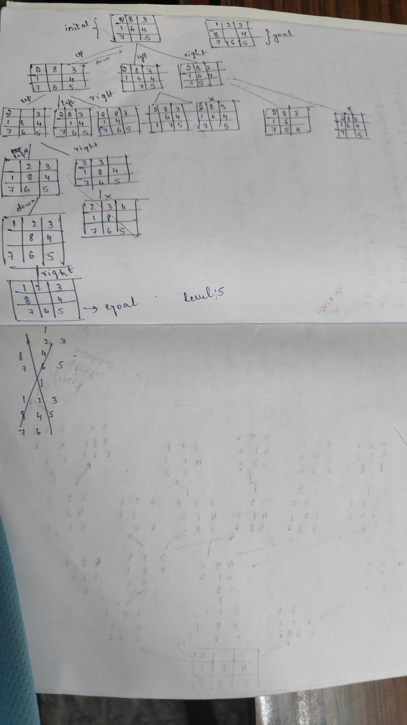S)
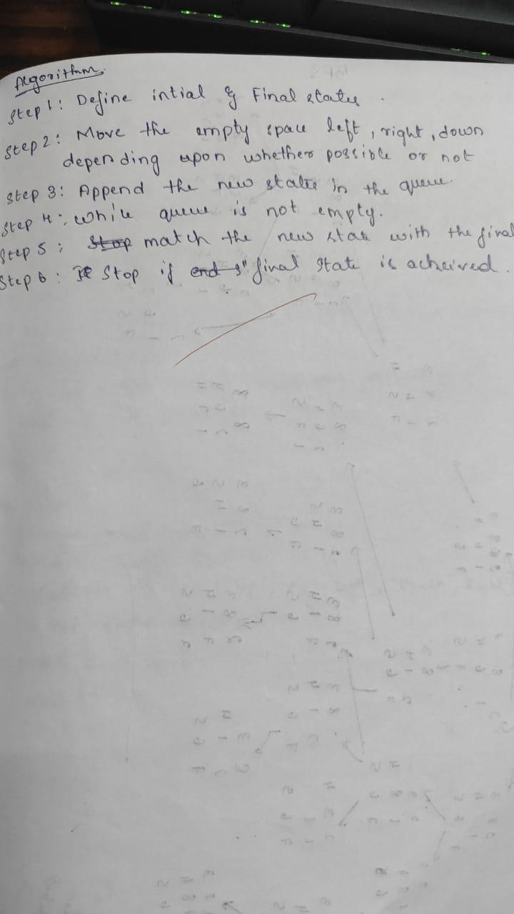
Code
from collections import deque
print("Shreyas R Achar_1BM23CS320")

initial_state = ((2, 8, 3),
(1, 6, 4),
(7, 0, 5))

goal_state = ((1, 2, 3),
(8, 0, 4),
(7, 6, 5))

directions = {'Up': (-1, 0), 'Down': (1, 0), 'Left': (0, -1), 'Right': (0, 1)}

def get_blank_pos(state):
for i in range(3):
for j in range(3):
if state[i][j] == 0:
return (i, j)

def swap_positions(state, pos1, pos2):
state_list = [list(row) for row in state]
r1, c1 = pos1
r2, c2 = pos2
state_list[r1][c1], state_list[r2][c2] = state_list[r2][c2], state_list[r1][c1]
return tuple(tuple(row) for row in state_list)

def get_neighbors(state):
neighbors = []
r, c = get_blank_pos(state)
for move, (dr, dc) in directions.items():
nr, nc = r + dr, c + dc
if 0 <= nr < 3 and 0 <= nc < 3:
new_state = swap_positions(state, (r, c), (nr, nc))
neighbors.append((new_state, move))
return neighbors

def bfs_8_puzzle(start, goal):
queue = deque()
visited = set()
visited.add(start)
queue.append((start, []))

levels = []

while queue:
level_size = len(queue)
current_level_states = []

for _ in range(level_size):
state, path = queue.popleft()
current_level_states.append(state)
if state == goal:
return path, levels + [current_level_states], len(visited)

for neighbor, move in get_neighbors(state):
if neighbor not in visited:
visited.add(neighbor)
queue.append((neighbor, path + [move]))

levels.append(current_level_states)

return None, levels, len(visited)

solution_path, level_states, total_visited = bfs_8_puzzle(initial_state, goal_state)

print(f"Solution length: {len(solution_path)} moves")
print("Solution moves:", solution_path)
print(f"Total states visited: {total_visited}\n")

print("States level-wise:")
for i, level in enumerate(level_states):
print(f"\nLevel {i}:")
for state in level:
for row in state:
print(row)
print("---")

program
Implement Iterative deepening search algorithm
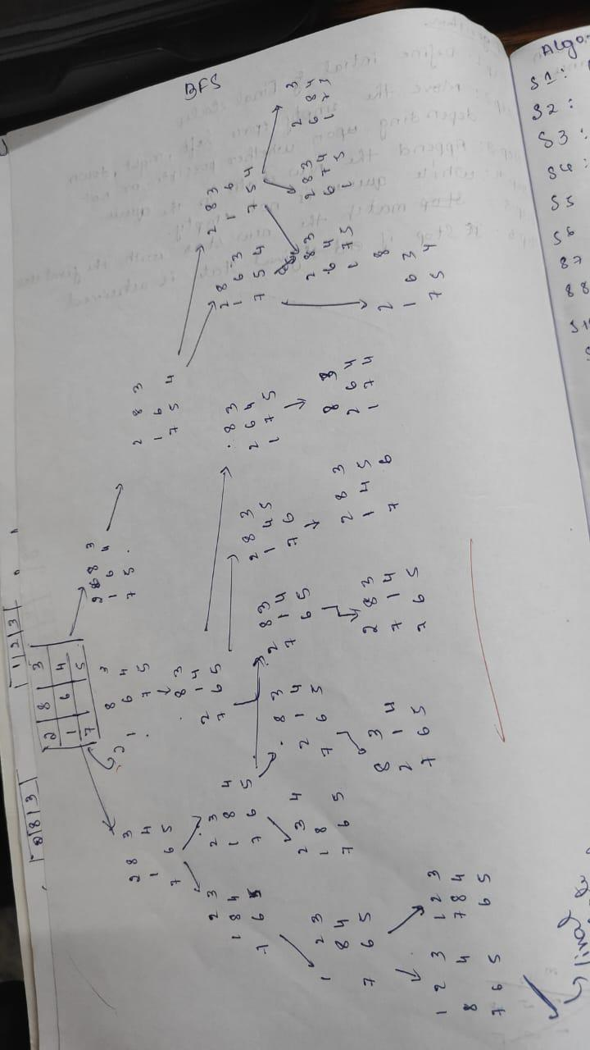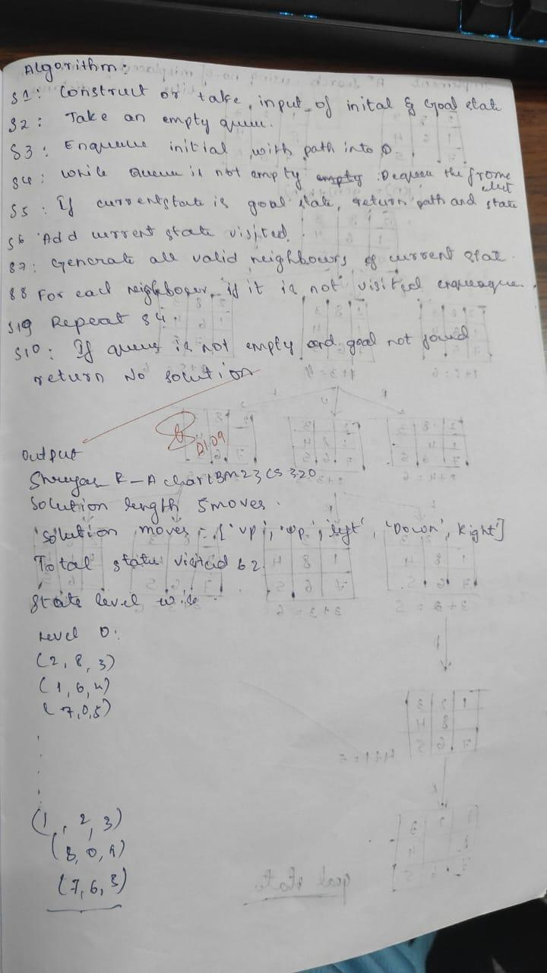

code
from collections import deque
print("Shreyas R Achar_1BM23CS320")

initial_state = ((2, 8, 3),
(1, 6, 4),
(7, 0, 5))

goal_state = ((1, 2, 3),
(8, 0, 4),
(7, 6, 5))

directions = {'Up': (-1, 0), 'Down': (1, 0), 'Left': (0, -1), 'Right': (0, 1)}

def get_blank_pos(state):
for i in range(3):
for j in range(3):
if state[i][j] == 0:
return (i, j)

def swap_positions(state, pos1, pos2):
state_list = [list(row) for row in state]
r1, c1 = pos1
r2, c2 = pos2
state_list[r1][c1], state_list[r2][c2] = state_list[r2][c2], state_list[r1][c1]
return tuple(tuple(row) for row in state_list)

def get_neighbors(state):
neighbors = []
r, c = get_blank_pos(state)
for move, (dr, dc) in directions.items():
nr, nc = r + dr, c + dc
if 0 <= nr < 3 and 0 <= nc < 3:
new_state = swap_positions(state, (r, c), (nr, nc))
neighbors.append((new_state, move))
return neighbors

def bfs_8_puzzle(start, goal):
queue = deque()
visited = set()
visited.add(start)
queue.append((start, []))

levels = []

while queue:
level_size = len(queue)
current_level_states = []

for _ in range(level_size):
state, path = queue.popleft()
current_level_states.append(state)
if state == goal:
return path, levels + [current_level_states], len(visited)

for neighbor, move in get_neighbors(state):
if neighbor not in visited:
visited.add(neighbor)
queue.append((neighbor, path + [move]))

levels.append(current_level_states)

return None, levels, len(visited)

solution_path, level_states, total_visited = bfs_8_puzzle(initial_state, goal_state)

print(f"Solution length: {len(solution_path)} moves")
print("Solution moves:", solution_path)
print(f"Total states visited: {total_visited}\n")

print("States level-wise:")
for i, level in enumerate(level_states):
print(f"\nLevel {i}:")
for state in level:
for row in state:
print(row)
print("---")

Shreyas R Achar_1BM23CS320
Solution length: 5 moves
Solution moves: ['Up', 'Up', 'Left', 'Down', 'Right']
Total states visited: 62

program 3:
Implement A* search algorithm
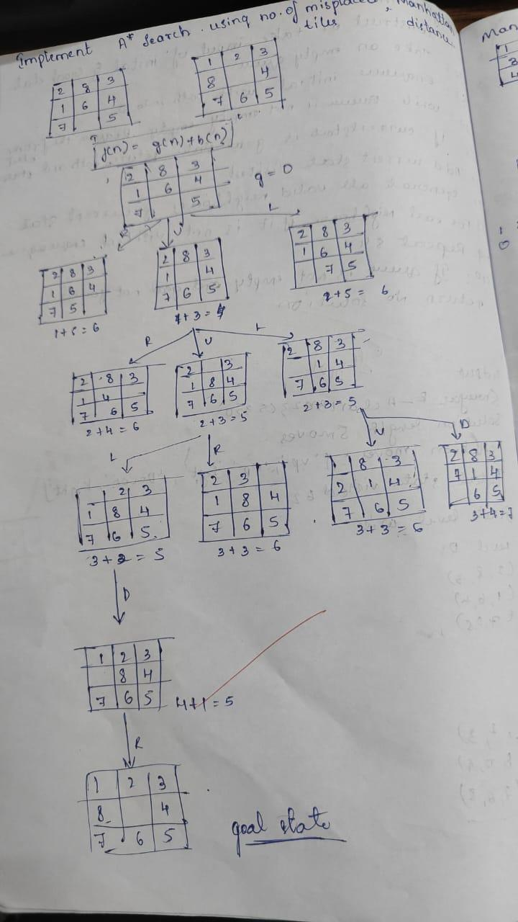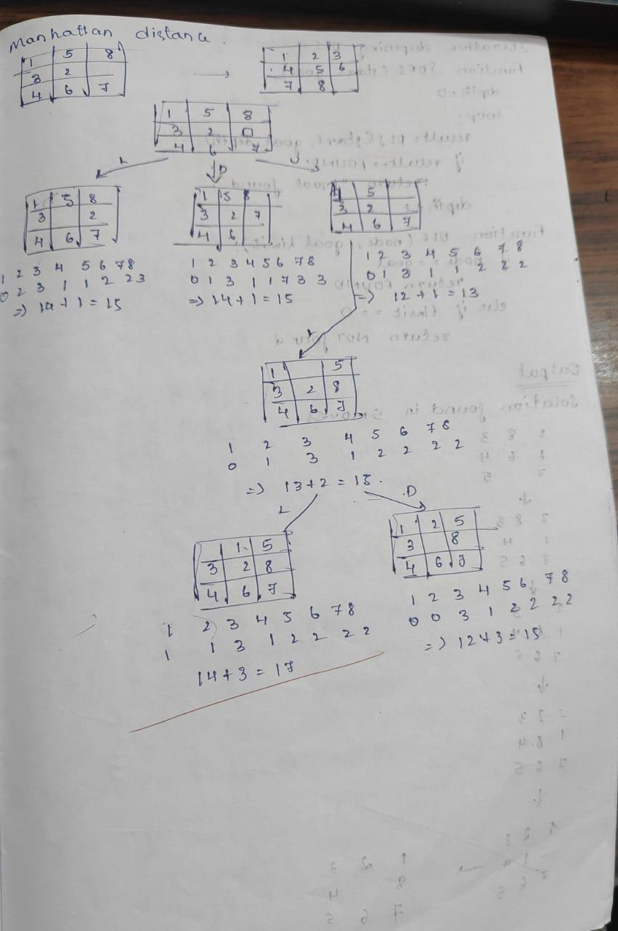

code:
import heapq
print("Shreyas.R.Achar_1BM23CS320")

def manhattan_distance(state, goal):
distance = 0
for i in range(3):
for j in range(3):
if state[i][j] != 0:
value = state[i][j]
# Find the position of the value in the goal state
for gi in range(3):
for gj in range(3):
if goal[gi][gj] == value:
goal_pos = (gi, gj)
break
else:
continue
break
distance += abs(i - goal_pos[0]) + abs(j - goal_pos[1])
return distance

def get_neighbors(state):
neighbors = []
for i in range(3):
for j in range(3):
if state[i][j] == 0:
x, y = i, j
break
else:
continue
break

moves = [(0, 1), (0, -1), (1, 0), (-1, 0)]
for dx, dy in moves:
nx, ny = x + dx, y + dy
if 0 <= nx < 3 and 0 <= ny < 3:
new_state = [list(row) for row in state]
new_state[x][y], new_state[nx][ny] = new_state[nx][ny], new_state[x][y]
neighbors.append(tuple(tuple(row) for row in new_state))
return neighbors

def astar_search_manhattan(initial, goal):
frontier = [(manhattan_distance(initial, goal), 0, initial)]
explored = set()
parent = {}
cost = {initial: 0}

while frontier:
f, g, current = heapq.heappop(frontier)

if current == goal:
path = []
while current in parent:
path.append(current)
current = parent[current]
path.append(initial)
return path[::-1]

explored.add(current)

for neighbor in get_neighbors(current):
new_cost = cost[current] + 1
if neighbor not in cost or new_cost < cost[neighbor]:
cost[neighbor] = new_cost
priority = new_cost + manhattan_distance(neighbor, goal)
heapq.heappush(frontier, (priority, new_cost, neighbor))
parent[neighbor] = current
return None

def get_state_input(prompt):
print(prompt)
state = []
for _ in range(3):
row = list(map(int, input().split()))
state.append(row)
return tuple(tuple(row) for row in state)

initial_state_m = get_state_input("Enter the initial state for Manhattan distance (3 rows of 3 numbers separated by spaces, use 0 for the blank):")
goal_state_m = get_state_input("Enter the goal state for Manhattan distance (3 rows of 3 numbers separated by spaces, use 0 for the blank):")

path_m = astar_search_manhattan(initial_state_m, goal_state_m)

if path_m:
print("Solution found using Manhattan distance:")
for step in path_m:
for row in step:
print(row)
print()
else:
print("No solution found using Manhattan distance.")

program 4:Implement Hill Climbing search algorithm to solve N-Queens problem
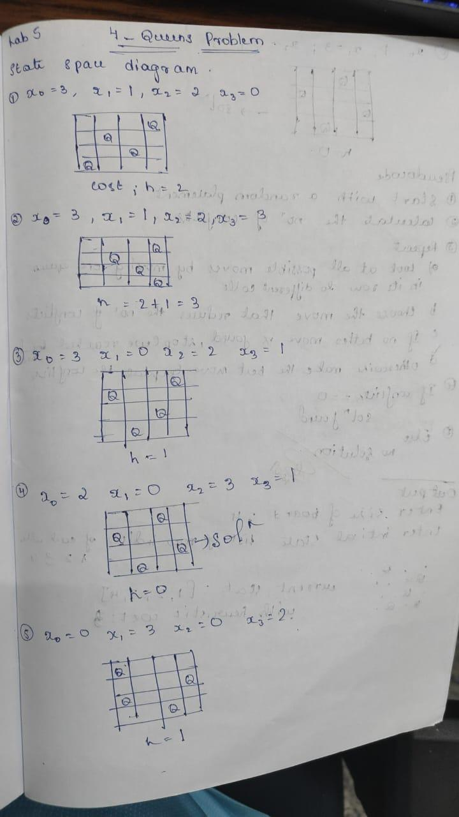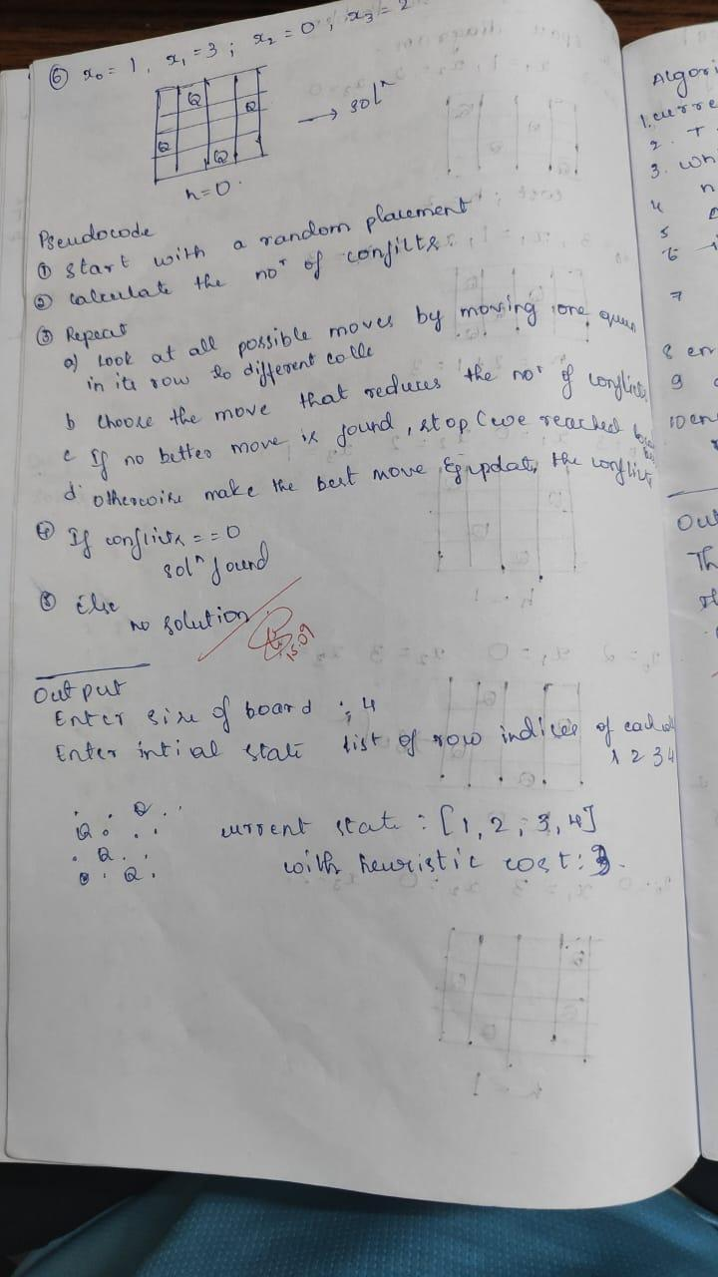

code:
import random

def print_board(state):
n = len(state)
for row in range(n):
line = ""
for col in range(n):
if state[col] == row:
line += "Q "
else:
line += ". "
print(line)
print()

def heuristic(state):
attacks = 0
n = len(state)
for i in range(n):
for j in range(i + 1, n):
if state[i] == state[j]:
attacks += 1
if abs(state[i] - state[j]) == abs(i - j):
attacks += 1
return attacks

def get_neighbors(state):
neighbors = []
n = len(state)
for col in range(n):
for row in range(n):
if state[col] != row:
neighbor = list(state)
neighbor[col] = row
neighbors.append(neighbor)
return neighbors

def hill_climbing(n=4, initial_state=None):
if initial_state is None:
current = [random.randint(0, n-1) for _ in range(n)]
else:
current = initial_state
current_heuristic = heuristic(current)
print(f"Initial state: {current} with heuristic cost: {current_heuristic}")
print("Initial board:")
print_board(current)

while True:
neighbors = get_neighbors(current)
neighbor_heuristics = [(heuristic(nei), nei) for nei in neighbors]
best_heuristic, best_neighbor = min(neighbor_heuristics, key=lambda x: x[0])

if best_heuristic >= current_heuristic:
break

print(f"\nCurrent state: {current} with heuristic cost: {current_heuristic}")
print("Current board:")
print_board(current)

current, current_heuristic = best_neighbor, best_heuristic

print(f"\nFinal state: {current} with heuristic cost: {current_heuristic}")
print("Final board:")
print_board(current)

return current, current_heuristic

def get_user_input():
n = int(input("Enter the size of the board (default is 4): ") or 4)
initial_state = input(f"Enter the initial state as a space-separated list of row indices for each column (length {n}): ")
initial_state = list(map(int, initial_state.split()))
return n, initial_state

n, initial_state = get_user_input()
solution, conflicts = hill_climbing(n, initial_state)
print("\nFinal board with conflicts =", conflicts)

program 5:Simulated Annealing to Solve 8-Queens problem
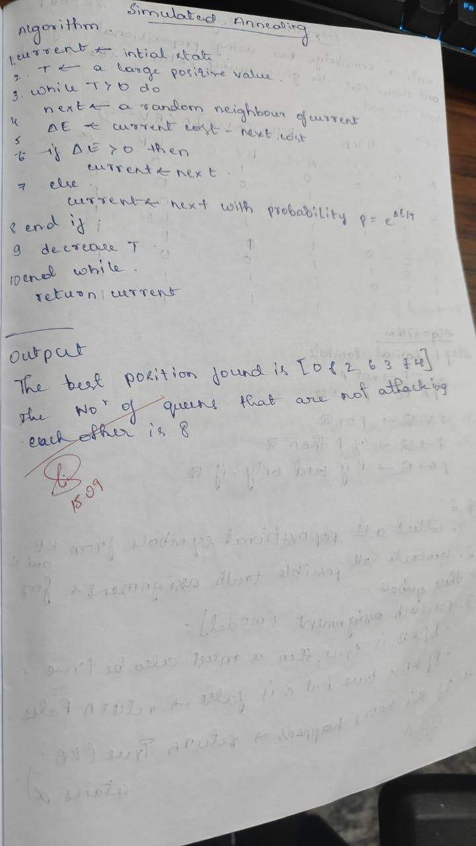
code:

import math
import random

# Example objective function (you can replace this with any function)
# Let's say we want to minimize f(x) = x^2 + 10*sin(x)
def objective_function(x):
return x**2 + 10 * math.sin(x)

# Simulated Annealing
def simulated_annealing(objective, bounds, max_iterations, initial_temp, cooling_rate):
# Random initial solution
current = random.uniform(bounds[0], bounds[1])
current_energy = objective(current)

# Best found solution
best = current
best_energy = current_energy

temp = initial_temp

for i in range(max_iterations):
# New candidate solution (neighbor)
candidate = current + random.uniform(-1, 1) # small random move
candidate = max(min(candidate, bounds[1]), bounds[0]) # keep inside bounds
candidate_energy = objective(candidate)

# Energy difference
delta_e = candidate_energy - current_energy

# Accept candidate if better OR with probability exp(-ΔE/T)
if delta_e < 0 or random.random() < math.exp(-delta_e / temp):
current, current_energy = candidate, candidate_energy

# Check for new best
if current_energy < best_energy:
best, best_energy = current, current_energy

# Decrease temperature
temp = temp * cooling_rate

# Debug: print iteration progress
# print(f"Iter {i}, Temp={temp:.4f}, Best={best:.4f}, Energy={best_energy:.4f}")

return best, best_energy

# ------------------------------
# Example Run
# ------------------------------

bounds = [-10, 10] # search space for x
max_iterations = 1000 # number of iterations
initial_temp = 100.0 # starting temperature
cooling_rate = 0.99 # cooling rate (0.8 - 0.99 is typical)

best_solution, best_value = simulated_annealing(objective_function, bounds,
max_iterations, initial_temp, cooling_rate)

print("Best solution found: x =", best_solution)
print("Objective function value:", best_value)

program 6:Create a knowledge base using propositional logic and show that the given query entails the knowledge base or not.
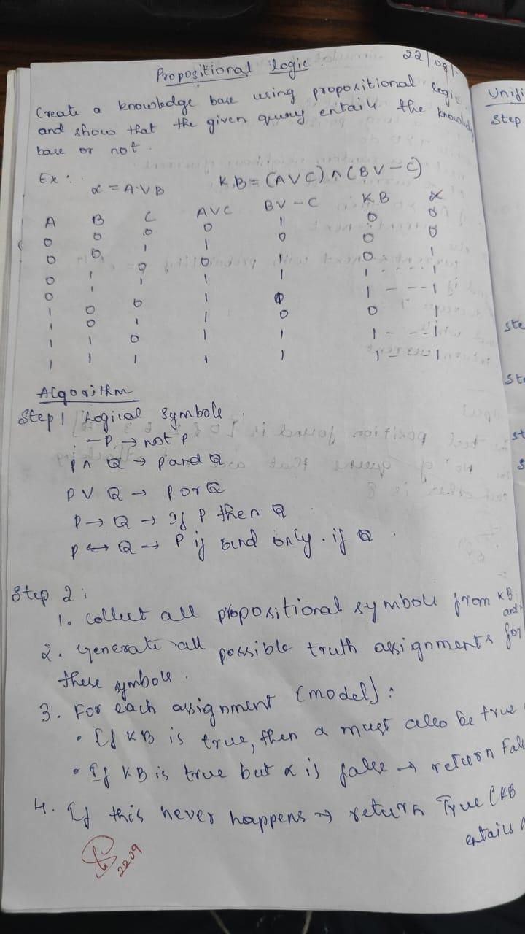
code:
import itertools
import pandas as pd
import re

def replace_implications(expr):
"""
Replace every X => Y with (not X or Y).
This uses regex with a callback to avoid partial string overwrites.
"""
# Pattern: capture left side and right side around =>
# Made more flexible to handle various expressions
pattern = r'([^=><]+?)\s*=>\s*([^=><]+?)(?=\s|$|[&|)])'
while re.search(pattern, expr):
expr = re.sub(pattern,
lambda m: f"(not {m.group(1).strip()} or {m.group(2).strip()})",
expr,
count=1)
return expr

def pl_true(sentence, model):
expr = sentence.strip()
expr = expr.replace("<=>", "==")
expr = replace_implications(expr)

# Replace propositional symbols with their truth values safely
for sym, val in model.items():
expr = re.sub(rf'\b{sym}\b', str(val), expr)

# Clean up spacing and add proper spacing for boolean operators
expr = re.sub(r'\s+', ' ', expr) # Remove extra spaces
expr = expr.replace(" and ", " and ").replace(" or ", " or ").replace(" not ", " not ")

return eval(expr)

def get_symbols(KB, alpha):
symbols = set()
for sentence in KB + [alpha]:
# Find all alphabetic tokens (propositional variables)
for token in re.findall(r'\b[A-Za-z]+\b', sentence):
if token not in ['and', 'or', 'not']: # Exclude boolean operators
symbols.add(token)
return sorted(list(symbols))

def tt_entails(KB, alpha):
symbols = get_symbols(KB, alpha)
rows = []
entails = True

for values in itertools.product([True, False], repeat=len(symbols)):
model = dict(zip(symbols, values))

try:
kb_val = all(pl_true(sentence, model) for sentence in KB)
alpha_val = pl_true(alpha, model)

rows.append({**model, "KB": kb_val, "alpha": alpha_val})

if kb_val and not alpha_val:
entails = False
except Exception as e:
print(f"Error evaluating with model {model}: {e}")
return False

df = pd.DataFrame(rows)

# Create a beautiful formatted table
print("\n" + "="*50)
print(" TRUTH TABLE")
print("="*50)

# Get column widths for proper alignment
col_widths = {}
for col in df.columns:
col_widths[col] = max(len(str(col)), df[col].astype(str).str.len().max())

# Calculate total table width
table_width = sum(col_widths.values()) + len(df.columns) * 3 - 1

# Print top border
print("┌" + "─" * table_width + "┐")

# Print header
header = "│"
for col in df.columns:
header += f" {col:^{col_widths[col]}} │"
print(header)

# Print separator
separator = "├"
for col in df.columns:
separator += "─" * (col_widths[col] + 2) + "┼"
separator = separator[:-1] + "┤"
print(separator)

# Print rows
for _, row in df.iterrows():
row_str = "│"
for col in df.columns:
value = str(row[col])
row_str += f" {value:^{col_widths[col]}} │"
print(row_str)

# Print bottom border
print("└" + "─" * table_width + "┘")

# Print result with styling
print("\n" + "="*50)
result_text = f"KB ENTAILS ALPHA: {'✓ YES' if entails else '✗ NO'}"
print(f"{result_text:^50}")
print("="*50)
return entails

# --- Interactive input ---
print("Enter Knowledge Base (KB) sentences, separated by commas.")
print("Use symbols like A, B, C and operators: and, or, not, =>, <=>")
kb_input = input("KB: ").strip()
KB = [x.strip() for x in kb_input.split(",")]
alpha = input("Enter query (alpha): ").strip()
result = tt_entails(KB, alpha)
print(f"Result: {result}")

program 7:Implement unification in first order logic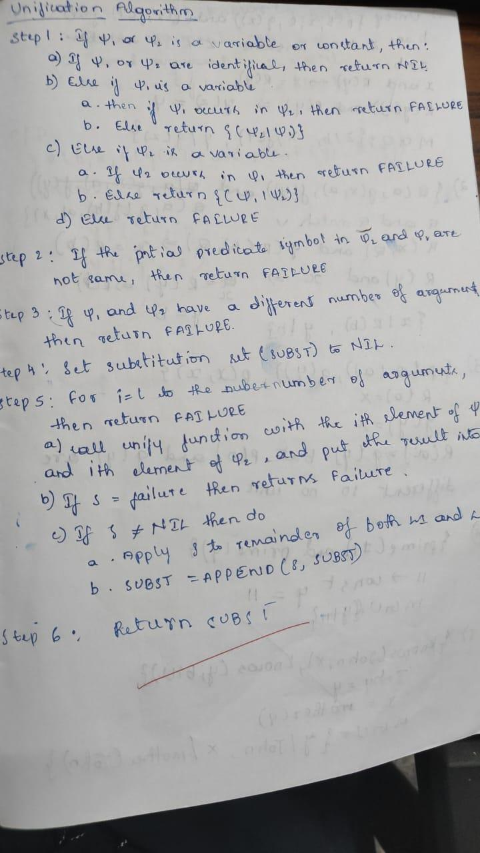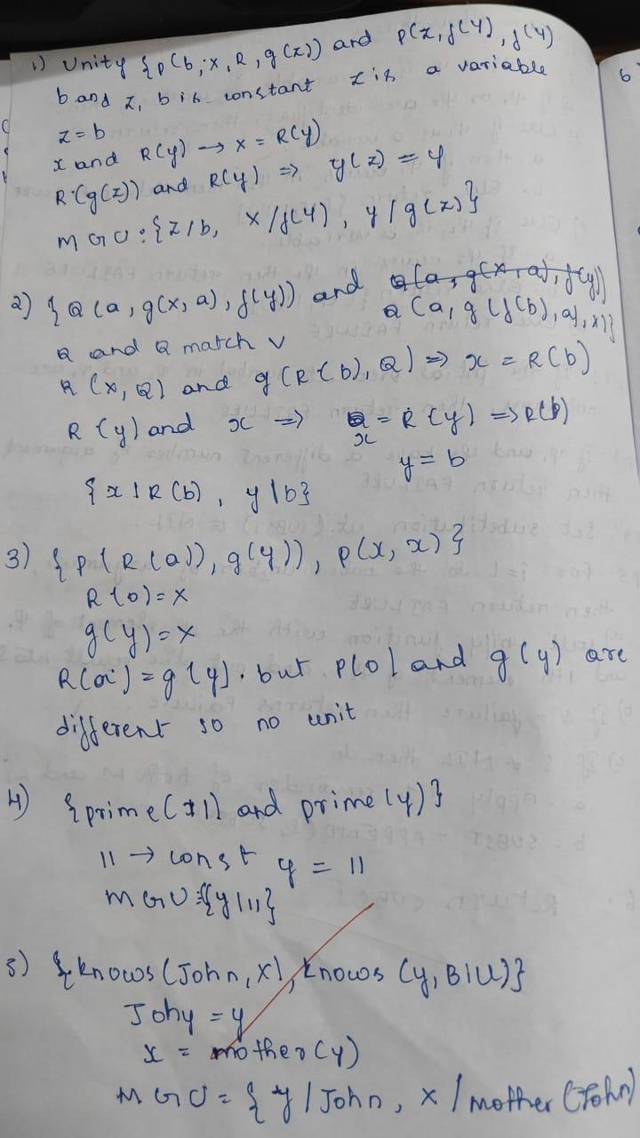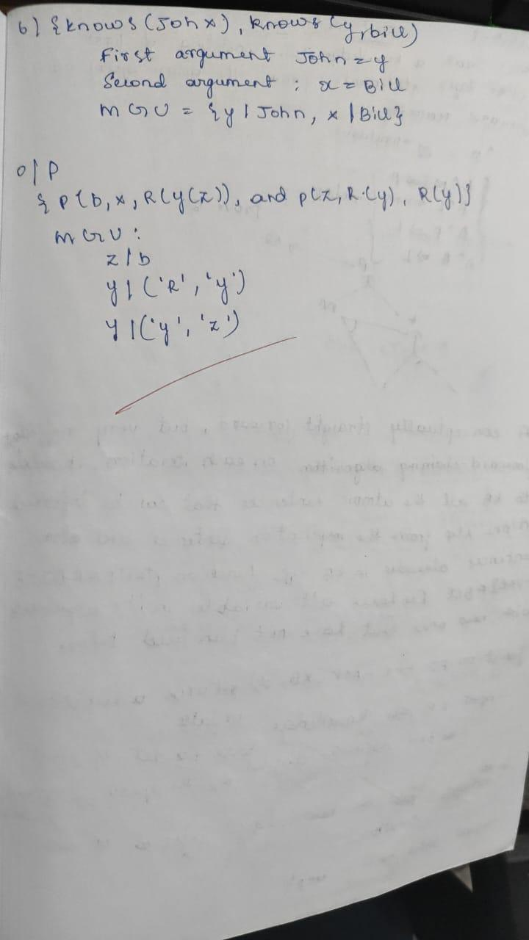

Code:print("Shreyas.R.Achar 1BM23CS320")
def is_variable(term):
return isinstance(term, str) and term[0].islower() and term.isalpha()

def is_compound(term):
return isinstance(term, tuple)

def occur_check(var, term, subst):
if var == term:
return True
elif is_variable(term) and term in subst:
return occur_check(var, subst[term], subst)
elif is_compound(term):
return any(occur_check(var, t, subst) for t in term[1])
else:
return False

def substitute(term, subst):
if is_variable(term):
return substitute(subst[term], subst) if term in subst else term
elif is_compound(term):
return (term[0], [substitute(t, subst) for t in term[1]])
else:
return term

def unify(x, y, subst=None):
if subst is None:
subst = {}

x = substitute(x, subst)
y = substitute(y, subst)

if x == y:
return subst

elif is_variable(x):
if occur_check(x, y, subst):
raise Exception(f"Occurs check failed: {x} in {y}")
subst[x] = y
return subst

elif is_variable(y):
if occur_check(y, x, subst):
raise Exception(f"Occurs check failed: {y} in {x}")
subst[y] = x
return subst

elif is_compound(x) and is_compound(y):
if x[0] != y[0] or len(x[1]) != len(y[1]):
raise Exception(f"Function symbols or arity mismatch: {x[0]} vs {y[0]}")
for a, b in zip(x[1], y[1]):
subst = unify(a, b, subst)
return subst

else:
raise Exception(f"Cannot unify {x} and {y}")

# -------------------- Example --------------------
if __name__ == "__main__":
# Example 1: Unify P(x, y) and P(a, b)
expr1 = ('P', ['x', 'y'])
expr2 = ('P', ['a', 'b'])

try:
result = unify(expr1, expr2)
print("Substitution:", result)
except Exception as e:
print("Unification failed:", e)

# Example 2: Unify Q(x, f(y)) and Q(f(a), f(b))
expr3 = ('Q', ['x', ('f', ['y'])])
expr4 = ('Q', [('f', ['a']), ('f', ['b'])])

try:
result = unify(expr3, expr4)
print("Substitution:", result)
except Exception as e:
print("Unification failed:", e)

program 8:Create a knowledge base consisting of first order logic statements and prove the given query using forward reasoning.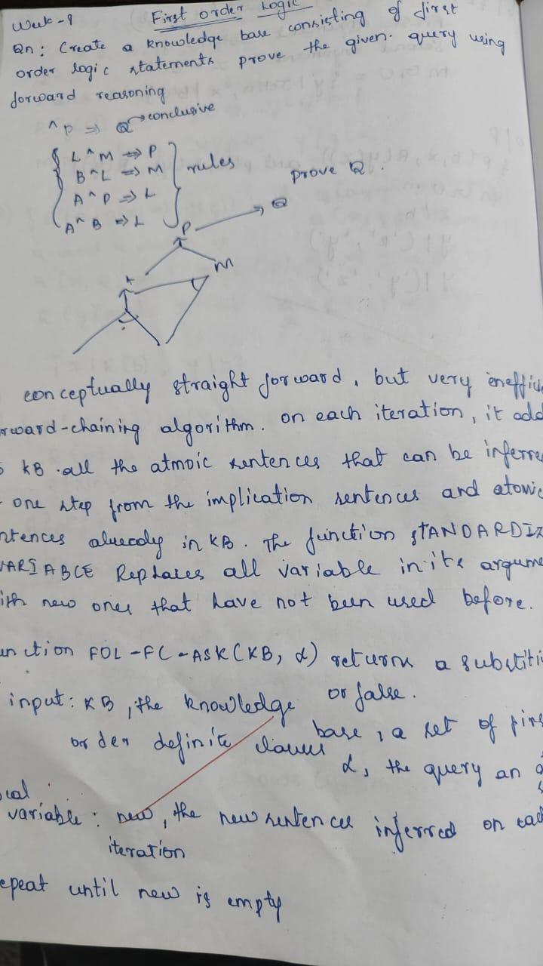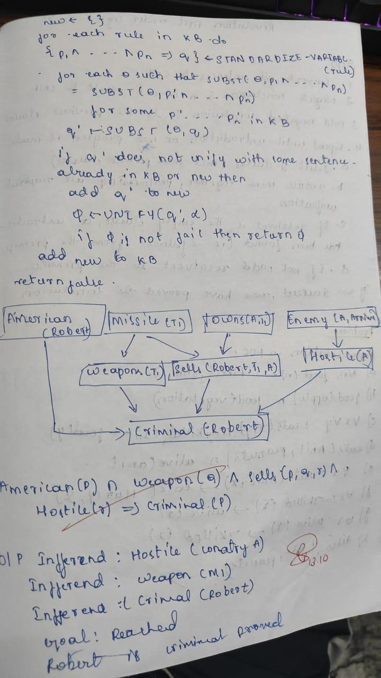
code:

#################################
class Term:
"""Base class for terms in first-order logic"""
pass

class Constant(Term):
"""Represents a constant"""
def __init__(self, name):
self.name = name

def __eq__(self, other):
return isinstance(other, Constant) and self.name == other.name

def __repr__(self):
return self.name

def __hash__(self):
return hash(('Constant', self.name))

class Variable(Term):
"""Represents a variable"""
def __init__(self, name):
self.name = name

def __eq__(self, other):
return isinstance(other, Variable) and self.name == other.name

def __repr__(self):
return self.name

def __hash__(self):
return hash(('Variable', self.name))

class Predicate(Term):
"""Represents a predicate with arguments"""
def __init__(self, name, args):
self.name = name
self.args = args if isinstance(args, list) else [args]

def __eq__(self, other):
return (isinstance(other, Predicate) and
self.name == other.name and
len(self.args) == len(other.args) and
all(a == b for a, b in zip(self.args, other.args)))

def __repr__(self):
return f"{self.name}({', '.join(str(arg) for arg in self.args)})"

def occurs_check(var, term, subst):
"""Check if variable occurs in term (prevents infinite structures)"""
if var == term:
return True
elif isinstance(term, Variable) and term in subst:
return occurs_check(var, subst[term], subst)
elif isinstance(term, Predicate):
return any(occurs_check(var, arg, subst) for arg in term.args)
return False

def apply_substitution(term, subst):
"""Apply substitution to a term"""
if isinstance(term, Variable):
if term in subst:
return apply_substitution(subst[term], subst)
return term
elif isinstance(term, Predicate):
new_args = [apply_substitution(arg, subst) for arg in term.args]
return Predicate(term.name, new_args)
else:
return term

def unify(term1, term2, subst=None):
"""
Unification Algorithm
Returns substitution set if unification succeeds, None if it fails
"""
if subst is None:
subst = {}

# Apply existing substitutions
term1 = apply_substitution(term1, subst)
term2 = apply_substitution(term2, subst)

# Step 1: If term1 or term2 is a variable or constant
# Step 1a: If both are identical
if term1 == term2:
return subst

# Step 1b: If term1 is a variable
elif isinstance(term1, Variable):
if occurs_check(term1, term2, subst):
return None # FAILURE
else:
new_subst = subst.copy()
new_subst[term1] = term2
return new_subst

# Step 1c: If term2 is a variable
elif isinstance(term2, Variable):
if occurs_check(term2, term1, subst):
return None # FAILURE
else:
new_subst = subst.copy()
new_subst[term2] = term1
return new_subst

# Step 1d: Both are constants but not equal
elif isinstance(term1, Constant) or isinstance(term2, Constant):
return None # FAILURE

# Step 2: Check if both are predicates with same name
elif isinstance(term1, Predicate) and isinstance(term2, Predicate):
if term1.name != term2.name:
return None # FAILURE

# Step 3: Check if they have same number of arguments
if len(term1.args) != len(term2.args):
return None # FAILURE

# Step 4 & 5: Unify arguments recursively
current_subst = subst.copy()
for arg1, arg2 in zip(term1.args, term2.args):
current_subst = unify(arg1, arg2, current_subst)
if current_subst is None: # If unification fails
return None

return current_subst

else:
return None # FAILURE

def print_substitution(subst):
"""Pretty print substitution set"""
if subst is None:
print("FAILURE: Unification failed")
elif not subst:
print("NIL: Terms are already unified")
else:
print("Substitution:")
for var, term in subst.items():
print(f" {var} -> {term}")

def parse_term(term_str):
"""Parse a string representation of a term into Term objects"""
term_str = term_str.strip()

# Check if it's a predicate (contains parentheses)
if '(' in term_str:
paren_idx = term_str.index('(')
pred_name = term_str[:paren_idx].strip()

# Extract arguments between parentheses
args_str = term_str[paren_idx+1:term_str.rindex(')')].strip()

# Split arguments by comma (handle nested predicates)
args = []
depth = 0
current_arg = ""
for char in args_str:
if char == ',' and depth == 0:
args.append(parse_term(current_arg))
current_arg = ""
else:
if char == '(':
depth += 1
elif char == ')':
depth -= 1
current_arg += char

if current_arg.strip():
args.append(parse_term(current_arg))

return Predicate(pred_name, args)

# Check if it's a variable (lowercase first letter or starts with ?)
elif term_str[0].islower() or term_str[0] == '?':
return Variable(term_str)

# Otherwise it's a constant (uppercase first letter)
else:
return Constant(term_str)

def run_interactive():
"""Interactive mode for user input"""
print("=== Unification Algorithm (Interactive Mode) ===")
print("Enter terms to unify. Use:")
print(" - Variables: lowercase letters (x, y, z) or ?x, ?y")
print(" - Constants: uppercase letters (John, Mary, A)")
print(" - Predicates: Name(arg1, arg2, ...) e.g., P(x, y)")
print(" - Type 'quit' to exit\n")

while True:
print("-" * 50)
term1_str = input("Enter first term: ").strip()

if term1_str.lower() == 'quit':
print("Exiting...")
break

term2_str = input("Enter second term: ").strip()

if term2_str.lower() == 'quit':
print("Exiting...")
break

try:
term1 = parse_term(term1_str)
term2 = parse_term(term2_str)

print(f"\nUnifying: {term1} and {term2}")
result = unify(term1, term2)
print_substitution(result)
print()

except Exception as e:
print(f"Error parsing terms: {e}")
print("Please check your input format.\n")

def run_examples():
"""Run predefined examples"""
print("=== Unification Algorithm Examples ===\n")

# Example 1: Unifying variables
print("Example 1: Unify(x, y)")
x = Variable('x')
y = Variable('y')
result = unify(x, y)
print_substitution(result)
print()

# Example 2: Unifying variable with constant
print("Example 2: Unify(x, John)")
x = Variable('x')
john = Constant('John')
result = unify(x, john)
print_substitution(result)
print()

# Example 3: Unifying predicates
print("Example 3: Unify(P(x, y), P(John, z))")
p1 = Predicate('P', [Variable('x'), Variable('y')])
p2 = Predicate('P', [Constant('John'), Variable('z')])
result = unify(p1, p2)
print_substitution(result)
print()

# Example 4: Unifying complex predicates
print("Example 4: Unify(P(x, f(y)), P(a, f(b)))")
p1 = Predicate('P', [Variable('x'), Predicate('f', [Variable('y')])])
p2 = Predicate('P', [Constant('a'), Predicate('f', [Constant('b')])])
result = unify(p1, p2)
print_substitution(result)
print()

# Example 5: Failure case - occurs check
print("Example 5: Unify(x, f(x)) - Occurs Check")
x = Variable('x')
fx = Predicate('f', [x])
result = unify(x, fx)
print_substitution(result)
print()

# Example 6: Failure case - different predicates
print("Example 6: Unify(P(x), Q(x)) - Different Predicates")
p1 = Predicate('P', [Variable('x')])
p2 = Predicate('Q', [Variable('x')])
result = unify(p1, p2)
print_substitution(result)
print()

# Example 7: Failure case - different constants
print("Example 7: Unify(John, Mary) - Different Constants")
john = Constant('John')
mary = Constant('Mary')
result = unify(john, mary)
print_substitution(result)

# Main program
if __name__ == "__main__":
print("Choose mode:")
print("1. Run predefined examples")
print("2. Interactive mode (enter your own terms)")

choice = input("\nEnter choice (1 or 2): ").strip()
print()

if choice == '1':
run_examples()
elif choice == '2':
run_interactive()
else:
print("Invalid choice. Running examples by default...\n")
run_examples()

program 9:Create a knowledge base consisting of first order logic statements and prove the given query using Resolution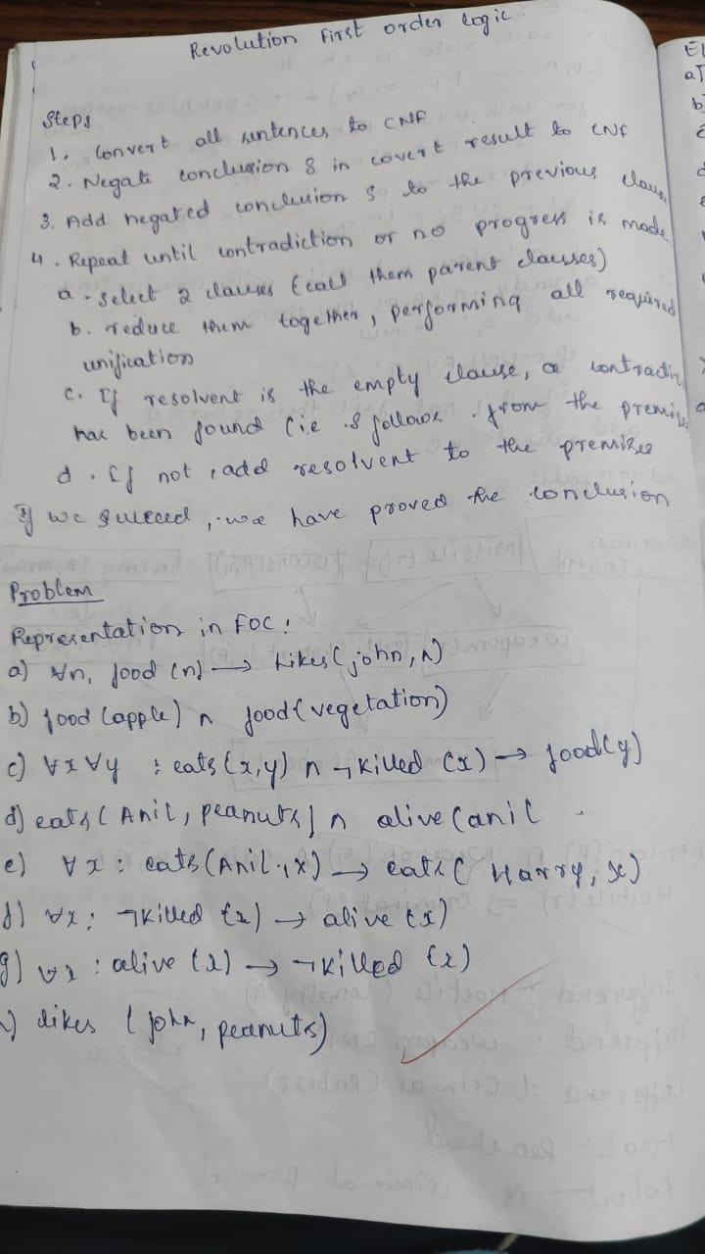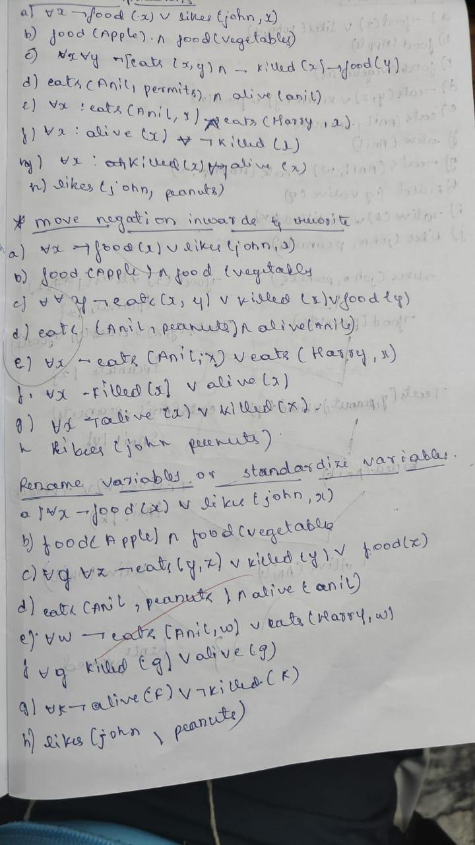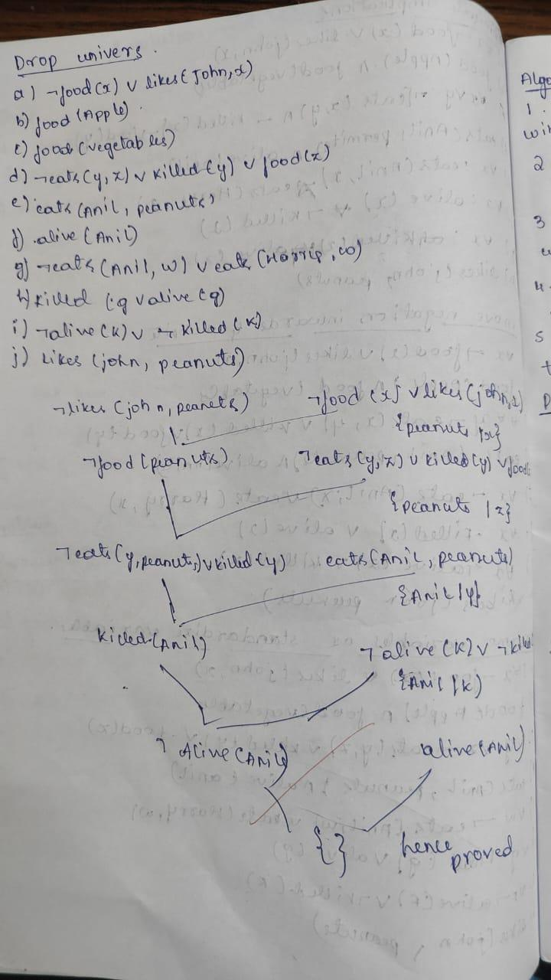
code:print("Shreyas.R.Achar 1BM23CS320")
from copy import deepcopy

# ------------------------------
# Utility functions
# ------------------------------
def substitute(clause, subs):
"""Apply substitutions to a clause."""
new_clause = []
for literal in clause:
pred, args, neg = literal
new_args = []
for a in args:
if a in subs:
new_args.append(subs[a])
else:
new_args.append(a)
new_clause.append((pred, new_args, neg))
return new_clause

def unify(x, y, subs=None):
"""Unify two literals/terms."""
if subs is None:
subs = {}
if x == y:
return subs
if isinstance(x, str) and x[0].islower():
return unify_var(x, y, subs)
elif isinstance(y, str) and y[0].islower():
return unify_var(y, x, subs)
elif isinstance(x, tuple) and isinstance(y, tuple):
if x[0] != y[0] or len(x[1]) != len(y[1]):
return None
for a, b in zip(x[1], y[1]):
subs = unify(a, b, subs)
if subs is None:
return None
return subs
else:
return None

def unify_var(var, x, subs):
if var in subs:
return unify(subs[var], x, subs)
elif x in subs:
return unify(var, subs[x], subs)
elif occur_check(var, x, subs):
return None
else:
subs[var] = x
return subs

def occur_check(var, x, subs):
if var == x:
return True
elif isinstance(x, str) and x in subs:
return occur_check(var, subs[x], subs)
elif isinstance(x, tuple):
return any(occur_check(var, arg, subs) for arg in x[1])
return False

# ------------------------------
# Resolution core
# ------------------------------
def resolve(clause1, clause2):
"""Try all pairs of literals to resolve."""
resolvents = []
for lit1 in clause1:
for lit2 in clause2:
if lit1[0] == lit2[0] and lit1[2] != lit2[2]: # same predicate, opposite polarity
subs = unify(tuple(lit1[:2]), tuple(lit2[:2]))
if subs is not None:
new_c1 = substitute(clause1, subs)
new_c2 = substitute(clause2, subs)
new_clause = [l for l in new_c1 if l != lit1] + [l for l in new_c2 if l != lit2]
# remove duplicates
new_clause = [x for i, x in enumerate(new_clause) if x not in new_clause[:i]]
resolvents.append(new_clause)
return resolvents

def pl_resolution(kb, query):
clauses = deepcopy(kb)
# add negated query
neg_query = [(query[0], query[1], not query[2])]
clauses.append(neg_query)

print("Initial clauses:")
for i, c in enumerate(clauses):
print(f"C{i+1}: {pretty_clause(c)}")
print("\nResolution steps:\n")

new = []
while True:
n = len(clauses)
pairs = [(clauses[i], clauses[j]) for i in range(n) for j in range(i + 1, n)]
for (ci, cj) in pairs:
resolvents = resolve(ci, cj)
for r in resolvents:
if not r:
print("Derived empty clause {} -> CONTRADICTION.".format(pretty_clause(r)))
return True
if r not in clauses and r not in new:
new.append(r)
print(f"Resolved {pretty_clause(ci)} and {pretty_clause(cj)} -> {pretty_clause(r)}")
if all(r in clauses for r in new):
return False
clauses.extend(new)

# ------------------------------
# Pretty printer
# ------------------------------
def pretty_clause(clause):
if not clause:
return "{}"
out = []
for pred, args, neg in clause:
s = f"{pred}({', '.join(args)})"
if neg:
s = "¬" + s
out.append(s)
return " ∨ ".join(out)

# ------------------------------
# Example Knowledge Base
# ------------------------------
if __name__ == "__main__":
# KB Clauses:
# 1. ¬parent(x,y) ∨ ancestor(x,y)
# 2. ¬ancestor(x,y) ∨ ¬ancestor(y,z) ∨ ancestor(x,z)
# 3. parent(tom,bob)
# 4. parent(bob,alice)
KB = [
[('parent', ['x', 'y'], True), ('ancestor', ['x', 'y'], False)],
[('ancestor', ['x', 'y'], True), ('ancestor', ['y', 'z'], True), ('ancestor', ['x', 'z'], False)],
[('parent', ['tom', 'bob'], False)],
[('parent', ['bob', 'alice'], False)]
]

# Query: ancestor(tom, alice)
QUERY = ('ancestor', ['tom', 'alice'], False)

result = pl_resolution(KB, QUERY)
print("\nResult:", "PROVED ✅" if result else "NOT PROVABLE ❌")

program 10:Implement Alpha-Beta Pruning.
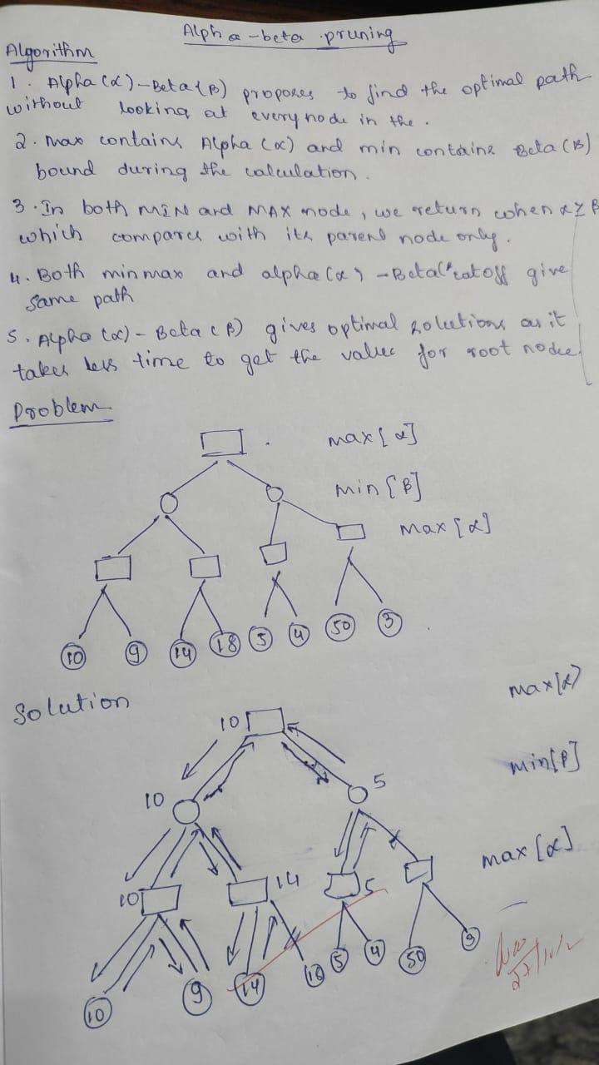
code:
import math

def alpha_beta(depth, node_index, maximizing_player, values, alpha, beta, max_depth):
if depth == max_depth:
return values[node_index]

if maximizing_player:
best = -math.inf
for i in range(2):
val = alpha_beta(depth + 1, node_index * 2 + i, False, values, alpha, beta, max_depth)
best = max(best, val)
alpha = max(alpha, best)
if beta <= alpha:
print(f"Pruned at depth {depth}, node {node_index}, α={alpha}, β={beta}")
break
return best
else:
best = math.inf
for i in range(2):
val = alpha_beta(depth + 1, node_index * 2 + i, True, values, alpha, beta, max_depth)
best = min(best, val)
beta = min(beta, best)
if beta <= alpha:
print(f"Pruned at depth {depth}, node {node_index}, α={alpha}, β={beta}")
break
return best

values = [10, 9, 14, 18, 5, 4, 50, 3]
max_depth = 3
print("Name:Shreyas.R.Achar\nUSN:1BM23CS320\n")
print("ALPHA–BETA PRUNING PROCESS\n")
optimal_value = alpha_beta(0, 0, True, values, -math.inf, math.inf, max_depth)
print("\nOptimal value (Root Node):", optimal_value)

