**VISVESVARAYA TECHNOLOGICAL UNIVERSITY**

**“JnanaSangama”, Belgaum -590014, Karnataka.**



**LAB REPORT**

**on**

**Data Structures using C Lab**

**(23CS3PCDST)**

***Submitted by***

**Shreyas R Achar(1BM23CS320)**

***in partial fulfillment for the award of the degree of***

**BACHELOR OF ENGINEERING**

***in***

**COMPUTER SCIENCE AND ENGINEERING**



**B.M.S. COLLEGE OF ENGINEERING**

**(Autonomous Institution under VTU)**

**BENGALURU-560019**

**Sep-2024 to Jan-2025**

**B.M.S. College of Engineering,**

**Bull Temple Road, Bangalore 560019**

(Affiliated To Visvesvaraya Technological University, Belgaum)

**Department of Computer Science and Engineering**



**CERTIFICATE**

This is to certify that the Lab work entitled “Data Structures using C Lab(23CS3PCDST)”carried out by **Shreyas R Achar1BM23CS320),** who is bonafide student of **B.M.S.College of Engineering.** It is in partial fulfillment for the award of **Bachelor of Engineering inComputer Science and Engineering** of the Visvesvaraya Technological University, Belgaum. The Lab report has been approved as it satisfies the academicrequirements in respect of Data Structures using C Lab(23CS3PCDST) work prescribed for the said degree.

|  |  |
| --- | --- |
| [Namratha M](https://bmsce.ac.in/home/facultyProfile/41/Namratha-M) Assistant Professor  Department of CSE, BMSCE | Dr. Jyothi S Nayak  Professor &HOD  Department of CSE, BMSCE |

**Index**

|  |  |  |  |
| --- | --- | --- | --- |
| **Sl.**  **No.** | **Date** | **Experiment Title** | **Page No.** |
| 1 |  | Program to implement stack using array | 1-5 |
| 2 |  | WAP to convert a given valid parenthesized infix arithmetic expression to postfix expression. The expression consists of single character operands and the binary operators + (plus), - (minus), * (multiply) and / (divide) | 6-11 |
| 3 |  | a) WAP to simulate the working of a queue of integers using an array. Provide the following operations: Insert, Delete, Display The program should print appropriate messages for queue empty and queue overflow conditions b ) WAP to simulate the working of a circular queue of integers using an array. Provide the following operations: Insert, Delete & Display The program should print appropriate messages for queue empty and queue overflow conditions | 12-18 |
| 4 |  | WAP to Implement Singly Linked List with following operations a) Createalinkedlist. b) Insertion of a node at first position, at any position and at end of list. Display the contents of the linked list. | 19-24 |
| 5 |  | WAP to Implement Singly Linked List with following operations a) Create a linked list. b) Deletion of first element, specified element and last element in the list. c) Display the contents of the linked list | 25-31 |
| 6 |  | a) WAP to Implement Single Link List with following operations: Sort the linked list, Reverse the linked list, Concatenation of two linked lists. b) WAP to Implement Single Link List to simulate Stack & Queue Operations. | 32-39 |
| 7 |  | WAP to Implement doubly link list with primitive operations a) Create a doubly linked list. b) Insert a new node to the left of the node. c) Delete the node based on a specific value d) Display the contents of the list | 40-44 |
| 8 |  | Write a program a) ToconstructabinarySearchtree. b) To traverse the tree using all the methods i.e., inorder, preorder and post order c) To display the elements in the tree | 45-56 |
| 9 |  | 1. Write a program to traverse a graph using BFS method. 2. Write a program to check whether given graph is connected or not using DFS method | 57-66 |
|  |  |  |  |

Github Link:

https://github.com/shreyasacharya1/ds_lab

**Program 1**

Write a program to simulate the working of stack using an array with the following:

a) Push

b) Pop

c) Display

The program should print appropriate messages for stack overflow, stack underflow

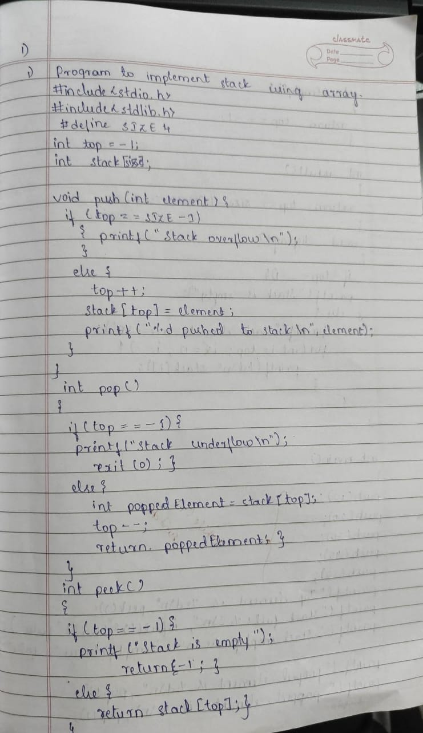

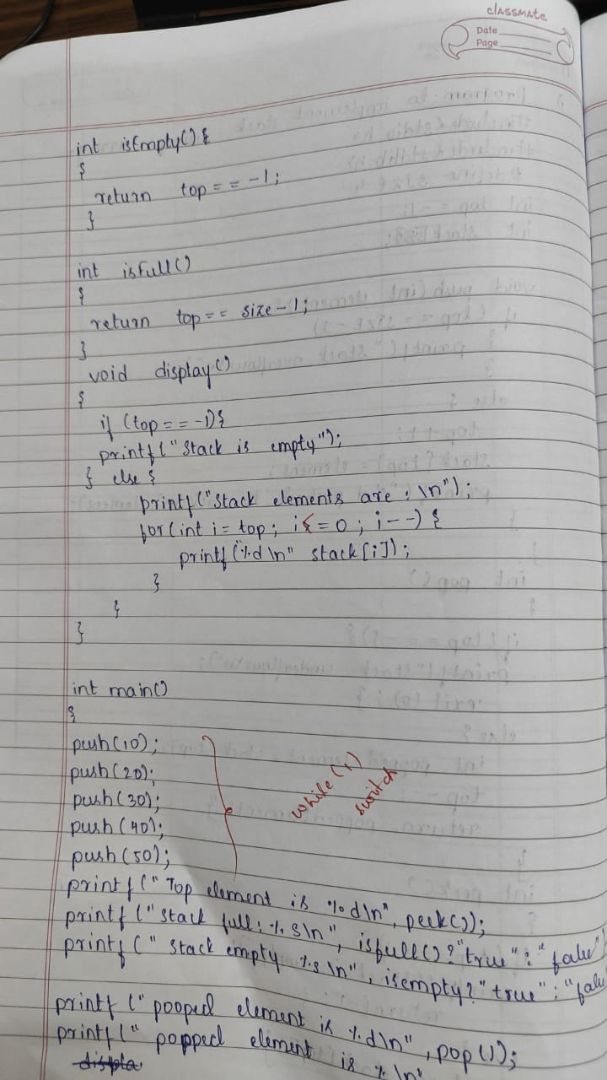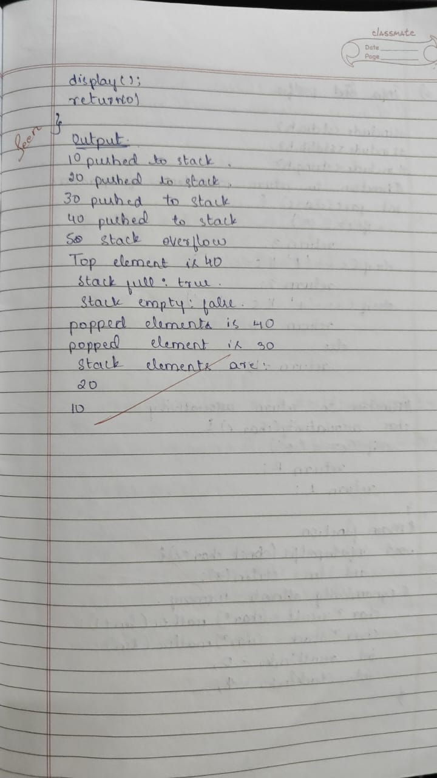

#include <stdio.h>

#define MAX 5

int stack[MAX];

int top = -1;

void push(int element) {

if (top == MAX - 1) {

printf("Stack Overflow! Unable to push %d\n", element);

} else {

stack[++top] = element;

printf("Pushed: %d\n", element);

}

}

void pop() {

if (top == -1) {

printf("Stack Underflow! The stack is empty.\n");

} else {

printf("Popped: %d\n", stack[top--]);

}

}

void display() {

if (top == -1) {

printf("The stack is empty.\n");

} else {

printf("Stack elements are: ");

for (int i = top; i >= 0; i--) {

printf("%d ", stack[i]);

}

printf("\n");

}

}

int main() {

int choice, element;

while (1) {

printf("\n--- Stack Operations ---\n");

printf("1. Push\n");

printf("2. Pop\n");

printf("3. Display\n");

printf("4. Exit\n");

printf("Enter your choice: ");

scanf("%d", &choice);

switch (choice) {

case 1:

printf("Enter the element to push: ");

scanf("%d", &element);

push(element);

break;

case 2:

pop();

break;

case 3:

display();

break;

case 4:

printf("Exiting program.\n");

return 0;

default:

printf("Invalid choice! Please try again.\n");

}

}

}

**Program 2**

WAP to convert a given valid parenthesized infix arithmetic expression to postfix expression. The expression consists of single character operands and the binary operators + (plus), - (minus), * (multiply) and / (divide)

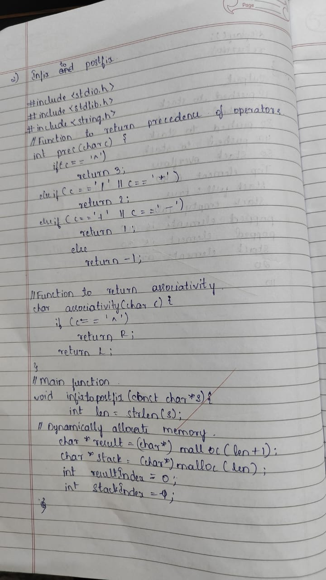

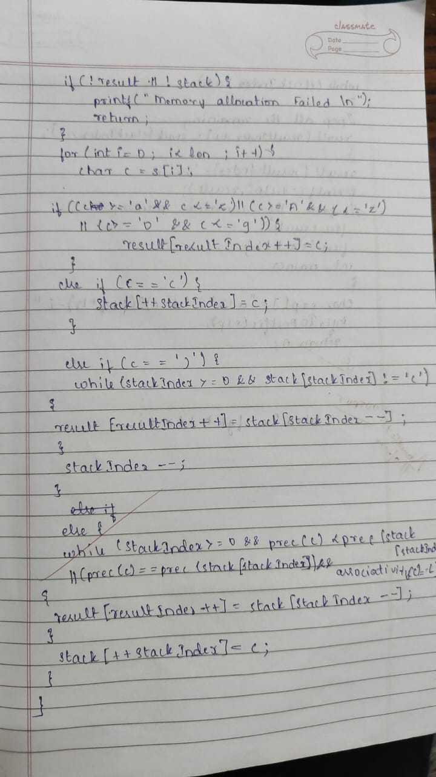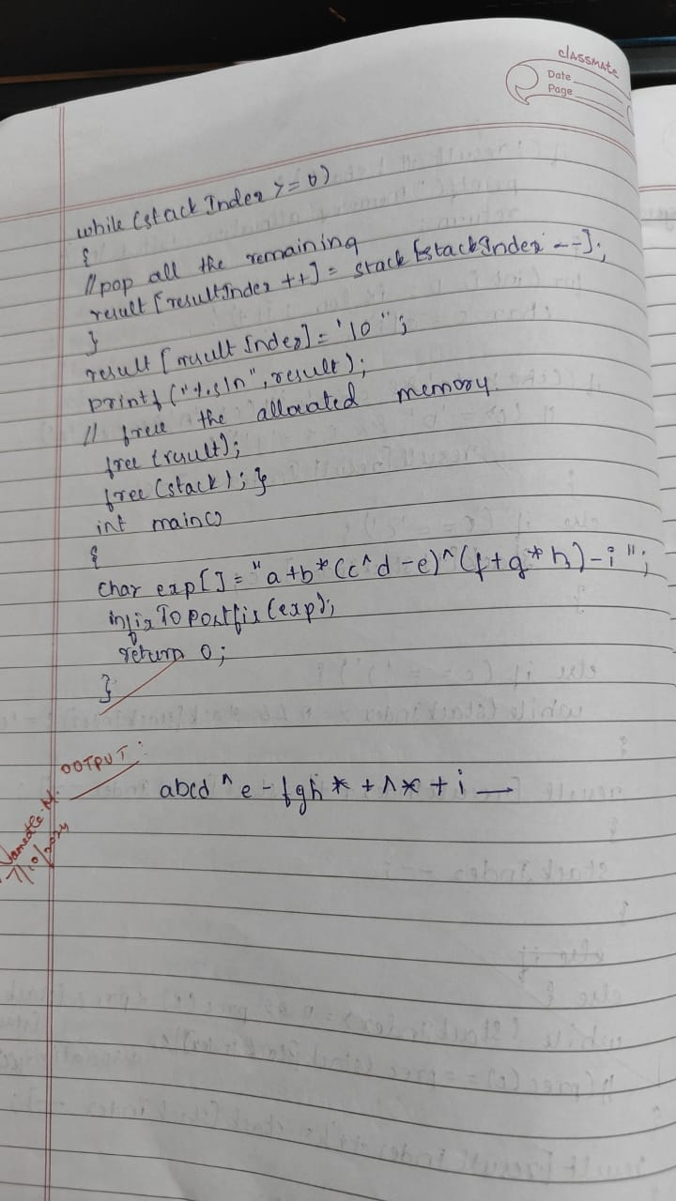

#include <stdio.h>

#include <stdlib.h>

#include <string.h>

int precedence(char c) {

if (c == '^') return 3;

else if (c == '*' || c == '/') return 2;

else if (c == '+' || c == '-') return 1;

else return -1;

}

char associativity(char c) {

if (c == '^') return 'R'; // Right-to-left associativity

return 'L'; // Left-to-right associativity

}

void infixToPostfix(const char *expr) {

int len = strlen(expr);

char *result = (char *)malloc(len + 1);

char *stack = (char *)malloc(len);

int resultIndex = 0;

int stackIndex = -1;

if (!result || !stack) {

printf("Memory allocation failed\n");

return;

}

for (int i = 0; i < len; i++) {

char c = expr[i];

if ((c >= 'a' && c <= 'z') || (c >= 'A' && c <= 'Z')) {

result[resultIndex++] = c;

}

else if (c == '(') {

stack[++stackIndex] = c;

}

else if (c == ')') {

while (stackIndex >= 0 && stack[stackIndex] != '(') {

result[resultIndex++] = stack[stackIndex--];

}

stackIndex--; // Pop the '(' from the stack

}

else {

while (stackIndex >= 0 && precedence(c) <= precedence(stack[stackIndex])) {

if (precedence(c) == precedence(stack[stackIndex]) && associativity(c) == 'R') break;

result[resultIndex++] = stack[stackIndex--];

}

stack[++stackIndex] = c;

}

}

while (stackIndex >= 0) {

result[resultIndex++] = stack[stackIndex--];

}

result[resultIndex] = '\0'; // Null-terminate the result

printf("Postfix expression: %s\n", result);

free(result);

free(stack);

}

int main() {

char expr[] = "a+b*(c^d-e)^(f+g*h)-i";

infixToPostfix(expr);

return 0;

}

**Program 3**

a) WAP to simulate the working of a queue of integers using an array. Provide the following operations: Insert, Delete, Display The program should print appropriate messages for queue empty and queue overflow conditions

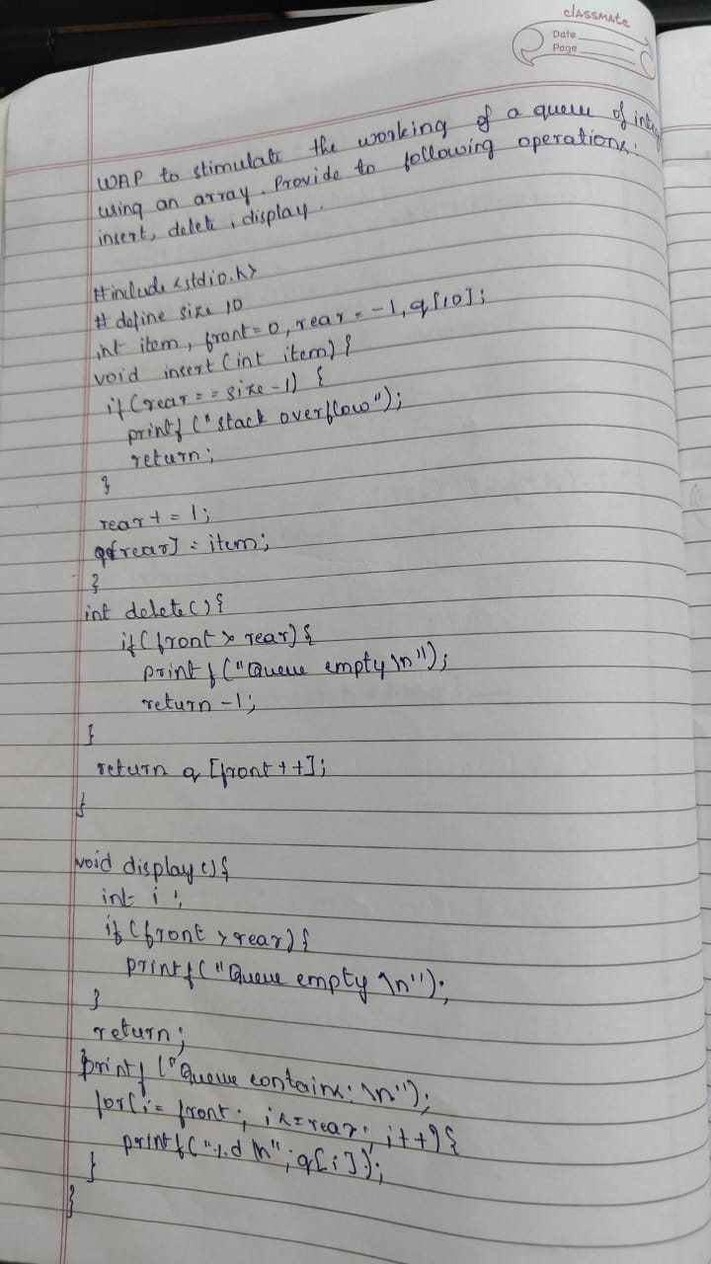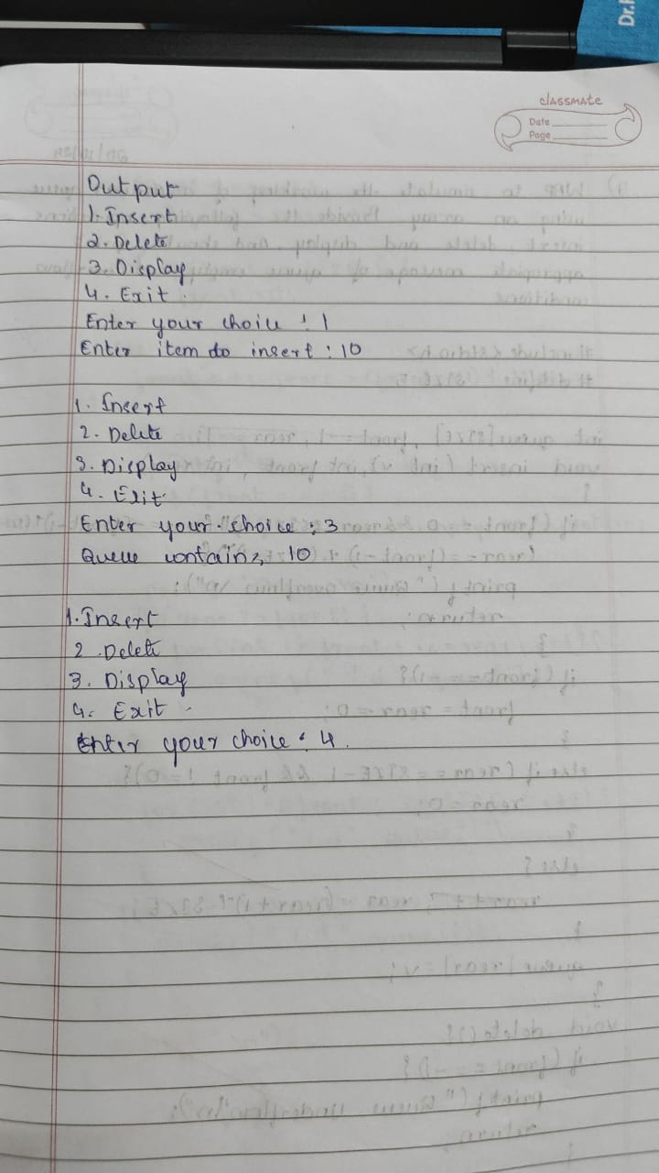

#include <stdio.h>

#define SIZE 5

int queue[SIZE];

int front = -1, rear = -1;

void insert(int value) {

if (rear == SIZE - 1) {

printf("Queue Overflow\n");

return;

}

if (front == -1) front = 0;

queue[++rear] = value;

}

void delete() {

if (front == -1 || front > rear) {

printf("Queue Underflow\n");

return;

}

front++;

}

void display() {

if (front == -1 || front > rear) {

printf("Queue is Empty\n");

return;

}

for (int i = front; i <= rear; i++) {

printf("%d ", queue[i]);

}

printf("\n");

}

int main() {

insert(10);

insert(20);

insert(30);

display();

delete();

display();

delete();

delete();

delete();

return 0;

}

**Program 3**

b ) WAP to simulate the working of a circular queue of integers using an array. Provide the following operations: Insert, Delete & Display The program should print appropriate messages for queue empty and queue overflow conditions

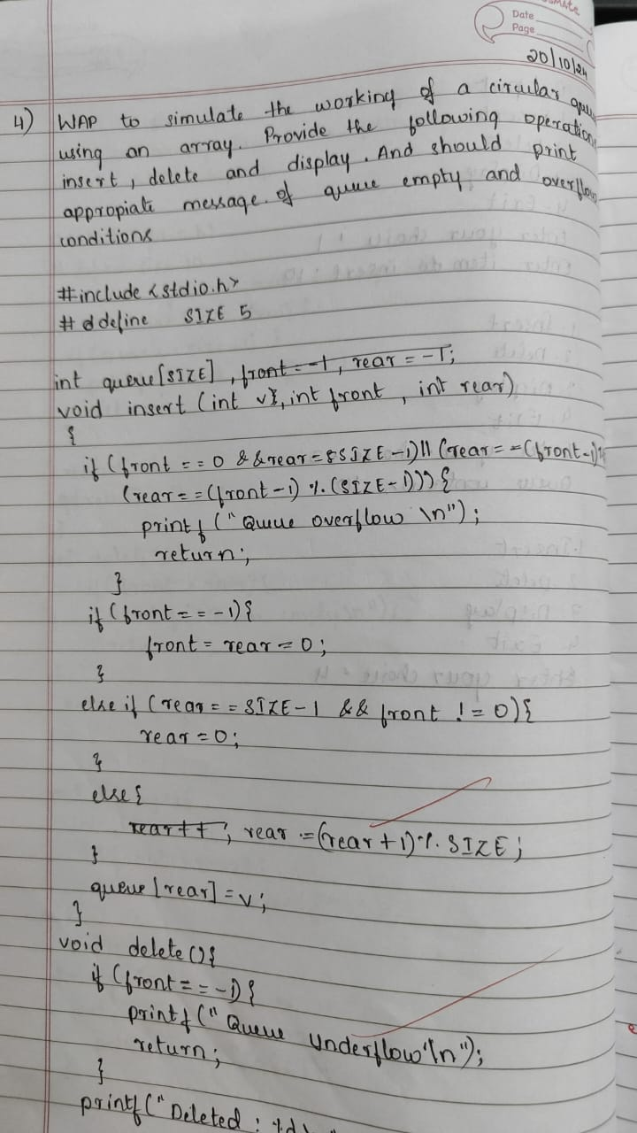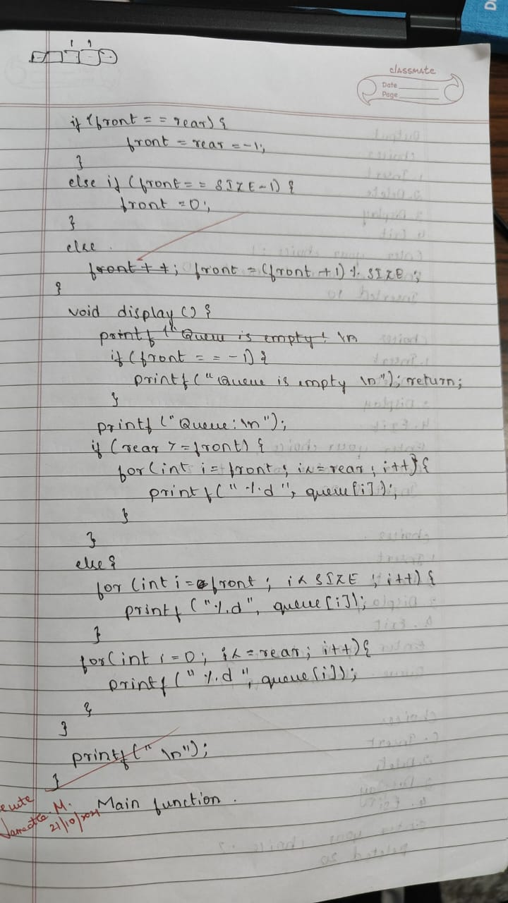

#include <stdio.h>

#define MAX 5

int queue[MAX];

int front = -1, rear = -1;

void insert(int value) {

if ((front == 0 && rear == MAX - 1) || (rear == (front - 1) % (MAX - 1))) {

printf("Queue Overflow\n");

return;

}

if (front == -1) {

front = rear = 0;

} else if (rear == MAX - 1 && front != 0) {

rear = 0;

} else {

rear++;

}

queue[rear] = value;

}

void delete() {

if (front == -1) {

printf("Queue Underflow\n");

return;

}

if (front == rear) {

front = rear = -1;

} else if (front == MAX - 1) {

front = 0;

} else {

front++;

}

}

void display() {

if (front == -1) {

printf("Queue is Empty\n");

return;

}

if (rear >= front) {

for (int i = front; i <= rear; i++) {

printf("%d ", queue[i]);

}

} else {

for (int i = front; i < MAX; i++) {

printf("%d ", queue[i]);

}

for (int i = 0; i <= rear; i++) {

printf("%d ", queue[i]);

}

}

printf("\n");

}

int main() {

int choice, value;

do {

printf("1. Insert\n2. Delete\n3. Display\n4. Exit\n");

printf("Enter your choice: ");

scanf("%d", &choice);

switch (choice) {

case 1:

printf("Enter the value to insert: ");

scanf("%d", &value);

insert(value);

break;

case 2:

delete();

break;

case 3:

display();

break;

case 4:

break;

default:

printf("Invalid choice\n");

}

} while (choice != 4);

return 0;

**Program 3**

**Program 4**

WAP to Implement Singly Linked List with following operations a) Create a linked list. b) Deletion of first element, specified element and last element in the list. c) Display the contents of the linked list

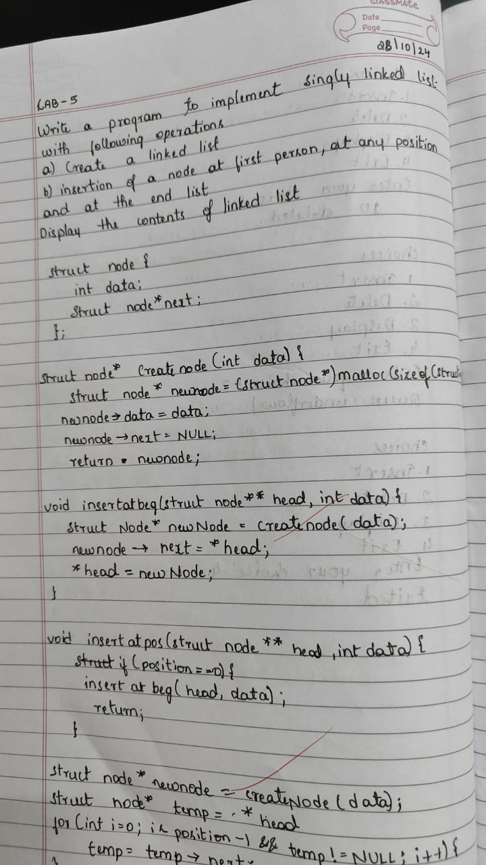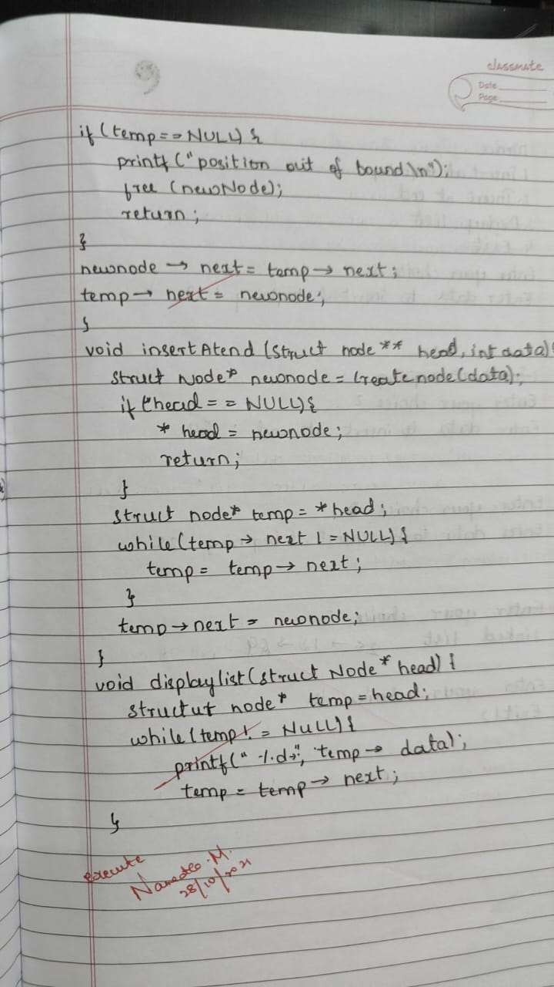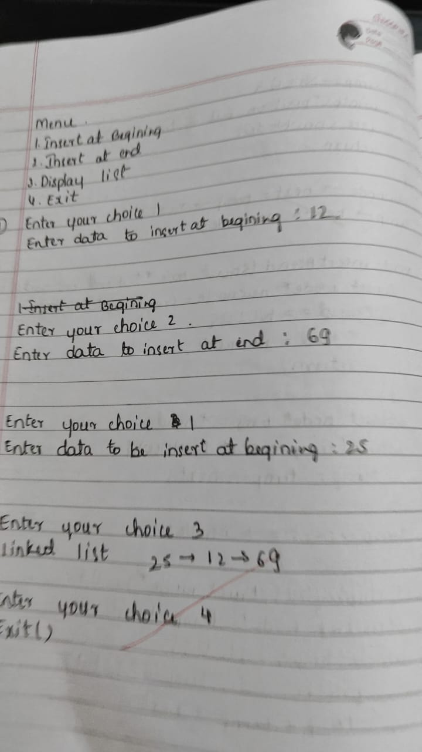

#include <stdio.h>

#include <stdlib.h>

struct Node {

int data;

struct Node* next;

};

struct Node* head = NULL;

void createList(int data) {

struct Node* newNode = (struct Node*)malloc(sizeof(struct Node));

newNode->data = data;

newNode->next = NULL;

if (head == NULL) {

head = newNode;

} else {

struct Node* temp = head;

while (temp->next != NULL) {

temp = temp->next;

}

temp->next = newNode;

}

}

void insertFirst(int data) {

struct Node* newNode = (struct Node*)malloc(sizeof(struct Node));

newNode->data = data;

newNode->next = head;

head = newNode;

}

void insertAtPosition(int data, int position) {

struct Node* newNode = (struct Node*)malloc(sizeof(struct Node));

newNode->data = data;

if (position == 1) {

newNode->next = head;

head = newNode;

return;

}

struct Node* temp = head;

for (int i = 1; temp != NULL && i < position - 1; i++) {

temp = temp->next;

}

if (temp == NULL) {

printf("Position out of range\n");

return;

}

newNode->next = temp->next;

temp->next = newNode;

}

void insertLast(int data) {

struct Node* newNode = (struct Node*)malloc(sizeof(struct Node));

newNode->data = data;

newNode->next = NULL;

if (head == NULL) {

head = newNode;

} else {

struct Node* temp = head;

while (temp->next != NULL) {

temp = temp->next;

}

temp->next = newNode;

}

}

void displayList() {

struct Node* temp = head;

while (temp != NULL) {

printf("%d ", temp->data);

temp = temp->next;

}

printf("\n");

}

int main() {

int choice, data, position;

while (1) {

printf("1. Create List\n");

printf("2. Insert at First Position\n");

printf("3. Insert at Any Position\n");

printf("4. Insert at Last Position\n");

printf("5. Display List\n");

printf("6. Exit\n");

printf("Enter your choice: ");

scanf("%d", &choice);

switch (choice) {

case 1:

printf("Enter data to create list: ");

scanf("%d", &data);

createList(data);

break;

case 2:

printf("Enter data to insert at first position: ");

scanf("%d", &data);

insertFirst(data);

break;

case 3:

printf("Enter data and position to insert: ");

scanf("%d %d", &data, &position);

insertAtPosition(data, position);

break;

case 4:

printf("Enter data to insert at last position: ");

scanf("%d", &data);

insertLast(data);

break;

case 5:

displayList();

break;

case 6:

exit(0);

default:

printf("Invalid choice\n");

}

}

**Program 5**

WAP to Implement Singly Linked List with following operations a) Create a linked list. b) Deletion of first element, specified element and last element in the list. c) Display the contents of the linked list.

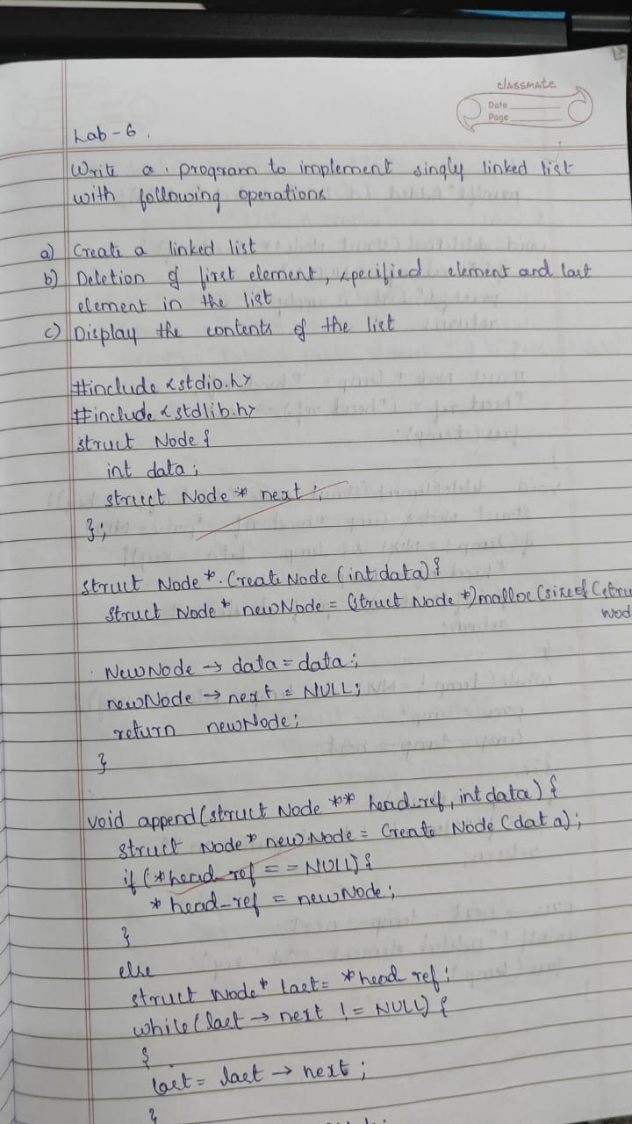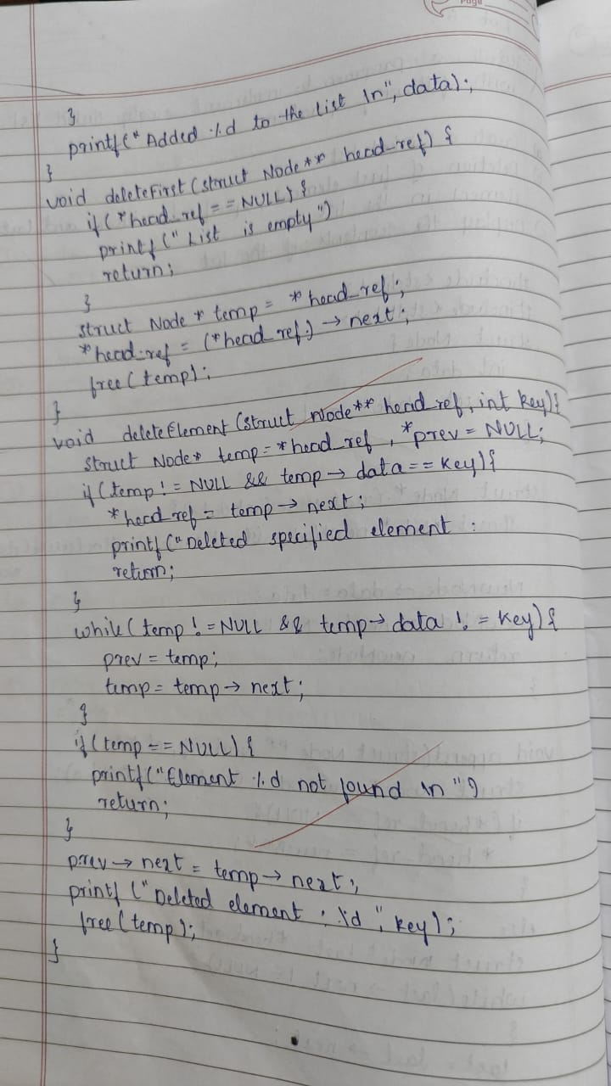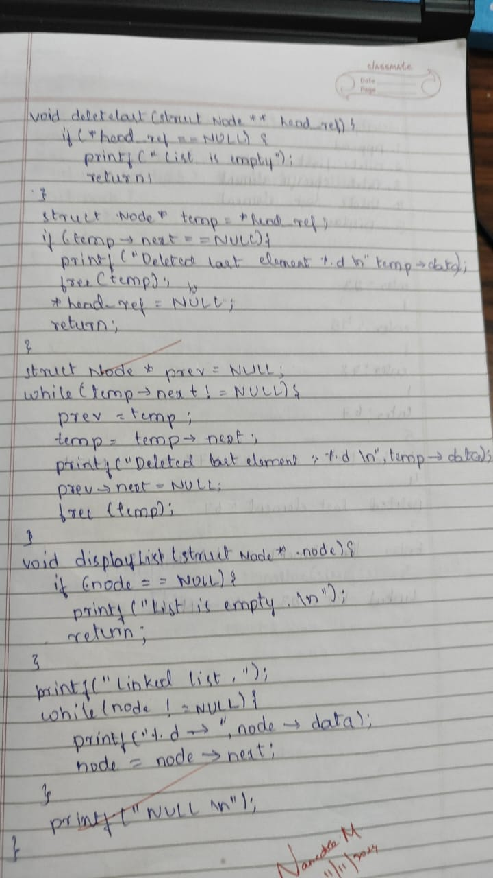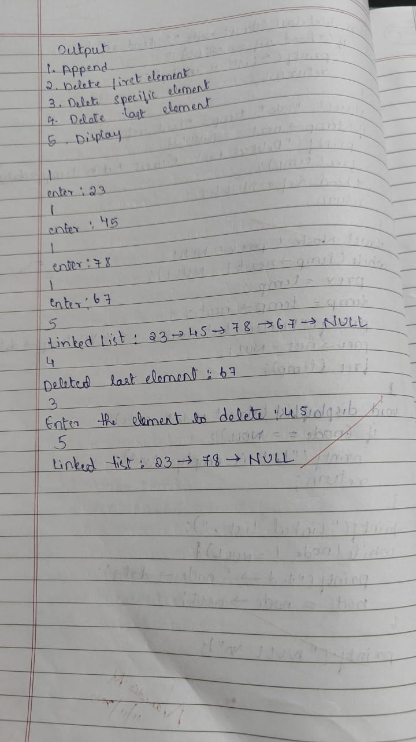

#include <stdio.h>

#include <stdlib.h>

struct Node {

int data;

struct Node* next;

};

struct Node* head = NULL;

void createList(int data) {

struct Node* newNode = (struct Node*)malloc(sizeof(struct Node));

newNode->data = data;

newNode->next = NULL;

if (head == NULL) {

head = newNode;

} else {

struct Node* temp = head;

while (temp->next != NULL) {

temp = temp->next;

}

temp->next = newNode;

}

}

void deleteFirst() {

if (head != NULL) {

struct Node* temp = head;

head = head->next;

free(temp);

}

}

void deleteLast() {

if (head != NULL) {

if (head->next == NULL) {

free(head);

head = NULL;

} else {

struct Node* temp = head;

while (temp->next != NULL && temp->next->next != NULL) {

temp = temp->next;

}

free(temp->next);

temp->next = NULL;

}

}

}

void deleteSpecified(int value) {

if (head != NULL) {

if (head->data == value) {

struct Node* temp = head;

head = head->next;

free(temp);

} else {

struct Node* temp = head;

while (temp->next != NULL && temp->next->data != value) {

temp = temp->next;

}

if (temp->next != NULL) {

struct Node* toDelete = temp->next;

temp->next = temp->next->next;

free(toDelete);

}

}

}

}

void displayList() {

struct Node* temp = head;

while (temp != NULL) {

printf("%d ", temp->data);

temp = temp->next;

}

printf("\n");

}

int main() {

int choice, data, value;

while (1) {

printf("1. Create List\n");

printf("2. Delete First Element\n");

printf("3. Delete Last Element\n");

printf("4. Delete Specified Element\n");

printf("5. Display List\n");

printf("6. Exit\n");

printf("Enter your choice: ");

scanf("%d", &choice);

switch (choice) {

case 1:

printf("Enter data to create list: ");

scanf("%d", &data);

createList(data);

break;

case 2:

deleteFirst();

printf("First element deleted.\n");

break;

case 3:

deleteLast();

printf("Last element deleted.\n");

break;

case 4:

printf("Enter value to delete: ");

scanf("%d", &value);

deleteSpecified(value);

printf("Specified element deleted.\n");

break;

case 5:

displayList();

break;

case 6:

exit(0);

default:

printf("Invalid choice\n");

}

}

**Program 6**

a) WAP to Implement Single Link List with following operations: Sort the linked list, Reverse the linked list, Concatenation of two linked lists

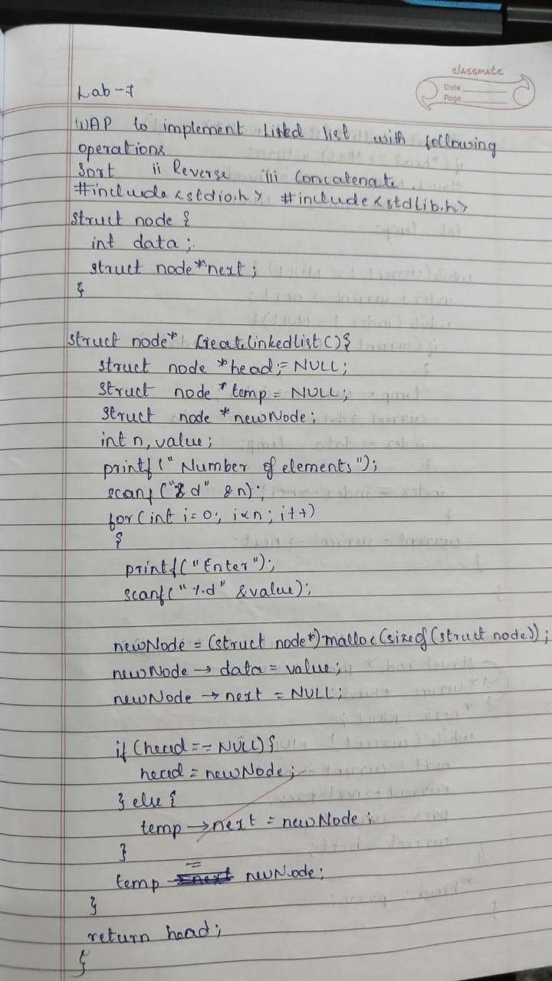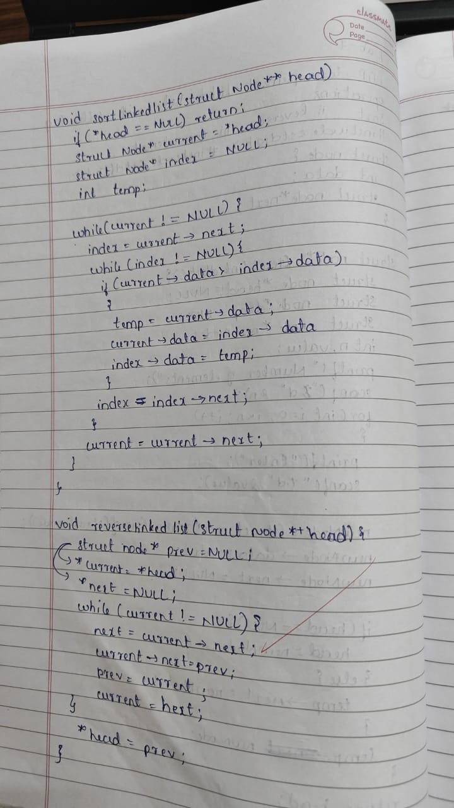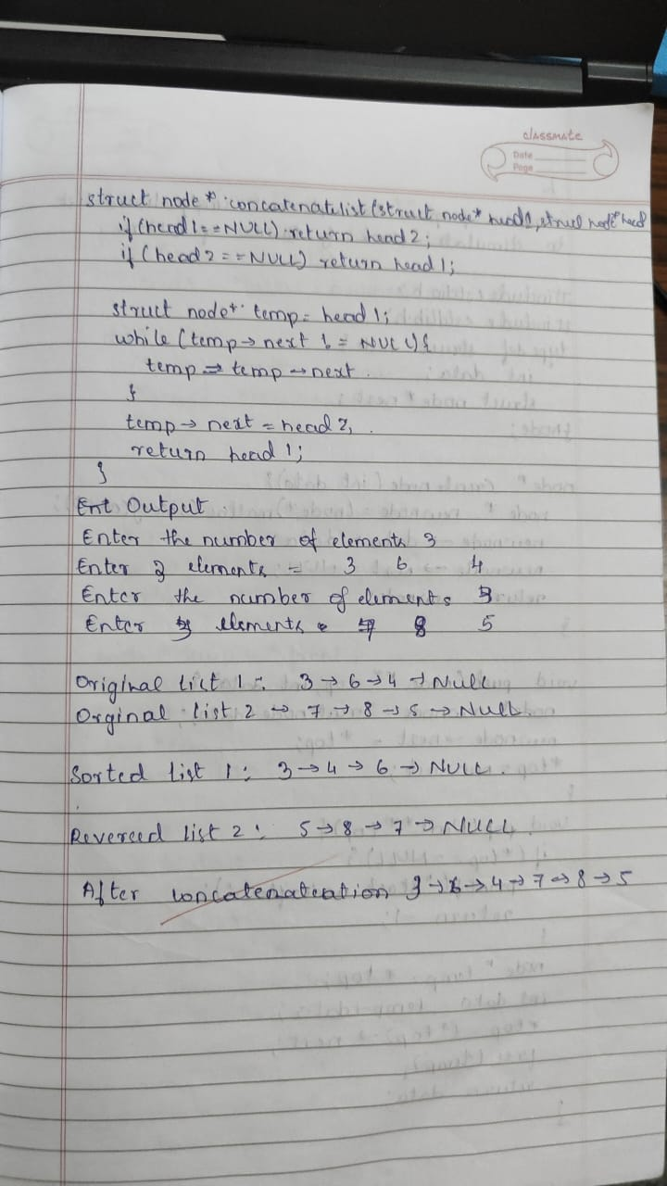

#include <stdio.h>

#include <stdlib.h>

struct Node {

int data;

struct Node* next;

};

struct Node* head = NULL;

struct Node* head2 = NULL;

void createList(struct Node** head, int data) {

struct Node* newNode = (struct Node*)malloc(sizeof(struct Node));

newNode->data = data;

newNode->next = NULL;

if (*head == NULL) {

*head = newNode;

} else {

struct Node* temp = *head;

while (temp->next != NULL) {

temp = temp->next;

}

temp->next = newNode;

}

}

void displayList(struct Node* head) {

struct Node* temp = head;

while (temp != NULL) {

printf("%d ", temp->data);

temp = temp->next;

}

printf("\n");

}

void sortList(struct Node* head) {

struct Node *i, *j;

int temp;

for (i = head; i != NULL; i = i->next) {

for (j = i->next; j != NULL; j = j->next) {

if (i->data > j->data) {

temp = i->data;

i->data = j->data;

j->data = temp;

}

}

}

}

void reverseList(struct Node** head) {

struct Node *prev = NULL, *current = *head, *next = NULL;

while (current != NULL) {

next = current->next;

current->next = prev;

prev = current;

current = next;

}

*head = prev;

}

void concatenateLists(struct Node* head1, struct Node* head2) {

if (head1 == NULL) {

head1 = head2;

return;

}

struct Node* temp = head1;

while (temp->next != NULL) {

temp = temp->next;

}

temp->next = head2;

}

int main() {

int choice, data;

while (1) {

printf("1. Create List 1\n");

printf("2. Create List 2\n");

printf("3. Display List 1\n");

printf("4. Display List 2\n");

printf("5. Sort List 1\n");

printf("6. Reverse List 1\n");

printf("7. Concatenate Lists\n");

printf("8. Exit\n");

printf("Enter your choice: ");

scanf("%d", &choice);

switch (choice) {

case 1:

printf("Enter data to create List 1: ");

scanf("%d", &data);

createList(&head, data);

break;

case 2:

printf("Enter data to create List 2: ");

scanf("%d", &data);

createList(&head2, data);

break;

case 3:

printf("List 1: ");

displayList(head);

break;

case 4:

printf("List 2: ");

displayList(head2);

break;

case 5:

sortList(head);

printf("List 1 sorted.\n");

break;

case 6:

reverseList(&head);

printf("List 1 reversed.\n");

break;

case 7:

concatenateLists(head, head2);

printf("Lists concatenated.\n");

break;

case 8:

exit(0);

default:

printf("Invalid choice\n");

}

}

return 0;

}

**Program 6**

b) WAP to Implement Single Link List to simulate Stack & Queue Operations

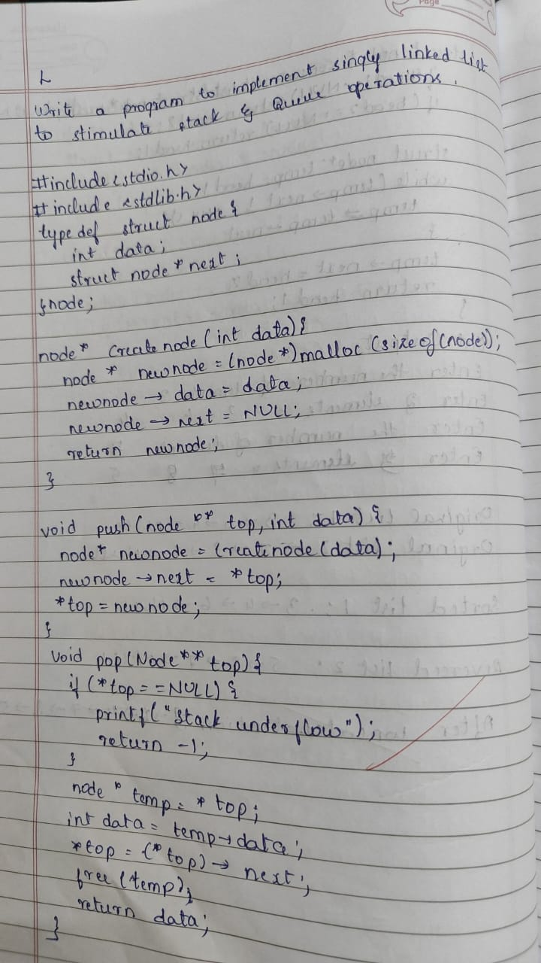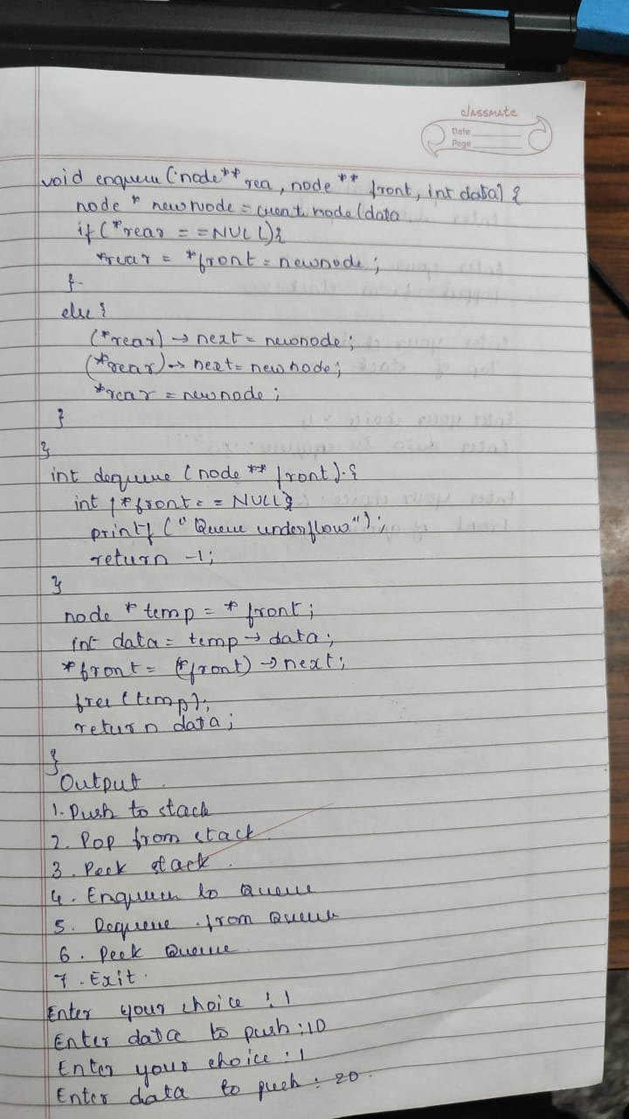

#include <stdio.h>

#include <stdlib.h>

struct Node {

int data;

struct Node* next;

};

struct Node* stackTop = NULL;

struct Node* queueFront = NULL;

struct Node* queueRear = NULL;

// Stack Operations

void push(int data) {

struct Node* newNode = (struct Node*)malloc(sizeof(struct Node));

newNode->data = data;

newNode->next = stackTop;

stackTop = newNode;

}

int pop() {

if (stackTop == NULL) {

printf("Stack is empty.\n");

return -1;

}

struct Node* temp = stackTop;

int data = temp->data;

stackTop = stackTop->next;

free(temp);

return data;

}

void displayStack() {

struct Node* temp = stackTop;

if (temp == NULL) {

printf("Stack is empty.\n");

} else {

printf("Stack: ");

while (temp != NULL) {

printf("%d ", temp->data);

temp = temp->next;

}

printf("\n");

}

}

// Queue Operations

void enqueue(int data) {

struct Node* newNode = (struct Node*)malloc(sizeof(struct Node));

newNode->data = data;

newNode->next = NULL;

if (queueRear == NULL) {

queueFront = queueRear = newNode;

return;

}

queueRear->next = newNode;

queueRear = newNode;

}

int dequeue() {

if (queueFront == NULL) {

printf("Queue is empty.\n");

return -1;

}

struct Node* temp = queueFront;

int data = temp->data;

queueFront = queueFront->next;

if (queueFront == NULL) {

queueRear = NULL;

}

free(temp);

return data;

}

void displayQueue() {

struct Node* temp = queueFront;

if (temp == NULL) {

printf("Queue is empty.\n");

} else {

printf("Queue: ");

while (temp != NULL) {

printf("%d ", temp->data);

temp = temp->next;

}

printf("\n");

}

}

int main() {

int choice, data;

while (1) {

printf("1. Push to Stack\n");

printf("2. Pop from Stack\n");

printf("3. Display Stack\n");

printf("4. Enqueue to Queue\n");

printf("5. Dequeue from Queue\n");

printf("6. Display Queue\n");

printf("7. Exit\n");

printf("Enter your choice: ");

scanf("%d", &choice);

switch (choice) {

case 1:

printf("Enter data to push to stack: ");

scanf("%d", &data);

push(data);

break;

case 2:

data = pop();

if (data != -1) {

printf("Popped from stack: %d\n", data);

}

break;

case 3:

displayStack();

break;

case 4:

printf("Enter data to enqueue to queue: ");

scanf("%d", &data);

enqueue(data);

break;

case 5:

data = dequeue();

if (data != -1) {

printf("Dequeued from queue: %d\n", data);

}

break;

case 6:

displayQueue();

break;

case 7:

exit(0);

default:

printf("Invalid choice\n");

}

}

return 0;

}

**Program 7**

WAP to Implement doubly link list with primitive operations a) Create a doubly linked list. b) Insert a new node to the left of the node. c) Delete the node based on a specific value d) Display the contents of the list

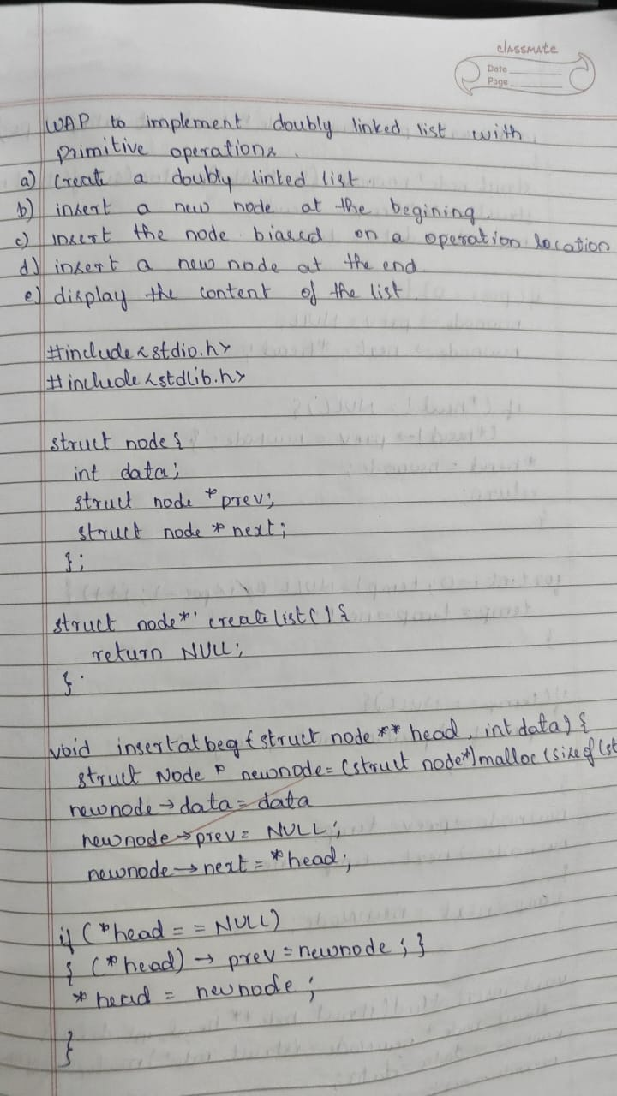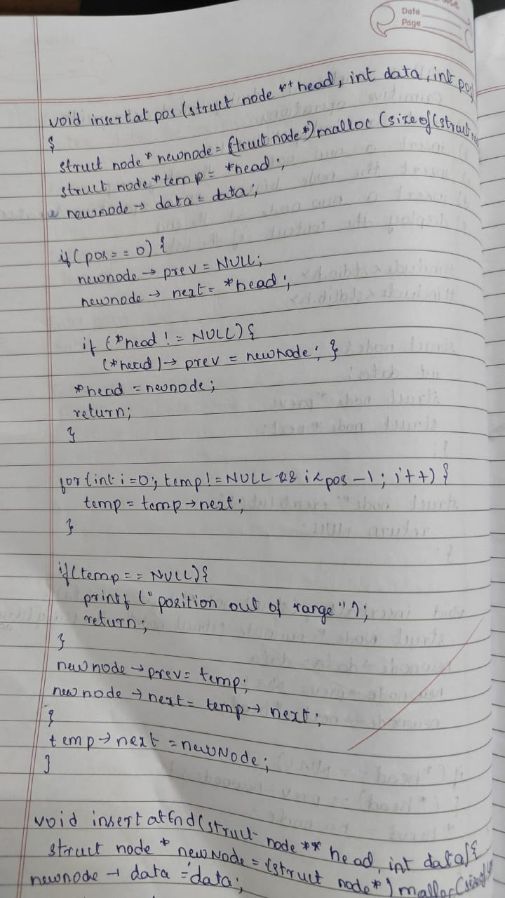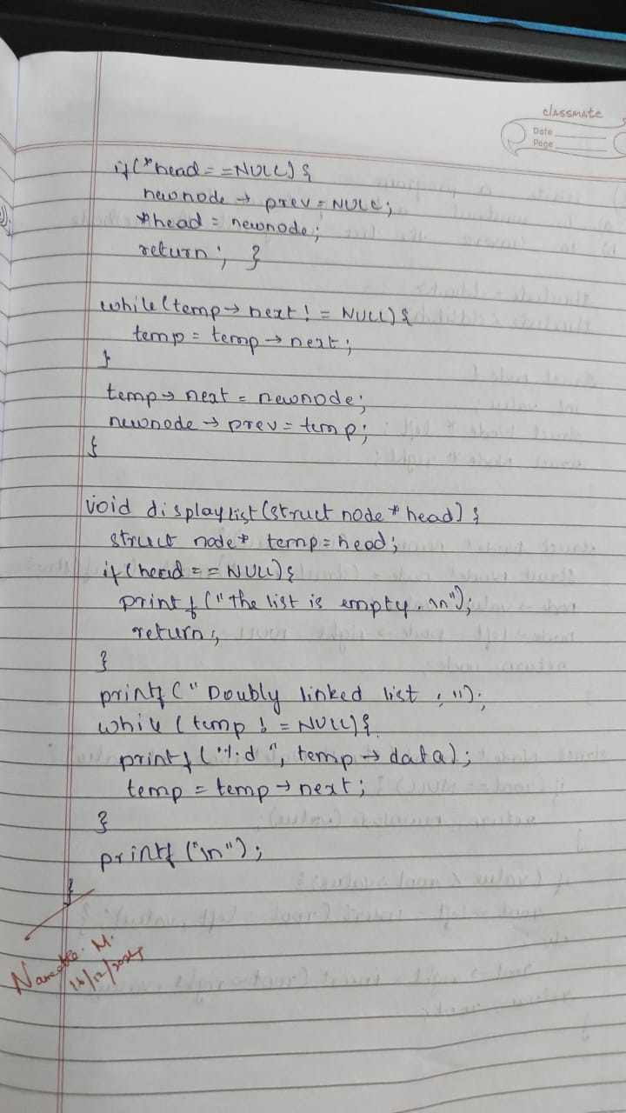

#include <stdio.h>

#include <stdlib.h>

struct Node {

int data;

struct Node* prev;

struct Node* next;

};

struct Node* head = NULL;

void createList(int data) {

struct Node* newNode = (struct Node*)malloc(sizeof(struct Node));

newNode->data = data;

newNode->prev = NULL;

newNode->next = NULL;

if (head == NULL) {

head = newNode;

} else {

struct Node* temp = head;

while (temp->next != NULL) {

temp = temp->next;

}

temp->next = newNode;

newNode->prev = temp;

}

}

void insertLeft(int newData, int existingData) {

struct Node* newNode = (struct Node*)malloc(sizeof(struct Node));

newNode->data = newData;

struct Node* temp = head;

while (temp != NULL && temp->data != existingData) {

temp = temp->next;

}

if (temp != NULL) {

newNode->next = temp;

newNode->prev = temp->prev;

if (temp->prev != NULL) {

temp->prev->next = newNode;

} else {

head = newNode;

}

temp->prev = newNode;

} else {

printf("Node with data %d not found.\n", existingData);

}

}

void deleteNode(int value) {

struct Node* temp = head;

while (temp != NULL && temp->data != value) {

temp = temp->next;

}

if (temp != NULL) {

if (temp->prev != NULL) {

temp->prev->next = temp->next;

} else {

head = temp->next;

}

if (temp->next != NULL) {

temp->next->prev = temp->prev;

}

free(temp);

printf("Node with value %d deleted.\n", value);

} else {

printf("Node with value %d not found.\n", value);

}

}

void displayList() {

struct Node* temp = head;

if (temp == NULL) {

printf("List is empty.\n");

} else {

printf("Doubly Linked List: ");

while (temp != NULL) {

printf("%d ", temp->data);

temp = temp->next;

}

printf("\n");

}

}

int main() {

int choice, data, existingData;

while (1) {

printf("1. Create List\n");

printf("2. Insert Node to the Left\n");

printf("3. Delete Node\n");

printf("4. Display List\n");

printf("5. Exit\n");

printf("Enter your choice: ");

scanf("%d", &choice);

switch (choice) {

case 1:

printf("Enter data to create list: ");

scanf("%d", &data);

createList(data);

break;

case 2:

printf("Enter new node data: ");

scanf("%d", &data);

printf("Enter the existing node data to insert left of: ");

scanf("%d", &existingData);

insertLeft(data, existingData);

break;

case 3:

printf("Enter the node value to delete: ");

scanf("%d", &data);

deleteNode(data);

break;

case 4:

displayList();

break;

case 5:

exit(0);

default:

printf("Invalid choice\n");

}

}

return 0;

}

**Program 8**

Write a program a) ToconstructabinarySearchtree. b) To traverse the tree using all the methods i.e., inorder, preorder and post order c) To display the elements in the tree

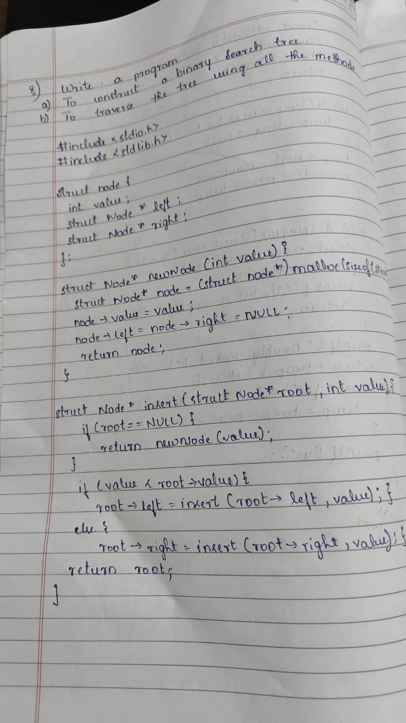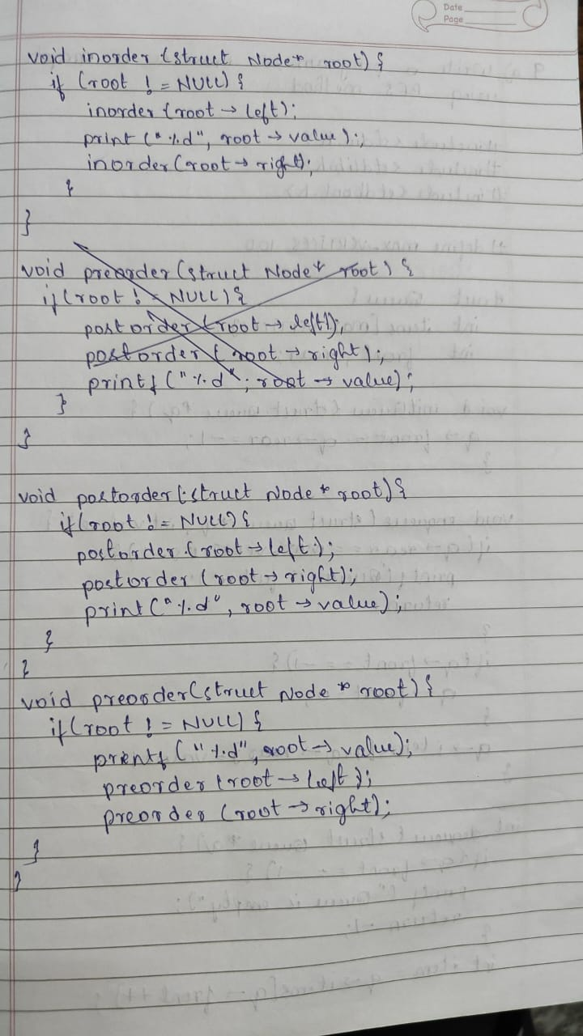

#include <stdio.h>

#include <stdlib.h>

// Structure for a node in the binary search tree

struct Node {

int data;

struct Node* left;

struct Node* right;

};

// Function to create a new node

struct Node* createNode(int data) {

struct Node* newNode = (struct Node*)malloc(sizeof(struct Node));

newNode->data = data;

newNode->left = newNode->right = NULL;

return newNode;

}

// Function to insert a node in the binary search tree

struct Node* insert(struct Node* root, int data) {

if (root == NULL) {

return createNode(data);

}

if (data < root->data) {

root->left = insert(root->left, data);

} else {

root->right = insert(root->right, data);

}

return root;

}

// In-order traversal (Left, Root, Right)

void inorder(struct Node* root) {

if (root != NULL) {

inorder(root->left);

printf("%d ", root->data);

inorder(root->right);

}

}

// Pre-order traversal (Root, Left, Right)

void preorder(struct Node* root) {

if (root != NULL) {

printf("%d ", root->data);

preorder(root->left);

preorder(root->right);

}

}

// Post-order traversal (Left, Right, Root)

void postorder(struct Node* root) {

if (root != NULL) {

postorder(root->left);

postorder(root->right);

printf("%d ", root->data);

}

}

// Function to display the elements in the tree using in-order traversal

void display(struct Node* root) {

printf("In-order traversal: ");

inorder(root);

printf("\n");

}

int main() {

struct Node* root = NULL;

int choice, data;

while (1) {

printf("1. Insert Node\n");

printf("2. In-order Traversal\n");

printf("3. Pre-order Traversal\n");

printf("4. Post-order Traversal\n");

printf("5. Display In-order Traversal\n");

printf("6. Exit\n");

printf("Enter your choice: ");

scanf("%d", &choice);

switch (choice) {

case 1:

printf("Enter data to insert: ");

scanf("%d", &data);

root = insert(root, data);

break;

case 2:

printf("In-order Traversal: ");

inorder(root);

printf("\n");

break;

case 3:

printf("Pre-order Traversal: ");

preorder(root);

printf("\n");

break;

case 4:

printf("Post-order Traversal: ");

postorder(root);

printf("\n");

break;

case 5:

display(root);

break;

case 6:

exit(0);

default:

printf("Invalid choice\n");

}

}

return 0;

}

**Program 9**

1. Write a program to traverse a graph using BFS method.

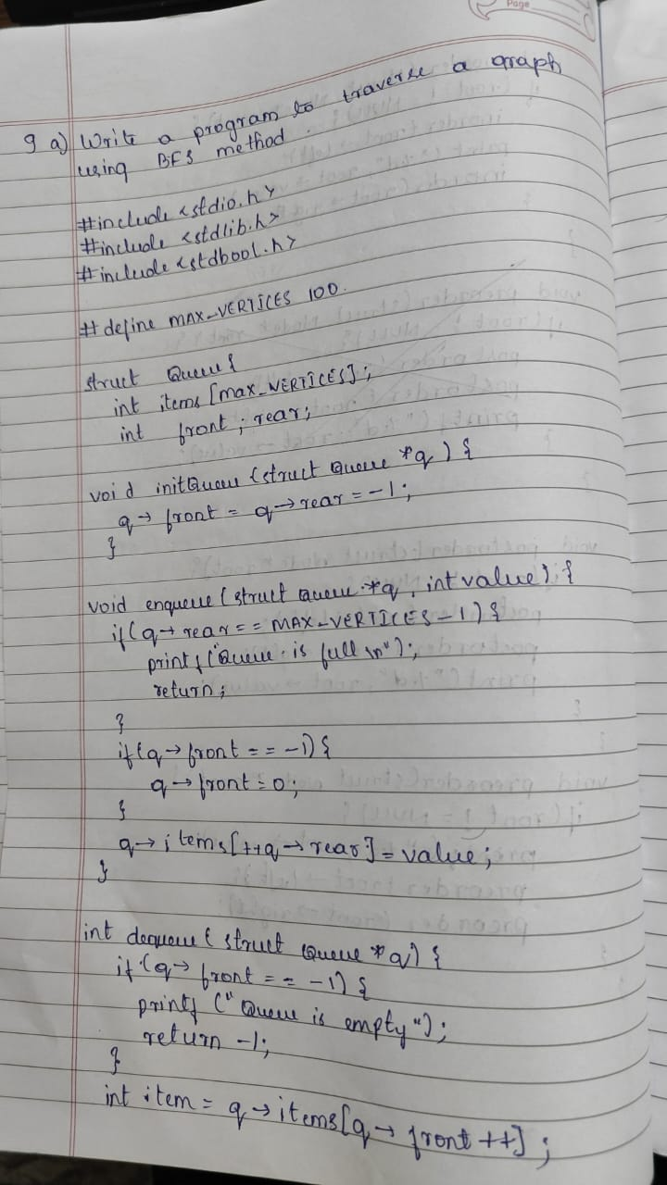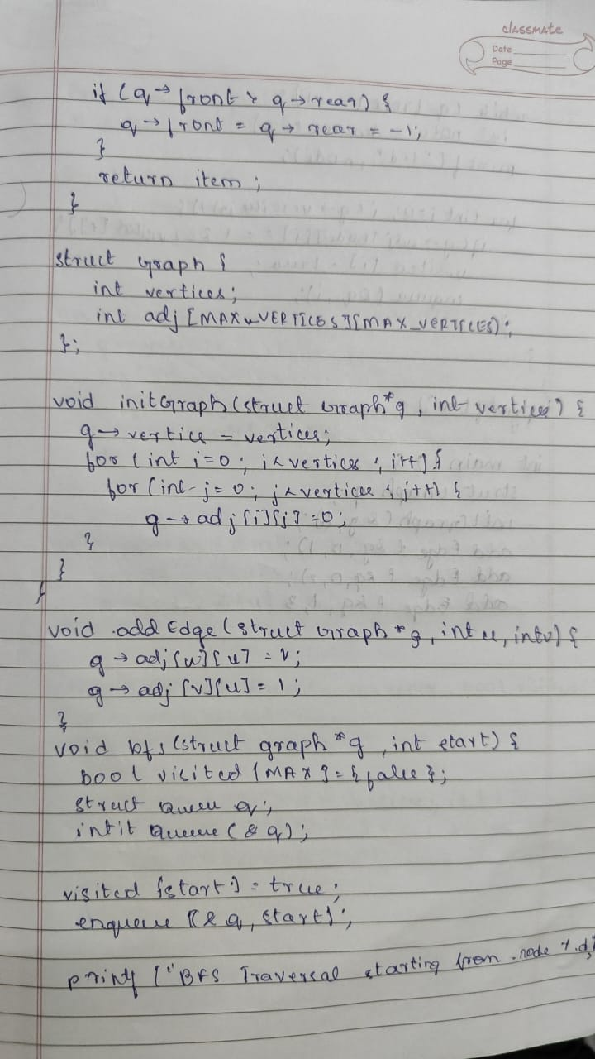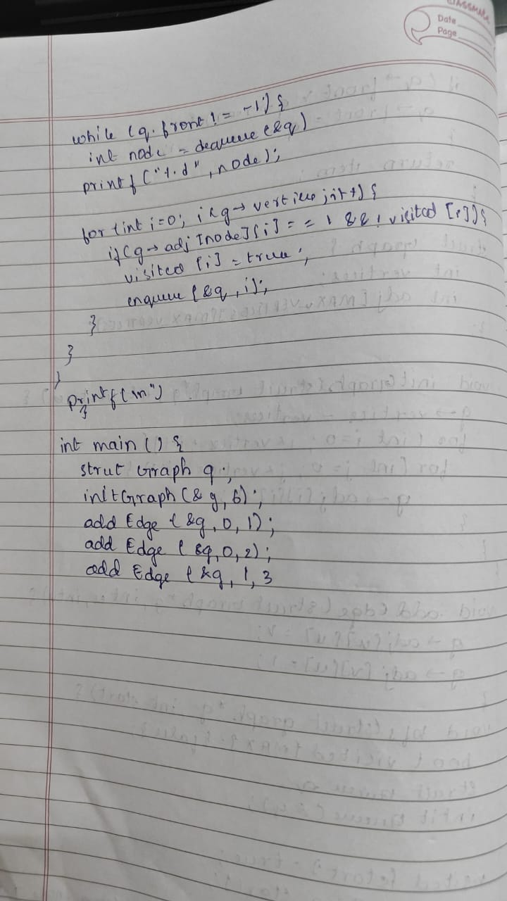

#include <stdio.h>

#include <stdlib.h>

#define MAX_VERTICES 100

struct Queue {

int items[MAX_VERTICES];

int front, rear;

};

struct Graph {

int adj[MAX_VERTICES][MAX_VERTICES];

int vertices;

};

void initQueue(struct Queue* q) {

q->front = -1;

q->rear = -1;

}

int isQueueEmpty(struct Queue* q) {

return q->front == -1;

}

void enqueue(struct Queue* q, int value) {

if (q->rear == MAX_VERTICES - 1) {

printf("Queue Overflow\n");

return;

}

if (q->front == -1)

q->front = 0;

q->rear++;

q->items[q->rear] = value;

}

int dequeue(struct Queue* q) {

if (isQueueEmpty(q)) {

printf("Queue Underflow\n");

return -1;

}

int item = q->items[q->front];

q->front++;

if (q->front > q->rear) {

q->front = q->rear = -1;

}

return item;

}

void initGraph(struct Graph* g, int vertices) {

g->vertices = vertices;

for (int i = 0; i < vertices; i++) {

for (int j = 0; j < vertices; j++) {

g->adj[i][j] = 0;

}

}

}

void addEdge(struct Graph* g, int u, int v) {

g->adj[u][v] = 1;

g->adj[v][u] = 1;

}

void bfs(struct Graph* g, int startVertex) {

int visited[MAX_VERTICES] = {0};

struct Queue q;

initQueue(&q);

visited[startVertex] = 1;

enqueue(&q, startVertex);

printf("BFS Traversal starting from vertex %d: ", startVertex);

while (!isQueueEmpty(&q)) {

int currentVertex = dequeue(&q);

printf("%d ", currentVertex);

for (int i = 0; i < g->vertices; i++) {

if (g->adj[currentVertex][i] == 1 && !visited[i]) {

enqueue(&q, i);

visited[i] = 1;

}

}

}

printf("\n");

}

int main() {

struct Graph g;

int vertices, edges, u, v, startVertex;

printf("Enter number of vertices: ");

scanf("%d", &vertices);

initGraph(&g, vertices);

printf("Enter number of edges: ");

scanf("%d", &edges);

for (int i = 0; i < edges; i++) {

printf("Enter edge (u v): ");

scanf("%d %d", &u, &v);

addEdge(&g, u, v);

}

printf("Enter the starting vertex for BFS: ");

scanf("%d", &startVertex);

bfs(&g, startVertex);

return 0;

}

**Program 9**

1. Write a program to check whether given graph is connected or not using DFS method.

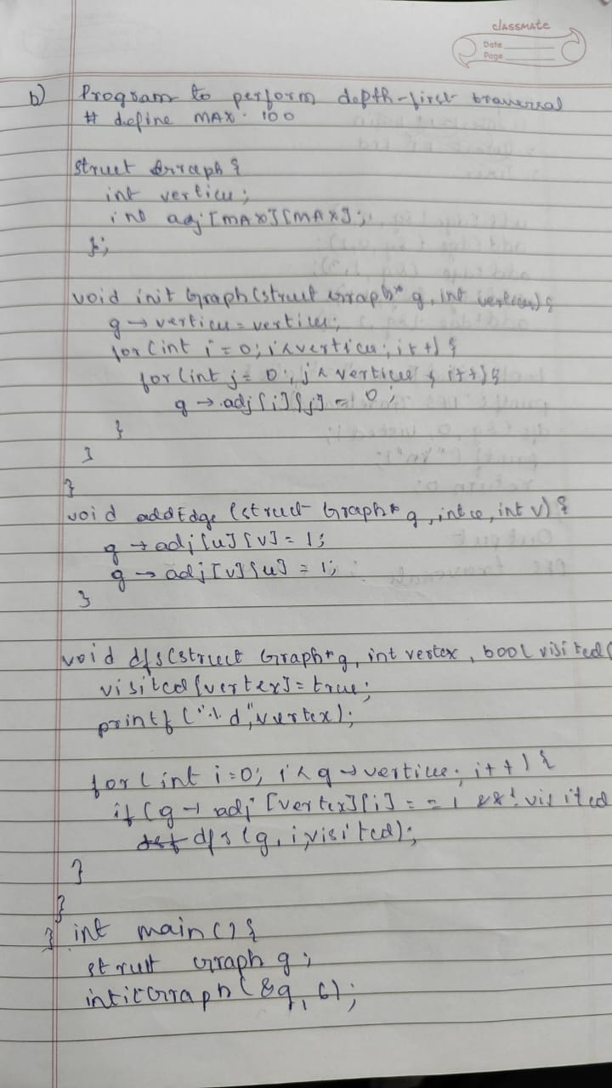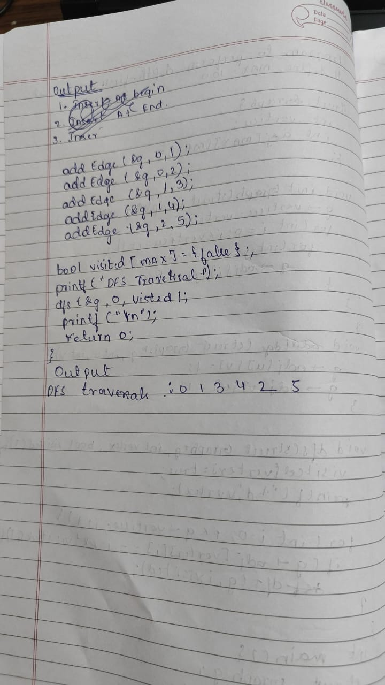

#include <stdio.h>

#include <stdlib.h>

#define MAX_VERTICES 100

struct Graph {

int adj[MAX_VERTICES][MAX_VERTICES];

int vertices;

};

void initGraph(struct Graph* g, int vertices) {

g->vertices = vertices;

for (int i = 0; i < vertices; i++) {

for (int j = 0; j < vertices; j++) {

g->adj[i][j] = 0;

}

}

}

void addEdge(struct Graph* g, int u, int v) {

g->adj[u][v] = 1;

g->adj[v][u] = 1;

}

void dfs(struct Graph* g, int vertex, int visited[]) {

visited[vertex] = 1;

for (int i = 0; i < g->vertices; i++) {

if (g->adj[vertex][i] == 1 && !visited[i]) {

dfs(g, i, visited);

}

}

}

int isConnected(struct Graph* g) {

int visited[MAX_VERTICES] = {0};

dfs(g, 0, visited);

for (int i = 0; i < g->vertices; i++) {

if (!visited[i]) {

return 0;

}

}

return 1;

}

int main() {

struct Graph g;

int vertices, edges, u, v;

printf("Enter number of vertices: ");

scanf("%d", &vertices);

initGraph(&g, vertices);

printf("Enter number of edges: ");

scanf("%d", &edges);

for (int i = 0; i < edges; i++) {

printf("Enter edge (u v): ");

scanf("%d %d", &u, &v);

addEdge(&g, u, v);

}

if (isConnected(&g)) {

printf("The graph is connected.\n");

} else {

printf("The graph is not connected.\n");

}

return 0;

}