The problem with the pd.read_excel() is that pandas no longer suppports anything other than xls files in their latest version.

To work around this do the following:

1) Install the openpyxl engine using the following command

2) In the pd.read_excel function, pass an additional engine parameter and set the engine to openpyxl

You will now be able to read excel files to pandas

Map Reduce program example
testmapper.py

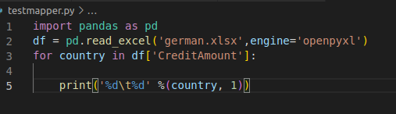

testreducer.py

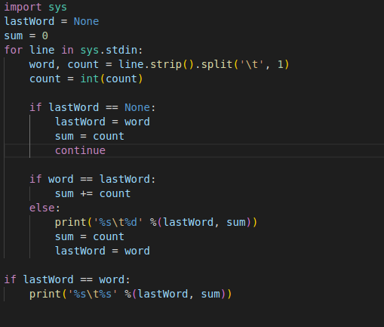

OUTPUT

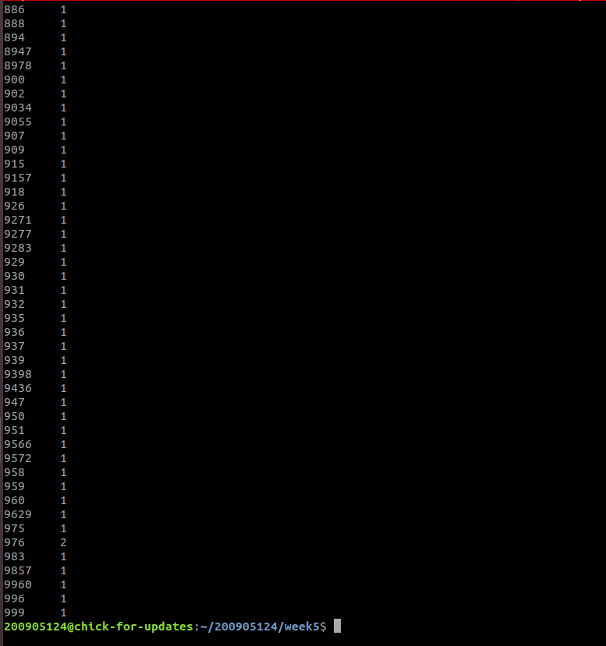

Program demonstrating plt function on excel file

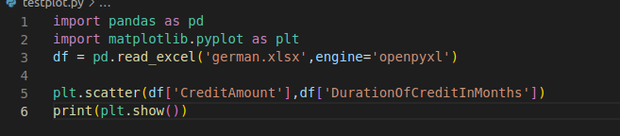

Output

