LAB 6: Computer Network Design using SWITCH and ROUTERS in GNS3

1. Switching Cisco IOS Command Modes
This exercise demonstrates how to log into a router and how to work with the different Cisco
IOS command modes. It is important to understand the different modes so you know where you are and what commands are accepted at any time.
i. Connect the Ethernet interfaces of the Linux PCs and the Cisco router as shown in Figure 6.7.
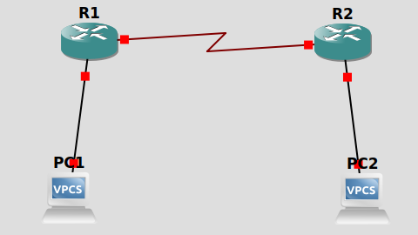
Do not turn on the Linux PCs yet.
ii. Right-click on Router1 and choose Start.
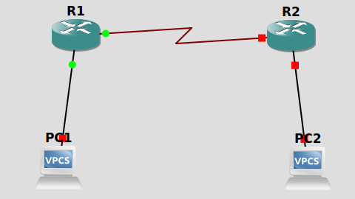
iii. Right-click on Router1 and choose Console. Wait a few seconds until the router is initialized.
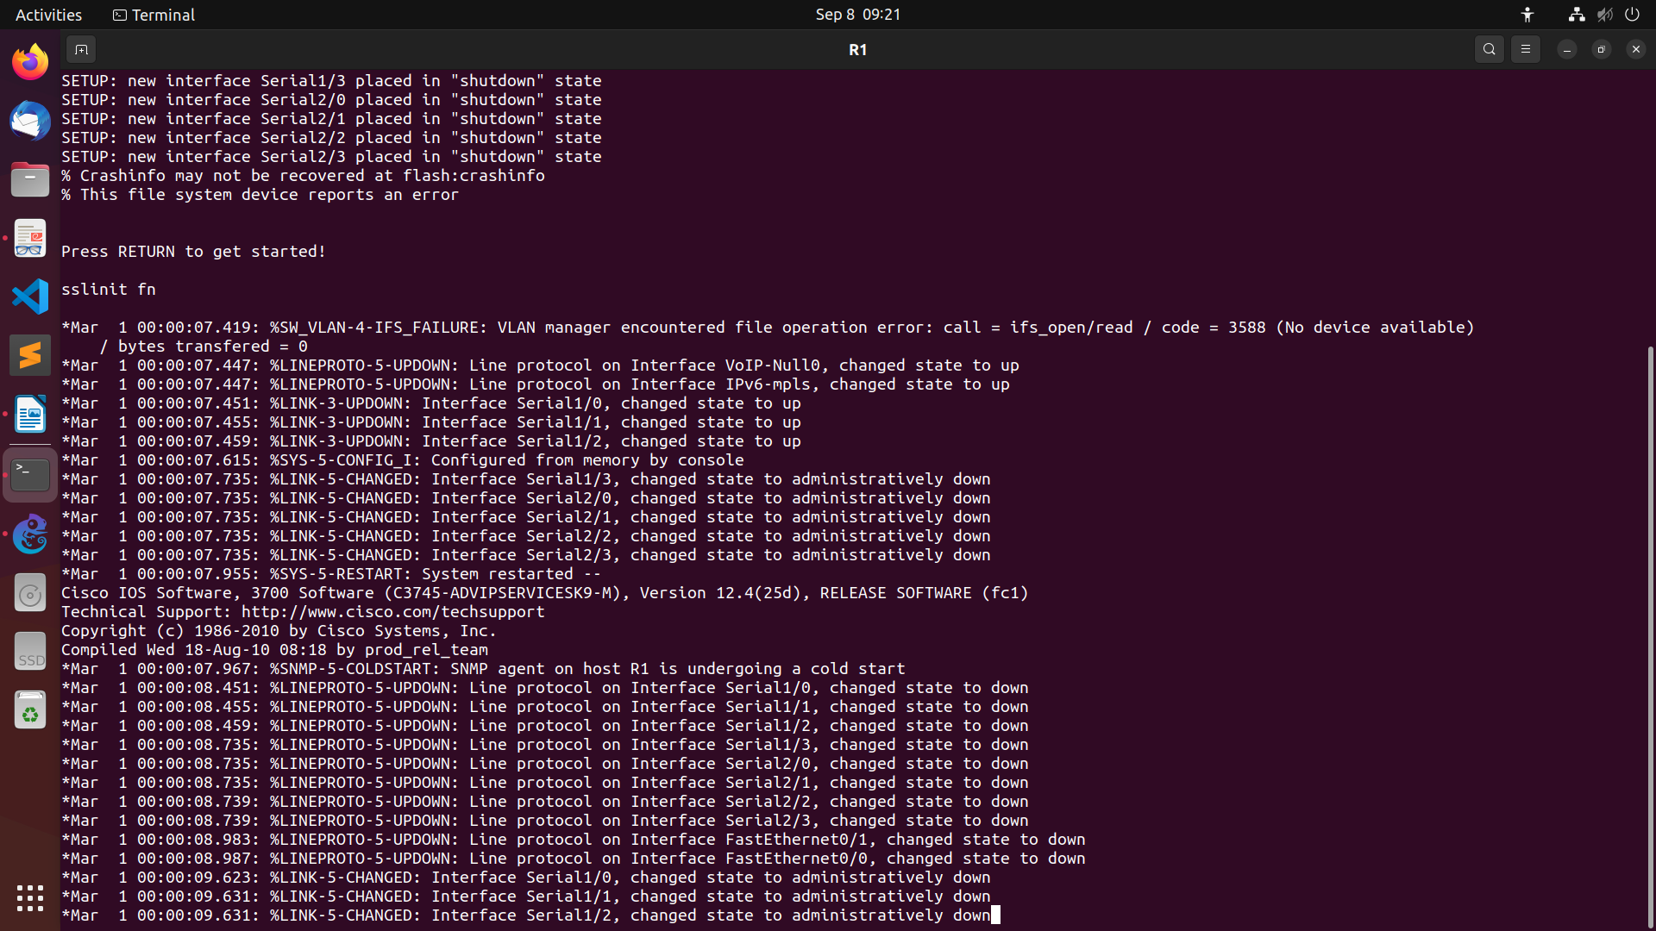
If everything is fine, you should see the prompt shown below. This is the User EXEC mode. If
the prompt does not appear, try to restart GNS3 and repeat the setup again.
Router1>
iv. To see which commands are available in this mode, type ?:
Router1>?
R1>?
Exec commands:
access-enable Create a temporary Access-List entry
access-profile Apply user-profile to interface
call Voice call
clear Reset functions
connect Open a terminal connection
crypto Encryption related commands.
disable Turn off privileged commands
disconnect Disconnect an existing network connection
enable Turn on privileged commands
exit Exit from the EXEC
help Description of the interactive help system
lock Lock the terminal
login Log in as a particular user
logout Exit from the EXEC
modemui Start a modem-like user interface
mrinfo Request neighbor and version information from a multicast
router
mstat Show statistics after multiple multicast traceroutes
mtrace Trace reverse multicast path from destination to source
name-connection Name an existing network connection
pad Open a X.29 PAD connection
--More--
v. To view and change system parameters of a Cisco router, you must enter the Privileged EXEC
mode by typing:
Router1>enable
Router1#

R1>enable
R1#
vi. Type the following command to disable the Privileged EXEC mode
Router1# disable
R1#disable
R1>
NOTE: The Cisco routers in GNS3 sometimes start up in Privileged instead of the User EXEC mode.
vii. To modify system wide configuration parameters, you must enter the global configuration
mode. This mode is entered by typing:
Router1#configure terminal
Router1(config)#
or
Router1#conf t
Router1(config)#
R1#configure terminal
Enter configuration commands, one per line. End with CNTL/Z.
R1(config)#
viii. To make changes to a network interface, enter the interface configuration mode, with the
command:
Router1(config)#interface FastEthernet0/0
Router1(config-if)#
The name of the interface is provided as an argument. Here, the network interface that is
configured is FastEthernet0/0.
R1(config)#interface FastEthernet0/0
R1(config-if)#
ix. To return from the interface configuration to the global configuration mode, or from the
global configuration mode to the Privileged EXEC mode, use the exit command:
Router1(config-if)#exit
Router1(config)#exit
Router1#
R1(config-if)#exit
R1(config)#exit
R1#
*Mar 1 00:04:18.995: %SYS-5-CONFIG_I: Configured from console by console
R1#
The exit command takes you one step up in the command hierarchy. To directly return to the
Privileged EXEC mode from any configuration mode, use the end command:
Router1(config-if)#end
Router1#
R1(config-if)#end
R1#
*Mar 1 00:04:59.183: %SYS-5-CONFIG_I: Configured from console by console
R1#
x. To terminate the console session from the User EXEC mode, type logout or exit:
Router1>logout
Router con0 is now available
Press RETURN to get started
R1 con0 is now available

Press RETURN to get started.

2. Configuring a Cisco Router via the console
The following exercises use basic commands from the Cisco IOS that are needed to configure a Cisco router.
i. Right-click on Router1 and choose Start.
ii. Right-click on Router1 and choose Console. Wait some seconds until the initial console
window is set up. When the router is ready to receive commands, proceed to the next step.
iii. Configure Router1 and Router 2 with the IP addresses given in Figure 6.7.
Note: In IOS Mode under Global Configuration,we can enable or disable IP Forwarding. When it is
disabled it also deletes the contents of the routing table.
Router1(config)#ip routing
Router1(config)#no ip routing
In IOS Mode under Interface Configuration,we can enable or disable a network interface
Router1(config-if)#no shutdown
Router1(config-if)#shutdown
Tip: “no ip routing” is used to guarantee that the routing cache is empty, not routing table.
In Router 1
Interface Fastethernet0/0 in global configuration mode
inter f 0/0
ip address 10.0.0.1 255.0.0.0
no shutdown
exit
R1#conf t
Enter configuration commands, one per line. End with CNTL/Z.
R1(config)#inter f0/0
R1(config-if)#ip address 10.0.0.1 255.0.0.0
R1(config-if)#no shutdown
R1(config-if)#exit
R1(config)#
*Mar 1 00:02:48.211: %LINK-3-UPDOWN: Interface FastEthernet0/0, changed state to up
*Mar 1 00:02:49.211: %LINEPROTO-5-UPDOWN: Line protocol on Interface FastEthernet0/0, changed state to up

Interface Serial 2/0
inter s2/0
ip address 20.0.0.1 255.0.0.0
clock rate 64000
encapsulation ppp
no shutdown
exit
R1(config)#inter s2/0
R1(config-if)#ip address 20.0.0.1 255.0.0.0
R1(config-if)#clock rate 64000
R1(config-if)#encapsulation ppp
R1(config-if)#no shutdown
R1(config-if)#exit
R1(config)#
*Mar 1 00:04:31.051: %LINK-3-UPDOWN: Interface Serial2/0, changed state to up

In Router 2
Interface Fastethernet 0/0
inter f0/0
ip address 30.0.0.1 255.0.0.0
no shutdown
exit
R2(config)#inter f0/0
R2(config-if)#ip address 30.0.0.1 255.0.0.0
R2(config-if)#no shutdown
R2(config-if)#exit
R2(config)#
*Mar 1 00:00:50.663: %LINK-3-UPDOWN: Interface FastEthernet0/0, changed state to up
*Mar 1 00:00:51.663: %LINEPROTO-5-UPDOWN: Line protocol on Interface FastEthernet0/0, changed state to up

Interface Serial 2/0
inter s2/0
ip address 20.0.0.2 255.0.0.0
encapsulation ppp
no shutdown
exit
R2(config)#inter s2/0
R2(config-if)#ip address 20.0.0.2 255.0.0.0
R2(config-if)#encapsulation ppp
R2(config-if)#no shutdown
R2(config-if)#exit
R2(config)#
*Mar 1 00:01:33.195: %LINK-3-UPDOWN: Interface Serial2/0, changed state to up

Tip to save Time: It will be tiring to manually type in the configuration data for a router, everytime you set a lab, you can save time by saving all this configurations in an excel file and simply copying
and pasting in the router console window.
iv. When you are done, use the following command to check the changes you made to the router configuration, and save the outputs:
R1# show interfaces
R1#show running-config
R1#show interfaces
FastEthernet0/0 is up, line protocol is up
Hardware is Gt96k FE, address is c401.1094.0000 (bia c401.1094.0000)
Internet address is 10.0.0.1/8
MTU 1500 bytes, BW 10000 Kbit/sec, DLY 1000 usec,
reliability 255/255, txload 1/255, rxload 1/255
Encapsulation ARPA, loopback not set
Keepalive set (10 sec)
Half-duplex, 10Mb/s, 100BaseTX/FX
ARP type: ARPA, ARP Timeout 04:00:00
Last input never, output 00:00:00, output hang never
Last clearing of "show interface" counters never
Input queue: 0/75/0/0 (size/max/drops/flushes); Total output drops: 0
Queueing strategy: fifo
Output queue: 0/40 (size/max)
5 minute input rate 0 bits/sec, 0 packets/sec
5 minute output rate 0 bits/sec, 0 packets/sec
0 packets input, 0 bytes
Received 0 broadcasts, 0 runts, 0 giants, 0 throttles
0 input errors, 0 CRC, 0 frame, 0 overrun, 0 ignored
0 watchdog
0 input packets with dribble condition detected
40 packets output, 4720 bytes, 0 underruns
0 output errors, 0 collisions, 1 interface resets
--More--

R1#show running-config
Building configuration...

Current configuration : 1495 bytes
!
version 12.4
service timestamps debug datetime msec
service timestamps log datetime msec
no service password-encryption
!
hostname R1
!
boot-start-marker
boot-end-marker
!
!
no aaa new-model
memory-size iomem 5
no ip icmp rate-limit unreachable
ip cef
!
!
!
!
no ip domain lookup
--More--

v. Assign ip addresses for both PC's as mentioned in Figure 6.7 with appropriate ip and subnet
maskand default gateway.

PC1> ip 10.0.0.10
Checking for duplicate address...
PC1 : 10.0.0.10 255.255.255.0

PC2> ip 30.0.0.10
Checking for duplicate address...
PC2 : 30.0.0.10 255.255.255.0

3. Setting static routing table entries on a Cisco router
In this exercise, you will add static routes to the routing table of Router1. The routing table must be configured so that it conforms to the network topology shown in Figure 6.7. The routes are configured manually, which is also referred to as static routing.
The IOS command to configure static routing is ip route. The command can be used to show,
clear, add, or delete entries in the routing table. The commands are summarized in the list below.
Note: Whenever an IP address is configured for a network interface on a router, routing
table entries for the directly connected network are added automatically.
By default, Routers know only directed connected networks here Router 1 know only 10.0.0.0
and 20.0.0.0 it doesn't know the 30.0.0.0 like this R2 doesn't know about 10.0.0.0.So we are
going to add Static route to this both router.
R1(config)#ip route Destination Network| Destination N/W Subnet Mask |Next Hop
Address
In Router R1, just give this command, in this case Destination is 30.0.0.0 and its subnet mask is
255.0.0.0 next hop address is 20.0.0.2
R1(config)#ip route 30.0.0.0 255.0.0.0 20.0.0.2
In Router R2
R2(config)#ip route 10.0.0.0 255.0.0.0 20.0.0.1
Now both routers know all the networks.
i. Issue a ping command from PC1 to PC2, Router1 and PC4, respectively
PC1> ping 30.0.0.10

No gateway found
PC1> ping 10.0.0.1

84 bytes from 10.0.0.1 icmp_seq=1 ttl=255 time=2.288 ms
84 bytes from 10.0.0.1 icmp_seq=2 ttl=255 time=11.241 ms
84 bytes from 10.0.0.1 icmp_seq=3 ttl=255 time=1.595 ms
84 bytes from 10.0.0.1 icmp_seq=4 ttl=255 time=2.275 ms
84 bytes from 10.0.0.1 icmp_seq=5 ttl=255 time=8.605 ms
ii. Save the captured Wireshark output.
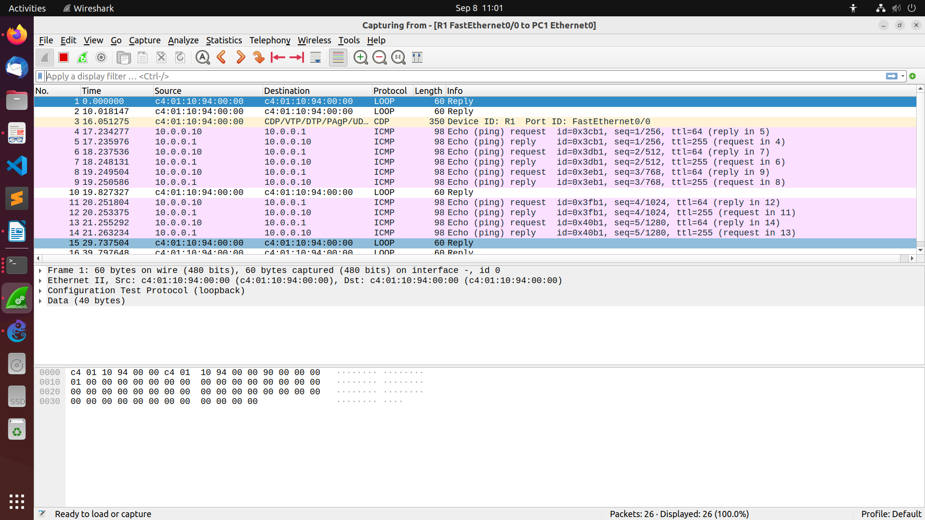
iii. Use the saved data to answer the following questions:
• What is the output on PC1 when the ping commands are issued?
• Which packets, if any, are captured by Wireshark?
• Do you observe any ARP packets? If so, what do they indicate?

In the CSE department, two students sitting in two different labs want to establish a
connection and send the data. So, configure the below network topology as shown in Figure.
6.8 and check the connectivity by pinging from PC0 to PC2.

