raceranalysis

shrey agrawal

2022-07-21

#setup and cleaning

Importing and cleaning data, removing an outlier

##   
## Attaching package: 'dplyr'

## The following objects are masked from 'package:stats':  
##   
## filter, lag

## The following objects are masked from 'package:base':  
##   
## intersect, setdiff, setequal, union

## Loading required package: mosaic

## Registered S3 method overwritten by 'mosaic':  
## method from   
## fortify.SpatialPolygonsDataFrame ggplot2

##   
## The 'mosaic' package masks several functions from core packages in order to add   
## additional features. The original behavior of these functions should not be affected by this.

##   
## Attaching package: 'mosaic'

## The following object is masked from 'package:Matrix':  
##   
## mean

## The following objects are masked from 'package:dplyr':  
##   
## count, do, tally

## The following object is masked from 'package:ggplot2':  
##   
## stat

## The following objects are masked from 'package:stats':  
##   
## binom.test, cor, cor.test, cov, fivenum, IQR, median, prop.test,  
## quantile, sd, t.test, var

## The following objects are masked from 'package:base':  
##   
## max, mean, min, prod, range, sample, sum

## [1] "Game" "Date" "PlayerID" "GroupID"   
## [5] "CarID" "Tire" "Engine" "Body"   
## [9] "Track" "FinishedTime" "TimeToTopSpeed" "TopSpeed"   
## [13] "TimeTo30" "TimeTo60" "TimeTo100" "CheckPoint1"   
## [17] "CheckPoint2" "CheckPoint3" "SpeedLimit" "Acceleration"   
## [21] "AccCurve" "Suspension" "Drag" "Steer"   
## [25] "Grip" "Gravity"

## int [1:187] 1 4 7 10 1 15 2 1 5 15 ...

#In restricted, which is the fastest car

## [1] "TABLE SORTED BY FINISHED TIME"

## Game Date PlayerID GroupID CarID Tire Engine Body  
## 1 811 2022-07-21 00:55:27 masaki trial1 15 Tiny Tube Tiny  
## 2 807 2022-07-21 00:46:42 masaki map22 15 Tiny Tube Tiny  
## 3 803 2022-07-21 00:21:27 masaki map22 15 Tiny Tube Tiny  
## 4 801 2022-07-20 22:02:01 masaki trial1 15 Tiny Tube Tiny  
## 5 805 2022-07-21 00:25:22 masaki map22 15 Tiny Tube Tiny  
## 6 810 2022-07-21 00:55:10 masaki trial1 1 Classic TheRev Classic  
## Track FinishedTime TimeToTopSpeed TopSpeed TimeTo30 TimeTo60  
## 1 TutorialTrack 10.68 7.58 97.02 0.45 0.99  
## 2 TutorialTrack 10.75 4.32 97.02 0.45 0.99  
## 3 TutorialTrack 10.81 4.26 97.02 0.43 0.96  
## 4 TutorialTrack 10.83 4.27 97.02 0.43 0.97  
## 5 TutorialTrack 10.87 3.63 97.02 0.45 0.99  
## 6 TutorialTrack 11.09 1.01 89.43 0.15 0.35  
## TimeTo100 CheckPoint1 CheckPoint2 CheckPoint3 SpeedLimit Acceleration  
## 1 0 2.10 4.41 7.63 97.2 8  
## 2 0 2.11 4.39 7.65 97.2 8  
## 3 0 2.08 4.37 7.60 97.2 8  
## 4 0 2.10 4.36 7.80 97.2 8  
## 5 0 2.11 4.41 7.71 97.2 8  
## 6 0 1.67 4.13 7.69 90.0 15  
## AccCurve Suspension Drag Steer Grip Gravity  
## 1 0.55 0.05 15 8 0.9 1.2  
## 2 0.55 0.05 15 8 0.9 1.2  
## 3 0.55 0.05 15 8 0.9 1.2  
## 4 0.55 0.05 15 8 0.9 1.2  
## 5 0.55 0.05 15 8 0.9 1.2  
## 6 0.85 0.10 10 7 0.3 0.6

## [1] "TABLE SORTED BY TOPSPEED TIME"

## Game Date PlayerID GroupID CarID Tire Engine Body  
## 1 725 2022-07-20 15:42:52 li trial1 1 Classic TheRev Classic  
## 2 634 2022-07-20 15:13:45 sk trial1 1 Classic TheRev Classic  
## 3 668 2022-07-20 15:25:43 li trial1 1 Classic TheRev Classic  
## 4 663 2022-07-20 15:24:31 masaki trial1 1 Classic TheRev Classic  
## 5 665 2022-07-20 15:25:02 masaki trial1 1 Classic TheRev Classic  
## 6 810 2022-07-21 00:55:10 masaki trial1 1 Classic TheRev Classic  
## Track FinishedTime TimeToTopSpeed TopSpeed TimeTo30 TimeTo60  
## 1 OvalTrack 17.12 5.10 78.69 0.16 0.38  
## 2 StraightTrack 13.24 0.78 78.70 0.13 0.35  
## 3 StraightTrack 13.24 0.80 78.70 0.15 0.36  
## 4 StraightTrack 13.25 0.78 78.70 0.15 0.37  
## 5 OvalTrack 17.20 0.80 78.70 0.15 0.37  
## 6 TutorialTrack 11.09 1.01 89.43 0.15 0.35  
## TimeTo100 CheckPoint1 CheckPoint2 CheckPoint3 SpeedLimit Acceleration  
## 1 6.07 4.71 7.74 12.35 79.2 15  
## 2 0.00 1.83 5.64 9.62 79.2 15  
## 3 0.00 1.85 5.64 9.62 79.2 15  
## 4 0.00 1.85 5.65 9.63 79.2 15  
## 5 0.00 4.83 7.87 12.45 79.2 15  
## 6 0.00 1.67 4.13 7.69 90.0 15  
## AccCurve Suspension Drag Steer Grip Gravity  
## 1 0.85 0.1 10 7 0.3 0.6  
## 2 0.85 0.1 10 7 0.3 0.6  
## 3 0.85 0.1 10 7 0.3 0.6  
## 4 0.85 0.1 10 7 0.3 0.6  
## 5 0.85 0.1 10 7 0.3 0.6  
## 6 0.85 0.1 10 7 0.3 0.6

## [1] "TABLE SORTED BY TIMETO30 TIME"

## Game Date PlayerID GroupID CarID Tire Engine Body  
## 1 634 2022-07-20 15:13:45 sk trial1 1 Classic TheRev Classic  
## 2 806 2022-07-21 00:46:25 masaki map22 1 Classic TheRev Classic  
## 3 804 2022-07-21 00:25:03 masaki map22 1 Classic TheRev Classic  
## 4 800 2022-07-20 22:01:26 masaki trial1 1 Classic TheRev Classic  
## 5 813 2022-07-21 00:56:28 masaki trial1 1 Classic TheRev Classic  
## 6 668 2022-07-20 15:25:43 li trial1 1 Classic TheRev Classic  
## Track FinishedTime TimeToTopSpeed TopSpeed TimeTo30 TimeTo60  
## 1 StraightTrack 13.24 0.78 78.70 0.13 0.35  
## 2 TutorialTrack 11.20 0.96 89.43 0.14 0.35  
## 3 TutorialTrack 11.28 0.99 89.43 0.14 0.34  
## 4 TutorialTrack 11.40 0.99 89.43 0.14 0.34  
## 5 StraightTrack 11.72 0.99 89.43 0.14 0.34  
## 6 StraightTrack 13.24 0.80 78.70 0.15 0.36  
## TimeTo100 CheckPoint1 CheckPoint2 CheckPoint3 SpeedLimit Acceleration  
## 1 0 1.83 5.64 9.62 79.2 15  
## 2 0 1.67 4.13 7.75 90.0 15  
## 3 0 1.66 4.12 7.84 90.0 15  
## 4 0 1.66 4.12 7.90 90.0 15  
## 5 0 1.70 5.04 8.54 90.0 15  
## 6 0 1.85 5.64 9.62 79.2 15  
## AccCurve Suspension Drag Steer Grip Gravity  
## 1 0.85 0.1 10 7 0.3 0.6  
## 2 0.85 0.1 10 7 0.3 0.6  
## 3 0.85 0.1 10 7 0.3 0.6  
## 4 0.85 0.1 10 7 0.3 0.6  
## 5 0.85 0.1 10 7 0.3 0.6  
## 6 0.85 0.1 10 7 0.3 0.6

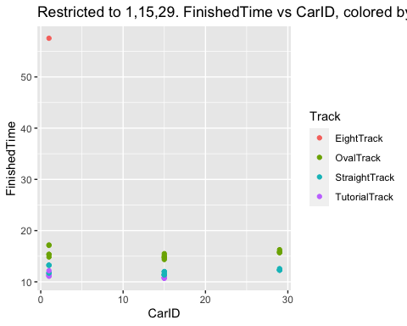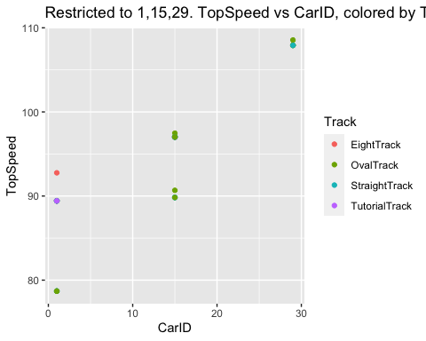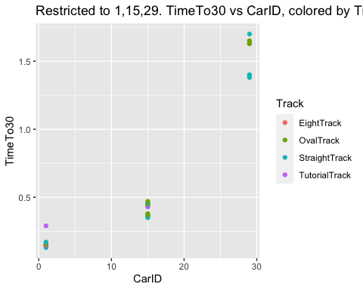

#all cars straight track - 3PLOTS, 1TABLE HERE

## Game Date PlayerID GroupID CarID Tire Engine Body  
## 1 643 2022-07-20 15:18:15 masaki trial1 15 Tiny Tube Tiny  
## 2 814 2022-07-21 01:06:48 masaki trial1 15 Tiny Tube Tiny  
## 3 648 2022-07-20 15:19:42 masaki trial1 15 Tiny Tube Tiny  
## 4 809 2022-07-21 00:47:28 masaki map22 15 Tiny Tube Tiny  
## 5 812 2022-07-21 00:56:05 masaki trial1 15 Tiny Tube Tiny  
## 6 641 2022-07-20 15:17:57 masaki trial1 1 Classic TheRev Classic  
## Track FinishedTime TimeToTopSpeed TopSpeed TimeTo30 TimeTo60  
## 1 StraightTrack 11.38 8.57 97.02 0.45 1.00  
## 2 StraightTrack 11.39 10.63 97.02 0.45 0.99  
## 3 StraightTrack 11.40 11.37 97.02 0.45 1.00  
## 4 StraightTrack 11.40 8.56 97.02 0.46 0.97  
## 5 StraightTrack 11.40 8.56 97.02 0.45 0.99  
## 6 StraightTrack 11.72 1.00 89.43 0.17 0.37  
## TimeTo100 CheckPoint1 CheckPoint2 CheckPoint3 SpeedLimit Acceleration  
## 1 0.00 2.13 5.22 8.43 97.2 8  
## 2 0.00 2.15 5.23 8.45 97.2 8  
## 3 6.35 2.13 5.22 8.47 97.2 8  
## 4 5.85 2.16 5.23 8.45 97.2 8  
## 5 0.00 2.15 5.23 8.45 97.2 8  
## 6 0.00 1.70 5.05 8.55 90.0 15  
## AccCurve Suspension Drag Steer Grip Gravity  
## 1 0.55 0.05 15 8 0.9 1.2  
## 2 0.55 0.05 15 8 0.9 1.2  
## 3 0.55 0.05 15 8 0.9 1.2  
## 4 0.55 0.05 15 8 0.9 1.2  
## 5 0.55 0.05 15 8 0.9 1.2  
## 6 0.85 0.10 10 7 0.3 0.6

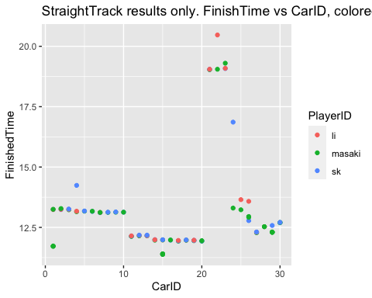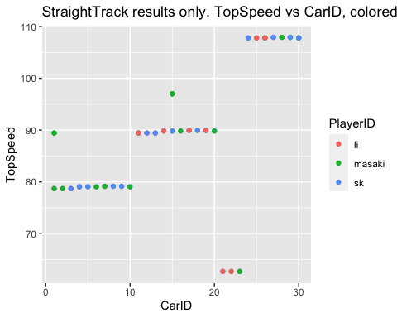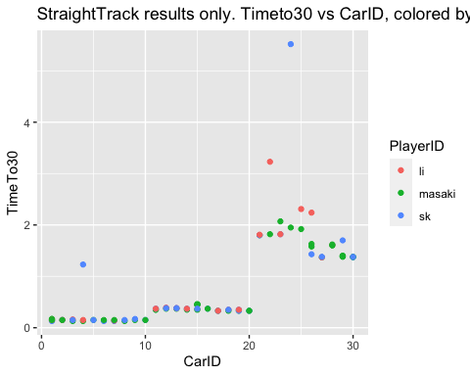

#all cars oval track - 3PLOTS, 1TABLE HERE

## Game Date PlayerID GroupID CarID Tire Engine Body  
## 1 818 2022-07-21 10:14:43 123 123 15 Tiny Tube Tiny  
## 2 639 2022-07-20 15:17:29 masaki trial1 15 Tiny Tube Tiny  
## 3 644 2022-07-20 15:18:43 masaki trial1 15 Tiny Tube Tiny  
## 4 651 2022-07-20 15:20:29 masaki trial1 15 Tiny Tube Tiny  
## 5 819 2022-07-21 10:15:03 123 123 1 Classic TheRev Classic  
## 6 754 2022-07-20 15:53:32 li trial1 15 Tiny Tube Tiny  
## Track FinishedTime TimeToTopSpeed TopSpeed TimeTo30 TimeTo60 TimeTo100  
## 1 OvalTrack 14.36 2.85 97.47 0.45 0.98 0.00  
## 2 OvalTrack 14.63 9.28 97.02 0.45 1.00 0.00  
## 3 OvalTrack 14.83 8.82 97.02 0.45 0.98 0.00  
## 4 OvalTrack 14.85 9.27 97.02 0.47 1.00 5.87  
## 5 OvalTrack 14.85 8.38 89.45 0.15 0.35 0.00  
## 6 OvalTrack 15.10 2.58 90.68 0.37 0.81 0.00  
## CheckPoint1 CheckPoint2 CheckPoint3 SpeedLimit Acceleration AccCurve  
## 1 4.48 8.16 11.56 97.2 8 0.55  
## 2 4.67 7.13 10.82 97.2 8 0.55  
## 3 4.57 7.02 10.85 97.2 8 0.55  
## 4 4.65 7.15 10.87 97.2 8 0.55  
## 5 4.23 8.19 11.91 90.0 15 0.85  
## 6 4.53 7.16 11.07 90.0 10 0.55  
## Suspension Drag Steer Grip Gravity  
## 1 0.05 15 8 0.9 1.2  
## 2 0.05 15 8 0.9 1.2  
## 3 0.05 15 8 0.9 1.2  
## 4 0.05 15 8 0.9 1.2  
## 5 0.10 10 7 0.3 0.6  
## 6 0.05 15 8 0.9 1.2

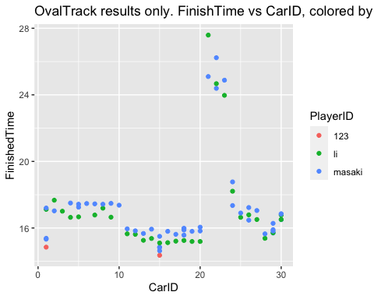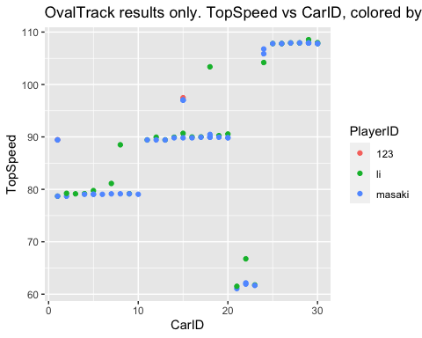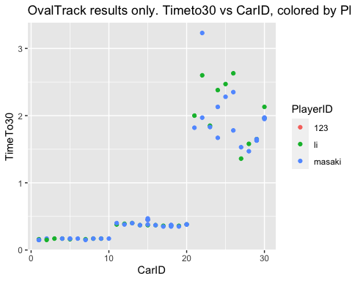

#q1. who was the fastest on the oval track? 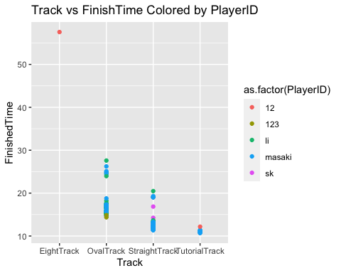

#q2. Which tire, body, engine combination is fastest on the STRAIGHT track? LOWEST FINISH TIME

## Game Date PlayerID GroupID CarID Tire Engine Body  
## 1 643 2022-07-20 15:18:15 masaki trial1 15 Tiny Tube Tiny  
## 2 814 2022-07-21 01:06:48 masaki trial1 15 Tiny Tube Tiny  
## 3 648 2022-07-20 15:19:42 masaki trial1 15 Tiny Tube Tiny  
## 4 809 2022-07-21 00:47:28 masaki map22 15 Tiny Tube Tiny  
## 5 812 2022-07-21 00:56:05 masaki trial1 15 Tiny Tube Tiny  
## 6 641 2022-07-20 15:17:57 masaki trial1 1 Classic TheRev Classic  
## Track FinishedTime TimeToTopSpeed TopSpeed TimeTo30 TimeTo60  
## 1 StraightTrack 11.38 8.57 97.02 0.45 1.00  
## 2 StraightTrack 11.39 10.63 97.02 0.45 0.99  
## 3 StraightTrack 11.40 11.37 97.02 0.45 1.00  
## 4 StraightTrack 11.40 8.56 97.02 0.46 0.97  
## 5 StraightTrack 11.40 8.56 97.02 0.45 0.99  
## 6 StraightTrack 11.72 1.00 89.43 0.17 0.37  
## TimeTo100 CheckPoint1 CheckPoint2 CheckPoint3 SpeedLimit Acceleration  
## 1 0.00 2.13 5.22 8.43 97.2 8  
## 2 0.00 2.15 5.23 8.45 97.2 8  
## 3 6.35 2.13 5.22 8.47 97.2 8  
## 4 5.85 2.16 5.23 8.45 97.2 8  
## 5 0.00 2.15 5.23 8.45 97.2 8  
## 6 0.00 1.70 5.05 8.55 90.0 15  
## AccCurve Suspension Drag Steer Grip Gravity  
## 1 0.55 0.05 15 8 0.9 1.2  
## 2 0.55 0.05 15 8 0.9 1.2  
## 3 0.55 0.05 15 8 0.9 1.2  
## 4 0.55 0.05 15 8 0.9 1.2  
## 5 0.55 0.05 15 8 0.9 1.2  
## 6 0.85 0.10 10 7 0.3 0.6

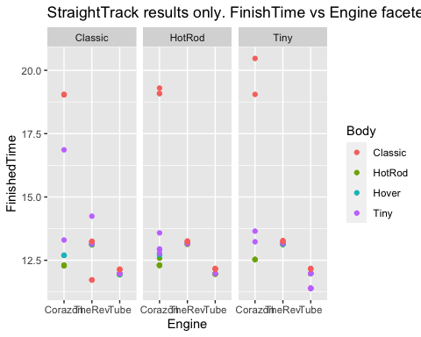

#q3. Which tire, body, engine combination is fastest on the OVAL track? LOWEST FINISH TIME

## Game Date PlayerID GroupID CarID Tire Engine Body  
## 1 818 2022-07-21 10:14:43 123 123 15 Tiny Tube Tiny  
## 2 639 2022-07-20 15:17:29 masaki trial1 15 Tiny Tube Tiny  
## 3 644 2022-07-20 15:18:43 masaki trial1 15 Tiny Tube Tiny  
## 4 651 2022-07-20 15:20:29 masaki trial1 15 Tiny Tube Tiny  
## 5 819 2022-07-21 10:15:03 123 123 1 Classic TheRev Classic  
## 6 754 2022-07-20 15:53:32 li trial1 15 Tiny Tube Tiny  
## Track FinishedTime TimeToTopSpeed TopSpeed TimeTo30 TimeTo60 TimeTo100  
## 1 OvalTrack 14.36 2.85 97.47 0.45 0.98 0.00  
## 2 OvalTrack 14.63 9.28 97.02 0.45 1.00 0.00  
## 3 OvalTrack 14.83 8.82 97.02 0.45 0.98 0.00  
## 4 OvalTrack 14.85 9.27 97.02 0.47 1.00 5.87  
## 5 OvalTrack 14.85 8.38 89.45 0.15 0.35 0.00  
## 6 OvalTrack 15.10 2.58 90.68 0.37 0.81 0.00  
## CheckPoint1 CheckPoint2 CheckPoint3 SpeedLimit Acceleration AccCurve  
## 1 4.48 8.16 11.56 97.2 8 0.55  
## 2 4.67 7.13 10.82 97.2 8 0.55  
## 3 4.57 7.02 10.85 97.2 8 0.55  
## 4 4.65 7.15 10.87 97.2 8 0.55  
## 5 4.23 8.19 11.91 90.0 15 0.85  
## 6 4.53 7.16 11.07 90.0 10 0.55  
## Suspension Drag Steer Grip Gravity  
## 1 0.05 15 8 0.9 1.2  
## 2 0.05 15 8 0.9 1.2  
## 3 0.05 15 8 0.9 1.2  
## 4 0.05 15 8 0.9 1.2  
## 5 0.10 10 7 0.3 0.6  
## 6 0.05 15 8 0.9 1.2

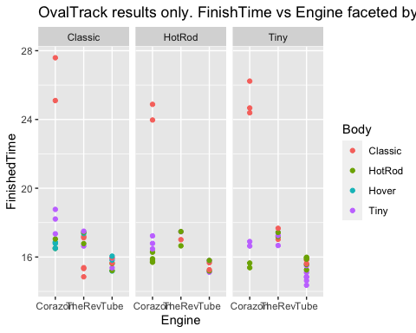

#q4. Which tire, body, engine combination has the highest TOP SPEED REACHED 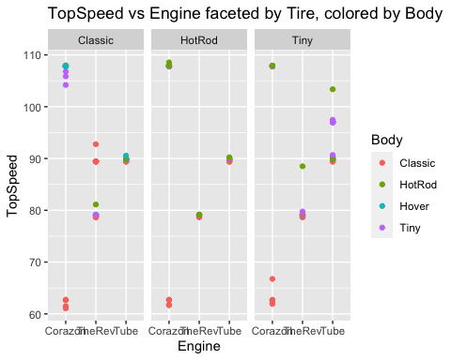

#Some extra analysis in table form with Mean Finish TIMES.

## `summarise()` has grouped output by 'Track', 'Engine', 'Tire'. You can override  
## using the `.groups` argument.

## # A tibble: 65 × 7  
## # Groups: Track, Engine, Tire [21]  
## Track Engine Tire Body TimesPlayed MeanFinishedTime SDFinishTime  
## <chr> <chr> <chr> <chr> <int> <dbl> <dbl>  
## 1 TutorialTrack Tube Tiny Tiny 5 10.8 0.0743   
## 2 TutorialTrack TheRev Classic Class… 6 11.4 0.395   
## 3 StraightTrack Tube Tiny Tiny 8 11.6 0.305   
## 4 StraightTrack Tube Classic Hover 3 11.9 0.0100   
## 5 StraightTrack Tube Classic HotRod 3 11.9 0.0153   
## 6 StraightTrack Tube HotRod HotRod 4 12.0 0.00816  
## 7 StraightTrack Tube Tiny HotRod 3 12.0 0.00577  
## 8 StraightTrack Tube HotRod Tiny 2 12.0 0.00707  
## 9 StraightTrack Tube Classic Tiny 3 12.0 0.0115   
## 10 StraightTrack Tube Classic Class… 4 12.1 0.00957  
## # … with 55 more rows

#anova test

## Df Sum Sq Mean Sq F value Pr(>F)   
## Track 3 2654.5 884.8 3636.591 < 2e-16 ***  
## Engine 2 255.7 127.8 525.388 < 2e-16 ***  
## Tire 2 5.6 2.8 11.454 2.76e-05 ***  
## Body 3 188.6 62.9 258.319 < 2e-16 ***  
## Track:Engine 3 12.6 4.2 17.329 1.95e-09 ***  
## Track:Tire 2 1.1 0.6 2.304 0.104145   
## Engine:Tire 4 13.4 3.4 13.779 2.66e-09 ***  
## Track:Body 3 10.6 3.5 14.492 3.91e-08 ***  
## Engine:Body 6 431.9 72.0 295.848 < 2e-16 ***  
## Tire:Body 6 6.0 1.0 4.134 0.000816 ***  
## Track:Engine:Tire 4 2.0 0.5 2.078 0.087729 .   
## Track:Engine:Body 6 12.6 2.1 8.615 8.18e-08 ***  
## Track:Tire:Body 4 1.2 0.3 1.231 0.301306   
## Engine:Tire:Body 8 2.7 0.3 1.387 0.208747   
## Track:Engine:Tire:Body 8 2.1 0.3 1.099 0.368281   
## Residuals 122 29.7 0.2   
## ---  
## Signif. codes: 0 '***' 0.001 '**' 0.01 '*' 0.05 '.' 0.1 ' ' 1

## Df Sum Sq Mean Sq F value Pr(>F)   
## Engine 2 151.08 75.54 225.616 < 2e-16 ***  
## Tire 2 6.51 3.25 9.715 0.000287 ***  
## Body 3 127.39 42.46 126.818 < 2e-16 ***  
## Engine:Tire 4 13.68 3.42 10.216 4.58e-06 ***  
## Engine:Body 6 269.07 44.85 133.937 < 2e-16 ***  
## Tire:Body 4 1.78 0.44 1.327 0.273379   
## Engine:Tire:Body 8 2.07 0.26 0.773 0.628271   
## Residuals 48 16.07 0.33   
## ---  
## Signif. codes: 0 '***' 0.001 '**' 0.01 '*' 0.05 '.' 0.1 ' ' 1

## Df Sum Sq Mean Sq F value Pr(>F)   
## Engine 2 108.77 54.39 275.986 < 2e-16 ***  
## Tire 2 0.81 0.40 2.053 0.13658   
## Body 3 77.55 25.85 131.180 < 2e-16 ***  
## Engine:Tire 4 3.71 0.93 4.707 0.00213 **   
## Engine:Body 6 175.65 29.28 148.560 < 2e-16 ***  
## Tire:Body 6 4.26 0.71 3.607 0.00378 **   
## Engine:Tire:Body 8 2.77 0.35 1.757 0.10209   
## Residuals 65 12.81 0.20   
## ---  
## Signif. codes: 0 '***' 0.001 '**' 0.01 '*' 0.05 '.' 0.1 ' ' 1

## Df Sum Sq Mean Sq F value Pr(>F)  
## Tire 2 1.3 0.643 0.157 0.855  
## Residuals 94 385.1 4.096

## Df Sum Sq Mean Sq F value Pr(>F)   
## Body 3 63.2 21.074 6.065 0.000812 ***  
## Residuals 93 323.1 3.474   
## ---  
## Signif. codes: 0 '***' 0.001 '**' 0.01 '*' 0.05 '.' 0.1 ' ' 1

## Df Sum Sq Mean Sq F value Pr(>F)   
## Engine 2 108.8 54.39 18.42 1.78e-07 ***  
## Residuals 94 277.6 2.95   
## ---  
## Signif. codes: 0 '***' 0.001 '**' 0.01 '*' 0.05 '.' 0.1 ' ' 1

## Df Sum Sq Mean Sq F value Pr(>F)  
## CarID 1 9 8.826 0.451 0.503  
## Residuals 185 3621 19.576