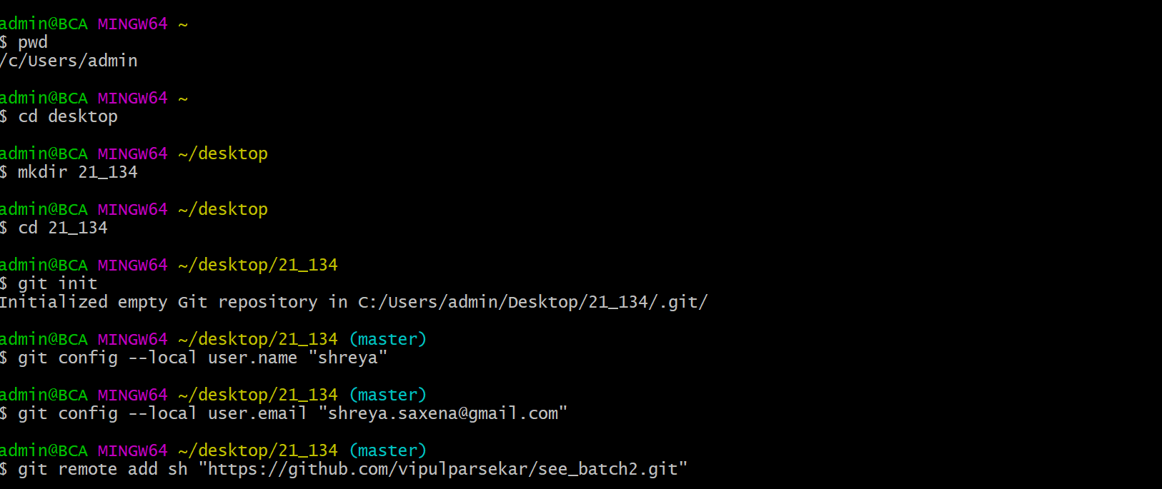1)

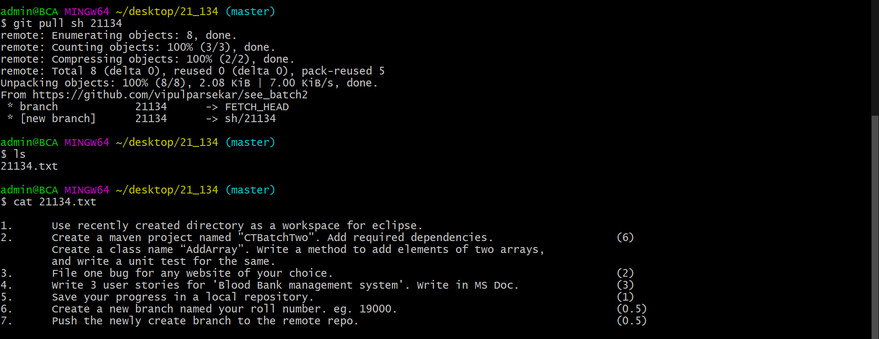

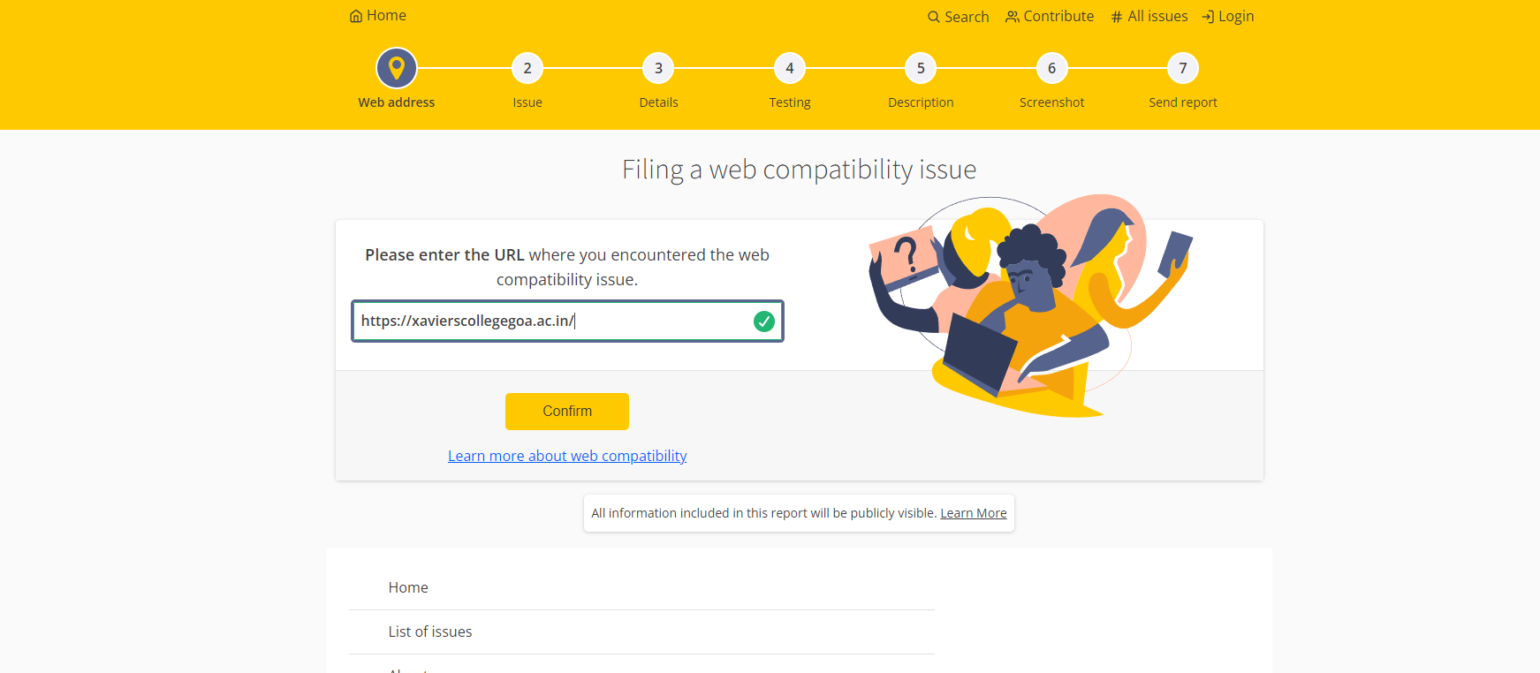**2)**

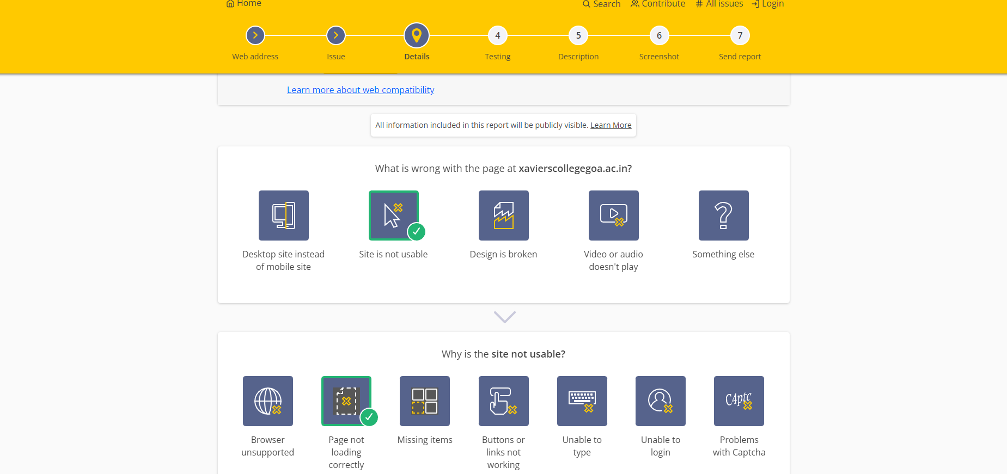

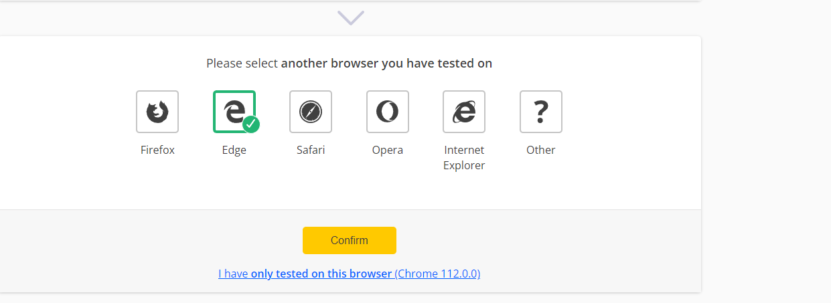

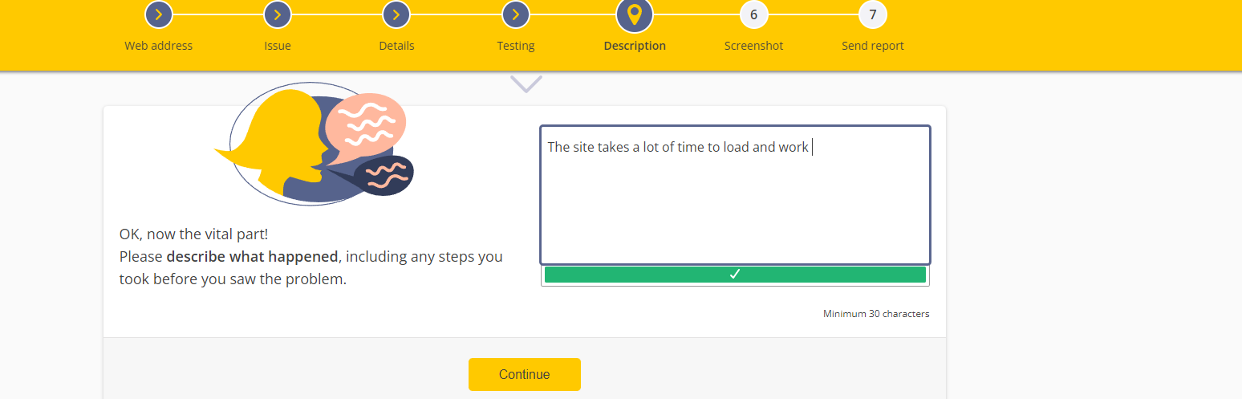



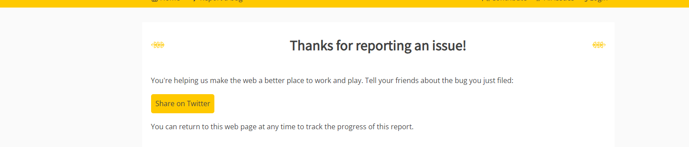

4) USER STORIES

As a donor

I want to login/Register

So that I can register for blood donation near me

As an admin

I want to login

So that I can view how many people have registered for a particular blood drive camp

As a receipient

I want to login

So that I can see blood donation drives near me