Department of Computer Technology

Vision of the Department
To be a well-known centre for pursuing computer education through innovative pedagogy, value-based education and industry collaboration.

Mission of the Department
To establish learning ambience for ushering in computer engineering professionals in core and multidisciplinary area by developing Problem- solving skills through emerging technologies.

Session 2025-2026

Vision: To harness the power of artificial intelligence and data science to solve real-world problems and enhance human potential. | Mission: To acquire skills through coursework, projects, and internships, while actively engaging in research and collaboration with peers to innovate and apply AI solutions.
Program Educational Objectives of the program (PEO): (broad statements that describe the professional and career accomplishments)
PEO1 | Preparation | P: Preparation | Pep-CL abbreviation pronounce as Pep-si-lL easy to recall
PEO2 | Core Competence | E: Environment (Learning Environment) | Pep-CL abbreviation pronounce as Pep-si-lL easy to recall
PEO3 | Breadth | P: Professionalism | Pep-CL abbreviation pronounce as Pep-si-lL easy to recall
PEO4 | Professionalism | C: Core Competence | Pep-CL abbreviation pronounce as Pep-si-lL easy to recall
PEO5 | Learning Environment | L: Breadth (Learning in diverse areas) | Pep-CL abbreviation pronounce as Pep-si-lL easy to recall

Program Outcomes (PO): (statements that describe what a student should be able to do and know by the end of a program)

Keywords of POs:
Engineering knowledge, Problem analysis, Design/development of solutions, Conduct Investigations of Complex Problems, Engineering Tool Usage, The Engineer and The World, Ethics, Individual and Collaborative Team work, Communication, Project Management and Finance, Life-Long Learning
PSO Keywords: Cutting edge technologies, Research

“I am an engineer, and I know how to apply engineering knowledge to investigate, analyse and design solutions to complex problems using tools for entire world following all ethics in a collaborative way with proper management skills throughout my life.” to contribute to the development of cutting-edge technologies and Research.
Integrity: I will adhere to the Laboratory Code of Conduct and ethics in its entirety Shreyas Chaurey 30 October 2025

Name and Signature of Student and Date
(Signature and Date in Handwritten)

Department of Computer Technology

Vision of the Department
To be a well-known centre for pursuing computer education through innovative pedagogy, value-based education and industry collaboration.

Mission of the Department
To establish learning ambience for ushering in computer engineering professionals in core and multidisciplinary area by developing Problem- solving skills through emerging technologies.

Session | 2025-26 (ODD) |  | Course Name | BDH Lab
Semester | 7 |  | Course Code | 22ADS704
Roll No | 61 |  | Name of Student | Shreyas Chaurey
Practical Number |  | 1
Course Outcome |  | CO1: Understand big data analytics and its business applications. CO2: Analyze the HADOOP and Map Reduce technologies associated with big data analytics.  CO3: Apply Big Data Analytics Using Pig and Hive.
Aim |  | Installation of Apache Hadoop on Linux System.
Theory (100 words) |  | Apache Hadoop is an open-source framework that enables distributed storage and processing of large datasets across clusters of computers. It follows the master-slave architecture with HDFS for storage and MapReduce for data processing. Installing Hadoop on a Linux system involves setting up Java, configuring environment variables, and creating a pseudo-distributed or fully distributed setup. The configuration includes editing XML files like core-site.xml, hdfs- site.xml, and mapred-site.xml to define directories, replication factors, and file system paths. Once installed, Hadoop allows efficient handling of big data through parallel computation and fault-tolerant data management.
Procedure and Execution (100 Words) |  | Steps of implementation:  - Install Java Development Kit (JDK).  - Download and extract Hadoop.  - Configure environment variables in .bashrc.  - Edit core, HDFS, and MapReduce XML files.  - Format the NameNode.  - Start NameNode and DataNode daemons.  - Verify installation using Hadoop web UI or shell commands.
Code:

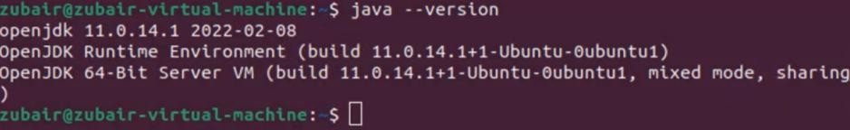

Department of Computer Technology

Vision of the Department
To be a well-known centre for pursuing computer education through innovative pedagogy, value-based education and industry collaboration.

Mission of the Department
To establish learning ambience for ushering in computer engineering professionals in core and multidisciplinary area by developing Problem- solving skills through emerging technologies.



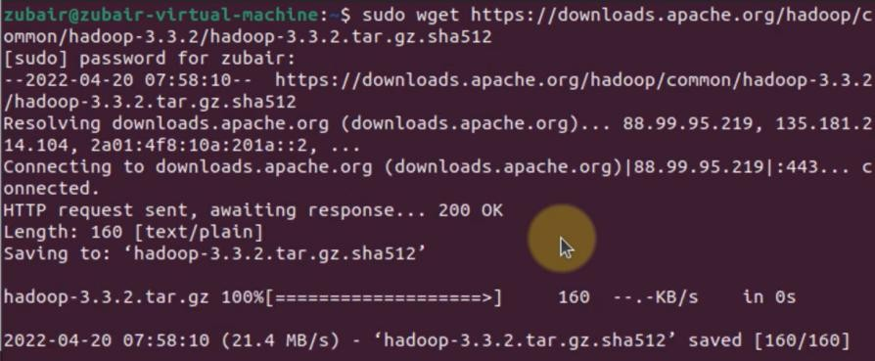

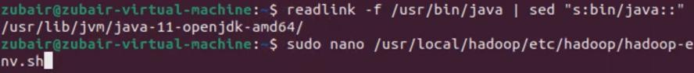

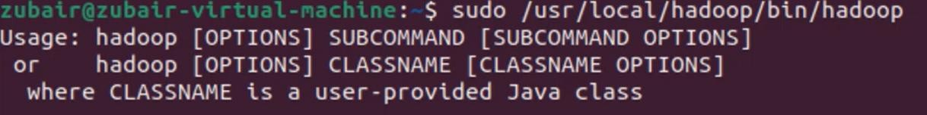
Output Analysis | After installation, Hadoop services such as NameNode, DataNode, ResourceManager, and NodeManager start successfully. The web interfaces display cluster information and running nodes. The hadoop fs  -ls / command confirms access to HDFS, verifying that Hadoop is properly configured and operational.
Github Link | https://github.com/shreyasc60/BDH_LAB
Conclusion | Installing Apache Hadoop on Linux provides a robust environment for distributed data storage and parallel processing. Once set up, the framework can efficiently handle large-scale datasets, forming the foundation for big data analytics and scalable computation.

Department of Computer Technology

Vision of the Department
To be a well-known centre for pursuing computer education through innovative pedagogy, value-based education and industry collaboration.

Mission of the Department
To establish learning ambience for ushering in computer engineering professionals in core and multidisciplinary area by developing Problem- solving skills through emerging technologies.

Plag Report (Similarity index  < 12%) | 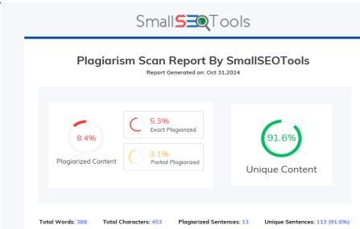
Date | 30 October 2025

Department of Computer Technology

Vision of the Department
To be a well-known centre for pursuing computer education through innovative pedagogy, value-based education and industry collaboration.

Mission of the Department
To establish learning ambience for ushering in computer engineering professionals in core and multidisciplinary area by developing Problem- solving skills through emerging technologies.

Session 2025-2026

Vision: To harness the power of artificial intelligence and data science to solve real-world problems and enhance human potential. | Mission: To acquire skills through coursework, projects, and internships, while actively engaging in research and collaboration with peers to innovate and apply AI solutions.
Program Educational Objectives of the program (PEO): (broad statements that describe the professional and career accomplishments)
PEO1 | Preparation | P: Preparation | Pep-CL abbreviation pronounce as Pep-si-lL easy to recall
PEO2 | Core Competence | E: Environment (Learning Environment) | Pep-CL abbreviation pronounce as Pep-si-lL easy to recall
PEO3 | Breadth | P: Professionalism | Pep-CL abbreviation pronounce as Pep-si-lL easy to recall
PEO4 | Professionalism | C: Core Competence | Pep-CL abbreviation pronounce as Pep-si-lL easy to recall
PEO5 | Learning Environment | L: Breadth (Learning in diverse areas) | Pep-CL abbreviation pronounce as Pep-si-lL easy to recall

Program Outcomes (PO): (statements that describe what a student should be able to do and know by the end of a program)

Keywords of POs:
Engineering knowledge, Problem analysis, Design/development of solutions, Conduct Investigations of Complex Problems, Engineering Tool Usage, The Engineer and The World, Ethics, Individual and Collaborative Team work, Communication, Project Management and Finance, Life-Long Learning
PSO Keywords: Cutting edge technologies, Research

“I am an engineer, and I know how to apply engineering knowledge to investigate, analyse and design solutions to complex problems using tools for entire world following all ethics in a collaborative way with proper management skills throughout my life.” to contribute to the development of cutting-edge technologies and Research.
Integrity: I will adhere to the Laboratory Code of Conduct and ethics in its entirety. Shreyas Chaurey 30 October 2025

Name and Signature of Student and Date
(Signature and Date in Handwritten)

Department of Computer Technology

Vision of the Department
To be a well-known centre for pursuing computer education through innovative pedagogy, value-based education and industry collaboration.

Mission of the Department
To establish learning ambience for ushering in computer engineering professionals in core and multidisciplinary area by developing Problem- solving skills through emerging technologies.

Session | 2025-26 (ODD) |  | Course Name | BDH Lab
Semester | 7 |  | Course Code | 22ADS704
Roll No | 61 |  | Name of Student | Shreyas Chaurey
Practical Number |  | 2
Course Outcome |  | CO1: Understand big data analytics and its business applications. CO2: Analyze the HADOOP and Map Reduce technologies associated with big data analytics.  CO3: Apply Big Data Analytics Using Pig and Hive.
Aim |  | Implementation of File management operations in Hadoop.
Theory (100 words) |  | Hadoop Distributed File System (HDFS) provides scalable and reliable storage for big data applications. It allows users to manage files across a distributed cluster using commands similar to traditional UNIX file systems. File management operations in Hadoop include creating directories, uploading and downloading files, viewing file contents, and deleting files from HDFS. These operations are performed through the Hadoop shell or API commands, ensuring data replication, fault tolerance, and efficient access. Understanding these operations is crucial for effectively handling data within the Hadoop ecosystem.
Procedure and Execution (100 Words) |  | Steps of implementation:  - Start Hadoop services (NameNode and DataNode).  - Create a directory in HDFS using hadoop fs -mkdir.  - Upload files with hadoop fs -put.  - View files using hadoop fs -ls or -cat.  - Download files using hadoop fs -get.  - Delete files or directories using hadoop fs -rm or -rmdir.
Code:

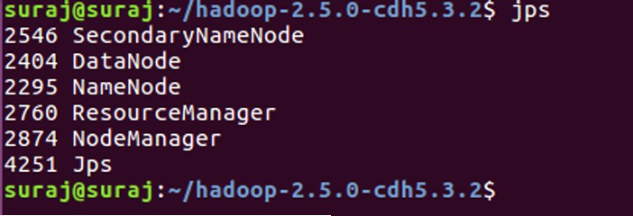

Department of Computer Technology

Vision of the Department
To be a well-known centre for pursuing computer education through innovative pedagogy, value-based education and industry collaboration.

Mission of the Department
To establish learning ambience for ushering in computer engineering professionals in core and multidisciplinary area by developing Problem- solving skills through emerging technologies.

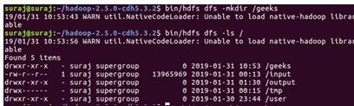

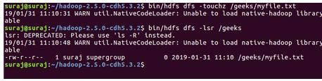

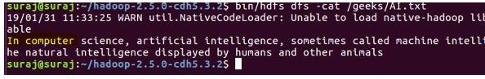

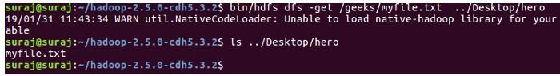

Output Analysis | Each command execution confirms successful file operations in HDFS. For instance, files uploaded with -put appear when listing directories, and -cat displays their contents. The successful execution of create, view, and delete commands verifies that the Hadoop file management system is functioning properly.
Github Link | https://github.com/shreyasc60/BDH_LAB
Conclusion | Implementing file management operations in Hadoop demonstrates efficient handling of files within a distributed system. These commands help manage large datasets seamlessly, ensuring scalability, reliability, and accessibility across the Hadoop cluster.

Department of Computer Technology

Vision of the Department
To be a well-known centre for pursuing computer education through innovative pedagogy, value-based education and industry collaboration.

Mission of the Department
To establish learning ambience for ushering in computer engineering professionals in core and multidisciplinary area by developing Problem- solving skills through emerging technologies.

Plag Report (Similarity index
< 12%)
Date | 30 October 2025

Department of Computer Technology

Vision of the Department
To be a well-known centre for pursuing computer education through innovative pedagogy, value-based education and industry collaboration.

Mission of the Department
To establish learning ambience for ushering in computer engineering professionals in core and multidisciplinary area by developing Problem- solving skills through emerging technologies.

Session 2025-2026

Vision: To harness the power of artificial intelligence and data science to solve real-world problems and enhance human potential. | Mission: To acquire skills through coursework, projects, and internships, while actively engaging in research and collaboration with peers to innovate and apply AI solutions.
Program Educational Objectives of the program (PEO): (broad statements that describe the professional and career accomplishments)
PEO1 | Preparation | P: Preparation | Pep-CL abbreviation pronounce as Pep-si-lL easy to recall
PEO2 | Core Competence | E: Environment (Learning Environment) | Pep-CL abbreviation pronounce as Pep-si-lL easy to recall
PEO3 | Breadth | P: Professionalism | Pep-CL abbreviation pronounce as Pep-si-lL easy to recall
PEO4 | Professionalism | C: Core Competence | Pep-CL abbreviation pronounce as Pep-si-lL easy to recall
PEO5 | Learning Environment | L: Breadth (Learning in diverse areas) | Pep-CL abbreviation pronounce as Pep-si-lL easy to recall

Program Outcomes (PO): (statements that describe what a student should be able to do and know by the end of a program)

Keywords of POs:
Engineering knowledge, Problem analysis, Design/development of solutions, Conduct Investigations of Complex Problems, Engineering Tool Usage, The Engineer and The World, Ethics, Individual and Collaborative Team work, Communication, Project Management and Finance, Life-Long Learning
PSO Keywords: Cutting edge technologies, Research

“I am an engineer, and I know how to apply engineering knowledge to investigate, analyse and design solutions to complex problems using tools for entire world following all ethics in a collaborative way with proper management skills throughout my life.” to contribute to the development of cutting-edge technologies and Research.
Integrity: I will adhere to the Laboratory Code of Conduct and ethics in its entirety. Shreyas Chaurey 30 October 2025

Name and Signature of Student and Date
(Signature and Date in Handwritten)

Department of Computer Technology

Vision of the Department
To be a well-known centre for pursuing computer education through innovative pedagogy, value-based education and industry collaboration.

Mission of the Department
To establish learning ambience for ushering in computer engineering professionals in core and multidisciplinary area by developing Problem- solving skills through emerging technologies.

Session | 2025-26 (ODD) |  | Course Name | BDH Lab
Semester | 7 |  | Course Code | 22ADS704
Roll No | 61 |  | Name of Student | Shreyas Chaurey
Practical Number |  | 3
Course Outcome |  | CO1: Understand big data analytics and its business applications. CO2: Analyze the HADOOP and Map Reduce technologies associated with big data analytics.  CO3: Apply Big Data Analytics Using Pig and Hive.
Aim |  | Write a MapReduce Program to Calculate Frequency of Words from Datasets.
Theory (100 words) |  | MapReduce is a programming model in Hadoop used to process large datasets in parallel. It works in two main phases: the Mapper and the Reducer. In a word frequency program, the Mapper reads text input and emits each word as a key with a count of one. The Reducer then aggregates these counts for each unique word, producing the total frequency of each word in the dataset. This approach efficiently distributes processing tasks across multiple nodes, enabling fast and scalable text analysis on big data stored in HDFS.
Procedure and Execution (100 Words) |  | Steps of implementation:  - Prepare input text files and store them in HDFS.  - Create Mapper class – split lines into words and emit (word, 1).  - Create Reducer class – sum counts for each word.  - Set up the Driver program to configure and run the job.  - Compile and run the program on Hadoop.  - View the output file in HDFS to see word frequencies.
Code:
import java.io.IOException; import java.util.StringTokenizer;
import org.apache.hadoop.conf.Configuration; import org.apache.hadoop.fs.Path;
import org.apache.hadoop.io.IntWritable; import org.apache.hadoop.io.Text;
import org.apache.hadoop.mapreduce.Job; import org.apache.hadoop.mapreduce.Mapper; import org.apache.hadoop.mapreduce.Reducer;
import org.apache.hadoop.mapreduce.lib.input.FileInputFormat; import org.apache.hadoop.mapreduce.lib.output.FileOutputFormat;

Department of Computer Technology

Vision of the Department
To be a well-known centre for pursuing computer education through innovative pedagogy, value-based education and industry collaboration.

Mission of the Department
To establish learning ambience for ushering in computer engineering professionals in core and multidisciplinary area by developing Problem- solving skills through emerging technologies.

public class WordCount {
public static class TokenizerMapper extends Mapper<Object, Text, Text, IntWritable> {
private final static IntWritable one = new IntWritable(1); private Text word = new Text();
public void map(Object key, Text value, Context context) throws IOException, InterruptedException {
StringTokenizer itr = new StringTokenizer(value.toString()); while (itr.hasMoreTokens()) {
word.set(itr.nextToken()); context.write(word, one);
}
}
}
public static class IntSumReducer extends Reducer<Text, IntWritable, Text, IntWritable> {
private IntWritable result = new IntWritable();
public void reduce(Text key, Iterable<IntWritable> values, Context context)
throws IOException, InterruptedException { int sum = 0;
for (IntWritable val : values) { sum += val.get();
}
result.set(sum); context.write(key, result);
}
}
public static void main(String[] args) throws Exception { Configuration conf = new Configuration();
Job job = Job.getInstance(conf, "word count"); job.setJarByClass(WordCount.class); job.setMapperClass(TokenizerMapper.class); job.setCombinerClass(IntSumReducer.class); job.setReducerClass(IntSumReducer.class); job.setOutputKeyClass(Text.class); job.setOutputValueClass(IntWritable.class); FileInputFormat.addInputPath(job, new Path(args[0])); FileOutputFormat.setOutputPath(job, new Path(args[1])); System.exit(job.waitForCompletion(true) ? 0 : 1);
}
}

Department of Computer Technology

Vision of the Department
To be a well-known centre for pursuing computer education through innovative pedagogy, value-based education and industry collaboration.

Mission of the Department
To establish learning ambience for ushering in computer engineering professionals in core and multidisciplinary area by developing Problem- solving skills through emerging technologies.

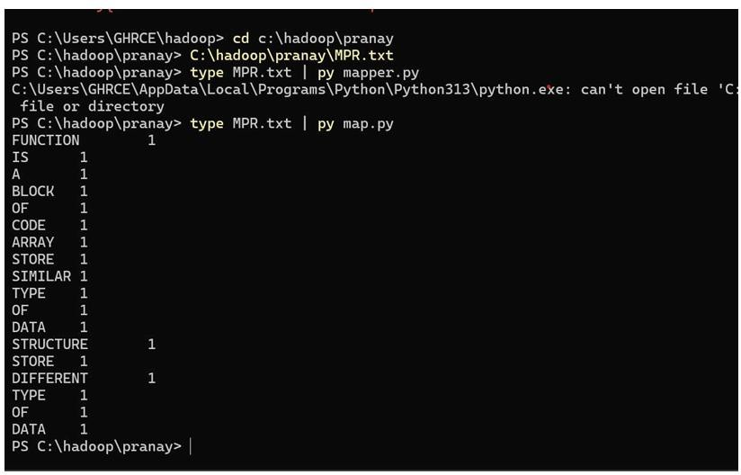
Output:
Output Analysis | The output displays each unique word from the dataset followed by its frequency count. For example:  Hadoop 3, Big 2, Data 5.  This confirms that the MapReduce program successfully reads, processes, and counts words in parallel across the cluster.
Github Link | https://github.com/shreyasc60/BDH_LAB
Conclusion | The MapReduce word frequency program demonstrates Hadoop’s capability to perform distributed data processing. By splitting and aggregating data across nodes, it efficiently computes word occurrences in large datasets, showcasing Hadoop’s strength in handling scalable and parallel data analysis tasks.

Department of Computer Technology

Vision of the Department
To be a well-known centre for pursuing computer education through innovative pedagogy, value-based education and industry collaboration.

Mission of the Department
To establish learning ambience for ushering in computer engineering professionals in core and multidisciplinary area by developing Problem- solving skills through emerging technologies.

Plag Report (Similarity index
< 12%)
Date | 30 October 2025

Department of Computer Technology

Vision of the Department
To be a well-known centre for pursuing computer education through innovative pedagogy, value-based education and industry collaboration.

Mission of the Department
To establish learning ambience for ushering in computer engineering professionals in core and multidisciplinary area by developing Problem- solving skills through emerging technologies.

Session 2025-2026

Vision: To harness the power of artificial intelligence and data science to solve real-world problems and enhance human potential. | Mission: To acquire skills through coursework, projects, and internships, while actively engaging in research and collaboration with peers to innovate and apply AI solutions.
Program Educational Objectives of the program (PEO): (broad statements that describe the professional and career accomplishments)
PEO1 | Preparation | P: Preparation | Pep-CL abbreviation pronounce as Pep-si-lL easy to recall
PEO2 | Core Competence | E: Environment (Learning Environment) | Pep-CL abbreviation pronounce as Pep-si-lL easy to recall
PEO3 | Breadth | P: Professionalism | Pep-CL abbreviation pronounce as Pep-si-lL easy to recall
PEO4 | Professionalism | C: Core Competence | Pep-CL abbreviation pronounce as Pep-si-lL easy to recall
PEO5 | Learning Environment | L: Breadth (Learning in diverse areas) | Pep-CL abbreviation pronounce as Pep-si-lL easy to recall

Program Outcomes (PO): (statements that describe what a student should be able to do and know by the end of a program)

Keywords of POs:
Engineering knowledge, Problem analysis, Design/development of solutions, Conduct Investigations of Complex Problems, Engineering Tool Usage, The Engineer and The World, Ethics, Individual and Collaborative Team work, Communication, Project Management and Finance, Life-Long Learning
PSO Keywords: Cutting edge technologies, Research

“I am an engineer, and I know how to apply engineering knowledge to investigate, analyse and design solutions to complex problems using tools for entire world following all ethics in a collaborative way with proper management skills throughout my life.” to contribute to the development of cutting-edge technologies and Research.
Integrity: I will adhere to the Laboratory Code of Conduct and ethics in its entirety. Shreyas Chaurey 30 October 2025

Name and Signature of Student and Date
(Signature and Date in Handwritten)

Department of Computer Technology

Vision of the Department
To be a well-known centre for pursuing computer education through innovative pedagogy, value-based education and industry collaboration.

Mission of the Department
To establish learning ambience for ushering in computer engineering professionals in core and multidisciplinary area by developing Problem- solving skills through emerging technologies.

Session | 2025-26 (ODD) |  | Course Name | BDH Lab
Semester | 7 |  | Course Code | 22ADS704
Roll No | 61 |  | Name of Student | Shreyas Chaurey
Practical Number |  | 4
Course Outcome |  | CO1: Understand big data analytics and its business applications. CO2: Analyze the HADOOP and Map Reduce technologies associated with big data analytics.  CO3: Apply Big Data Analytics Using Pig and Hive.
Aim |  | Installation of Apache Hive on Linux with Hadoop Integration.
Theory (100 words) |  | Apache Hive is a data warehouse system built on top of Hadoop that provides a SQL-like interface (HiveQL) for querying and managing large datasets stored in HDFS. It converts SQL queries into MapReduce or Tez/Spark jobs, enabling users to perform data analysis without complex programming. Installing Hive on a Linux system integrated with Hadoop involves configuring environment variables, setting up Hive metastore, and connecting it to Hadoop’s HDFS. This setup allows users to manage structured data efficiently using queries while leveraging Hadoop’s distributed processing power.
Procedure and Execution (100 Words) |  | Steps of implementation:  - Ensure Hadoop is installed and running.  - Download and extract Apache Hive.  - Configure environment variables in .bashrc.  - Edit hive-site.xml to set metastore and warehouse paths.  - Initialize the Hive metastore database.  - Start Hive using the hive command.  - Create and query tables to verify integration with Hadoop.
Code:

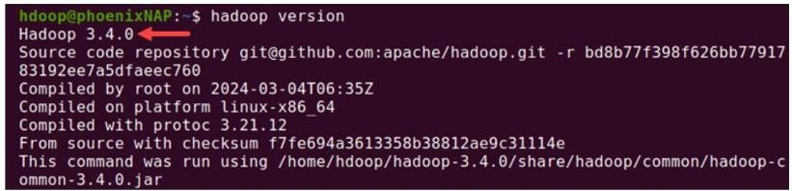

Department of Computer Technology

Vision of the Department
To be a well-known centre for pursuing computer education through innovative pedagogy, value-based education and industry collaboration.

Mission of the Department
To establish learning ambience for ushering in computer engineering professionals in core and multidisciplinary area by developing Problem- solving skills through emerging technologies.

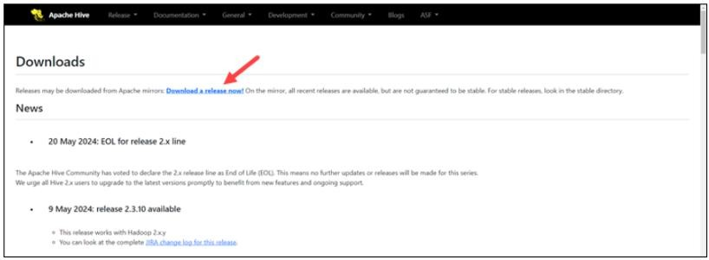

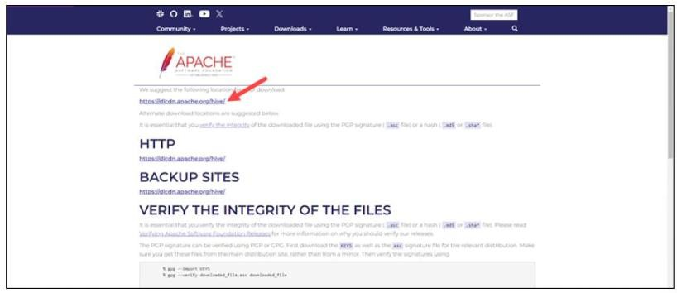

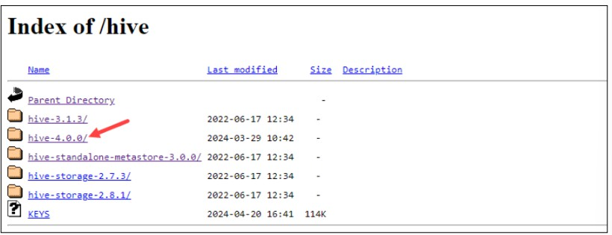

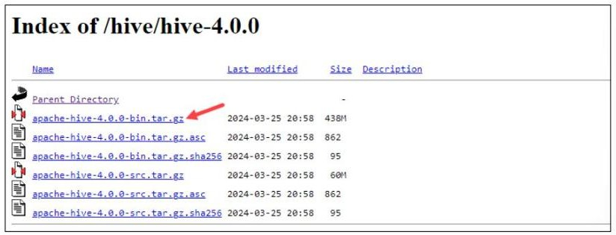

Department of Computer Technology

Vision of the Department
To be a well-known centre for pursuing computer education through innovative pedagogy, value-based education and industry collaboration.

Mission of the Department
To establish learning ambience for ushering in computer engineering professionals in core and multidisciplinary area by developing Problem- solving skills through emerging technologies.

Output:

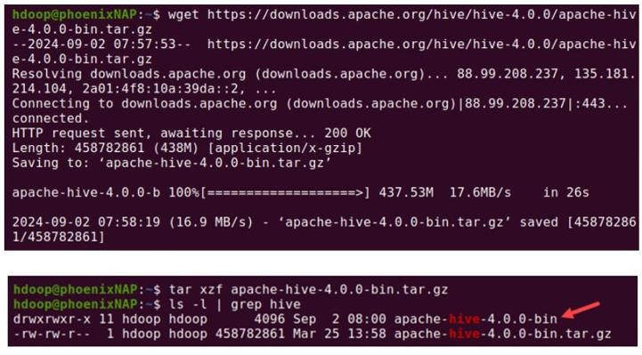
Output Analysis | After successful installation, Hive starts with the prompt hive>. Commands like CREATE TABLE, LOAD DATA, and SELECT execute successfully using HDFS as storage. Query outputs confirm proper communication between Hive and Hadoop, ensuring seamless data processing and retrieval.
Github Link | https://github.com/shreyasc60/BDH_LAB
Conclusion | Installing Apache Hive on Linux with Hadoop integration enables efficient management and querying of large datasets through a familiar SQL-like interface. This setup simplifies big data analytics by combining Hive’s ease of use with Hadoop’s scalability and distributed processing power.
Plag Report (Similarity index
< 12%)
Date | 30 October 2025

Department of Computer Technology

Vision of the Department
To be a well-known centre for pursuing computer education through innovative pedagogy, value-based education and industry collaboration.

Mission of the Department
To establish learning ambience for ushering in computer engineering professionals in core and multidisciplinary area by developing Problem- solving skills through emerging technologies.

Session 2025-2026

Vision: To harness the power of artificial intelligence and data science to solve real-world problems and enhance human potential. | Mission: To acquire skills through coursework, projects, and internships, while actively engaging in research and collaboration with peers to innovate and apply AI solutions.
Program Educational Objectives of the program (PEO): (broad statements that describe the professional and career accomplishments)
PEO1 | Preparation | P: Preparation | Pep-CL abbreviation pronounce as Pep-si-lL easy to recall
PEO2 | Core Competence | E: Environment (Learning Environment) | Pep-CL abbreviation pronounce as Pep-si-lL easy to recall
PEO3 | Breadth | P: Professionalism | Pep-CL abbreviation pronounce as Pep-si-lL easy to recall
PEO4 | Professionalism | C: Core Competence | Pep-CL abbreviation pronounce as Pep-si-lL easy to recall
PEO5 | Learning Environment | L: Breadth (Learning in diverse areas) | Pep-CL abbreviation pronounce as Pep-si-lL easy to recall

Program Outcomes (PO): (statements that describe what a student should be able to do and know by the end of a program)

Keywords of POs:
Engineering knowledge, Problem analysis, Design/development of solutions, Conduct Investigations of Complex Problems, Engineering Tool Usage, The Engineer and The World, Ethics, Individual and Collaborative Team work, Communication, Project Management and Finance, Life-Long Learning
PSO Keywords: Cutting edge technologies, Research

“I am an engineer, and I know how to apply engineering knowledge to investigate, analyse and design solutions to complex problems using tools for entire world following all ethics in a collaborative way with proper management skills throughout my life.” to contribute to the development of cutting-edge technologies and Research.
Integrity: I will adhere to the Laboratory Code of Conduct and ethics in its entirety. Shreyas Chaurey 30 October 2025

Name and Signature of Student and Date
(Signature and Date in Handwritten)

Department of Computer Technology

Vision of the Department
To be a well-known centre for pursuing computer education through innovative pedagogy, value-based education and industry collaboration.

Mission of the Department
To establish learning ambience for ushering in computer engineering professionals in core and multidisciplinary area by developing Problem- solving skills through emerging technologies.

Session | 2025-26 (ODD) |  | Course Name | BDH Lab
Semester | 7 |  | Course Code | 22ADS704
Roll No | 61 |  | Name of Student | Shreyas Chaurey
Practical Number |  | 5
Course Outcome |  | CO1: Understand big data analytics and its business applications. CO2: Analyze the HADOOP and Map Reduce technologies associated with big data analytics.  CO3: Apply Big Data Analytics Using Pig and Hive.
Aim |  | Perform Hive Operations: Create, Alter and Drop Databases, Tables, Views, and Indexes.
Theory (100 words) |  | Apache Hive provides a SQL-like interface for managing structured data in Hadoop. It allows users to perform Data Definition Language (DDL) operations such as creating, altering, and dropping databases, tables, views, and indexes. These operations help organize and optimize large datasets stored in HDFS. Databases group related tables, tables store structured data, views act as virtual tables for simplified queries, and indexes improve query performance. Hive translates these SQL operations into MapReduce or Tez/Spark jobs, enabling scalable and efficient data management within the Hadoop ecosystem.
Procedure and Execution (100 Words) |  | Steps of implementation:  - Start Hive shell using hive command.  - Create a database: CREATE DATABASE dbname;  - Use the database: USE dbname;  - Create a table: CREATE TABLE tablename (...);  - Alter table: ALTER TABLE tablename ADD COLUMNS (...);  - Drop table: DROP TABLE tablename;  - Create a view: CREATE VIEW viewname AS SELECT ...;  - Drop view: DROP VIEW viewname;  - Create index: CREATE INDEX idx_name ON TABLE tablename (column);  - Drop index: DROP INDEX idx_name ON tablename;
Code:

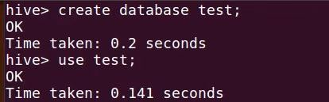

Department of Computer Technology

Vision of the Department
To be a well-known centre for pursuing computer education through innovative pedagogy, value-based education and industry collaboration.

Mission of the Department
To establish learning ambience for ushering in computer engineering professionals in core and multidisciplinary area by developing Problem- solving skills through emerging technologies.

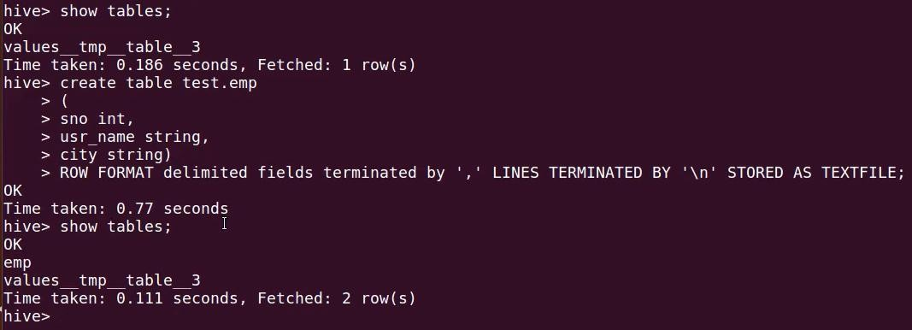

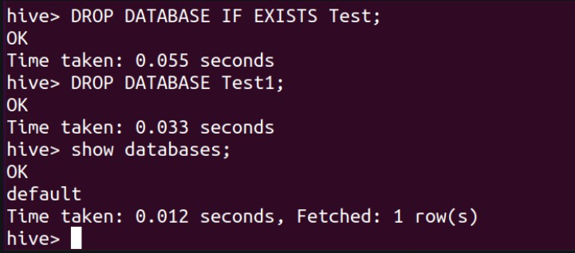

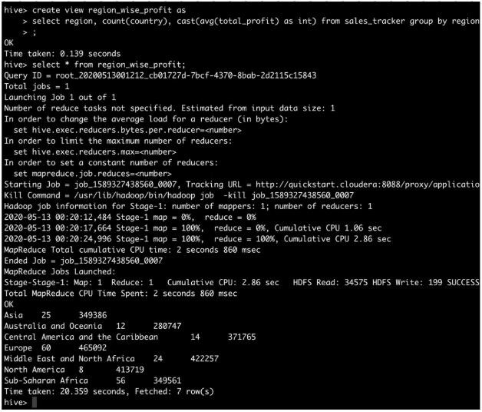

Department of Computer Technology

Vision of the Department
To be a well-known centre for pursuing computer education through innovative pedagogy, value-based education and industry collaboration.

Mission of the Department
To establish learning ambience for ushering in computer engineering professionals in core and multidisciplinary area by developing Problem- solving skills through emerging technologies.

 | Output:
Output Analysis | Each command executes successfully, displaying confirmation messages like “Table created,” “Database dropped,” or “Index created.” Listing commands (SHOW DATABASES;, SHOW TABLES;) verify the changes. The output demonstrates successful management of Hive databases, tables, views, and indexes within Hadoop.
Github Link | https://github.com/shreyasc60/BDH_LAB
Conclusion | Performing Hive operations such as creating, altering, and dropping databases, tables, views, and indexes enables structured organization and optimized querying of big data. These operations simplify data management while leveraging Hadoop’s scalability and Hive’s SQL- like interface for efficient analytics.
Plag Report (Similarity index
< 12%)
Date | 30 October 2025

Department of Computer Technology

Vision of the Department
To be a well-known centre for pursuing computer education through innovative pedagogy, value-based education and industry collaboration.

Mission of the Department
To establish learning ambience for ushering in computer engineering professionals in core and multidisciplinary area by developing Problem- solving skills through emerging technologies.

Session 2025-2026

Vision: To harness the power of artificial intelligence and data science to solve real-world problems and enhance human potential. | Mission: To acquire skills through coursework, projects, and internships, while actively engaging in research and collaboration with peers to innovate and apply AI solutions.
Program Educational Objectives of the program (PEO): (broad statements that describe the professional and career accomplishments)
PEO1 | Preparation | P: Preparation | Pep-CL abbreviation pronounce as Pep-si-lL easy to recall
PEO2 | Core Competence | E: Environment (Learning Environment) | Pep-CL abbreviation pronounce as Pep-si-lL easy to recall
PEO3 | Breadth | P: Professionalism | Pep-CL abbreviation pronounce as Pep-si-lL easy to recall
PEO4 | Professionalism | C: Core Competence | Pep-CL abbreviation pronounce as Pep-si-lL easy to recall
PEO5 | Learning Environment | L: Breadth (Learning in diverse areas) | Pep-CL abbreviation pronounce as Pep-si-lL easy to recall

Program Outcomes (PO): (statements that describe what a student should be able to do and know by the end of a program)

Keywords of POs:
Engineering knowledge, Problem analysis, Design/development of solutions, Conduct Investigations of Complex Problems, Engineering Tool Usage, The Engineer and The World, Ethics, Individual and Collaborative Team work, Communication, Project Management and Finance, Life-Long Learning
PSO Keywords: Cutting edge technologies, Research

“I am an engineer, and I know how to apply engineering knowledge to investigate, analyse and design solutions to complex problems using tools for entire world following all ethics in a collaborative way with proper management skills throughout my life.” to contribute to the development of cutting-edge technologies and Research.
Integrity: I will adhere to the Laboratory Code of Conduct and ethics in its entirety. Shreyas Chaurey 30 October 2025

Name and Signature of Student and Date
(Signature and Date in Handwritten)

Department of Computer Technology

Vision of the Department
To be a well-known centre for pursuing computer education through innovative pedagogy, value-based education and industry collaboration.

Mission of the Department
To establish learning ambience for ushering in computer engineering professionals in core and multidisciplinary area by developing Problem- solving skills through emerging technologies.

Session | 2025-26 (ODD) |  | Course Name | BDH Lab
Semester | 7 |  | Course Code | 22ADS704
Roll No | 61 |  | Name of Student | Shreyas Chaurey
Practical Number |  | 6
Course Outcome |  | CO1: Understand big data analytics and its business applications. CO2: Analyze the HADOOP and Map Reduce technologies associated with big data analytics.  CO3: Apply Big Data Analytics Using Pig and Hive.
Aim |  | Perform Case Study: Analyzing Olympic Data Set Using Hive.
Theory (100 words) |  | Apache Hive enables large-scale data analysis using SQL-like queries on data stored in Hadoop. In this case study, the Olympic dataset containing details like athletes, countries, sports, medals, and years is analyzed using Hive. By loading the dataset into Hive tables, users can execute queries to extract insights such as total medals by country, top athletes, or performance trends over the years. Hive translates these queries into MapReduce or Tez/Spark jobs, enabling efficient distributed processing of massive datasets and simplifying analytics through its structured query interface.
Procedure and Execution (100 Words) |  | Steps of implementation:  - Start Hadoop and Hive services.  - Create a database, e.g., CREATE DATABASE olympics;  - Create an external table with appropriate schema.  - Load the dataset using LOAD DATA INPATH '/path/olympic.csv' INTO TABLE olympic;  - Run queries like:  - SELECT country, COUNT(medal) FROM olympic GROUP BY country;  - SELECT athlete, COUNT(*) FROM olympic GROUP BY athlete ORDER BY COUNT(*) DESC;  - Save or export query results if needed.

Department of Computer Technology

Vision of the Department
To be a well-known centre for pursuing computer education through innovative pedagogy, value-based education and industry collaboration.

Mission of the Department
To establish learning ambience for ushering in computer engineering professionals in core and multidisciplinary area by developing Problem- solving skills through emerging technologies.

Code:
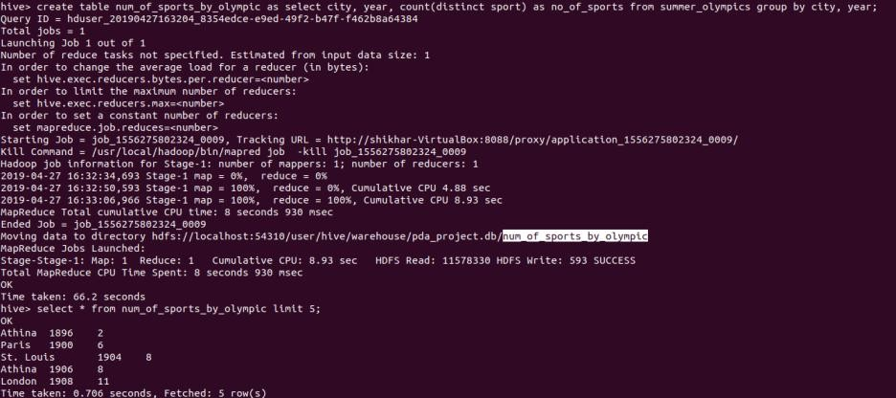

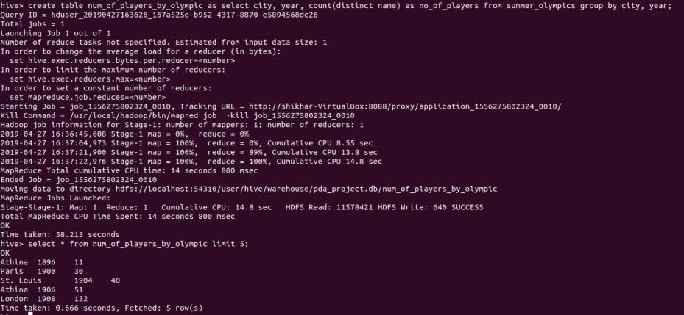

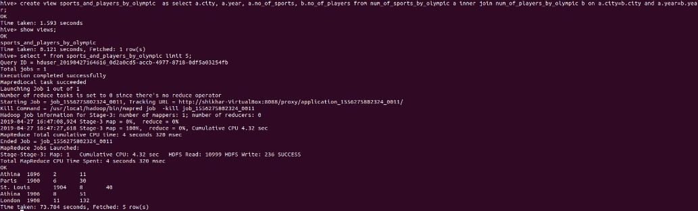

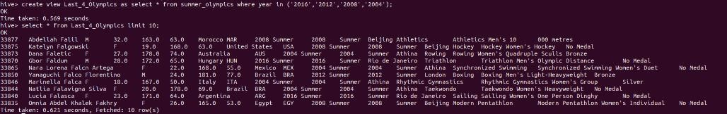
Output Analysis | Hive queries produce analytical summaries such as the number of medals won by each country, the most successful athletes, and trends across different Olympic years. The results confirm Hive’s ability to efficiently process and analyze large structured datasets stored in HDFS.

Department of Computer Technology

Vision of the Department
To be a well-known centre for pursuing computer education through innovative pedagogy, value-based education and industry collaboration.

Mission of the Department
To establish learning ambience for ushering in computer engineering professionals in core and multidisciplinary area by developing Problem- solving skills through emerging technologies.

Github Link | https://github.com/shreyasc60/BDH_LAB
Conclusion | Analyzing the Olympic dataset using Hive demonstrates how big data analytics can be simplified through HiveQL. The case study highlights Hive’s capability to manage and query large datasets efficiently, providing meaningful insights from complex data with minimal coding effort.
Plag Report (Similarity index
< 12%)
Date | 30 October 2025

Department of Computer Technology

Vision of the Department
To be a well-known centre for pursuing computer education through innovative pedagogy, value-based education and industry collaboration.

Mission of the Department
To establish learning ambience for ushering in computer engineering professionals in core and multidisciplinary area by developing Problem- solving skills through emerging technologies.

Session 2025-2026

Vision: To harness the power of artificial intelligence and data science to solve real-world problems and enhance human potential. | Mission: To acquire skills through coursework, projects, and internships, while actively engaging in research and collaboration with peers to innovate and apply AI solutions.
Program Educational Objectives of the program (PEO): (broad statements that describe the professional and career accomplishments)
PEO1 | Preparation | P: Preparation | Pep-CL abbreviation pronounce as Pep-si-lL easy to recall
PEO2 | Core Competence | E: Environment (Learning Environment) | Pep-CL abbreviation pronounce as Pep-si-lL easy to recall
PEO3 | Breadth | P: Professionalism | Pep-CL abbreviation pronounce as Pep-si-lL easy to recall
PEO4 | Professionalism | C: Core Competence | Pep-CL abbreviation pronounce as Pep-si-lL easy to recall
PEO5 | Learning Environment | L: Breadth (Learning in diverse areas) | Pep-CL abbreviation pronounce as Pep-si-lL easy to recall

Program Outcomes (PO): (statements that describe what a student should be able to do and know by the end of a program)

Keywords of POs:
Engineering knowledge, Problem analysis, Design/development of solutions, Conduct Investigations of Complex Problems, Engineering Tool Usage, The Engineer and The World, Ethics, Individual and Collaborative Team work, Communication, Project Management and Finance, Life-Long Learning
PSO Keywords: Cutting edge technologies, Research

“I am an engineer, and I know how to apply engineering knowledge to investigate, analyse and design solutions to complex problems using tools for entire world following all ethics in a collaborative way with proper management skills throughout my life.” to contribute to the development of cutting-edge technologies and Research.
Integrity: I will adhere to the Laboratory Code of Conduct and ethics in its entirety. Shreyas Chaurey 30 October 2025

Name and Signature of Student and Date
(Signature and Date in Handwritten)

Department of Computer Technology

Vision of the Department
To be a well-known centre for pursuing computer education through innovative pedagogy, value-based education and industry collaboration.

Mission of the Department
To establish learning ambience for ushering in computer engineering professionals in core and multidisciplinary area by developing Problem- solving skills through emerging technologies.

Session | 2025-26 (ODD) |  | Course Name | BDH Lab
Semester | 7 |  | Course Code | 22ADS704
Roll No | 61 |  | Name of Student | Shreyas Chaurey
Practical Number |  | 7
Course Outcome |  | CO1: Understand big data analytics and its business applications. CO2: Analyze the HADOOP and Map Reduce technologies associated with big data analytics.  CO3: Apply Big Data Analytics Using Pig and Hive.
Aim |  | Installation of Apache Pig on Linux with Hadoop Integration
Theory (100 words) |  | Apache Pig is a high-level platform built on top of Hadoop for processing and analyzing large datasets using a scripting language called Pig Latin. It simplifies the development of MapReduce programs by providing easy-to-understand commands for data transformation, filtering, and aggregation. Installing Pig on a Linux system integrated with Hadoop allows users to execute Pig scripts that run as MapReduce jobs on the cluster. This integration enables efficient handling of structured and semi-structured data without writing complex Java code, making Pig a powerful tool for big data analytics.
Procedure and Execution (100 Words) |  | Steps of implementation:  - Ensure Hadoop is installed and running.  - Download and extract Apache Pig.  - Configure environment variables in .bashrc (set PIG_HOME and update PATH).  - Verify Java and Hadoop paths in Pig configuration.  - Start Pig in local or MapReduce mode using pig command.  - Run sample Pig Latin scripts to test Hadoop integration.
Code:

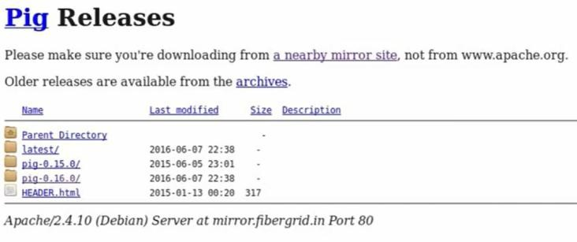

Department of Computer Technology

Vision of the Department
To be a well-known centre for pursuing computer education through innovative pedagogy, value-based education and industry collaboration.

Mission of the Department
To establish learning ambience for ushering in computer engineering professionals in core and multidisciplinary area by developing Problem- solving skills through emerging technologies.

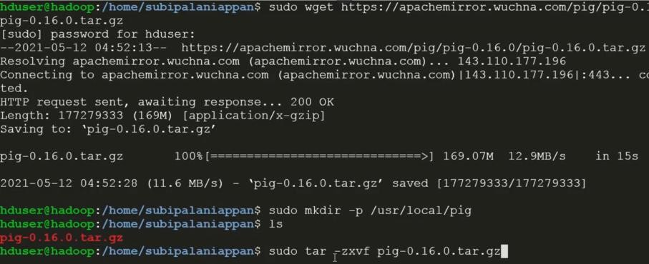

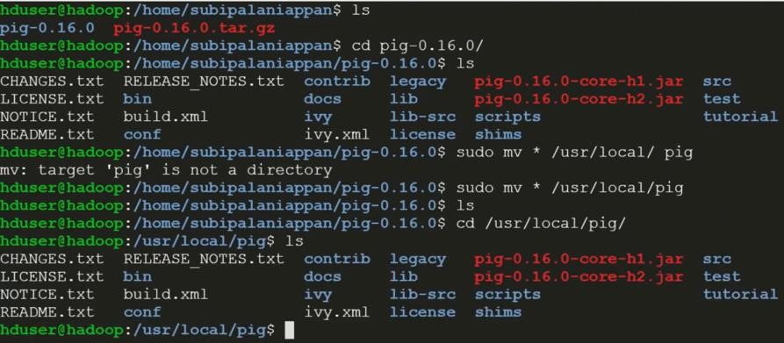

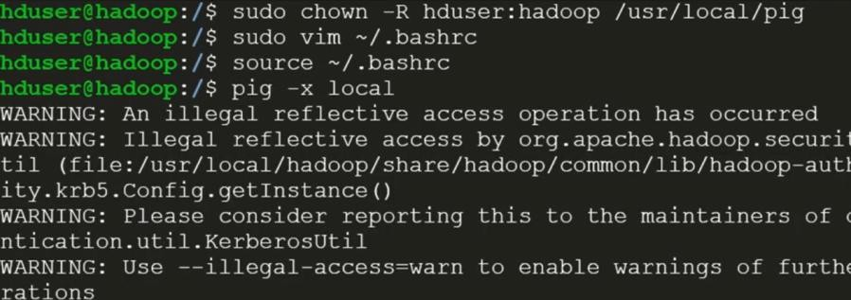
Output Analysis | After installation, the pig shell starts successfully, displaying the grunt> prompt. Executing Pig Latin scripts (like word count) produces output stored in HDFS. Successful job completion messages confirm that Pig is properly integrated with Hadoop and capable of running MapReduce  tasks.
Github Link | https://github.com/shreyasc60/BDH_LAB
Conclusion | Installing Apache Pig on Linux with Hadoop integration provides a simplified way to process large datasets using Pig Latin scripts. This setup enhances productivity by abstracting complex MapReduce logic and enabling efficient big data analysis within the Hadoop ecosystem.

Department of Computer Technology

Vision of the Department
To be a well-known centre for pursuing computer education through innovative pedagogy, value-based education and industry collaboration.

Mission of the Department
To establish learning ambience for ushering in computer engineering professionals in core and multidisciplinary area by developing Problem- solving skills through emerging technologies.

Plag Report (Similarity index
< 12%)
Date | 30 October 2025

Department of Computer Technology

Vision of the Department
To be a well-known centre for pursuing computer education through innovative pedagogy, value-based education and industry collaboration.

Mission of the Department
To establish learning ambience for ushering in computer engineering professionals in core and multidisciplinary area by developing Problem- solving skills through emerging technologies.

Session 2025-2026

Vision: To harness the power of artificial intelligence and data science to solve real-world problems and enhance human potential. | Mission: To acquire skills through coursework, projects, and internships, while actively engaging in research and collaboration with peers to innovate and apply AI solutions.
Program Educational Objectives of the program (PEO): (broad statements that describe the professional and career accomplishments)
PEO1 | Preparation | P: Preparation | Pep-CL abbreviation pronounce as Pep-si-lL easy to recall
PEO2 | Core Competence | E: Environment (Learning Environment) | Pep-CL abbreviation pronounce as Pep-si-lL easy to recall
PEO3 | Breadth | P: Professionalism | Pep-CL abbreviation pronounce as Pep-si-lL easy to recall
PEO4 | Professionalism | C: Core Competence | Pep-CL abbreviation pronounce as Pep-si-lL easy to recall
PEO5 | Learning Environment | L: Breadth (Learning in diverse areas) | Pep-CL abbreviation pronounce as Pep-si-lL easy to recall

Program Outcomes (PO): (statements that describe what a student should be able to do and know by the end of a program)

Keywords of POs:
Engineering knowledge, Problem analysis, Design/development of solutions, Conduct Investigations of Complex Problems, Engineering Tool Usage, The Engineer and The World, Ethics, Individual and Collaborative Team work, Communication, Project Management and Finance, Life-Long Learning
PSO Keywords: Cutting edge technologies, Research

“I am an engineer, and I know how to apply engineering knowledge to investigate, analyse and design solutions to complex problems using tools for entire world following all ethics in a collaborative way with proper management skills throughout my life.” to contribute to the development of cutting-edge technologies and Research.
Integrity: I will adhere to the Laboratory Code of Conduct and ethics in its entirety. Shreyas Chaurey 30 October 2025

Name and Signature of Student and Date
(Signature and Date in Handwritten)

Department of Computer Technology

Vision of the Department
To be a well-known centre for pursuing computer education through innovative pedagogy, value-based education and industry collaboration.

Mission of the Department
To establish learning ambience for ushering in computer engineering professionals in core and multidisciplinary area by developing Problem- solving skills through emerging technologies.

Session | 2025-26 (ODD) |  | Course Name | BDH Lab
Semester | 7 |  | Course Code | 22ADS704
Roll No | 61 |  | Name of Student | Shreyas Chaurey
Practical Number |  | 8
Course Outcome |  | CO1: Understand big data analytics and its business applications. CO2: Analyze the HADOOP and Map Reduce technologies associated with big data analytics.  CO3: Apply Big Data Analytics Using Pig and Hive.
Aim |  | Perform Pig Operations: Load & Store Data, Aggregation Operations, Filtering Data and Joining Datasets.
Theory (100 words) |  | Apache Pig is a data flow scripting platform built on Hadoop that uses Pig Latin for analyzing large datasets. It simplifies complex MapReduce operations with simple commands for loading, transforming, and storing data. Pig allows users to load data from HDFS or local systems, apply filters, perform aggregation functions (like COUNT, SUM, AVG), and join multiple datasets. These operations are internally converted into MapReduce jobs, making Pig an efficient tool for scalable data analysis while maintaining simplicity and flexibility in handling structured and semi-structured data.
Procedure and Execution (100 Words) |  | Steps of implementation:  - Start Hadoop and Pig.  - Load data: A = LOAD '/input/data.csv' USING PigStorage(',') AS (id:int, name:chararray, marks:int);  - Filter data: B = FILTER A BY marks > 50;  - Perform aggregation: C = GROUP B BY name; D = FOREACH C GENERATE group, COUNT(B);  - Join datasets: E = JOIN A BY id, Other BY id;  - Store output: STORE D INTO '/output/result' USING PigStorage(',');
 |  | Code:

Department of Computer Technology

Vision of the Department
To be a well-known centre for pursuing computer education through innovative pedagogy, value-based education and industry collaboration.

Mission of the Department
To establish learning ambience for ushering in computer engineering professionals in core and multidisciplinary area by developing Problem- solving skills through emerging technologies.



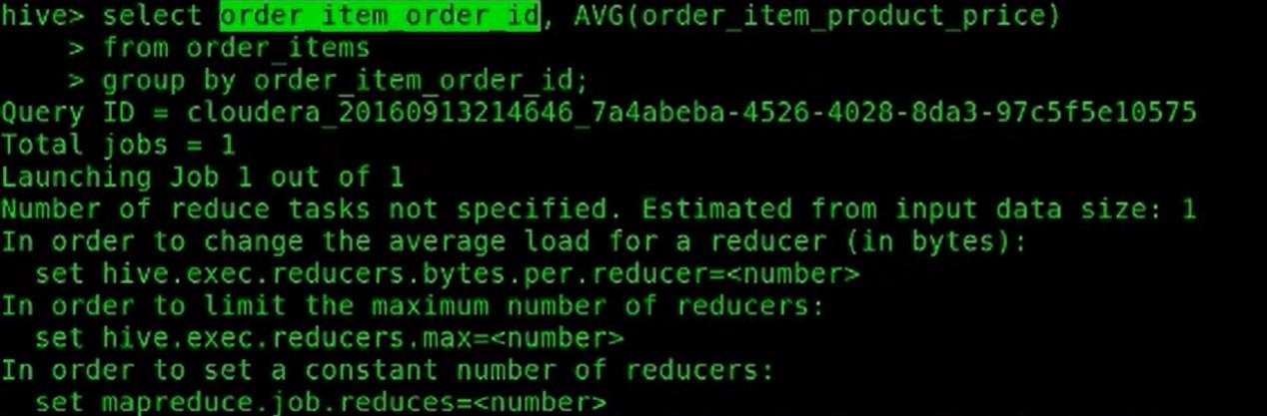

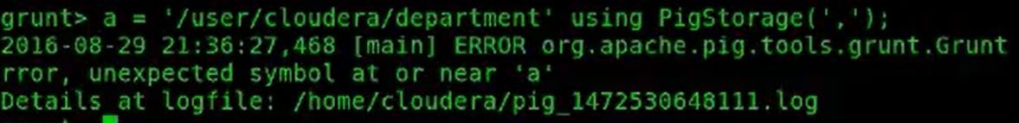

Output:

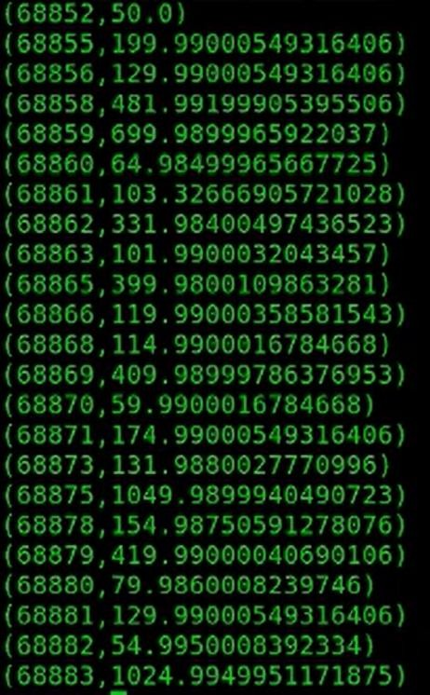

Department of Computer Technology

Vision of the Department
To be a well-known centre for pursuing computer education through innovative pedagogy, value-based education and industry collaboration.

Mission of the Department
To establish learning ambience for ushering in computer engineering professionals in core and multidisciplinary area by developing Problem- solving skills through emerging technologies.

 | 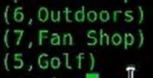
Output Analysis | The Pig script runs successfully and outputs processed data stored in HDFS. Results show filtered records, aggregated values, and joined datasets. Each operation generates a corresponding MapReduce job, confirming correct data loading, filtering, and transformation within the  Hadoop environment.
Github Link | https://github.com/shreyasc60/BDH_LAB
Conclusion | Performing Pig operations like load, store, aggregation, filtering, and joining demonstrates how Pig simplifies big data processing. These operations efficiently transform and analyze datasets through concise Pig Latin scripts, leveraging Hadoop’s distributed framework for large- scale data computation.
Plag Report (Similarity index
< 12%)
Date | 30 October 2025

Department of Computer Technology

Vision of the Department
To be a well-known centre for pursuing computer education through innovative pedagogy, value-based education and industry collaboration.

Mission of the Department
To establish learning ambience for ushering in computer engineering professionals in core and multidisciplinary area by developing Problem- solving skills through emerging technologies.

Session 2025-2026

Vision: To harness the power of artificial intelligence and data science to solve real-world problems and enhance human potential. | Mission: To acquire skills through coursework, projects, and internships, while actively engaging in research and collaboration with peers to innovate and apply AI solutions.
Program Educational Objectives of the program (PEO): (broad statements that describe the professional and career accomplishments)
PEO1 | Preparation | P: Preparation | Pep-CL abbreviation pronounce as Pep-si-lL easy to recall
PEO2 | Core Competence | E: Environment (Learning Environment) | Pep-CL abbreviation pronounce as Pep-si-lL easy to recall
PEO3 | Breadth | P: Professionalism | Pep-CL abbreviation pronounce as Pep-si-lL easy to recall
PEO4 | Professionalism | C: Core Competence | Pep-CL abbreviation pronounce as Pep-si-lL easy to recall
PEO5 | Learning Environment | L: Breadth (Learning in diverse areas) | Pep-CL abbreviation pronounce as Pep-si-lL easy to recall

Program Outcomes (PO): (statements that describe what a student should be able to do and know by the end of a program)

Keywords of POs:
Engineering knowledge, Problem analysis, Design/development of solutions, Conduct Investigations of Complex Problems, Engineering Tool Usage, The Engineer and The World, Ethics, Individual and Collaborative Team work, Communication, Project Management and Finance, Life-Long Learning
PSO Keywords: Cutting edge technologies, Research

“I am an engineer, and I know how to apply engineering knowledge to investigate, analyse and design solutions to complex problems using tools for entire world following all ethics in a collaborative way with proper management skills throughout my life.” to contribute to the development of cutting-edge technologies and Research.
Integrity: I will adhere to the Laboratory Code of Conduct and ethics in its entirety. Shreyas Chaurey 30 October 2025

Name and Signature of Student and Date
(Signature and Date in Handwritten)

Department of Computer Technology

Vision of the Department
To be a well-known centre for pursuing computer education through innovative pedagogy, value-based education and industry collaboration.

Mission of the Department
To establish learning ambience for ushering in computer engineering professionals in core and multidisciplinary area by developing Problem- solving skills through emerging technologies.

Session | 2025-26 (ODD) |  | Course Name | BDH Lab
Semester | 7 |  | Course Code | 22ADS704
Roll No | 61 |  | Name of Student | Shreyas Chaurey
Practical Number |  | 9
Course Outcome |  | CO1: Understand big data analytics and its business applications. CO2: Analyze the HADOOP and Map Reduce technologies associated with big data analytics.  CO3: Apply Big Data Analytics Using Pig and Hive.
Aim |  | Analyzing Various Data Visualization Methods Using R
Theory (100 words) |  | R is a powerful programming language widely used for statistical computing and data visualization. It provides rich libraries like ggplot2, lattice, and plotly for creating various types of visualizations, including bar charts, histograms, scatter plots, box plots, and line graphs. Data visualization in R helps interpret complex datasets through graphical representations, revealing trends, patterns, and relationships. By analyzing different visualization methods, users can choose the most appropriate plots to effectively communicate insights and make data- driven decisions in research, analytics, and business intelligence.
Procedure and Execution (100 Words) |  | Steps of implementation:  - Install and open R/RStudio.  - Import dataset using read.csv() or similar functions.  - Use base R plots like plot(), hist(), barplot().  - Install and load ggplot2 package.  - Create advanced plots: ggplot(data) + geom_bar(), geom_point(), geom_boxplot().  - Customize plots with titles, labels, and colors.  - Optionally use interactive libraries like plotly for dynamic visualizations.
Code:
library(tidyverse) library(palmerpenguins) # Bar Plot
penguins |> ggplot(aes(x = species)) + geom_bar(aes(fill = species)) # Scatter Plot
penguins |> ggplot(aes(x = body_mass_g, y = flipper_length_mm)) + geom_point()

Department of Computer Technology

Vision of the Department
To be a well-known centre for pursuing computer education through innovative pedagogy, value-based education and industry collaboration.

Mission of the Department
To establish learning ambience for ushering in computer engineering professionals in core and multidisciplinary area by developing Problem- solving skills through emerging technologies.

# Box Plot
penguins |> ggplot(aes(x = species, y = flipper_length_mm)) + geom_boxplot()
# Line Plot
penguins |> ggplot(aes(x = body_mass_g, y = flipper_length_mm)) + geom_line()
# Stacked Bar Plot
ggplot(penguins, aes(fill=sex, y=flipper_length_mm, x=species)) + geom_bar(position="dodge", stat="identity")
# Histogram Plot
penguins |> ggplot(aes(x = body_mass_g)) + geom_histogram()
Output:

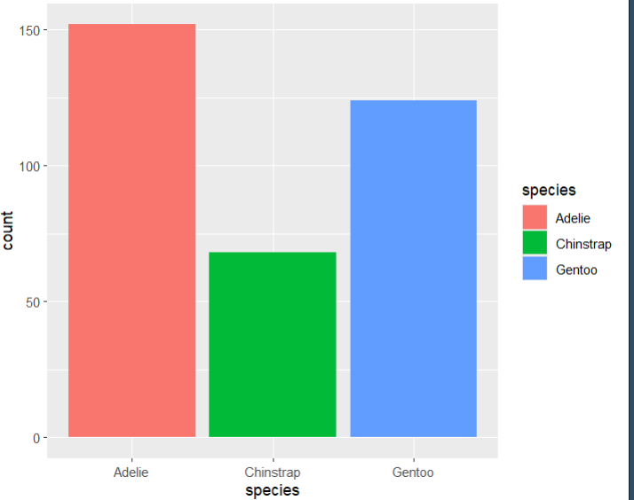

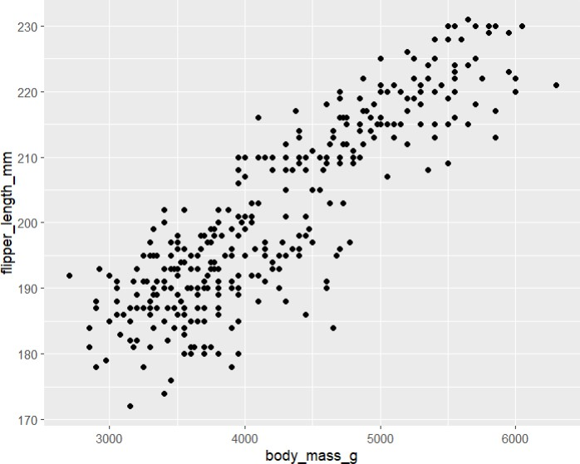

Department of Computer Technology

Vision of the Department
To be a well-known centre for pursuing computer education through innovative pedagogy, value-based education and industry collaboration.

Mission of the Department
To establish learning ambience for ushering in computer engineering professionals in core and multidisciplinary area by developing Problem- solving skills through emerging technologies.

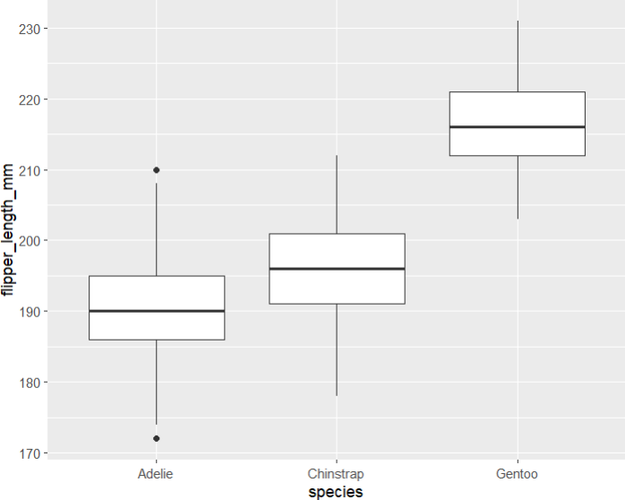

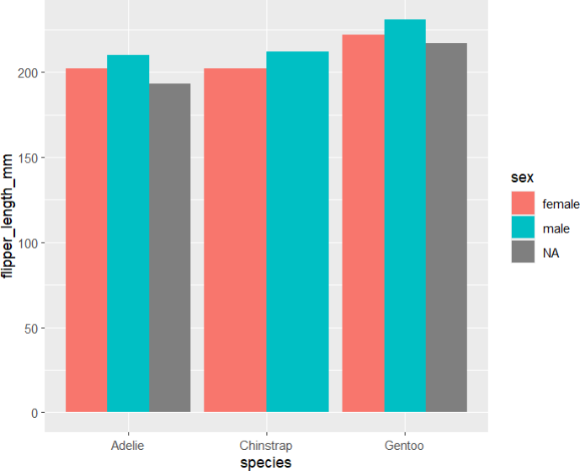
Output Analysis | Various graphs such as bar charts, scatter plots, and histograms are successfully generated, visually representing data trends and relationships. Each plot highlights different aspects of the dataset, making analysis clearer and more insightful. The output confirms R’s  effectiveness in producing high-quality, customizable visualizations.
Github Link | https://github.com/shreyasc60/BDH_LAB
Conclusion | Analyzing data visualization methods in R demonstrates how visual tools enhance understanding of complex datasets. Using libraries like ggplot2 and plotly, R provides flexibility and precision in presenting data, enabling clearer insights and better decision-making through visual analytics.

Department of Computer Technology

Vision of the Department
To be a well-known centre for pursuing computer education through innovative pedagogy, value-based education and industry collaboration.

Mission of the Department
To establish learning ambience for ushering in computer engineering professionals in core and multidisciplinary area by developing Problem- solving skills through emerging technologies.

Plag Report (Similarity index
< 12%)
Date | 30 October 2025

