The 72-Hour Warning
An urban digital twin that predicts how one failure becomes many — and says what to do about it, and by when
A working prototype for Nagpur, Maharashtra and Raleigh, North Carolina. The city model is real OpenStreetMap data; the cascade intelligence is an analytical layer that forecasts how a flood, a grid fault, a toxic release or a crowd propagates through drainage, roads, power, telecom, emergency response and hospitals up to 72 hours ahead.
EXECUTIVE SUMMARY
QUESTION | ANSWER
What is broken | City emergencies are forecast system by system. Nobody forecasts the handoffs between systems, which is where the harm compounds.
Who it hurts | City emergency operations centres, municipal utilities, hospital and EMS controllers, and the residents whose warning never arrives.
What we built | A digital twin with a learned dependency graph, a 200-member ensemble, a crisis registry, a counterfactual planner and multilingual public warnings — all in one browser page.
Our moat | The dependency graph is learned from sensor streams, not written down; every number is reproducible from a seeded simulation; and the system states a decision deadline, not just a risk score.
Status | Working prototype, two cities, seven scenarios, 31 automated interface checks, replay-validated end to end. Not connected to live telemetry.

THE PROTOTYPE, IN ONE VIEW
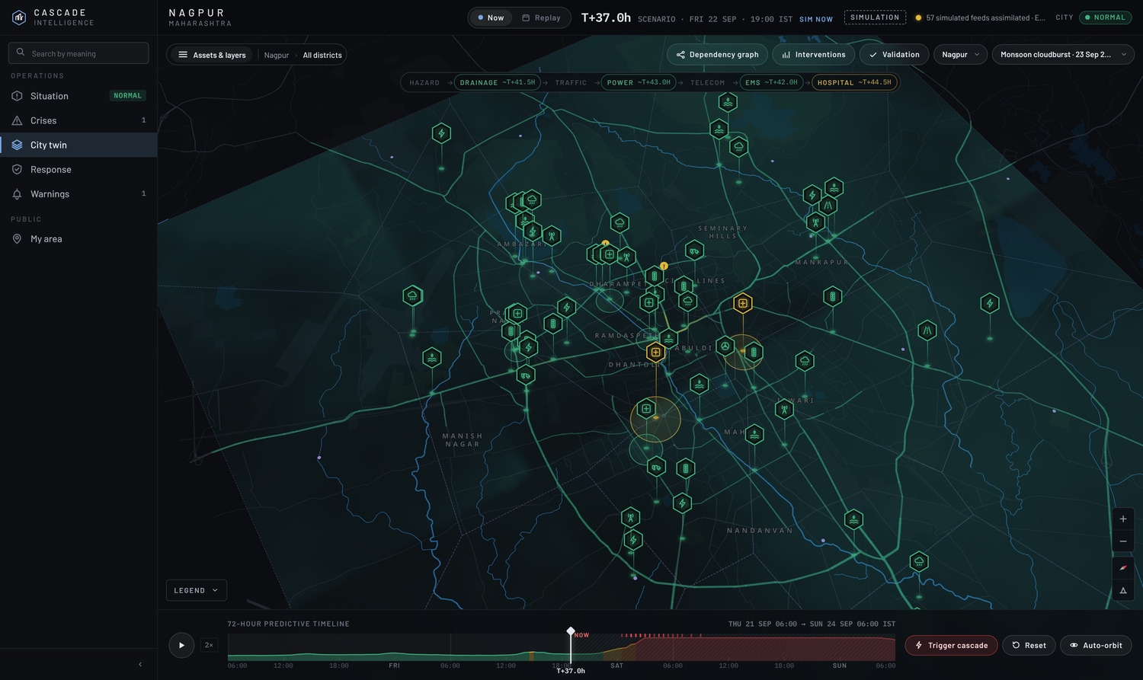
The operations room at #/twin: Nagpur at T+37 h of the 23 September 2023 cloudburst reconstruction. Left: the feature sidebar and 57 monitored assets. Centre: the 3D city with facility markers, learned cascade flows and crisis footprints. Below: the 72-hour timeline, scrubbable.

01 THE PROBLEM
A city does not fail all at once. It fails in sequence, and the sequence is the part nobody owns.
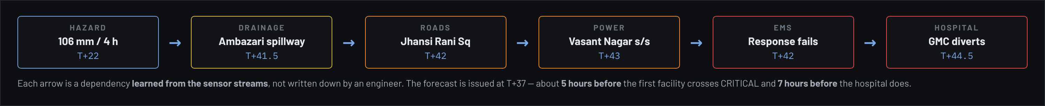
Figure 1 — The chain the system forecasts. Each arrow is a dependency learned from the sensor streams, not supplied by an engineer.

What actually happens
On the night of 23 September 2023, roughly 106 mm of rain fell on Nagpur in four hours. Ambazari Lake overtopped into the Nag river. What followed was not one emergency but a chain of them, and each link was handled by a different department:
— The drainage department saw a lake spillway and a rising river. It did not see that two of the junctions about to flood were on the only fast route from the northern suburbs to the trauma centre.
— The traffic police closed flooded roads. They did not know that one of those closures put an ambulance corridor behind the flood, or that a substation yard on the diverted route was itself about to go under.
— The distribution utility watched feeder load. It did not know that losing one substation would take four mobile sites off air within ninety minutes, because their battery hold-up is shorter than the repair time.
— The hospital saw its census rising. It learned that ambulances were slowing when they stopped arriving, not before.
Every one of those teams did its job. The failure was in the handoffs — and no system in the city is responsible for those.

Who carries the cost
WHO | WHAT THEY FACE TODAY | WHAT IT COSTS
City EOC duty officer | Six dashboards, one per department, each showing its own system as green or red. No view of how one feeds another. | Decisions taken late, or taken on the wrong system entirely.
Municipal utility control | SCADA tells them a feeder is loaded. Nothing tells them which hospital is downstream of that feeder. | Load shed in the wrong order; diesel delivered after the batteries die.
Hospital / EMS controller | Bed board and unit board. No forecast of inbound demand, no warning that the approach roads are closing. | Diversion decided under pressure, with no time to pre-stage.
Traffic police | Camera feeds and incident calls. No way to see which closure cuts an emergency corridor. | Closures that solve one problem and create another.
Residents | A district-level rainfall warning that names no street and recommends no action. | People drive into flooded underpasses because nothing told them not to.

Why a risk number is not enough
Most civic dashboards answer how bad is it? The operator's real questions are different, and harder:
— Is this one emergency or four? Connected stressed facilities form distinct crises with distinct owners.  — Is it still the weather, or is it now the network? Once stress circulates through dependencies, stopping the rain stops nothing.  — What breaks next, and when? Not a probability on a facility — an ordered sequence with times. | — With the crews I have, what do I do? Options have crew costs and side effects elsewhere.  — By when must I start? Some plans survive a ten-hour delay. Some are worthless in six.  — Who do I warn, in what language, and will the message fit? A warning that does not arrive is not a warning.

The gap in one sentence
Cities have good single-system monitoring and almost no cross-system forecasting — so the compounding, which is where the harm is, is exactly the part that is invisible.

02 WHAT EXISTS TODAY, AND WHAT IT LACKS
CATEGORY | EXAMPLES OF THE APPROACH | WHAT IT DOES WELL | WHAT IT LACKS
City digital twins / CIM platforms | Virtual Singapore; municipal twins in Helsinki, Zurich and Rotterdam; vendor CIM stacks | Accurate 3D city models, asset registries, planning and what-if for construction | Built for planning horizons, not 72-hour operations. No live cascade forecasting across utilities.
Flood forecasting services | National hydromet agencies; IMD and CWC bulletins; catchment hydraulic models | Genuine physical skill on rainfall and river stage; long operational track record | Forecasts water, not consequences. Stops at the river bank — nothing about hospitals or power.
Utility SCADA and outage management | Distribution SCADA, OMS, ADMS | Second-by-second truth about the grid; proven dispatch workflows | One utility, one system. No model of what the outage does to EMS or telecom.
Emergency management software | Incident command and resource-tracking suites | Excellent at logging what happened and who was assigned | Records the present; does not forecast the next six hours or evaluate counterfactuals.
Smart-city command centres | Integrated command and control centres across Indian cities | Genuine data integration; many feeds on one wall | Integration is visual, not analytical. Screens sit side by side; the model does not join them.
Public alerting | Cell broadcast, CAP gateways, SMS blasts | Reach, and established standards | Generic district-level text. No link to which street, which hour, or which action.

The common gap
Every category above is strong within one system and silent between systems. Flood models stop at the water. SCADA stops at the meter. Command centres put the feeds on one wall but leave the joining to a human under time pressure at three in the morning. Nothing in the standard stack answers "if this substation goes, when does the trauma centre start diverting?" — and that is the question the next six hours turn on.
Our position
We are not replacing the flood model, the SCADA or the command centre. We consume what they produce and add the one layer none of them has: the learned graph of how they affect each other, and the decision it implies.

Where we sit against each category
CAPABILITY | FLOOD MODEL | SCADA / OMS | ICCC | CITY TWIN | OURS
Forecasts its own system | Yes | Partly | No | No | Yes
Forecasts other systems | No | No | No | No | Yes
Learns the links from data | No | No | No | No | Yes
Groups failures into named crises | No | No | Partly | No | Yes
Evaluates counterfactual actions | Partly | No | No | Partly | Yes
States a decision deadline | No | No | No | No | Yes
Issues public warnings | Via agency | No | Partly | No | Yes — CAP + SMS, multilingual
Scores its own past forecasts | Yes | No | No | No | Yes

03 RESEARCH BEHIND THE BUILD
The design borrows deliberately from four established fields rather than inventing method where good method exists.
FIELD | WHAT WE TOOK | WHERE IT IS USED
Numerical weather prediction | Ensemble forecasting: run many plausible futures, read probability from their spread rather than from a single deterministic run. | 200-member ensemble; fan charts; P(critical) at +1/6/12/24/48 h.
Data assimilation | Particle filtering with localisation and forgetting — standard where the state is non-Gaussian and drifting. | Per-facility weights; adaptive tempering holds effective sample size above 12%.
Sparse Bayesian learning | Automatic Relevance Determination: zero-mean priors with per-feature precision, re-estimated by EM, so irrelevant causes are driven out. | Learning which dependency links are real; 7 deliberately fake links per city are the control.
Operational meteorology verification | Brier score, skill against climatology, reliability diagrams, probability of detection and false-alarm ratio, lead time. | Replay validation across all seven scenarios; every forecast scored against the hidden truth.
Emergency alerting practice | OASIS CAP 1.2 vocabulary; GSM 03.38 encoding limits; the distinction between exercise and live messages. | The Warnings page; segment counting; every product marked EXERCISE.
Epidemiology | The reproduction number: whether a process is self-sustaining or externally driven. | Cascade-R — stress arriving through dependencies divided by stress arriving from the hazard.

Case studies: what the record shows
Each of these is a documented event in which the individual warnings existed and the sequence did not. The last column is the link no single agency owned.
EVENT | THE CHAIN, AS IT HAPPENED | THE UNOWNED LINK
Delhi, 13 Jul 2023  Yamuna at 208.66 m | Upper-catchment rain, plus releases from the Hathnikund barrage in Haryana, put the Yamuna over a record that had stood since 1978. River water inundated the Wazirabad, Chandrawal and Okhla water treatment plants, which sit on the floodplain. All three shut. Delhi cut supply by 25%. | A barrage release in one state against drinking-water production in another. The flood caused a water shortage.
India, 30–31 Jul 2012  Grid collapse | States overdrawing from the grid amid a weak monsoon — farmers running electric pumps — tripped the Northern grid, then the Northern and Eastern grids together. Over 620 million people lost power. 300+ trains stopped; the Delhi Metro shut for a second day; hundreds of miners were trapped underground in West Bengal and Jharkhand when pithead lifts stopped. | Irrigation demand against mine-lift power. The two share one edge — the grid — and nothing watched it.
Nagpur, 23 Sep 2023  Ambazari / Nag river | Over 100 mm overnight. Ambazari lake filled; weed growth had blocked discharge points and construction had narrowed the channel. The lake crossed its overflow into the Nag river, whose encroached and silted bed could not carry it. About 10,000 houses affected, 400+ evacuated, four deaths. Residents later filed a PIL alleging civic negligence. | Lake discharge capacity against downstream housing. The failing variable was weed growth, which no threshold alarm measures.
Mumbai, 26 Jul 2005  944.2 mm in 24 h | The heaviest single-day rainfall then recorded in India. Rail, road and air stopped together for about two days in a city where suburban rail is how most people get home. Communications were paralysed; damage exceeded ₹2,000 crore. Over 1,000 died across Maharashtra. | Three transport modes failed simultaneously, not in sequence — a system modelling them independently predicts two problems, not one trap.
USA / Canada, 14 Aug 2003  Northeast blackout | Overgrown trees contacted three 345-kV lines in Ohio while a stalled alarm system left operators unaware. The Sammis–Star trip started a cascade that darkened 55 million people. Backup generators at New York wastewater plants failed, releasing about 500 million gallons of untreated sewage into city waterways. | Vegetation management against wastewater treatment. Different ministries, different budgets, one edge.
Texas, Feb 2021  Winter Storm Uri | Wellhead freeze-offs cut gas output by 45%; gas plants could not run; blackouts followed — and the blackouts then cut power to the gas compressors, deepening the shortage that caused them. Nearly 15 million lost clean water. 246 deaths officially, 700+ by independent estimate; more than two dozen from loss of oxygen or dialysis equipment. | A closed feedback loop. A threshold alarm cannot represent a cycle; a simulation can.

What we concluded
In every case the individual warnings existed. What did not exist was a statement of sequence and timing across departments — which failure arrives next, how long until it does, and what action still has time to work. Delhi had river gauges and plant elevations. The 2012 grid had load telemetry. Nagpur had rainfall radar. Every input existed; nobody had composed them into a chain.

Two of these are reproduced as scenarios in the prototype: Nagpur 23 September 2023 as the primary reconstruction, and a grid-fault-plus-telecom cascade modelled on the 2012 and 2003 failure patterns. The remainder shaped which dependencies the model is allowed to learn — notably power to water treatment, power to telecom battery life, and road closure to ambulance travel.

04 OUR APPROACH
One model of the city, one ensemble, and six views onto it. Everything a user sees is computed from the same state at the same issue time, so no two screens can disagree.
The architecture follows from one decision: the dependency graph is a product of the system, not an input to it. If an engineer writes down that power feeds telecom, the model can only ever be as good as that engineer. If the model infers it from how the two streams actually move together, it can also infer the link nobody thought to write down — the weed growth that cost Ambazari its discharge capacity, the fuel pump in a basement, the barrage release two states upstream. Everything else in the design exists to make that inference trustworthy: an ensemble so uncertainty is carried rather than asserted, a particle filter so the forecast bends as evidence arrives, and a planner that re-simulates rather than looks up an effectiveness rating.
The consequence is a system with no configuration file for the thing that matters most. Adding a city means supplying its geometry and its sensor streams, not its causal structure; the structure is learned on arrival and kept under continuous revision while the event runs.
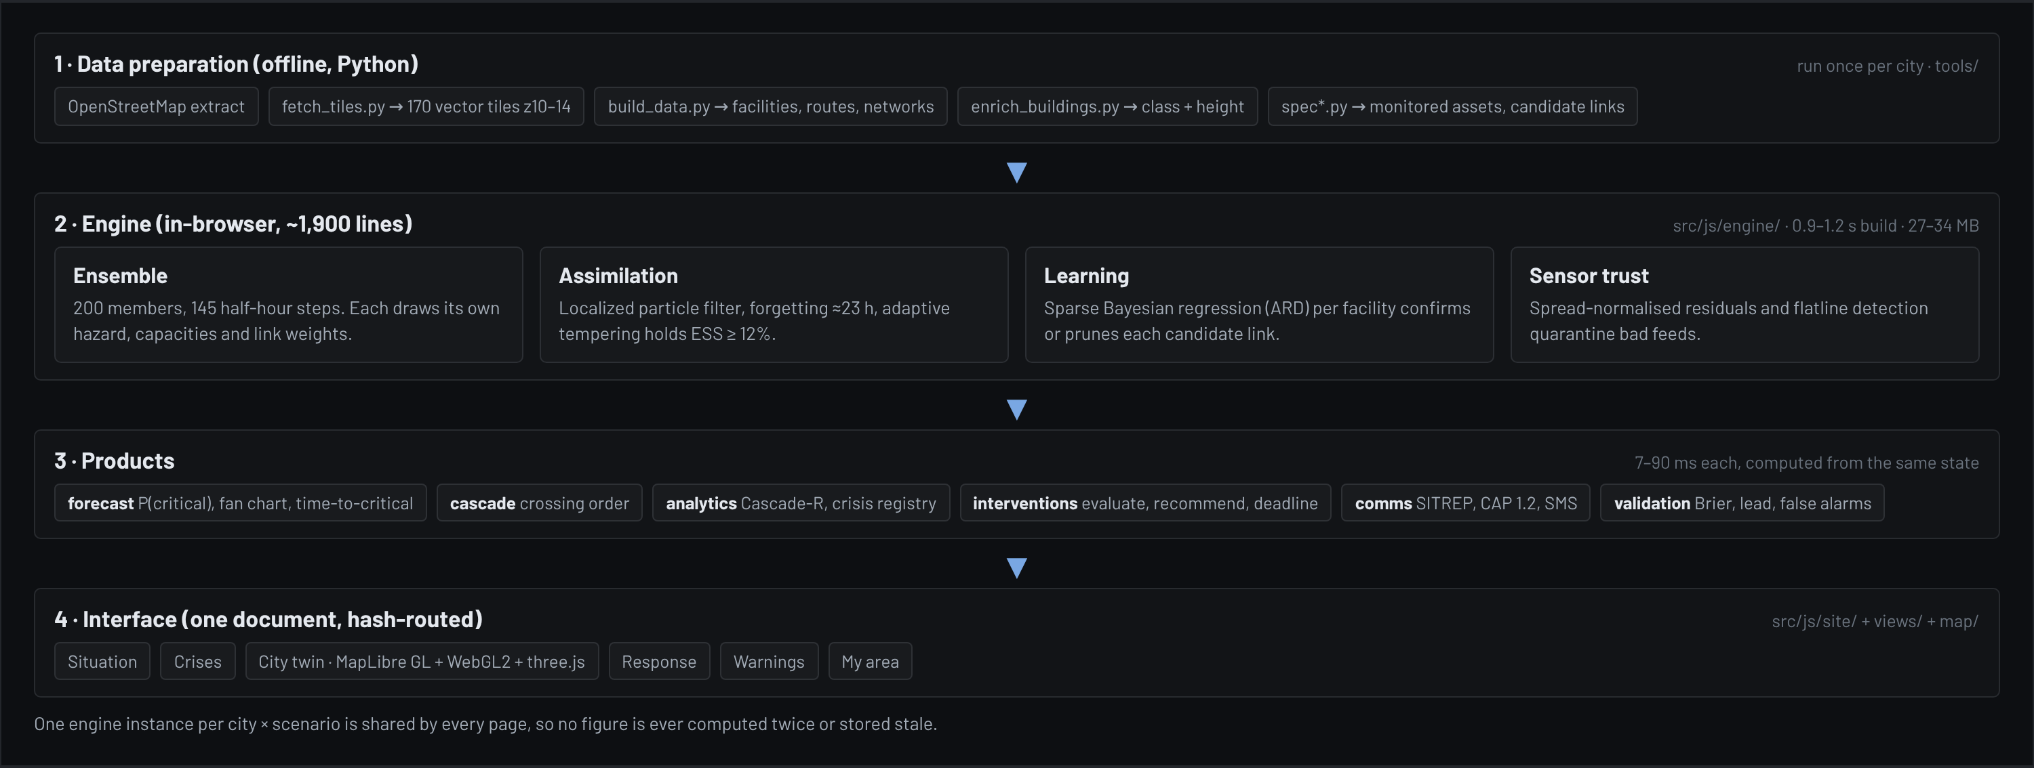
Figure 2 — System architecture. Data preparation is offline and per city; everything above it runs in the browser from a single shared engine instance.

Four ideas that make it work
 | WHAT IT IS | WHY IT MATTERS
Learned dependencies | We supply 71 (Raleigh) / 102 (Nagpur) candidate links that engineers consider possible — including 7 deliberately fake ones. The system confirms or prunes each from the data. | A hand-written graph is only as good as the person who wrote it, and it cannot adapt. Ours is evidence, and the fakes prove it discriminates.
Cascade-R | Stress arriving through dependencies divided by stress arriving from the hazard. Above 1, the cascade sustains itself. | Tells the operator whether to wait out the weather or cut links. These need opposite actions.
Crisis registry | Connected stressed facilities are grouped into distinct crises with an ID, a lifecycle stage, a footprint, residents affected, and the couplings between them. | Turns "the city is at 71%" into "four separate emergencies, here are their owners".
Decision deadline | The plan re-run with crews starting 0, 2, 4 … 24 h later, deciding on the same information. | The single most actionable output. Converts "act soon" into a time.

Unique approach, stated plainly
Other systems forecast states. We forecast transitions between systems, and then price the delay. The question we answer that nothing else does is: by when must we move, and what does it cost us if we do not?

05 MOAT AND DIFFERENTIATION
MOAT | WHY IT IS HARD TO COPY
Learned structure, not configuration | A competitor can copy a dependency diagram. They cannot copy a system that discovers and re-learns the diagram per hazard — the learned graph for a flood differs from the one for a heat wave in the same city, and ours changes with the scenario.
Portability by specification | A new city needs an OSM extract and one specification file naming its monitored assets and candidate links. Raleigh is deliberately kept as the "unseen city" test: the same engine, untuned, runs it.
Verifiable honesty | Member trajectories are simulated from parameters alone and never touched by observations; only weights move. A forecast issued at T+30 physically cannot contain T+31 data. That is architectural, not procedural — and it is auditable.
Reproducibility | Every figure is seeded and deterministic. A regression guard diffs the entire engine output byte-for-byte, so interface work provably does not move a single forecast.
Decision-grade output | We ship the counterfactual, the side effects and the deadline — not a dashboard that leaves the inference to the operator.
Last-mile reach | CAP 1.2 and cell-broadcast text in the city's own languages, with encoding and segment counts. Hindi costs three SMS segments where English costs one; a system that ignores this issues warnings that get truncated.

USP
The only urban twin that tells you how long you have left to act. Risk scores are commodity. A calibrated statement that a plan worth 55% now is worth nothing in six hours is not.
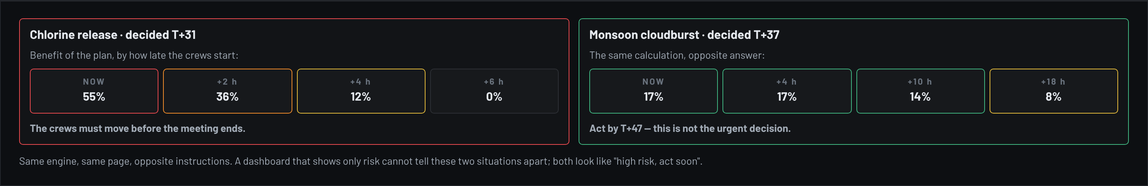
Figure 6 — The same calculation, opposite instructions. A dashboard showing only risk cannot tell these two situations apart.

06 FEATURES AND FUNCTIONS
Six features in a permanent sidebar, ordered as the operator works: what is happening, what crises, see it, what we do, tell responders, tell residents.
# | FEATURE | FUNCTION | OUTPUT
1 | Situation | The state of the city in computed sentences; the predicted course of Cascade-R; when each facility first crosses HIGH RISK and CRITICAL, by system. | One-screen brief, no interpretation needed
2 | Crises | The registry: distinct emergencies with ID, stage, member systems, districts, residents, next facility to go critical, and couplings between crises. | Ownership and scope per emergency
3 | City twin | 3D operations room on real OSM buildings. Per-facility inspector: what drives it now, which upstream links, sensor trust, forecast fan. Dependency graph and replay validation in drawers. | Situational awareness and audit
4 | Response | Action catalogue with crew costs; what each action is worth alone; a before/after ledger; side effects elsewhere; and the decision deadline. | A plan, its price, and a start-by time
5 | Warnings | Situation report for responders; CAP 1.2 alert per crisis with one block per language; public cell-broadcast text with encoding and segment count. | Products ready for an alerting gateway
6 | My area | The same forecast for a resident: plain-language verdict, next 36 hours per system, advice in the city's languages, nearest hospital, roads to avoid. | The last mile

Seven scenarios, one engine
The same model runs every hazard family without retuning. Each scenario was chosen because it stresses a different part of the chain.
SCENARIO | CITY | WHAT IT IS | WHAT IT TESTS
Monsoon cloudburst · 23 Sep 2023 | Nagpur | Reconstruction: about 106 mm in four hours, Ambazari Lake overflowing into the Nag. Timing and totals follow IMD-reported figures. | The full chain, against a real event
Chlorine release | Nagpur | A cylinder fails at the Seminary Hills treatment plant. The plume follows the wind; closures load the roads ambulances need. | A non-weather hazard with a hard deadline
Immersion-day crowds + storm | Nagpur | Processions converge on Gandhi Sagar and Futala while a thunderstorm builds over the streets that flood first. | Crowd and weather interacting
Grid fault + telecom blackout | Both | A transmission fault drops a cluster of substations overnight. Mobile sites run down their batteries; calls stop reaching dispatch. | A cascade with no weather in it at all
Tropical remnant rainfall | Both | Two rain bands from a decaying tropical system; soils already saturated. | Slow-onset, wide-area flooding
Convective flash flood | Both | Training thunderstorms stall over one part of the city for three hours. | Fast, local, little warning
Heat wave + derecho | Both | Three-day heat dome; a derecho line crosses late on day two. | Compound hazard on the grid

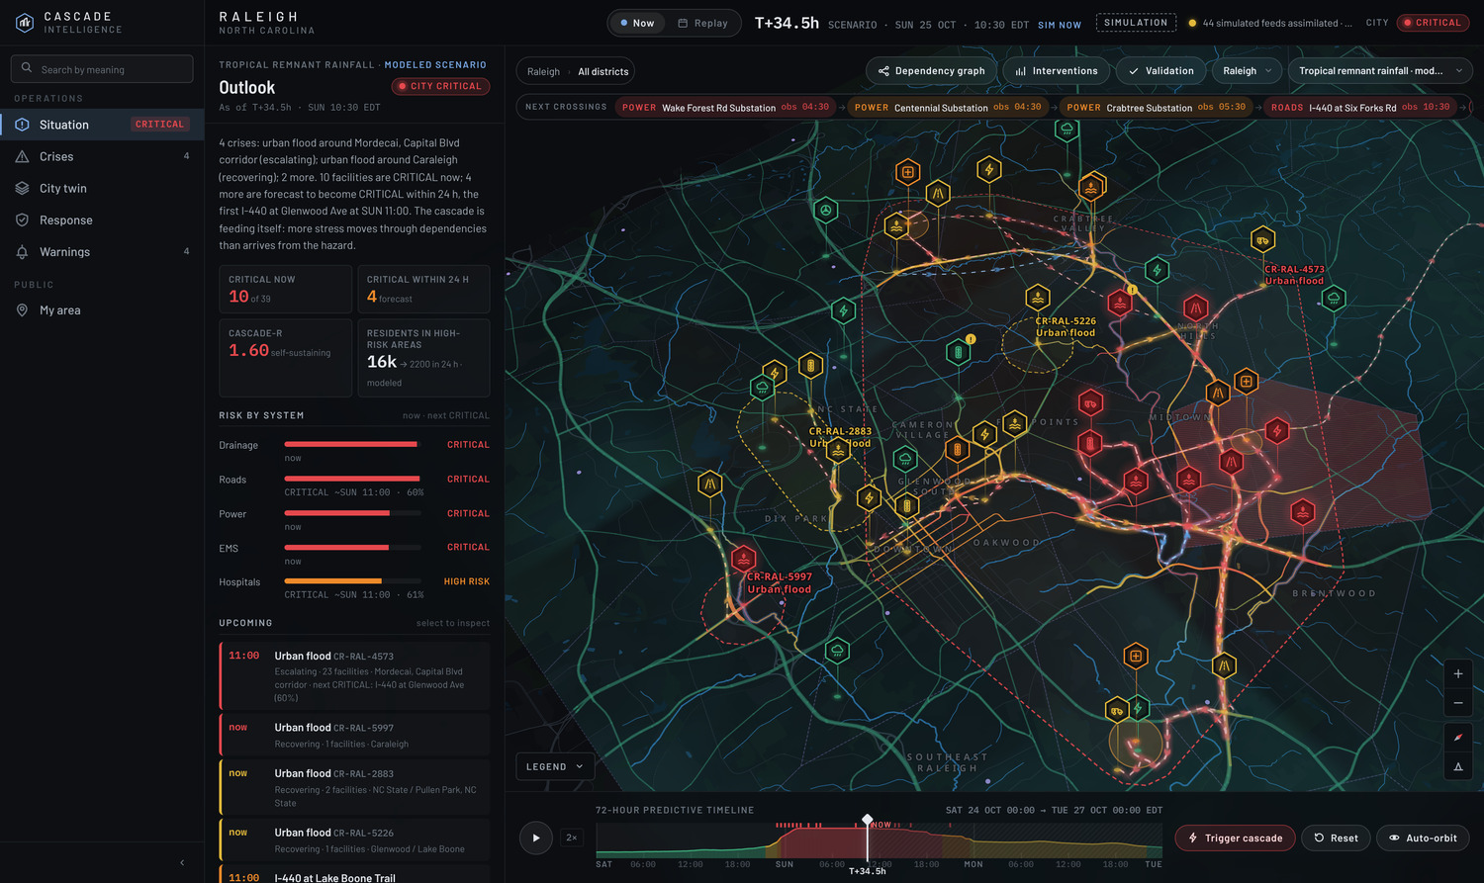
Feature 1 — Situation. The lede sentence, the predicted-course chart (Cascade-R observed then forecast, with first HIGH RISK and CRITICAL crossings by system), the crisis registry and the recommended response. Every figure recomputes when the clock is scrubbed.

From one risk number to named emergencies
The registry is what turns a city-wide index into something a duty officer can assign. Connected stressed facilities are grouped by the learned graph: two facilities belong to the same crisis when a live link joins them, or when the forecast carries stress from one to the other. Each group gets a stable ID, a lifecycle stage, the systems and districts it touches, the residents inside its footprint, and the next facility forecast to go critical.
— Couples — a live link runs from a member of one crisis to a member of another, so one can propagate into the other. Shown with the mechanism and the lag.  — Contends — two crises both load the same facility that belongs to neither. A shared hospital or substation is where separate emergencies collide. | — Stage — precursor, emerging, escalating, active or recovering, derived from whether members are observed or forecast and whether the peak is still rising.  — Footprint — a hull around the member facilities, drawn on the twin and exported as the CAP alert polygon, so the warning area and the analysis agree by construction.

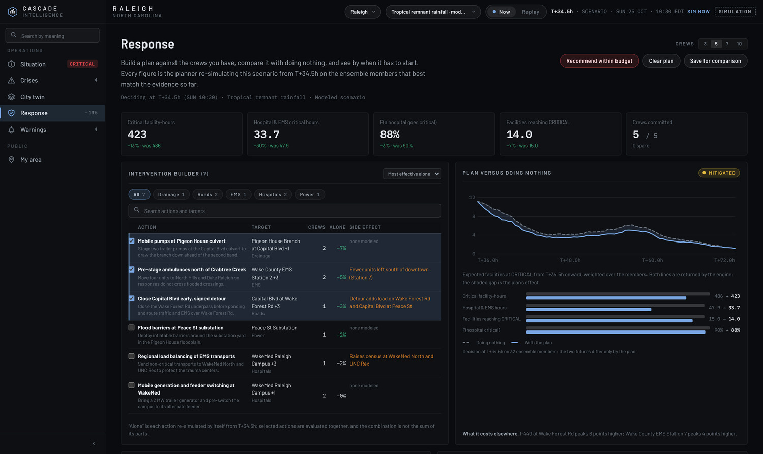
Feature 4 — Response, the decision workspace at #/plan. Top: five outcomes, each measured against doing nothing. Left: the intervention builder, with every action's effect alone computed separately. Right: the plan against the do-nothing baseline — both curves are returned by the engine, and the shaded gap between them is the plan's whole effect.
The planner searches greedily by benefit per crew: it adds the action with the largest marginal reduction in expected critical facility-hours until the budget is spent or nothing is worth another crew. Every candidate is re-simulated from the decision time on the ensemble members that best match the evidence so far — so an action is judged on what it does to this event, not on a stored effectiveness rating. Side effects are found the same way: any facility whose expected peak rises by more than three points is reported, which is how an evacuation that loads a neighbouring corridor becomes visible before it is ordered.

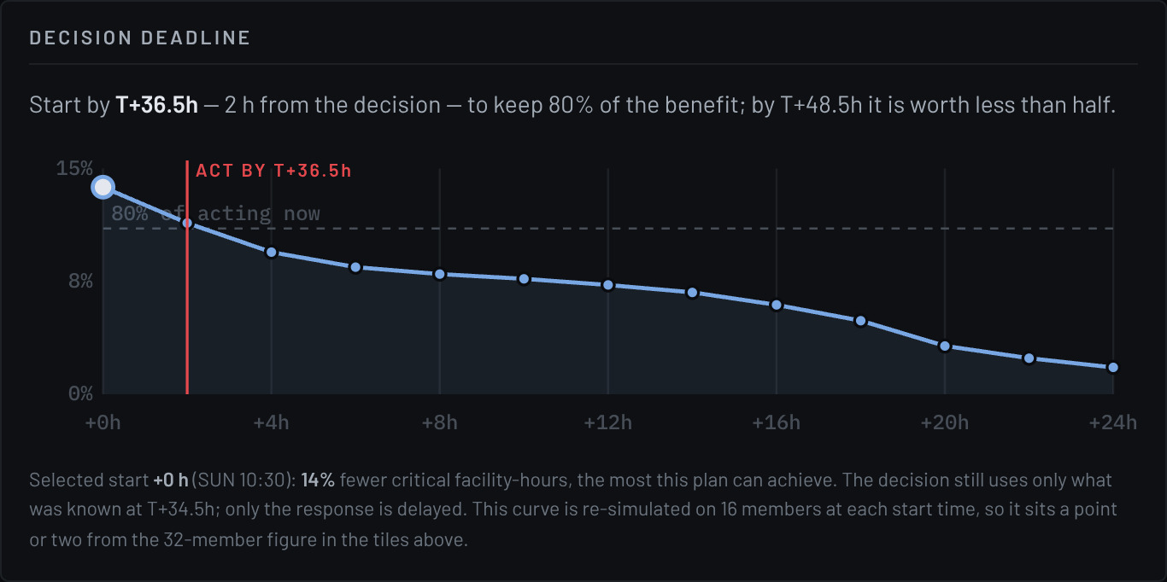  The decision deadline: the same plan re-run with the crews starting 0, 2, 4 … 24 h later, deciding on the same information. The marker is the last start that keeps 80% of the benefit. | 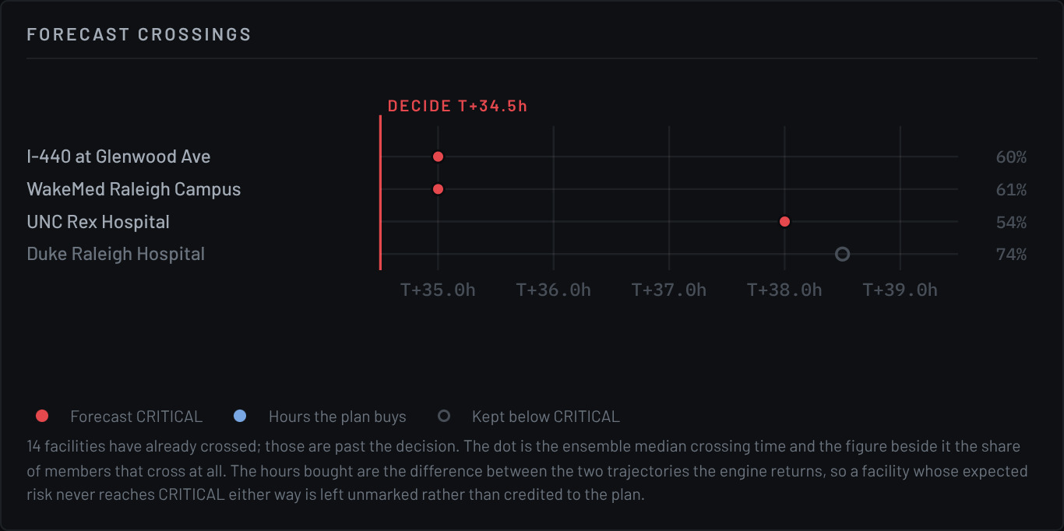  Forecast crossings, one row per facility. A hollow mark is a crossing the plan removes; the hours it buys are the difference between the two trajectories, never the plan's alone.

The deadline is the output nothing else produces
A forecast says a hospital is likely to go critical. A planner says which action helps. Neither answers the question a duty officer actually has, which is when must I start. Re-running the plan at later start times, on information frozen at the decision moment, turns "act soon" into an hour — and the curve shows how fast it decays, so a two-hour meeting is visibly expensive.

What the Response page refuses to show
There are no monetary costs, financial savings, crew locations, vehicle or pump counts, travel times, residents-protected figures or per-intervention timelines anywhere on the page. The model does not compute them, so displaying them would be fabrication dressed as precision — and an operator would have no way to tell which figures were earned and which were invented. A crew is the model's only resource constraint: an abstract unit of capacity, labelled as one. The page carries a section saying all of this, in the product, not only in this document.

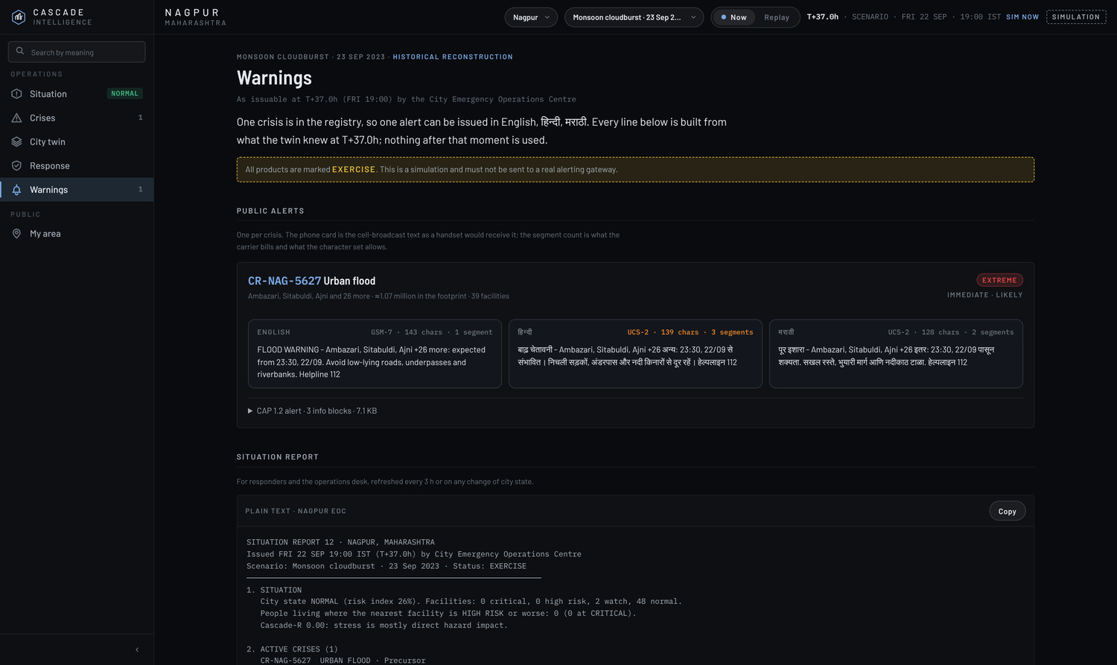
Feature 5 — Warnings. One alert per crisis, graded Extreme / Immediate / Likely under CAP 1.2, with the public text as a handset receives it. English fits one SMS segment; Hindi needs three, because Devanagari forces UCS-2 encoding at 70 characters.
The alert grading is not editorial. Severity, urgency and certainty are derived from the registry: severity from the number of critical members and the residents inside the footprint, urgency from how soon the next facility is forecast to cross, certainty from whether the crisis is observed or still forecast. The polygon is the crisis footprint itself, so the area warned and the area analysed are the same object rather than two drawings that can drift apart.
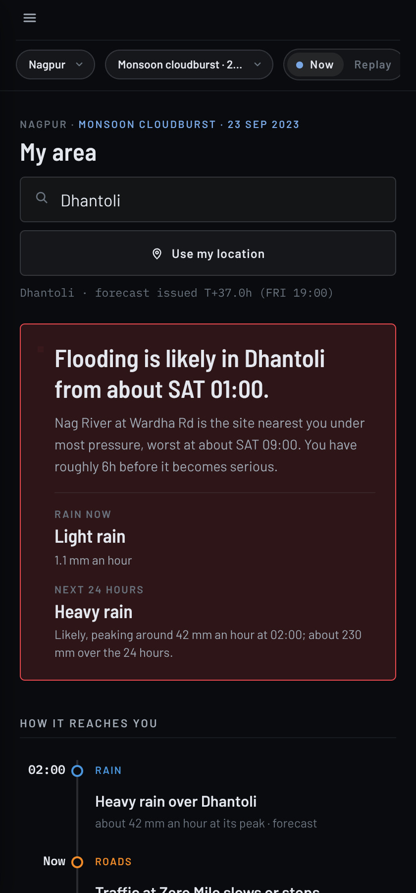  Feature 6 — My area, at 420 px. | Feature 6 — My area. The same engine, written for someone who lives there: a verdict with a time in it, the next 36 hours per system, advice in English, हिन्दी or मराठी with the city's own helpline numbers, the nearest hospital now and at +6 and +12 h, and the roads forecast to become impassable.  The resident view deliberately drops everything an operator needs and a resident does not. There is no risk index, no Cascade-R and no facility ID unless asked for. What remains is a sentence with a time in it, a strip showing when each system near you gets worse, the advice for that hazard family in a language you read, and two phone numbers.  It runs on exactly the same engine state as the operations pages — the same forecast, issued at the same moment, in different words. One engine, two audiences, is a stronger claim than two products.

The public message as a handset receives it, in each of the city's languages, with the encoding and segment count the carrier will actually bill. English fits GSM-7 at 160 characters per segment; Devanagari forces UCS-2 at 70, so the same warning costs three segments in Hindi and one in English — and the half that gets truncated on a feature phone is the half that says what to do.

Interface and interaction design
The prototype is built as a control-room instrument, not a consumer dashboard: a single dark surface, colour reserved exclusively for risk, measurements in a monospaced face, and no decoration that is not information.
— Permanent left sidebar with live chips — the crisis count and city state update as the clock moves, so navigation itself carries state.  — One shared context in the link — city, scenario, time, selection and district all travel in the URL. Any view can be bookmarked or sent to a colleague exactly as it was.  — Honesty in the chrome — a Simulation badge, Now/Replay instead of "live", scenarios tagged modeled or reconstruction, derived readings marked illustrative. | — Scrub-to-understand — dragging the 72-hour timeline moves the forecast, the sun on the 3D city, the crisis registry and the sidebar together.  — Responsive to phone width — the sidebar becomes an overlay; every page reflows without horizontal scrolling.  — Accessible by construction — real buttons and links, visible focus rings, ARIA labels on canvases, reduced-motion respected.

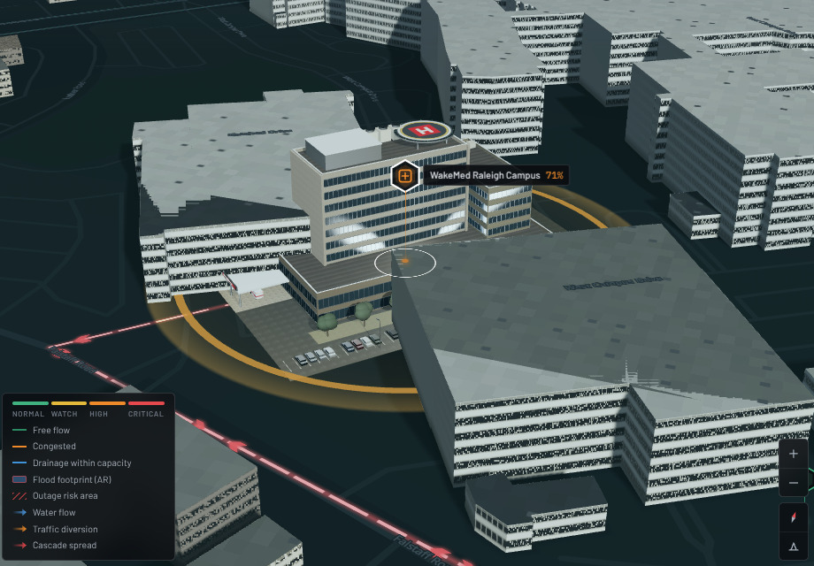  Facility detail: an authored 3D model replaces the OSM footprint at the selected site, with a risk-coloured ground ring. | 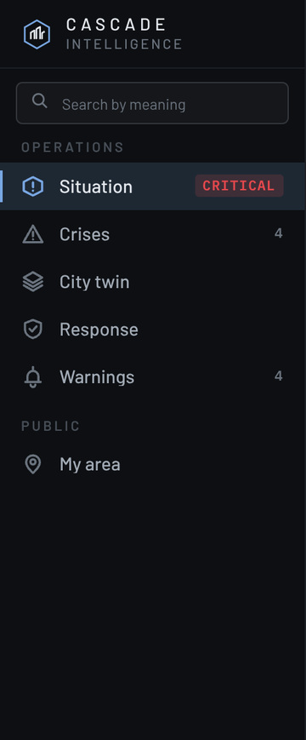  The feature sidebar: six live features grouped Operations and Public, each with a chip computed from the engine at the issue time; chips become coloured dots. The choice persists across reloads.

Why the city is rendered in 3D at all
The 3D view is not decoration. An operator reasons about a flood in terms of which underpass, which side of the river, which approach to the hospital — and that reasoning needs the city to look like the city. The prototype renders every OpenStreetMap building with a procedural facade, a real roof form and a sun shadow computed from the scenario clock, so the scene at 01:00 looks like 01:00. Scrubbing the timeline moves the sun with the forecast.
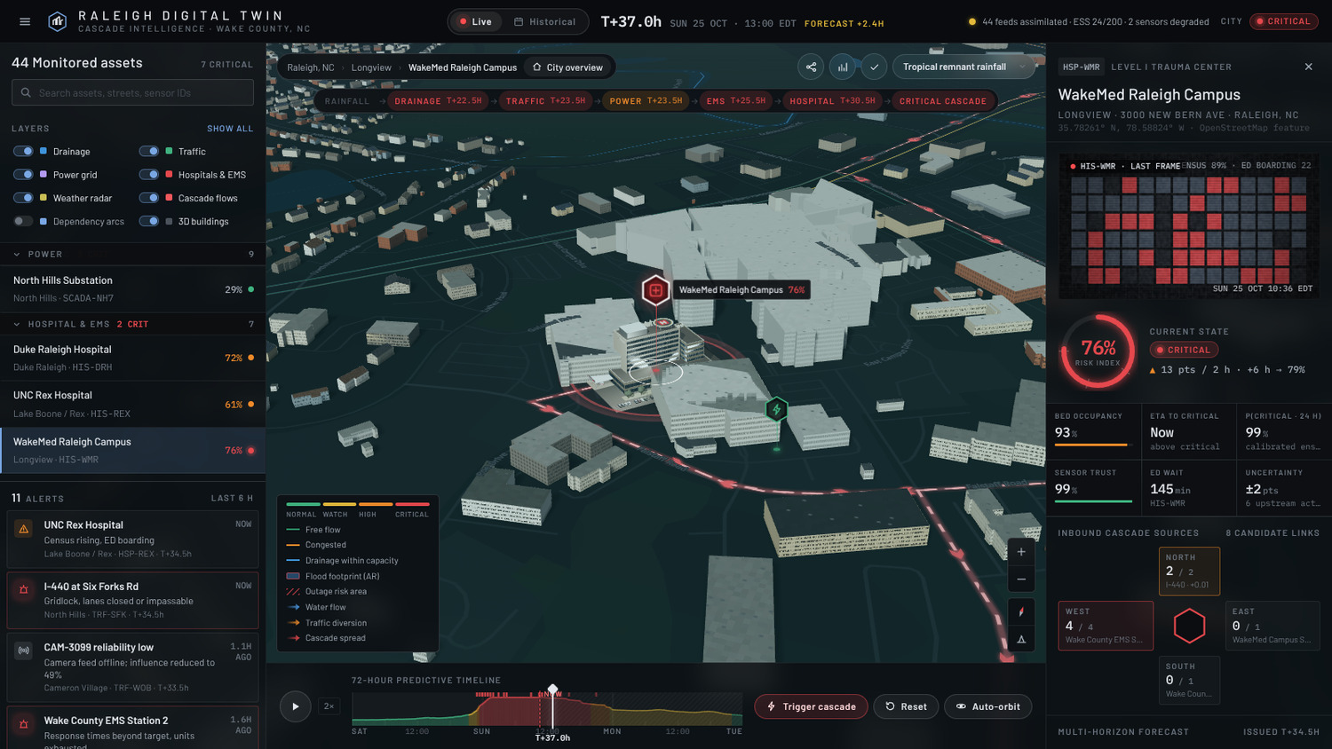  Midday: buildings, shadows and the facility model in daylight. | 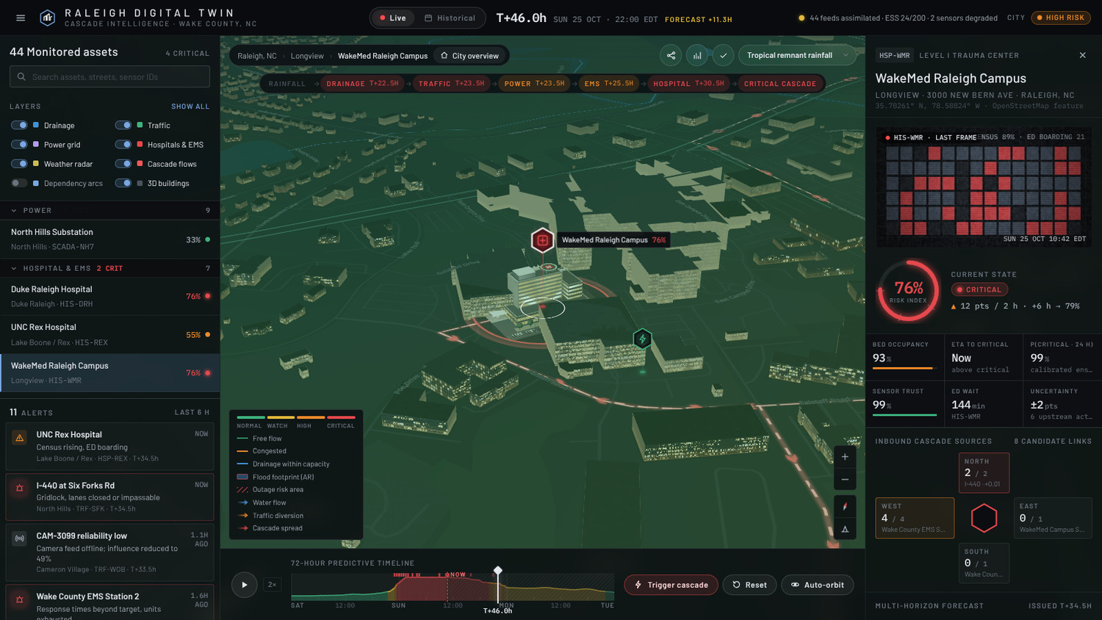  The same view at night — lit windows, street lighting, the sun below the horizon.
Each monitored facility carries a marker coloured by its state, and the one under inspection is replaced by a detailed model at real scale. Crisis footprints are drawn on the ground as dashed hulls, and the learned dependency links animate as flows when they are carrying stress — so the cascade is visible as movement, not inferred from a table.

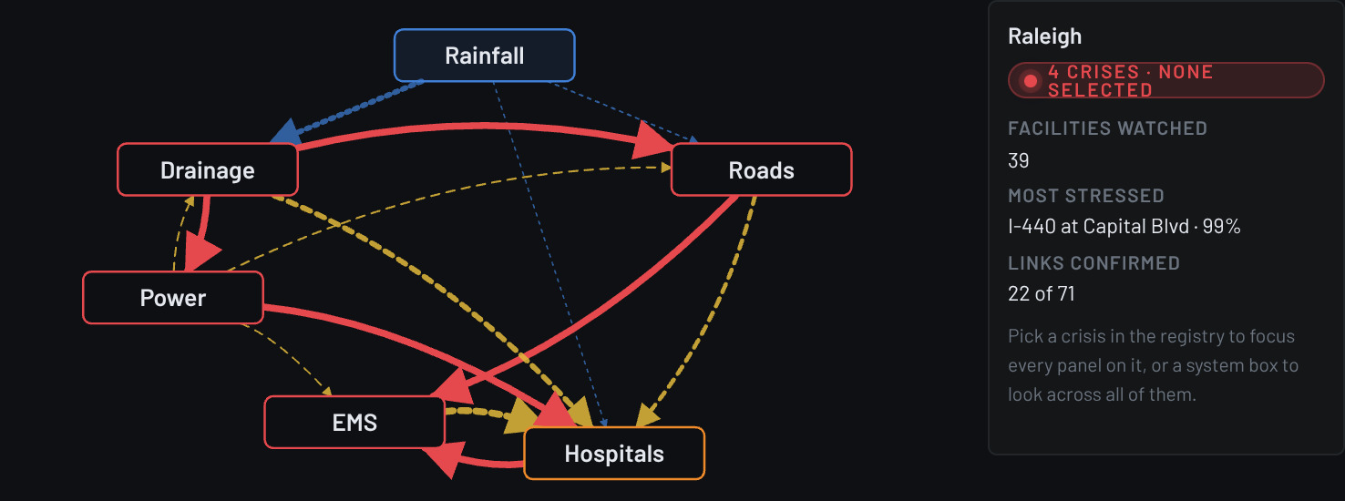  The learned dependency network, with the inspector beside it. Edge style carries confidence: confirmed, candidate and pruned. A configured graph has no such thing as a pruned edge. | 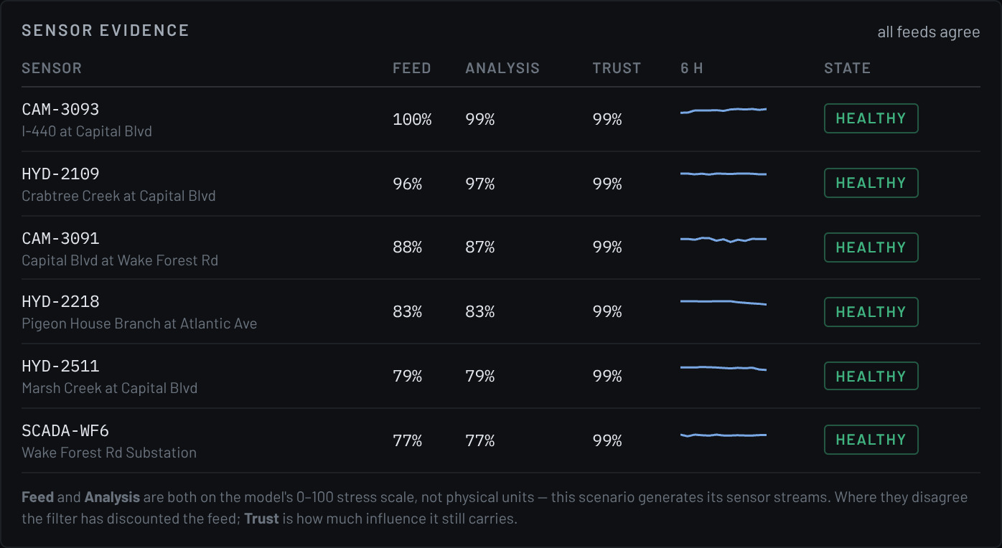  Sensor evidence, kept in three separate columns: what the feed reported, what the model inferred from it, and how far the model trusts that stream. A 42% trust score is never shown as a 42% reading.

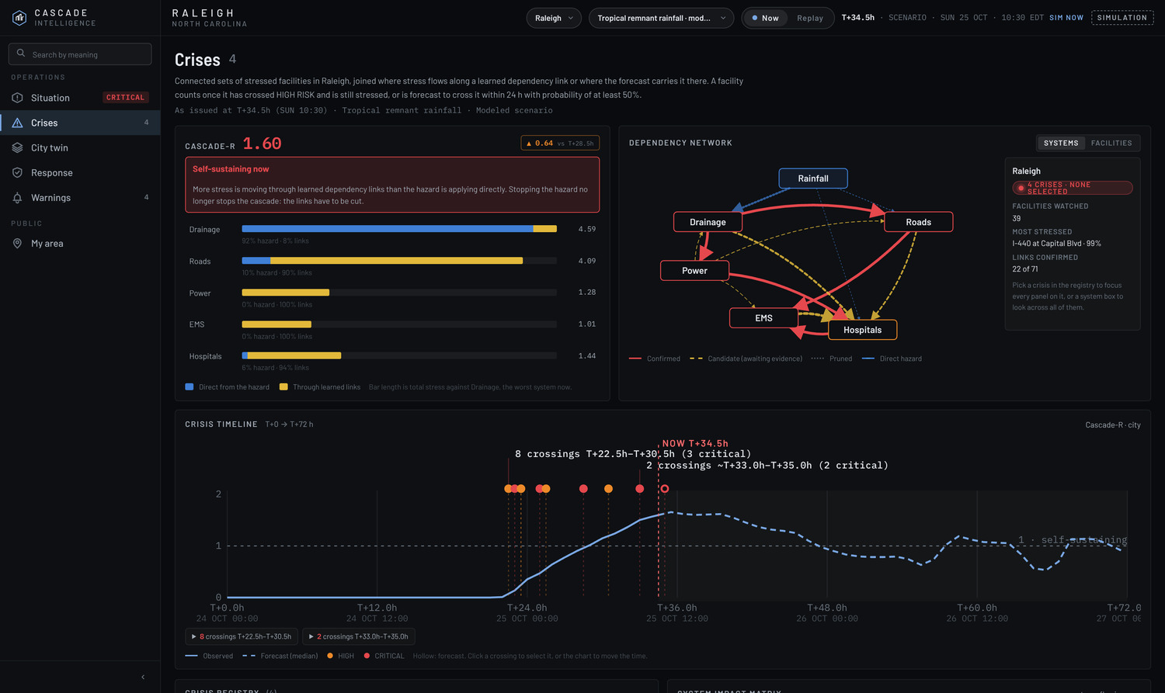
Feature 2 — Crises. The registry card for the Nagpur flood: stage, systems, districts, residents in the footprint and the next facility forecast to go critical. Below it, the registry as it was issued each hour — showing which crises were already known at T+37 and which were still invisible.

The registry also records what was known when. The strip above shows the registry as issued each hour: at T+37 only one crisis is visible, and the four that appear later are genuinely not knowable yet. That record is what makes an after-action review possible — it separates "we did not see it" from "we saw it and did not act".

07 DATA SOURCES AND INPUTS
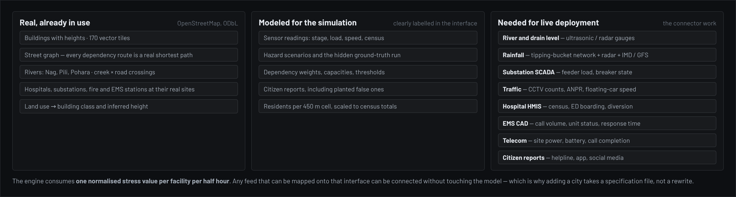
Figure 5 — What is real today, what is modeled, and what a live deployment would connect.

The connector contract
The engine consumes one normalised stress value per facility per half hour, plus an uncertainty. Everything else — units, vendor protocol, polling rate — is the connector's problem. This is why a new city is a specification file rather than a rewrite.
INPUT | SOURCE IN A LIVE DEPLOYMENT | MAPS TO | AVAILABILITY IN INDIAN CITIES
Rainfall | Tipping-bucket network, IMD radar/AWS, GFS ensemble | Hazard forcing for all systems | Good — IMD AWS and public APIs exist
River / drain level | Ultrasonic or radar gauges at crossings | Drainage facility stress | Partial — growing under smart-city programmes
Substation load | Distribution SCADA / ADMS | Power facility stress | Good, but commercially gated
Traffic | CCTV vehicle counts, ANPR, floating-car speed | Traffic facility stress | Good — ICCC camera estates are widespread
Hospital census | HMIS: occupancy, ED boarding, diversion status | Hospital facility stress | Weak — the hardest feed to obtain
EMS load | CAD: call volume, unit status, response time | EMS facility stress | Moderate — 108 services are centralised
Telecom | Site power, battery state, call-completion rate | Telecom facility stress | Weak — operator-held, needs agreement
Citizen reports | Helpline, municipal app, social media | Corroboration, not state | Good — already collected, rarely used analytically

Inputs that are not telemetry
Three kinds of input matter that no sensor produces, and all three are survey or record data a city already holds.
INPUT | WHERE IT COMES FROM | WHAT IT DETERMINES
Drainage asset survey | Municipal engineering records: culvert sizes, pump capacities, spillway levels | Facility capacities and thresholds — currently modeled, and the single highest-value correction
Historic flood marks | Ward records, past incident reports, resident recall surveys | Which crossings fail first, and at what river stage
Census and ward boundaries | Census of India; municipal ward maps | Residents per cell, replacing the modeled population grid with measured counts
Response-time records | EMS and fire run logs from past events | Validating the road-to-EMS link lags against what actually happened
Community reporting | Helpline transcripts, municipal app, ward-level volunteers | Corroboration of forecasts, and ground truth for the verification record

Deliberate design consequence
Because reports are used only for corroboration and never to set state, a flood of false reports cannot move the forecast. In the prototype, planted false reports score 12–16% corroboration while genuine ones score 84–96%.

A note on what the inputs are not
The system does not need video analytics, a bespoke IoT estate or a new sensor rollout to be useful. It needs the feeds a city already has, mapped onto one normalised scale. Where a feed is missing, the facility simply carries more uncertainty — the ensemble widens rather than the model breaking, and the interface says which feeds are degraded.

08 INSIDE THE ENGINE
Four mechanisms do the work. None of them is novel on its own; the contribution is applying them together to cross-system urban failure.

1 · Ensemble — many futures, not one
Two hundred members are drawn, each with its own hazard realisation, facility capacities, exposure and dependency weights. Each is simulated across all 145 half-hour steps. Probability comes from the spread of the members, not from a confidence interval bolted onto a single run. This is standard practice in numerical weather prediction and the reason the system can say 61% within 24 hours rather than high risk.

2 · Assimilation — which futures still look right
As readings arrive, members that match the evidence gain weight. The filter is localised: each facility gets its own weights from its own evidence and that of its upstream neighbours, so a disagreement at a rain gauge does not wrongly reweight a hospital across the city. Forgetting (about a 23-hour memory) lets the picture drift as the event evolves. Adaptive tempering flattens the weights just enough to keep at least 12% of members effective, which prevents the filter collapsing onto one member and becoming falsely certain.

3 · Learning — which dependencies are real
No structure is assumed. Each facility runs a sparse Bayesian regression (Automatic Relevance Determination) of its own residual on the stress arriving from each upstream candidate. Priors are zero-mean, so no link is presumed to exist, and each link's precision is re-estimated, which drives redundant co-moving causes out. A link whose upstream never leaves its normal band carries no evidence and stays awaiting evidence rather than being wrongly confirmed. Seven deliberately false links per city are the control: they are pruned.

4 · Trust — which sensors to believe
Each feed is scored on how far its reading sits from the ensemble's own prediction, measured in units of the total predictive spread — so a sensor disagreeing with an uncertain forecast is not taken as broken. Flatline detection catches a frozen gauge. A suspect channel is quarantined, meaning its past evidence is forgotten quickly, rather than deleted, so the system degrades gracefully instead of going blind.

Explainability is not an add-on
Every risk value decomposes into a baseline, the hazard's direct push, and each upstream link with its posterior weight, lag, mechanism, upstream reading and sensor trust. The strongest chain back to the hazard is shown as a sentence — for example Rainfall → Pigeon House Branch → Capital Blvd → EMS Station 2 → WakeMed. An operator can always ask why, and get an answer in terms of their own city.

08 TECHNICAL STACK, AND WHY
LAYER | TECHNOLOGY | WHY THIS CHOICE
Data pipeline | Python 3, no framework | Runs once per city, offline. A dependency-free MVT decoder keeps the toolchain installable anywhere; output is committed, so the site never depends on the pipeline at runtime.
City geometry | OpenStreetMap via OpenMapTiles vector tiles (z10–14) | Open licence, global coverage, same schema in Nagpur and Raleigh. 170 tiles ship with the app, so the twin works with no network.
Routing | Dijkstra on the real street and waterway graphs | Every dependency link follows a route that physically exists, with a real length and a defensible lag.
Engine | Vanilla JavaScript, typed arrays | No framework tax on a numerical inner loop. Float32Array state makes a 200-member ensemble over 145 steps fit in 27–34 MB and build in about a second.
Map rendering | MapLibre GL JS 4.7 (Mapbox GL v3 optional) | Open-source, offline-capable, same API as Mapbox. Mapbox Standard is supported when a token is supplied, for photoreal buildings.
3D city | Custom WebGL2 layer + earcut | Procedural facades and real sun shadow maps at city scale, which fill-extrusion boxes cannot deliver.
Facility models | three.js 0.160, glTF, CC0 PBR textures | Detailed models load only for the selected facility, so 57 assets cost nothing city-wide.
Interface | Vanilla JS, hash router, one document | The engine and the 3D city are built once and shared by all six pages. No build step; the whole app is static files.
Distribution | Single-page build, base64-bundled tiles | Runs under a strict Content-Security-Policy with connect-src 'self'. Deployable to any static host, or handed over as one file.
Testing | Playwright + Node probes | 31 interface checks, six engine baselines diffed byte-for-byte, plus probes for the planner and the comms products.

Why no backend server
Everything runs in the browser from committed data. The upside is real: it works offline, deploys anywhere, costs nothing to host, and a judge or official can open it with no account. The limit is equally real and stated in §12 — this architecture caps at roughly 200–300 monitored facilities before memory becomes the binding constraint, and a live multi-user deployment needs the engine to move server-side.

Adding a city
STEP | WHAT IS DONE | EFFORT
1 | Fetch OpenStreetMap vector tiles for the extent | Automated — one command
2 | Write a specification file: which assets are monitored, which links engineers consider possible, the time zone, the overview camera | The only real work — days, by someone who knows the city
3 | Run the builder: it places gauges at real river-road crossings, routes every link on the street and waterway graphs, chunks the networks and computes substation service areas | Automated — minutes
4 | Enrich buildings: class and height from land use, lift hero-site footprints | Automated
5 | Pick scenarios — the generic four run anywhere; city-specific ones are authored | Optional
The intervention catalogue does not need writing: for any city other than Raleigh it is generated from the learned dependency graph, giving the remedies to the facilities that feed the most consequential links. Nagpur's nine actions were produced this way.

09 SYSTEM FLOW
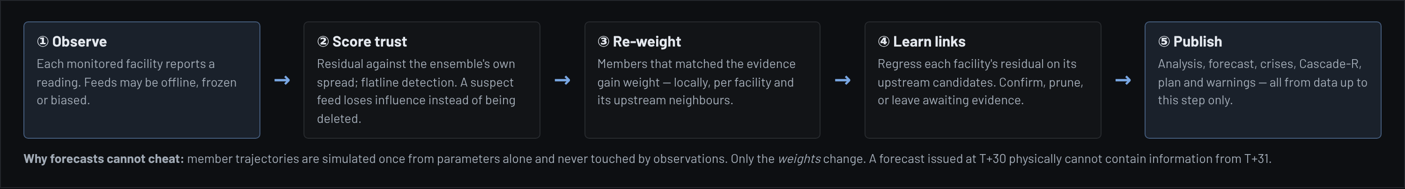
Figure 3 — What happens in each half-hour step, and why a forecast cannot contain future information.

Measured performance
OPERATION | RALEIGH (44 FACILITIES) | NAGPUR (57 FACILITIES)
Full engine build — 200 members × 145 steps | 911 ms | 1,174 ms
Memory resident per engine | 27 MB | 34 MB
Replay validation across the whole window | 46 ms | 91 ms
Crisis registry at one step | 7 ms | 10 ms
Counterfactual evaluation of one plan | 74 ms | 78 ms
Candidate links learned | 71 (7 fake) | 102 (7 fake)

The build is the only expensive operation, and it happens once per city and scenario. Everything a page asks for afterwards is tens of milliseconds, which is why six views can share one engine without a worker thread.

10 USER FLOW AND FEATURE FLOW
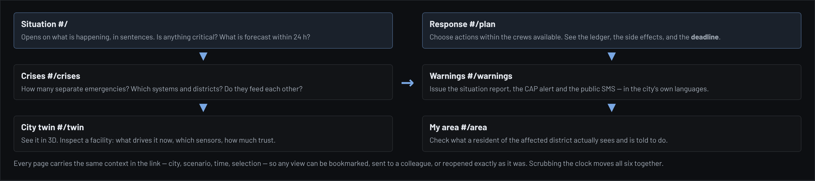
Figure 4 — The duty officer's path through the six features, and the shared context that connects them.

A worked session — Nagpur, T+37 h
STEP | THE OPERATOR DOES | THE SYSTEM ANSWERS
1 | Opens the Situation page | One crisis in the registry: an urban flood, precursor stage, around Ambazari and Sitabuldi. 32 facilities forecast to cross CRITICAL within 24 h, the first at T+42.5.
2 | Checks whether it is self-sustaining | Cascade-R is below 1 now but forecast to cross at T+46 — the hazard still dominates, but not for much longer.
3 | Opens the crisis | Members, districts, about 1.07 million residents in the footprint, and the order in which facilities are forecast to fail.
4 | Opens Response | Nine actions. The planner recommends four within five crews: flood barriers at Vasant Nagar, early closure at Jhansi Rani Square, pre-staged ambulances, and fuel to the mobile sites. Expected: 16% fewer critical facility-hours.
5 | Asks how long there is | The crews can start as late as T+47 and still keep 80% of the benefit. This is not the urgent decision.
6 | Issues the warning | CAP 1.2 alert graded Extreme / Immediate / Likely, plus cell-broadcast text in English, Hindi and Marathi — with a warning that the Hindi version costs three segments.
7 | Checks the resident view | "Flooding is likely in Dhantoli from about 01:00." Nearest hospital, roads to avoid, and what to do, in the reader's own language.

The design intent
Seven steps, one context, no re-entry of information. The operator never types a facility name twice, and every view they pass through can be sent to someone else as a link that reopens exactly that state.

11 EVIDENCE: DOES IT ACTUALLY FORECAST?
Every scenario is replayed with the future locked away. Each forecast is scored against the scenario's hidden ground truth using the standard operational-meteorology measures.
CITY | SCENARIO | BRIER | SKILL VS CLIMATOLOGY | DETECTION | FALSE ALARMS | MEDIAN LEAD
Nagpur | Monsoon cloudburst · 23 Sep 2023 | 0.040 | +0.81 | 85% | 0% | 22.5 h
Nagpur | Tropical remnant rainfall | 0.060 | +0.74 | 96% | 13% | 20.5 h
Nagpur | Heat wave and grid stress | 0.023 | +0.80 | 94% | 0% | 18.5 h
Nagpur | Grid fault and telecom blackout | 0.017 | +0.68 | 50% | 0% | 21.5 h
Raleigh | Tropical remnant rainfall | 0.076 | +0.59 | 82% | 25% | 19.0 h
Raleigh | Convective flash flood | 0.070 | +0.63 | 77% | 5% | 16.5 h
Raleigh | Heat wave and grid stress | 0.019 | +0.81 | 77% | 0% | 23.0 h

Warning rule: raise an alarm when P(critical within 24 h) reaches 60%. Median lead across scenarios is 16–23 hours — inside the 72-hour window the brief asks for, and long enough to matter operationally.

What we tested that is harder than the headline
— Planted fake links. 7 of the candidate links in each city do not exist. The learner prunes them; by T+72 on the Raleigh tropical run, 32 links are confirmed and 12 pruned.  — Injected sensor faults. A frozen gauge, an offline camera and a biased rain gauge are planted in every run and are flagged with no false positives. | — False citizen reports. Planted reports score 12–16% corroboration; genuine ones score 84–96%.  — An unseen city. Raleigh runs on the same engine with no retuning — the generalisation test the brief asks for.

Stated honestly
These numbers come from a synthetic ground truth generated by the same family of models as the forecast. They show the pipeline works end to end and is genuinely isolated from future data. They are not evidence of real-world skill, and we do not present them as such. Our own analysis also finds the ensemble is over-dispersed — an 80% band covers 92% of outcomes — so the system is currently under-confident rather than over-confident.

12 IMPACT
WHERE | MECHANISM | MEASURABLE AS
Lives and injuries | A 16–23 hour lead on hospital and EMS failure allows pre-staging and diversion before the corridor closes rather than after. | Ambulance response time during events; diversion hours
Continuity of care | Power-to-hospital and telecom-to-dispatch links are forecast, so diesel and batteries move before they are needed. | Generator-start lead time; call-completion rate
Economic loss | Closing one junction early, on evidence, instead of five late. | Critical facility-hours — the prototype shows 13–29% reductions
Public reach | Warnings that name a district, an hour and an action, in the reader's own language, correctly encoded. | Delivery rate; message truncation rate
Institutional learning | Every forecast is scored against what happened. The city accumulates a verification record instead of anecdotes. | Brier and lead time, tracked season on season

Scale of the addressable problem
Nagpur alone has about 2.9 million residents across the modeled grid, with 57 monitored assets in the prototype. India has more than 50 cities above a million people, most with an Integrated Command and Control Centre already collecting the feeds this system consumes. The data largely exists; the joining layer does not.

13 FEASIBILITY AND VIABILITY
DIMENSION | ASSESSMENT | EVIDENCE / WHAT IT NEEDS
Technical — built | Proven. Seven scenarios, two cities, full replay validation, 31 automated checks. | Working prototype, open to inspection
Technical — live data | Moderate. The engine needs one normalised value per facility per half hour; connectors are adapters, not model changes. | 3–6 months per city for the first integrations
Technical — scale | Constrained. Browser-side state caps at roughly 200–300 facilities; beyond that the engine moves server-side. | Known and measured, not discovered late
Data access | The real risk. Rainfall and traffic are obtainable; hospital HMIS and telecom site data need institutional agreements. | MoUs with the municipal corporation, utility and health department
Organisational | Moderate. It must sit inside an existing EOC workflow, not beside it. Shift handover and logging are the missing pieces. | Pilot embedded with a duty roster, not a demo
Cost | Low to run. Static hosting; no per-seat licence; no GPU. Cost is integration effort, not infrastructure. | Prototype hosts for effectively nothing today
Regulatory | Light for decision support. Becomes significant if it drives public alerting directly. | CAP output is marked EXERCISE until certified

The honest critical path
The hard part is not the model. It is hospital and telecom data access, and embedding the tool in a shift workflow. Everything upstream of those two is built and measured.

Risk register
RISK | LIKELIHOOD | IMPACT | MITIGATION
Hospital data cannot be obtained | High | High | Run the chain to EMS only and state the gap; pursue a single anchor hospital first rather than a system-wide agreement.
Telecom operators decline site data | High | Medium | Infer site stress from substation state and known battery hold-up; label it as inferred rather than measured.
A real event behaves unlike the model | Medium | High | This is the point of the pilot. The verification record is published either way; a miss is a finding, not a failure.
Operators do not adopt it | Medium | High | Embed in a duty roster, not a demo. Build shift handover and a decision log so it fits the existing workflow.
Over-reliance on a simulation | Medium | High | Simulation badge, modeled labels and stated limits in the interface; CAP output marked EXERCISE until certified.
Sensor spoofing | Low | Medium | Trust scoring already catches frozen, offline and biased feeds; a step test and buddy check are designed for spoofed plausible values.
Scale beyond browser limits | Medium | Low | Measured at 200–300 facilities; the engine is portable to a server with no model change.

What a pilot would be judged on
MEASURE | TARGET | WHY THIS ONE
Median lead time | > 6 h on real events | The whole premise is warning before, not reporting after. Six hours is the threshold at which pre-staging becomes possible.
Probability of detection | > 70% | Missing events is worse than a false alarm in this domain.
False-alarm ratio | < 30% | Above this, operators stop reading the alerts and the system is worse than nothing.
Brier skill vs persistence | > 0 | The honest floor: beat assuming tomorrow looks like today.
Unprompted operator use | At least once in a real event | The only adoption measure that cannot be gamed.
Decisions traceable to the tool | Logged per event | Establishes whether it changed anything, which is the question a funder will ask.

14 BUSINESS VIEW
Who buys  — Municipal corporations and smart-city SPVs operating an ICCC — the primary buyer; the budget line already exists.  — State disaster management authorities — multi-city deployments, standardised reporting.  — Distribution utilities — a narrower product: what my outage does downstream.  — Hospital networks — inbound-demand forecasting and diversion planning. | How it is sold  — Pilot — one city, one hazard family, one season. Fixed fee, success measured on verified lead time.  — Annual licence — per city, tiered by monitored assets and scenarios.  — Integration — one-off per connector; the largest first-year line.  — Verification report — seasonal scoring of what was forecast against what happened.

PHASE | GOAL | PROOF REQUIRED TO ADVANCE
Now | Prototype on two cities, replay-validated | Done — this document and the working build
0–6 months | One live feed (rainfall + river level) in Nagpur; forecast verified against a real monsoon | Positive skill against a real observed event, not a synthetic one
6–18 months | Full ICCC integration: traffic, power, EMS. Embedded in a duty roster. | An operator chooses to use it unprompted during a real event
18+ months | Second and third city; engine moves server-side for scale | Unchanged engine, new city, no retuning — as Raleigh already demonstrates

Why this is defensible commercially
Integration work is replicable by anyone. The learned dependency graph, the verification record accumulated season on season, and the deadline calculation are not. A city that has run this for two monsoons owns a calibrated model of its own failure modes that a new entrant cannot reproduce from a standing start.

15 LIMITS WE STATE UP FRONT
LIMIT | DETAIL | MITIGATION
Not connected to live data | Every sensor reading, citizen report and outcome in the prototype is modeled. The city geometry is real; the telemetry is not. | Connector work is specified and costed; the interface already carries the labels
Synthetic ground truth | Validation scores come from a truth generated by the same model family, so there is no structural model error. They are an upper bound. | A live pilot against a real monsoon is the only answer
Prior is informative | Candidate links are supplied with a plausible scale; the system refines and prunes rather than discovering from nothing. The 7 fake links per city are the genuinely adversarial part. | A mis-specified-prior experiment is the next engine test
Ensemble over-dispersed | An 80% band covers 92% of outcomes; the system is under-confident, which costs skill score. | Spread calibration, identified and measurable
Scale ceiling | Roughly 200–300 facilities in a browser; 57 today. | Server-side engine for larger deployments
Adversarial inputs | Sensor trust catches frozen, offline and biased feeds, but not a spoofed value close to a plausible level. | A step test and a buddy check are designed and pending
3D models are representative | Facility models are authored at real scale, not surveyed replicas. Building heights are inferred from footprint area where OSM has no tag. | Clearly labelled; cosmetic, not analytical

Why we lead with the limits
A warning system is only useful if the people using it know exactly how far to trust it. Every one of the limits above is measured and stated in the interface, not buried. That discipline is itself part of the product.

The same product on a phone
A duty officer is not always at a desk, and a ward officer never is. Every page reflows to phone width with no horizontal scrolling: the sidebar becomes an overlay, tables scroll inside their own containers, and the 3D twin keeps working. The resident view in particular is designed to be read on a phone, because that is the only device it will ever be read on.
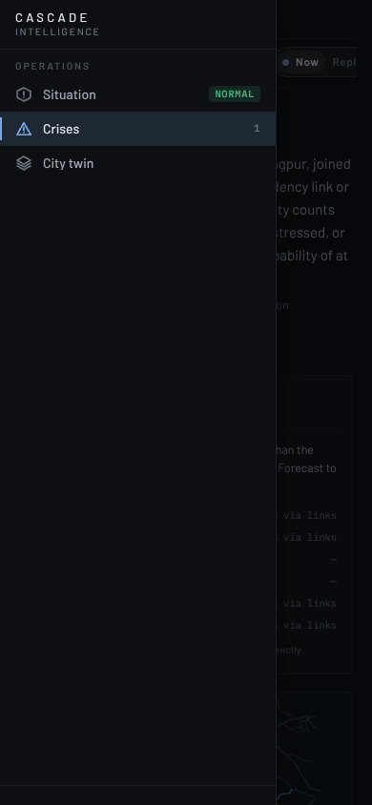  The feature sidebar as an overlay at 390 px, with a scrim; any link or Escape closes it. | 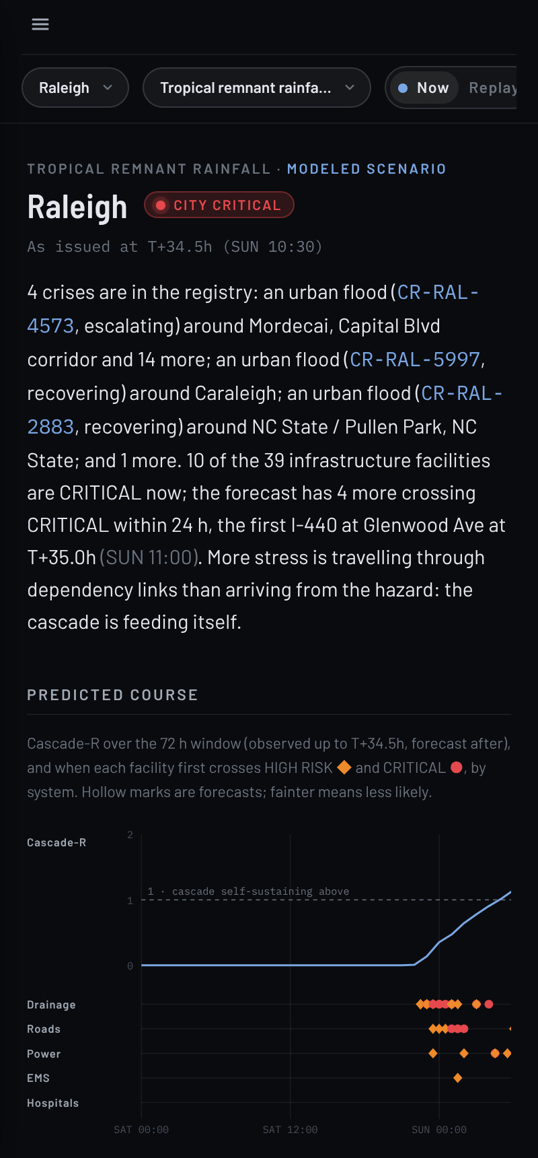  The Situation page at phone width — the same computed sentences and the same chart, reflowed.

16 WHAT WE WOULD BUILD NEXT
FEATURE | WHAT IT DOES | WHY IT IS NEXT
Resource board | Crews become real units with a home depot and a travel time on the street graph, instead of an abstract budget of five. | Turns the plan into an operation
Red-team console | Inject a frozen gauge, a spoofed spike, a bot burst or a 60% feed blackout, rebuild the twin on the poisoned streams and score it against the clean run. | Proves robustness instead of asserting it
Decision log and shift handover | Every action journalled against scenario time; one button produces the brief for the officer taking over. | The missing workflow piece
Exposure lens | Remove flooded corridors from the street graph and recompute who can still reach a hospital. | "17,000 people are cut off" beats "298,751 exposed"
Standing triggers | Rules the operator writes, backtested instantly against the whole replay. | Scales beyond watching a screen
Live weather | Drive the hazard from a real ensemble forecast rather than a scripted scenario. | First step out of simulation

17 HOW TO REVIEW THE PROTOTYPE
Everything below is reproducible in a browser in about ten minutes. No account, no server, no sample data to load — the prototype opens on Nagpur with the monsoon reconstruction already running.
# | DO THIS | WHAT TO LOOK FOR
1 | Open the Situation page and read the first paragraph. | It is generated, not written. Change the scenario and the sentence rewrites itself from the new engine state.
2 | Drag the 72-hour timeline backwards and forwards. | The forecast, the crisis registry, the sidebar chips and the sun on the 3D city all move together. Nothing is a stored snapshot.
3 | Set the time to before the event and compare with after. | Forecasts issued early contain no knowledge of what follows. The crisis history strip shows exactly which crises were knowable at each hour.
4 | Open Response and switch between the chlorine and monsoon scenarios. | The deadline curve inverts: a cliff in one case, a gentle slope in the other. Same engine, opposite instruction.
7 | Switch the city to Raleigh. | The same engine, untuned, on a city with different systems, a different time zone and no telecom layer. This is the generalisation test.
8 | Open the twin, select a facility, read the inspector. | Risk decomposes into baseline, hazard and each upstream link with its weight, lag and sensor trust. Ask why, get an answer.

What would change our mind
If a live pilot shows the lead time collapsing on a real event, the honest conclusion is that cross-system forecasting needs better physical models than ours, not better presentation. We would publish that result. The verification machinery is already built to measure it either way, which is the point of building it before the claim rather than after.

Deployment options
MODE | WHAT IT IS | BEST FOR
Offline briefcase | The whole application as one file with the city data bundled. No network, no install, no account. | Exercises, training, field use where connectivity fails — which is exactly during an event
Static hosting | Served from any web host or an internal server. Shareable by link, with the context in the URL. | Day-to-day use across departments
Integrated in an ICCC | Connectors feed live telemetry; the engine moves server-side as the asset count grows. | Full operational deployment
The first two modes work today, which is unusual for this class of system and is a direct consequence of having no backend. A city can evaluate the whole thing before committing to a single integration.

18 SUMMARY
ASPECT | IN ONE LINE
Problem | Cities forecast each system separately. Nobody forecasts the handoffs, which is where the harm compounds — as Nagpur saw on 23 September 2023.
Gap | Flood models stop at the water, SCADA at the meter, command centres at the wall of screens. The joining is left to a human at 3 a.m.
Approach | One digital twin per city with a dependency graph learned from the sensor streams, a 200-member ensemble, a crisis registry, a counterfactual planner, and warnings in the city's own languages.
Unique | We forecast transitions between systems, not states within them — and we price the delay. Nothing else states a decision deadline.
Evidence | Seven scenarios, two cities, replay-validated with 16–23 hour median lead; 7 fake dependency links pruned; planted false reports rejected.
Status | Working prototype, open to inspection, running in a browser with no server.
Next | One live feed in Nagpur, verified against a real monsoon. That is the step that converts every number in this document from plausible to proven.

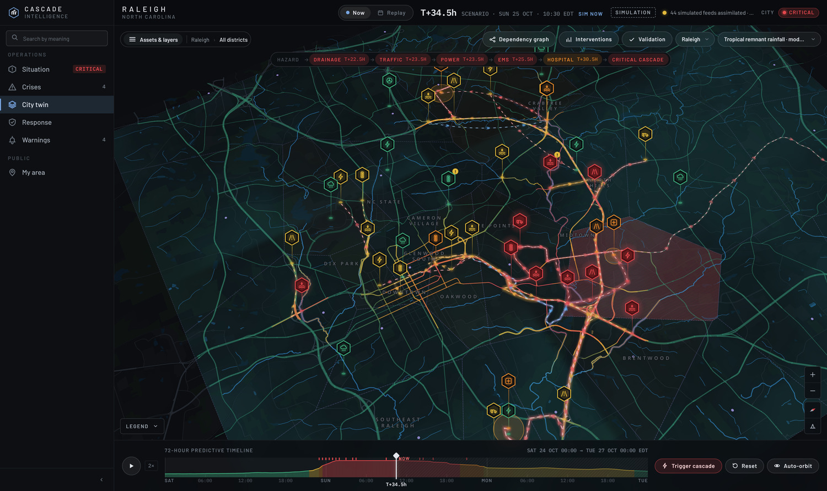
The operations room with a facility selected: the inspector shows what drives its risk now, which upstream links carry it, sensor trust, and the forecast — all from data available at the issue time.

The prototype in numbers
MEASURE | NAGPUR | RALEIGH | NOTE
Monitored facilities | 57 | 44 | Nagpur adds a telecom layer
Candidate dependency links | 102 | 71 | 7 deliberately false in each
Residents in the modeled grid | 2.94 million | 454,000 | 450 m cells
Scenarios | 7 | 4 | One is a real-event reconstruction
Ensemble members × steps | 200 × 145 | 200 × 145 | Half-hourly over 72 hours
Engine build time | 1.17 s | 0.91 s | Once per city and scenario
Memory per engine | 34 MB | 27 MB | Measured, not estimated
Median warning lead | 18.5–22.5 h | 16.5–23.0 h | Across replayed scenarios

Everything in this document is computed by the prototype described in it. Map data © OpenStreetMap contributors (ODbL); tiles © OpenMapTiles; rendering by MapLibre GL JS and three.js; textures by Poly Haven (CC0).

