AWS Series -

CloudFront

what is cloudfront -
Cloud = server
Front = something(server) in front of the server

Cloud Front is a CDN (content Delivery Network – geographically local group of servers).
Cloud front stores cache data from the various servers so that data is easily and quickly available to the
user local to a particular geographical area. CloudFront is a proxy server sitting besides the main server in the location close to a user, so that data is quickly made available to the user as it is geographically
near the user hence low latency to fetch/access data.
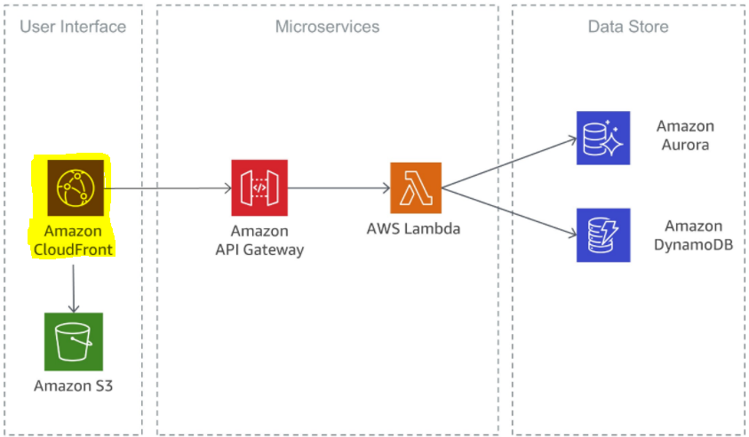

Example for humans -
Consider a cow/buffalo stable in a village (main server) and the milk(data) is transported and stored in a DIARY(proxy server- cloudfront) local to the buyer(user) so the milk(data) is easily and quickly made available to the consumer(user) thus saving time(low latency) to get the milk(data) to the stable far in the village

