**Hollo Scenario I**

**Group 7 - Mateusz Wszolek, Darias Skiedra, Shreyas Gaonkar, Heeba Mohammed**

The Hollo application will eventually become a cross platform app where users can communicate with each other via several means. Users will be able to send text based messages to each other and the text will be stored for future or until manually deleted. Users will also be able to make calls to one another in real time. Additionally, users will be able to video chat with each other.

**Basic Message Sending Scenario:** The user will be prompted with account creation and initialization. If the user already has an existing account he will be able to choose to log in to the system sinated. Once the user is logged in, he will have abilities to add and remove contacts from accessible friend list.

The contacts and previous conversations will be stored on the server. User can select a contact which will create a new interface where previous messages as well as text entrance box will be shown. When user types a message to and clicks on send button, the receiving user will get a notification. If he chooses to accept the message he too will find himself in a new graphical interface with the received message shown above the text entrance area.

When the user receives a contact request he will receive a notification about a friend request. User will have an option whether or not to accept pending friend request(s). A user will also be able to remove friends even after he accepted the request. The user whom is removed from someone else’s friend list will not be able to send any more messages to that person. A user can also choose to block another user. A blocked user will not be able to send any more messages or friend requests to that person.

Users will be able to use the application on multiple platforms. Starting supported platforms include Android OS, various Linux based operating systems, Mac OS X, and Windows. The user experience will be uniform across all platforms.

A user will have an option to select their status. Statuses to choose from are: Available, Away, Busy, Offline. When friend’s status changes it will be updated on your contact list.

Mobile users will have an option to share their location with the person they are chatting with. Users can send their location on request is integrated with Google Maps API.

client A

client B

Server

Figure 1: Basic communication scheme where client can be on any platform.

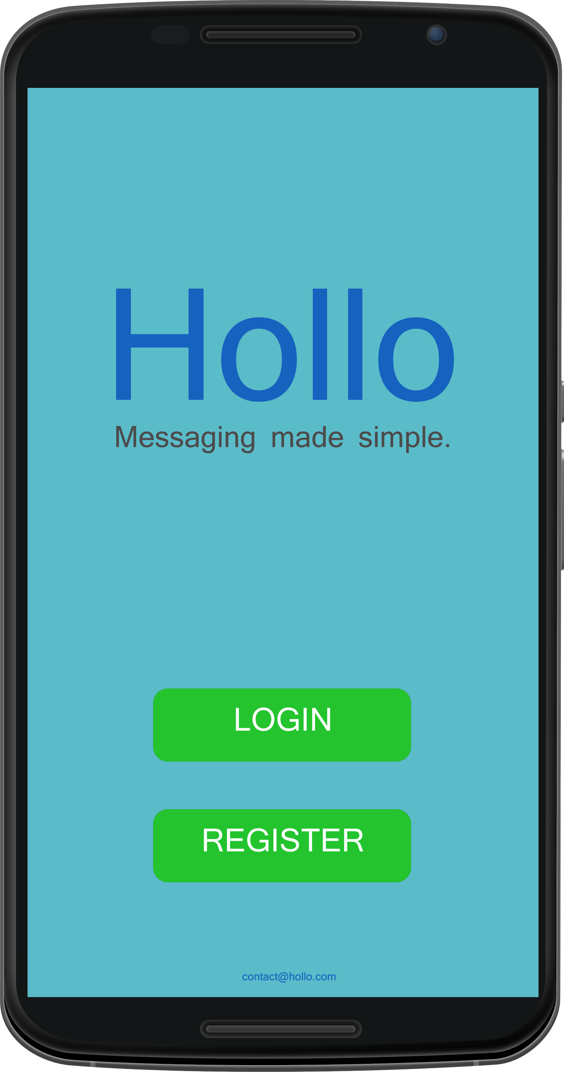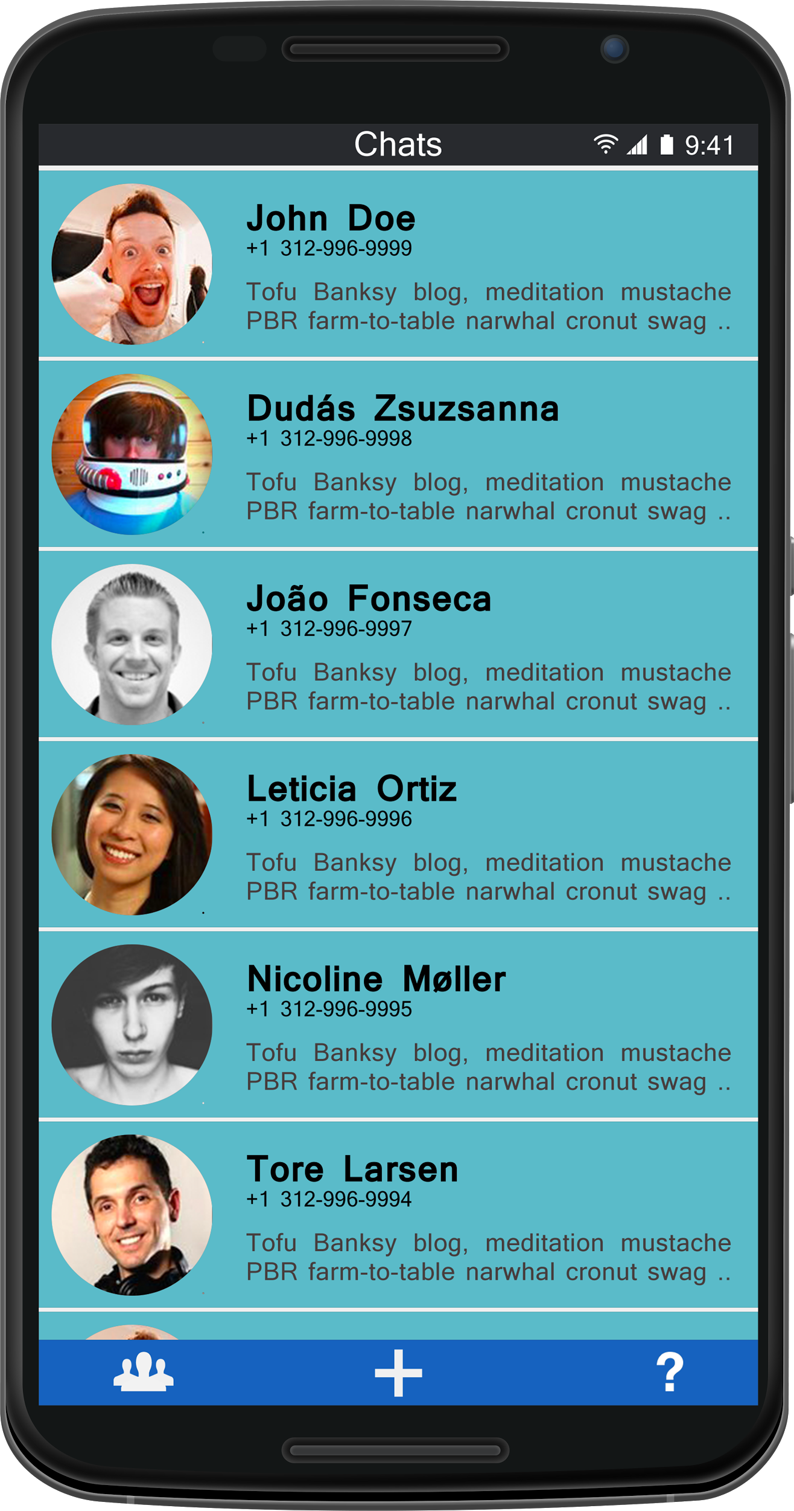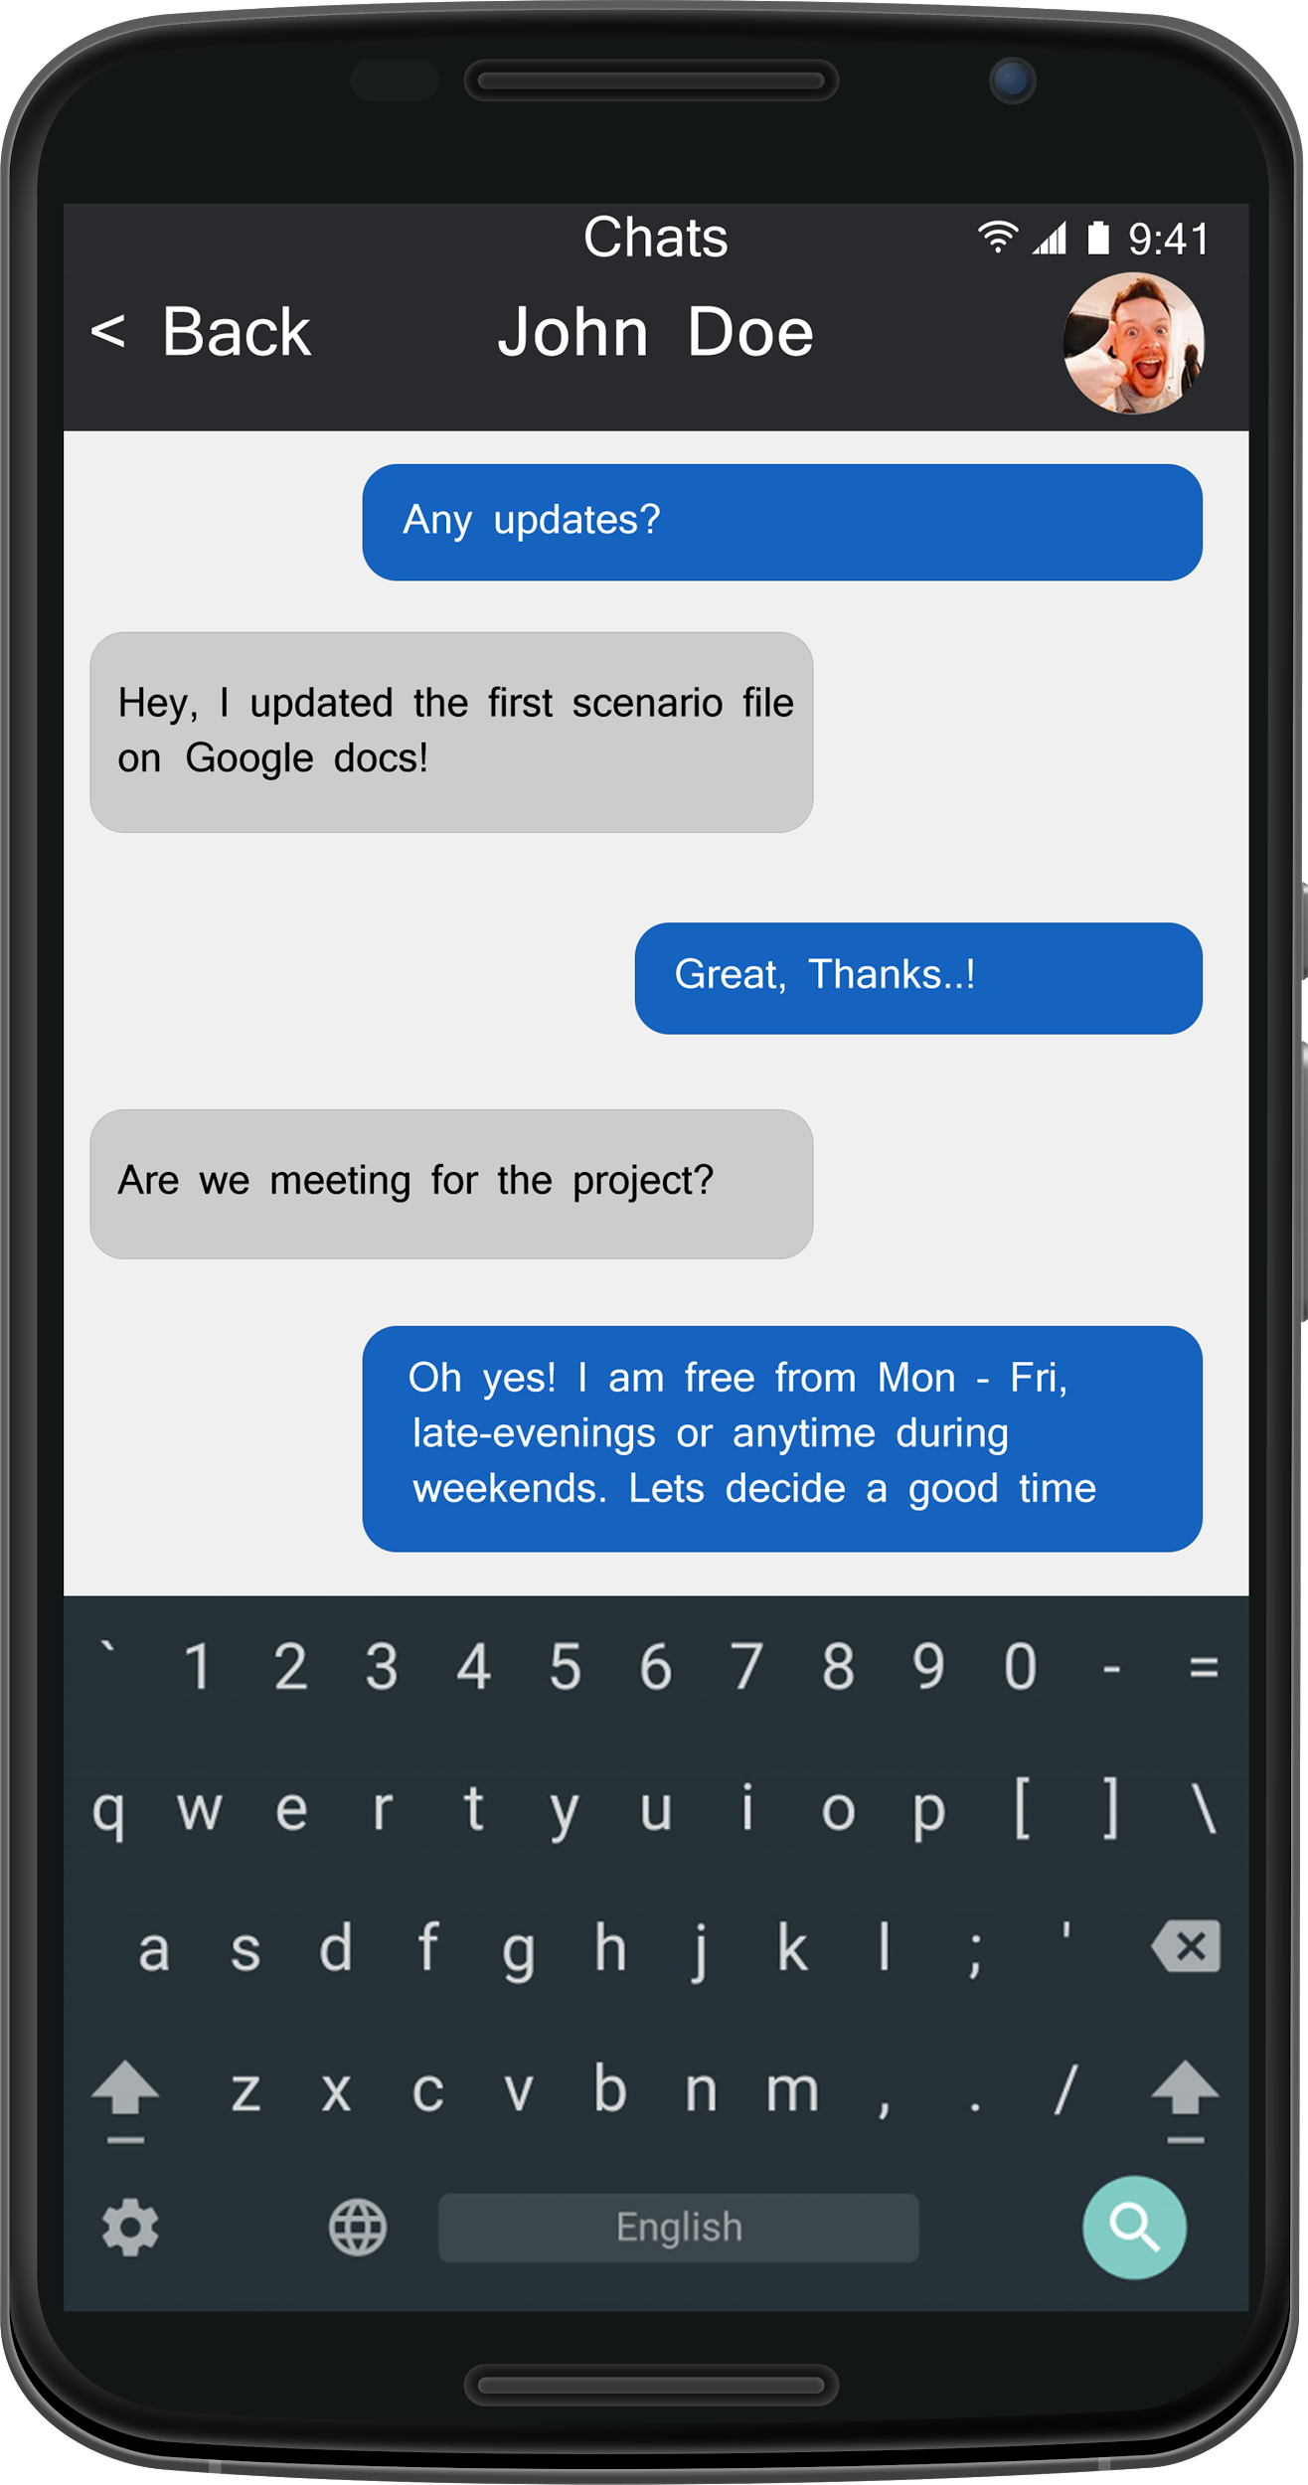

Left: Hollo App start page.  
Center: Friends chat window  
Right: Personal Chat Window