Synopsis Of

GROCERY MART

For

( Web Technology)

Galgotias College of Engineering and Technology

Submitted To:
Submitted By:

Mr.Mayank Dixit

Shreyash

Shiv Chandra Yadav

Tanishk Merothiya

Siddharth bhadauriya

GROCERY MART

Abstract

Online Grocery Store is the norm these days. There are lot of successful websites such as BigBasket.com, askmegrocery.com etc in this space. Purpose of Grocery Mart is to allow customer to shop virtually using internet. Computerization of online store will increase the ease, efficiency and reduce the chances of manual errors. With the popularity of PCs, and mobiles easy access to Internet and World Wide Web (WWW), Internet is increasingly used by consumers & vendors as a channel for shopping, payment & other operations.

Objective & Scope

The main objective of proposed system, is used to provide Online Grocery Store solution to consumers and vendors. It will automate some of the basic operations of an online store. Scope would be to provide basic functionalities using a web application so that those manual process can be automated. It will include to provide administration access to vendors and admins and user specific access to customers.

About Solution

The system will ease the shopping operations for customer of online store. It will provide vendor or administration functionality to manage categories and products. Consumer will be able to browse and search products under different categories. Selected products or items selected for purchase would be added into the virtual shopping cart. Which can be managed separately by customer. It can be examined at any time by customer for selected products, their quantity & price. These would be main functionalities apart from some usual operations such as login, logout, manage profile etc.

Possible use cases are mentioned in below diagram which will illustrate the scope of solution which we intend to develop.
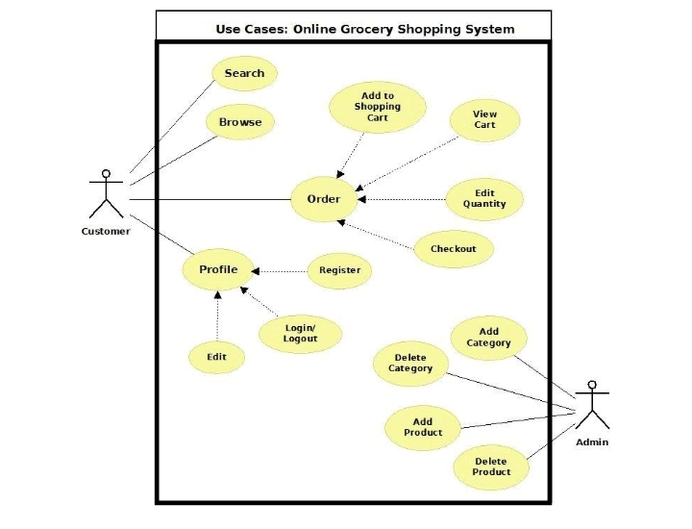

Project Category

This project is a web based application develop on PHP technology frameworks using the following tools:

RDBMS (Relational Data base System)

OOPS (Object Oriented Programming System)

PHP

MySQL

Html,CSS, JavaScript

Web based applications, as opposed to client/server, are primarily server based; almost all the code for the application resides on the server. There is usually no client component and users access the application through a web browser. Web based applications have evolved greatly in the last few years from simple websites to full-fledged enterprise business systems and business portals integrating with databases, mail systems and a host of third party software.

Web based applications enjoy a number of advantages over the more traditional client/server technology:

Easier and faster to develop

Easier to deploy since all the code resides on the server machine. No individual client machine installations are required.

Easier to support and upgrade since no individual client machine up gradations are required.

Feasibility Study

An important outcome of the preliminary investigation is the determination that system requested is feasible. In our case, System will allow basic transactions online for customers and administrators for which data will be stored in database. Records in DB will be used for authentication, and all other operations. Further there are three aspects in the feasibility study portion of the preliminary investigation

Economic Feasibility

Are there sufficient benefits in creating the system to make the costs acceptable? Or, are the costs of not creating the system so great that it is advisable to undertake the project? These are the important questions to be answered in economic feasibility. Proposed system will not face any economic constraint as it will be developed by students only. And it will help to automate manual processing, which will save time and money. This will provide economic benefits.

Operational Feasibility

Will the system be used if it is developed and implemented? Will there be resistance from users that will undermine the possible application benefits? When we look from this perspective, we don’t see any risk in implementing and making
it operational. This project will help everyone, as it is planned to be more reliable, maintainable, affordable and producible.
Technical Feasibility

Can the work for the project be done with current equipment, existing software technology and available personnel? These are the questions which needs to be answered to check Technical feasibility. Project will be developed using PHP and back end as mySQL which will store details related to this project. There are basic requirement of hardware to run this application. This application will be web application so this application can be accessed by using any device like (Personal Computers, Laptop and with some hand held devices) provided they are on same network.

Software Requirements:

OS: Windows/Unix/Linux

Database: MySQL (Free-Open source)

IDE: Visual Studio (Free-Open source)

Server: Apache (Free-Open source)

Language: PHP (Free-Open source)

Front end: Browser with support for Javascript

Hardware Components:

Processor – Dual Core

Hard Disk – 50 GB

Memory – 1GB RAM

Mouse – Any Standard

Keyboard – Any Standard

Monitor – Any color monitor

Local Area Network Preferable

Advantages

Performance: Most of Operations and tasks in underlined system are repetitive and time consuming. Also there are chances of manual errors in the system. So an efficient, effective, fast system is desired. Hence this web based computerized system is undertaken which is very fast and user friendly.

Ease & Efficiency: The basic need of this website is efficiency and simplicity. This website is efficient as it provides easy browsing & data entry for user. Users can easily view all the related operations along with all relevant details.
Control: The complete control of the project is under the hands of authorized person. Only customer can access their own account. All control is under the administrator and members have the rights to just see their concerned records and transactions.

Security: Security is one of the main concerns for any modern application. So, security is the important criteria for the purposed system. Proper authentication and authorization is implemented so that only right person will get right access.

Limitations of the software

System would be a basic project which is intended to provide base for further development.
Other functionalities are supposed to be developed as per custom need on this framework.

User needs to have access to website either on LAN or other network.

Future Scope

There will be lot of scope to improve this project, since currently basic functionality would be provided.
Some of the modules to improve are admin part such as personalized recommendations, discount & offer management. For customers, notification & messaging etc can be improved. These can be developed to make it more effective.

References

https://www.php.net/

https://www.w3schools.com/css/

https://www.w3schools.com/js/

