**Project Proposal**

**For Consideration Under**

**TIH – IoT Technology Development Program - 2025**

**DILBOT**

**Submitted by:**

**Shreyash Gadgil**

**Name of Project Investigator:**

**Dr. Prasad Ramanathan**

**Affiliation:**

**Principal Engineer -TIH**

**Date of Submission:**

**07-July-2025**



**Contents**

1. Cover Sheet 3

2. Executive Summary 4

3. Background 4

a. History 4

b. Statement of the problem 4

c. Objectives 5

d. Proposed Solution 5,6

e. Deliverables 7

f. Project Plan with Major Milestones 8

g. Resources and budget 9

h. Category of New Technology/Product 10

4. Appendix 10

a. Supporting Documentation 10

# Cover Sheet

|  |  |  |
| --- | --- | --- |
| Sr. No. | Name | Details |
| 1 | Project Title | DILBOT (Devices and Interface Lab’s Design and Development of AI assisted Robotic System) |
| 2 | **Principal Investigator (PI)/Project Leader (PL)** |  |
|  | Name | Dr. Prasad Ramanathan |
|  | Designation | CTO |
|  | Affiliation | TIH IITB |
|  | Address | 3rd Floor, CSRE Building, IIT Bombay Campus, Powai, Mumbai-400076 |
|  | Phone Number | +91 9323194737 |
|  | Email ID | cto@tihiitb.org |
| 3 | **Co-Principal Investigator (Co - PI)** |  |
|  | Name |  |
|  | Designation |  |
|  | Affiliation |  |
|  | Address |  |
|  | Phone Number |  |
|  | Email ID |  |
| 4 | **Collaborator Details** |  |
|  | Name | Dr. Shaibal Sarkar |
|  | Designation | Professor |
|  | Affiliation | DIL, IIT Bombay |
|  | Address | Lab 704, 7th Floor, DIL, New DESE Bldg, IIT Bombay, Powai, Mumbai-400076 |
|  | Phone Number | +91 9820867575 |
|  | Email ID | Shaibal.sarkar@iitb.ac.in |

# Executive Summary

**DILBOT** automates the spin-coating process for thin-film deposition, enabling the fabrication of all solution-processable layers with high precision. Equipped with a robotic arm, the system incorporates nitrogen flush, pipetting, and gripping modules to handle substrates. DILBOT offers precise control over critical parameters, including substrate pre- and post-treatment, spin speed, annealing time, and temperature, ensuring reproducible preparation of multi-layered samples. Additionally, it features interchangeable modules for enhanced versatility and facilitates parameter variation experiments, streamlining the process for optimized material development.

# Background

## History

Recent advancements in automation have greatly enhanced the development and optimization of novel solar materials, improving both process efficiency and device performance. In paper[1] Zhang J. discusses the creation of automated systems for material discovery and optimization, including robotic platforms capable of autonomous operation, leading to more efficient development of new materials and devices. In another paper[2] Zhang J highlights the impact of automation in optimizing fabrication steps for solar devices, particularly by controlling key variables like chemical addition speed, resulting in high efficiency, consistency, and stability in device performance.

A machine learning-based approach for predicting material stability using spectral data, bypassing lengthy aging tests and achieving over 86% accuracy in predicting stable materials is stated in experiments done in work [3] by Liu et al.. An automated platform for optimizing thin films, which demonstrated significant improvements in efficiency and long-term stability of solar devices, underlining the potential of integrating robotics with intelligent algorithms for accelerated material optimization is presented in work [4]. Overall, these studies show that automation is aiding material science by enabling faster, more reliable experimentation, enhancing scalability, and advancing the development of next-generation solar technologies.

A common platform used in the above automations is SPINBOT[5] by sciprios , the only commercially available platform for this process according to our knowledge.

The Sciprios spin-coating robot has some shortcomings, including limited flexibility for different material systems and substrates, a costly setup, and a lack of modularity. Its current substrate-picking method is inefficient, and the system is not easily adaptable for various applications. Additionally, it lacks modularity for adding or replacing a station in the current workflow, highlighting the need for a more cost-effective, versatile alternative.

## Statement of the problem

Design and development of "DILBOT" an automated spin-coater workflow designed to address the need for precise, reproducible, and flexible thin-film deposition in material development.

## 

## Objectives

* Create a workflow of the process based on common understanding
* Sequencing of the process for better optimization and higher throughput
* Validation of the workflow in a simulation environment
* Selection of a robotic arm/manipulator with custom gripper for picking and placing of substrate without damaging the substrate. This will act as the central node of the automation workflow doing material transfer. Another gripper also needs to have a liquid dispensing mechanism.
* Procurement and modification of this robot arm with integration of custom gripper
* Modification of the individual modules (UV tray, spin coater, heating module) for creating a sequenced workflow.
  1. **Proposed solution**

We propose the development and deployment of an autonomous workflow. The individual stations will be equipped with sensors and actuators designed to automate the process. We have divided the process into stations(according to current understanding, we can add or remove or change the stations):

* **Station A: Substrate placing tray**

This will be the first station where we will place the substrates in an orderly manner.

* **Station B: UV ozone cleaning station**

It will have a tray, which can extend or retract. This station functions as a chamber for UV Ozone cleaning. The system activates high-intensity UV light to clean the substrates, ensuring surface readiness. To maintain safety and avoid UV exposure, the tray remains fully enclosed during this phase. After the high-intensity UV cleaning phase, the substrates are transitioned to a low-intensity light to stabilize before further processing

* **Station C: UV ozone cleaning station**

It will have a tray, which can extend or retract. This station functions as a chamber for UV Ozone cleaning. The system activates high-intensity UV light to clean the substrates, ensuring surface readiness. To maintain safety and avoid UV exposure, the tray remains fully enclosed during this phase. After the high-intensity UV cleaning phase, the substrates are transitioned to a low-intensity light to stabilize before further processing

* **Station D: Spin coater**
* The robot gripper picks up substrates from station B and places it on the spin coater.
* Change the gripper or use another robot arm to extract and dispense liquid on the substrate on the spin coater in a controlled manner using an electronic pipette.
* Then the spin coater activates and applies a thin layer of liquid on the substrate.
* **Station E: Hot plate/plates**

The hot plate does the annealing or curing process after spin coating. There can be multiple hot plates(currently 2), where the curing is sequential

* **Station F: Final placement tray**

The cured/processed substrates will be placed on this station for further processing.

The above process is visually shown in Figure 1. below.

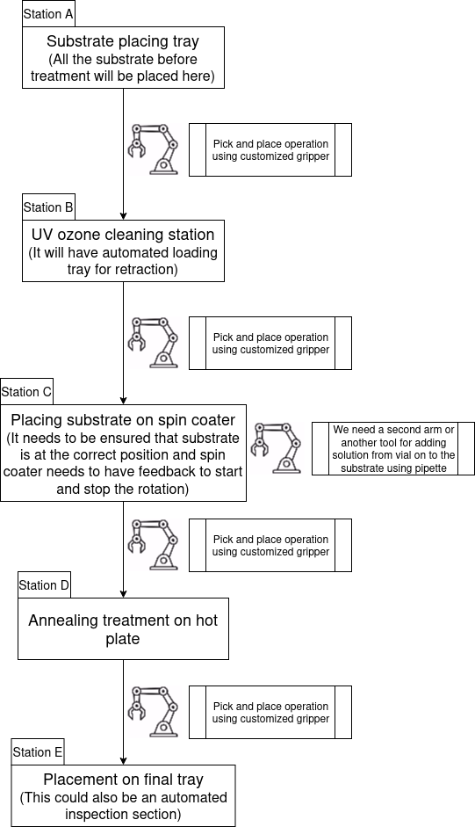

**Figure 1: A schematic flowchart of the proposed solution**

## 

## Deliverables

**1. Simulation environment:** A brief literature review of simulation environment as shown by M. Sentos et. al.[6], helped us reach the conclusion that Coppeliasim(Educational version)[7] would be suitable for this project. (The visualisation of the simulation and actual hardware may differ due to availability of hardware or changes during fabrication)

**2. Robot arm and custom gripper:** We will be procuring a suitable robotic arm according to the project requirements and from the simulation studies to meet project requirements. And design a custom gripper for our purpose. This will also include a mechanism to deliver liquid on to the substrate as well.

**3. Customization of existing hardware stack or stations**: We will have to make changes to the stations(UV ozone cleaning station, spin coater, hot plate) to make them autonomous and be able to send their current status to the next process in line

**4. Sequencing of the process:** Sequencing of the tasks, number of substrates at each station, time taken by substrates at each station will be decided by scheduling algorithm to minimize the time without compromising on the quality of substrate.

## Project Plan with Major Milestones

#### **Phase 1: Requirements Gathering and Design / Feasibility study (Month 1)**

* **Deliverables:**
  + A simulation environment with the required stations(The visualisation of the simulation and actual hardware may differ due to availability of hardware or changes during fabrication)
  + A workflow diagram and sequencing solution for efficient completion of the process
  + Sensors requirements for the workflow
  + Vendor list for the robotic arm/manipulator
  + First iteration of gripper design
* **Milestones**:
  + Completion of system architecture design.
  + Confirmation of the required sensor and robot specifications.
  + A simulation environment for visualization

#### **Phase 2: Robot procurement and mechatronics customization(development phase) (Month 1)**

* **Deliverables:**
  + Give the requirement of the manipulator arm to the vendor.
  + Prototype testing of gripper
  + Customization of the stations(UV ozone cleaning station, spin coater, hot plate) for making them autonomous
  + Develop a scheduling algorithm for the process and find out the requirements at each station
* **Milestones**:
  + Gripper first iteration design
  + Customized stations design and give the requirement to vendors.

#### **Phase 3: Testing and Calibration of h/w (Month 2-5)**

* **Deliverables:**
  + Motion and path planning of robotic arm
  + Customized station testing
  + Customized gripper testing with arm
* **Milestones**:
  + Completion of initial testing and calibration of arm and all individual stations.

#### **Phase 4: Full System Integration (Month 6-8)**

* **Deliverables:**
  + Final integration of all components
  + Parameters tuning for accuracy and precision
  + Testing of the accuracy and precision of whole process(Specifically arm precision)
* **Milestones**:
  + Full run of integrated solution

## Resources and budget for TIH-IoT

1. **Phase 1: Feasibility study**
2. **Phase 2 to 4: Design and development of DILBOT**

|  |  |  |  |
| --- | --- | --- | --- |
| Sr. No. | Item | 1st Year (Rs) | Total (Rs.) |
| 1 | Design and Development of AI assisted Robotic System Equipment/set-up. The cost for equipment and fabrication would be incurred by the DIL | 18,00,000 | 18,00,000 |
| 2 | GST (@18% of 1) | 3,24,000 | 3,24,000 |
| 3 | **Grand Total (1+2)** | **21,24,000** | **21,24,000** |

Tranche Disbursement Schedule

|  |  |  |  |
| --- | --- | --- | --- |
| Sr. No. | Timelines | Amount Required (INR) | Milestone/Deliverables that will be completed by the timeline |
| 1 | Phase 1-Project Start date | 10% of the total Cost | Project Beginning and feasibility report |
| 2 | Phase 2 initiation | 50% of the total Cost | Phase 2 initiation and modifications to requirements based on feasibility report |
| 3 | After completion of 6 months from T0 | 30% of the total Cost | Milestone completion + Project status report |
| 4 | Project completion | 10% of the total Cost | UC/SE submission |

## Category of New Technology/Product

Indicate the category of the new technology/product according to your understanding. If you could not categorize simply indicate the **“not known”**

|  |  |  |
| --- | --- | --- |
| Sr. No. | Category | Details |
| 1 | New-to-the-firm Products/Technology (new Product Lines) | Precision robotics is a new technology improvement we will be doing at the firm |

# Appendix

## References

#### 1. Zhang, Jiyun, Jens A. Hauch, and Christoph J. Brabec. "Toward self-driven autonomous material and device acceleration platforms (amadap) for emerging photovoltaics technologies." Accounts of chemical research 57, no. 9 (2024): 1434-1445.

2. Zhang, J., Wu, J., Barabash, A., Du, T., Qiu, S., Le Corre, V.M., Zhao, Y., Zhang, K., Schmitt, F., Peng, Z. and Tian, J., 2024. Precise control of process parameters for> 23% efficiency perovskite solar cells in ambient air using an automated device acceleration platform. *Energy & Environmental Science*, *17*(15), pp.5490-5499.

3. Liu, Z., Zhang, J., Rao, G., Peng, Z., Huang, Y., Arnold, S., Liu, B., Deng, C., Li, C., Li, H. and Zhi, H., 2024. Accelerating Photostability Evaluation of Perovskite Films through Intelligent Spectral Learning-Based Early Diagnosis. *ACS Energy Letters*, *9*(2), pp.662-670.

4. Zhang, Jiyun, Bowen Liu, Ziyi Liu, Jianchang Wu, Simon Arnold, Hongyang Shi, Tobias Osterrieder et al. "Optimizing Perovskite Thin‐Film Parameter Spaces with Machine Learning‐Guided Robotic Platform for High‐Performance Perovskite Solar Cells." *Advanced Energy Materials* 13, no. 48 (2023): 2302594.

5. <https://www.sciprios.de/lab-automation/spin-coating-robot/>

6. M. Santos Pessoa de Melo, J. Gomes da Silva Neto, P. Jorge Lima da Silva, J. M. X. Natario Teixeira and V. Teichrieb, "Analysis and Comparison of Robotics 3D Simulators," *2019 21st Symposium on Virtual and Augmented Reality (SVR)*, Rio de Janeiro, Brazil, 2019, pp. 242-251, doi: 10.1109/SVR.2019.00049.

7. <https://www.coppeliarobotics.com/>