WEBXPLOIT
Web Application Security Testing Toolkit
Combined Technical Project Documentation
and Web Application VAPT Assessment
Prepared by
Shreyash Navnath Vidhate
Project / training context: Fortune Cloud Technologies
Industry Trainer / Reviewer: Mr. Vaibhav Barde
Assessment evidence reviewed: 03–24 October 2026
Version: 2.0 • 24 October 2026
Classification: Controlled Laboratory Assessment
GitHub: https://github.com/shreyash-vidhate/WebXploit

Document Control
Field | Details
Document title | WebXploit — Combined Technical Project Documentation and VAPT Assessment
Prepared by | Shreyash Navnath Vidhate
Project context | Fortune Cloud Technologies (as stated in source documents)
Reviewer / trainer | Mr. Vaibhav Barde (as stated in source documents)
Environment | Local Docker-based controlled security laboratory
Evidence sources | Existing technical documentation and VAPT report PDFs; supplied Screenshots.zip; manual retest details from project notes
Document version / date | 2.0 / 24 October 2026
Use limitation | Portfolio and controlled-lab demonstration;

Document Guide
Part I explains the project, architecture, components and operating workflow. Part II records the security assessment observations for OWASP Top 10 scenario IDs A01–A10. Each finding separates what was observed from what can reasonably be concluded. Screenshots are included as evidence, with a short explanation for both technical and non-technical readers.
Important evidence note: the earlier source report records a safe-run dated 03 October 2026. Newer manual retests for A08, A09 and A10 are described separately based on the later test details. These two evidence periods are not treated as if they were one execution. The supplied screenshots are used as provided; no missing test outcome is invented.

Contents
Document Control 2
Document Guide 2
Contents 3
Management Takeaway 4
PART I — TECHNICAL PROJECT DOCUMENTATION 5
1. Project Overview 5
2. Problem Statement 5
3. Objectives 5
4. Scope and Boundaries 5
5. Architecture and Data Flow 5
6. Technology Stack 6
7. Operating Workflow 6
8. Safety and Reproducibility 6
9. Project Validation Evidence 6
PART II — WEB APPLICATION VAPT ASSESSMENT 8
10. Assessment Methodology 8
11. Assessment Environment and Limitations 8
12. Findings Summary 9
13. Detailed Scenario Evidence 10
A01 — Broken Access Control 10
A02 — Cryptographic Failures / Backup File Exposure 10
A03 — Injection / SQL Injection Demonstration 11
A04 — Insecure Design / Negative Quantity 13
A05 — Security Misconfiguration / FTP Listing 14
A06 — Vulnerable and Outdated Components 15
A07 — Identification and Authentication Failures 16
A08 — Software and Data Integrity Failures 17
A09 — Security Logging and Monitoring Failures 18
A10 — Server-Side Request Forgery (SSRF) 20
14. Remediation Plan 21
15. Conclusion 21
Appendix A — Evidence Inventory 21
Appendix B — Interpretation Rules 22
Appendix C — Source Material and Provenance 22

Executive Summary
WebXploit is a local web application security testing and defence-validation toolkit. It turns repeatable test scenarios into YAML manifests, runs controlled HTTP requests through a Python runner, compares direct-target and WAF-path behaviour, and stores structured evidence for review. The environment combines demonstration services with a shared ModSecurity / OWASP Core Rule Set (CRS) web application firewall (WAF), where applicable.
The supplied assessment report records ten scenario evidence files from a 03 October 2026 safe run. The screenshot archive adds visual evidence for project validation and scenarios A01–A10. Later manual retest notes confirm additional WAF responses for A08, A09 and A10. Those later results are identified as manual retests, not as a regenerated automated run.
Area | Evidence-based summary
Coverage | Ten representative scenario IDs, A01–A10, aligned to OWASP Top 10 category labels used by the project.
Defensive behaviour | Multiple tested WAF routes returned HTTP 403; A07 browser testing showed HTTP 429 after repeated login attempts.
Application behaviour | Some direct demo endpoints returned simulated or deliberately exposed data to make a scenario observable.
A06 limitation | The direct component-report endpoint displayed demo component information. The WAF URL loaded the main application instead; this is a routing observation, not proof of a complete access-control fix.
A08 retest | Direct integrity-validation simulation returned HTTP 200; the tested WAF request returned HTTP 403. The direct response explicitly states that the simulation is non-persistent.
A09 retest | The tested encoded CRLF/log-injection request returned HTTP 403 after a dedicated Nginx route condition was added. This verifies the tested payload only.
A10 retest | A local mock-metadata SSRF simulation returned fake metadata directly; the tested WAF request returned HTTP 403 after a hostname-specific rule was added. No real cloud metadata service was accessed.
Overall limitation | This is a controlled lab assessment. It does not establish that all vulnerabilities are fixed, all payloads are blocked, or a production system is secure.

Management Takeaway
The project demonstrates a useful repeatable workflow for observing how selected web-security test cases behave directly and through a WAF. The strongest claims are the HTTP responses visible in the supplied screenshots and the specifically described retests. Further testing is required before describing any control as comprehensive or production-ready.

PART I — TECHNICAL PROJECT DOCUMENTATION

1. Project Overview
WebXploit is a controlled web application attack-simulation and defence-validation toolkit. The goal is to make selected security tests reproducible, preserve evidence, and connect observations to practical remediation guidance.

2. Problem Statement
Security tests are difficult to compare when they are performed manually without consistent inputs or evidence. WebXploit addresses this by storing scenario definitions in YAML, executing repeatable requests, collecting response evidence, evaluating observed behaviour and documenting defensive recommendations.

3. Objectives
- Create a reproducible local web-security test environment.
- Define each scenario in a YAML manifest.
- Run controlled HTTP requests through direct-target and WAF routes where applicable.
- Capture structured JSON evidence and visual screenshots.
- Compare observed behaviour with scenario expectations.
- Map findings to clear remediation recommendations.
- Keep the lab isolated from production systems and real third-party targets.

4. Scope and Boundaries
In scope: the local Docker-based demo services, Juice Shop, the common ModSecurity / OWASP CRS WAF, scenario manifests, the Python runner, evidence collection and the A01–A10 scenario set. A10 uses a local mock metadata service.
Out of scope: production systems, real cloud metadata endpoints, destructive testing, exhaustive penetration testing, and any claim that the toolkit has undergone independent certification.

5. Architecture and Data Flow
Component / stage | Role
YAML scenario manifest | Defines scenario ID, target, endpoint, method, payload, WAF routing and expected behaviour.
Python exploit / scenario runner | Sends the defined controlled HTTP requests.
Common WAF | ModSecurity with OWASP CRS and project-specific rules; evaluates applicable traffic before proxying.
Controlled target services | Local demo or intentionally vulnerable services that make test behaviour observable.
Evidence collector | Records request/response observations and execution metadata as structured JSON.
Evaluation engine | Compares observed behaviour with scenario expectations and assigns a scenario result.
Remediation mapping | Connects observations to defensive recommendations.
Screenshots | Provide human-readable visual evidence of selected direct and WAF-path results.

Logical flow: YAML manifest → scenario runner → direct target and/or common WAF → controlled service → evidence capture → evaluation → remediation guidance. Actual routing differs by scenario; a screenshot of a WAF response should not be interpreted as proof that every path is protected.

6. Technology Stack
Technology | Purpose in the project
Python | Scenario execution, evaluation and supporting application logic.
YAML | Declarative scenario manifests.
Docker / Docker Compose | Local service isolation and repeatable lab startup.
ModSecurity + OWASP CRS | Common WAF layer for defensive validation.
Nginx | Reverse proxy and selected project-specific request-handling rules.
Flask | Application / dashboard components described in the source project materials.
SQLite / JSON | Structured persistence and scenario evidence, where used by the project.
OWASP Juice Shop and demo services | Controlled targets for scenario demonstrations.
curl / browser | Manual verification and screenshot evidence.

7. Operating Workflow
- Start the Docker Compose lab and confirm the intended services are healthy.
- Select the scenario manifest and review the target, method, payload and expected result.
- Run the scenario only against the local lab.
- Capture direct-target behaviour where the scenario includes a direct comparison.
- Capture the WAF-path behaviour using the required routing configuration.
- Save the JSON evidence and screenshots with the scenario ID in the filename.
- Compare actual results with expected behaviour; record mismatches rather than forcing a pass.
- Document limitations and remediation actions, then repeat the exact test after a change.

8. Safety and Reproducibility
All examples in this report refer to local lab endpoints such as 127.0.0.1 and local Docker services. The A10 metadata response contains fake, redacted lab data. Do not redirect these tests to a public system without explicit written authorization. Keep test payloads, service versions, configuration changes and retest dates in the project evidence.

9. Project Validation Evidence
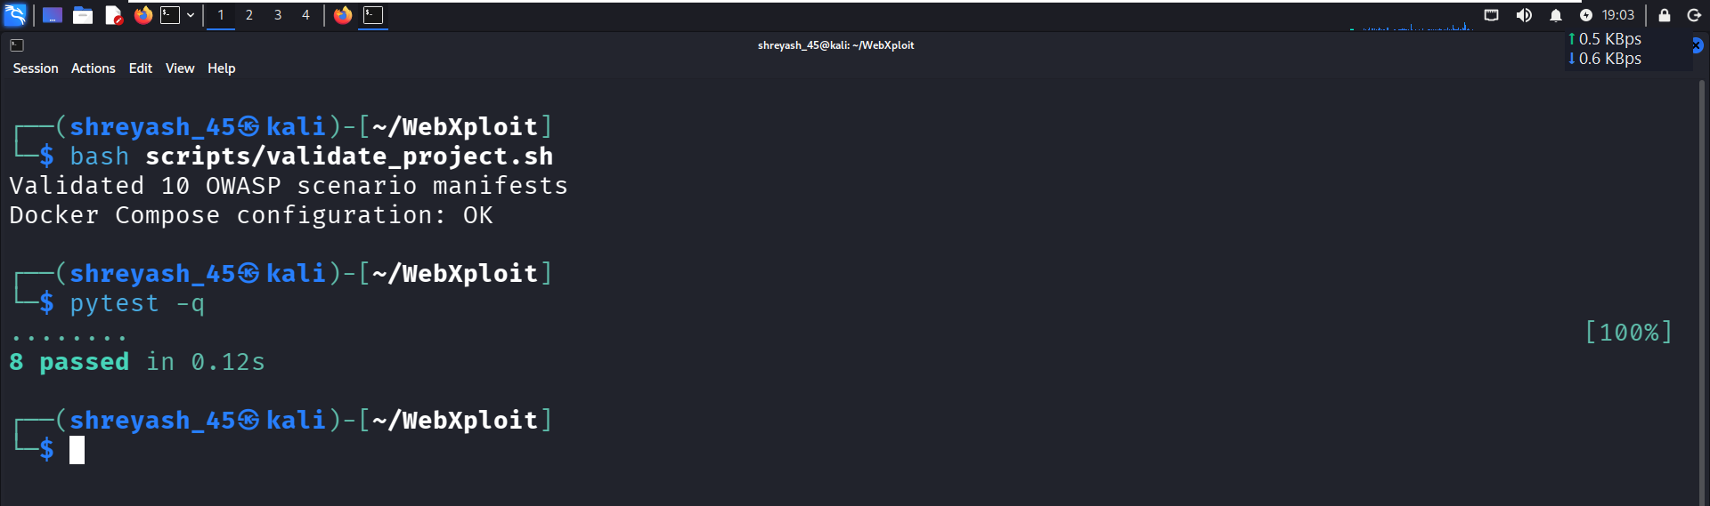
Figure 1. Project validation
This screenshot provides a high-level visual record of project validation. It supports the existence of a validation step but does not, by itself, prove every scenario or every automated test passed.
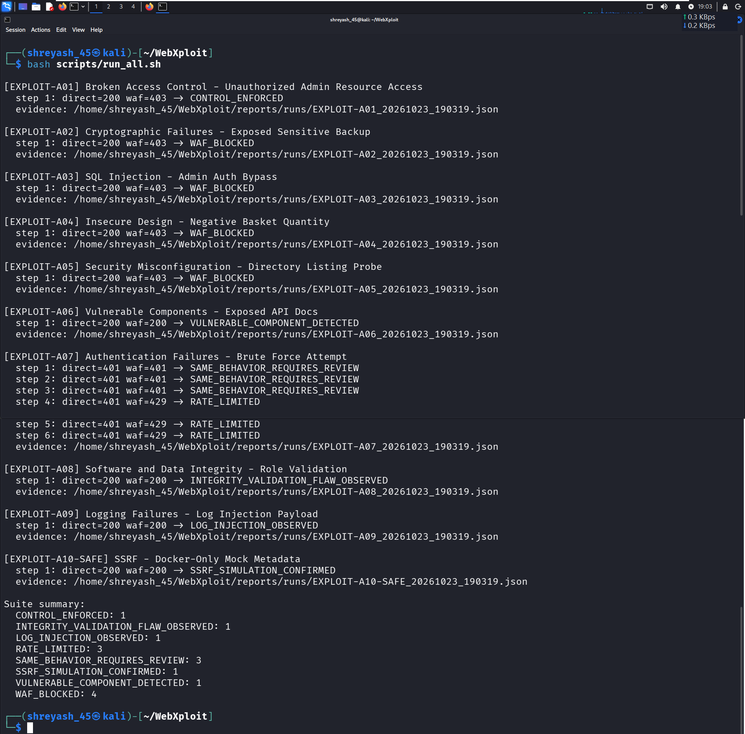
Figure 2. OWASP scenario execution
This image shows the scenario execution view supplied in the evidence archive. Use it as execution evidence; scenario-specific conclusions are documented separately in Part II.
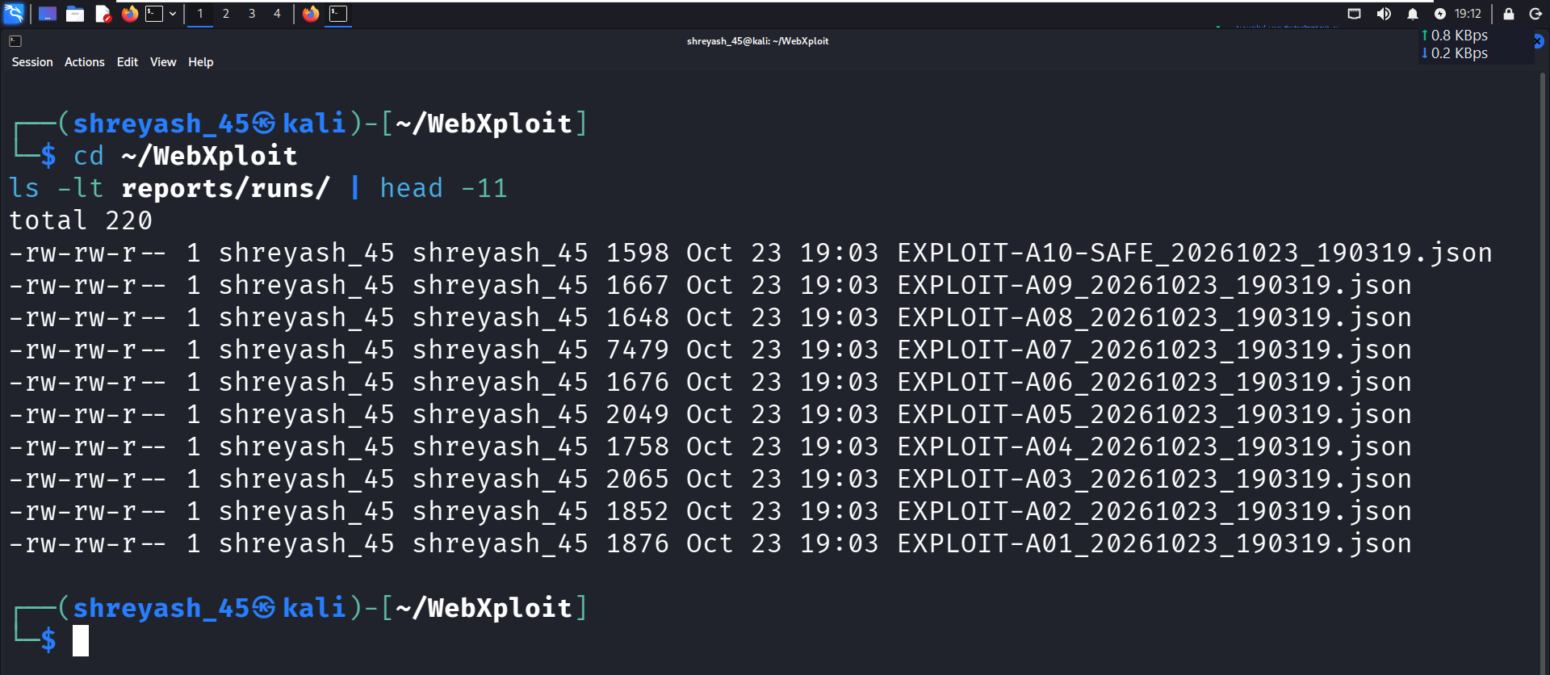
Figure 3. Generated JSON evidence
This screenshot illustrates structured evidence output. The underlying JSON files were not individually re-executed as part of this document preparation, so the image is treated as evidence of the displayed output only.

PART II — WEB APPLICATION VAPT ASSESSMENT

10. Assessment Methodology
The assessment uses scenario-driven testing. For each category, the evidence is interpreted in context: direct endpoint behaviour shows what the controlled target returned; WAF-path behaviour shows what happened for the tested request through the configured proxy/WAF route. HTTP 403 means the tested request was denied at that route; it does not automatically prove that all variants of the vulnerability are prevented.
Phase | Activity
Scenario definition | Review the YAML manifest and expected behaviour.
Execution | Send controlled requests to the local demo target and WAF path as applicable.
Observation | Record status code, visible response, routing behaviour and relevant headers.
Evidence | Use screenshots and the source report's JSON-evidence summary.
Evaluation | Classify only what the evidence supports; note uncertainty.
Remediation | Recommend controls and verify them with a repeatable retest.

11. Assessment Environment and Limitations
- Environment: local Docker-based lab, demo services and Juice Shop.
- WAF: common ModSecurity / OWASP CRS layer with project-specific rules.
- Assessment dates: original safe-run 03 October 2026; selected manual retests described in later notes up to 24 October 2026.
- Evidence limitation: this document uses the supplied ZIP and prior PDFs; it does not claim to have re-run the complete scenario suite during document generation.
- A screenshot proves only what is visible in that capture. It may not reveal all headers, backend state or alternative request paths.
- Risk ratings are not presented as formal CVSS scores because no complete CVSS scoring exercise was supplied.

12. Findings Summary
ID | Scenario area (project label) | Observed evidence | Interpretation / caveat
A01 | Broken Access Control | Direct admin-users endpoint returned demo user data; WAF screenshot shows a blocked response. | WAF-path block is observed for the tested request. This alone does not prove all authorization checks are correct.
A02 | Cryptographic Failures / exposed backup file | Direct backup configuration file displayed demo configuration with redacted placeholders; WAF path returned 403. | The tested backup-file route was denied through the WAF; verify sensitive files are not deployed and are not directly accessible.
A03 | Injection / SQL injection demonstration | Screenshots show a direct SQLi-style login attempt/result and a WAF 403 capture. | The observed result followed the test attempt, but the screenshots alone do not conclusively establish the exact database-level cause or a general SQL injection bypass.
A04 | Insecure Design / negative quantity | Direct validation endpoint returned HTTP 200 with accepted=true, persisted=false and a non-persistent simulation note; WAF request returned 403. | The demo accepts the input in a non-persistent simulation. Business impact in a real application was not established.
A05 | Security Misconfiguration / exposed FTP listing | Direct /ftp view displayed a file listing including backup-like files; WAF path returned 403. | The tested route was blocked through the WAF. Confirm that backup files and directory listings are disabled or removed at the origin.
A06 | Vulnerable and Outdated Components | Direct component-report endpoint displayed demo component/version/advisory information. WAF URL loaded the main application instead of displaying that report. | This is a routing/access observation. It does not prove an explicit deny rule or complete access control; confirm route mapping and authorization separately.
A07 | Identification and Authentication Failures | Six direct demo login POST attempts returned 401 invalid credentials; browser evidence shows 429 after repeated login attempts through the WAF path. | Rate limiting was observed for the tested browser path. Validate thresholds, account lockout, credential-stuffing protection and bypass paths separately.
A08 | Software and Data Integrity Failures | Direct POST to /users/validate with role=admin returned HTTP 200 and explicitly said persisted=false; manual WAF retest returned 403. | The WAF denied the tested endpoint request. The direct response is a non-persistent integrity-validation simulation, not proof of a real privilege change.
A09 | Security Logging and Monitoring Failures | Manual encoded CRLF/log-injection request to /search returned HTTP 403 after a dedicated Nginx condition was added; supplied browser screenshot is the evidence item. | The tested payload was blocked. This does not prove all log-injection payloads are blocked or that monitoring/alerting works end-to-end.
A10 | Server-Side Request Forgery (SSRF) | Direct local fetch to mock-metadata returned fake lab metadata; manual WAF retest returned HTTP 403 after a hostname-specific rule was added. | This is a local SSRF simulation. No real cloud metadata service was accessed; the tested mock-metadata hostname request was blocked.

13. Detailed Scenario Evidence

A01 — Broken Access Control
Objective: observe whether a demonstration administrative endpoint exposes user data and whether the tested WAF path denies the request.
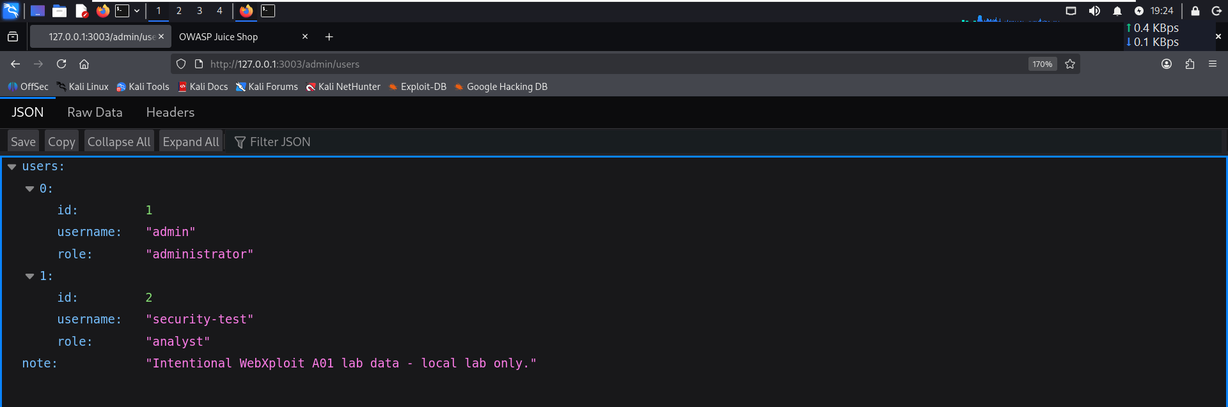
Figure 4. A01 direct endpoint
The direct endpoint returns demonstration user information. This establishes that the controlled target exposes the displayed data when accessed directly in this lab.

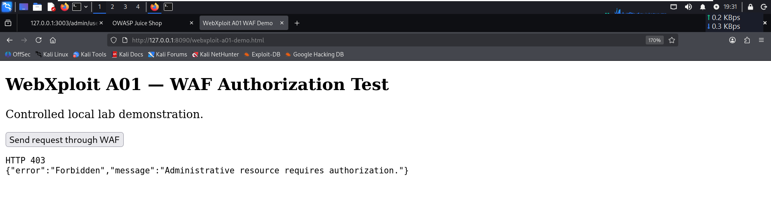
Figure 5. A01 WAF-path response
The screenshot records the blocked WAF-path response for the tested request. It is evidence of that route's behaviour, not a full authorization review.
Recommended action: enforce authorization in the application for every administrative endpoint, deny by default, and test both direct-origin and proxied access. Do not rely on a WAF as the only access-control layer.

A02 — Cryptographic Failures / Backup File Exposure
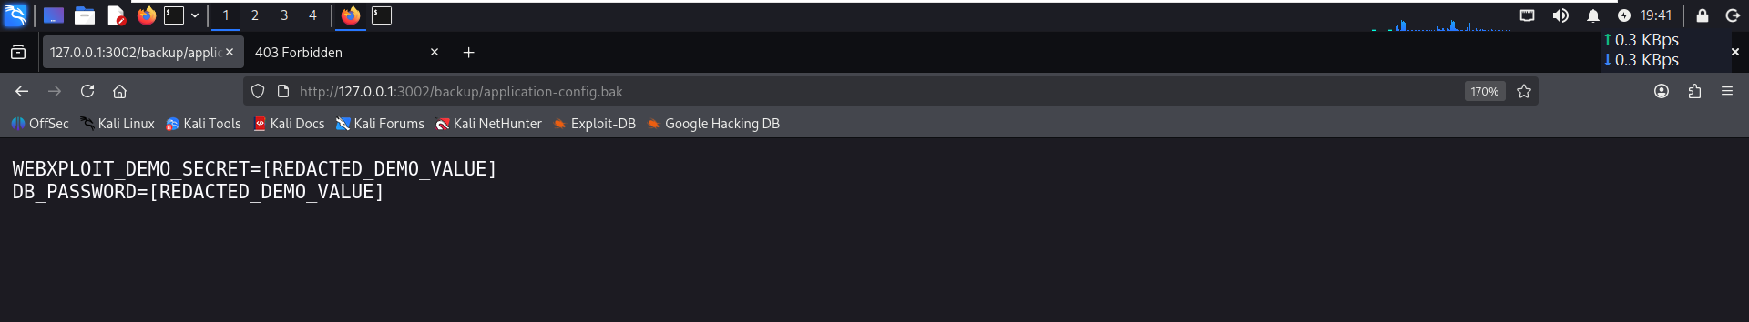
Figure 6. A02 direct backup-file response
The direct request displays a demo backup configuration. Sensitive values are represented with redacted placeholders in the supplied evidence.
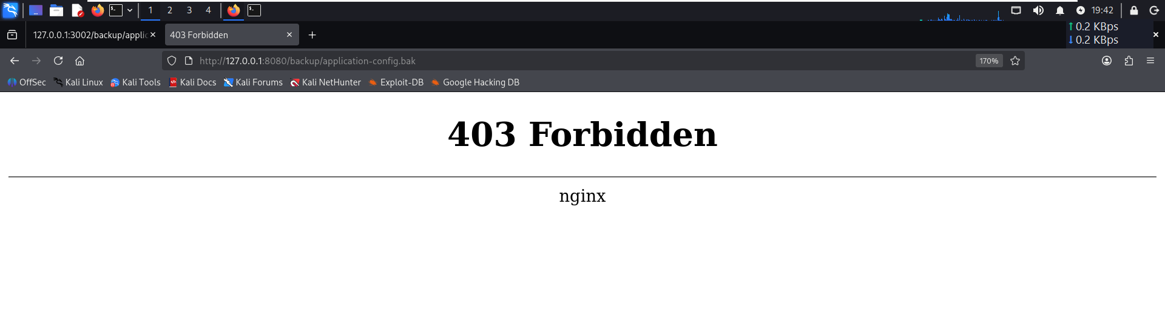
Figure 7. A02 WAF-path response
The WAF-path screenshot shows a 403 denial for the tested backup-file URL.
Recommended action: remove backup/configuration files from web roots, prevent directory listing, restrict deployment artifacts, and keep secrets outside static files. WAF rules are a secondary control.

A03 — Injection / SQL Injection Demonstration
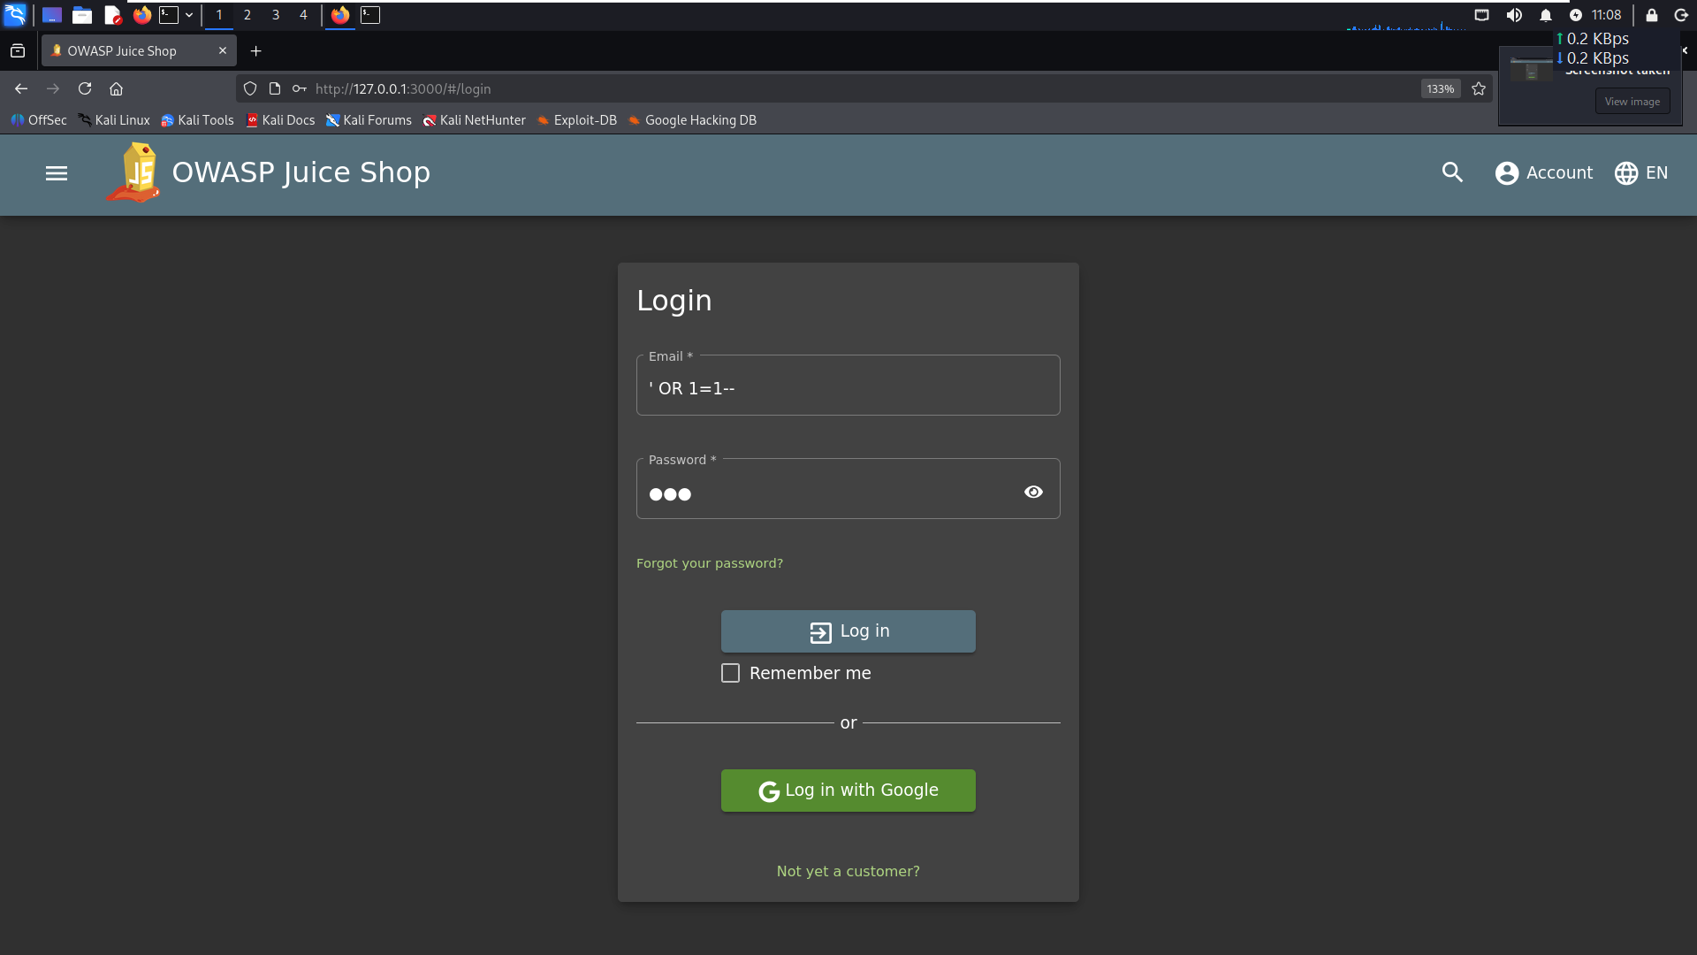
Figure 8. A03 direct SQLi-style attempt
This screenshot records the direct login test input/request. It is a test attempt, not proof of exploitability by itself.

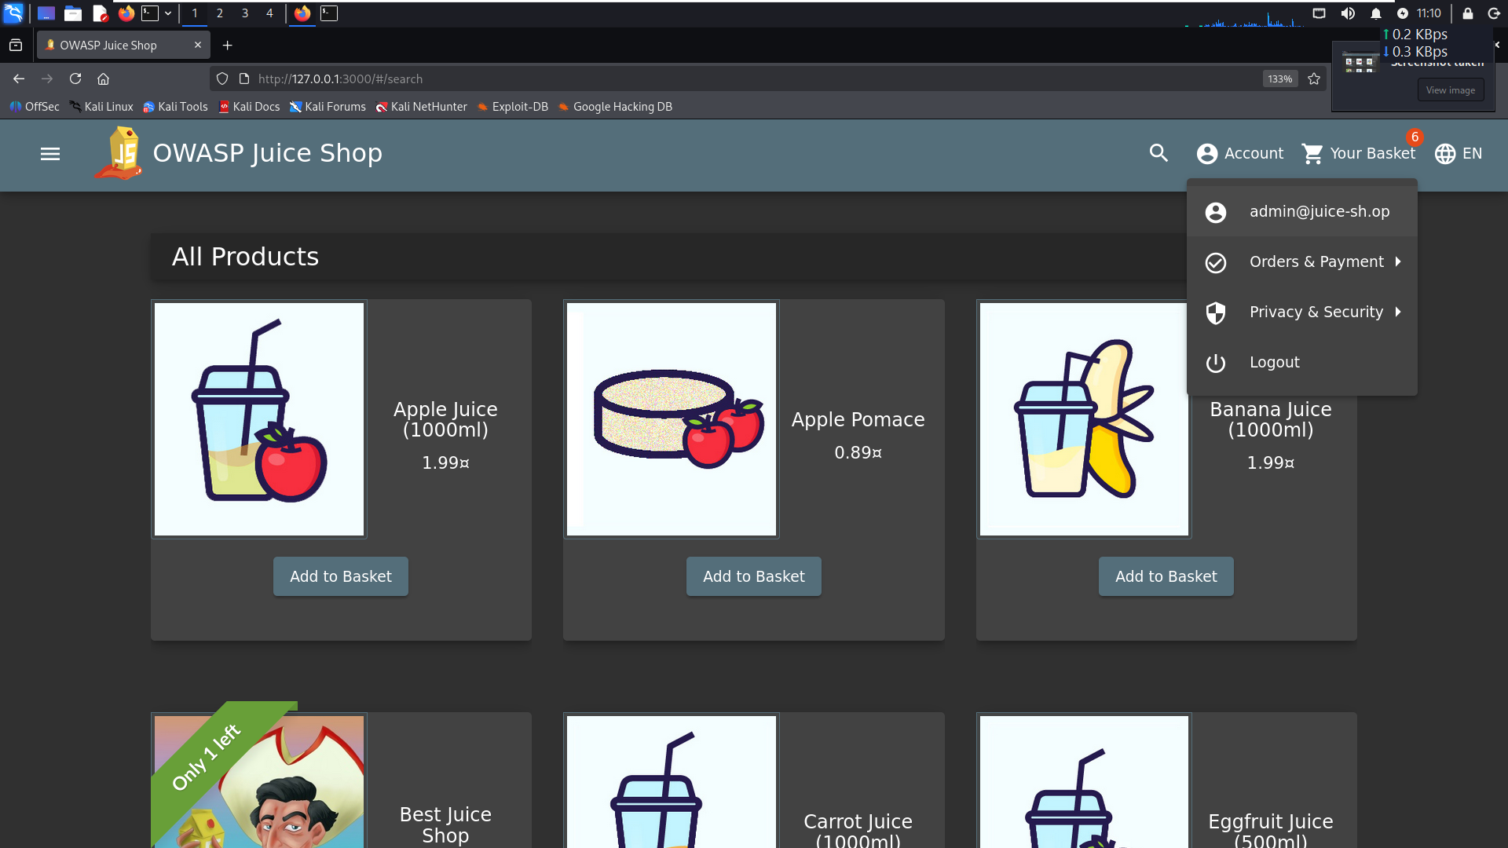
Figure 9. A03 observed browser result
The screenshot records the browser state observed after the test. Interpret it as an observed result; the image alone does not prove the internal SQL query or database effect.

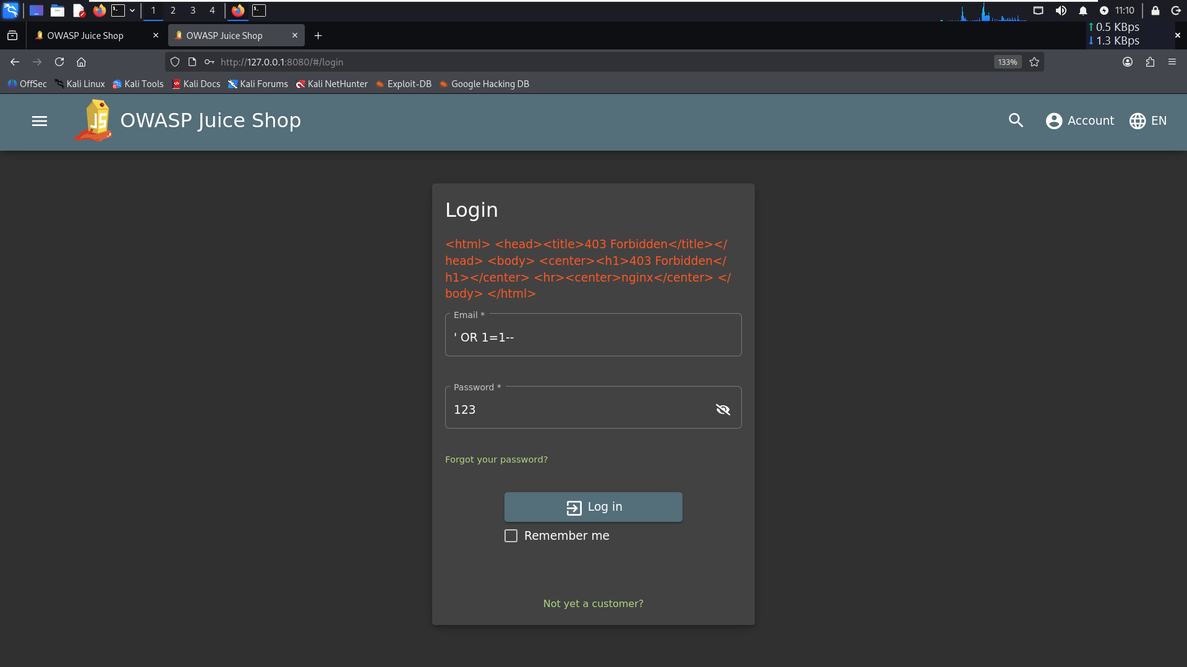
Figure 10. A03 WAF-path denial
The WAF-path screenshot shows HTTP 403 for the tested SQLi-style request.
Recommended action: use parameterized queries, avoid building SQL with string concatenation, apply least-privilege database accounts, and add server-side validation. Retest with multiple safe payloads and inspect application logs to establish the precise cause.

A04 — Insecure Design / Negative Quantity
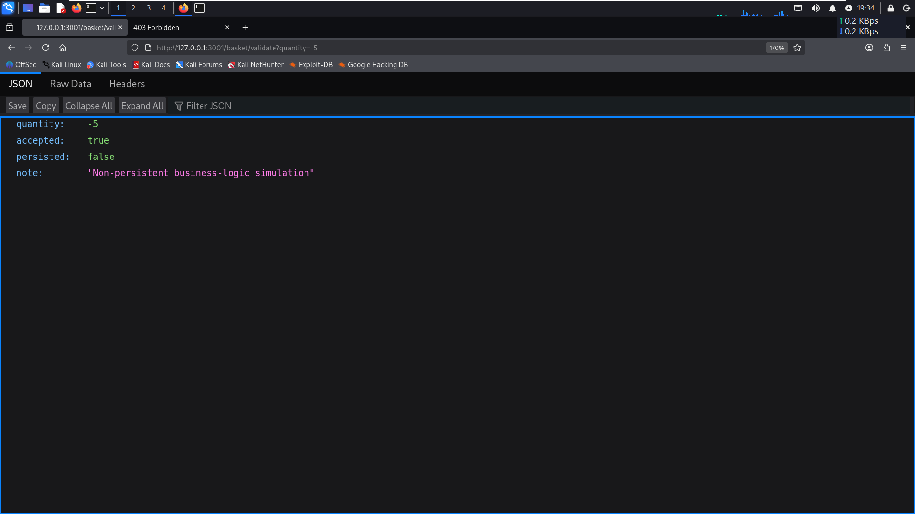
Figure 11. A04 direct negative-quantity simulation
The endpoint returned accepted=true but also stated persisted=false and identified the response as a non-persistent simulation. No real order, basket or financial state change is established by this evidence.

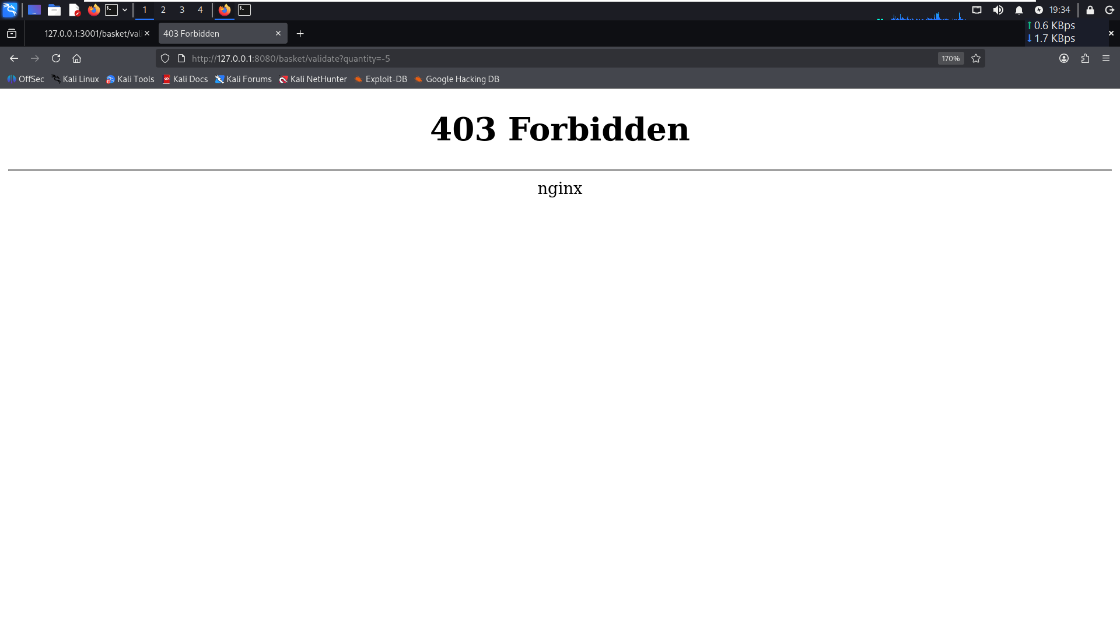
Figure 12. A04 WAF-path denial
The screenshot shows the tested negative-quantity request was denied through the WAF.
Recommended action: validate quantity and business rules on the server, reject negative or out-of-range values, and test business logic independently of WAF filtering.

A05 — Security Misconfiguration / FTP Listing
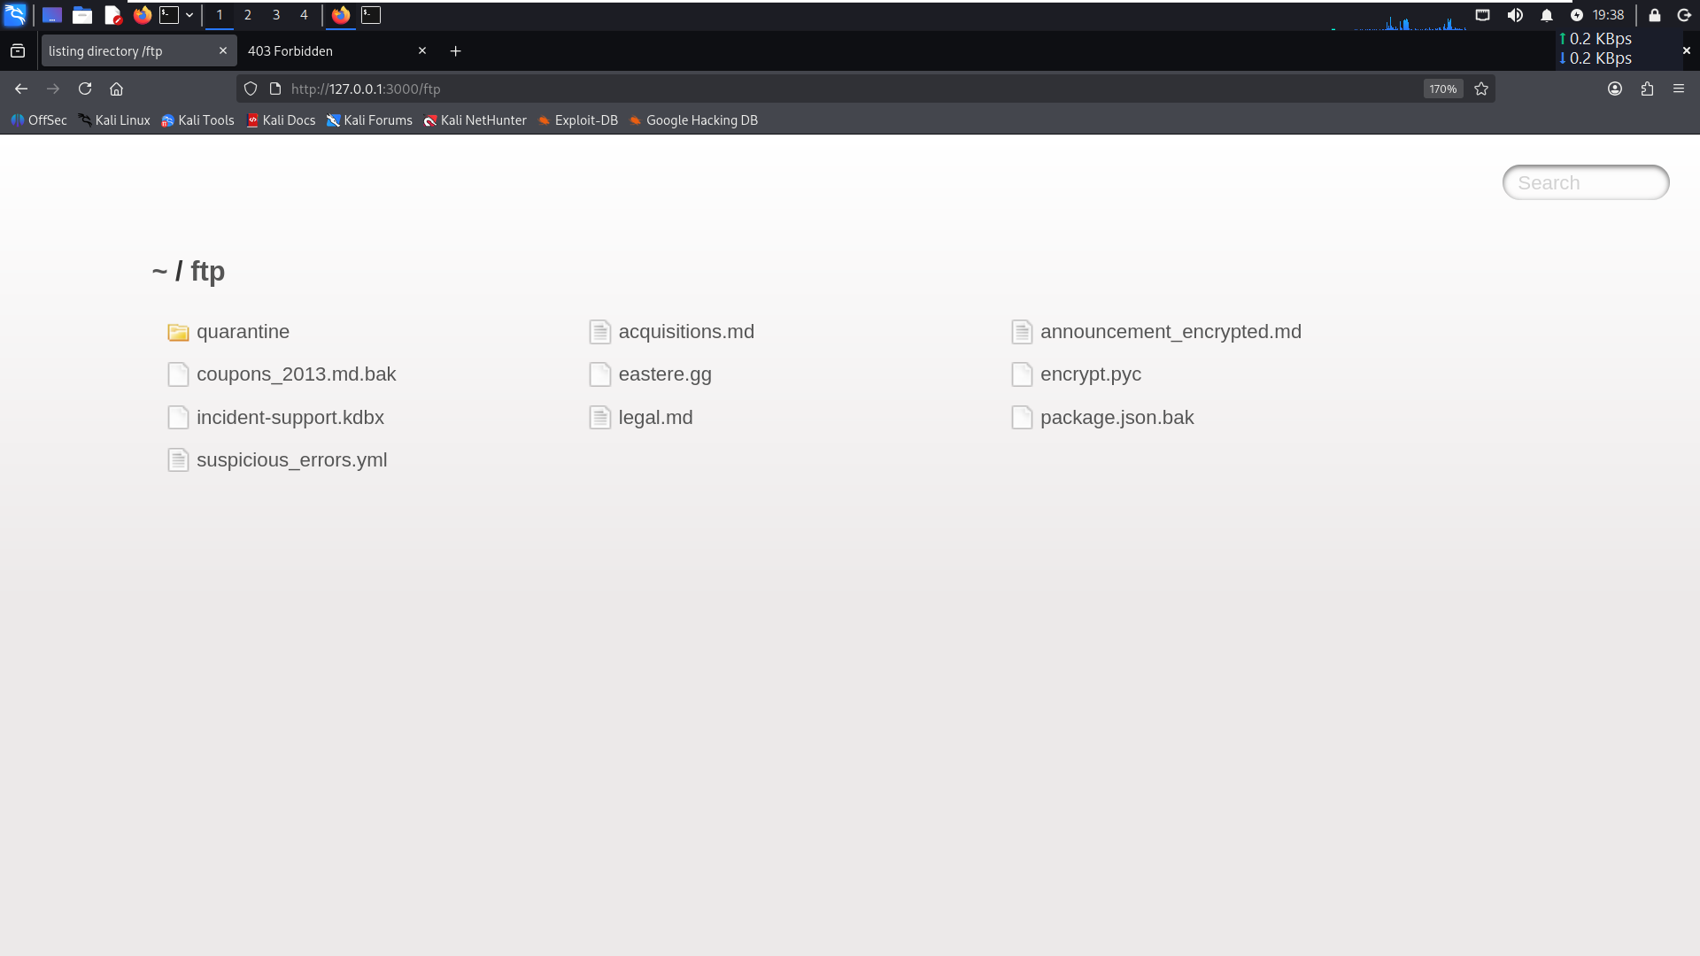
Figure 13. A05 direct file listing
The direct /ftp view displays a demo file listing, including backup-like files. The screenshot supports the observed exposure in the controlled target.

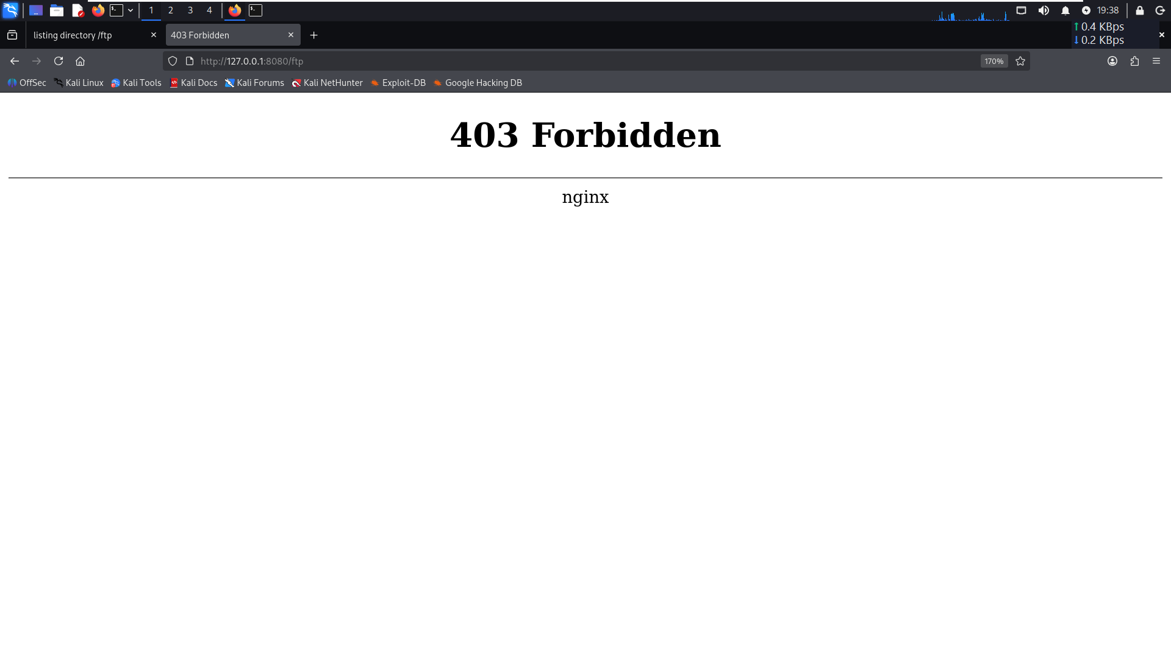
Figure 14. A05 WAF-path denial
The WAF-path response shows the tested /ftp request was blocked.
Recommended action: disable directory listing, remove unused files, restrict access at the origin, and ensure deployment pipelines exclude backups and debug artifacts.

A06 — Vulnerable and Outdated Components
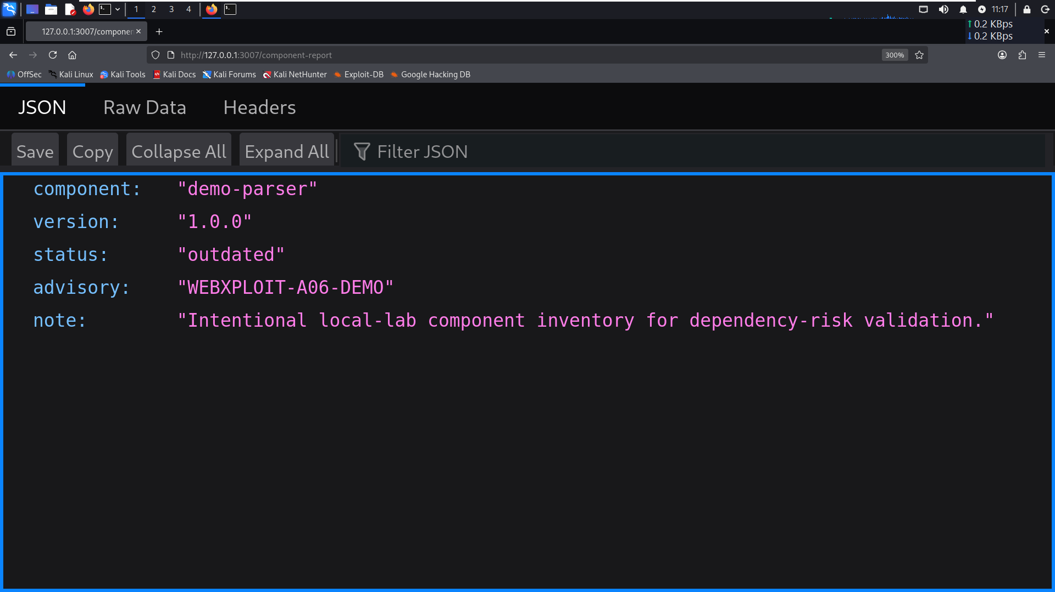
Figure 15. A06 direct component report
The direct endpoint displays demo component name, version, status and a lab advisory identifier.

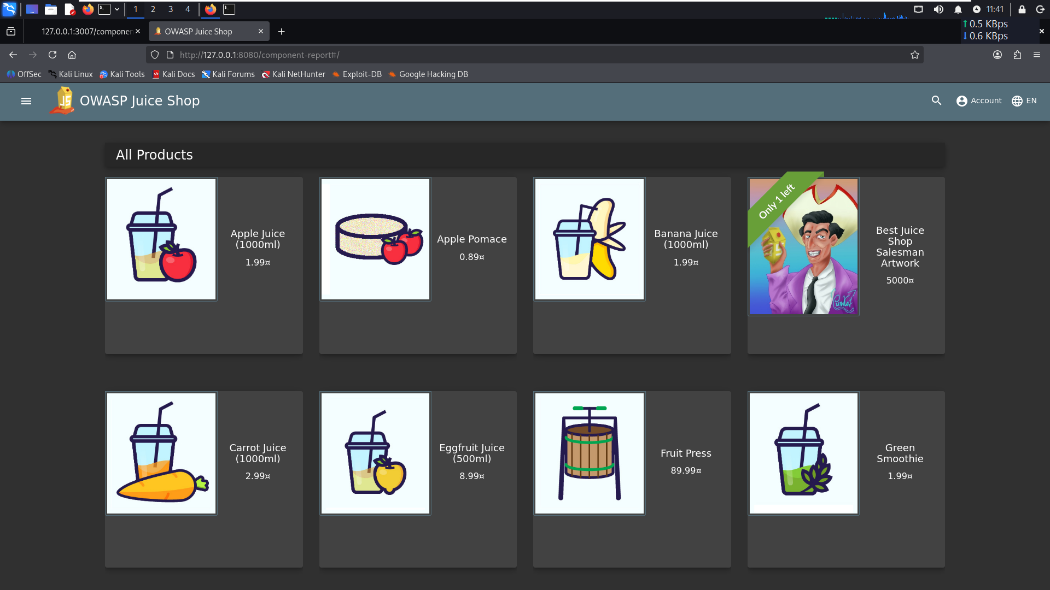
Figure 16. A06 WAF URL result
The supplied screenshot shows the main application loading at the WAF URL instead of the component-report data. This is consistent with the reported routing behaviour. It does not independently demonstrate an explicit 403 deny or authentication requirement.
Recommended action: verify the proxy route and host/path mapping, restrict inventory endpoints to authorized users if they are not intended to be public, and maintain an accurate software inventory with a patching process.

A07 — Identification and Authentication Failures
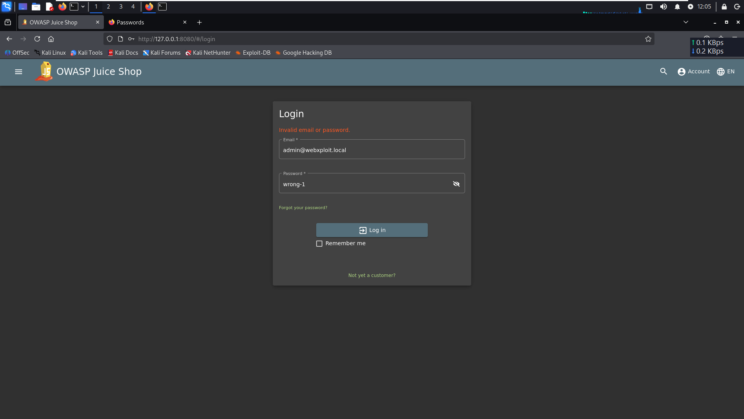
Figure 17. A07 login attempt evidence
This screenshot shows the login page of the OWASP Juice Shop application during the authentication testing scenario. It provides visual evidence of the login interface used for testing. The screenshot alone does not establish the number of login attempts or the HTTP response codes returned by the server.

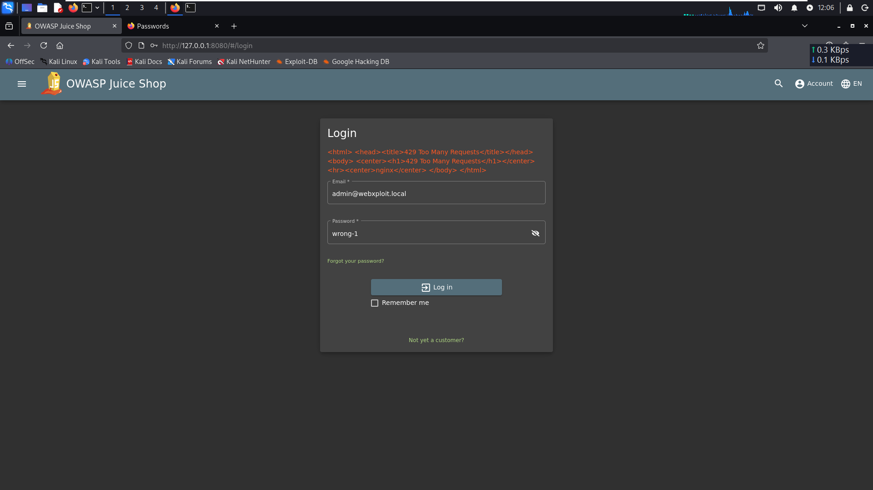
Figure 18. A07 WAF-path rate limiting
The browser screenshot shows HTTP 429 Too Many Requests after repeated login attempts through the WAF path. This supports rate limiting for the tested route and sequence.
Recommended action: use adaptive rate limits, MFA where appropriate, breached-password screening, safe authentication error messages, monitoring and testing for rate-limit bypasses. A 429 screenshot alone does not establish the effectiveness of the full authentication design.

A08 — Software and Data Integrity Failures
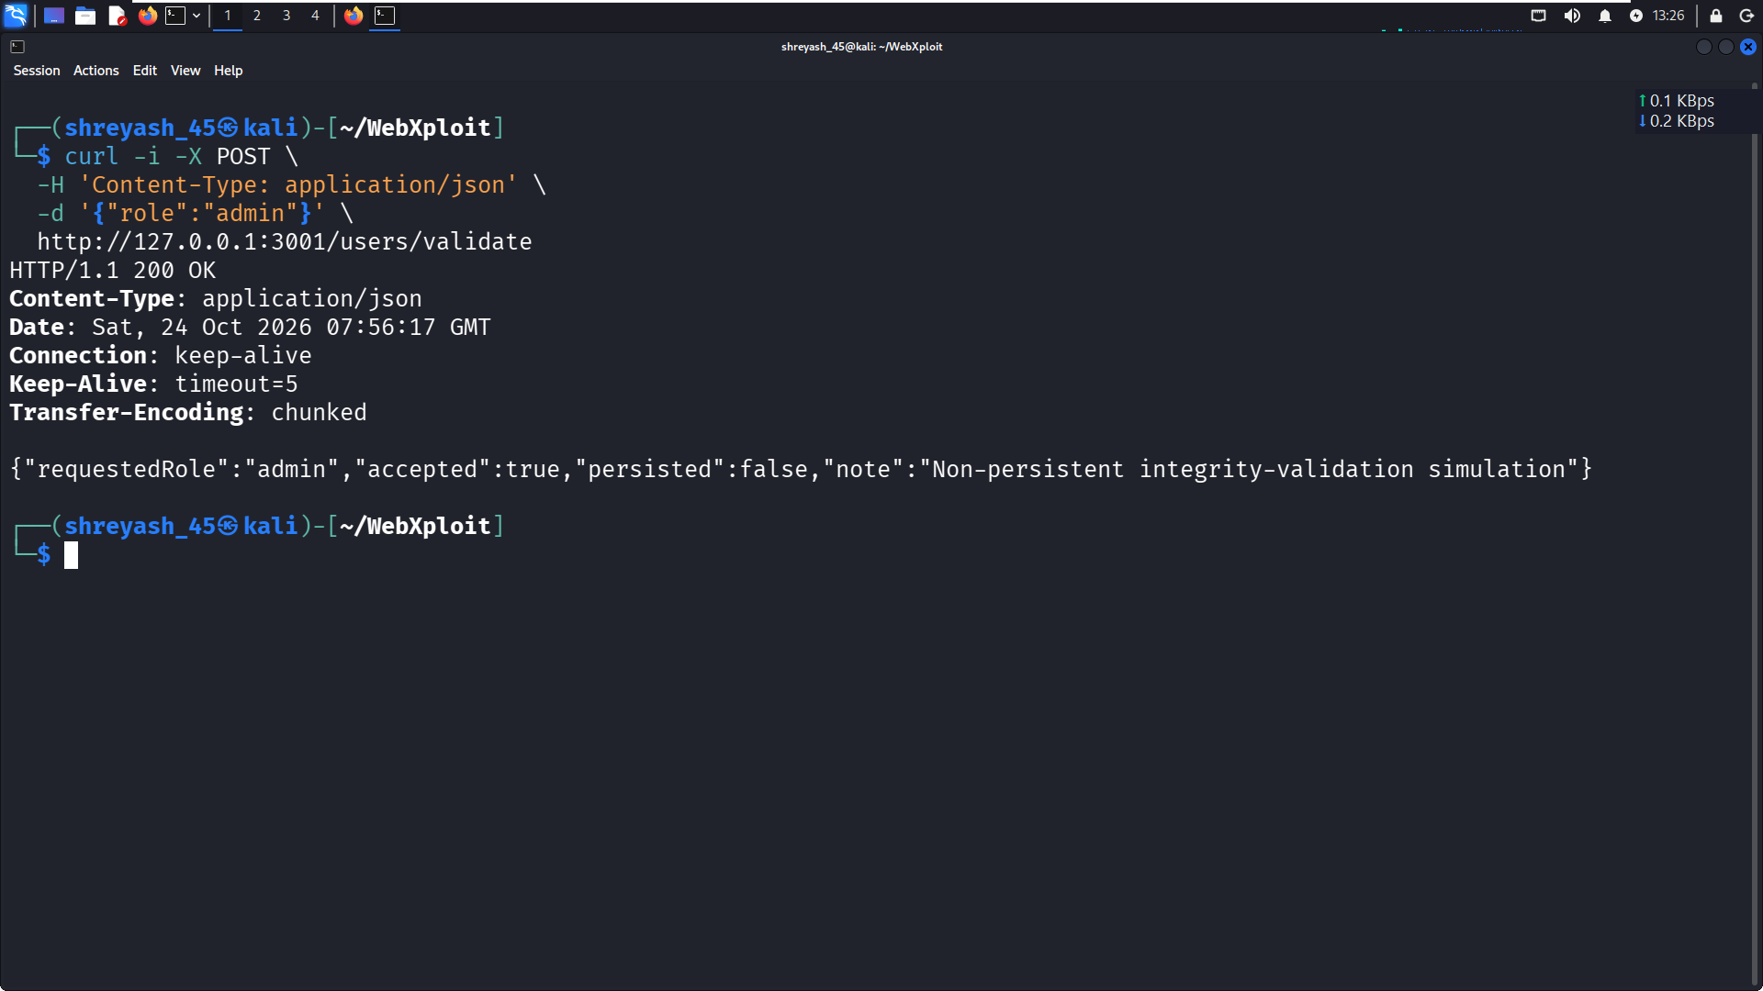
Figure 19. A08 direct integrity-validation simulation
The direct response is HTTP 200 and includes accepted=true, persisted=false and a note that the simulation is non-persistent. This is not evidence that a role change was stored.

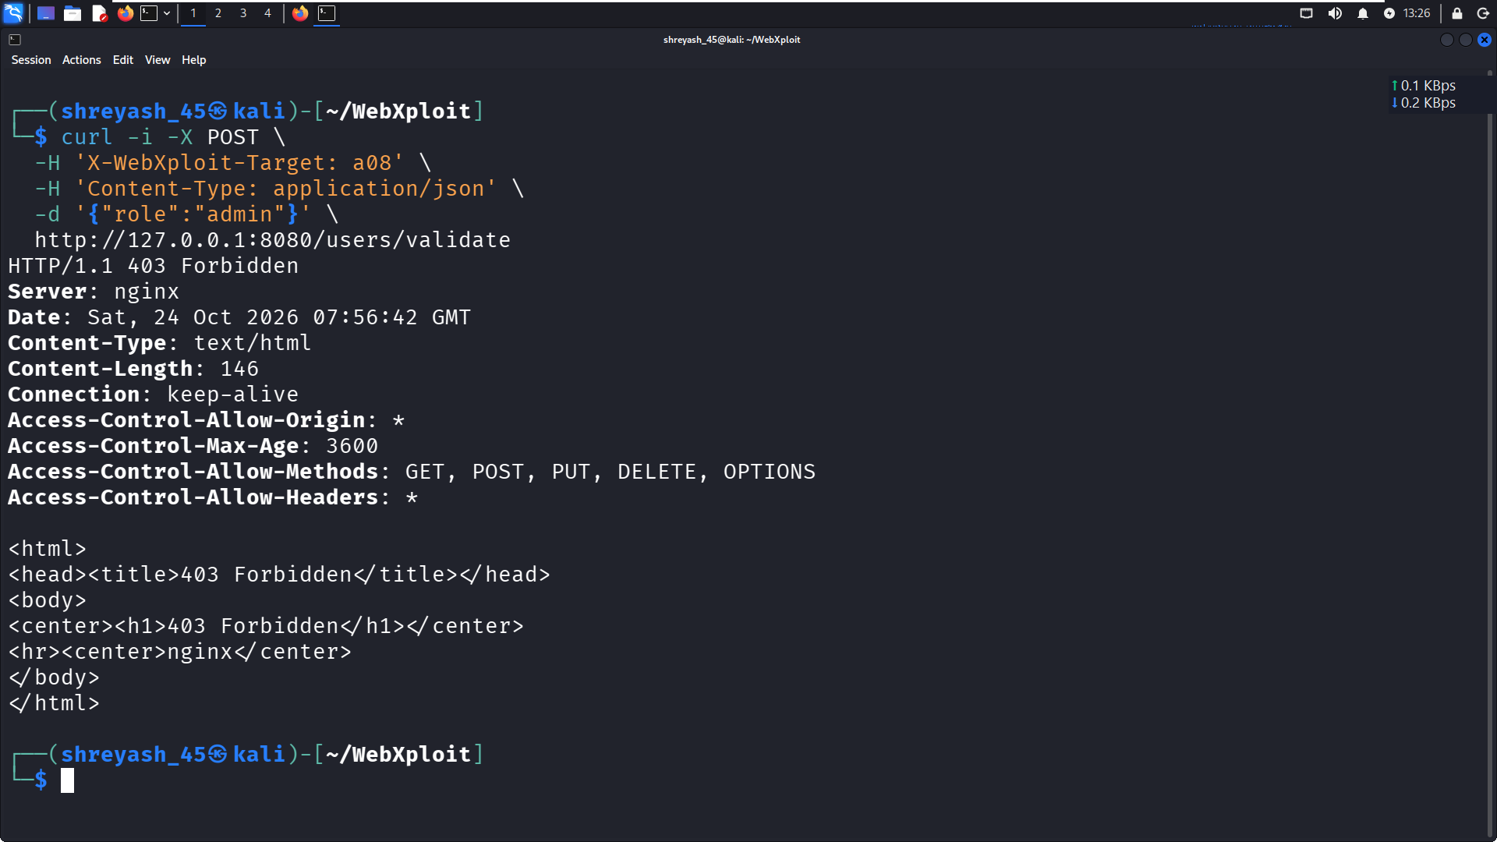
Figure 20. A08 WAF-path denial
The manual retest through the WAF returned HTTP 403 for the tested POST request to /users/validate with the role=admin body.
Retest interpretation: the configured rule denied this tested endpoint request. It is an endpoint-level block and does not prove that every data-integrity attack is prevented.
Recommended action: enforce authorization and integrity checks in the application, validate privileged fields server-side, sign/verify trusted update mechanisms where appropriate, and add tests proving unauthorized changes are rejected and not persisted.

A09 — Security Logging and Monitoring Failures
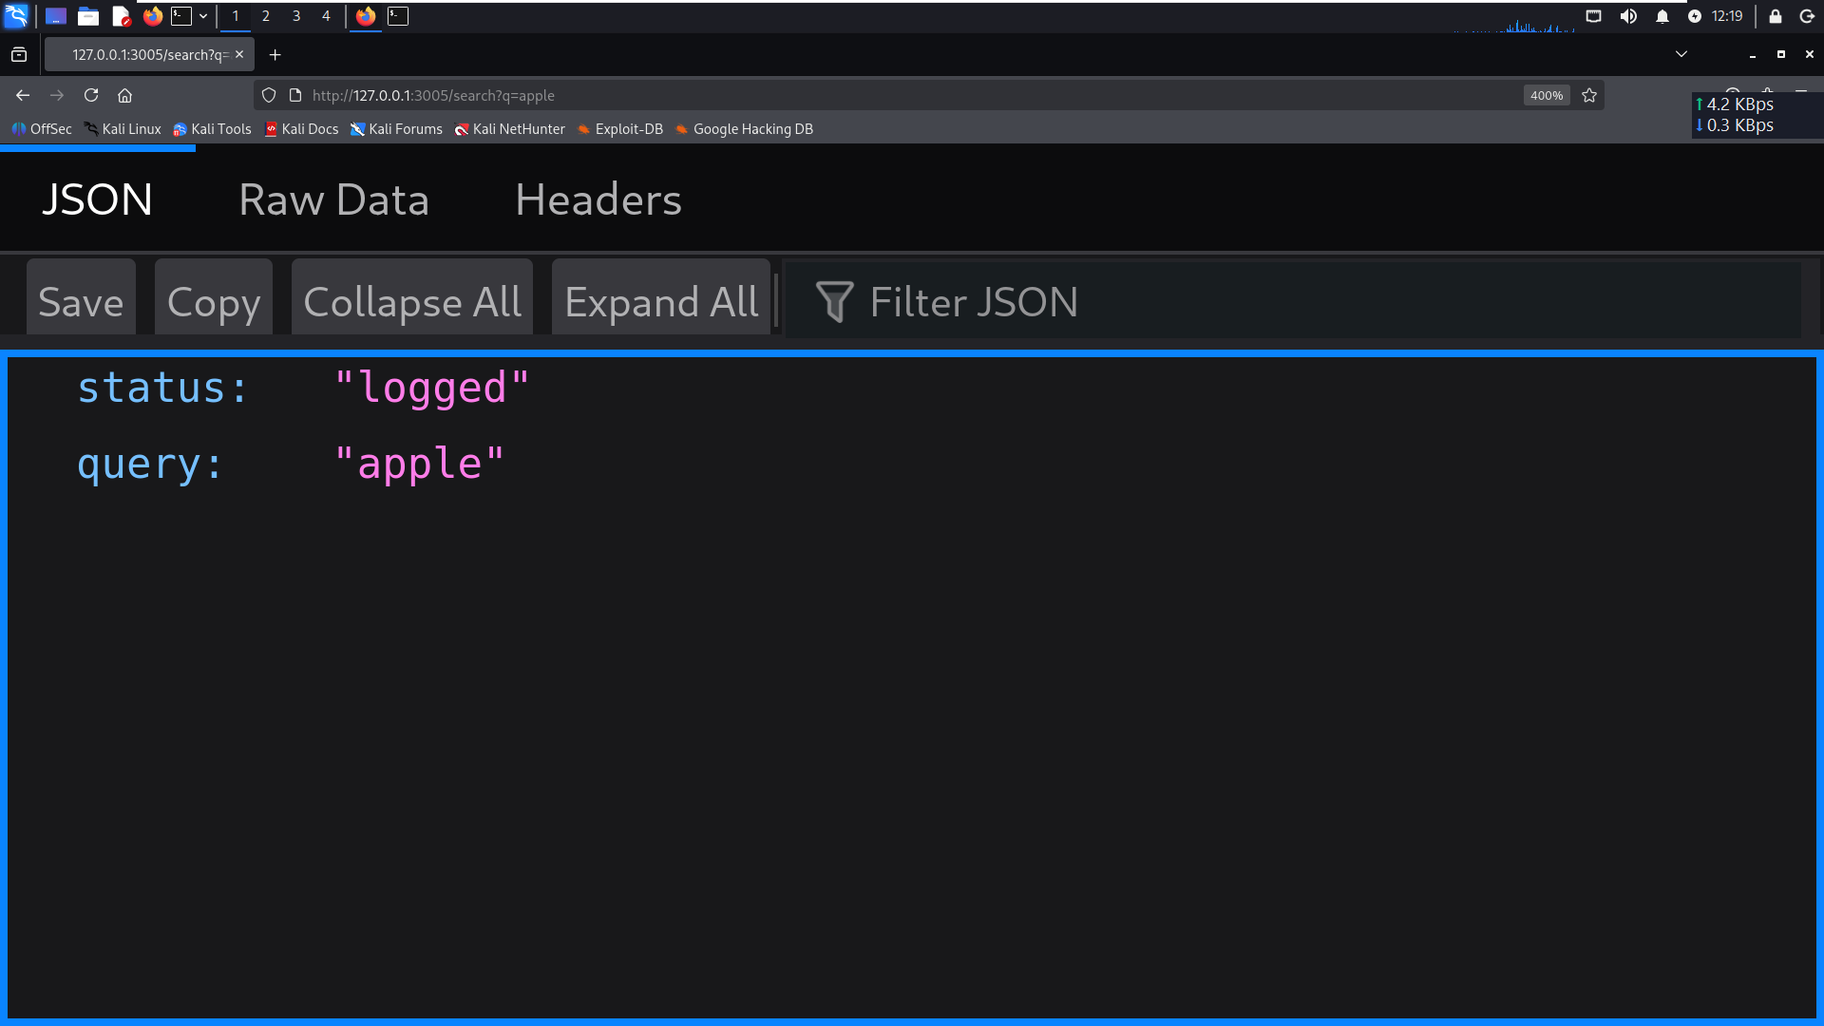
Figure 21. A09 direct logging demonstration
The supplied direct screenshot records the controlled logging-related request/response demonstration.

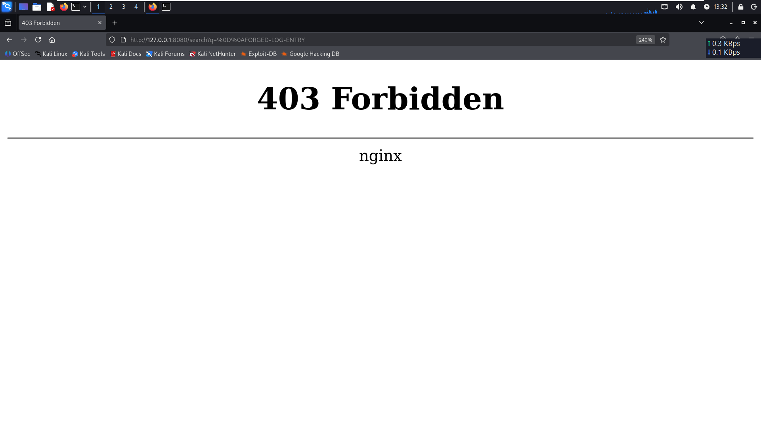
Figure 22. A09 encoded CRLF request through the WAF
The screenshot is the browser evidence supplied for the WAF-path test. The later manual test details report that the encoded CRLF payload to /search returned HTTP 403 after a dedicated Nginx route condition was added. The 403 proves this payload was denied; it does not establish comprehensive log-injection protection.
Recommended action: normalize and validate log fields, encode untrusted data before logging, prevent CR/LF injection, protect log integrity, centralize logs and test whether alerts fire. Verify the actual browser capture and application/WAF logs before claiming alerting is operational.

A10 — Server-Side Request Forgery (SSRF)
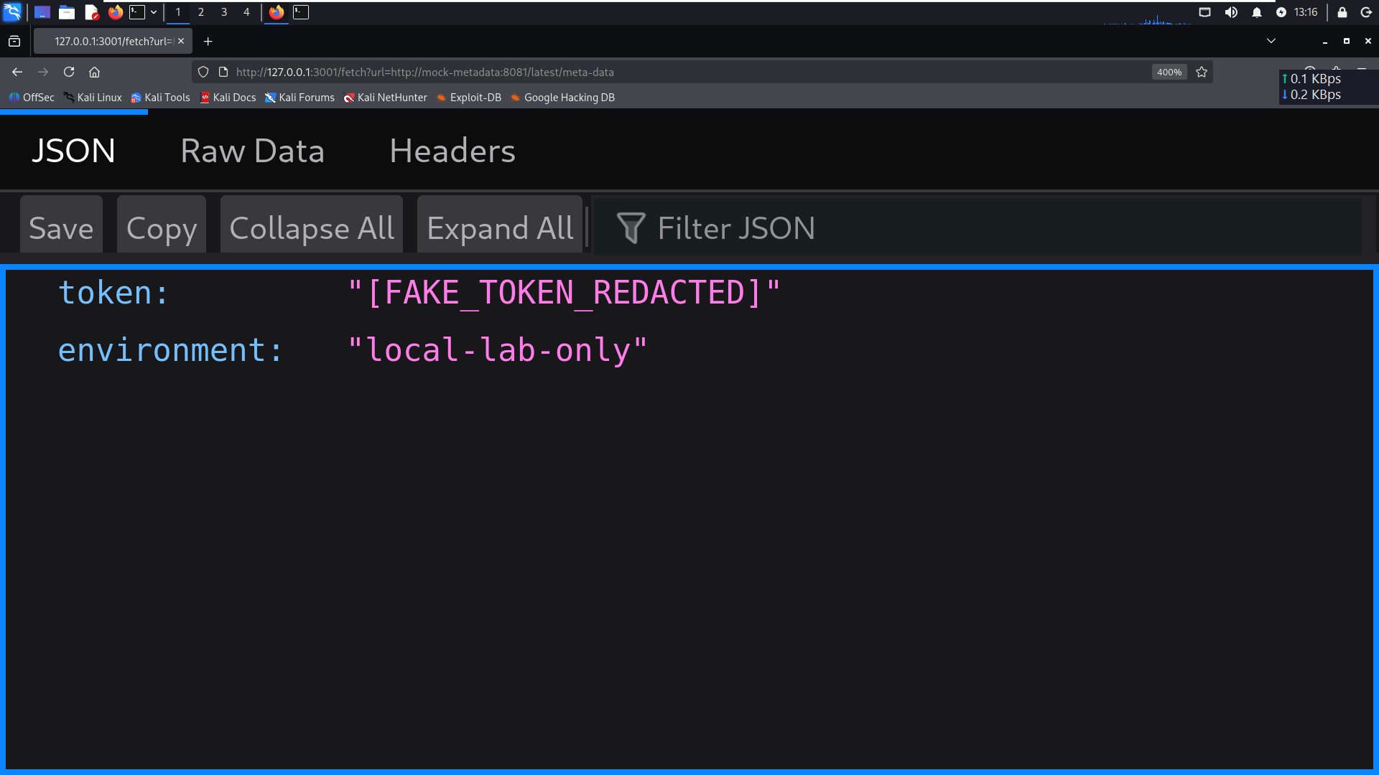
Figure 23. A10 direct local SSRF simulation
The direct local fetch response displays fake, redacted metadata from the lab's mock-metadata service. This is intentionally simulated data; it is not a real cloud credential or token.

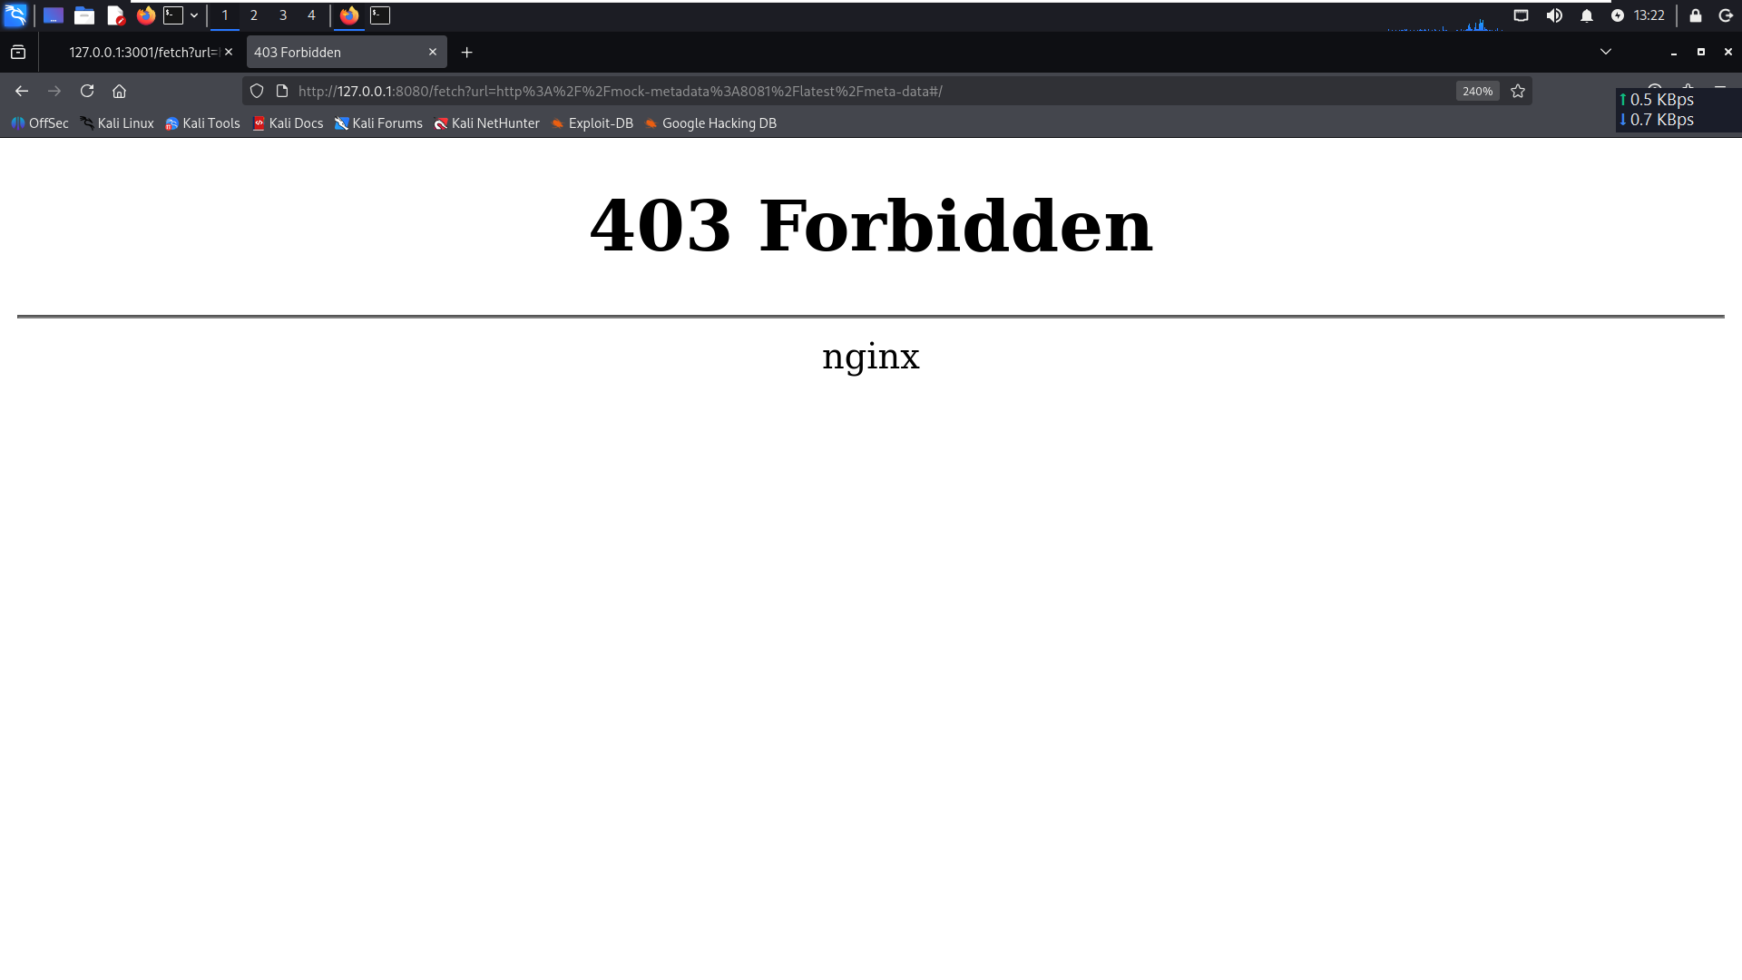
Figure 24. A10 WAF-path denial
The supplied screenshot records the WAF block for the tested mock-metadata request. The later manual retest notes report HTTP 403 after a hostname-specific rule was added.
Recommended action: enforce server-side destination allowlists, block private/link-local and metadata ranges where appropriate, validate redirects and DNS resolution, restrict outbound network access, and test equivalent hostname/IP/encoding variations. A hostname-specific rule is useful but is not a complete SSRF defence.

14. Remediation Plan
Priority | Action | Validation evidence to collect
P1 | Implement authorization and server-side validation at the application layer for A01/A04/A08. | Positive and negative tests, authorization matrix, state/persistence checks.
P1 | Remove or restrict exposed backup files and directory listings for A02/A05. | Origin-level checks confirming files are absent or access-controlled.
P1 | Harden SSRF protections for A10 using destination allowlists and egress controls. | Retests using approved variations; prove no request reaches disallowed destinations.
P2 | Use parameterized queries and add regression tests for A03. | Application-level tests plus logs demonstrating safe query handling.
P2 | Review route mapping and component inventory exposure for A06. | Direct-origin and WAF-path tests; verify intended response and access policy.
P2 | Test authentication rate limits and monitoring for A07/A09. | Repeatable threshold tests, logs, alert delivery and bypass checks.
P2 | Expand automated regression tests for the A08–A10 manual rule changes. | Run the full suite and retain dated JSON outputs plus screenshots.

15. Conclusion
WebXploit demonstrates a structured way to execute selected web-security scenarios and compare application behaviour with WAF behaviour in an isolated lab. The evidence supports several specific route-level blocks and controlled vulnerability simulations. It also reveals why result wording matters: an endpoint returning the main application is not the same as an explicit access-denied response, a simulated response is not a persistent business impact, and blocking one payload is not proof of comprehensive protection.
The next engineering step is to keep automated JSON evidence, configuration versions and screenshot evidence synchronized, run the full A01–A10 regression suite after WAF changes, and verify application-level controls independently of the WAF.

Appendix A — Evidence Inventory
Evidence item | Supplied filename
Project validation | 01_Project_Validation.png
Scenario execution | 02_OWASP_Scenario_Execution.png
Generated evidence | 03_Generated_JSON_Evidence.png
A01 Direct Application | A01_Direct_Application.png
A01 WAF Blocked | A01_WAF_Blocked.png
A02 Direct Backup File | A02_Direct_Backup_File.png
A02 WAF Blocked | A02_WAF_Blocked.png
A03 SQLi Direct Attempt | A03_SQLi_Direct_Attempt.png
A03 SQLi WAF 403 | A03_SQLi_WAF_403.png
A03 SQLi result | A03_SQLi_result.png
A04 Direct Negative Quantity | A04_Direct_Negative_Quantity.png
A04 WAF Blocked | A04_WAF_Blocked.png
A05 Direct FTP Listing | A05_Direct_FTP_Listing.png
A05 WAF Blocked | A05_WAF_Blocked.png
A06 Direct Component Report | A06_Direct_Component_Report.png
A06 WAF | A06_WAF.png
A07 WAF Login Attempt 1 | A07_WAF_Login_Attempt_1.png
A07 WAF Rate Limit 429 | A07_WAF_Rate_Limit_429.png
A08 Direct Integrity Simulation | A08_Direct_Integrity_Simulation.png
A08 WAF Blocked | A08_WAF_Blocked.png
A09 Direct Logging Demo | A09_Direct_Logging_Demo.png
A09 WAF Blocked Browser | A09_WAF_Blocked_Browser.png
A10 Direct SSRF Simulation | A10_Direct_SSRF_Simulation.png
A10 WAF Blocked | A10_WAF_Blocked.png

Appendix B — Interpretation Rules
- HTTP 403: the tested request was forbidden at the captured route; it is not proof all attack variants are blocked.
- HTTP 429: the captured route applied a rate limit to the tested request sequence; threshold coverage and bypasses need separate testing.
- HTTP 200: the endpoint returned a successful HTTP response; this does not by itself prove secure or persistent business behaviour.
- Direct endpoint vs WAF route: different results may reflect routing, WAF rules, or application logic. Confirm the actual request path and configuration before assigning cause.
- Demo or mock data: clearly identify it as simulated and do not describe it as real user data, real secrets or real cloud credentials.

Appendix C — Source Material and Provenance
Primary project sources reviewed for this combined document: WebXploit_VAPT_Assessment_Report(1).pdf; WebXploit_Project_Technical_Documentation(1).pdf; Screenshots.zip; and the later manual retest details recorded in the project conversation. The source PDFs identify the earlier safe-run date as 03 October 2026. The manual retest details are explicitly distinguished in this document where known. The GitHub project URL supplied in the source material is https://github.com/shreyash-vidhate/WebXploit.
External framework note: the report structure is consistent with common OWASP Web Security Testing Guide reporting practices: scope, methodology, executive summary, findings, impact/limitations and remediation. No external framework has been used to claim certification or compliance.

