

**DEPARTMENT OF INFORMATION TECHNOLOGY**

**G. V. ACHARYA POLYTECHNIC**

SHELU, TAL. KARJAT, DIST. RAIGAD

**Project Report**

Of

**Phone Directory**

By

Kushal Patil 04

Shreyash Karandikar 10

Suyash Chaudhari 06

Tanuja Sidankar 07

Under the guidance of

**Miss.Shital Kadam**

**DEPARTMENT OF INFORMATION TECHNOLOGY**

**G. V. ACHARYA POLYTECHNIC**

SHELU, TAL. KARJAT, DIST. RAIGAD

**CERTIFICATE**

This is to certify that Java Mini Project “TELEPHONE DIRECTORY” submitted by,

Kushal Patil 04

Shreyash Karandikar 10

Suyash Chaudhari 06

Tanuja Sidankar 07

Mini Project work is completed by this group during the study of Java Programming (5th Sem )and the report embodies the result of work. It is therefore recommended and forwarded for submission

___________________________

___________________________

**(Signature and Name of Guide.)**

Department of Information Technology in G.V.Acharya Polytechnic.

**CONTENTS**

* Title
* Project Introduction
* Algorithm / Stepwise Procedure
* Flow Chart
* Source code
* Output
* Applications
* Future Scope
* References

**TELEPHONE DIRECTORY**

**PROJECT INTRODUCTION**

In this project the main aim is to manage contacts. This project include all features available in basic Telephone Directory like add-remove contacts, Search contacts, Edit contacts etc.

This java project includes a class with first_name, Last_name and Phone_number. There are functions for operations such as searching, adding, removing, displaying etc.

**ALGORITHM / STEPWISE PROCEDURE**

1. Start
2. Enter n number of entries n is user specified.
3. Provide menu 1. Exit 2. Display 3. Add 4.Edit 5.Remove 6.Search.
4. Take input from user
5. If input is 1 then call System.exit() and stop.
6. Else if input is 2 then display all contacts and again go to 3.
7. Else if input is 3 then add new contact and go to 3.
8. Else if input is 4 then 1st Search the contact if found then go to 9 else

Go to 3.

1. Enter new details and go to 3.
2. Else if input is 5 then provide menu 1. Remove by name 2. Remove all
3. If user enters 1 then search the contact if found then go to 12 if user enters 2 then go to 13 else go to 3.
4. Remove specified contact and go to 3.
5. If user enters 2 then remove all contacts and go to 3.
6. Else if input is 6 then search by name if found then display and go to 3
7. Else go to 3.
8. Stop
9. asdf

**FLOWCHART**

1.Exit

2.Search

3.Add

4.Edit

5.Remove

6.Display

Add new contact

Remove all

Enter name for edit

Exit

Case1

Case2

Case3

Case4

Case5

Case6

All

name

Found

Not Found

Display all

Name of contact

Add n contacts

**SOURCE CODE**

import java.util.*;

import java.math.BigInteger;

import java.lang.*;

class contacts

{

Scanner sc = new Scanner(System.in);

String fname;

String lname;

BigInteger pno;

int entryno;

public void replace(contacts c[],int index,int ent)

{

for(int k=index;k<ent-1;k++)

{

this.fname = c[k+1].fname;

this.lname = c[k+1].lname;

this.pno = c[k+1].pno;

}

}

public void edit(BigInteger a,String x,String y)

{

pno = a;

fname = x;

lname = y;

}

public void addnew(int x)

{

System.out.println("------------------------------------");

System.out.println("Entry NO: "+x);

System.out.print("First Name: ");

fname = sc.next();

System.out.print("Last Name: ");

lname = sc.next();

System.out.print("Phone Number: ");

pno = sc.nextBigInteger();

entryno=x;

System.out.println("");

}

public void display()

{

System.out.println("------------------------------------");

System.out.println("Entry NO: "+entryno);

System.out.println("First Name: "+fname);

System.out.println("Last Name: "+lname);

System.out.println("Phone Number:"+pno);

System.out.println("");

}

public boolean compare(String f,String l)

{

if(f.equals(fname)&& l.equals(lname))

{

return(true);

}

else

return (false);

}

public boolean comparenum(BigInteger i)

{

System.out.println(pno+""+i);

if(pno.equals(i))

{

return (true);

}

else

{

return (false);

}

}

}

public class pdirectory

{

public static void main(String arg[])

{

int count=0;

Scanner sc = new Scanner(System.in);

System.out.println("Enter no of entries:");

int entry = sc.nextInt();

try

{

contacts[] c = new contacts[100];

for(int i=0;i<entry;i++)

{

c[i]= new contacts();

c[i].addnew(i);

}

do

{

System.out.println("------------------------------------");

System.out.println("0.Exit \n1.Search by name \n2.Search by number\n3.Edit\n4.Add\n5.Remove\n6.Display\n"); //menu..............

int ch = sc.nextInt();

switch(ch)

{

case 0:{

System.out.println("EXIT");

System.exit(0);

break;

}

case 1:{

if(entry ==0)

{

System.out.println("------------------------------------");

System.out.println("EMPTY CONCTACT LIST PLEASE ADD NEW CONTACT");

break;

}

System.out.println("SEARCH BY NAME");

System.out.println("\nEnter first name and last name to search: ");

String x=sc.next();

String y=sc.next();

for(int i=0;i<entry;i++)

{

if(c[i].compare(x,y)==true)

{

System.out.println("------------------------------------");

System.out.println("---Found---");

c[i].display();

break;

}

if(i==entry-1)

{

System.out.println("------------------------------------");

System.out.println("---NOT Found---");

break;

}

}//for

break;

}// case1

case 2:{

if(entry ==0)

{

System.out.println("------------------------------------");

System.out.println("EMPTY CONCTACT LIST PLEASE ADD NEW CONTACT");

break;

}

System.out.println("SEARCH BY NUMBER");

System.out.println("\nEnter number ");

BigInteger x=sc.nextBigInteger();

for(int i=0;i<entry;i++)

{

if(c[i].comparenum(x)==true)

{

System.out.println("------------------------------------");

System.out.println("---Found---");

c[i].display();

break;

}

if(i==entry-1)

{

System.out.println("------------------------------------");

System.out.println("---NOT Found---");

break;

}

}

break;

}//case2

case 3:{

if(entry ==0)

{

System.out.println("------------------------------------");

System.out.println("EMPTY CONCTACT LIST PLEASE ADD NEW CONTACT");

break;

}

int z;

System.out.println("EDIT........................USING\n1.NUMBER\t2.NAME");

z=sc.nextInt();

switch(z)

{

case 1:{

System.out.println("EDIT USING NUMBER");

System.out.println("\nEnter number ");

BigInteger x=sc.nextBigInteger();

for(int i=0;i<entry;i++)

{

if(c[i].comparenum(x)==true)

{

System.out.println("Enter new fname ");

String f = sc.next();

System.out.println("Enter new lname ");

String l = sc.next();

System.out.println("Enter new number:");

BigInteger o=sc.nextBigInteger();

c[i].edit(o,f,l);

System.out.println("------------------------------------");

System.out.println("--Succesfuly edited--");

break;

}

if(i==entry-1)

{

System.out.println("---NOT Found---");

break;

}

}

break;

}

case 2:{

System.out.println("EDIT USING NAME");

System.out.println("\nEnter first name and last name to search: ");

String x=sc.next();

String y=sc.next();

for(int i=0;i<entry;i++)

{

if(c[i].compare(x,y)==true)

{ System.out.println("Enter new fname ");

String f = sc.next();

System.out.println("Enter new lname ");

String l = sc.next();

System.out.println("Enter new number:");

BigInteger o=sc.nextBigInteger();

c[i].edit(o,f,l);

System.out.println("------------------------------------");

System.out.println("--Succesfuly edited--");

break;

}

if(i==entry-1)

{

System.out.println("---NOT Found---");

break;

}

}

break;

}//case 2 of inner switch

}//inner switch

break;

}//3rd case of outer switch

case 4:

{

System.out.println("ADD NEW CONTACT");

c[entry] = new contacts();

c[entry].addnew(entry);

entry++;

System.out.println("------------------------------------");

System.out.println("--Succesfuly added--");

break;

}

case 5:

{

if(entry ==0)

{

System.out.println("------------------------------------");

System.out.println("EMPTY CONCTACT LIST PLEASE ADD NEW CONTACT");

break;

}

else

{

System.out.println("REMOVE");

System.out.println("1.Remove by name\n2.Remove all");

int h = sc.nextInt();

if(h==1)

{

System.out.println("\nEnter first name and last name to search: ");

String x=sc.next();

String y=sc.next();

for(int i=0;i<entry;i++)

{

if(c[i].compare(x,y)==true)

{

if(i==entry-1)//last element

{

entry = entry -1;

System.out.println("------------------------------------");

System.out.println("Succesfuly removed");

break;

}

else

{

c[i].replace(c,i,entry);

entry--;

System.out.println("------------------------------------");

System.out.println("Succesfuly removed");

break;

}

}

if(i==entry-1)

{

System.out.println("------------------------------------");

System.out.println("---NOT Found---");

break;

}

}//for

}

else if(h==2)

{

System.out.println("------------------------------------");

System.out.println("REMOVED ALL CONTACTS");

entry = 0;

}

else

{

System.out.println("------------------------------------");

System.out.println("Wrong choise ");

}

break;

}//else

}

case 6:

{

if(entry ==0)

{ System.out.println("------------------------------------");

System.out.println("EMPTY CONCTACT LIST PLEASE ADD NEW CONTACT");

}

else

{

System.out.println("ALL CONCTACTS ");

for(int i=0;i<entry;i++)

{

c[i].display();

}

}

break;

}

default:

{

System.out.println("------------------------------------");

System.out.println("wrong choise dude");

break;

}

}//switch

count++;

}while(true); //while loop for menu

}//try

catch(Exception e)

{

System.out.println(e);

}

}

}

/* ALL RIGHTS RESERVERD BY SK&Group */

**OUTPUT**

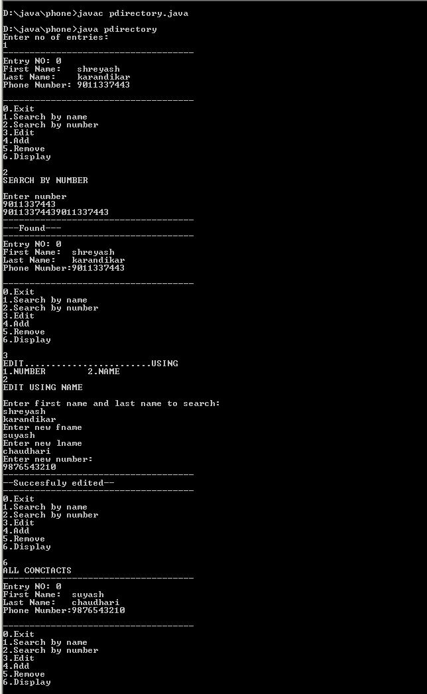

**OUTPUT**

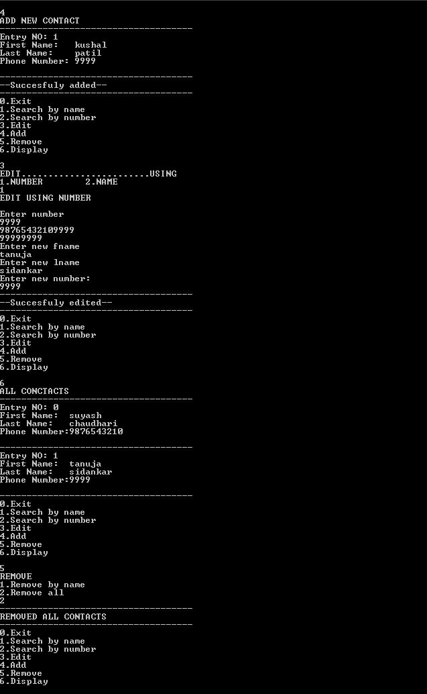

**APPLICATIONS**

* Can be used to manage contacts.
* Edit contact details.
* Add new contacts.
* Remove contacts.
* Search for contacts by name or number.
* Display all contacts by different orders.

**FUTURE SCOPE**

In future we can add multiple fields like email, office number, home numbers etc. We can link these contacts with google account for backup. We can add GUI interface to it. We can convert it into .vcf file for sharing purpose.

**REFERENCES**

We got the references for our project from various websites and different books based on Java Programming.

* Websites:

1. [www.google.com](http://www.google.com)
2. [www.wikipedia.com](http://www.wikipedia.com)

* Books:

1. Techmax