AIRWARE
AQI Forecasting Driven Health Prediction System

How the whole project works
Theory and technical guide

Data · Time-series forecasting · Health-risk models · FastAPI · Supabase · Next.js

Course: Time Series and Analysis Project
Prepared: October 2026

Contents
1. What the project does 2
1.1 The two linked pipelines 2
1.2 The user's journey 3
2. System architecture 3
2.1 Why this split 4
2.2 Repository map 4
3. Data 5
3.1 The AQI dataset 5
3.2 What AQI means (theory) 5
3.3 Cleaning and missing values 6
3.4 The Ahmedabad correction 6
3.5 The health dataset 7
4. Time-series theory used 7
4.1 Components of a series 7
4.2 Stationarity and differencing 7
4.3 Seasonal decomposition (STL) 8
4.4 Why a naive baseline 8
5. The forecasting models 9
5.1 What each model is (theory) and how it is set up (technical) 9
5.2 Evaluation: rolling-origin windows 9
5.3 Results 10
5.4 Pollutant forecasts 11
5.5 From experiment to deployment 11
6. The health-risk models 12
6.1 The task in plain terms 12
6.2 Inputs 12
6.3 The three model families 12
6.4 Training and selection 12
6.5 Results 13
6.6 The boundary rule 13
6.7 Backtest on real forecasts 13
6.8 The 0 to 100 score on the website 14
7. The backend (FastAPI) 14
7.1 Files 14
7.2 Endpoints 14
7.3 What happens in one risk request 15
7.4 Sign-in and privacy in the backend 15
7.5 Testing 15
8. The database and sign-in (Supabase) 15
8.1 Tables 16
8.2 Row Level Security (theory) 16
9. The website (Next.js) 17
9.1 Stack 17
9.2 Pages 17
9.3 How data reaches a page 18
9.4 Design rules 18
9.5 Showing risk clearly 18
10. End-to-end walkthrough 19
11. Running and checking the project 19
11.1 Run it locally 19
11.2 Retrain or regenerate 19
11.3 Quality checks 20
12. Limits and what comes next 20
12.1 Known limits 20
12.2 Remaining build steps 20
13. Glossary 20

1. What the project does
Airware answers two questions for people in Indian cities. First: how clean will the air be over the next 7 or 30 days? Second: what does that air mean for my own health? The first question is a time-series forecasting problem. The second is a prediction problem that combines the forecast with a person's saved health profile.

1.1 The two linked pipelines
Table 1: The two pipelines
Pipeline | Input | Output | Main techniques
AQI forecasting | Daily AQI, PM2.5 and NO2 history for six cities (2015 to mid-2020) | Daily AQI, PM2.5 and NO2 for the next 7 or 30 days | ARIMA, SARIMA, Holt-Winters, Prophet, XGBoost, LSTM, compared with naive baselines
Health-risk prediction | A person's profile plus the forecast AQI, PM2.5 and NO2 for each day | Risk level (Low to Severe), risk score, confidence, borderline flag | Random Forest, XGBoost, MLP (neural network), selected by cross-validation

Two supporting features sit around them: a hospital map that shows contact details (never booking) when risk is High or Severe, and a light assistant that gives precautions matched to the risk. The map and assistant are the next build steps.

1.2 The user's journey
- The visitor opens the site. Current and forecast AQI for any of the six cities is public, with no login.
- The user signs in (Supabase Auth) and fills a health profile once: age, gender, health condition, smoking, occupation, area type, mask use and hours outdoors are required. BMI, exercise hours and family history are optional.
- The backend combines the saved profile with the forecast for the chosen city and horizon.
- The health models return, for each day, a risk level, a risk score, a confidence and a borderline flag. The page shows this day by day, following the forecast curve.
- Every estimate is saved to the user's history. If risk reaches High or Severe, the page warns the user and (later) shows nearby hospitals.
- Every result is labelled as an estimate for decision support, not a medical diagnosis.

Scope note
The course rubric covers the AQI time-series forecasting part. The health prediction, hospital map and website are an extension built on top of it, so the forecasting part is documented in the most depth here.

2. System architecture
The system has four layers. The browser never talks to the models or the database directly, except for one thing: signing in with Supabase.
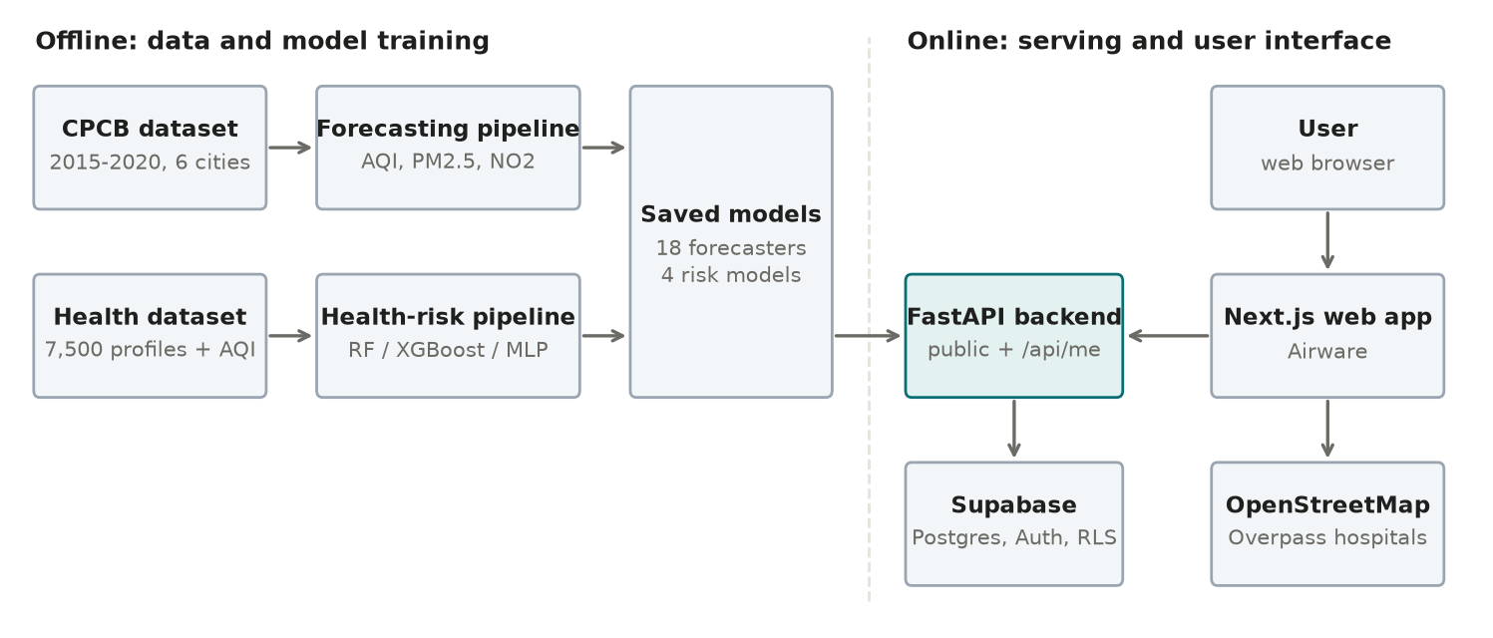
Figure 1: Overall architecture: website, API, models and database.
Table 2: Layers and responsibilities
Layer | Technology | Responsibility
Frontend | Next.js 16, React 19, TypeScript, Tailwind CSS, shadcn/ui, Motion, ECharts, Lucide | Pages, charts, forms, light and dark themes. Calls the API and signs users in.
Backend API | FastAPI (Python) | Loads the saved models once, serves forecasts and risk estimates, checks sign-in tokens, saves history.
Models | statsmodels, Prophet, XGBoost, PyTorch (LSTM), scikit-learn | Forecast AQI, PM2.5 and NO2; predict health risk. Saved to disk and loaded at startup.
Database and auth | Supabase (PostgreSQL, Supabase Auth, Row Level Security) | Stores profiles and history privately per user; handles accounts.

2.1 Why this split
- Models are loaded once, not trained per request. Training happens offline. The API only loads the saved result, so a forecast takes well under a second after a 20-second startup.
- The API is the only door to user data. The website sends the user's Supabase token to the API, and the API talks to Supabase with that same token. The database therefore enforces privacy itself (section 8).
- Public and private data are separated. Forecasts, leaderboards and precautions are public; profiles and history are private.

2.2 Repository map
src/ Python: data loading, models, evaluation, API
data_loader.py Loads city_day.csv, builds the daily AQI series
aqi.py CPCB AQI calculation (used for the Ahmedabad fix)
preprocessing.py Stationarity tests, STL, log transform, train/test split
models/ ARIMA/SARIMA/Holt-Winters, Prophet, XGBoost, LSTM, baselines
evaluation.py Rolling-origin evaluation and metrics
model_store.py Save and load the deployed forecasters
health/ Health data, model training, backtest, predictor store
api/ FastAPI app (main, services, me, schemas, supabase_client)
models/ Saved models: aqi/, pm25/, no2/, health/
reports/ Generated results, leaderboards and figures
supabase/ SQL schema and setup guide
frontend/ The Next.js website
docs/ Design spec, report, progress file, this guide
tests/ 41 automated API tests

3. Data

3.1 The AQI dataset
The forecasting data is city_day.csv, real daily readings from India's Central Pollution Control Board (CPCB) monitoring stations, published through Kaggle. It has about 29,500 rows covering 26 cities from 1 January 2015 to 1 July 2020, with columns for the pollutants (PM2.5, PM10, NO, NO2, NOx, NH3, CO, SO2, O3, benzene, toluene, xylene) and the published AQI and AQI bucket.
Only six cities have enough history to forecast well: Delhi, Bengaluru, Chennai, Hyderabad, Lucknow and Ahmedabad (1,300 to 2,000 days each). Cities with under about 300 days were excluded.
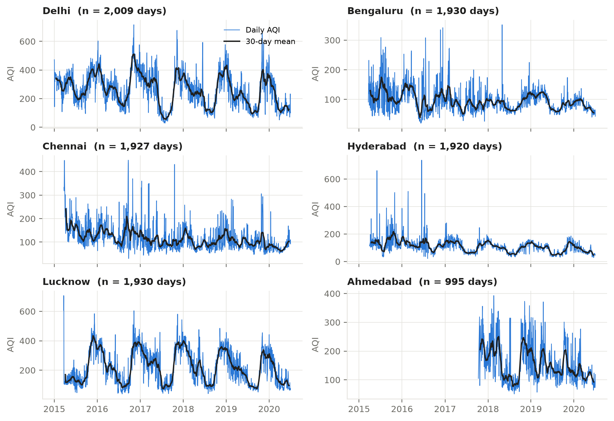
Figure 2: Daily AQI for the six cities, showing the strong yearly cycle and the difference between cities.

3.2 What AQI means (theory)
The Air Quality Index turns many pollutant concentrations into one number from 0 to 500 that ordinary people can read. CPCB's National AQI works in three steps:
- For each pollutant, take its average concentration over the averaging period (24 hours for most pollutants; the 8-hour maximum for CO and O3).
- Convert each concentration to a sub-index by straight-line interpolation between published concentration breakpoints.
- The day's AQI is the highest sub-index. The worst pollutant sets the AQI. CPCB requires at least three pollutants, one of them PM2.5 or PM10.
Sub-index I = (I_hi - I_lo) / (BP_hi - BP_lo) * (C - BP_lo) + I_lo
AQI = max( I_PM2.5, I_PM10, I_NO2, I_SO2, I_CO, I_O3, I_NH3, ... )

Table 3: CPCB AQI categories (the colours used on the website)
AQI | Category | Meaning for health
0 - 50 | Good | Minimal impact
51 - 100 | Satisfactory | Minor breathing discomfort for sensitive people
101 - 200 | Moderate | Discomfort for people with lung or heart disease, children and older adults
201 - 300 | Poor | Discomfort for most people on prolonged exposure
301 - 400 | Very poor | Respiratory illness possible on prolonged exposure
401 - 500 | Severe | Affects healthy people and seriously affects those with existing disease

Important: what the models forecast
The forecasting models predict the daily AQI series directly, as published by CPCB. They do not forecast every pollutant and rebuild the AQI. PM2.5 and NO2 are forecast separately because the health model uses them as extra inputs.

3.3 Cleaning and missing values
- Interpolation. Gaps of up to 21 days are filled by interpolating between the neighbouring observed days. Longer gaps stay missing and are ignored when scoring.
- Log transform. Models are fitted on log1p(AQI), which stabilises the spread (high-pollution days vary far more than clean days) and keeps forecasts positive. Forecasts are converted back to the AQI scale before scoring.
- Median fill is used only where a complete row is needed for a join, never for the forecasting series.
Missingness varies a lot by city: about 0.5% of Delhi's AQI is missing, against about 34% for Ahmedabad. That is one reason the models are compared city by city.

3.4 The Ahmedabad correction
Ahmedabad's published AQI contained values up to 2,049 on a scale that ends at 500. The cause was its carbon-monoxide sensor. Its median daily CO was 16 mg/m3 against about 1 in the other cities, and the readings drifted upward for years before falling in 2020, a pattern that fits sensor drift or a calibration fault rather than real pollution. Because AQI takes the maximum sub-index, one faulty sensor made CO the deciding pollutant on most hours.
The fix was to rebuild Ahmedabad's AQI from the hourly file (city_hour.csv) using the CPCB method without CO. The same code reproduces the published values exactly when CO is included, which shows the method is right and CO is the cause. The switch is AQI_EXCLUDED_POLLUTANTS in src/data_loader.py. The other five cities use the published AQI.
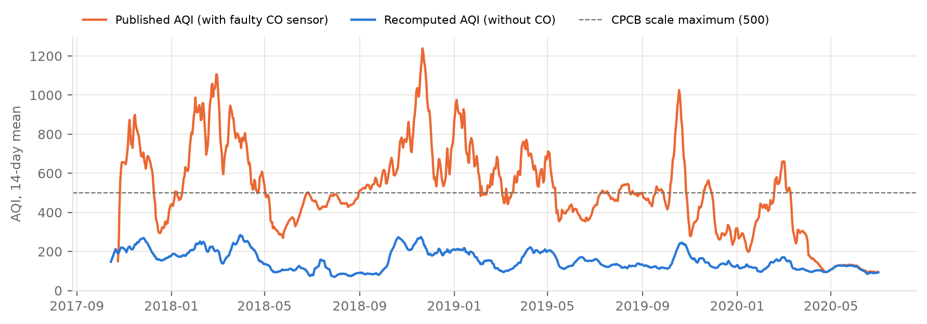
Figure 3: Ahmedabad's carbon-monoxide readings compared with other cities, and the AQI before and after the fix.

3.5 The health dataset
Health prediction needs rows that link a person (age, condition, habits) to the air they breathe. No public dataset does this for Indian cities, so the project uses a person-level table of 7,500 records with 28 columns and no missing values.
- Air columns (AQI, PM2.5, PM10, NO2, SO2, O3) are real CPCB values taken from city_day.csv by real city and date.
- Person columns are age, gender, occupation, area type, condition (none, asthma, COPD, heart disease, diabetes, hypertension), family history, smoking, BMI, exercise, outdoor hours and mask use.
- The risk label follows a documented formula: a vulnerability multiplier (age, condition, smoking, family history, BMI, exercise) times an effective-exposure term (the air values adjusted by outdoor hours, mask use and area type), plus noise, cut into four risk bands.
This is a constructed dataset: real air-quality values joined to person profiles by a documented formula. It is not a set of clinical records, and results should be read as an illustration of the method rather than medical evidence. This note is kept in the data-loading code (src/health/data.py) as well.
Sanity checks on the data behave sensibly: average risk rises from AQI near 86 (Low) to near 515 (Severe); mask use lowers risk; industrial areas score higher than residential ones.

4. Time-series theory used
A time series is a sequence of values recorded in time order, here one AQI value per day. Forecasting uses the pattern in the past to predict the future. Four ideas matter most.

4.1 Components of a series
Table 4: Components of a time series
Component | Meaning | In daily AQI
Trend | Slow long-term rise or fall | Weak; some cities improve slowly
Seasonality | A repeating cycle with a fixed period | Strong yearly cycle (winter smog, monsoon wash-out) and a weekly one
Autocorrelation | Today's value depends on recent days | Strong; AQI changes slowly from day to day
Noise | Unpredictable day-to-day variation | Large, especially in Delhi

4.2 Stationarity and differencing
Many classical models assume a stationary series: its mean and variance do not drift over time. Two tests check this, and they ask opposite questions so that they can confirm each other.
- ADF test (null: the series has a unit root, i.e. is non-stationary). A small p-value means the series is stationary.
- KPSS test (null: the series is stationary). A small p-value means it is not.
If a series is not stationary, differencing (subtracting yesterday's value) usually fixes it; the number of times is called d. For these cities the tests showed the level series is already stationary, so no differencing was needed (d = 0).

4.3 Seasonal decomposition (STL)
STL splits a series into trend, seasonal and remainder parts. It is a diagnostic: the strength of the seasonal part confirms how strong the yearly cycle is, and the autocorrelation function (ACF) peaks at lags 363 to 370 days, confirming a period of about 365 days. This decided which seasonal models to try.
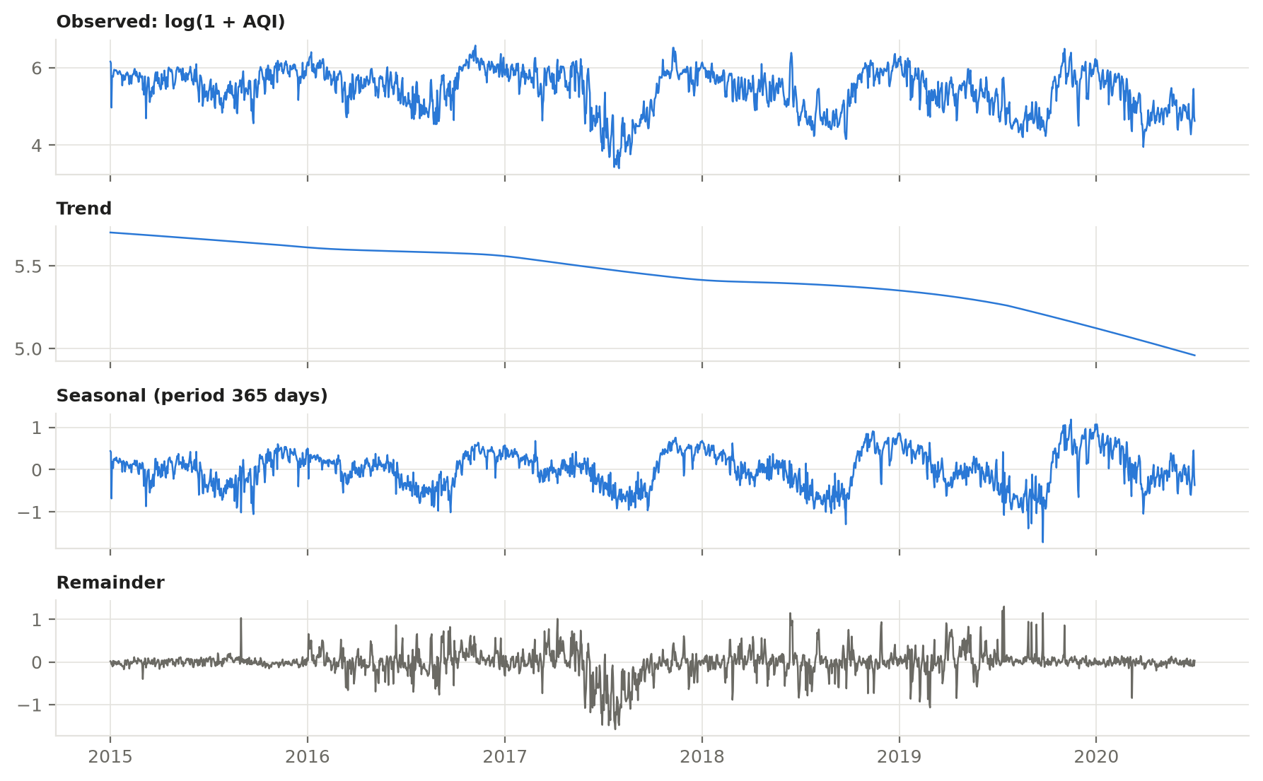
Figure 4: STL decomposition of Delhi's AQI into trend, yearly seasonality and remainder.

4.4 Why a naive baseline
A forecast is only useful if it beats something trivial. Three naive baselines are scored on exactly the same test windows.
- Naive (last value): repeat the last observed value for every future day.
- Seasonal naive (weekly): repeat the value from the same weekday last week.
- Seasonal naive (annual): repeat the value from the same day last year.
For AQI, the last-value baseline is hard to beat over a few days because the series changes slowly. That is why the project requires a model to beat the best of the three baselines before it is deployed.

5. The forecasting models

5.1 What each model is (theory) and how it is set up (technical)

ARIMA
AutoRegressive Integrated Moving Average. It predicts the next value from a weighted sum of recent past values (the AR part, order p) and recent past forecast errors (the MA part, order q), after differencing d times. Written ARIMA(p, d, q). Our set-up: d from the stationarity tests; p and q from 0 to 3 chosen by lowest AIC (a score that rewards fit and penalises complexity).

SARIMA
ARIMA plus a seasonal part, written SARIMA(p,d,q)(P,D,Q)m. A true yearly period of 365 makes the model extremely slow and unstable on about 2,000 points, so the standard remedy is used: weekly seasonality (m = 7) plus three yearly Fourier pairs as external regressors. Fourier terms are sine and cosine waves of the yearly period; they let the model draw a smooth yearly curve cheaply.

Holt-Winters exponential smoothing
It keeps a running estimate of level, trend and seasonality and updates each with exponentially fading weights, so recent days count more. Our set-up: additive damped trend and additive seasonality; the seasonal period (365 or 7) is picked by AIC.

Prophet
Facebook's additive model: y(t) = trend(t) + seasonality(t) + noise. The trend is piecewise linear with automatically detected change points, and seasonality uses Fourier series. It copes well with missing days. Our set-up: yearly and weekly seasonality, additive mode, change-point prior 0.05.

XGBoost on lag features
A gradient-boosted tree model turns forecasting into ordinary regression: predict today's value from lagged values and calendar features. Our features: lags 1 to 7, 14, 21, 28; rolling mean and standard deviation over 7, 14 and 30 days; the 1-day difference; sine and cosine of the day of year; weekday and month. It forecasts recursively, feeding each prediction back in as the next day's lag. 400 trees, depth 4, learning rate 0.03.

LSTM
A Long Short-Term Memory network is a recurrent neural network with gates that decide what to remember and what to forget, which lets it learn patterns across many days. Our set-up: one LSTM layer of 64 units reads the last 60 days (each day described by the scaled value plus the sine and cosine of the day of year) and a dropout layer plus a linear layer produce all 30 future days at once (a direct multi-step forecast, which avoids the error build-up of recursion). Early stopping with up to 150 epochs. Results are averaged over three random seeds (42, 43, 44), because a single seed once gave a misleadingly good Delhi result.

5.2 Evaluation: rolling-origin windows
Testing on one final month is risky: that month might be unusually easy or hard. Instead each city is tested on six non-overlapping 30-day windows, 120 days apart. For each window every model is trained only on data before it, then forecasts the 30 days that follow. This mimics real use, where the model always forecasts the future from the past.
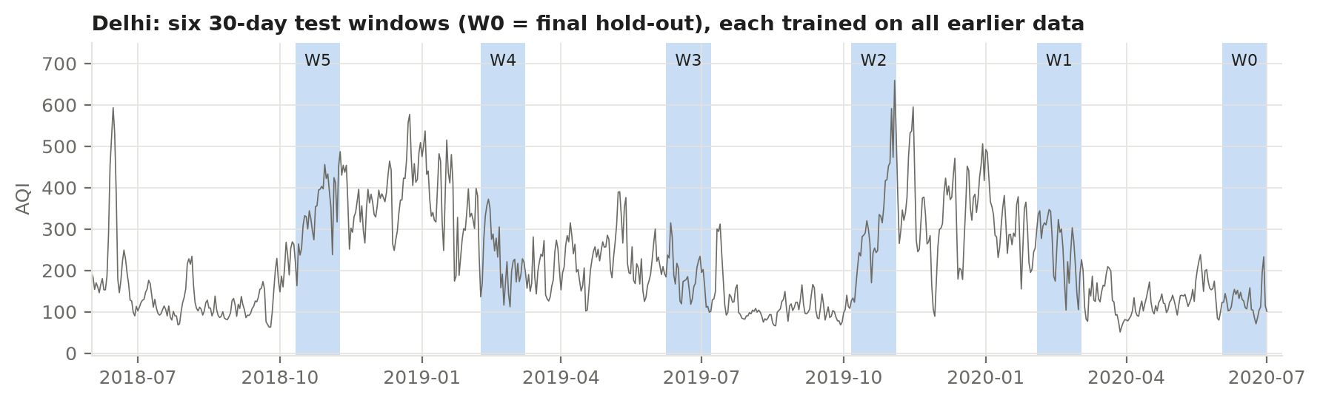
Figure 5: The six rolling test windows for one city; each trains on everything before it.

Metrics
RMSE = sqrt( mean( (y - yhat)^2 ) ) punishes large misses; used to pick the winner
MSE = mean( (y - yhat)^2 )
MAE = mean( |y - yhat| ) average miss, in AQI points
MAPE = mean( |y - yhat| / y ) * 100 average miss as a percentage

The winner for each city is the model with the lowest mean RMSE across the six windows. It is deployed only if it also beats the best naive baseline; otherwise the baseline itself is deployed (this happens for Hyderabad PM2.5 and Ahmedabad NO2).

5.3 Results
Table 5: AQI forecasting: deployed model per city (mean over 6 windows of 30 days)
City | Deployed model | Mean RMSE | Best baseline RMSE | Improvement
Delhi | SARIMA | 69.21 | 98.91 | -30%
Lucknow | Prophet | 55.90 | 83.16 | -33%
Bengaluru | SARIMA | 19.35 | 25.55 | -24%
Chennai | ARIMA | 37.45 | 42.87 | -13%
Hyderabad | Prophet | 22.39 | 25.88 | -13%
Ahmedabad | Holt-Winters | 57.44 | 60.75 | -5%

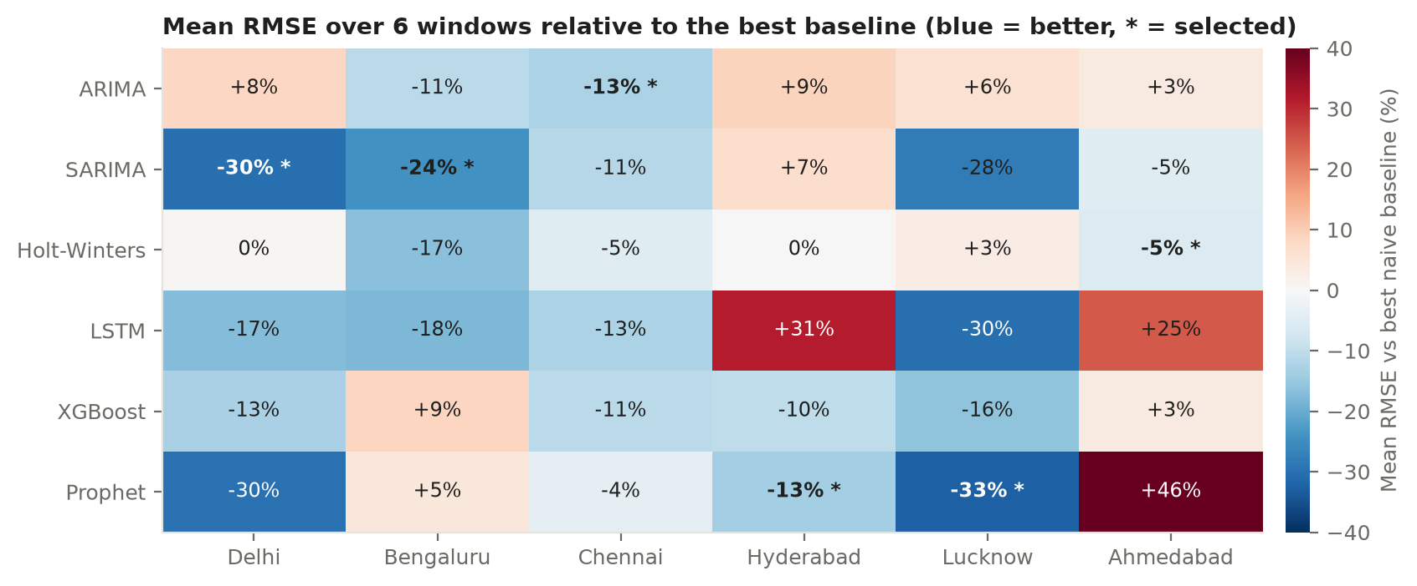
Figure 6: Mean RMSE of every model in every city. No single model wins everywhere.
Reading the results. Different cities prefer different models, which is why selection is automatic and per city. Gains over the baseline are large for Delhi and Lucknow (strong seasonal swings) and small for Ahmedabad (noisy, heavily gap-filled data). Errors are largest in Delhi simply because its AQI is highest and most variable.

5.4 Pollutant forecasts
PM2.5 and NO2 go through the same pipeline, because they have usable history in all six cities and improve the health model. PM10, SO2 and O3 are not forecast: they have too little data in several cities and do not improve the health model.
Table 6: Deployed PM2.5 and NO2 models
City | PM2.5 model | NO2 model
Delhi | Prophet | Prophet
Lucknow | Prophet | Prophet
Bengaluru | SARIMA | LSTM
Chennai | Holt-Winters | SARIMA
Hyderabad | Naive (last value) | XGBoost
Ahmedabad | Holt-Winters | Naive (last value)

5.5 From experiment to deployment
- Evaluation picks the winner per city and target (python -m src.run_forecasting).
- python -m src.train_final_models retrains each winner on the full history and saves it in its native format (joblib, XGBoost .ubj, PyTorch state_dict, Prophet JSON) under models/aqi/<city>/, with a registry.json index.
- At startup the API loads every saved model with load_forecaster(city).forecast(horizon) and caches a 30-day forecast per city. Reloaded models reproduce the in-memory forecasts exactly.
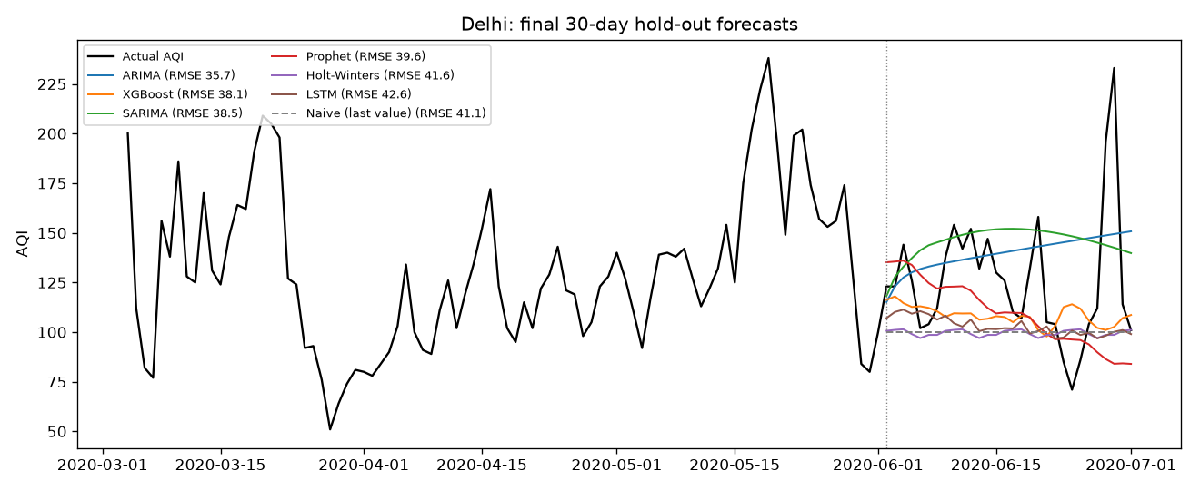
Figure 7: Example: Delhi's 30-day forecast against the actual values of the final test window.

6. The health-risk models

6.1 The task in plain terms
Given a person and one day's air quality, predict how risky that day is for them. Two related questions are answered by two different kinds of model:
- Classification: which risk level (Low, Moderate, High, Severe)? The model also gives a probability for each level, and the highest probability is the confidence.
- Regression: what risk score (a number)? Levels are just bands cut from this score, so the two answers should agree.

6.2 Inputs
Table 7: Health model inputs
Group | Features
Person (numeric) | Age, BMI, exercise hours per week, outdoor hours per day
Person (categories) | Gender, occupation, area type, health condition, family history, smoker, mask use
Air, primary model | AQI, PM2.5, NO2
Air, fallback model | AQI only

Two columns are deliberately excluded because they would leak the answer: VulnerabilityScore is part of the formula that produced the risk label, and HospitalVisitsLastYear is derived from the risk level. A model that saw them would score well and be useless on a new person. City and date are also excluded; the air values already represent them, and keeping them would tie the model to the training cities and dates.
Two variants are deployed. The primary model uses AQI, PM2.5 and NO2. The fallback uses AQI only and is used automatically when pollutant forecasts are not available.

6.3 The three model families
Table 8: Health models compared
Model | How it works | Our set-up
Random Forest | Many decision trees, each trained on a random sample; their votes are averaged. Robust and hard to overfit. | 400 trees, minimum leaf size 2
XGBoost | Trees built one after another, each correcting the previous trees' mistakes (gradient boosting). | 500 trees, depth 5, learning rate 0.05, 80% row and column sampling
MLP (neural network) | Layers of simple units; each layer transforms the inputs so the network can learn curved relationships. | Two hidden layers (64 and 32 units), L2 penalty 0.001, standardised inputs

6.4 Training and selection
- 80/20 split, stratified by risk level, so both parts keep the same mix of levels. The 20% test set is touched only for final reporting.
- 5-fold stratified cross-validation on the 80% to compare models fairly. Each model is also compared with a dummy baseline that always predicts the most common class.
- Classification winner: highest weighted F1. F1 balances precision (how many predicted cases were right) and recall (how many true cases were found). "Weighted" averages the per-level F1 by how common each level is. Recall is also checked per level, because the classes are imbalanced.
- Regression winner: lowest RMSE; MSE, MAE and R-squared are reported too.
Precision = TP / (TP + FP) Recall = TP / (TP + FN)
F1 = 2 * Precision * Recall / (Precision + Recall)
R2 = 1 - SSE / SST (1.0 = perfect, 0 = no better than the mean)

6.5 Results
Table 9: Selected model (MLP) on the held-out test set
Variant | Level F1 | Level accuracy | Recall Low / Mod / High / Severe | Score RMSE | Score R2
Primary: profile + AQI + PM2.5 + NO2 | 0.873 | 0.873 | 92% / 79% / 88% / 91% | 0.198 | 0.986
Fallback: profile + AQI | 0.839 | 0.838 | 88% / 81% / 74% / 86% | 0.377 | 0.948

The MLP won both tasks in both variants. Against the baseline (about 41% accuracy, always guessing the commonest level) the models are far better, and the extra pollutant inputs clearly help (primary beats fallback).
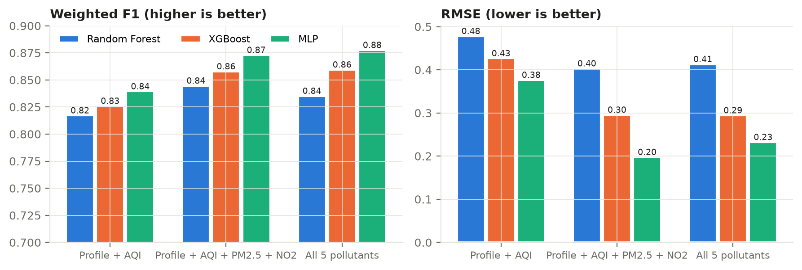
Figure 8: Health models compared on the test set.

6.6 The boundary rule
The classifier and the regressor can disagree near a level edge: the classifier says Moderate while the score sits just inside High. About 7% of days are like this. Instead of hiding it, the system uses a clear rule:
- The classifier's level is the headline.
- If the score implies a different level, the day is marked borderline and shown as a range, for example "Moderate to High".
- The higher of the two levels (the alert level) decides precautions and High/Severe warnings, so the system errs on the side of caution.
On the test set, when both models agree the level is right 90% of the time, and on borderline days the true level lies inside the shown range 75% of the time. High and Severe days are caught 96% of the time with the rule, against 95% with the classifier alone, for a false-alert rate of about 4%.

6.7 Backtest on real forecasts
The health models were trained on real observed air values but are used on forecast air values, which contain forecast error. A backtest feeds real historical forecasts into the models: the primary variant agrees with the reference level 73.3% of the time against 68.5% for the fallback. The main source of remaining error is now the quality of the air forecast, not the health model.

6.8 The 0 to 100 score on the website
The raw risk score has no upper limit (the data reaches about 18), which is hard for users to read. The website maps it to 0 to 100 so that each level fills a quarter of the scale. The mapping is display only; stored and API values stay raw.
Table 10: Score mapping (piecewise linear)
Level | Score out of 100 | Raw score
Low | 0 - 25 | 0 - 1.0
Moderate | 25 - 50 | 1.0 - 1.8
High | 50 - 75 | 1.8 - 2.8
Severe | 75 - 100 | 2.8 and above (6+ shows as 100)

7. The backend (FastAPI)
FastAPI is a Python web framework. Each endpoint is a function; request and response shapes are declared as types, and FastAPI validates them automatically and generates interactive documentation at /docs.

7.1 Files
Table 11: Backend files
File | Role
src/api/main.py | Creates the app, allows cross-origin requests from the website, defines the public endpoints
src/api/services.py | ModelService: loads all models at startup; forecast, risk and leaderboard logic
src/api/schemas.py | Request and response definitions with validation (for example, required profile fields)
src/api/me.py | Signed-in endpoints: profile, saved runs, history
src/api/supabase_client.py | Small client for Supabase's auth and table API

7.2 Endpoints
Table 12: API endpoints
Endpoint | Auth | What it does
GET /api/health | Public | Is the service up and are models loaded
GET /api/cities | Public | Cities, forecast start date, deployed model per target
GET /api/forecast/{city}?horizon=7|30 | Public | Daily AQI, PM2.5, NO2 forecast
POST /api/risk/predict | Public | Risk for a profile sent in the request (not saved); used for the example profiles
GET /api/profile/schema | Public | Describes the profile fields
GET /api/leaderboard/forecast?target= | Public | Forecast model ranking per city (AQI, PM2.5, NO2)
GET /api/leaderboard/health | Public | Health model ranking and boundary-rule statistics
GET, PUT /api/me/profile | Signed in | Read or save the user's profile (404 if none yet)
POST /api/me/risk | Signed in | Predict with the saved profile and save the run to history
GET /api/me/history | Signed in | List the user's past runs, newest first
GET, DELETE /api/me/history/{id} | Signed in | Open or delete one run

7.3 What happens in one risk request
- Take the city's cached 30-day forecast and cut it to 7 or 30 days.
- Validate the profile. Required fields must be present. Missing optional fields (BMI, exercise, family history) are filled with typical values and listed in imputed_fields. Values far outside the training range produce a warning.
- For each day, build the model input from the profile and that day's AQI, PM2.5 and NO2. If the pollutant forecasts are missing, switch to the AQI-only fallback model.
- Run the classifier (level and per-level probabilities) and the regressor (score). Apply the boundary rule to set borderline, risk_range and alert_level.
- Add the run summary: highest alert level, days per level, borderline days and show_hospitals.
Why exposure fields are required
Filling the exposure fields (occupation, area type, mask use, outdoor hours) with typical values once turned a 67-year-old COPD patient from Moderate into Low. They change the answer too much to guess, so the form requires them.

7.4 Sign-in and privacy in the backend
- The browser sends the user's Supabase access token as Authorization: Bearer <token>.
- The API asks Supabase Auth who owns the token. Invalid or expired tokens get a 401.
- Every table call is then made with the user's own token, so Supabase's row-level security (section 8) applies. Even a bug in the API could not read another user's rows. The powerful service-role key is not used for user data and is never placed in the frontend.

7.5 Testing
41 automated tests cover the endpoints, validation and the history flow. The signed-in tests use an in-memory stand-in for Supabase that enforces the same per-user rules. scripts/check_accounts_live.py runs the full flow against the real Supabase project with a real test user (8 of 8 checks passed).

8. The database and sign-in (Supabase)
Supabase provides a PostgreSQL database and an authentication service. The schema is in supabase/migrations/0001_init.sql.

8.1 Tables
Table 13: Database tables
Table | Access | Holds
profiles | Private | One row per user: age, gender, condition, smoker, occupation, area type, mask use, outdoor hours, optional BMI, exercise and family history, city, updated time
saved_forecasts | Private | One row per prediction run: user, city, horizon, start date, models used, the air forecast
risk_predictions | Private | One row per forecast day of a run: level, probabilities, confidence, score, borderline, range, alert level, input snapshot
aqi_forecasts_cache | Public read | Cached forecasts (written only by the backend)
model_leaderboard | Public read | Model rankings (written only by the backend)

8.2 Row Level Security (theory)
Normally a database trusts the program that connects to it. Row Level Security (RLS) moves the rule into the database itself: a policy is attached to each table, and every query is filtered by it, whoever sends it. Here the policy is auth.uid() = user_id: a signed-in user can only see and change rows whose user_id is their own. Because the API uses each user's token, RLS applies to every request.
- History tables are append-only: users can add and delete runs but not edit them, so saved results cannot be altered afterwards.
- The public tables also have RLS, with a read-only policy. Without it, the public anon key could write to them.
- Only the public anon key is in the website. The service-role key (which bypasses RLS) is never placed in the frontend or in git; .env files are git-ignored.

9. The website (Next.js)

9.1 Stack
Table 14: Frontend tools
Tool | Used for
Next.js 16 (App Router) and React 19 | Pages, routing, rendering
TypeScript | Type-checked code; the API's response shapes are typed in src/lib/api.ts
Tailwind CSS v4 and shadcn/ui | Styling and base components (shadcn's current style uses Base UI primitives)
Motion | Small fade-in animations (respects the user's reduced-motion setting)
ECharts 6 | Charts (forecast, risk score, sparklines), loaded as small tree-shaken pieces
Lucide React | Icons
@supabase/supabase-js | Sign-in only; all data goes through the API
IBM Plex Sans and Mono | Typeface; Mono for numbers so columns align

9.2 Pages
Table 15: Pages
Route | Needs login | Shows
/ | No | Landing page: what the project does, live example of two people breathing the same air, how it works, model results, FAQ
/dashboard | No | Overview: city tabs, tomorrow's AQI on the CPCB scale, 7/30-day chart, pollutants, example risk, precautions, all-cities table
/sign-in | No | Sign in or create account (email and password; new accounts confirm by email)
/profile | Yes | Three-step health-profile form, saved once and editable
/risk | Yes | Personal day-by-day risk, charts, precautions for the selected day, saves each new estimate
/history, /history/[id] | Yes | Past estimates, full detail view, delete
/models | No | Leaderboards for AQI, PM2.5, NO2 and health models
/forecast | No | Placeholder, built later

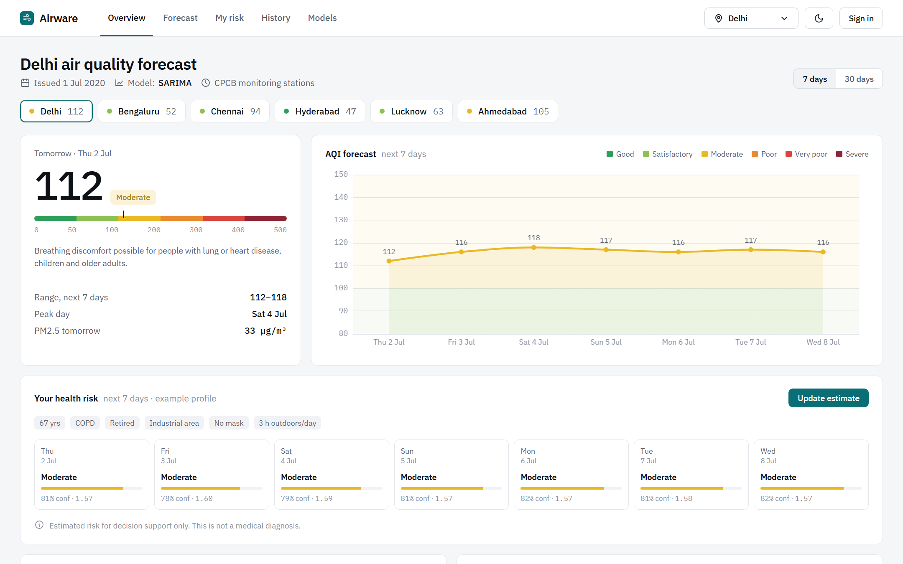
Figure 9: The dashboard (overview) page.

9.3 How data reaches a page
- useAsync is a small hook that runs a request when its inputs change, cancels the previous one, and keeps the last data on screen while a new request loads.
- AuthProvider keeps the Supabase session; RequireAuth sends signed-out visitors to /sign-in?next=... and returns them afterwards.
- meApi(token) wraps the signed-in endpoints. The My risk page shows the latest saved run and only calculates (and saves) a new one when none exists or the profile has changed since, so ordinary visits do not flood the history.

9.4 Design rules
- A data-first dashboard using the full screen width, in the style of weather and air-quality sites, not a marketing template.
- Neutral greys with one deep-teal brand colour. The official CPCB colours are reserved for data so colour always means something.
- Light and dark themes with a toggle; the choice is applied before the page paints to avoid a flash.
- Every page is checked at 1280, 1536 and 1920 px wide (a 1920x1080 laptop at 150%, 125% and 100% scaling).
- A visible reminder on every result that it is an estimate for decision support, not a medical diagnosis.

9.5 Showing risk clearly
- Each day card shows the level (or a range on borderline days), confidence, AQI and the score out of 100.
- The risk-score chart has the four level bands behind the line; the AQI chart is separate (no two-scale charts).
- Precautions follow the selected day (tomorrow by default), using that day's alert level, with a note when risk rises later in the week.

10. End-to-end walkthrough
What happens when a signed-in user opens My risk for the first time:
Table 16: One My risk visit
# | Where | Step
1 | Browser | RequireAuth finds the Supabase session; if none, redirects to sign-in
2 | Browser to API | GET /api/me/profile with the token. If 404, redirect to the profile form
3 | API to Supabase | The API verifies the token and reads the profiles row under RLS
4 | Browser to API | GET /api/me/history?limit=1 to look for a recent run
5 | Browser to API | No run (or profile changed since): POST /api/me/risk {horizon: 7}
6 | API | Cached forecast, profile validation, health models, boundary rule, summary
7 | API to Supabase | Insert one saved_forecasts row and one risk_predictions row per day
8 | Browser | Draw the summary, day cards, two charts and the precautions for tomorrow
9 | Later visits | The latest saved run is shown instantly; the user can change city or horizon and recalculate

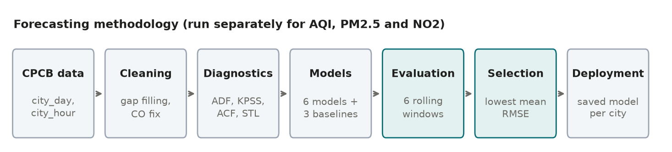
Figure 10: Pipeline from data to the user's screen.

11. Running and checking the project

11.1 Run it locally
Run these from the project folder, each in its own terminal.
# backend (loads models; ready after about 20 seconds)
venv\Scripts\python -m uvicorn src.api.main:app --port 8000

# frontend
npm --prefix frontend run dev

Open http://localhost:3000 for the site and http://localhost:8000/docs for the API documentation. The backend needs SUPABASE_URL and SUPABASE_ANON_KEY in the git-ignored .env; the frontend needs NEXT_PUBLIC_API_URL, NEXT_PUBLIC_SUPABASE_URL and NEXT_PUBLIC_SUPABASE_ANON_KEY in frontend/.env.local.

11.2 Retrain or regenerate
python -m src.run_forecasting # evaluate forecasters (--target for PM2.5, NO2)
python -m src.train_final_models # retrain winners on full history, save
python -m src.health.train # train and save the health models
pytest # 41 API tests

11.3 Quality checks
- Models: naive-baseline comparison, six rolling windows, three LSTM seeds, reload-equals-original checks.
- API: 41 automated tests; a live check against the real Supabase project.
- Frontend: TypeScript type check, ESLint, production build, and screenshots at three widths in light and dark.

12. Limits and what comes next

12.1 Known limits
- Data period. The training data ends on 1 July 2020, so forecasts start from there. Showing today's AQI needs live data (planned: OpenAQ station data, a daily refresh job and periodic retraining with the naive-baseline check).
- Error compounds. Health-risk error now comes mostly from air-forecast error, especially in Delhi and Ahmedabad.
- Seasonality in Holt-Winters. The model picks weekly seasonality; a proper yearly version needs the series deseasonalised first.
- No single model dominates. Averaging the top two or three models per city could make forecasts more stable.
- Health dataset. The risk labels come from a documented formula, so the models learn that formula; they are a demonstration of the method, not a validated clinical tool.

12.2 Remaining build steps
Table 17: Remaining work
Step | Notes
Forecast detail page | /forecast: one city in depth
Hospital map | Leaflet with OpenStreetMap tiles; hospital name, address, phone and website from the Overpass API; shown when alert level is High or Severe; contact details only, no booking
Recommendation assistant | Intent matching over a curated precautions list, personalised with AQI and risk; an LLM can be added later
Live 2026 data | OpenAQ station data, daily refresh, retraining
Deployment | Frontend on Vercel; FastAPI on Render or Railway (handle the 20-second model load)
Course submissions | Mid-sem (19 to 30 Oct): classical models. Final (16 to 27 Nov): ML/DL models and the comparison

13. Glossary
Table 18: Glossary
Term | Meaning
AQI | Air Quality Index, 0 to 500; the highest pollutant sub-index of the day
CPCB | Central Pollution Control Board, India's pollution regulator; source of the data
PM2.5, PM10 | Particles smaller than 2.5 or 10 micrometres; PM2.5 reaches deep into the lungs
NO2 | Nitrogen dioxide, mainly from traffic and combustion
Time series | Values recorded in time order
Stationary | A series whose mean and variance do not drift over time
ADF, KPSS | Two stationarity tests that ask opposite questions
Differencing | Subtracting the previous value to remove a trend
Seasonality | A pattern that repeats at a fixed period (weekly, yearly)
STL | Seasonal-trend decomposition using Loess; splits a series into trend, season and remainder
ACF | Autocorrelation function: how a series relates to its own past
AIC | A score that balances model fit against complexity; lower is better
Baseline | A trivial forecast (such as repeating the last value) that a model must beat
Rolling-origin evaluation | Testing on several windows, always training only on earlier data
RMSE, MAE, MAPE | Error measures: root mean squared error, mean absolute error, mean absolute percentage error
F1, recall, precision | Classification scores; recall is the share of true cases found, precision the share of predictions that were right
R-squared | Share of the variation a regression model explains
Cross-validation | Splitting training data into folds so each part is used for testing once
Data leakage | Giving a model a feature that contains the answer, which inflates scores
Borderline day | A day where the level and score point to neighbouring levels; shown as a range
Alert level | The higher of the two levels on a borderline day; drives warnings
RLS | Row Level Security: database rules that limit each user to their own rows
Token (JWT) | A signed proof of sign-in that the browser sends with each request
Anon key, service-role key | Public Supabase key (safe in the website) and the all-powerful private key (never in the website)

