1. **Write a Java program that uses an advanced for loop to iterate through an array of integers and prints each element.**

**Program :**

**package** myPackage;

**public** **class** continue_Statement {

**public** **static** **void** main(String[] args) {

**for**(**int** i=0;i<=10;i++){

System.***out***.println(i);

}

}

}

**Output :**

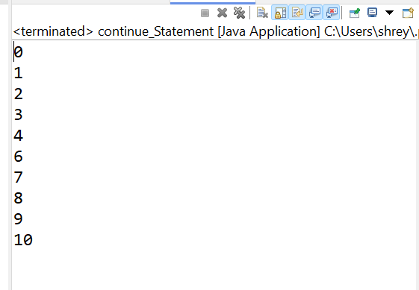

1. **Write a Java program that uses an advanced for loop and the continue**

**Program :**

**public** **class** continue_Statement {

**public** **static** **void** main(String[] args) {

**for**(**int** i=0;i<=10;i++){

**if**(i==5) {

**continue**;

}

System.***out***.println(i);

}

}

}

Outpu :

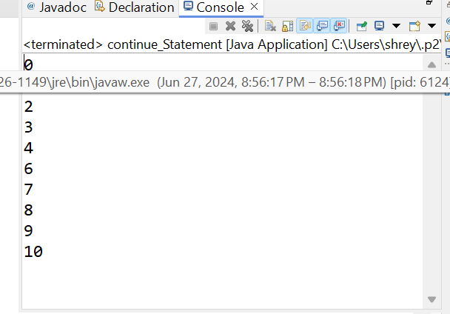

1. **statement to print only the odd numbers from an array of integers.**

**Program :**

**package** myPackage;

**public** **class** advance_For_Odd_Even {

**public** **static** **void** main(String[] args) {

// **TODO** Auto-generated method stub

**for**(**int** i=0;i<=10;i++){

**if**(i%2==0) {

**continue**;

}

System.***out***.println(i);

}

}

}

**Output:**



1. **Write a Java program that uses an advanced for loop and the break statement to stop printing elements when a specific element is encounter.**

**package** myPackage;

**public** **class** breakStatement {

**public** **static** **void** main(String[] args) {

**for**(**int** i=0;i<=10;i++){

**if**(i==3) {

**continue**;

}

System.***out***.println(i);

}

}

}

**Output:**

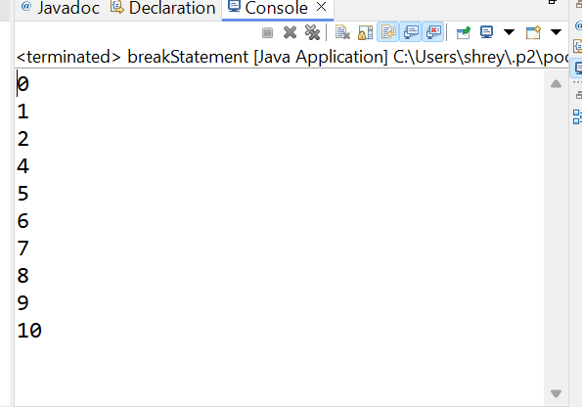

**Write a program that takes an integer as input and checks if it is positive, negative, or zero.**