**1. Perform the following tasks:**

**a. Create Student table with following attributes (STUDENT_ID , FIRST_NAME, LAST_NAME, PHONE_NUMBER, MARKS, COURSE_ID).**

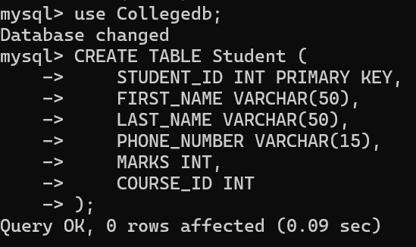

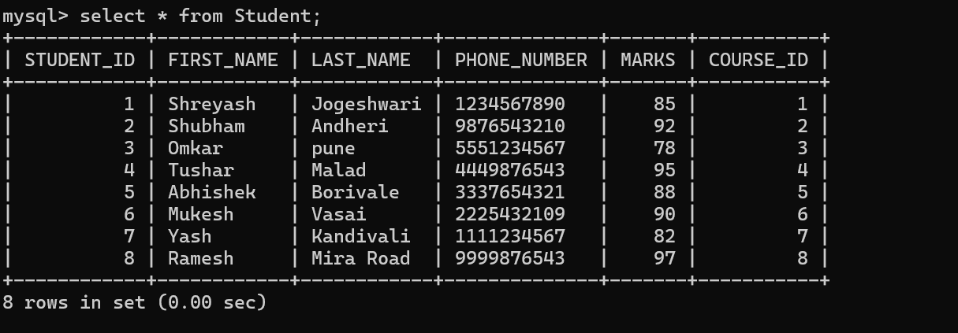

**b. Create Course table with following attributes (COURSE_ID, COURSE_NAME).**

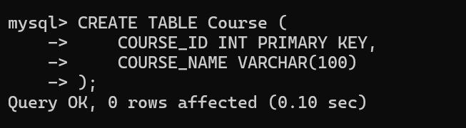

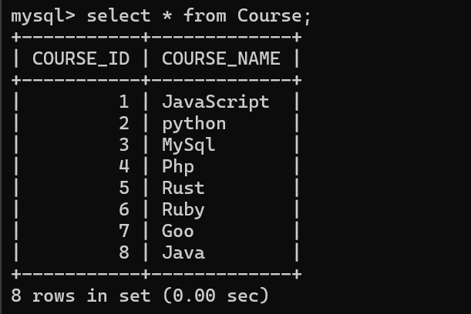

**c. Write a SQL statement to insert 8 records with your own value into the tables.**

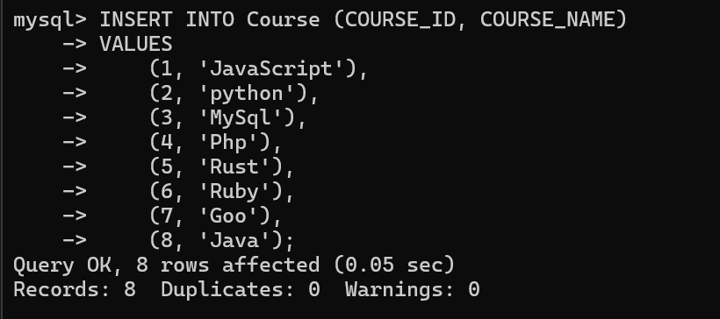

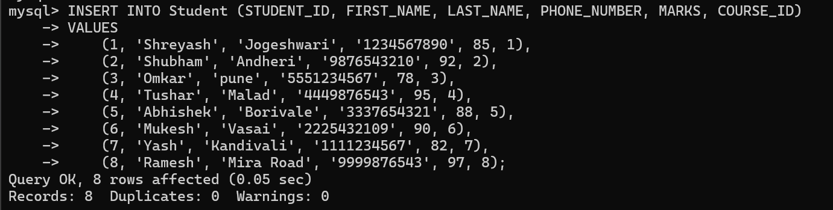

**d. Write a query to get the number of students with the same course.**

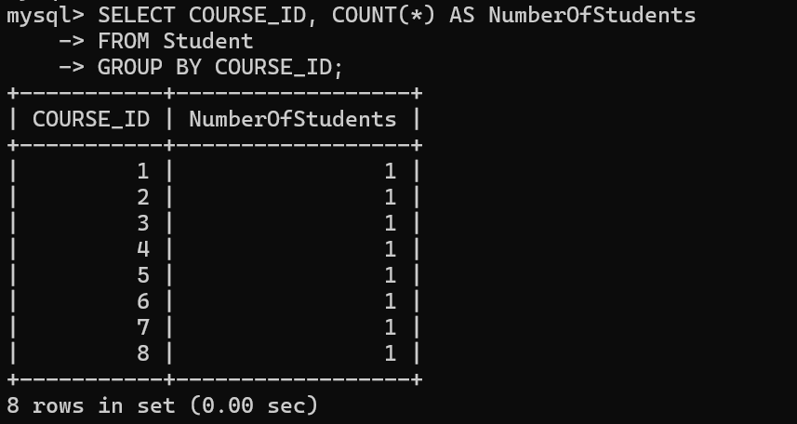

**f. Write a query to get the student name, course name and marks of the students.**

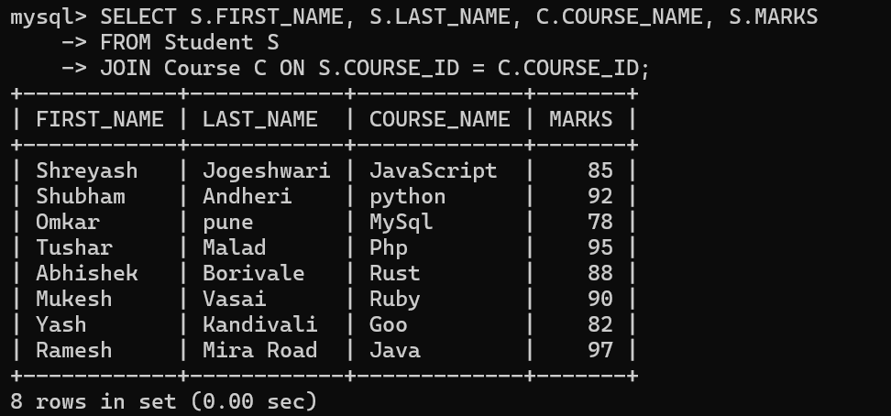

**g. Write a query to get the Average marks of students course wise.**

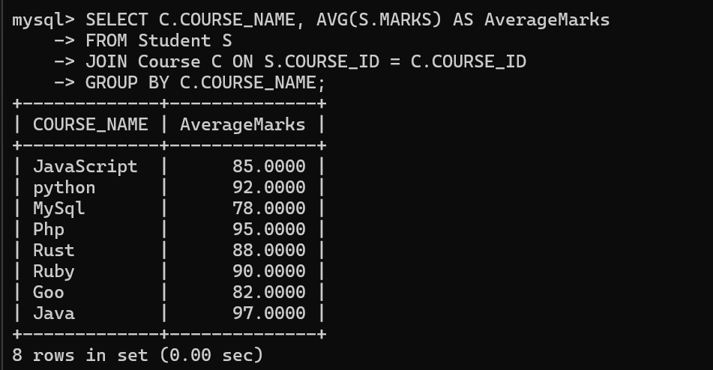

**2.  Create database for hospital management system & Perform the following tasks:**

**a. Create HEALTH CARE WORKERS table with following attributes (EMPLOYEE_ID , FIRST_NAME, LAST_NAME,EMAIL, PHONE_NUMBER, HIRE_DATE, SALARY, DESIGNATION).**

**Screenshot 2024-08-31 151849**

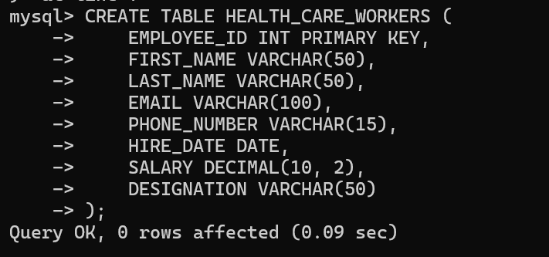

**b. Create PATIENT table with following attributes (PATIENT_ID,NAME, PHONE_NUMBER).**

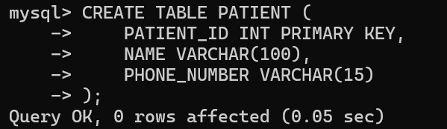

**c. Write a SQL statement to insert 10 records with your own value into the tables.**

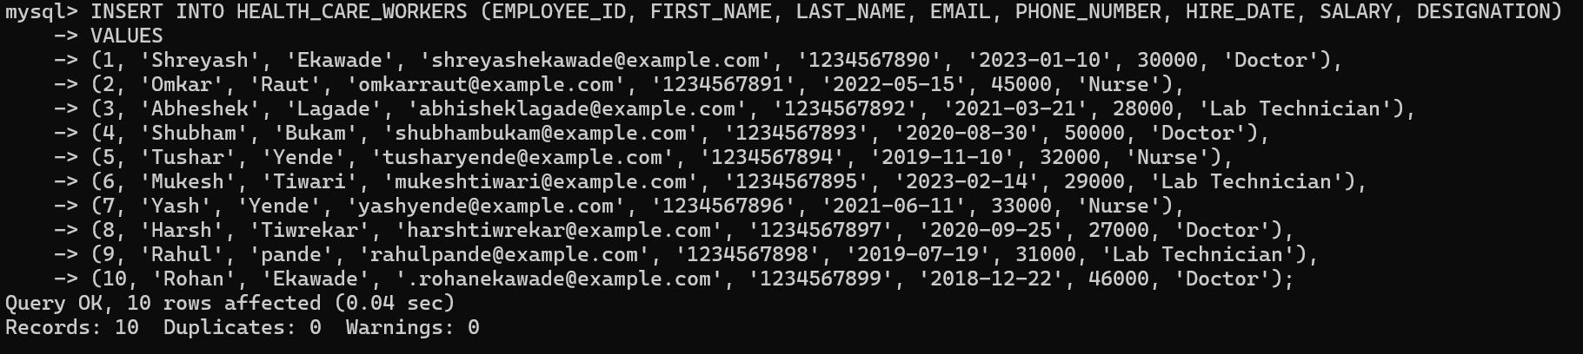

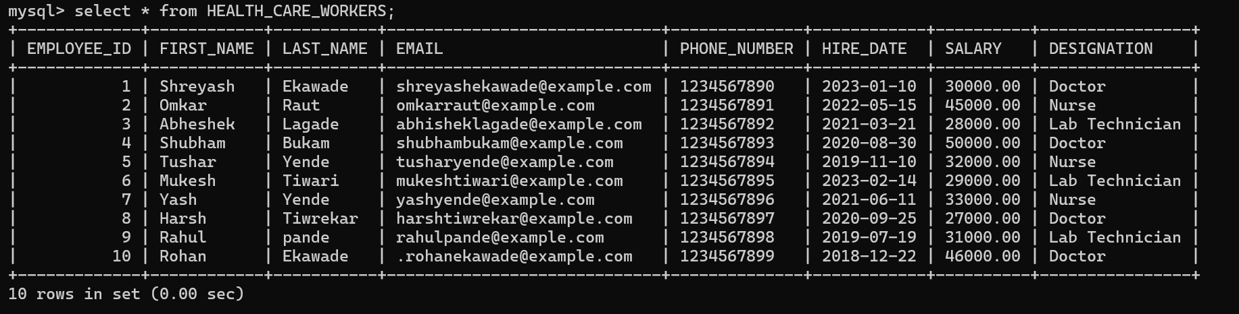

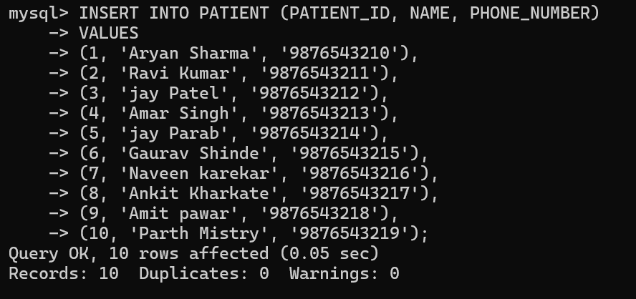

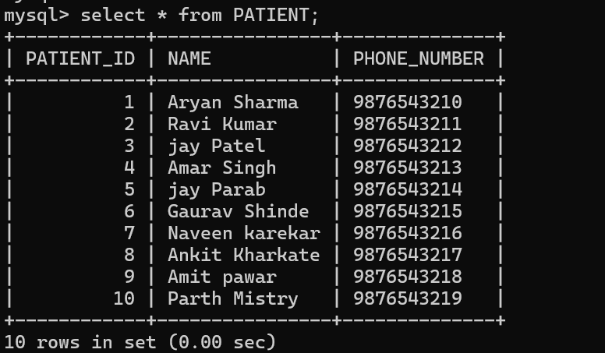

**d. Write a query to get the names (first_name, last_name),Designation, salary.**

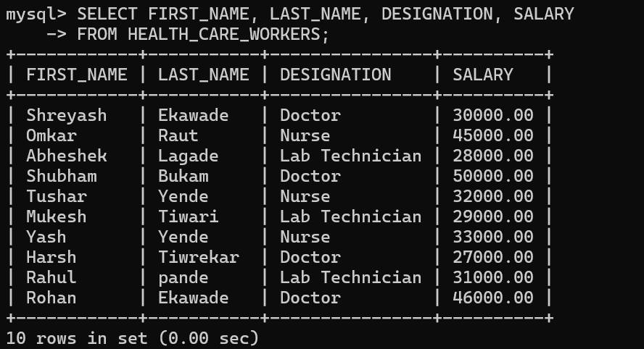

**e. Write a query to get the number of employees with the same Designation**

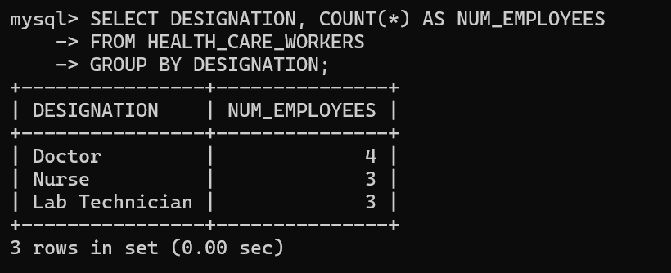

**f. Write a query to get employee name who are getting salary more than 25000.**

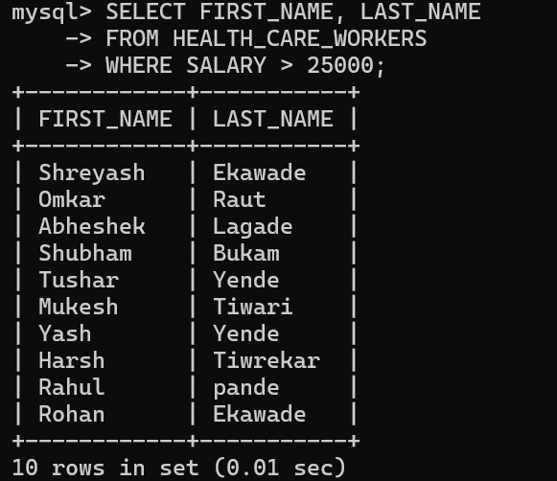

**g. Fetch HEALTH CARE WORKERS name using their employee id.**

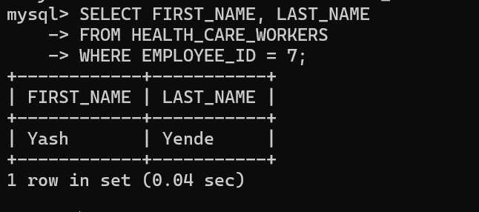

1. **Consider two tables, customers and orders, with the following structures:**

**Customers Table: customer_id (Primary Key) first_name Last_name**

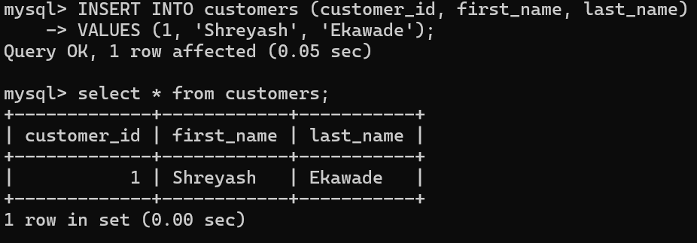

**Orders Table: order_id (Primary Key) customer_id (Foreign Key) order_date Total_amount .**

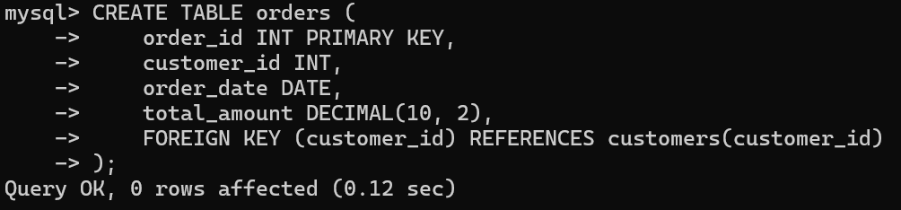

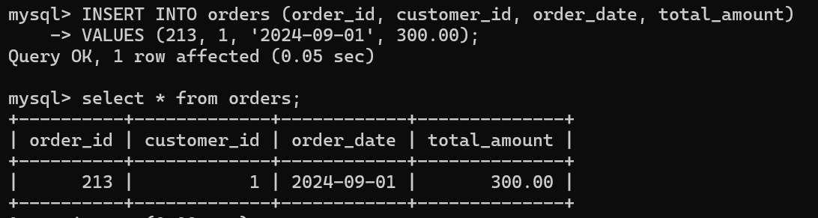

**Write an SQL query to retrieve the first and last names of customers along with the order date and total amount of their orders. Use an INNER JOIN to connect the two tables.**

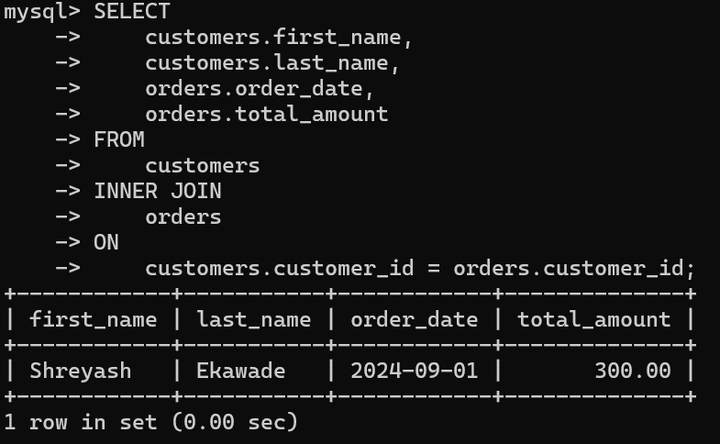

1. **Consider two tables, departments and employees, with the following structures:**

**Departments Table: department_id (Primary Key) department_name**

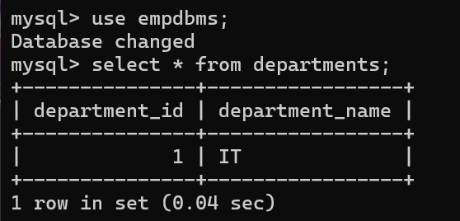

**Employees Table: employee_id (Primary Key) first_name last_name department_id (Foreign Key)**

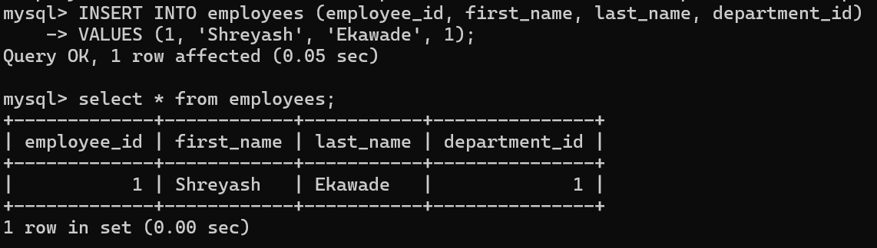

**Write an SQL query to retrieve a list of all departments and the names of employees who belong to each department. Use a LEFT JOIN to include departments that have no employees.**

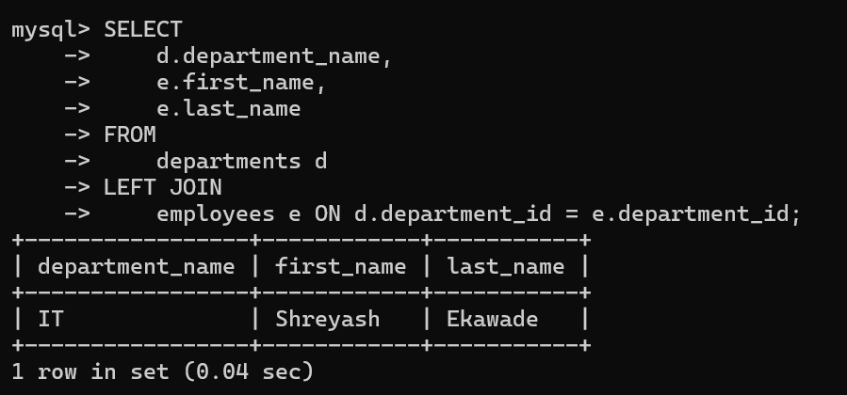

**4. Write a program to show  JDBC connection with MYSQL and perform the following operations:**

**Create table Customer with following fields:**

**Custno, Custame,Custaddress,Phoneno, City, Pincode, Country**

**Insert 5 records in Customer table.**

**a.     Insert values**

**b.    Delete values**

**c.     update city name Shimla to Shilong.**

**d.    Show table in the console**

**Program:**

**myPackage** Demo_JDBC;

**import** java.sql.Connection;

**import** java.sql.DriverManager;

**import** java.sql.PreparedStatement;

**import** java.sql.ResultSet;

**import** java.sql.SQLException;

**import** java.sql.Statement;

**public** **class** CustomerJDBC {

// JDBC URL, username, and password of MySQL server

**static** **final** String ***JDBC_URL*** = "jdbc:mysql://localhost:3306/CustomerDB";

**static** **final** String ***JDBC_USER*** = "root"; // Replace with your MySQL username

**static** **final** String ***JDBC_PASSWORD*** = "123456"; // Replace with your MySQL password

// SQL statements

**static** **final** String ***INSERT_SQL*** = "INSERT INTO Customer (Custno, Custname, Custaddress, Phoneno, City, Pincode, Country) VALUES (?, ?, ?, ?, ?, ?, ?)";

**static** **final** String ***DELETE_SQL*** = "DELETE FROM Customer WHERE Custno = ?";

**static** **final** String ***UPDATE_SQL*** = "UPDATE Customer SET City = 'Shilong' WHERE City = 'Shimla'";

**static** **final** String ***SELECT_SQL*** = "SELECT * FROM Customer";

**public** **static** **void** main(String[] args) {

**try** {

// Establishing connection to MySQL database

Connection connection = DriverManager.*getConnection*(***JDBC_URL***, ***JDBC_USER***, ***JDBC_PASSWORD***);

System.***out***.println("Connected to the database successfully!");

// Insert records

*insertRecords*(connection);

// Delete a record

*deleteRecord*(connection, 2); // Delete customer with Custno = 2

// Update city name from Shimla to Shilong

*updateCity*(connection);

// Display the records

*displayRecords*(connection);

// Close connection

connection.close();

} **catch** (SQLException e) {

e.printStackTrace();

}

}

**private** **static** **void** insertRecords(Connection connection) **throws** SQLException {

PreparedStatement pstmt = connection.prepareStatement(***INSERT_SQL***);

// Insert 5 records

pstmt.setInt(1, 1);

pstmt.setString(2, "John Doe");

pstmt.setString(3, "123 Main St");

pstmt.setString(4, "9876543210");

pstmt.setString(5, "Shimla");

pstmt.setString(6, "171001");

pstmt.setString(7, "India");

pstmt.executeUpdate();

pstmt.setInt(1, 2);

pstmt.setString(2, "Jane Smith");

pstmt.setString(3, "456 Elm St");

pstmt.setString(4, "9876543211");

pstmt.setString(5, "Delhi");

pstmt.setString(6, "110001");

pstmt.setString(7, "India");

pstmt.executeUpdate();

pstmt.setInt(1, 3);

pstmt.setString(2, "Alice Johnson");

pstmt.setString(3, "789 Pine St");

pstmt.setString(4, "9876543212");

pstmt.setString(5, "Mumbai");

pstmt.setString(6, "400001");

pstmt.setString(7, "India");

pstmt.executeUpdate();

pstmt.setInt(1, 4);

pstmt.setString(2, "Bob Brown");

pstmt.setString(3, "101 Oak St");

pstmt.setString(4, "9876543213");

pstmt.setString(5, "Kolkata");

pstmt.setString(6, "700001");

pstmt.setString(7, "India");

pstmt.executeUpdate();

pstmt.setInt(1, 5);

pstmt.setString(2, "Charlie Davis");

pstmt.setString(3, "202 Maple St");

pstmt.setString(4, "9876543214");

pstmt.setString(5, "Bangalore");

pstmt.setString(6, "560001");

pstmt.setString(7, "India");

pstmt.executeUpdate();

System.***out***.println("Records inserted successfully!");

pstmt.close();

}

**private** **static** **void** deleteRecord(Connection connection, **int** custNo) **throws** SQLException {

PreparedStatement pstmt = connection.prepareStatement(***DELETE_SQL***);

pstmt.setInt(1, custNo);

pstmt.executeUpdate();

System.***out***.println("Record deleted successfully where Custno = " + custNo);

pstmt.close();

}

**private** **static** **void** updateCity(Connection connection) **throws** SQLException {

Statement stmt = connection.createStatement();

**int** rowsAffected = stmt.executeUpdate(***UPDATE_SQL***);

System.***out***.println("Updated city from Shimla to Shilong for " + rowsAffected + " records.");

stmt.close();

}

**private** **static** **void** displayRecords(Connection connection) **throws** SQLException {

Statement stmt = connection.createStatement();

ResultSet rs = stmt.executeQuery(***SELECT_SQL***);

System.***out***.println("Custno | Custname | Custaddress | Phoneno | City | Pincode | Country");

System.***out***.println("---------------------------------------------------------------------");

**while** (rs.next()) {

System.***out***.println(rs.getInt("Custno") + " | " +

rs.getString("Custname") + " | " +

rs.getString("Custaddress") + " | " +

rs.getString("Phoneno") + " | " +

rs.getString("City") + " | " +

rs.getString("Pincode") + " | " +

rs.getString("Country"));

}

rs.close();

stmt.close();

}

}

