**Weather Prediction App**

**Introduction**

Weather Prediction System Using AI and IoT. The application uses data from numerous sensors to forecast weather conditions. Sensor S1 (temperature) will provide the temperature of a specific place and, using training data, will forecast the temperature for the following day. Other sensors will do the same. Finally, we will forecast weather using this information.

S1

{

Sensor_name : wind,

sensor_ip: localhost,

sensor_port: 8004,

sensor_data_type: float

}

S2

{

Sensor_name: temperature,

sensor_ip: localhost,

sensor_port: 8005,

sensor_data_type: float

}

S3

{

Sensor_name: air pressure,

sensor_ip: localhost,

sensor_port: 8006,

sensor_data_type: float

}

S4

{

Sensor_name: humidity,

sensor_ip: localhost,

sensor_port: 8007,

sensor_data_type: float

}

Database used:

1. Model DB

* Model Name
* Path of zip file

1. Application DB

* Application Name
* Path of zip file

1. Sensor DB

* Sensor ID
* Sensor Type
* Location

Artifacts:

1. Model:

* Model.py
* Class.py
* Contract.json
* Model Pickle file

1. Application:

* App.py
* Contract.json
* run.sh

**Application Contract:**

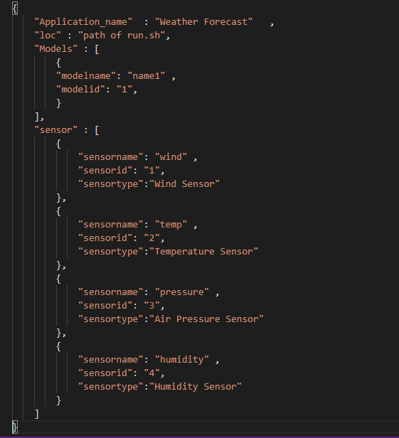

**Model Contract:**

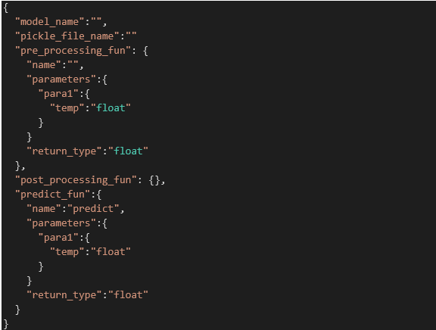

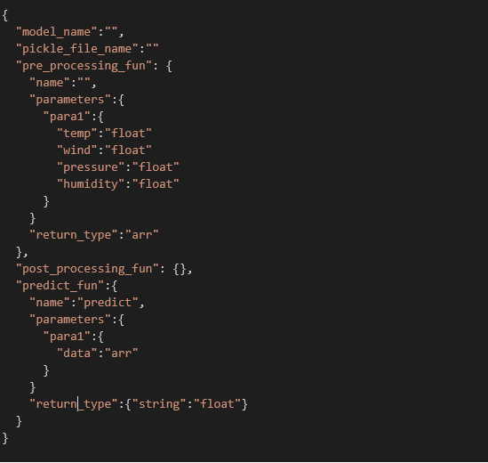

**End User Flow:**

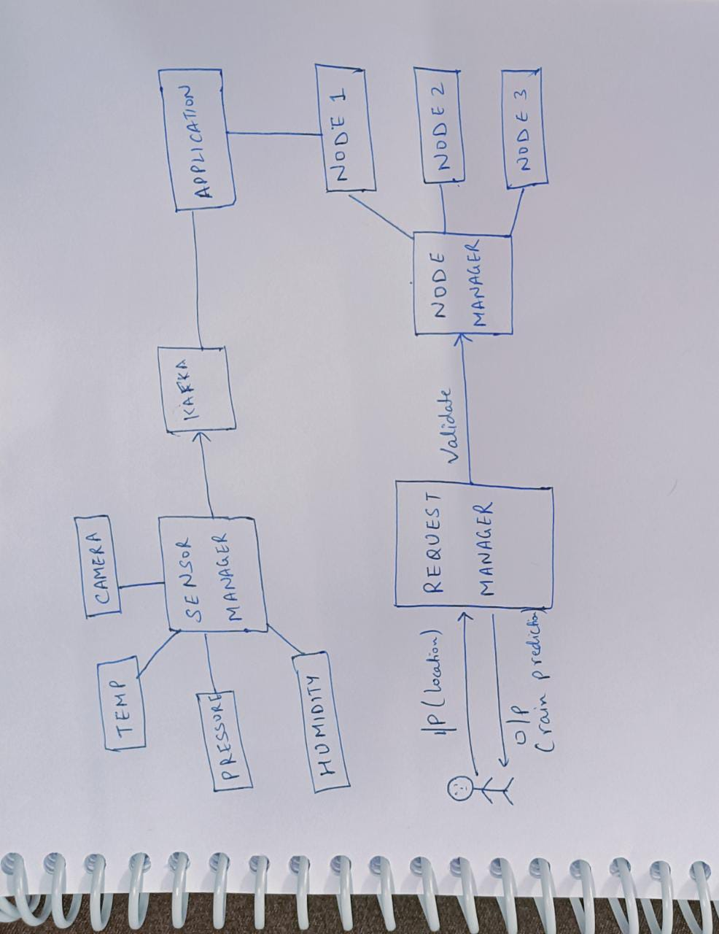

**Artifact Diagram**

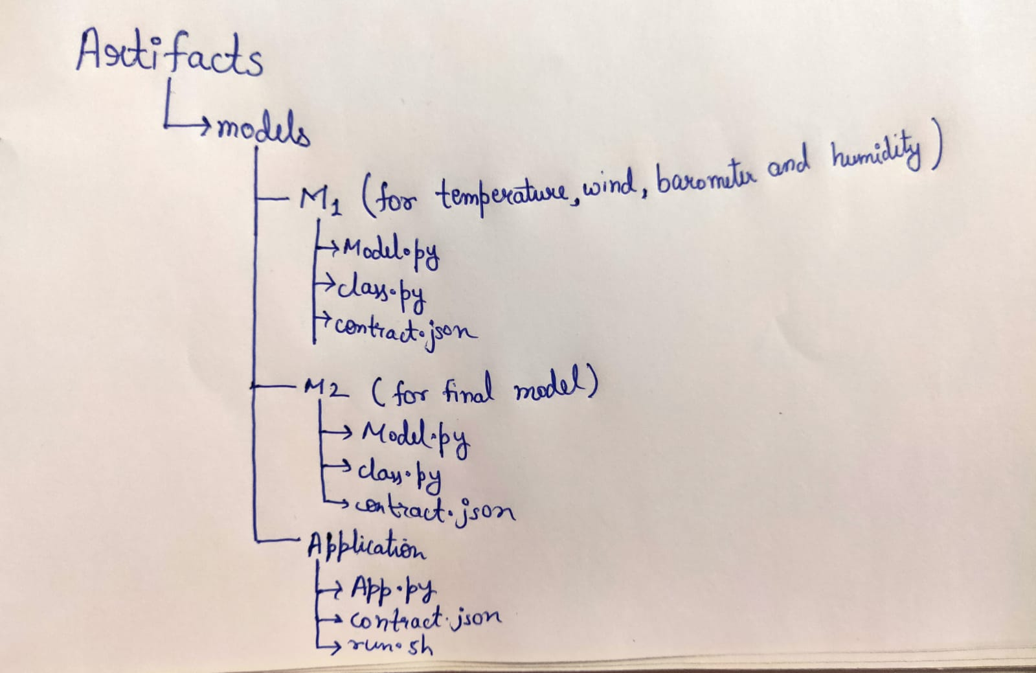

**App Flow:**

