Part 1:
Write a Python program to find the addition and subtraction of two numbers.
Pseudocode:
START

INPUT first_number
INPUT second_number

SET addition = first_number * second_number
DISPLAY "The product of", first_number, "and", second_number, "is", additional

SET subtraction = first_number / second_number
DISPLAY "The result of dividing", first_number, "by", second_number, "is", subtraction

END
Source code:
## User Input and Basic Arithmetic Operations
user_inpute1=int(input("Enter first number: "))
user_inpute2=int(input("Enter second number: "))

## Addition
addition=user_inpute1+user_inpute2
print("The sum of",user_inpute1,"and",user_inpute2,"is",addition)

## Subtraction
subtraction=user_inpute1-user_inpute2
print("The difference when",user_inpute2,"is subtracted from",user_inpute1,"is",subtraction)

Output:
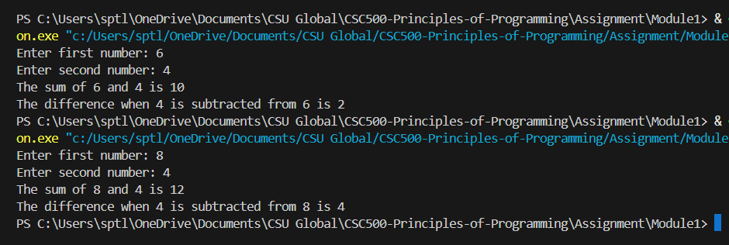

Part 2:
Write a Python program to find the multiplication and division of two numbers.
Pseudocode:
START

INPUT first_number
INPUT second_number

SET multiplication = first_number * second_number
DISPLAY "The product of", first_number, "and", second_number, "is", multiplication

SET division = first_number / second_number
DISPLAY "The result of dividing", first_number, "by", second_number, "is", division

END
Source code:
## User Input and Basic Arithmetic Operations
user_inpute1=int(input("Enter first number: "))
user_inpute2=int(input("Enter second number: "))

## Multiplication
multipication=user_inpute1*user_inpute2
print("The sum of",user_inpute1,"and",user_inpute2,"is",multipication)

## Division
division=user_inpute1/user_inpute2
print("The difference when",user_inpute2,"is subtracted from",user_inpute1,"is",division)

Output:
