Part 1
# Write a program that calculates the total amount of a meal purchased at a restaurant. The # program should ask the user to enter the charge for the food and then calculate the
# amounts with an 18 percent tip and 7 percent sales tax. Display each of these amounts and the total price.

#constant
TIP_RATE=0.18
TAX_RATE=0.07

# input total number of meals
total_meal=int(input("Enter total number of meals: "))

# input meals
meals = {}

for meal in range(total_meal):
meal_name = input("Enter meal name: ")
meal_price = float(input("Enter meal price: "))
meals[meal_name] = meal_price

# receipt header
print("\n" + "=" * 35)
print(f" YOUR RECEIPT")
print("=" * 35)
print(f"{'Item':20}{'Price':>10}")
print("-" * 35)

# print meal items
for meal_name, meal_price in meals.items():
print(f"{meal_name:20}{meal_price:>9.2f} $")

print("-" * 35)

# calculations
food_charge = sum(meals.values())
tip = food_charge * TIP_RATE
tax = food_charge * TAX_RATE
total_bill = food_charge + tip + tax

# summary section
print(f"{'Subtotal':20}{food_charge:>9.2f} $")
print(f"{'Tip (18 %)':20}{tip:>9.2f} $")
print(f"{'Tax (7 %)':20}{tax:>9.2f} $")
print("-" * 35)
print(f"{'TOTAL':20}{total_bill:>9.2f} $")
print("=" * 35)
print(" Thank you! Visit again ")
print("=" * 35)
Output :
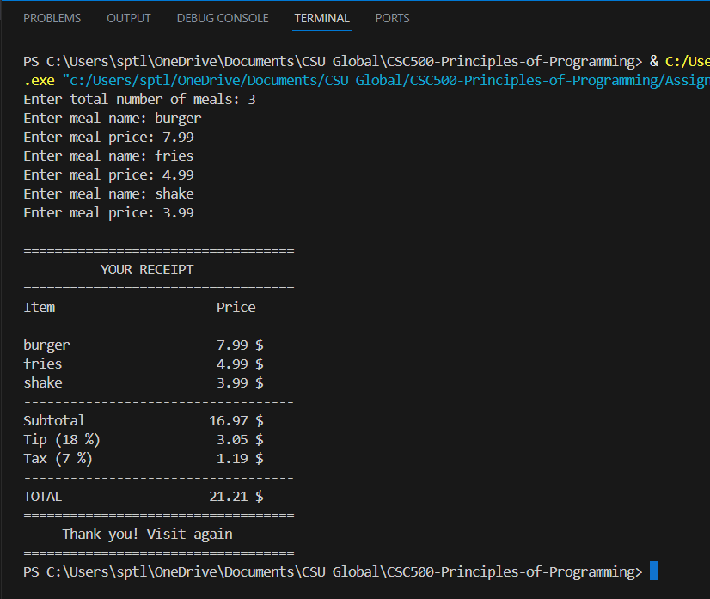

Github linke : Part1.py

Part 2
# Many people keep time using a 24-hour clock (11 is 11am and 23 is 11pm, 0 is midnight).
# If it is currently 13 and you set your alarm to go off in 50 hours, it will be 15 (3pm).
# Write a Python program to solve the general version of the above problem. Ask the user
# for the time now (in hours) and then ask for the number of hours to wait for the alarm.
# Your program should output what the time will be on a 24-hour clock when the alarm goes off.

current_time = int(input("Enter current time in hours (0-23): "))
# Hours to wait before arriving
wait_time = int(input("Enter wait time in hours: "))

# Wrap around the 24-hour clock using modulo to keep the hour in 0-23
arrival_time = (current_time + wait_time) % 24

# Convert to 12-hour format with an A.M./P.M. label
if arrival_time < 12:
print("The arrival time is:", 12 if arrival_time == 0 else arrival_time, "A.M.")
else:
arrival_time -= 12
print("The arrival time is:", 12 if arrival_time == 0 else arrival_time, "P.M.")

Output :
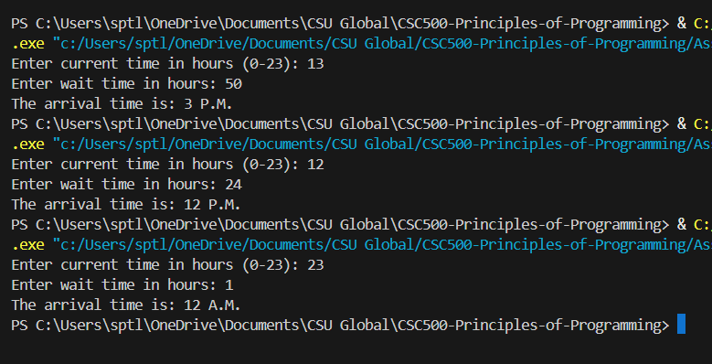
GitHub link : Part2.py

