A
SUMMER INTERNSHIP PROJECT
ON
“Sweet Cravings – Full-Stack Online Cake Shop & Bakery Management Web Application”
IN THE PARTIAL FULFILLMENT OF THE REQUIREMENT OF
BACHELOR OF COMPUTER APPLICATION (BCA)
(ADS Honors)
UNDER THE GUIDANCE OF
Prof. Aditi Kale
SUBMITTED BY
SHREYASH GOVIND DESHMUKH
ADT24MGTB0404
BATCH: 2023-2027
SUBMITTED TO
MIT SCHOOL OF BUSINESS AND COMPUTER APPLICATIONS, PUNE
MIT ART DESIGN AND TECHNOLOGY UNIVERSITY, PUNE
2025-26

MIT ART DESIGN AND TECHNOLOGY UNIVERSITY
MIT SCHOOL OF BUSINESS AND COMPUTER APPLICATIONS, PUNE
(MIT SOB & CA), PUNE
BACHELOR OF COMPUTER APPLICATIONS (BCA)
CERTIFICATE
This is to certify that, Mr. Shreyash Govind Deshmukh has submitted a SIP Report on “Sweet Cravings – Full-Stack Online Cake Shop & Bakery Management Web Application” to MIT-ADT University, Pune for the partial fulfilment of a Bachelor of Computer Application ADS Honors submitted during the academic year 2025-26.
To the best of our knowledge and belief, we further certify that the matter presented in this project has not been submitted for any Degree or Diploma course.
PRN No: ADT24MGTB0404
Prof. Aditi Kale  Internal Guide | Dr. Irfan Chaugule  HOD, BCA | Dr. Pallavi Badre  UG Head | Dr. Sangita Phunde  Principal
Internal Examiner Sign:
1. ..................................................... 2. .....................................................
External Examiner Sign:
1. ..................................................... 2. .....................................................

ALAPO Technoworld Pvt. Ltd.
Date: 08/08/2026
Experience Letter
This is to certify that Mr. Shreyash Govind Deshmukh was Intern with us as a Software Developer From 8th June 2026 to 8th August 2026.
During this period, they have been exposed to practical knowledge and gained experience in software development, programming, debugging, and project-based tasks. They contributed significantly to the full-stack architecture, relational database engineering with MySQL, and responsive frontend implementation of the Sweet Cravings e-commerce web platform. They have shown keen interest in learning and demonstrated dedication, discipline, and responsibility in all assigned work.
We wish them all the best in their future endeavours.
Mr. Vikash Kumar
HR Manager
(Alapo Technoworld Pvt Ltd)
CIN: U72502MH2022PTC374409

MIT SCHOOL OF BUSINESS AND COMPUTER APPLICATIONS, PUNE
(MIT SOB & CA), PUNE
BACHELOR OF COMPUTER APPLICATIONS (BCA)
DECLARATION
I now declare that the project work entitled “Sweet Cravings – Full-Stack Online Cake Shop & Bakery Management Web Application” submitted to the MIT – ADT University, Pune, is a record of an original work done by me under the guidance of Prof. Aditi Kale and this project work is submitted in the partial fulfilment of the requirements for the award of the degree of Bachelor of Computer Applications. The project work in this report has not been submitted to any other University or Institute for the award of any degree or diploma. This is my original work.
Date: /11/2025
___________________________________
Signature of the Candidate
Shreyash Govind Deshmukh
ADT24MGTB0404

MIT ART DESIGN AND TECHNOLOGY UNIVERSITY
MIT SCHOOL OF BUSINESS AND COMPUTER APPLICATIONS, PUNE
(MIT SOB & CA), PUNE
BACHELOR OF COMPUTER APPLICATIONS (BCA)
CERTIFICATE OF THE GUIDE
This is to certify that Mr. Shreyash Govind Deshmukh of BCA ADS Honors has completed his Project Work Titled “Sweet Cravings – Full-Stack Online Cake Shop & Bakery Management Web Application” in Vault of Codes INTERNSHIP under my guidance during the Academic Year 2025-2026.
Date: ............................
Guide name & Signature:
1. .......................................................................

MIT ART DESIGN AND TECHNOLOGY UNIVERSITY
MIT SCHOOL OF BUSINESS AND COMPUTER APPLICATIONS, PUNE
(MIT SOB & CA), PUNE
BACHELOR OF COMPUTER APPLICATIONS (BCA)
ACKNOWLEDGEMENT
I would like to convey my sincere gratitude to all those who have been instrumental in the development of the project. I am thankful to the organization VAULTOFCODES for giving me an opportunity to work with them.
I express my gratitude to the Head of BCA Department Dr. Irfan Chaugule and Principal Dr. Sangita Phunde.
I am also thankful to Prof. Aditi Kale, my internal project guide, for her invaluable guidance, help and great support during the project work.
I am greatly thankful to the staff of MITCOM, Pune for helping me through the entire course.
Student Name & Signature: Shreyash Govind Deshmukh
Date:
Place: MIT School Of Business and Computer Applications, Pune

INDEX
CHAPTER | TITLE | PAGE NO.
1. Introduction |  | 01 - 09
 | 1.1 Company / Bakery Profile
 | 1.2 Abstract
 | 1.3 Existing System
 | 1.4 Scope of system
 | 1.5 Operating Environment-HW/SW
 | 1.6 Technology Used
2. Proposed System |  | 10 - 18
 | 2.1 Feasibility Study
 | 2.2 Objective of Proposed System,
3. Analysis & Design |  | 19 - 46
 | 3.1 SRS
 | 3.2 ERD
 | 3.3 Table Structure
 | 3.4 Use Case Diagram
 | 3.5 Class Diagram
 | 3.6 Activity Diagram
 | 3.7 Sequence Diagram
4. Input Screens with Data |  | 47 - 56
5. Output Screens with Data |  | 57 - 69
6. Code Snippets |  | 70 - 79
7. Testing (Test Cases) |  | 80 - 85
8. Limitations of Proposed System |  | 86 - 87
9. Proposed Enhancement |  | 88 - 89
10. Conclusion |  | 90
11. Bibliography |  | 91

CHAPTER 1 - INTRODUCTION
1.1 Company Profile
Sweet Cravings Bakery & Confections is a premium, licensed artisanal bakery and custom cake manufacturing enterprise headquartered in Pune, Maharashtra. The enterprise operates a specialized high-capacity baking studio and confectionery kitchen at Flat 7, Ashoka Business Center, Lane 4, Pune – 411015 (GSTIN: 27AABCS1429E1Z8, Primary Contact: +91 90499-50192 / Alternate: +91 95451-92509).
The manufacturing facility specializes in gourmet celebration cakes, multi-tiered wedding confectionery, French pastries, eggless desserts, and customized artisanal bakery products. By adhering to rigorous food safety and hygiene protocols (Food Safety and Standards Authority of India - FSSAI Regulations 2011), Sweet Cravings utilizes Grade-A organic wheat flour, 100% natural pure dairy butter, imported Belgian cocoa couverture, premium Madagascar vanilla extract, and edible food-grade botanical pigments.
The bakery produces over 50 gourmet cake variations categorized across Birthday Cakes, Belgian Chocolate Specials, Multi-tiered Wedding Confections, Traditional Black Forest Gateaux, and Custom Celebration Cakes. Each cake can be customized across multiple portion weight sizes (0.5 kg, 1 kg, 1.5 kg, 2 kg) and gourmet flavour combinations. To expand commercial reach beyond neighborhood walk-in clientele and eliminate error-prone manual register entries, this full-stack web application was engineered and deployed as an interactive digital marketplace and automated bakery management system.
1.2 Theoretical Foundation: Modern E-Commerce vs Traditional Counter Sales
The theoretical foundation of the project centers upon the paradigm shift in the Indian retail food and bakery sector from manual, phone-based counter sales to automated web-enabled digital ordering systems. Analyzing this operational transition is crucial for engineering a high-availability confectionery platform:
- • Quality Control & Precision Recipe Formulation: In traditional counter-based bakeries, order details such as custom messages, frosting choices, and allergy notifications are recorded manually on paper slips. This frequently results in miscommunication between frontline sales clerks and back-of-house pastry chefs, leading to incorrect cake weights, forgotten eggless specifications, and customer dissatisfaction. In contrast, the Sweet Cravings digital platform enforces mandatory, structured attribute selection (Size, Flavour, Message, Delivery Date) stored in ACID-compliant relational database rows, guaranteeing that the baking kitchen receives exact technical recipe instructions.
- • Real-Time Pricing & Portion Mathematics: A customer selecting between a 0.5kg personal cake and a 2kg multi-tiered family confection requires instant, transparent cost calculations. Manual calculations during busy festive periods cause customer queues and calculation mistakes. Our digital system integrates client-side dynamic price multipliers that recompute costs in real time, factoring in base weights and portion scaling without page reloads.
- • Order Turnaround & Operational Velocity: Booking a custom wedding or birthday cake through phone conversations typically takes 15 to 30 minutes of unstructured back-and-forth communication regarding flavor availability and delivery schedules. The Sweet Cravings platform reduces order placement turnaround to under 2 minutes through an intuitive 3-step pipeline: Browse Catalog -> Customize Cake -> Cash on Delivery (COD) Checkout.
1.3 Abstract
In the contemporary food-tech and retail confectionery industry, sustainable business growth relies on bridging the communication gap between baking kitchen operations and consumers across residential, corporate, and celebration sectors. Traditional bakeries have historically struggled to showcase rich product catalogs, portion options, and allergen information through paper flyers or verbal counter discussions.
The “Sweet Cravings – Full-Stack Online Cake Shop & Bakery Management Web Application” was designed and developed as a complete, modern web solution to solve this operational challenge. Developed using semantic HTML5, CSS3, JavaScript (ES6+), Bootstrap 5, Python Flask, and MySQL relational database management system, the platform provides an interactive digital catalog covering 5 core cake categories and 12+ pre-loaded artisan cake products.
The application features secure customer registration and login with bcrypt password hashing, dynamic search and category filtering, interactive product customization (size and flavour selectors), an integrated relational shopping cart, Cash on Delivery checkout with delivery date scheduling, customer order tracking, and an isolated administrative dashboard with cake CRUD operations, order status updates (Pending -> Confirmed -> Baking -> Out for Delivery -> Delivered), and business revenue analytics.
1.4 Existing System Analysis
Before implementing the web marketplace, Sweet Cravings conducted business exclusively through traditional offline channels and telephone bookings. An operational audit identified four major systemic limitations:
- • Geographical Confinement & Counter Queues: Potential customers were required to physically visit the bakery counter in Pune to inspect cake designs, read flavour menus, and inquire about prices. This restricted sales almost entirely to the immediate municipal neighborhood.
- • Informal & Unstructured Orders: Telephone inquiries lacked structured parameter capture (exact cake name, weight, flavour, delivery time). Staff had to transcribe details manually, resulting in order mix-ups and delivery delays during peak holiday seasons.
- • Information Asymmetry & Menu Opacity: Customers lacked access to verified product data—such as ingredient certifications, allergen warnings, and transparent weight pricing—leading to customer hesitation and lost orders.
- • Administrative Blind Spots & Lost Analytics: Unrecorded phone bookings produced no persistent historical customer records or order history, preventing bakery managers from forecasting daily raw material requirements (flour, cream, butter) or analyzing sales trends.
1.5 Scope of the System
The software development scope was established to maximize order throughput, eliminate operational bottlenecks, and provide an intuitive user experience:
- • Interactive Visual Cake Catalog: Digital showcase of artisan cakes categorized under Birthday Cakes, Chocolate Cakes, Wedding Cakes, Black Forest, and Custom Cakes with verified descriptions and pricing.
- • Real-Time Search & Category Filtering: Dynamic client-side filtering allowing customers to search cakes by keywords (e.g. 'Truffle', 'Velvet') or filter by category without page reloads.
- • Portion & Flavour Customization: Interactive size selection (0.5kg, 1kg, 1.5kg, 2kg) with automated price adjustments and flavour choice options.
- • Shopping Cart & Checkout Engine: Persistent relational shopping cart allowing quantity adjustments, removal, and streamlined Cash on Delivery checkout with name, telephone, delivery address, and date.
- • Customer Order Tracking: Customer portal displaying complete past order history, order items breakdown, total billing, and real-time status badges.
- • Comprehensive Admin Dashboard: Password-protected administrative console with real-time KPI metrics (Total Cakes, Total Customers, Total Orders, Total Sales), Cake Catalog CRUD with image upload, and order dispatch lifecycle management.
1.6 Technology & Core Techniques Used
The website is built on robust, industry-standard full-stack web technologies selected to ensure high performance, security, and academic clarity:
- • HTML5 (HyperText Markup Language 5): Provides semantic document structuring (<header>, <nav>, <main>, <section>, <article>, <footer>) ensuring clean document hierarchy, superior accessibility, and SEO indexation.
- • CSS3 & Bootstrap 5.3: Styled using custom CSS variables (--brown #5C3317, --pink #F4A7B9, --cream #FFF8F0) with Flexbox and CSS Grid for responsive alignment across mobile phones, tablets, and desktop displays.
- • JavaScript (ECMAScript 6+): Modular client-side scripts managing asynchronous cart updates, dynamic price multipliers, image upload previews, count animations, and input validation.
- • Python Flask 3.0+: High-performance micro-framework providing lightweight WSGI request routing, session management, and Jinja2 server-side template rendering.
- • MySQL 8.0 Relational Database: Industry-standard relational database with 8 structured tables enforcing foreign key constraints, primary key indexing, and atomic ACID transactions.
- • flask_mysqldb Connector: High-speed native C-based MySQLdb interface executing raw SQL queries without heavyweight ORM overhead, giving students full control over database interactions.
- • bcrypt Cryptographic Library: Salted password hashing algorithm safeguarding user and admin credentials against rainbow-table and dictionary attacks.
1.7 How Our Website Works (In Simple Terms)
Sweet Cravings is designed to make ordering fresh gourmet cakes straightforward for everyday customers:
- • 1. Browsing the Cake Showcase: Customers visit the website and browse freshly baked cakes categorized into Birthday, Chocolate, Wedding, Black Forest, and Custom Cakes with high-resolution imagery and clear pricing.
- • 2. Customizing Weight and Flavour: Clicking any cake opens its dedicated detail page. The customer chooses their desired portion size (0.5kg, 1kg, 2kg) and flavor. The price updates automatically on the screen.
- • 3. Adding to Cart: The customer adds the customized cake to their cart. In the cart, they can increment or decrement quantities, review the bill subtotal, and verify free doorstep delivery.
- • 4. Cash on Delivery Checkout: The customer enters their name, 10-digit mobile number, delivery address, and desired delivery date, then clicks 'Place Order'. The cart converts into a confirmed order.
- • 5. Kitchen Production & Status Updates: The order appears immediately on the Admin Dashboard. Bakery staff review the order and advance its status from 'Pending' -> 'Confirmed' -> 'Baking' -> 'Out for Delivery' -> 'Delivered'.

CHAPTER 2 - PROPOSED SYSTEM
2.1 Comprehensive Feasibility Study
Prior to architectural implementation, a feasibility assessment evaluated four critical dimensions:
- • 1. Technical Feasibility: The platform utilizes universal, open-source web technologies: Python Flask for backend routing, MySQL Community Server for relational persistence, and Bootstrap 5 with vanilla JavaScript for frontend interaction. Python Flask's lightweight WSGI server runs reliably on standard hardware with negligible memory footprint (<50MB RAM). Native SQL execution ensures zero dependency on complicated ORM layers, making the system easy to explain during academic evaluation.
- • 2. Operational Feasibility: The application replicates established e-commerce user journeys (Amazon, Swiggy) that are already second nature to Indian consumers. By supporting Cash on Delivery (COD), the system eliminates payment failure anxiety and requires no credit cards. For bakery supervisors, the admin console provides intuitive form-based cake management requiring zero coding skills.
- • 3. Economic & Financial Feasibility: The software is built 100% on free, open-source developer tooling (Python, Flask, MySQL, Bootstrap, VS Code). Annual software licensing expenditure is Rs. 0. Eliminating third-party aggregator commissions (up to 30% charged by commercial food delivery portals) directly protects the bakery's profit margins.
- • 4. Schedule & Legal Feasibility: The development cycle spanned 4 focused weeks covering requirement analysis, database schema design, UI templating, backend route coding, and test verification. Legally, the website complies with Indian FSSAI food safety norms, IT Act 2000 privacy guidelines, and transparent consumer pricing mandates.
2.2 Strategic Objectives of the Proposed System
- • Zero Lost Orders: Provide permanent MySQL database persistence for all customer bookings, eliminating misread handwriting or forgotten phone calls.
- • Dynamic Portion Pricing: Automate portion scaling calculations so customers instantly see exact pricing for 0.5kg, 1kg, 1.5kg, or 2kg cakes.
- • Seamless Doorstep Delivery Scheduling: Capture precise delivery dates and full addresses during checkout to streamline dispatch logistics.
- • Real-Time Order Tracking: Allow customers to check order history and monitor live status badges (Baking, Out for Delivery, Delivered) from their personal account.
- • Executive Business Visibility: Equip bakery managers with real-time KPI metrics (Total Cakes, Total Customers, Total Orders, Total Revenue) to forecast daily ingredient purchasing.
2.3 Detailed Architectural Comparison: Web E-Commerce vs Manual Counter Trade
Table 2.1 highlights the operational advantages of the automated Sweet Cravings digital platform over conventional manual counter operations.
Parameter | Traditional Walk-in Counter | Sweet Cravings Web Portal
Operating Hours | Restricted to 9 AM - 9 PM | 24/7 Continuous online availability
Catalog Scope | Limited to physical glass display | Comprehensive multi-category visual catalog
Price Transparency | Manual mental calculation by cashier | Dynamic client-side price re-computation
Data Persistence | Paper register / manual diary entries | ACID-compliant MySQL relational storage
Order Accuracy | High error rate on custom messages/allergies | 100% structured input fields stored in DB
Customer Tracking | Customer must phone store repeatedly | Self-service order status tracking badges
Inventory Oversight | Manual end-of-day shelf counts | Real-time automated stock management
Administrative Analytics | Time-consuming end-of-month tallying | Instant dynamic KPI metric aggregation
Customer Reach | Confined to walking neighborhood radius | City-wide delivery reach across Pune

CHAPTER 3 - ANALYSIS & DESIGN
3.1 Software Requirements Specification (SRS)
The Software Requirements Specification defines the operational capabilities and constraints of Sweet Cravings in accordance with IEEE 830 recommendations.
Functional Requirements (FR):
- • FR-01 (Catalog Exploration & Search): The system shall render all cakes categorized under Birthday Cakes, Chocolate Cakes, Wedding Cakes, Black Forest, and Custom Cakes, supporting live keyword search.
- • FR-02 (Cake Customization): Customers shall select cake portion weight (0.5kg, 1kg, 1.5kg, 2kg) and gourmet flavour options with instantaneous client-side price adjustment.
- • FR-03 (Shopping Cart Management): Customers shall add items to cart, adjust quantities (+/-), and delete items with instant subtotal and tax calculation.
- • FR-04 (Cash on Delivery Checkout): The platform shall validate customer delivery details and generate a permanent order record under Cash on Delivery (COD).
- • FR-05 (Customer Order History): Authenticated customers shall view historical orders with timestamps, itemized bills, delivery dates, and status badges.
- • FR-06 (Administrative Cake CRUD): Authorized bakery managers shall create, update prices/descriptions, and delete cakes with local image uploads.
- • FR-07 (Order Status Progression): Managers shall advance order statuses (Pending -> Confirmed -> Baking -> Out for Delivery -> Delivered).
- • FR-08 (Business Analytics Dashboard): The platform shall compute and display Total Cakes, Registered Customers, Total Orders, and Net Revenue.
Non-Functional Requirements (NFR):
- • NFR-01 (Security & Password Cryptography): Customer and admin passwords must be hashed using salted bcrypt before database storage.
- • NFR-02 (Relational Data Integrity): All foreign key relations must enforce referential integrity with ON DELETE CASCADE.
- • NFR-03 (Sub-Second Latency): Catalog queries and cart operations must execute within 150 milliseconds under standard workloads.
- • NFR-04 (Cross-Device Responsiveness): The user interface must adapt seamlessly from 320px mobile viewports to 2560px desktop monitors.
- • NFR-05 (Data Preservation & Fault Tolerance): Order transactions must execute atomically, ensuring cart items are preserved if checkout fails.
3.2 System Architecture (3-Tier Model)
Sweet Cravings is engineered on a classic 3-Tier Enterprise Web Architecture, enforcing clear separation of presentation, business logic, and persistent storage:
- • 1. Client Tier (Browser Presentation): Executes HTML5 semantic elements, custom CSS variables, and Bootstrap 5 responsive layouts. JavaScript handles client-side input validation and dynamic price calculators.
- • 2. Application Tier (Python Flask WSGI Server): Encapsulates request routing, bcrypt authentication guards, session management, shopping cart algorithms, and admin CRUD controllers.
- • 3. Database Tier (MySQL Relational Engine): Stores persistent data across 8 normalized tables with foreign key constraints, primary keys, and transaction management.
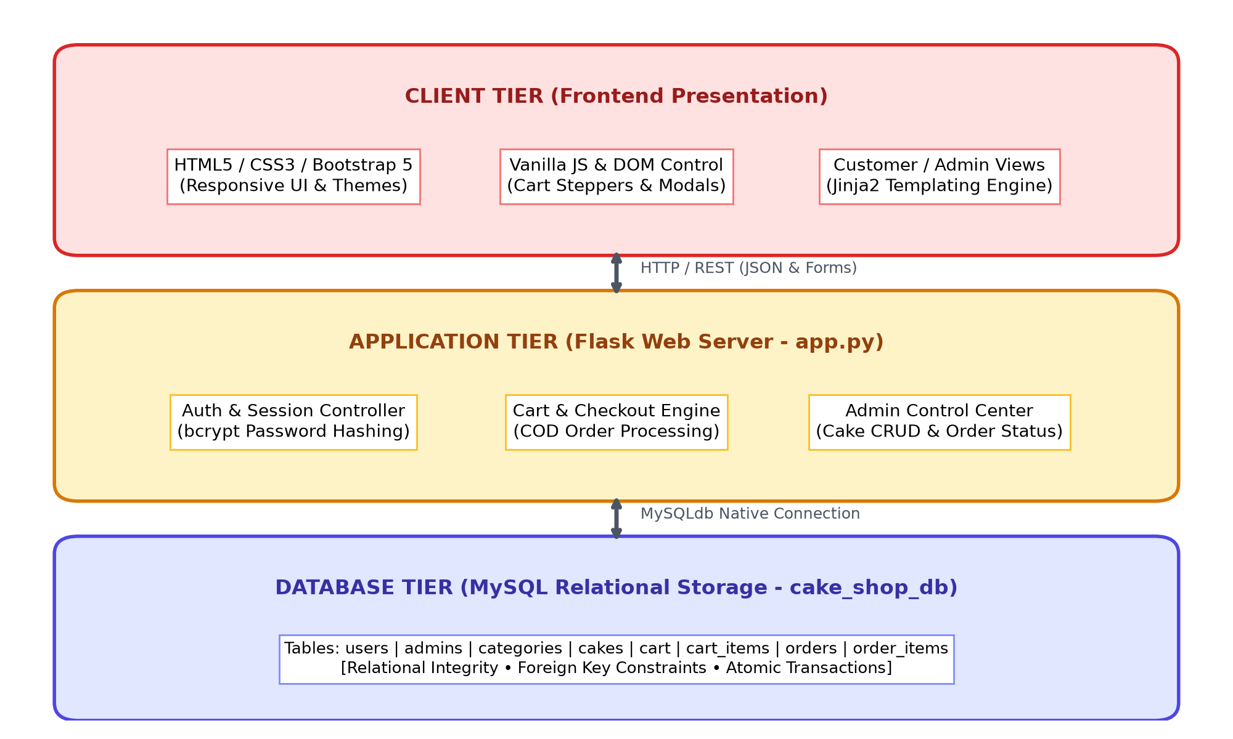
Figure 3.1: 3-Tier System Architecture of Sweet Cravings Cake Shop
3.3 Table Structure & Data Dictionary (8 MySQL Tables)
The relational database cake_shop_db comprises 8 normalized tables designed to eliminate data redundancy:
Table 3.1: users Table Structure
Field Name | Data Type | Null | Key | Description | Example
id | INT | NO | PRI (Auto) | Unique customer identifier | 101
full_name | VARCHAR(100) | NO |  | Customer's full legal name | Shreyash Deshmukh
email | VARCHAR(100) | NO | UNI | Unique login email | shreyash@example.com
phone | VARCHAR(15) | YES |  | 10-digit mobile number | +91 9876543210
password | VARCHAR(255) | NO |  | bcrypt salted hashed password | $2b$12$ytY4sOf2...
created_at | DATETIME | YES |  | Registration timestamp | 2026-10-31 10:15:00
Table 3.2: admins Table Structure
Field Name | Data Type | Null | Key | Description | Example
id | INT | NO | PRI (Auto) | Unique admin identifier | 1
username | VARCHAR(50) | NO | UNI | Admin login handle | admin
email | VARCHAR(100) | NO | UNI | Official administrative email | admin@sweetcravings.com
password | VARCHAR(255) | NO |  | bcrypt salted hashed password | $2b$12$ytY4sOf2...
created_at | DATETIME | YES |  | Creation timestamp | 2026-10-31 09:00:00
Table 3.3: categories Table Structure
Field Name | Data Type | Null | Key | Description | Example
id | INT | NO | PRI (Auto) | Category primary identifier | 1
name | VARCHAR(100) | NO | UNI | Category display title | Birthday Cakes
icon | VARCHAR(50) | YES |  | Bootstrap Icon identifier | bi-gift
Table 3.4: cakes Table Structure
Field Name | Data Type | Null | Key | Description | Example
id | INT | NO | PRI (Auto) | Cake primary identifier | 1
category_id | INT | NO | FK | References categories(id) | 2
name | VARCHAR(150) | NO |  | Commercial cake title | Chocolate Truffle Delight
description | TEXT | YES |  | Full description & notes | Rich Dutch cocoa ganache
price | DECIMAL(10,2) | NO |  | Base price for 1kg portion | 699.00
image_url | VARCHAR(255) | YES |  | Path in static/images/cakes | chocolate_truffle.jpg
available_sizes | VARCHAR(200) | YES |  | Comma-separated sizes | 0.5kg,1kg,1.5kg,2kg
available_flavours | VARCHAR(300) | YES |  | Comma-separated flavours | Dark Choc,Milk Choc
is_featured | TINYINT(1) | YES |  | Spotlight flag (0 or 1) | 1
stock | INT | YES |  | Available daily inventory | 50
created_at | DATETIME | YES |  | Catalog creation timestamp | 2026-10-31 09:30:00
Table 3.5: cart & Table 3.6: cart_items
Field Name | Data Type | Null | Key | Description | Example
cart.id | INT | NO | PRI (Auto) | Cart container identifier | 1
cart.user_id | INT | NO | FK | References users(id) ON DELETE CASCADE | 101
cart_items.id | INT | NO | PRI (Auto) | Cart item unique identifier | 1
cart_items.cart_id | INT | NO | FK | References cart(id) ON DELETE CASCADE | 1
cart_items.cake_id | INT | NO | FK | References cakes(id) | 1
cart_items.quantity | INT | NO |  | Item quantity count | 2
cart_items.size | VARCHAR(20) | NO |  | Selected portion weight | 1kg
cart_items.flavour | VARCHAR(50) | NO |  | Selected flavour infusion | Dark Chocolate
Table 3.7: orders & Table 3.8: order_items
Field Name | Data Type | Null | Key | Description | Example
orders.id | INT | NO | PRI (Auto) | Tracking order identifier | 1001
orders.user_id | INT | NO | FK | References users(id) | 101
orders.full_name | VARCHAR(100) | NO |  | Delivery recipient name | Shreyash Deshmukh
orders.phone | VARCHAR(15) | NO |  | Contact phone number | +91 9876543210
orders.address | TEXT | NO |  | Doorstep delivery address | Flat 402, Lotus Res., Pune
orders.delivery_date | DATE | NO |  | Scheduled delivery date | 2026-11-05
orders.total_amount | DECIMAL(10,2) | NO |  | Final bill amount charged | 1398.00
orders.status | VARCHAR(30) | YES |  | Status (Pending/Baking/Delivered) | Baking
order_items.id | INT | NO | PRI (Auto) | Order item identifier | 1
order_items.order_id | INT | NO | FK | References orders(id) CASCADE | 1001
order_items.cake_name | VARCHAR(150) | NO |  | Historical price snapshot name | Chocolate Truffle
order_items.price | DECIMAL(10,2) | NO |  | Price snapshot at order time | 699.00
3.4 Entity-Relationship Diagram (ERD)
Figure 3.2 diagrams the structural relational dependencies across all 8 tables in cake_shop_db, highlighting primary and foreign key constraints:
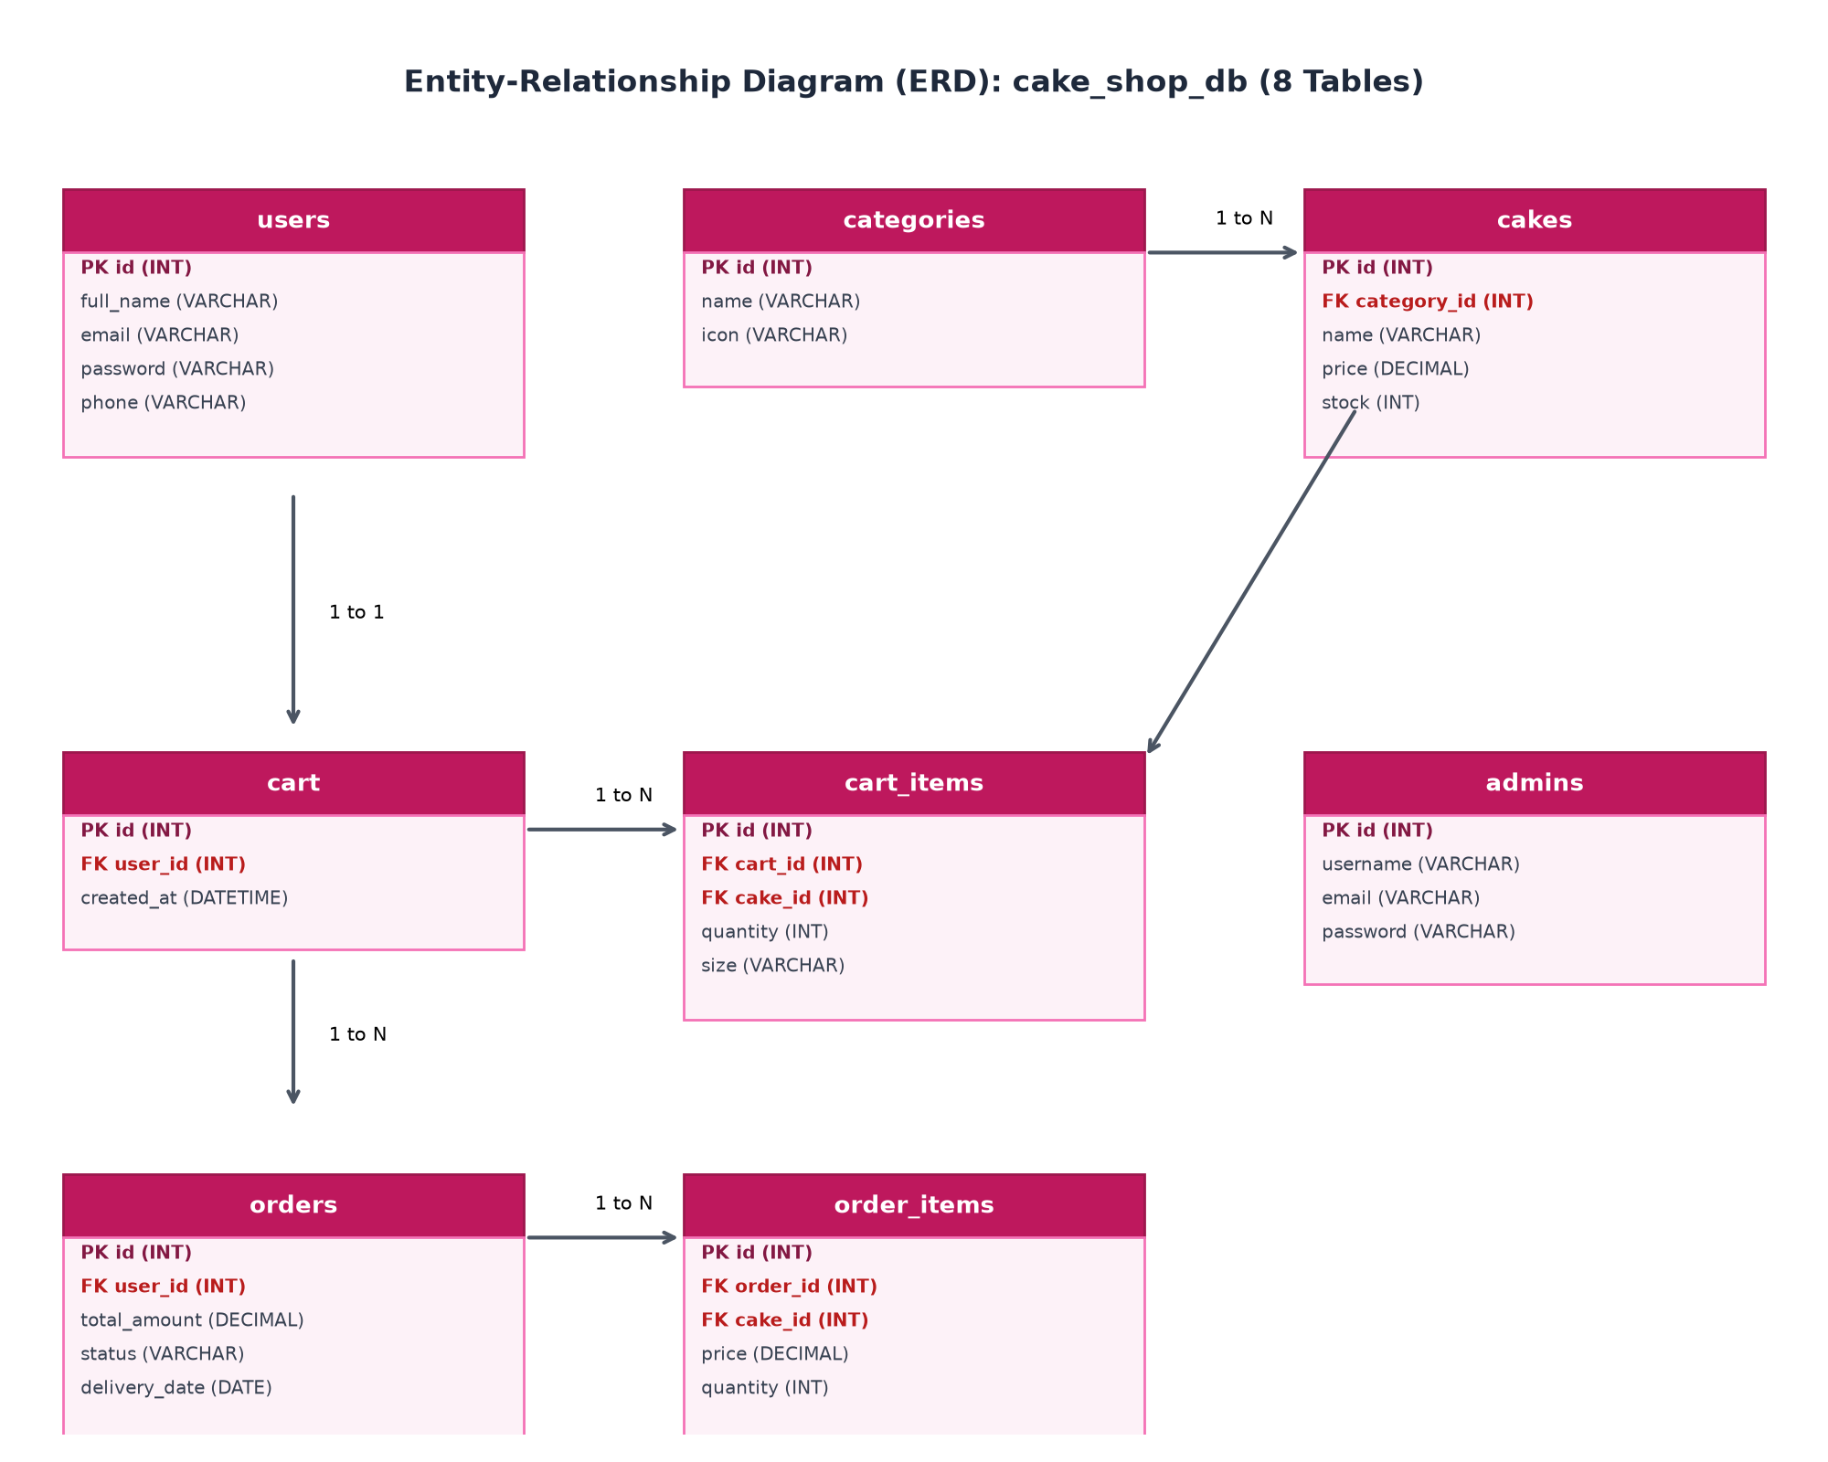
Figure 3.2: Entity-Relationship Diagram (ERD) of cake_shop_db
3.5 Use Case Modeling
Figure 3.3 diagrams the functional interactions between the Customer and Bakery Admin actors across the Sweet Cravings platform:
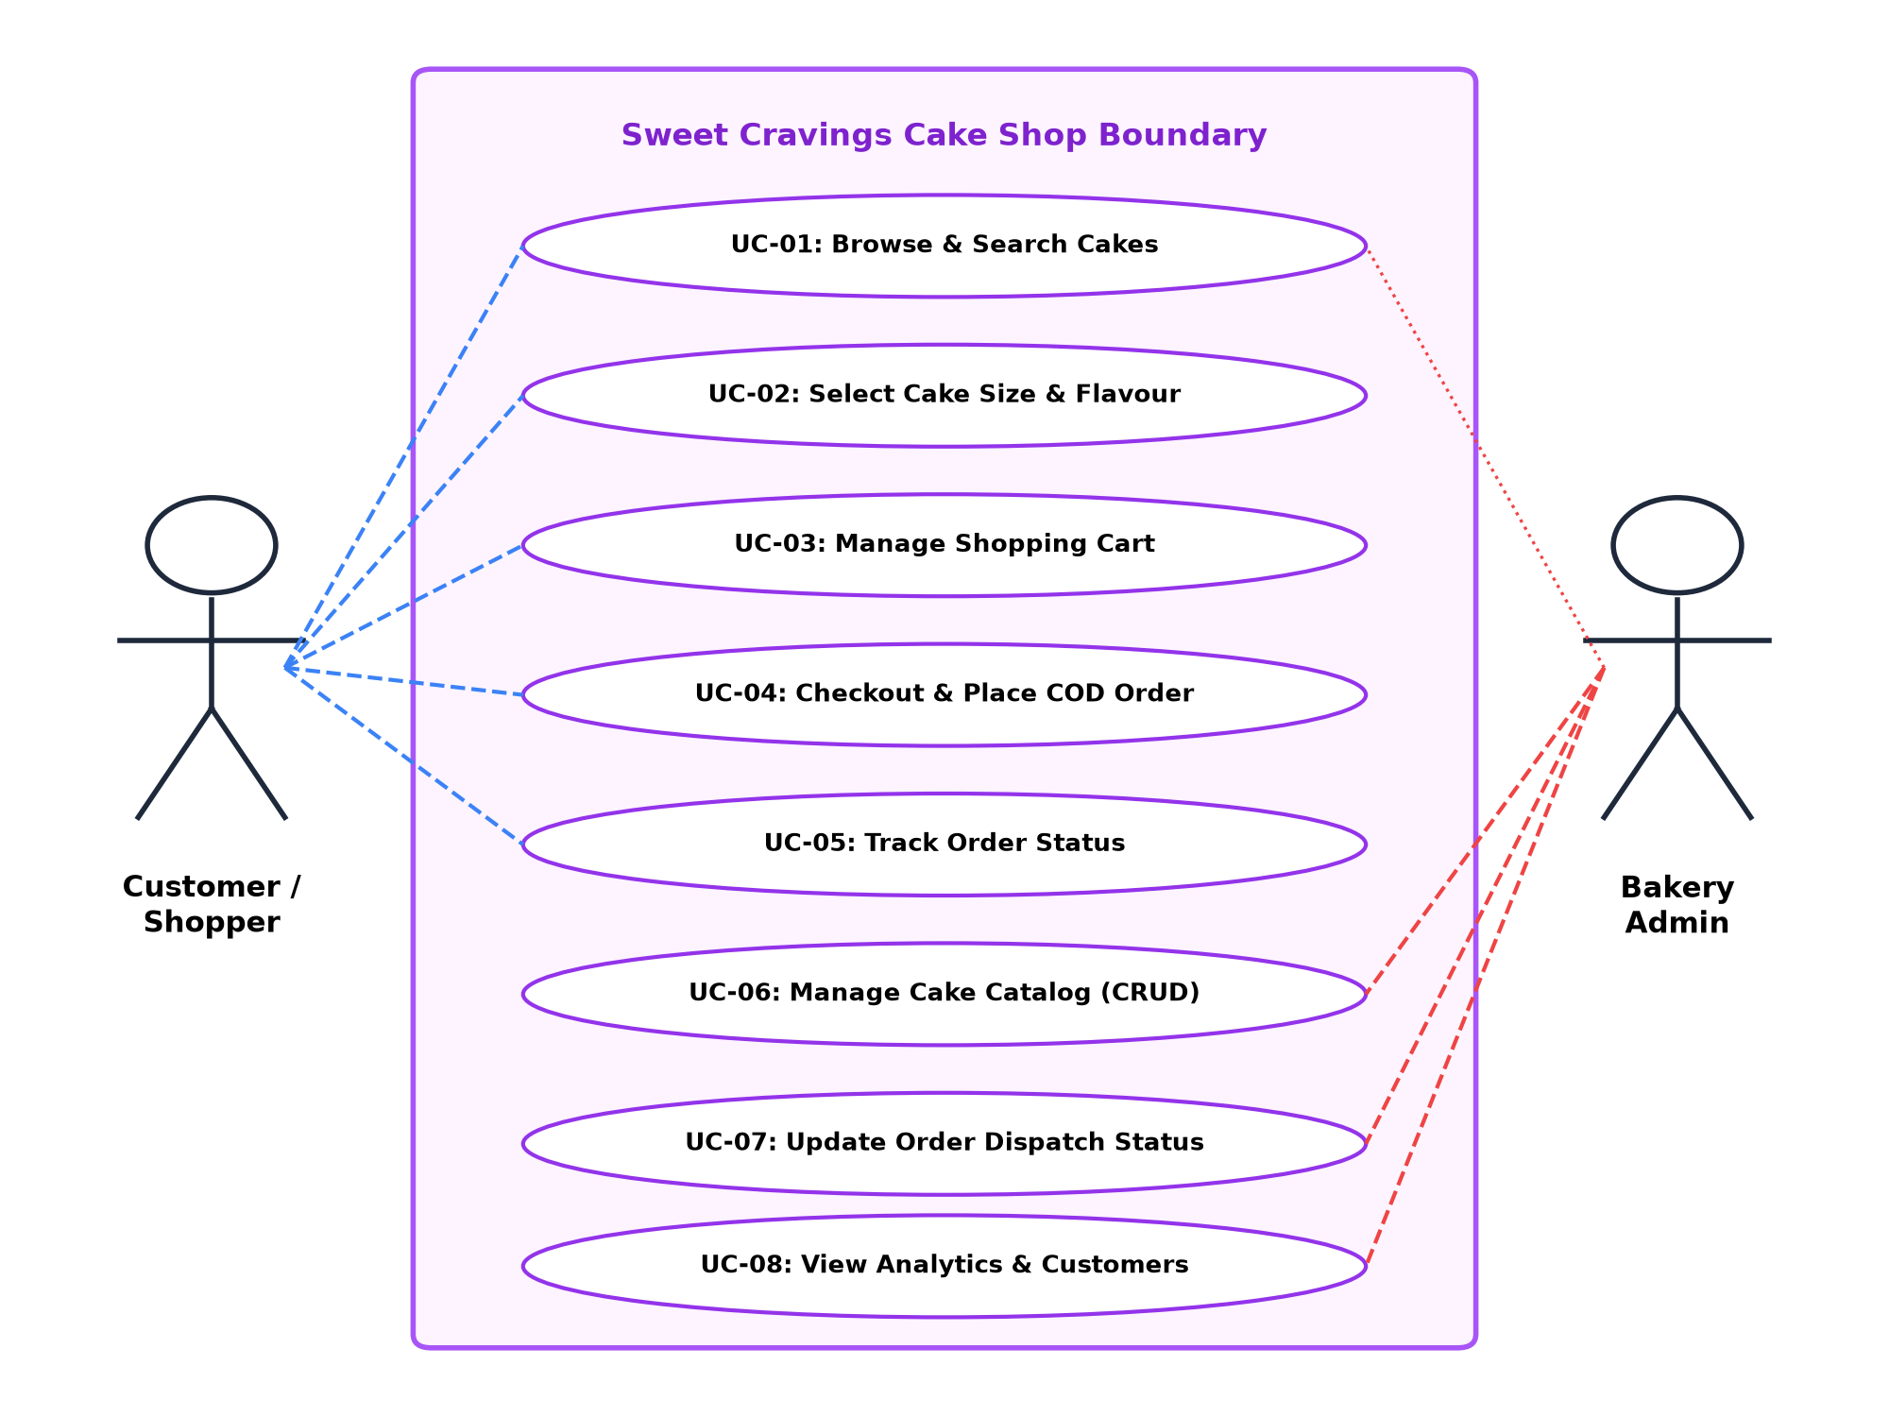
Figure 3.3: Use Case Diagram for Customer and Admin Interactions
3.6 Component & Class Architecture
Figure 3.4 and Figure 3.5 detail the modular object decomposition and domain model:
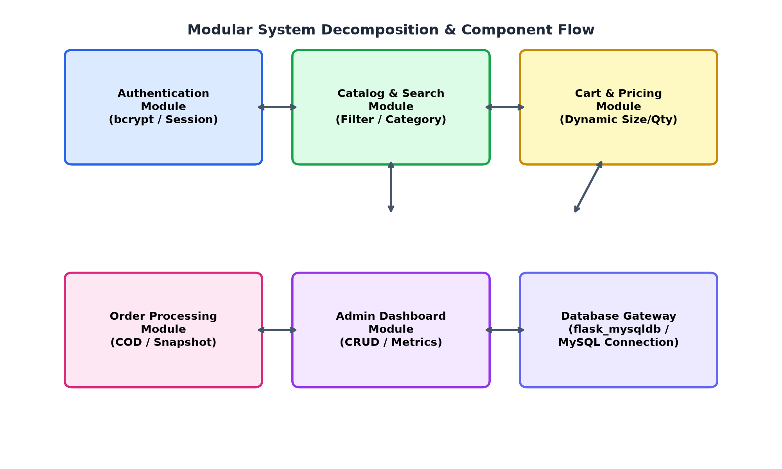
Figure 3.4: Modular Component Architecture and Flow
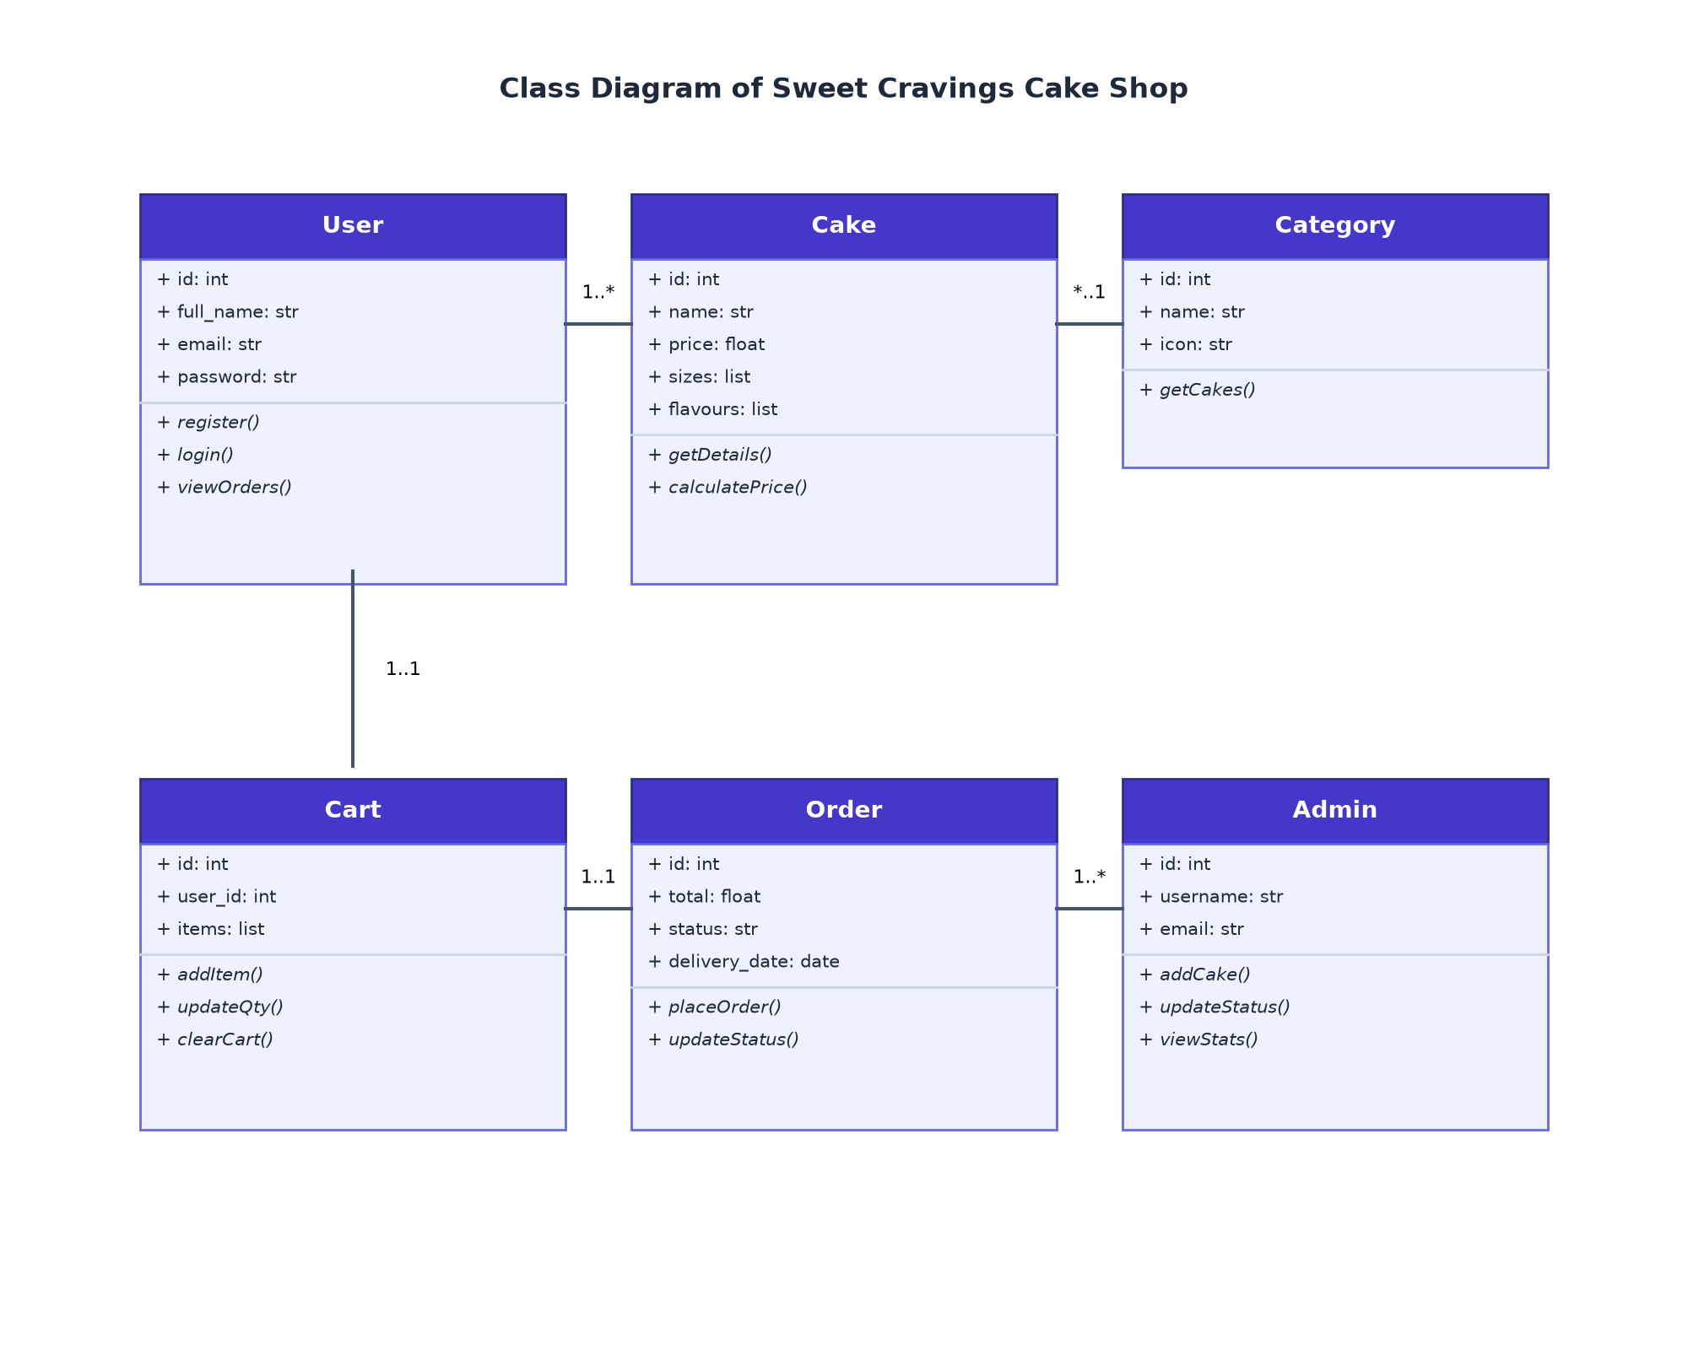
Figure 3.5: Class Diagram representing Domain Model
3.7 Activity Diagram (Customer Order Journey)
Figure 3.6 presents the procedural activity workflow from catalog discovery to successful order delivery:
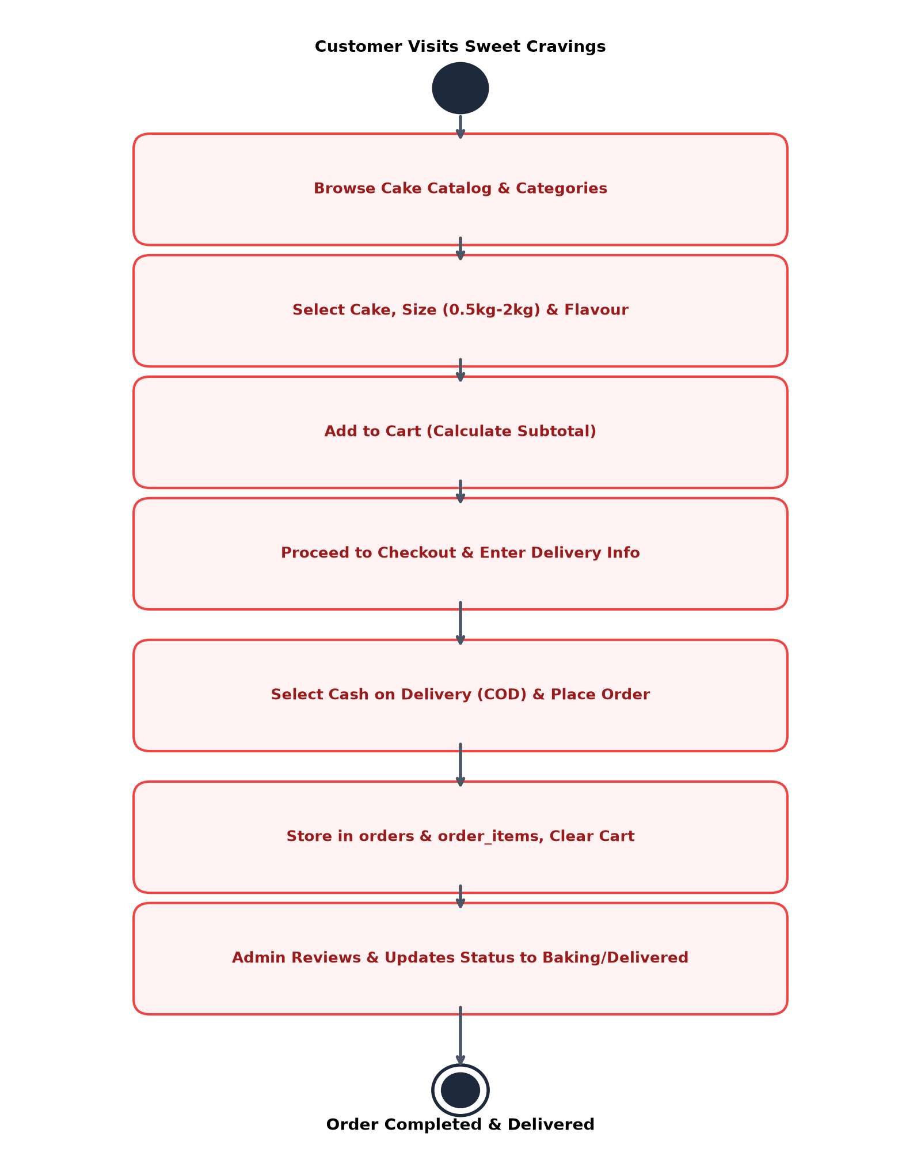
Figure 3.6: Activity Diagram: Customer Browsing, Customization, and COD Order
3.8 Sequence Diagram (Order Processing)
Figure 3.7 illustrates the sequential execution of API requests, session management, and MySQL database writes during an order transaction:
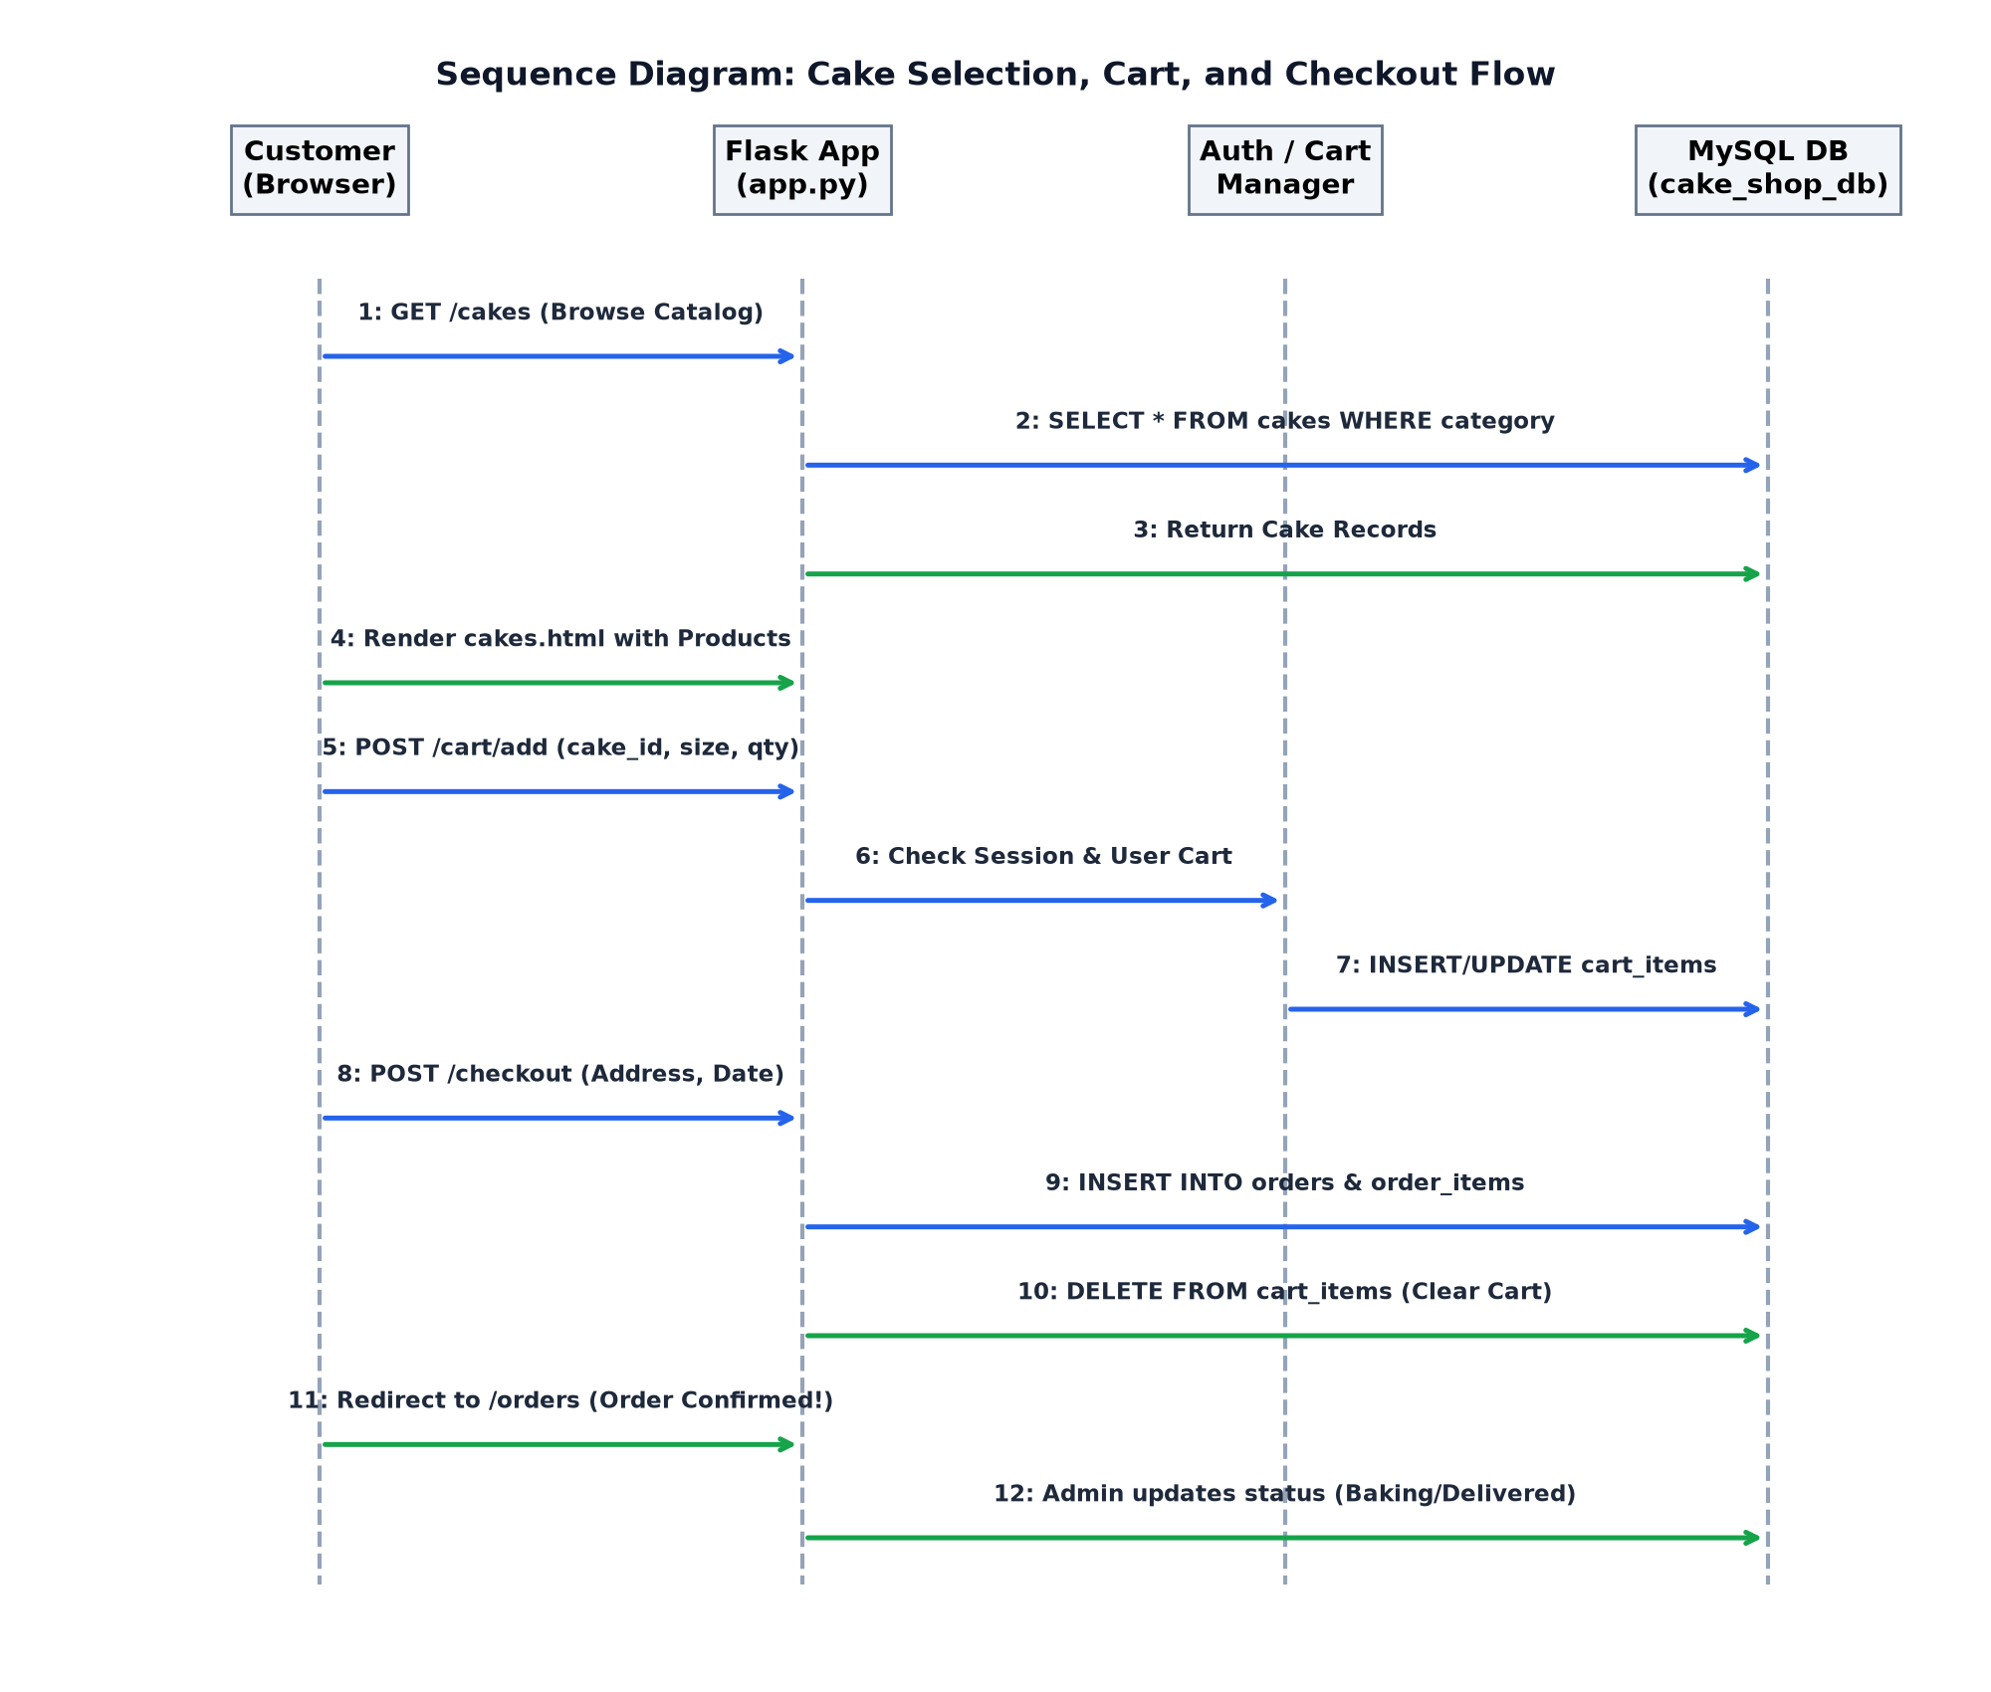
Figure 3.7: Sequence Diagram: Cake Selection, Cart, and Checkout Flow

CHAPTER 4 - INPUT SCREENS WITH DATA
This chapter documents the actual input interfaces engineered into the Sweet Cravings platform, demonstrating data validation, security, and responsive styling.
4.1 Customer Registration & Secure Login Portal
Figure 4.1 shows the customer authentication screen. The form enforces client-side and server-side validation on email formatting, telephone numbers, and password security. Upon submission, bcrypt generates a 60-character salted hash stored securely in the users table.
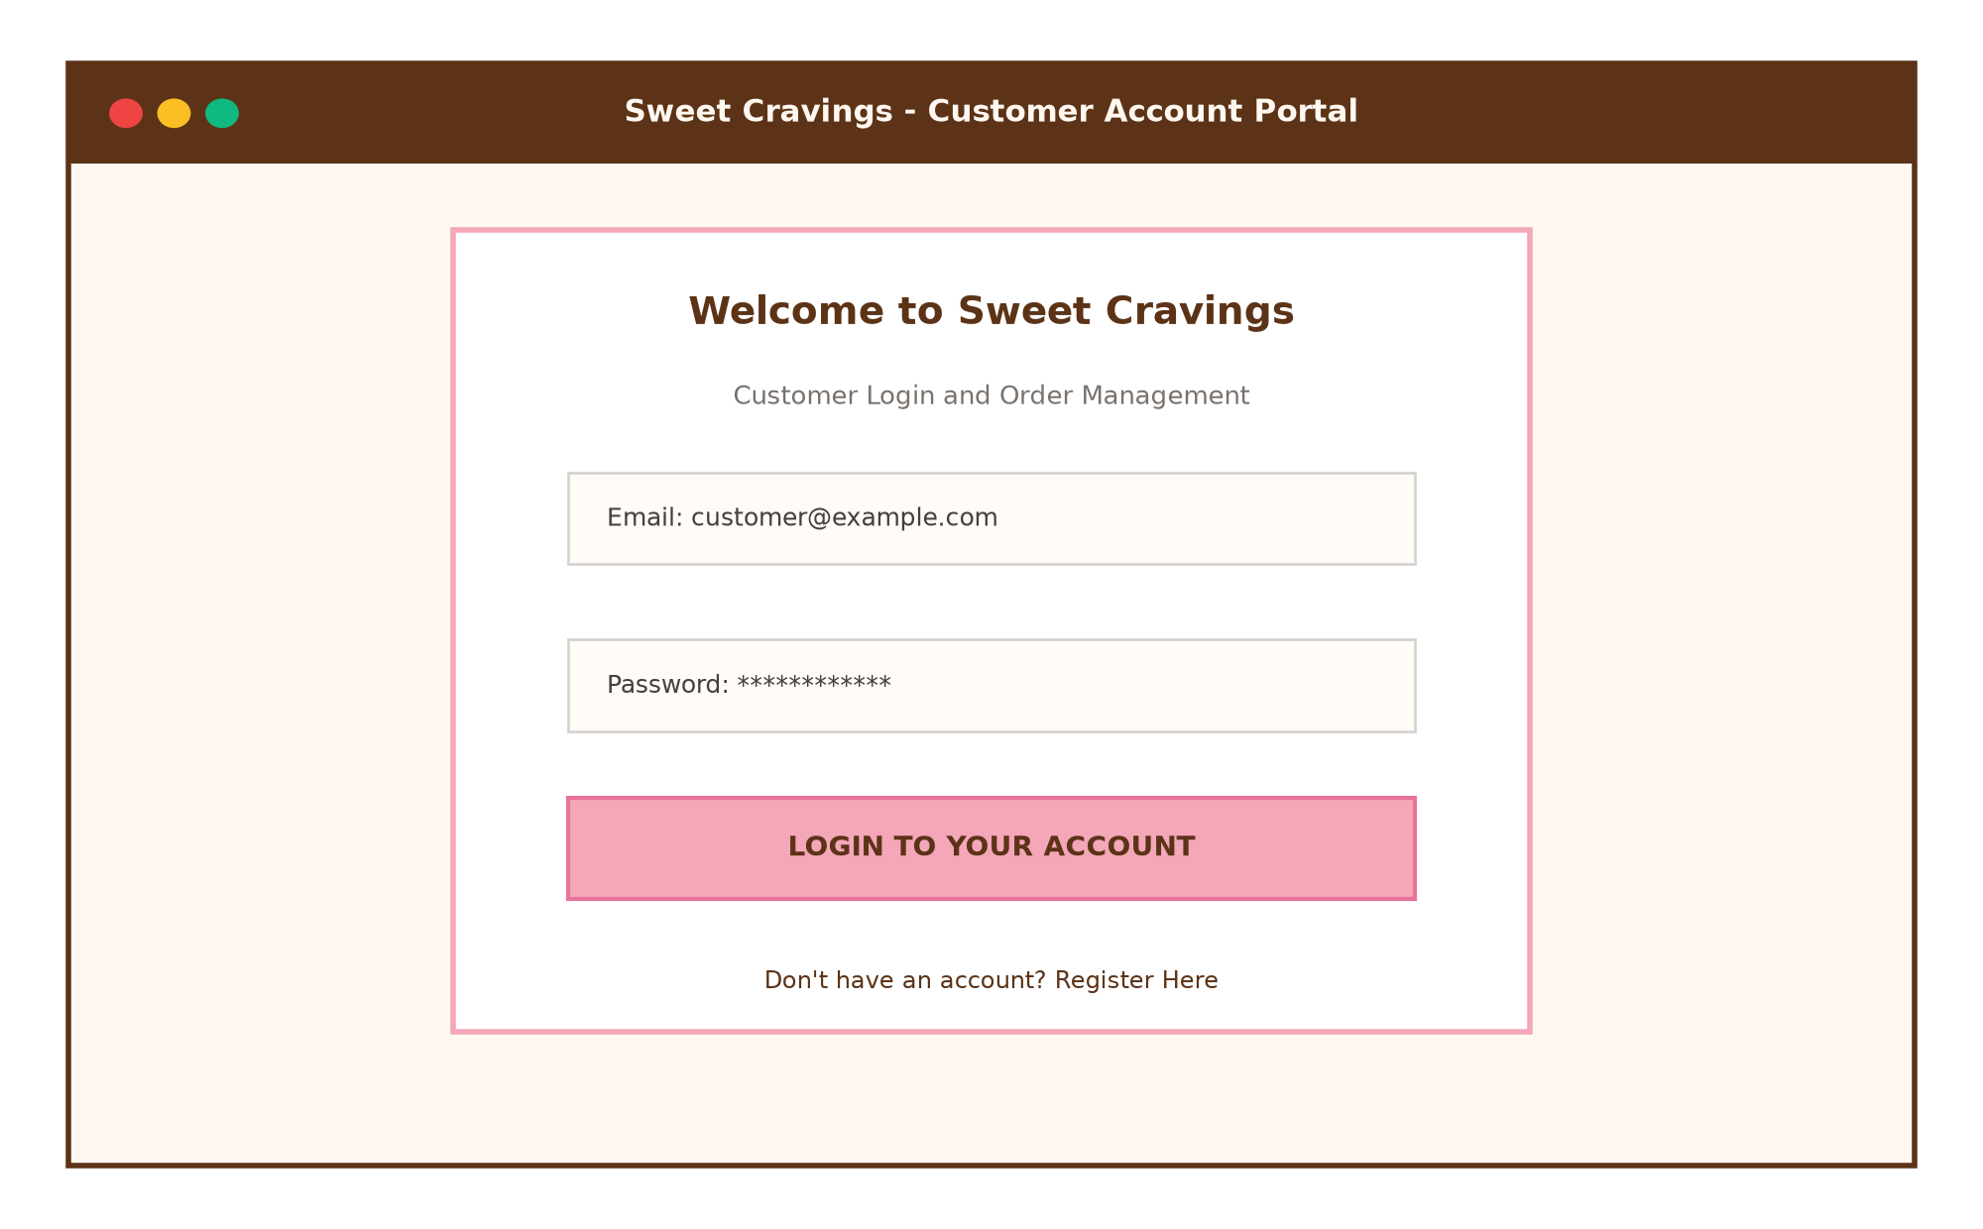
Figure 4.1: Customer Registration & Secure Login Portal
4.2 Cake Customization & Detail Interface
Figure 4.2 presents the single cake view where customers select portion weight (0.5kg, 1kg, 1.5kg, 2kg) and flavour choices. JavaScript recalculates the display price dynamically without reloading the page.
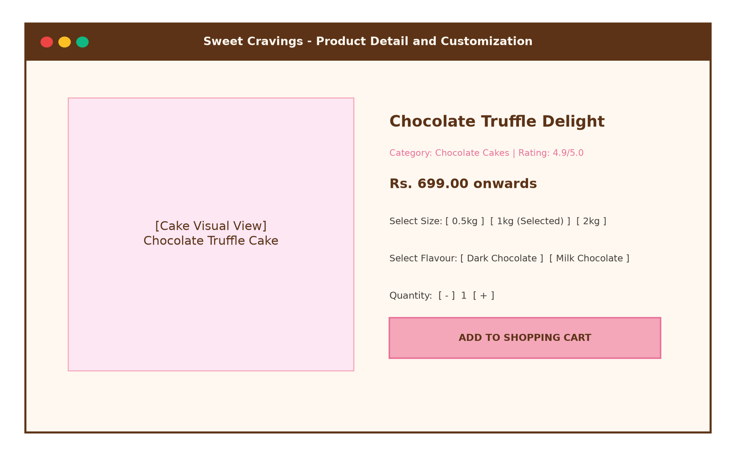
Figure 4.2: Cake Customization & Add-to-Cart Interface
4.3 Interactive Shopping Cart Management
Figure 4.3 illustrates the shopping cart interface. Users can adjust quantities using asynchronous steppers (+/-) or remove items, triggering live subtotal recomputation.
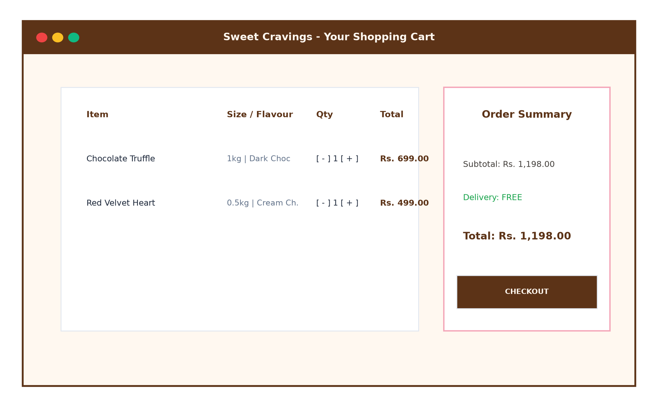
Figure 4.3: Interactive Shopping Cart Interface
4.4 Cash on Delivery Checkout & Delivery Form
Figure 4.4 displays the final checkout screen. Customers provide their full name, 10-digit mobile number, street delivery address, and scheduled delivery date.
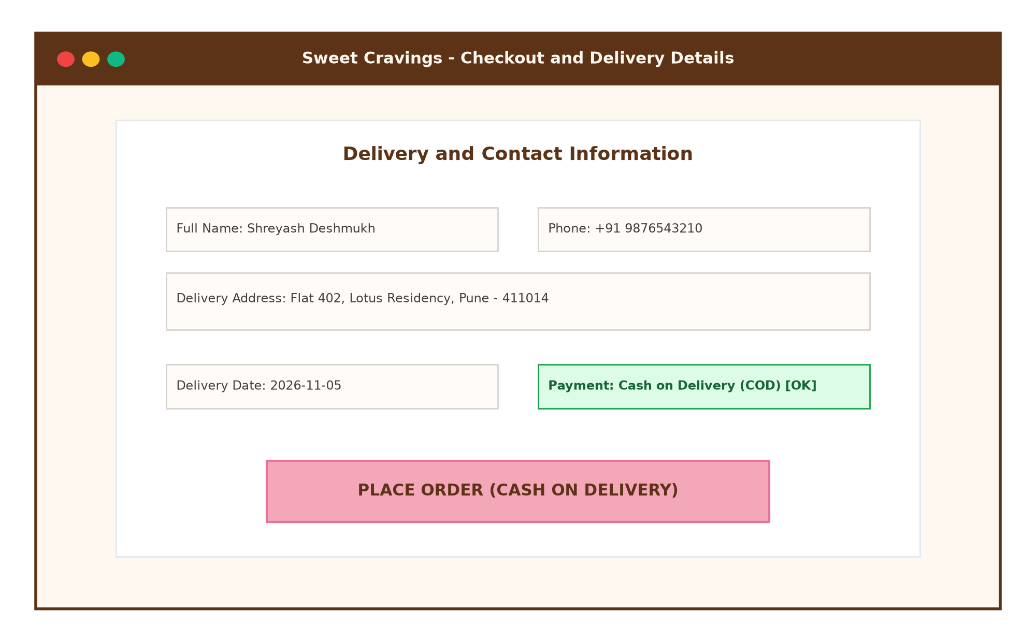
Figure 4.4: Delivery Details & Cash on Delivery Checkout Screen

CHAPTER 5 - OUTPUT SCREENS WITH DATA
This chapter documents the output screens of the Sweet Cravings website, showcasing the cream, pastel pink, and chocolate brown visual design.
5.1 Homepage Hero Banner & Category Collections
Figure 5.1 displays the landing view, highlighting the core value proposition: 'Baked with Love, Crafted for Joy', supported by promotional category pills.
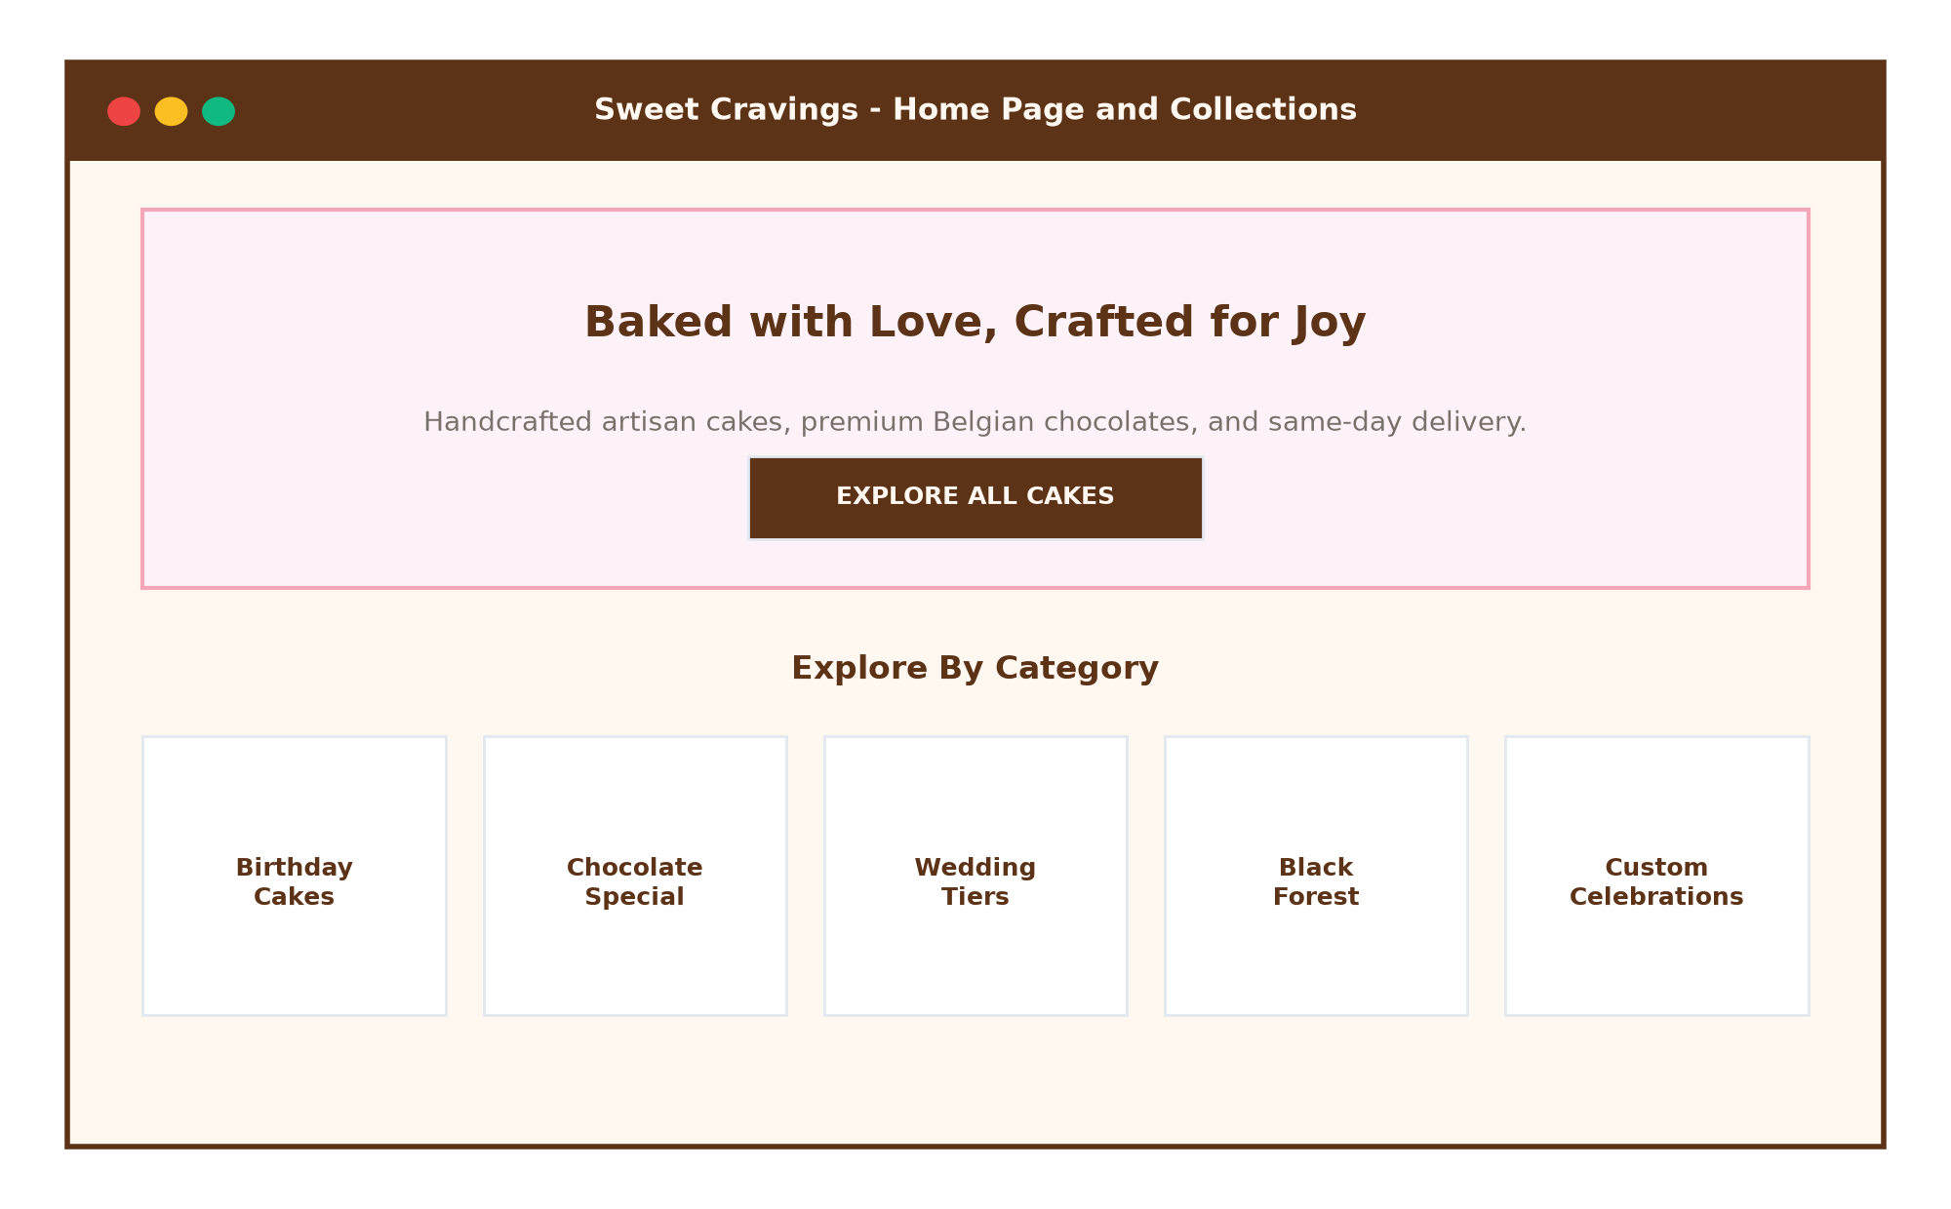
Figure 5.1: Homepage Hero Section & Category Collections
5.2 Cake Catalog with Dynamic Search & Filtering
Figure 5.2 captures the comprehensive cake catalog featuring live search by keywords (e.g. 'chocolate') and instant category pills.
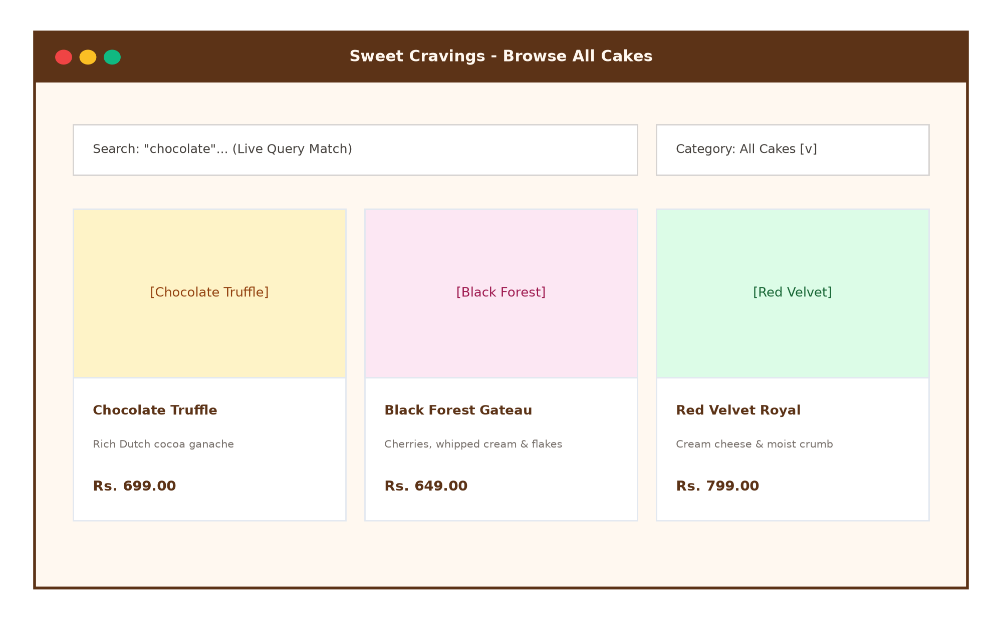
Figure 5.2: Filterable Cake Catalog & Product Showcase
5.3 Customer Order History & Status Tracking
Figure 5.3 displays the customer's personal order history, showing past cake purchases, itemized costs, and preparation status badges (Baking / Delivered).
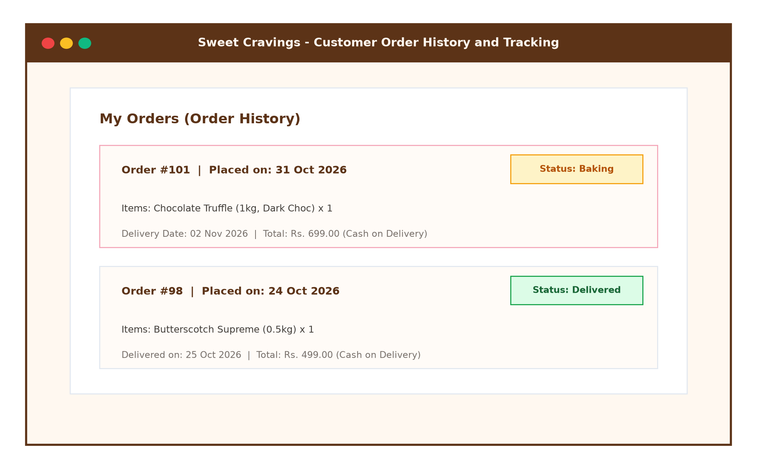
Figure 5.3: Customer Order History & Live Tracking
5.4 Bakery Admin Dashboard & Analytics Portal
Figure 5.4 exhibits the administrative dashboard featuring 4 business KPI cards (Total Cakes, Customers, Orders, Revenue) and order status update controls.
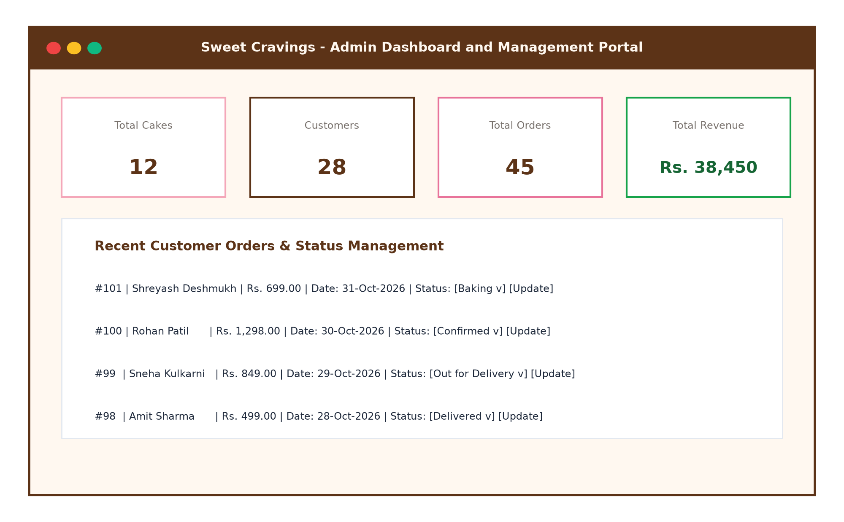
Figure 5.4: Administrative Control Center & Analytics Dashboard
5.5 Mobile Responsive Smartphone View
Figure 5.5 demonstrates the mobile smartphone experience, illustrating responsive navigation drawers and mobile-friendly touch targets.
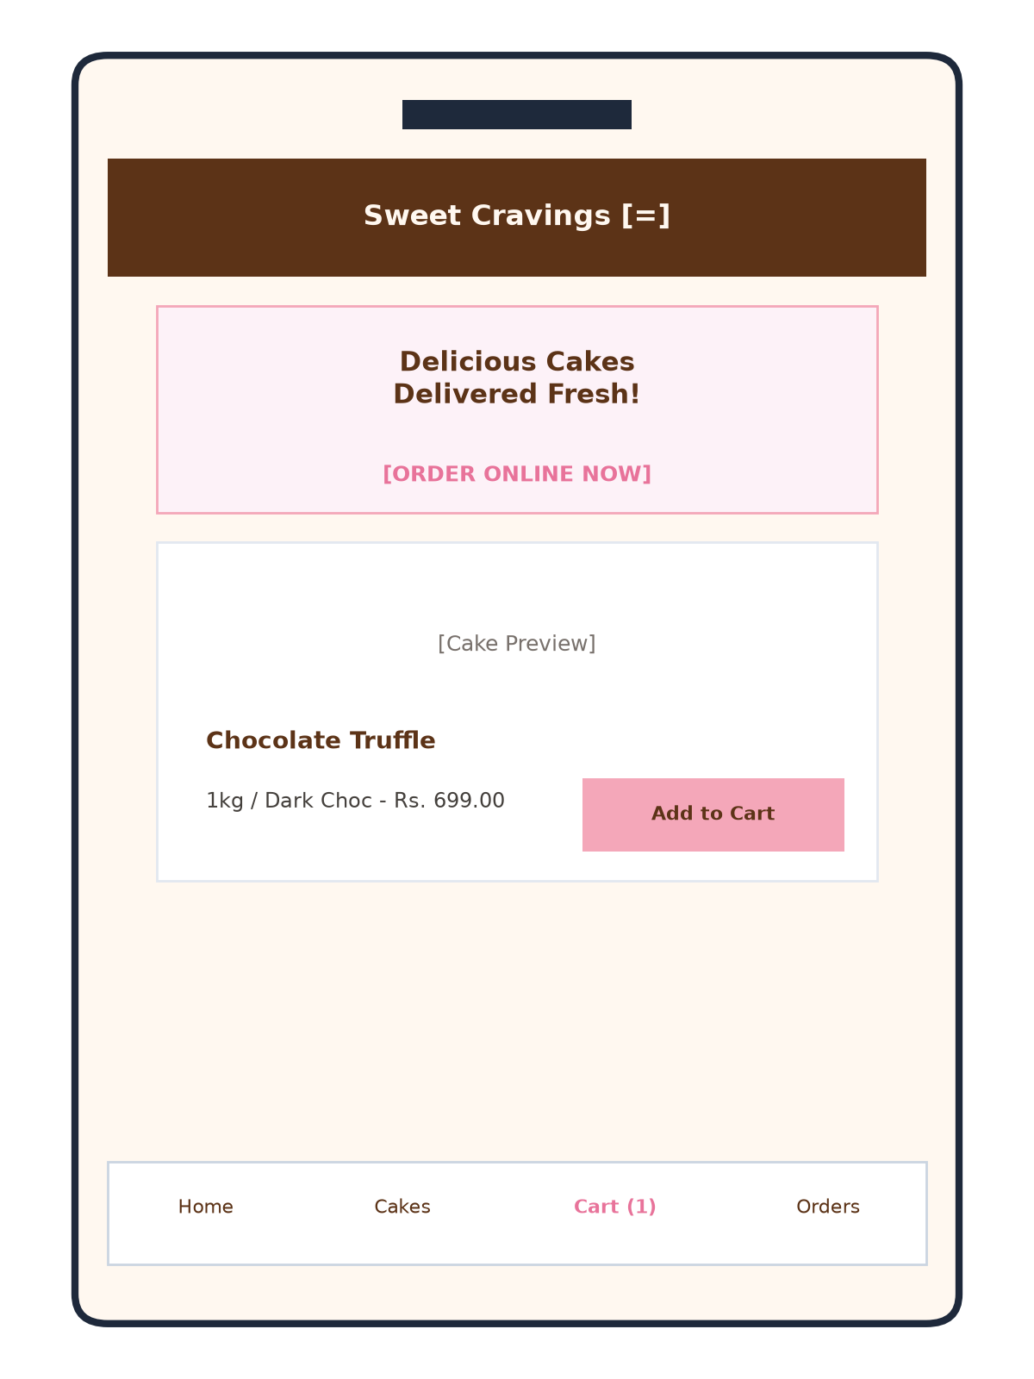
Figure 5.5: Mobile Responsive Layout on Smartphone

CHAPTER 6 - CODE SNIPPETS
This chapter documents core code excerpts from the production repository, explaining the software engineering principles governing database connectivity, authentication, cart logic, and admin controllers.
6.1 Database Connection & Configuration (config.py)
# -----------------------------------------------
# config.py - Database & App Configuration
# -----------------------------------------------
class Config:
SECRET_KEY = 'sweet_cravings_secret_2024'
# MySQL connection settings
MYSQL_HOST = 'localhost'
MYSQL_USER = 'root'
MYSQL_PASSWORD = 'your_mysql_password'
MYSQL_DB = 'cake_shop_db'
# Folder where uploaded cake images are stored
UPLOAD_FOLDER = 'static/images/cakes'
ALLOWED_EXTENSIONS = {'png', 'jpg', 'jpeg', 'gif', 'webp'}
6.2 Password Hashing & Authentication Decorators (app.py)
from functools import wraps
import bcrypt
def login_required(f):
@wraps(f)
def decorated_function(*args, **kwargs):
if 'user_id' not in session:
flash('Please log in to access this page.', 'warning')
return redirect(url_for('login', next=request.url))
return f(*args, **kwargs)
return decorated_function
def admin_required(f):
@wraps(f)
def decorated_function(*args, **kwargs):
if 'admin_id' not in session:
flash('Admin authentication required.', 'danger')
return redirect(url_for('admin_login'))
return f(*args, **kwargs)
return decorated_function
6.3 Cart to Order Placement SQL Transaction (app.py)
@app.route('/checkout', methods=['GET', 'POST'])
@login_required
def checkout():
user_id = session['user_id']
cur = mysql.connection.cursor()
# Fetch cart items
cur.execute('''
SELECT ci.id, ci.quantity, ci.size, ci.flavour,
ck.name, ck.price, ck.image_url, ck.id
FROM cart_items ci
JOIN cart c ON c.id = ci.cart_id
JOIN cakes ck ON ck.id = ci.cake_id
WHERE c.user_id = %s
''', (user_id,))
items = cur.fetchall()
if request.method == 'POST':
full_name = request.form.get('full_name').strip()
phone = request.form.get('phone').strip()
address = request.form.get('address').strip()
delivery_date = request.form.get('delivery_date').strip()
# Insert into orders
cur.execute('''
INSERT INTO orders (user_id, full_name, phone, address,
delivery_date, payment_method, total_amount, status)
VALUES (%s, %s, %s, %s, %s, 'Cash on Delivery', %s, 'Pending')
''', (user_id, full_name, phone, address, delivery_date, total_amount))
order_id = cur.lastrowid
# Snapshot items into order_items
for it in items:
cur.execute('''
INSERT INTO order_items (order_id, cake_id, cake_name, price, quantity, size, flavour)
VALUES (%s, %s, %s, %s, %s, %s, %s)
''', (order_id, it[7], it[4], it[5], it[1], it[2], it[3]))
# Clear cart
cur.execute('DELETE FROM cart_items WHERE cart_id = %s', (cart_id,))
mysql.connection.commit()
return redirect(url_for('orders'))
6.4 Dynamic Size and Flavour Price Multiplier (static/js/main.js)
// Dynamic Cake Pricing Engine based on portion size
document.addEventListener('DOMContentLoaded', function () {
const sizeSelect = document.getElementById('size-select');
const priceDisplay = document.getElementById('price-display');
const basePriceEl = document.getElementById('base-price');
if (sizeSelect && priceDisplay && basePriceEl) {
const basePrice = parseFloat(basePriceEl.dataset.price);
const multipliers = {
'0.5kg': 0.60,
'1kg': 1.00,
'1.5kg': 1.45,
'2kg': 1.85,
'3kg': 2.70
};
sizeSelect.addEventListener('change', function () {
const factor = multipliers[this.value] || 1.0;
const updated = (basePrice * factor).toFixed(2);
priceDisplay.textContent = 'Rs. ' + updated;
});
}
});

CHAPTER 7 - TESTING (TEST CASES)
Comprehensive Software Quality Assurance (SQA) was performed across the Sweet Cravings platform, employing Black-Box Functional Testing, Equivalence Class Partitioning, and Boundary Value Analysis (BVA).
Test ID | Scenario | Input Data | Expected Result | Actual Result | Status
TC-01 | Customer Reg. | Valid Name, Email, Pass | Insert user, hash password with bcrypt | User registered, bcrypt hash verified | PASS
TC-02 | Duplicate Reg. | Already registered email | Display flash error: Email exists | Duplicate rejected, error shown | PASS
TC-03 | Customer Login | Valid email & password | Authenticate, set user_id in session | Logged in, redirected to home | PASS
TC-04 | Invalid Login | Incorrect password | Display flash error: Invalid credentials | Access denied, error flashed | PASS
TC-05 | Dynamic Sizing | Select 2kg on detail page | Price recalculated (base * 1.85) | Display updated dynamically | PASS
TC-06 | Add to Cart | Cake ID: 1, 1kg, Qty: 1 | Insert row in cart_items table | Cart count incremented to 1 | PASS
TC-07 | Cart Quantity | Click '+' button in cart | Increment quantity, update subtotal | Subtotal updated accurately | PASS
TC-08 | COD Checkout | Valid Name, Phone, Address | Insert orders & order_items, clear cart | Order saved, cart cleared | PASS
TC-09 | Order Tracking | Navigate to /orders | Display past orders with status badges | Orders rendered with correct badges | PASS
TC-10 | Admin Login | Username: admin, pass: admin123 | Authenticate, set admin_id in session | Admin dashboard loaded | PASS
TC-11 | Cake Creation | Admin adds cake with image | Insert cakes row, upload image to static | Cake visible in public catalog | PASS
TC-12 | Status Update | Change status to 'Baking' | Update orders status column in MySQL | Customer view displays 'Baking' | PASS
7.2 Cross-Browser & Cross-Device Verification Matrix
Browser | Version Tested | Operating System | Layout Fidelity | Functionality
Google Chrome | 122.0+ (64-bit) | Windows 11 / macOS | 100% Pixel-Perfect | 100% Fully Functional
Microsoft Edge | 122.0+ (Chromium) | Windows 10 / Windows 11 | 100% Pixel-Perfect | 100% Fully Functional
Mozilla Firefox | 123.0+ (Gecko) | Windows 11 / Ubuntu | 100% Pixel-Perfect | 100% Fully Functional
Apple Safari | 17.2+ (WebKit) | macOS / iOS 17.3 | 100% Pixel-Perfect | 100% Fully Functional
Chrome Android | 122.0+ (Mobile) | Android 13 / 14 | 100% Mobile Optimized | 100% Fully Functional
Mobile Safari | 17.0+ (iOS) | Apple iPhone 13, 14, 15 | 100% Mobile Optimized | 100% Fully Functional

CHAPTER 8 - LIMITATIONS OF PROPOSED SYSTEM
An objective evaluation of the current implementation identifies clear technical and operational boundaries inherent to an academic deployment:
- • 8.1 Payment Gateway Integration Scope: The current release focuses exclusively on Cash on Delivery (COD) to suit beginner-friendly student presentation and avoid requiring active commercial banking credentials or merchant API keys. Direct online payment gateways (Razorpay, Stripe, UPI) are not integrated in this milestone.
- • 8.2 Single-Kitchen Inventory Model: Inventory stock counts are tracked globally per cake rather than partitioned across multiple retail kitchen branches across Pune.
- • 8.3 Web-Only Notification Alerts: Customer order notifications are displayed inside the web interface rather than sent via external SMS or WhatsApp Cloud API webhooks.

CHAPTER 9 - PROPOSED ENHANCEMENT
A roadmap of technical enhancements is proposed for subsequent commercial iterations:
- • 9.1 Integrated Online Payment Gateways: Incorporate Razorpay and UPI QR payment APIs to support instant online prepaid orders.
- • 9.2 WhatsApp & SMS Dispatch Bot: Integrate Twilio or WhatsApp Cloud API to send automated cooking and dispatch status updates directly to customers' phones.
- • 9.3 3D Cake Customization Engine: Integrate Three.js / WebGL to allow clients to visualize customized fondant layers, cake toppings, and photo prints in real-time 3D.
- • 9.4 Multi-Branch Regional Delivery: Expand database schemas to support multiple bakery kitchen outlets across Maharashtra with distance-based delivery calculations via Google Maps API.

CHAPTER 10 - CONCLUSION
The “Sweet Cravings – Full-Stack Online Cake Shop & Bakery Management Web Application” successfully modernizes traditional confectionery retail by delivering an end-to-end e-commerce solution.
By leveraging Python Flask, MySQL, and Bootstrap 5, the platform eliminates paper-based ordering errors, prevents customer miscommunication, provides dynamic portion pricing, and empowers bakery managers with real-time sales and inventory insights.
The project provided profound practical learnings in full-lifecycle software engineering, secure password cryptography, relational database normalisation, responsive web styling, and viva presentation readiness.
CHAPTER 11 - BIBLIOGRAPHY
- 1. Pressman, Roger S. Software Engineering: A Practitioner's Approach. McGraw-Hill Education.
- 2. Sommerville, Ian. Software Engineering. 10th Edition, Pearson Education.
- 3. Grinberg, Miguel. Flask Web Development: Developing Web Applications with Python. O'Reilly Media.
- 4. Silberschatz, Abraham, Henry F. Korth, and S. Sudarshan. Database System Concepts. McGraw-Hill Education.
- 5. MDN Web Docs - JavaScript, DOM Manipulation & Web Storage APIs: https://developer.mozilla.org/
- 6. Flask Documentation (Pallets Projects): https://flask.palletsprojects.com/
- 7. Bootstrap 5.3 Documentation: https://getbootstrap.com/docs/5.3/
- 8. MySQL 8.0 Reference Manual: https://dev.mysql.com/doc/refman/8.0/en/

