DAY 1 — DATA ANALYTICS & DATA SCIENCE
FUNDAMENTALS
Completed Assignment with Answers and Python Programs

1. Task Day & Date
- Day: Friday
- Date: 11/09/2026

2. Task Description
Today's task was to learn the basics of Data Analytics and Data Science. I learned what data means and how it is used in real life. I also learned the difference between a Data Analyst and a Data Scientist. Along with this, I studied the types of analytics and the difference between structured and unstructured data. Lastly, I understood the complete data project lifecycle, from collecting data to making business decisions.

3. Task Elaboration

1. Definition of Data Analytics
Data Analytics is the process of collecting, cleaning, transforming, examining and interpreting data to discover useful patterns, trends and insights. It helps organizations understand what is happening, why it is happening and what actions can be taken based on evidence.
Main objectives of Data Analytics:
- Understand business performance using data.
- Identify trends, patterns and relationships.
- Find problems and their possible causes.
- Support better and faster decision-making.
- Measure results using meaningful metrics and reports.

2. Definition of Data Science
Data Science is an interdisciplinary field that combines statistics, mathematics, programming, data analysis and machine learning to extract knowledge and build useful predictive or intelligent solutions from data.

Data Science commonly involves:
- Data collection and preparation.
- Exploratory data analysis and visualization.
- Statistical analysis and experimentation.
- Machine learning and predictive modeling.
- Model evaluation and deployment.
- Communication of results to technical and business users.

3. Data Analyst vs Data Scientist
Aspect | Data Analyst | Data Scientist
Primary focus | Analyze existing data and generate insights. | Build models and discover patterns for prediction/optimization.
Typical questions | What happened? Why did it happen? | What will happen? What should we optimize or predict?
Common work | Cleaning, SQL queries, dashboards, reports, analysis. | Feature engineering, modeling, experiments, machine learning.
Tools | SQL, Excel, Power BI/Tableau, Python, pandas. | Python/R, pandas, scikit-learn, statistics, ML frameworks.
Output | Reports, dashboards, KPIs and business insights. | Predictive models, experiments, forecasts and data products.

4. Data Engineer vs ML Engineer
Aspect | Data Engineer | ML Engineer
Main responsibility | Build and maintain reliable data pipelines and platforms. | Build, deploy and maintain machine-learning systems.
Focus | Data ingestion, transformation, storage and availability. | Model serving, ML pipelines, monitoring and production performance.
Common technologies | SQL, Python, Spark, ETL/ELT, cloud data platforms. | Python, ML frameworks, APIs, Docker, cloud ML platforms.
Typical output | Clean, reliable and accessible datasets. | Production-ready ML models and srvices.

5. Structured vs Unstructured Data
Type | Meaning | Examples
Structured data | Organized in a defined schema such as rows and columns. | Employee table, sales transactions, relational database records.
Unstructured data | Does not follow a fixed tabular structure. | Images, videos, audio, emails, social-media posts, documents.

6. Types of Analytics
Type | Question | Purpose | Example
Descriptive | What happened? | Summarize historical data. | Monthly sales report shows total sales and revenue.
Diagnostic | Why did it happen? | Find causes and relationships. | Analyze why sales dropped in one region.
Predictive | What is likely to happen? | Forecast future outcomes. | Predict next month's sales or customer churn.
Prescriptive | What should we do? | Recommend an action. | Suggest the best inventory level or marketing action.

7. Complete Data Science / Data Project Lifecycle
A data project normally moves from a business problem to data collection, preparation, analysis, modeling, evaluation and finally a business decision or deployed/reporting solution.
Business Problem
↓
Data Collection
↓
Data Cleaning
↓
Data Exploration
↓
Statistical Analysis
↓
Visualization
↓
Machine Learning
↓
Model Evaluation
↓
Business Decision
↓
Deployment / Reporting
Workflow: Business Problem → Data Collection → Data Cleaning → Data Exploration → Statistical Analysis → Visualization → Machine Learning → Model Evaluation → Business Decision → Deployment/Reporting.

8. Real-World Examples
E-commerce: Analyze orders, customers and products to understand sales, identify high-performing categories and improve inventory.
Banking: Analyze transactions and customer behavior to detect unusual activity and assess risk.
Healthcare: Analyze patient and operational data to identify trends and support better planning.
Education: Analyze attendance and marks to identify students who may need additional academic support.
Manufacturing: Analyze machine and sensor data to identify maintenance needs and reduce downtime.
Dam / Water Management: Analyze water-level and sensor data to monitor conditions, support automated gate control and improve safety decisions.

9. Technologies Used by Data Analysts
- Microsoft Excel / Google Sheets — data cleaning, formulas, pivot tables and basic reporting.
- SQL / MySQL / SQL Server — querying and aggregating data stored in databases.
- Python — automation, data cleaning and analysis.
- pandas — tabular data manipulation and analysis.
- Matplotlib / Seaborn — data visualization.
- Power BI / Tableau — interactive dashboards and business reporting.
- Jupyter Notebook — interactive analysis and documentation.

10. Technologies Used by Data Scientists
- Python / R — programming and statistical analysis.
- pandas / NumPy — data manipulation and numerical computing.
- Matplotlib / Seaborn — visualization and exploratory analysis.
- scikit-learn — machine-learning algorithms and model evaluation.
- TensorFlow / PyTorch — deep-learning development.
- SQL — retrieving and preparing data from databases.
- Jupyter Notebook — experimentation and analysis.
- Cloud and deployment tools — scaling, serving and monitoring data science solutions.

11. Why Data Analytics and Data Science Are Important
Before learning tools, interns need to understand where those tools are actually used. A tool is useful only when it helps solve a real business or technical problem. Understanding the project lifecycle makes it easier to select the right tool at each stage.
- Data helps organizations make evidence-based decisions.
- Analytics can identify inefficiencies, opportunities and risks.
- Visualization makes complex information easier to understand.
- Predictive models can support planning and forecasting.
- A clear lifecycle connects technical work with measurable business outcomes

DAY 2 — DATA ANALYTICS & DATA SCIENCE
FUNDAMENTALS
Completed Assignment with Answers and Python Programs

1. Task Day & Date
- Day : Friday
- Date: 11/09/2026

2. Task Description
Today's task was to learn the basics of Python programming. I learned about variables, data types, strings, numbers, and boolean values. I also learned about lists, tuples, sets, and dictionaries. Along with this, I studied operators, conditions, and loops. After learning these topics, I wrote small Python programs to practice what I learned.

3. Task Elaboration

12. Python Basics — Topics and Answers
Variables: A variable is a name used to store a value in a program. Example: name = 'Amit' and age = 21.
Data Types: Python provides data types such as int, float, str, bool, list, tuple, set and dict.
String: A string is a sequence of characters enclosed in quotes. Example: name = 'Shreyash'.
Integer: An integer is a whole number without a decimal point. Example: age = 21.
Float: A float represents a number containing a decimal value. Example: salary = 45000.50.
Boolean: A Boolean value represents True or False. Example: is_active = True.
List: A list is an ordered and mutable collection. Example: marks = [80, 75, 90].
Tuple: A tuple is an ordered and immutable collection. Example: point = (10, 20).
Set: A set is an unordered collection of unique values. Example: cities = {'Pune', 'Mumbai', 'Pune'}.
Dictionary: A dictionary stores data as key-value pairs. Example: student = {'name': 'Amit', 'age': 21}.
Operators: Operators perform operations on values, including arithmetic, comparison, logical, assignment and membership operations.
Conditions: Conditional statements such as if, elif and else execute different code depending on a condition.
Loops: Loops repeat a block of code. Python commonly uses for and while loops.

13. Python Programs — day02_python_basics.py

1. Calculator
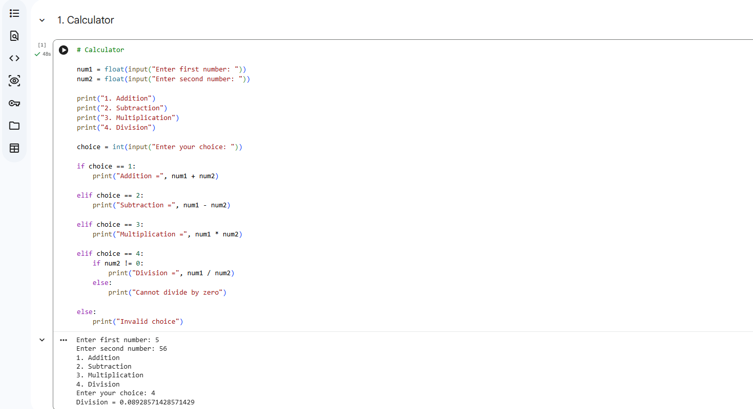
This program is a simple calculator that performs four basic mathematical operations: addition, subtraction, multiplication, and division. The user enters two numbers and selects an operation from the menu. The program uses if-elif-else conditions to perform the selected operation. It also checks whether the second number is zero before performing division.
Output shown: For 5 and 56, the selected division operation gives 0.08928571428571429.

2. Even / Odd Number
This program checks whether the entered number is even or odd. It uses the modulus (%) operator to check the
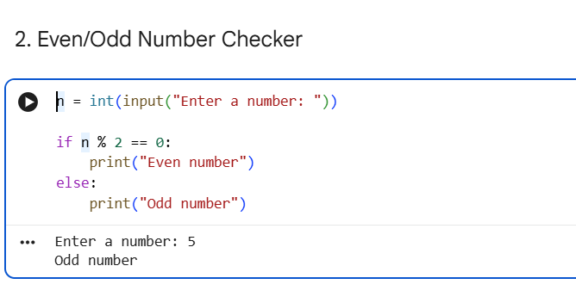

This program checks whether the entered number is even or odd. It uses the modulus (%) operator to check the remainder when the number is divided by 2.

- If n % 2 == 0, the number is Even.
- Otherwise, the number is Odd.
Output shown: For the input 5, the result is Odd number.

3. Positive / Negative Number
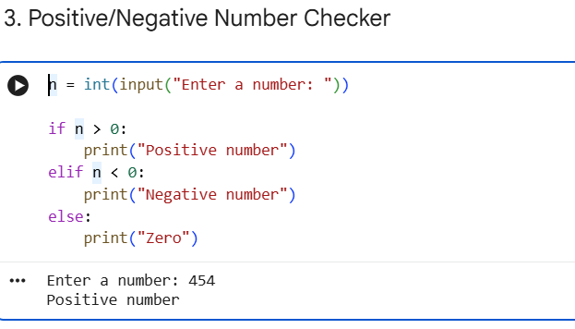
This program determines whether an entered number is positive, negative, or zero. It uses if, elif, and else conditions.
- If the number is greater than 0, it is positive.
- If the number is less than 0, it is negative.
- Otherwise, it is zero.
Output shown: For the input 454, the result is Positive number.

4. Largest of 3 Numbers

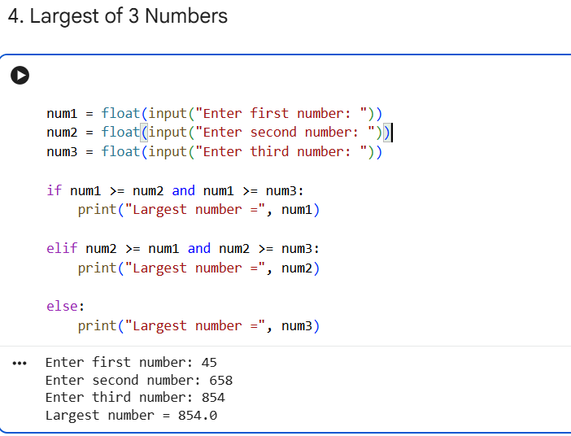
This program finds the largest number among three numbers entered by the user. It compares the three numbers using relational operators (>=) and logical operator and.
Output shown: For the numbers 45, 658, and 854, the largest number is 854.0

5. Student Grade Calculator
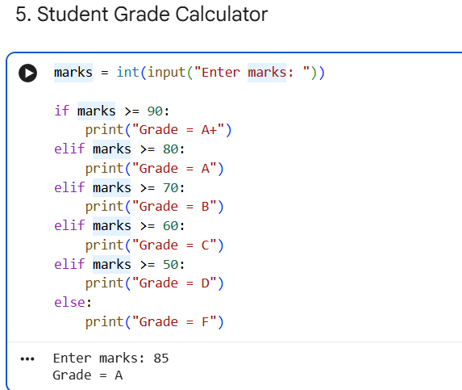
This program calculates a student's grade based on their marks. It uses an if-elif-else structure to compare the marks with different grade ranges.
The grading system shown is:
- 90 or above → A+
- 80–89 → A
- 70–79 → B
- 60–69 → C
- 50–59 → D
- Below 50 → F
Output shown: For 85 marks, the result is Grade = A.

6. Multiplication Table
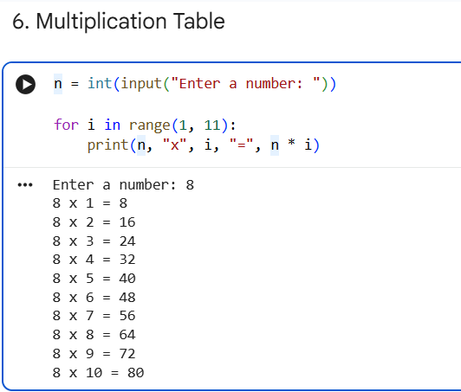
This program generates the multiplication table of a given number. It uses a for loop with range(1, 11) to print the table from 1 to 10.
Output shown: For the input 8, the program prints the multiplication table of 8 from:
8 × 1 = 8 to 8 × 10 = 80.

7. Factorial

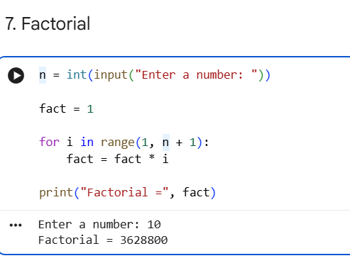
This program calculates the factorial of a number using a for loop. The factorial is calculated by multiplying all positive integers from 1 up to the given number.
For example:
5! = 5 × 4 × 3 × 2 × 1 = 120
Output shown: For the input 10, the factorial is 3628800.

8. Fibonacci Series
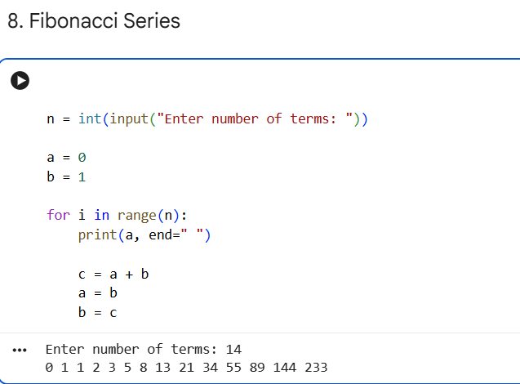
This program generates the Fibonacci series for a specified number of terms. It starts with 0 and 1, and each next number is calculated by adding the previous two numbers.
For example:
0, 1, 1, 2, 3, 5, 8, 13, ...
Output shown: For 14 terms, the program displays:
0 1 1 2 3 5 8 13 21 34 55 89 144 233

9. Count Vowels

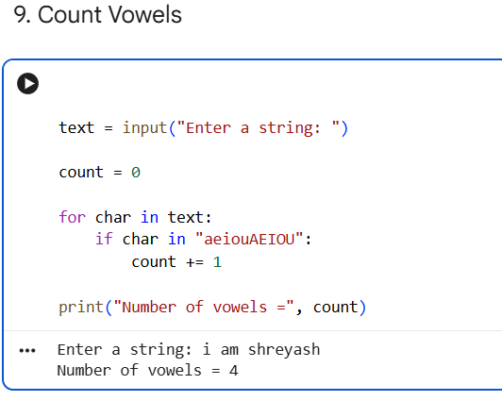

This program counts the number of vowels in a string entered by the user. It checks each character using a for loop and verifies whether the character exists in the vowel collection: aeiouAEIOU
If a vowel is found, the counter is increased by 1.
Output shown: For the string "i am shreyash", the program finds 4 vowels

10. Reverse a String
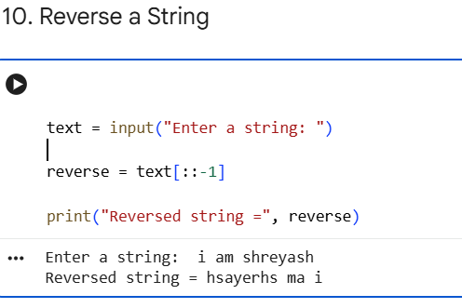
This program reverses a string entered by the user. It uses Python's slicing technique [::-1] to reverse the characters.
For example:
Python → nohtyP
Output shown: For the input "i am shreyash", the reversed string is:
hsayerhs ma i

DAY 3 — FUNCTIONS + ADVANCED PYTHON BASICS
Completed Assignment with Answers and Python Program

1. Task Day & Date
- Day: saturday
- Date: 12/09/2026

2. Task Description
Today's task was to learn about functions in Python. I learned how to create functions, pass values to them using parameters, and get results back using return values. I also learned about lambda functions, map(), filter(), list comprehension, dictionary comprehension, exception handling, and modules. After learning these topics, I created a few functions and used them together in one program.

3. Task Elaboration

1. Functions
A function is a reusable block of Python code designed to perform a specific task. Functions make programs reusable, readable, and maintainable.
Syntax:
def function_name(parameters):
# statements
return value

2. Parameters
Parameters are variables written inside a function definition. They receive values (arguments) when the function is called.
Example:
def greet(name):
print(f"Hello, {name}")
greet("Amit")

3. Return Values
The return statement sends a result from a function back to the part of the program that called it.
Example:
def add(a, b):
return a + b
result = add(10, 20)
print(result)

4. Lambda
A lambda is a small anonymous function written in a single expression. It is useful for short operations.
Example:
square = lambda x: x * x
print(square(5))

5. map()
The map() function applies a function to every item in an iterable and returns a map object.
Example:
numbers = [1, 2, 3, 4]
squares = list(map(lambda x: x * x, numbers))
print(squares)

6. filter()
The filter() function selects items from an iterable for which a given condition is True.
Example:
numbers = [1, 2, 3, 4, 5, 6]
even = list(filter(lambda x: x % 2 == 0, numbers))
print(even)

7. List Comprehension
List comprehension is a short and readable way to create a new list from an iterable.
Example:
numbers = [1, 2, 3, 4, 5]
squares = [x * x for x in numbers]
print(squares)

8. Dictionary Comprehension
Dictionary comprehension provides a concise way to create dictionaries using an iterable.
Example:
numbers = [1, 2, 3, 4]
squares = {x: x * x for x in numbers}
print(squares)

9. Exception Handling
Exception handling prevents a program from stopping unexpectedly when an error occurs. Python commonly uses try, except, else, and finally.
Example:
try:
a = int(input("Enter a number: "))
print(10 / a)
except ValueError:
print("Please enter a valid number.")
except ZeroDivisionError:
print("Cannot divide by zero.")

10. Modules
A module is a Python file containing reusable code such as functions, variables, or classes. Modules can be imported into another Python program.
Example:
import math
print(math.sqrt(25))

11. Complete Python Program
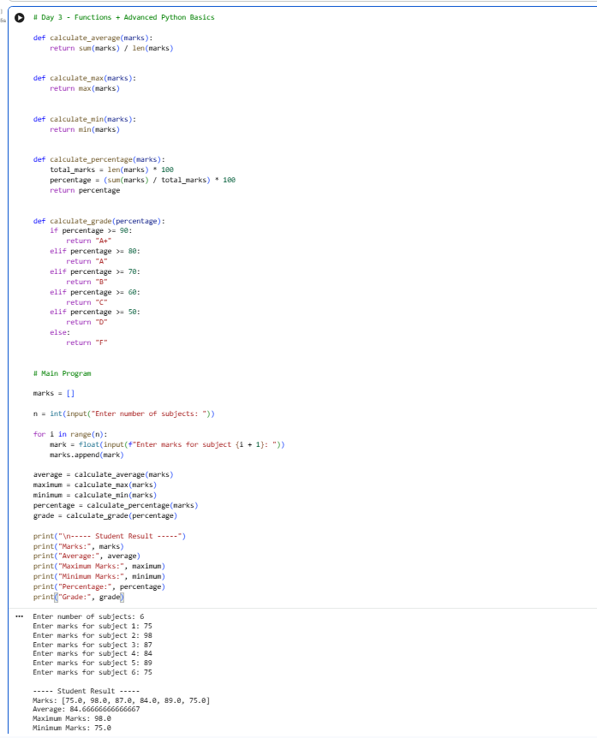
First, the program creates an empty marks list and asks the user to enter the number of subjects and marks for each subject. The for loop is used to collect the marks, and marks.append() stores each mark in the list.
The calculate_average() function calculates the average by adding all the marks using sum() and dividing the total by the number of subjects using len(). The calculate_max() function uses max() to find the highest mark, while the calculate_min() function uses min() to find the lowest mark. The calculate_percentage() function calculates the total possible marks based on the number of subjects and then calculates the student's percentage.
Finally, the calculate_grade() function checks the percentage using if, elif, and else conditions and assigns a grade such as A+, A, B, C, D, or F. In the given example, the marks are 75, 98, 87, 84, 89, and 75, giving an average and percentage of approximately 84.67%, a maximum mark of 98, a minimum mark of 75, and a final grade of A.
This program demonstrates the use of functions, parameters, return values, lists, loops, conditional statements, and built-in Python functions. The Day 3 task specifically requires these five functions to be created and used together in one program.

12. Why Functions Are Used
- Reusable — the same function can be called multiple times.
- Readable — each function performs a clearly defined task.
- Maintainable — changes can be made in one place.
- Modular — a large program can be divided into smaller logical parts.

DAY 4 — FUNCTIONS + ADVANCED PYTHON BASICS
Completed Assignment with Answers and Python Program

1. Task Day & Date
- Day: Tuesday
- Date: 15/09/2026

2. Task Description
Today's task was to learn NumPy, which is a Python library used for working with numbers and arrays. I learned about arrays, dimensions, shape, indexing, slicing, and reshaping. I also learned how to perform arithmetic operations and find aggregations like mean, median, and standard deviation. I practiced all of this using a NumPy array of sales data.

3. Task Elaboration

1.Create a NumPy array containing sales data
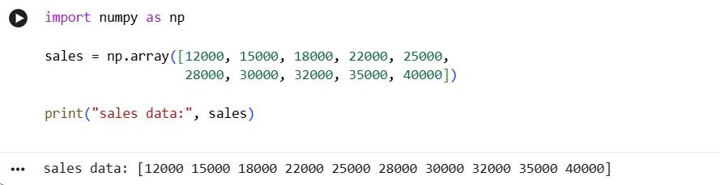
This program imports the NumPy library and creates a NumPy array named sales containing sales data for 10 values. The np.array() function is used to store the sales values in an array. Finally, the print() function displays the sales data.
Output: The sales array contains values ranging from 12,000 to 40,000.

2. Total Sales, Average, Maximum, Minimum, Standard Deviation, Median and Percentiles
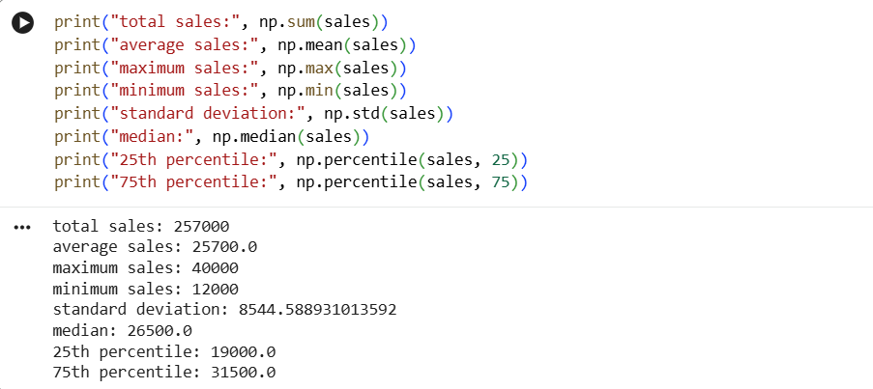
This program uses NumPy aggregation and statistical functions to analyze the sales array. np.sum() calculates the total sales, np.mean() calculates the average, np.max() and np.min() find the maximum and minimum sales, while np.std() calculates the standard deviation. np.median() finds the middle value, and np.percentile() calculates the 25th and 75th percentiles of the sales data.
Output: The output provides a statistical summary of the given sales data.

3.1D Array, Dimensions and Shape
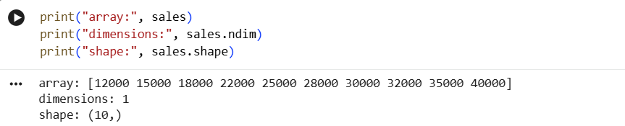
This program displays the sales data, the number of dimensions, and the shape of the NumPy array. The sales array contains 10 sales values. The sales.ndim function shows that the array has 1 dimension, while sales.shape shows (10,), meaning the array contains 10 elements in one dimension.
Output: The output shows the complete sales array, 1 dimension, and a shape of (10,).

4. Indexing
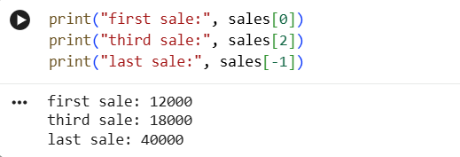
This program demonstrates indexing in a NumPy array by accessing specific sales values using their index positions. sales[0] accesses the first sale, sales[2] accesses the third sale, and sales[-1] accesses the last sale in the array.
Output: The output shows the first sale as 12,000, the third sale as 18,000, and the last sale as 40,000.

5. Slicing
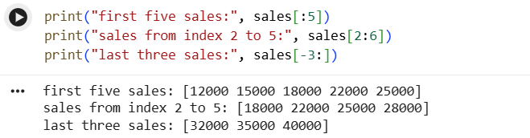
This program demonstrates slicing in a NumPy array. It is used to access a specific range of elements from the sales array. sales[:5] displays the first five sales, sales[2:6] displays the sales from index 2 to index 5, and sales[-3:] displays the last three sales
Output: The output displays the first five sales, the sales from index 2 to 5, and the last three sales from the array.

6. 2D Array
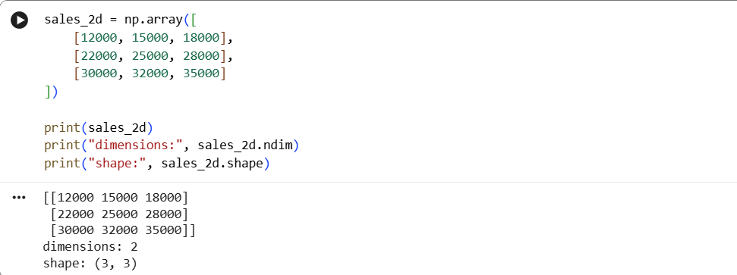
This program creates a 2D NumPy array named sales_2d containing sales data arranged in 3 rows and 3 columns. The sales_2d.ndim function is used to find the number of dimensions, while sales_2d.shape shows the number of rows and columns.
Output: The output displays the 2D sales array, shows 2 dimensions, and confirms the shape as (3, 3), meaning the array has 3 rows and 3 columns.

7. Reshaping
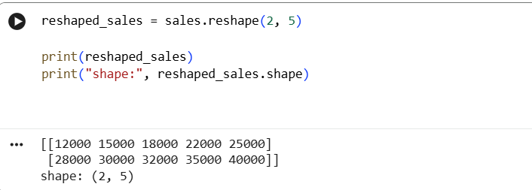
This program demonstrates reshaping a NumPy array. The sales.reshape(2, 5) function changes the sales array into 2 rows and 5 columns without changing the data values.
Output: The output displays the reshaped sales array with 2 rows and 5 columns and confirms the shape as (2, 5).

8. Arithmetic Operations
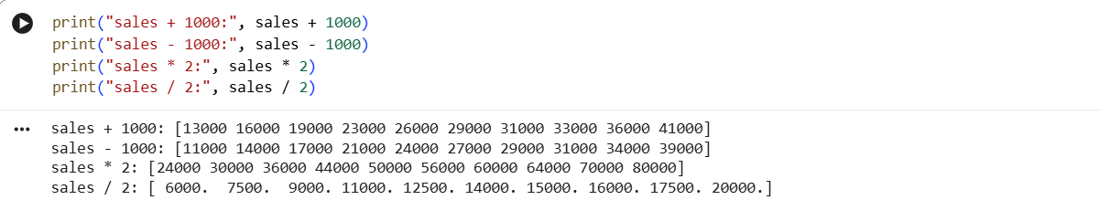
This program demonstrates arithmetic operations in a NumPy array. It adds 1000, subtracts 1000, multiplies by 2, and divides the sales values by 2 using NumPy operations.
Output: The output displays the updated sales values after addition, subtraction, multiplication, and division

9. Matrix Multiplication
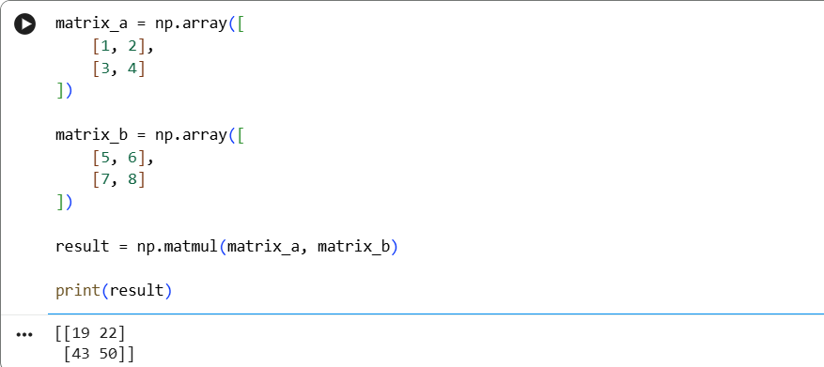
This program demonstrates matrix multiplication using NumPy. It creates two 2D matrices, matrix_a and matrix_b, and uses the np.matmul() function to multiply them. The result is stored in the result variable and displayed using the print() function.
Output: The output displays the resulting 2 × 2 matrix after multiplying matrix_a and matrix_b. The result is [[19, 22], [43, 50]].

DAY 5— FUNCTIONS + ADVANCED PYTHON BASICS
Completed Assignment with Answers and Python Program

1. Task Day & Date
- Day: Wednesday
- Date: 16/09/2026

2. Task Description
Today's task was to learn Pandas, which is a Python library used to work with data in table form. I learned about Series and DataFrame, and how to load a dataset using read_csv(). I also learned how to check the first and last rows, the number of rows and columns, data types, missing values, and summary statistics of a dataset.

3. Task Elaboration

1.load Dataset
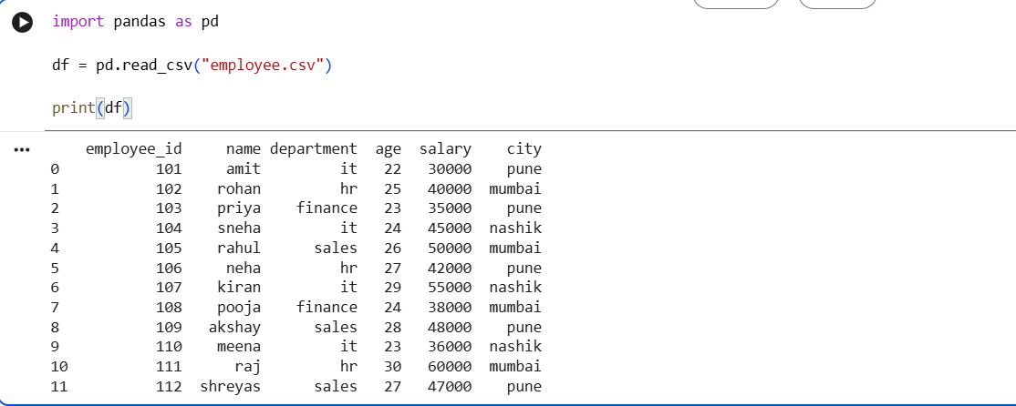
In this step, I loaded the employee dataset into a Pandas DataFrame using the read_csv() function. This allows me to read the CSV file and work with the data using Pandas for further analysis.
Output: The output displays the complete employee dataset in tabular form. It shows the employee ID, employee name, department, age, salary, and city for each employee. This confirms that the CSV dataset has been successfully loaded into the Pandas DataFrame.

2. Display First 10 Rows
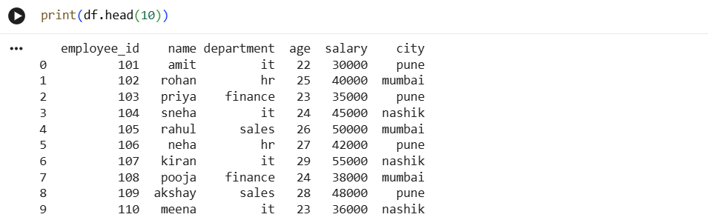
In this step, I used the head(10) function to display the first 10 rows of the employee dataset. This helps me view the initial records and understand the structure and information contained in the dataset.
Output: The output displays the first 10 rows of the employee dataset. It shows the initial employee records along with their employee ID, name, department, age, salary, and city.

3. Display Last 10 Rows
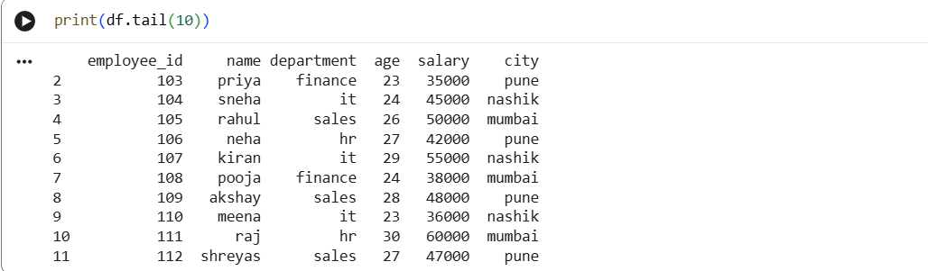
In this step, I used the tail(10) function to display the last 10 rows of the employee dataset. This helps me view the final records and check the data present at the end of the dataset.
Output: The output displays the last 10 rows of the employee dataset. It shows the final employee records along with their employee ID, name, department, age, salary, and city.

4. Find Number of Rows
In this step, I used the shape attribute to find the total number of rows in the employee dataset. The shape[0] value represents the number of rows present in the DataFrame.
Output: The output shows that the employee dataset contains 12 rows. This means there are 12 employee records present in the DataFrame.

5. Find Number of Columns
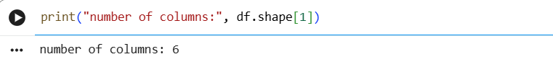
In this step, I used the shape[1] attribute to find the total number of columns in the employee dataset. The shape[1] value represents the number of columns present in the DataFrame.
Output: The output shows that the employee dataset contains 6 columns. These columns represent the different types of information available for each employee, such as employee ID, name, department, age, salary, and city.

6. Check Data Types
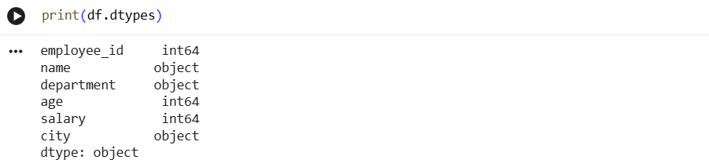
In this step, I used the dtypes attribute to check the data type of each column in the employee dataset. This helps identify whether the data is stored as integers, text, or other data types.
Output: The output displays the data type of each column in the employee dataset. The numerical columns such as employee_id, age, and salary are stored as integer (int64), while text columns such as name, department, and city are stored as object (object).

7. Find Missing Values
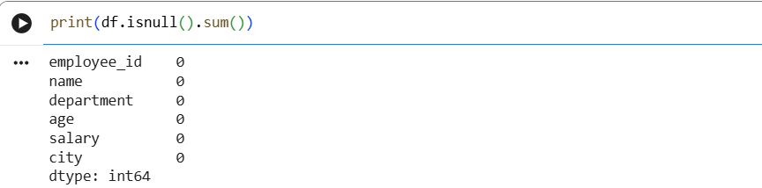
In this step, I used isnull().sum() to check for missing values in each column of the employee dataset. This helps identify whether any data is missing and shows the total number of missing values in each column.
Output: The output shows the number of missing values present in each column of the employee dataset. All columns have 0 missing values, which means the dataset does not contain any missing or null values.

8. Generate Summary Statistics
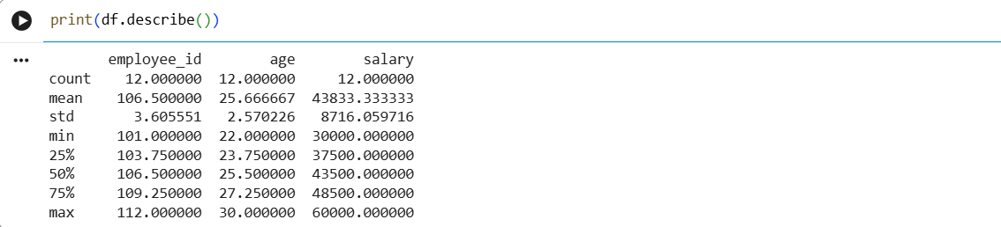
In this step, I used the describe() function to generate summary statistics for the numerical columns in the employee dataset. It provides information such as count, mean, standard deviation, minimum value, maximum value, and quartiles, which helps in understanding the basic characteristics of the data.
Output: The output displays the summary statistics of the numerical columns in the employee dataset. It shows values such as count, mean, standard deviation, minimum, maximum, and quartiles, helping to understand the basic characteristics of the numerical data.

DAY 6— FUNCTIONS + ADVANCED PYTHON BASICS
Completed Assignment with Answers and Python Program

1. Task Day & Date
- Day: Thursday
- Date: 17/09/2026

2. Task Description
Today's task was to learn how to clean dirty data. I learned how to find missing values, duplicate rows, wrong data types, incorrect values, inconsistent text, and outliers. I took a dirty dataset and cleaned it step by step so that it became ready to use.

3. Task Elaboration

1.Created a Dirty Dataset
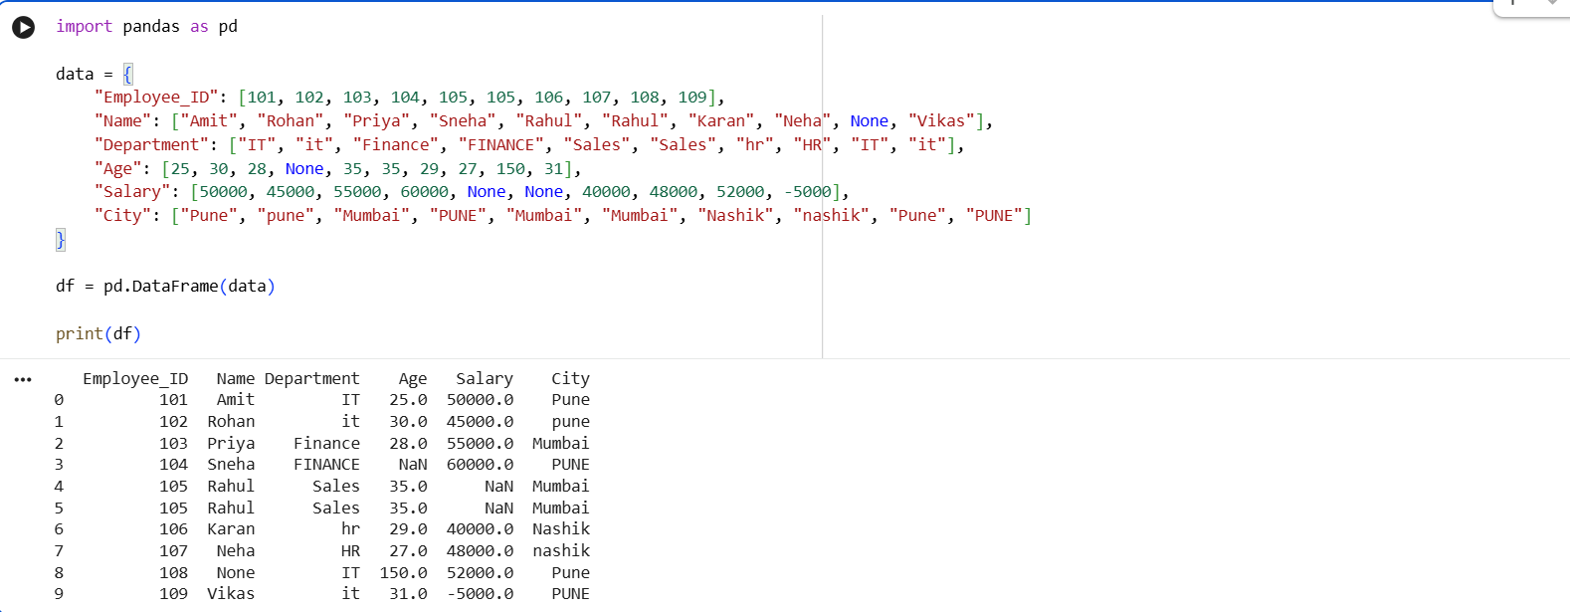
This step creates a dirty employee dataset containing missing values, duplicate records, inconsistent department and city names, and abnormal age and salary values.

2. Identify Missing Values
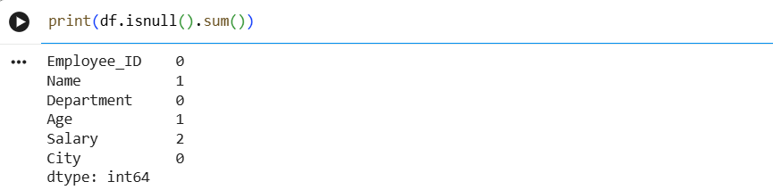
The isnull() function identifies missing values, while sum() counts the number of missing values in each column.
Output: The output displays the number of missing values present in each column.

3. Count Duplicates
The duplicated() function identifies duplicate rows, and sum() counts the total number of duplicate records.
Output: The output displays the total number of duplicate rows found in the dataset.

4. Fix Data Types
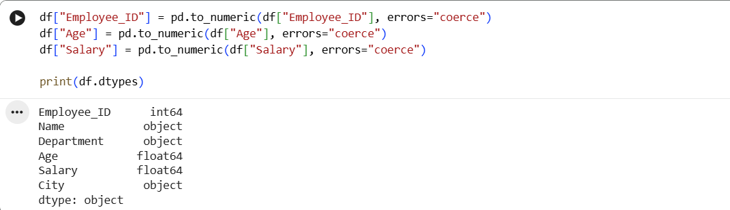
pd.to_numeric() converts columns into numeric data types. The errors="coerce" option converts invalid values into missing values instead of producing an error.
Output: The output shows the corrected numeric data types for the employee ID, age, and salary columns.

5. Standardize Text
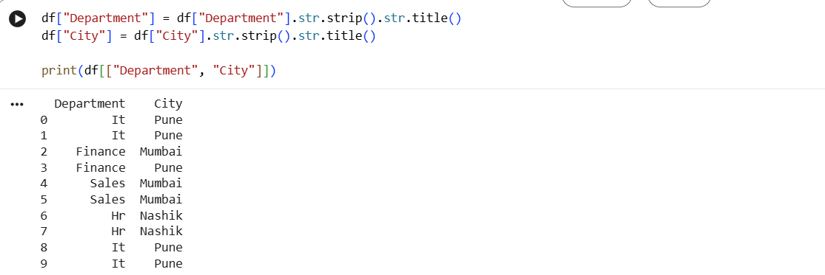
The strip() method removes extra spaces, while title() standardizes the capitalization of text values.
Output: The output shows standardized department and city names with consistent capitalization.

6. Remove Duplicate Records
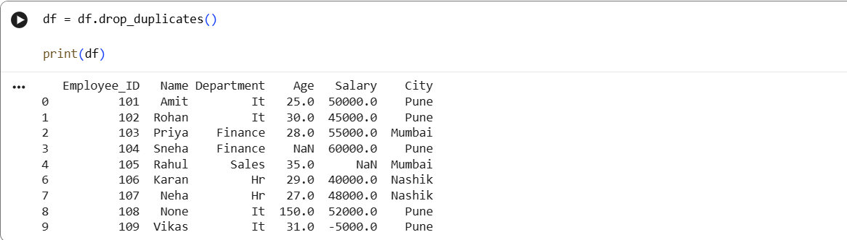
The drop_duplicates() function removes duplicate rows from the dataset.
Output: The output displays the dataset after removing duplicate employee records.

7. Handle Missing Values
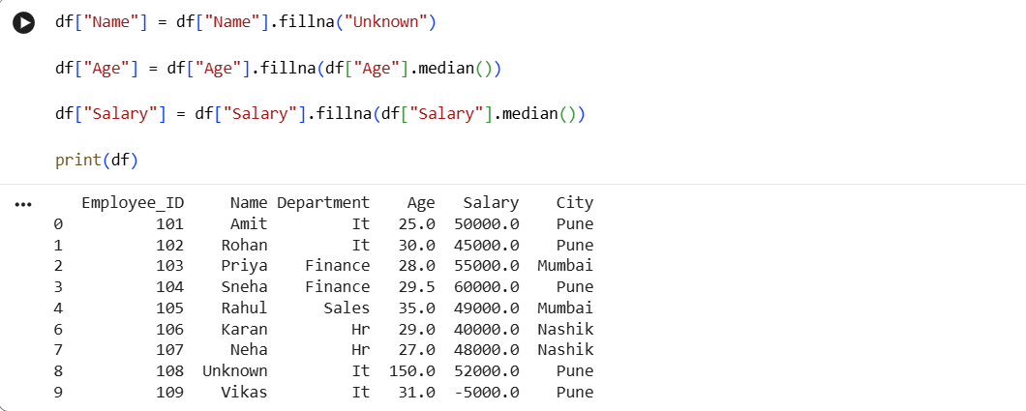
The fillna() function is used to replace missing values. Text missing values are replaced with "Unknown", while numeric missing values are replaced using the median.
Output: The output shows the dataset after filling the missing values.

8. Identify Abnormal Values
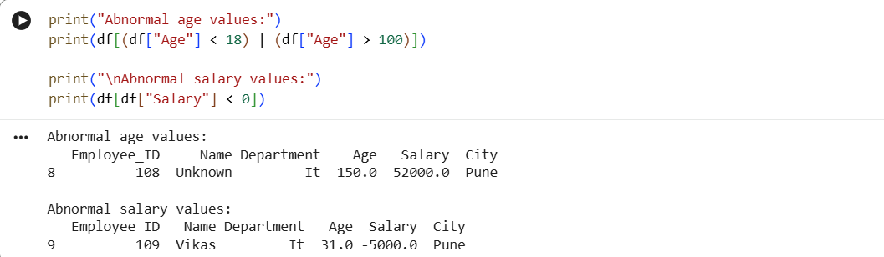
This step identifies abnormal values using conditions. An age greater than 100 and a negative salary are treated as abnormal values for this exercise.
Output: The output displays the employee records containing abnormal age and salary values.

DAY 7— FUNCTIONS + ADVANCED PYTHON BASICS
Completed Assignment with Answers and Python Program

1. Task Day & Date
• Day: Friday
• Date:18/09/2026
2. Task Description
Today's task was to create a small database with three tables: customers, products, and orders. After creating the database, I wrote more than 20 SQL queries to practice fetching, filtering, and calculating data. These queries covered simple searches, conditions, sorting, and calculations like total sales and average order value.

3. Task Elaboration

1.Create Database
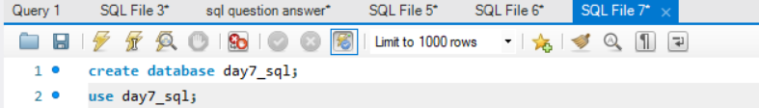
Creates a new database named day7_sql.

2. Create Customers Table
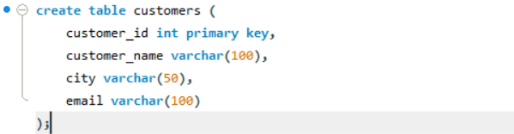
Creates the customers table to store customer information.

3. Create Products Table
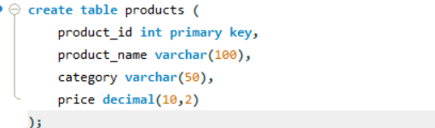
Creates the products table to store product information and prices.

4. Create Orders Table
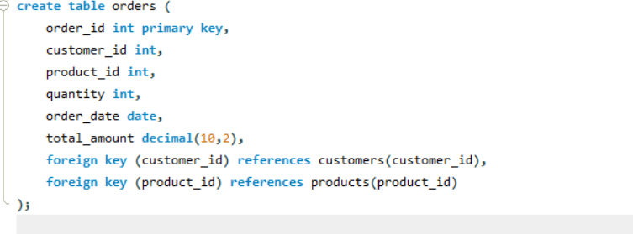
Creates the orders table to store order details. customer_id and product_id connect the orders with the customers and products tables.

5. Display All Customers
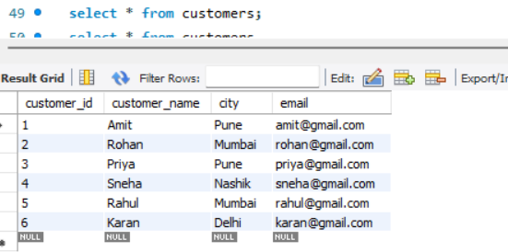
Displays all records from the customers table.

6. Find Customers From Pune
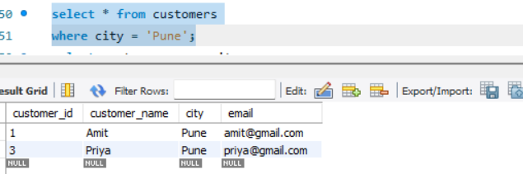
Finds customers whose city is Pune.

7. Display Customer Names and Cities
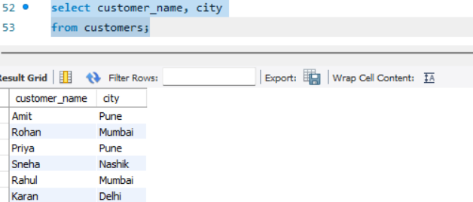
Displays only the customer name and city columns.

8. Find Orders Above ₹5,000
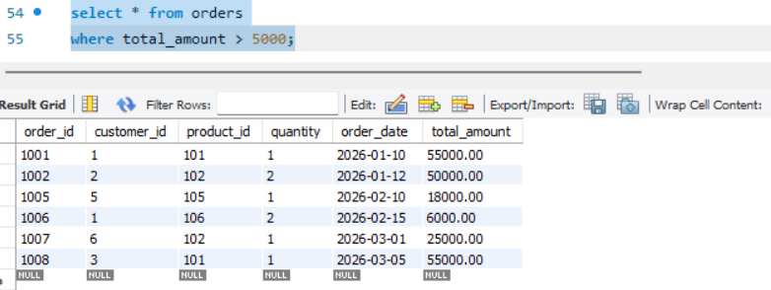
Displays orders where the total amount is greater than ₹5,000.

9. Find Orders Equal To or Above ₹50,000
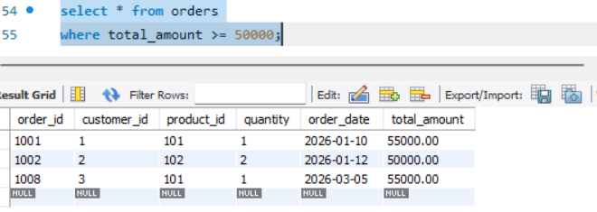
Finds high-value orders of ₹50,000 or more.

10. Display Products By Price
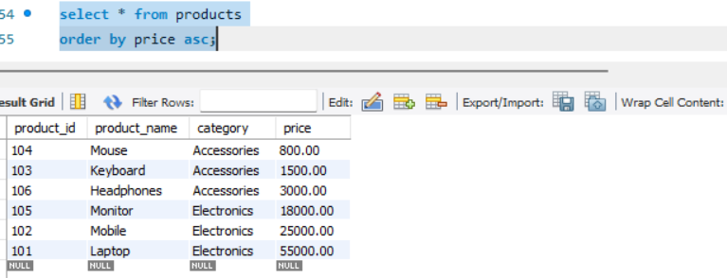
Displays products in ascending order of price.

11. Display Products From Highest Price

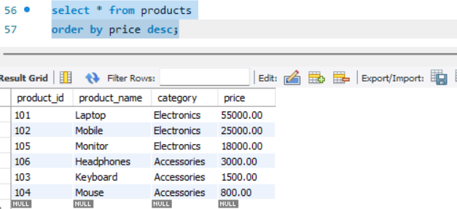
Displays products from highest price to lowest price.

12. Find Top 3 Products
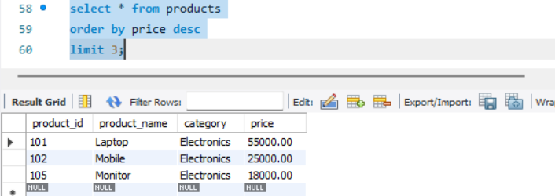
Finds the three most expensive products.

13. Display Different Cities
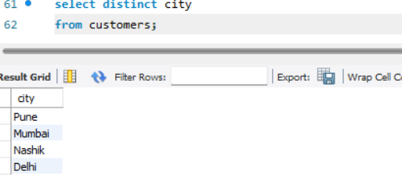
Displays unique cities from the customers table.

14. Count Customers In Each City
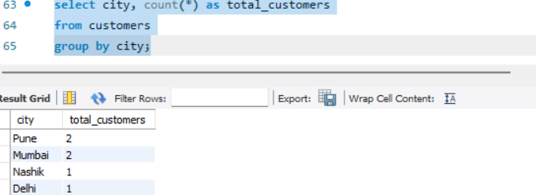
Counts the number of customers in each city.

15. Calculate Total Sales
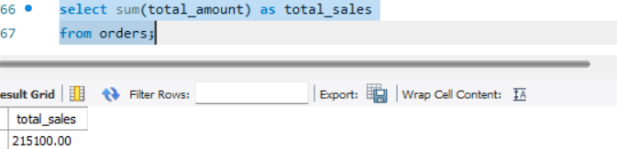
Calculates the total sales amount from all orders.

16. Calculate Average Order Value
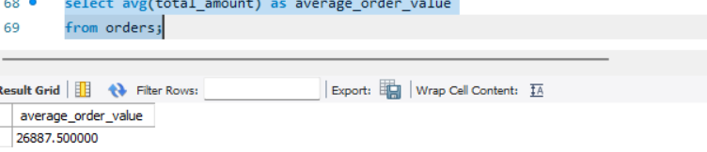
Calculates the average value of all orders.

17. Find Maximum Order Amount
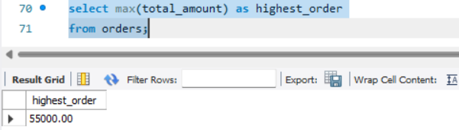
Finds the highest order amount.

18. Find Minimum Order Amount
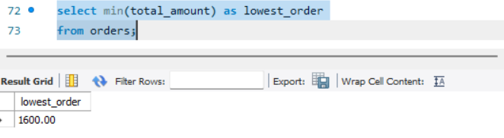
Finds the lowest order amount.

19. Count Total Orders
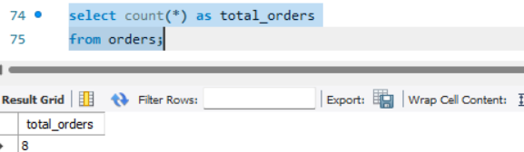
Counts the total number of orders.

20. Total Sales By Customer
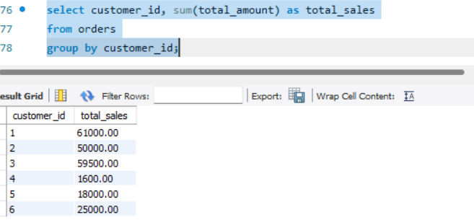
Calculates the total amount spent by each customer.

21. Customers With Total Sales Above ₹30,000
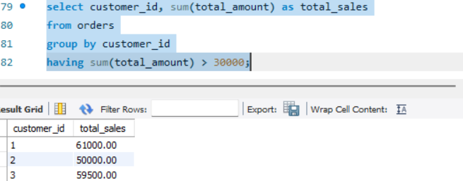
Uses GROUP BY and HAVING to find customers whose total purchases are above ₹30,000.

22. Product Categories
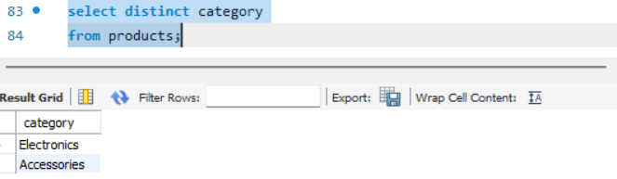
Displays the unique product categories.

23. Products Above ₹10,000
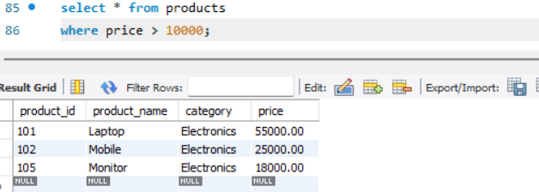
Finds products whose price is greater than ₹10,000.

24. CASE Statement — Product Price Category
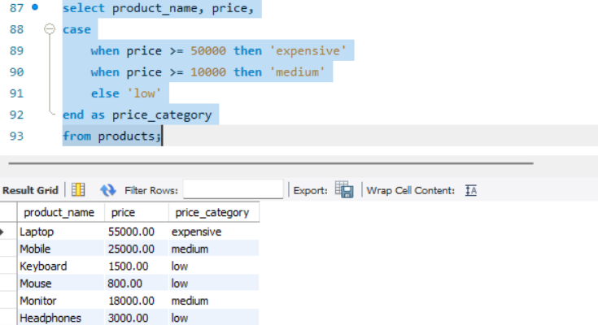
Uses CASE to classify products based on their price.

25. CASE Statement — Order Category
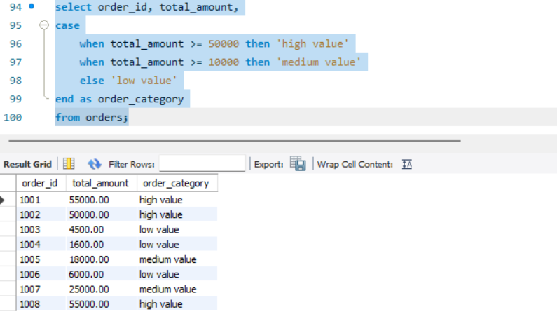
Classifies orders based on their total amount.

DAY 8— FUNCTIONS + ADVANCED PYTHON BASICS
Completed Assignment with Answers and Python Program

1. Task Day & Date
- Day: Saturday
- Date: 19/09/2026

2. Task Description
Today's task was to learn how to clean dirty data. I learned how to find missing values, duplicate rows, wrong data types, incorrect values, inconsistent text, and outliers. I took a dirty dataset and cleaned it step by step so that it became ready to use.

3. Task Elaboration
SQL Task Outputs

Figure 1: Top 3 Customers
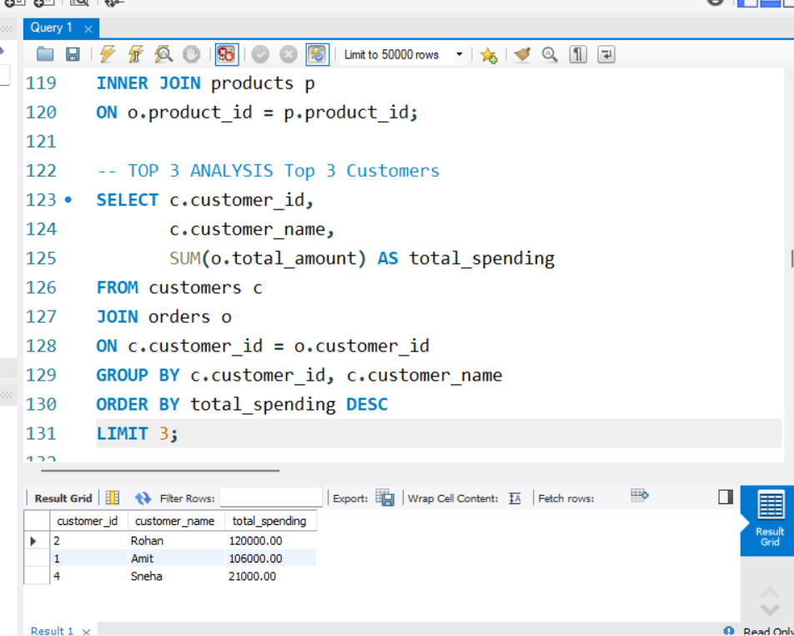
Description: This output shows the three customers with the highest total spending. Rohan is ranked first with ₹120,000, Amit is second with ₹106,000, and Sneha is third with ₹21,000. The query groups orders by customer, calculates total spending using SUM(), sorts the result in descending order, and uses LIMIT 3 to display the top three customers.

Figure 2: Top 3 Products Overall
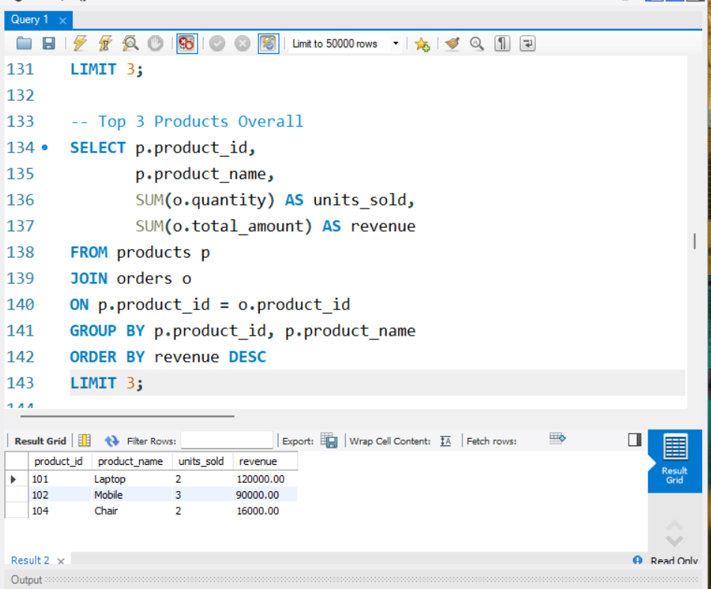
Description: This output shows the three products with the highest overall revenue. Laptop generated ₹120,000, Mobile generated ₹90,000, and Chair generated ₹16,000. The query joins products with orders, calculates units sold and revenue, groups the data by product, sorts by revenue in descending order, and returns the top three products.

Figure 3: Top 3 Products Per Category
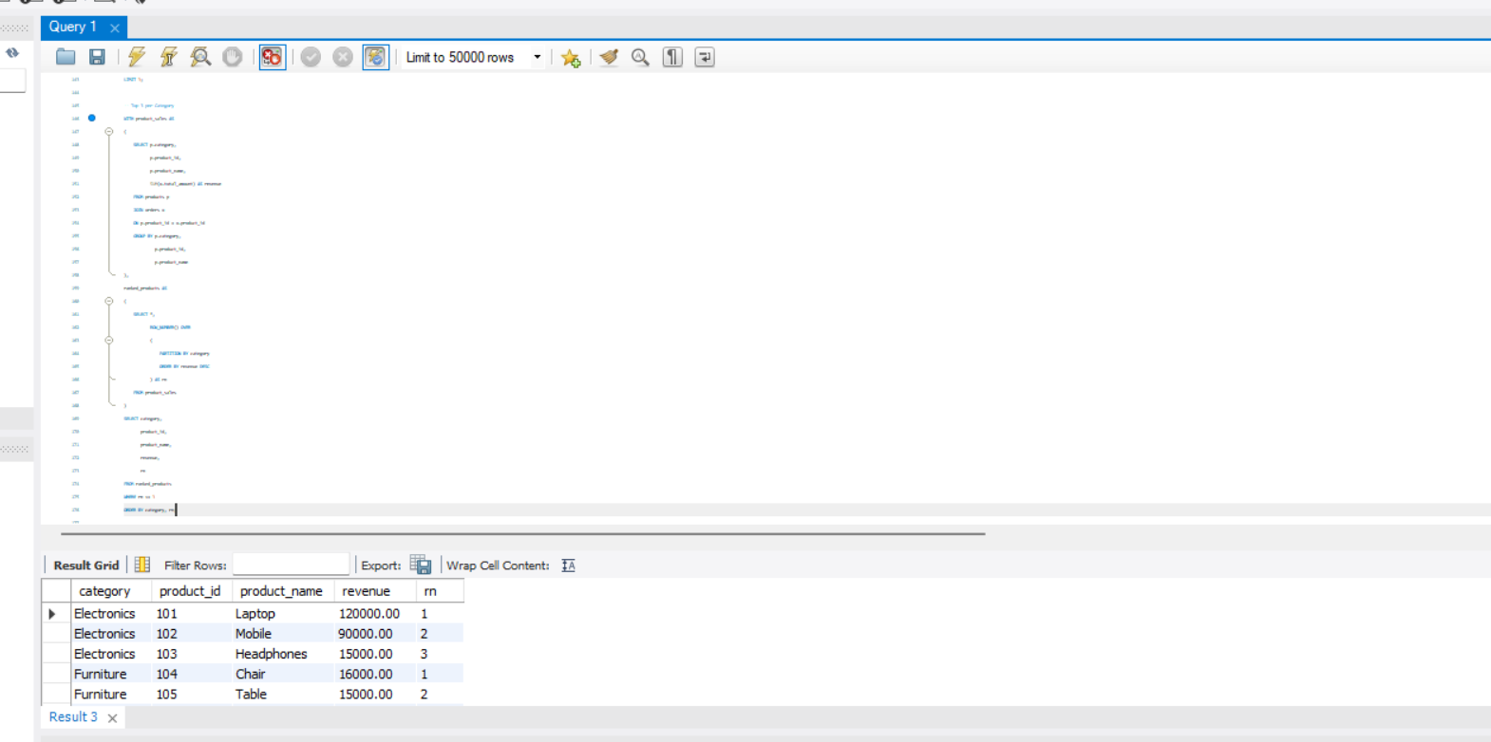
Description: This output demonstrates ranking products separately within each category. Electronics products are ranked by revenue, followed by products in the Furniture category. ROW_NUMBER() with PARTITION BY category assigns a separate ranking sequence to each category.

Figure 4: Customer Ranking Using RANK()
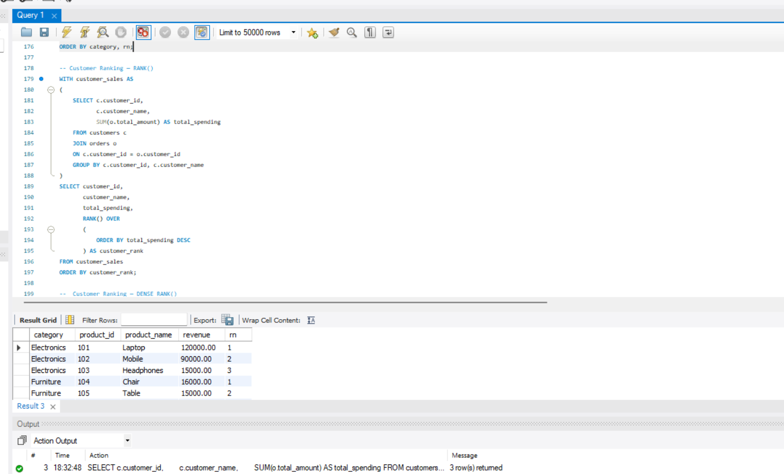

Description: This output ranks customers according to their total spending. Rohan receives rank 1, Amit rank 2, Sneha rank 3, Priya rank 4, and Rahul rank 5. The RANK() window function orders customers by total spending in descending order.

Figure 5: Customer Ranking Using DENSE_RANK()
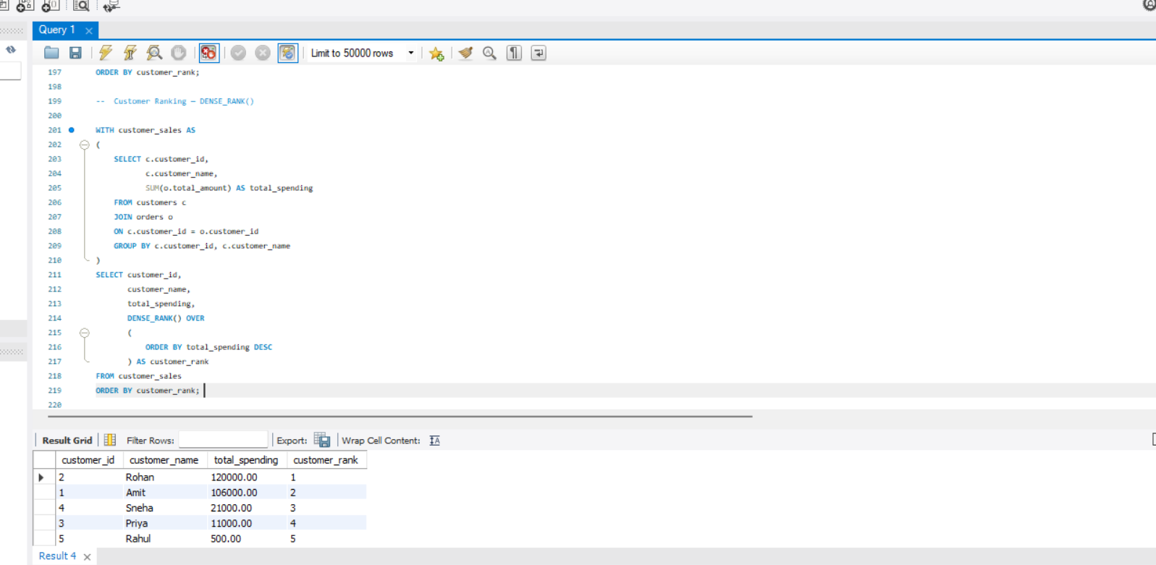
Description: This output demonstrates customer ranking using the DENSE_RANK() window function. Customer sales are first calculated in a CTE, and then customers are ranked from highest to lowest total spending. DENSE_RANK() is useful when equal values should receive the same rank without gaps in the ranking sequence.

Figure 6: Monthly Revenue
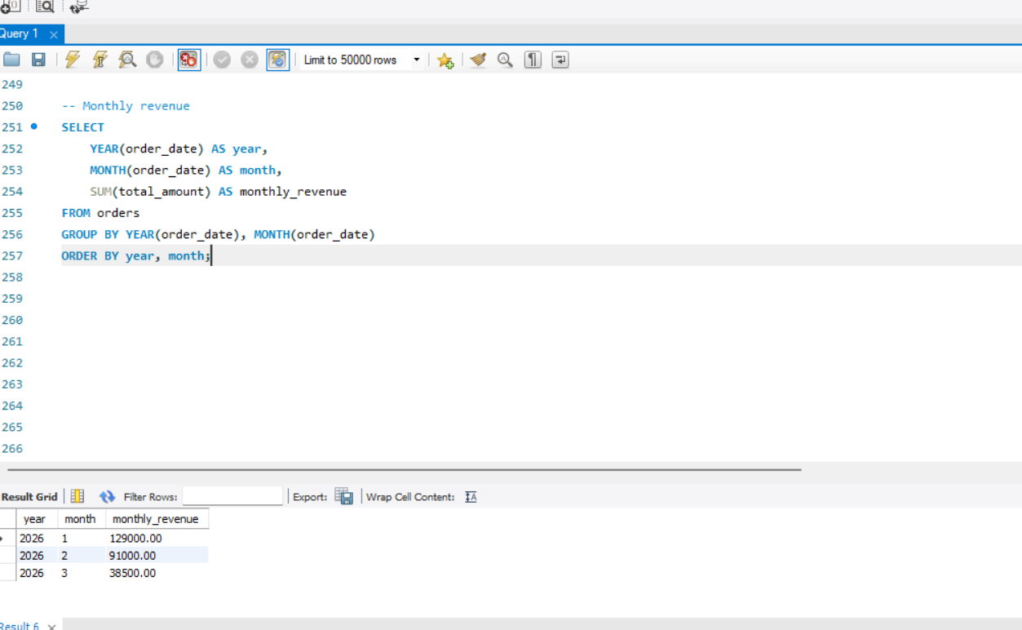
Description: This output calculates total revenue for each month. The results show ₹129,000 for January 2026, ₹91,000 for February 2026, and ₹38,500 for March 2026. YEAR() and MONTH() are used to group order data by year and month, while SUM() calculates monthly revenue.

Figure 7: Previous Month Revenue Using LAG()
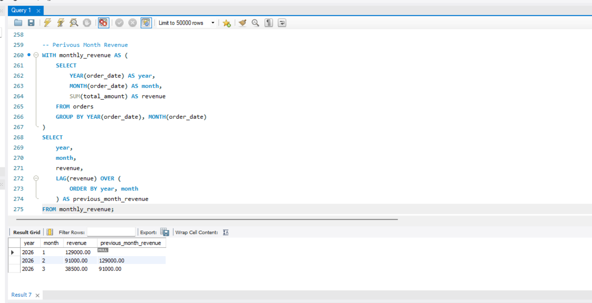
Description: This output shows the current month's revenue together with the revenue from the previous month. January has no previous month in the dataset, so its previous revenue is NULL. February shows January revenue of ₹129,000, and March shows February revenue of ₹91,000. The LAG() window function retrieves the previous row's revenue.

Figure 8: Month-over-Month Revenue Growth
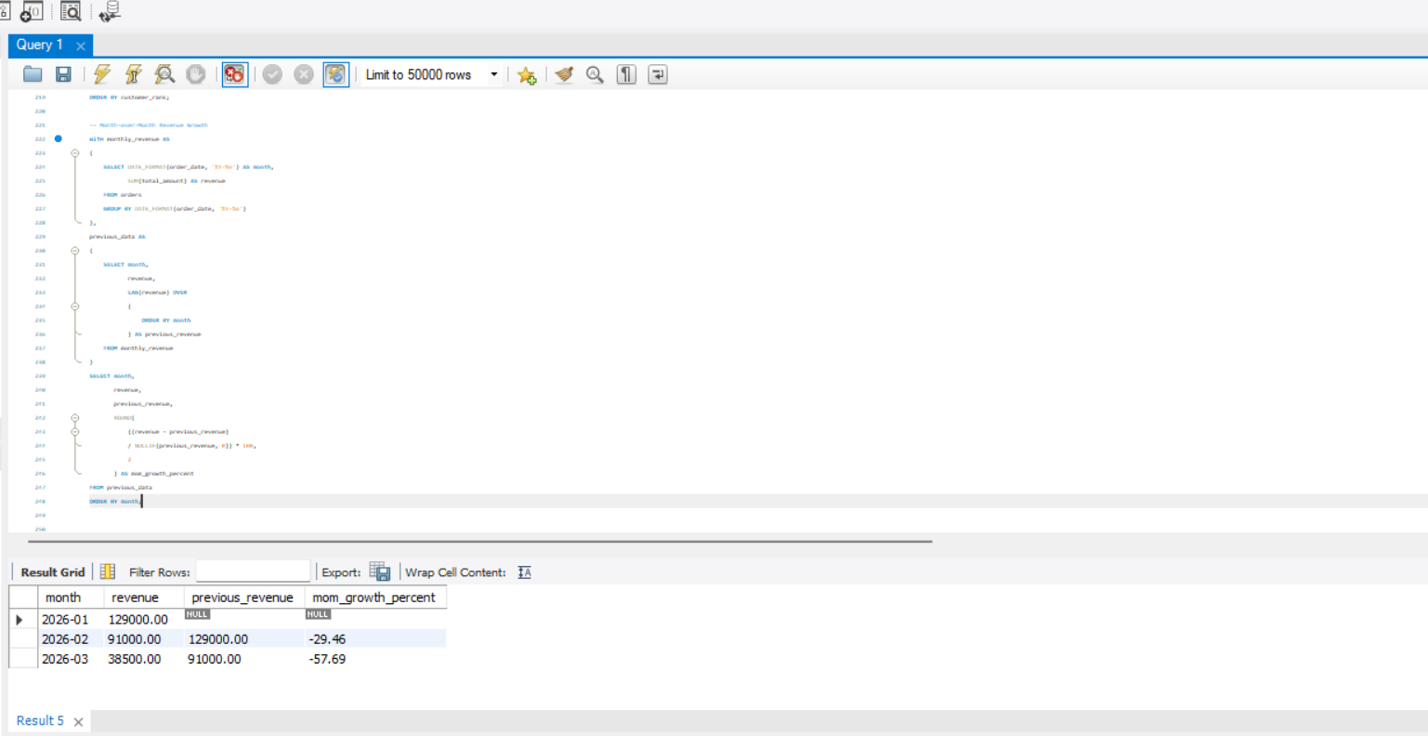
Description: This output calculates the percentage change in revenue compared with the previous month. February shows a growth of -29.46%, while March shows -57.69%. The calculation uses the current revenue and previous revenue returned by LAG(), then calculates the percentage change.
Figure 9: Employee Salary Ranking 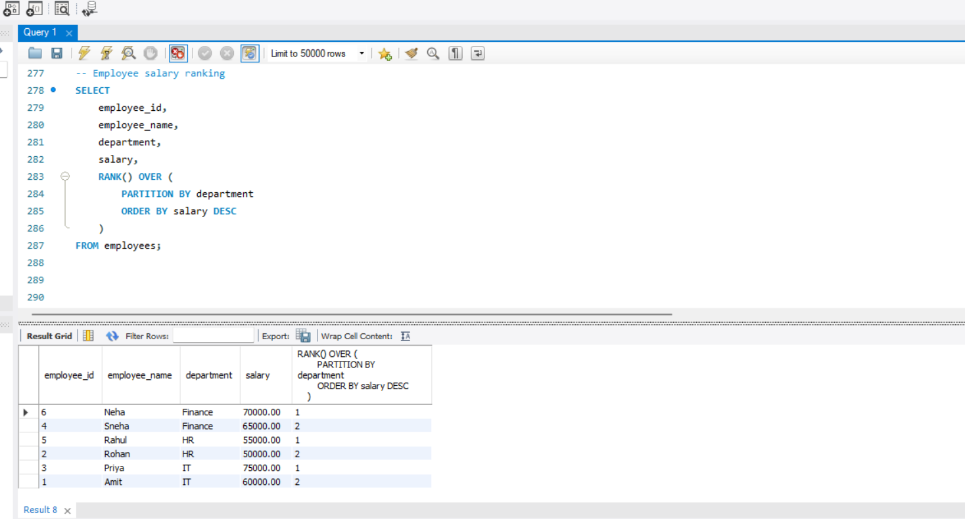
Description: This output ranks employees within each department according to salary. Neha is rank 1 in Finance, Sneha is rank 2 in Finance, Rahul is rank 1 in HR, Rohan is rank 2 in HR, Priya is rank 1 in IT, and Amit is rank 2 in IT. PARTITION BY department creates a separate ranking for each department.

DAY 9— FUNCTIONS + ADVANCED PYTHON BASICS
Completed Assignment with Answers and Python Program

1. Task Day & Date
- Day: Monday
- Date: 21/09/2026

2. Task Description
Today's task was to learn how to clean dirty data. I learned how to find missing values, duplicate rows, wrong data types, incorrect values, inconsistent text, and outliers. I took a dirty dataset and cleaned it step by step so that it became ready to use.

3. Task Elaboration
- Measure | - Description
- Mean | - Arithmetic average of all values. Sensitive to outliers.
- Median | - Middle value when data is sorted. Robust to outliers.
- Mode | - Most frequently occurring value.
- Range | - Difference between maximum and minimum values.
- Variance | - Average of squared differences from the mean (sample uses n−1).
- Standard Deviation | - Square root of variance. Shows typical distance from the mean.
- Percentile | - Value below which a given percentage of data falls.
- Quartile | - Special percentiles: Q1 (25%), Q2 (50% = Median), Q3 (75%).
- IQR | - Q3 − Q1. Spread of the middle 50% of data. Good for outlier detection.
- Covariance | - Measures how two variables change together (direction only).
- Correlation (Pearson) | - Standardized linear relationship between two variables (−1 to +1).

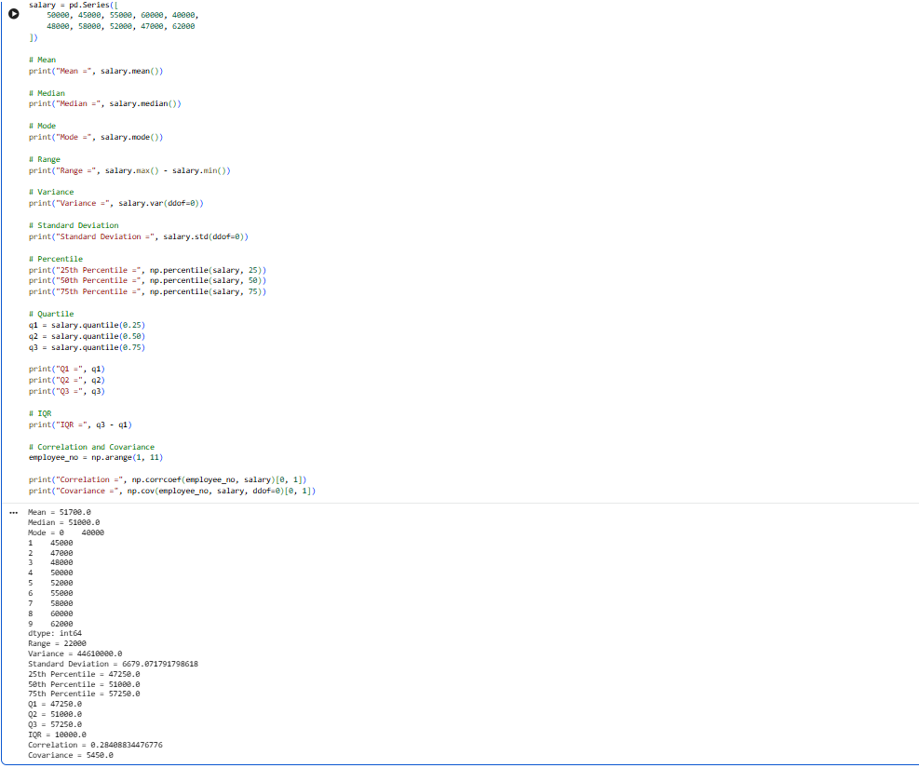
Key Observations from the Output
- Mean (51,700) > Median (51,000) → Mild right skew (a few higher salaries pull the average up).
- Standard Deviation ≈ 6,679 → Salaries vary moderately around the mean.
- IQR = 10,000 → The middle 50% of salaries lie within a 10,000 range (from 47,250 to 57,250).
- Correlation ≈ 0.285 → Very weak positive linear relationship between employee serial number and salary (almost no real relationship).
- Covariance = 5,450 → Confirms the same weak positive direction.

DAY 10— FUNCTIONS + ADVANCED PYTHON BASICS
Completed Assignment with Answers and Python Program

1. Task Day & Date
- Day: Wednesday
- Date: 23/09/2026

2. Task Description

This task focuses on the basic concepts of probability and probability distributions used in data science and machine learning. It includes solving probability problems and implementing selected problems using Python

3. Task Elaboration
1. Probability of Heads
Question: A fair coin is tossed once. Find the probability of getting heads.
Answer:
Total outcomes = 2
Favorable outcome = 1
$$P\left(H\right)=\frac{1}{2}=0.5$$
Answer: 0.5 or 50%
2. Probability of an Even Number
Question: A fair die is rolled once. Find the probability of getting an even number.
Even numbers = 2, 4, 6
$$P\left(Even\right)=\frac{3}{6}=\frac{1}{2}=0.5$$
Answer: 0.5 or 50%

3. Probability of Drawing an Ace
Question: One card is drawn from a standard 52-card deck. Find the probability of getting an Ace.
Number of Aces = 4
Total cards = 52
$$P\left(Ace\right)=\frac{4}{52}=\frac{1}{13}$$
Answer: 0.0769 or 7.69%
4. Probability of Getting Sum 7
Question: Two dice are rolled. Find the probability that the sum is 7.
Favorable combinations:
(1,6), (2,5), (3,4), (4,3), (5,2), (6,1)
Favorable outcomes = 6
Total outcomes = 36
$$P\left(Sum=7\right)=\frac{6}{36}=\frac{1}{6}$$
Answer: 0.1667 or 16.67%
5. Conditional Probability
Question: A card is drawn from a standard deck. Given that it is a face card, find the probability that it is a King.
Face cards = 12
Kings = 4
$$P\left(King∣Face\right)=\frac{4}{12}=\frac{1}{3}$$
Answer: 0.3333 or 33.33%
6. Independent Events
Question: A coin is tossed and a die is rolled. Find the probability of getting Heads and 6.
$$P\left(H\right)=\frac{1}{2} \\ P\left(6\right)=\frac{1}{6}$$
Since the events are independent:
$$P\left(H∩6\right)=P\left(H\right)×P\left(6\right) \\ =\frac{1}{2}×\frac{1}{6}=\frac{1}{12}$$
Answer: 0.0833 or 8.33%
7. Dependent Events
Question: A bag contains 5 red and 3 blue balls. Two balls are drawn without replacement. Find the probability that both are red.
First red:
$$P\left(R_{1}\right)=\frac{5}{8}$$
After drawing one red, 4 red balls remain out of 7:
$$P\left(R_{2}∣R_{1}\right)=\frac{4}{7}$$
Therefore:
$$P\left(R_{1}∩R_{2}\right)=\frac{5}{8}×\frac{4}{7} \\ =\frac{5}{14}$$
Answer: 0.3571 or 35.71%
8. At Least One Six
Question: A die is rolled twice. Find the probability of getting at least one 6.
Probability of not getting 6:
$$P\left(No 6\right)=\frac{5}{6}$$
For two rolls:
$$P\left(No 6\right)={\left(\frac{5}{6}\right)}^{2}=\frac{25}{36}$$
Therefore:
$$P\left(At least one 6\right)=1-\frac{25}{36} \\ =\frac{11}{36}$$
Answer: 0.3056 or 30.56%

9. Bayes' Theorem
Question: A disease affects 1% of a population. A test is positive for 95% of people with the disease and 5% of people without it. Find the probability that a person has the disease given a positive test.
Given: $P\left(D\right)=0.01$$$P\left(+∣D\right)=0.95 \\ P\left(+∣\text{Not D}\right)=0.05 \\ P\left(\text{Not D}\right)=0.99$$First:
$$P\left(+\right)=0.95\left(0.01\right)+0.05\left(0.99\right) \\ P\left(+\right)=0.059$$Using Bayes' theorem:
$$P\left(D∣+\right)=\frac{P\left(+∣D\right)P\left(D\right)}{P\left(+\right)} \\ =\frac{0.95×0.01}{0.059} \\ =0.1610$$
Answer: approximately 16.10%

10. Binomial Distribution — Exactly 3 Heads
Question: A fair coin is tossed 5 times. Find the probability of getting exactly 3 heads.
Formula:
$$P\left(X=k\right)=C\left(n , k\right)p^{k}{\left(1-p\right)}^{n-k}$$Here:
- $n=5$
- $k=3$
- $p=0.5$
$$P\left(X=3\right)=C\left(5 , 3\right){\left(0.5\right)}^{3}{\left(0.5\right)}^{2} \\ =10×0.125×0.25 \\ =0.3125$$
Answer: 0.3125 or 31.25%

11. Defective Items
Question: A machine produces defective items with probability 0.1. For 10 items, find the probability of exactly 2 defective items.
$$P\left(X=2\right)=C\left(10 , 2\right){\left(0.1\right)}^{2}{\left(0.9\right)}^{8} \\ =0.1937$$Answer: approximately 0.1937 or 19.37%
12. True/False Questions
Question: A student guesses answers to 8 true/false questions. Find the probability of getting exactly 5 correct.
$$n=8, k=5, p=0.5 \\ P\left(X=5\right)=C\left(8 , 5\right){\left(0.5\right)}^{5}{\left(0.5\right)}^{3} \\ =56{\left(0.5\right)}^{8} \\ =\frac{56}{256} \\ =0.21875$$
Answer: 0.21875 or 21.875%
13. Normal Distribution — Z Score
Question: Test scores have mean 70 and standard deviation 10. Find the z-score for a score of 85.
Formula:
$$Z=\frac{X-μ}{σ} \\ Z=\frac{85-70}{10} \\ Z=1.5$$Answer: Z = 1.5
14. Standard Normal Distribution
Question: Find $P\left(Z<1.96\right)$.
From the standard normal distribution table:
$$P\left(Z<1.96\right)≈0.9750$$
Answer: 0.9750 or 97.50%

15. Expected Value
Question: A fair die is rolled once. Find its expected value.
$$E\left(X\right)=\sum{x}P\left(x\right) \\ E\left(X\right)=\frac{1+2+3+4+5+6}{6} \\ E\left(X\right)=\frac{21}{6} \\ E\left(X\right)=3.5$$
Answer: 3.5

- Python Implementation — 5 Problems

Python Program 1: Probability of Even Number
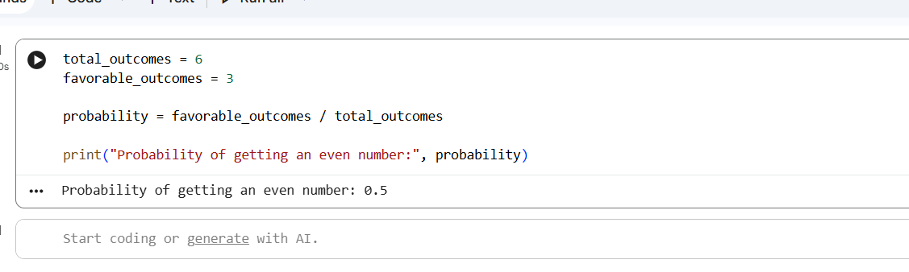
This program calculates the probability of getting an even number when a fair die is rolled. It divides the number of favorable outcomes, 3, by the total number of possible outcomes, 6.

Python Program 2: Conditional Probability
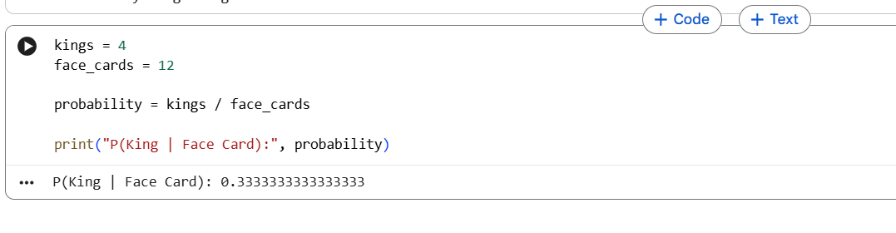
This program calculates the probability of drawing a King when it is already known that the selected card is a face card. It uses the number of Kings and total face cards to calculate the conditional probability.

Python Program 3: Dependent Events
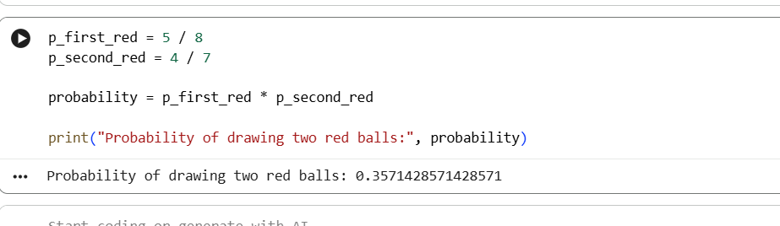
This program calculates the probability of drawing two red balls consecutively without replacement. It multiplies the probability of drawing a red ball first by the probability of drawing another red ball after the first one has been removed.

Python Program 4: Bayes' Theorem
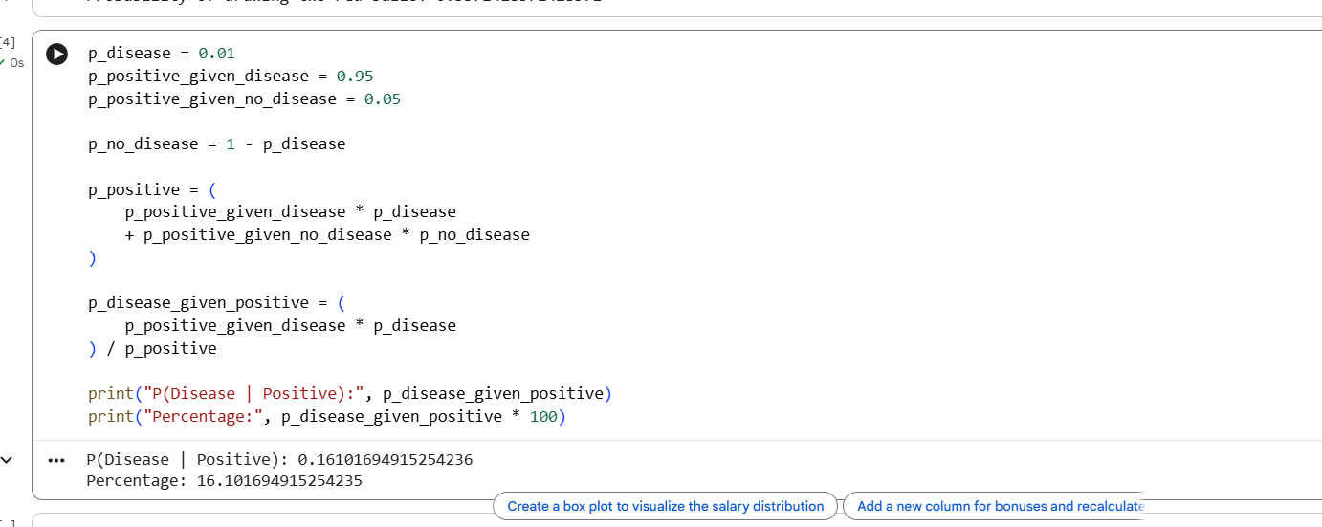
This program applies Bayes' theorem to calculate the probability of having a disease given a positive test result. It uses the disease probability, test sensitivity, and false-positive probability to obtain the final conditional probability.

Python Program 5: Binomial Distribution
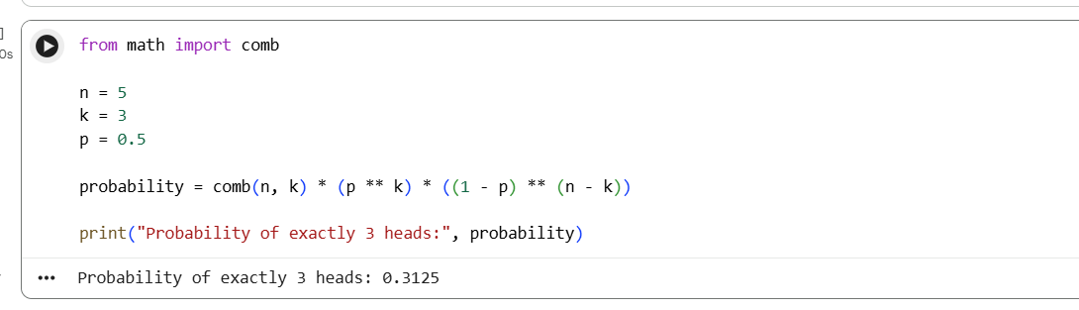
This program calculates the probability of getting exactly three Heads in five fair coin tosses. Python's comb() function calculates the number of possible combinations, which is then used in the binomial probability formula.

DAY 11— FUNCTIONS + ADVANCED PYTHON BASICS
Completed Assignment with Answers and Python Program

1. Task Day & Date
• Day: Thursday
• Date:24/09/2026
2. Task Description
The Day 11 task focuses on learning and applying Matplotlib for data visualization. The main objective is to understand how different types of charts can be used to represent and communicate information from a dataset.The task requires using one dataset and creating at least 10 different charts. The charts should include visualizations such as line charts, bar charts, histograms, scatter plots, pie charts, box plots, and area charts.

3. Task Elaboration

Dataset Used: Titanic Dataset

Step 1 — Import Libraries and Dataset
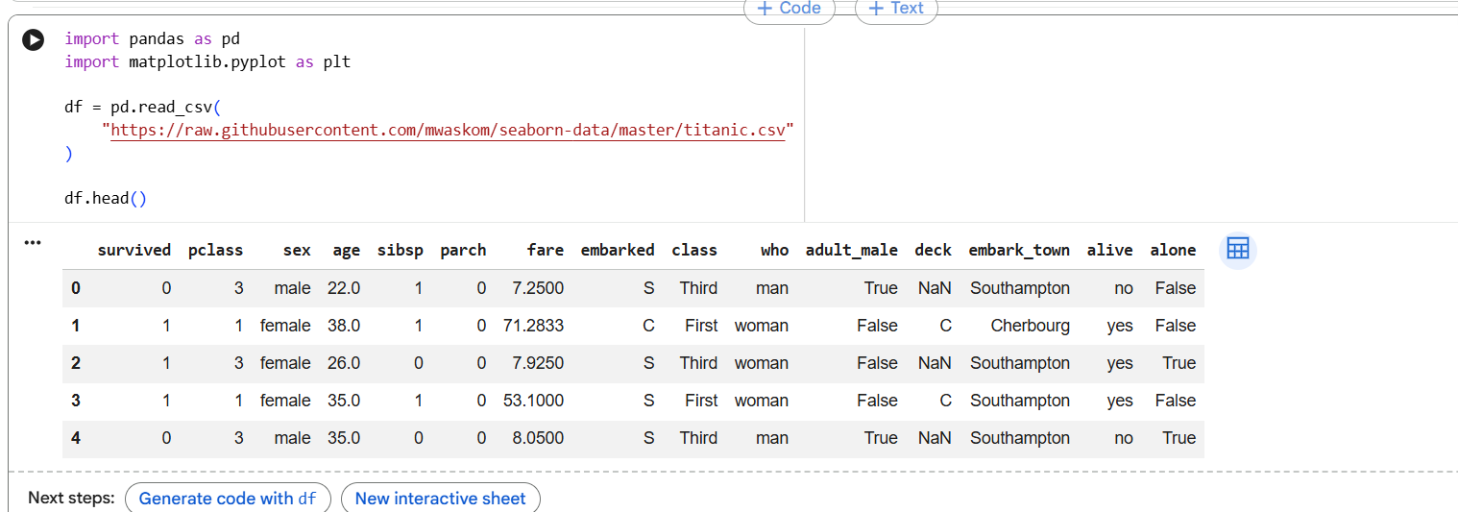
Description:
The Titanic dataset contains information about passengers, including their age, gender, passenger class, fare, and survival status. This dataset is used to create different visualizations and understand patterns in the data.

Line Chart — Average Fare by Passenger Class
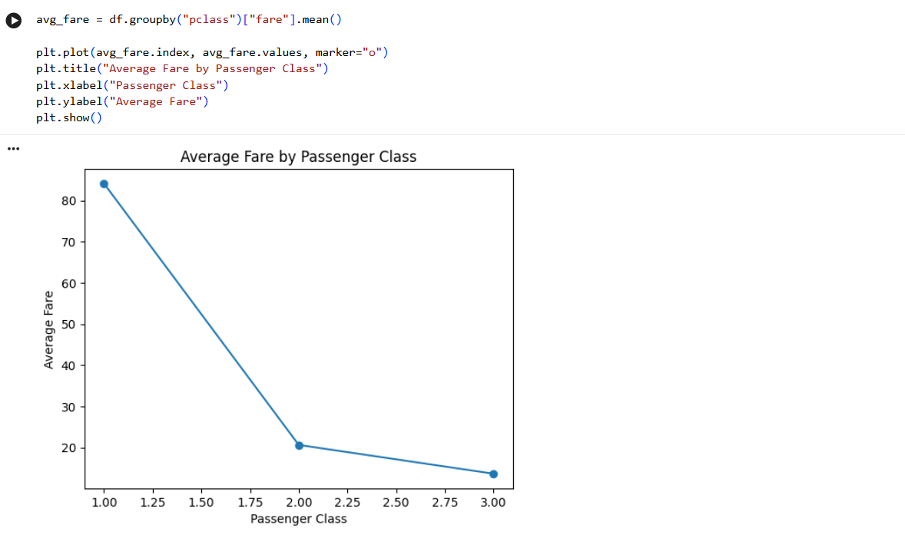
Description:
This line chart represents the average fare paid by passengers in each passenger class. It helps us compare the average ticket prices between first, second, and third class.

Bar Chart — Number of Passengers by Class
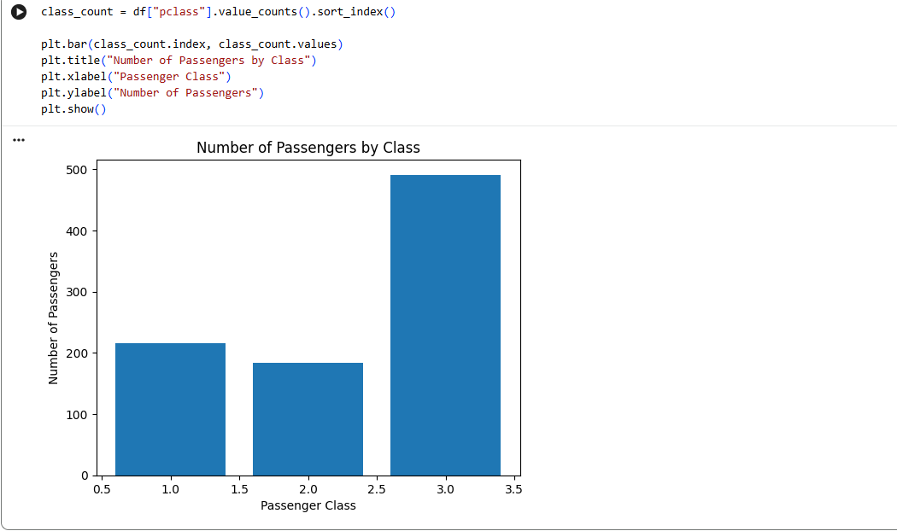
Description:
The bar chart shows the number of passengers belonging to each passenger class.

Histogram — Age Distribution
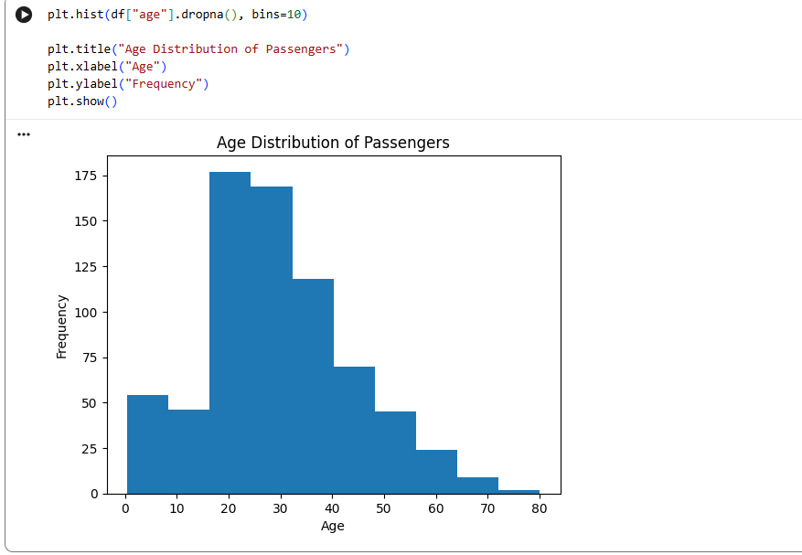
Description:
A histogram is used to understand the distribution of passenger ages.

4.Scatter Plot — Age vs Fare
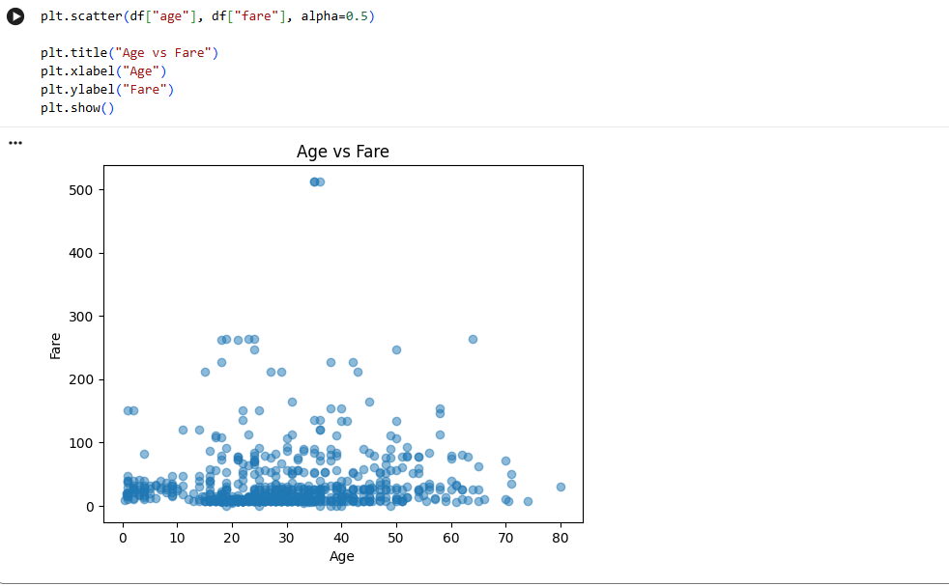
Description:
The scatter plot compares passenger age with the fare they paid.

5. Pie Chart — Passenger Class Distribution
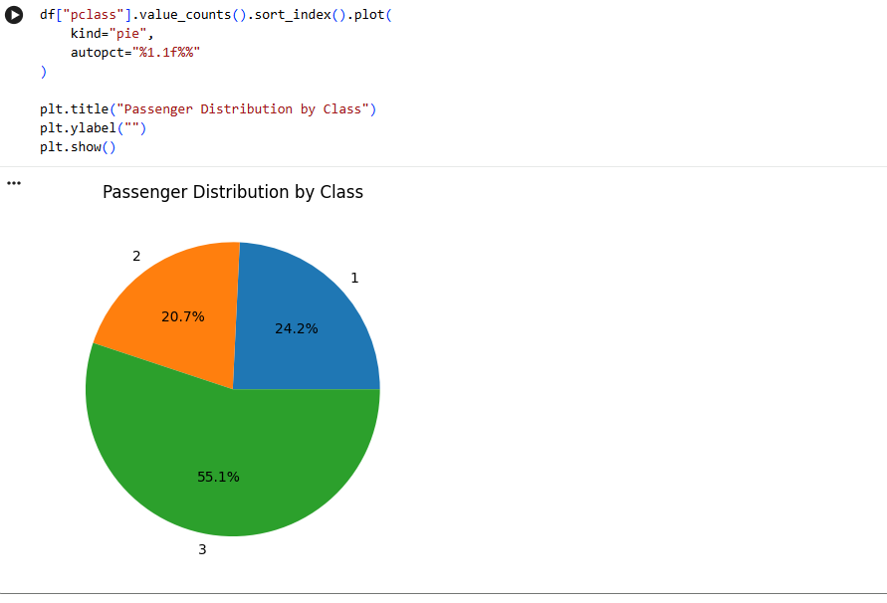
Description:
The pie chart displays the proportion of passengers in each passenger class.

6.Box Plot — Fare Distribution
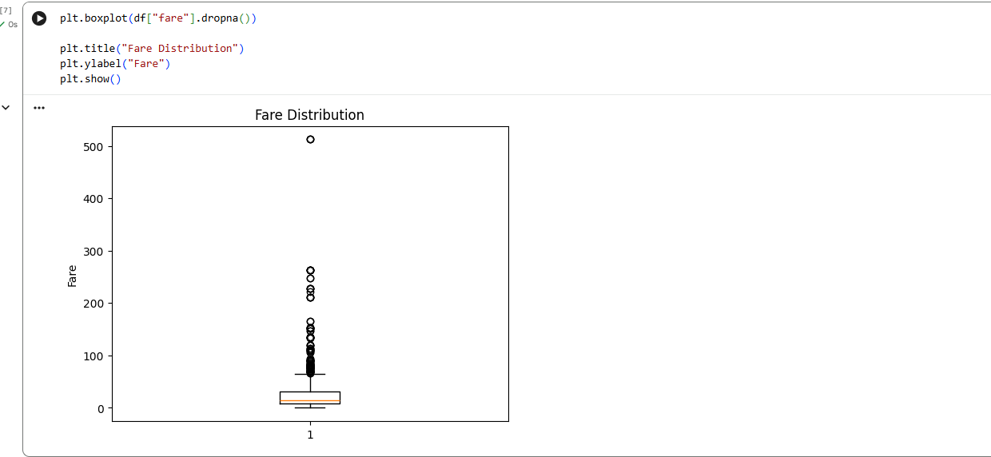
Description:
A box plot is used to understand the distribution, median, spread, and possible outliers of passenger fares.

7.Area Chart — Passenger Count by Class
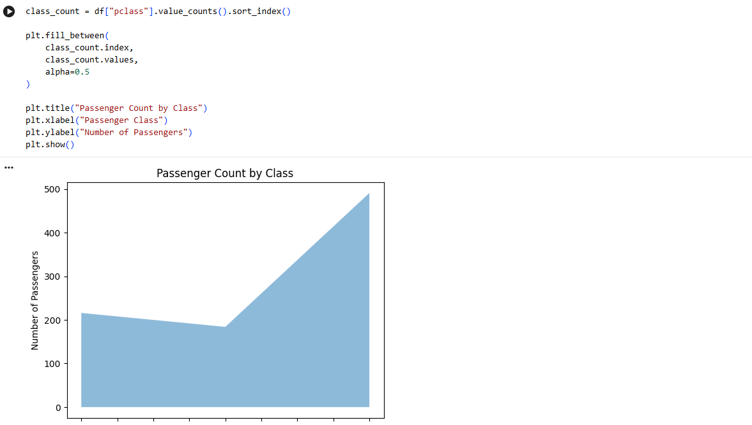

Description:
The area chart represents the number of passengers in each class using a filled area.

8. Bar Chart — Survivors by Gender
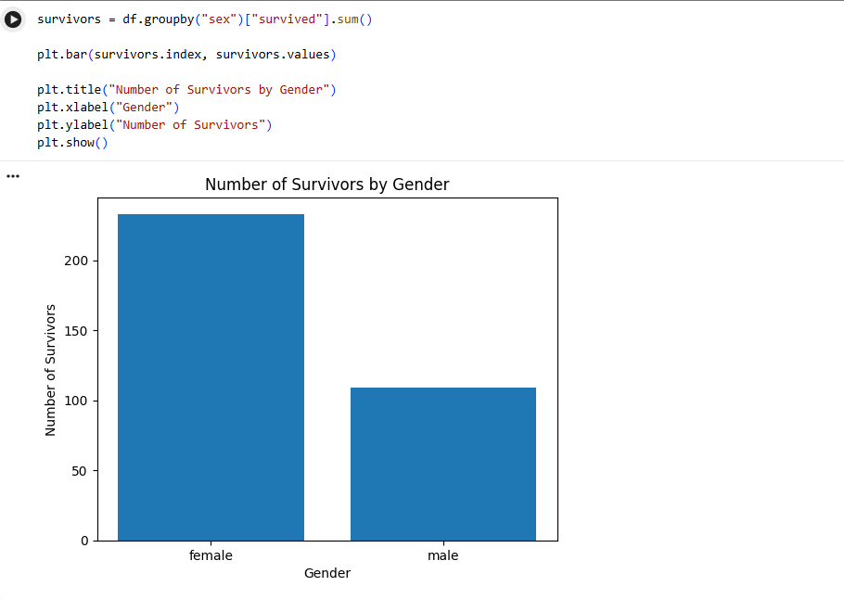
Description:
This chart compares the number of surviving passengers according to gender.

9. Line Chart — Survival Rate by Class
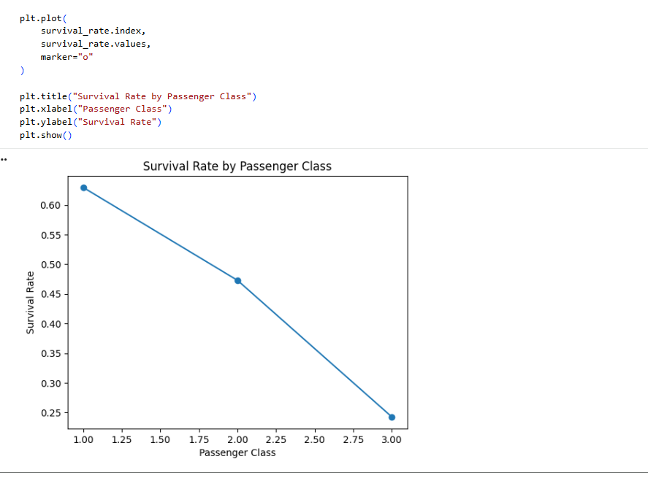
Description:
This chart calculates the average survival value for each passenger class. Since survived is represented as 0 or 1, its mean represents the survival rate.

10. Histogram — Fare Distribution
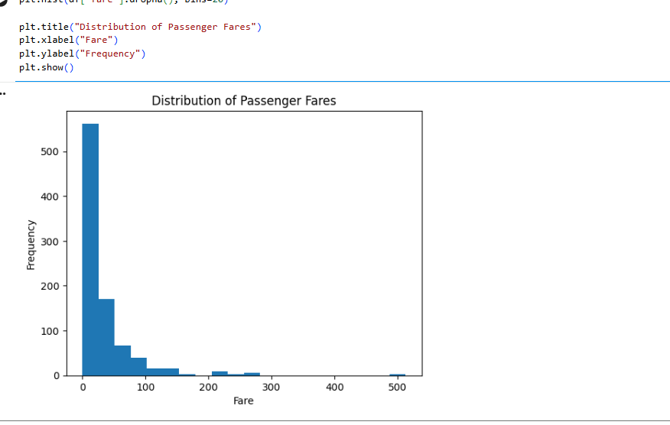
Description:
This histogram shows how passenger fares are distributed.

DAY 12— FUNCTIONS + ADVANCED PYTHON BASICS
Completed Assignment with Answers and Python Program

1. Task Day & Date
• Day: Thursday
• Date:24/09/2026
2. Task Description
The Day 12 task focuses on Seaborn and Advanced Exploratory Data Analysis (EDA). The objective is to analyze a dataset using statistical and graphical techniques to understand its distributions, categories, outliers, and relationships between variables.The task requires creating different Seaborn visualizations such as countplots, boxplots, violin plots, heatmaps, pairplots, and distribution plots.

3. Task Elaboration

Step 1 — Import Libraries
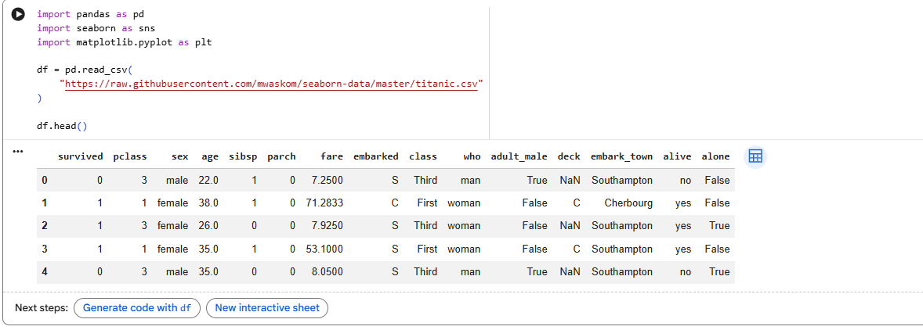

1. Distribution Analysis
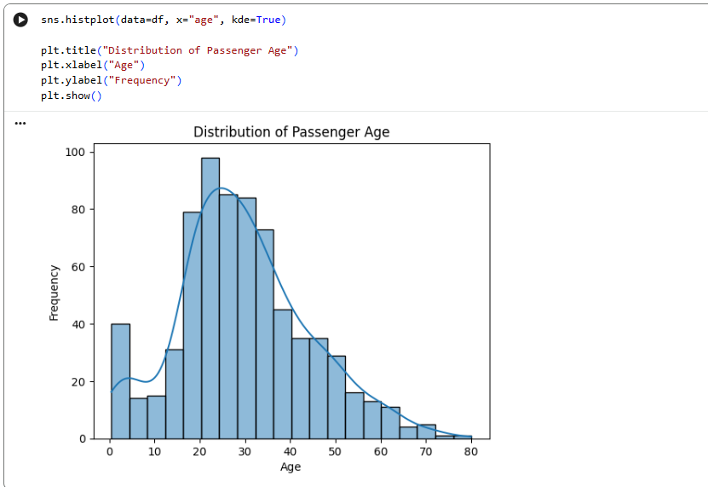
Description
This distribution plot shows how passenger ages are spread throughout the Titanic dataset. The KDE curve provides an approximate view of the shape of the age distribution.

2. Category Analysis — Countplot
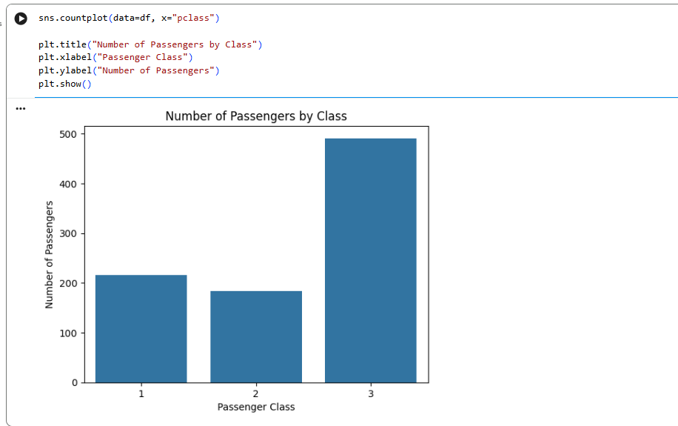
Description
The countplot counts the number of passengers in each passenger class.

3. Gender Category Analysis
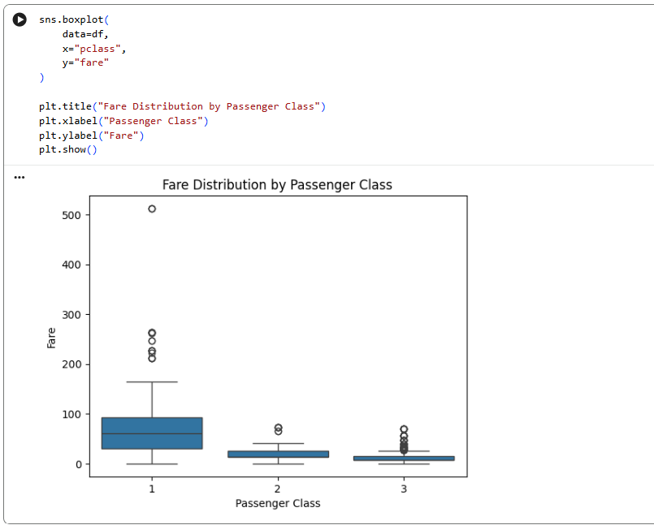
Description
This countplot displays the number of male and female passengers.

4. Boxplot — Fare by Passenger Class
Description
The boxplot compares fare distributions across the three passenger classes.

5. Violin Plot — Age by Passenger Class
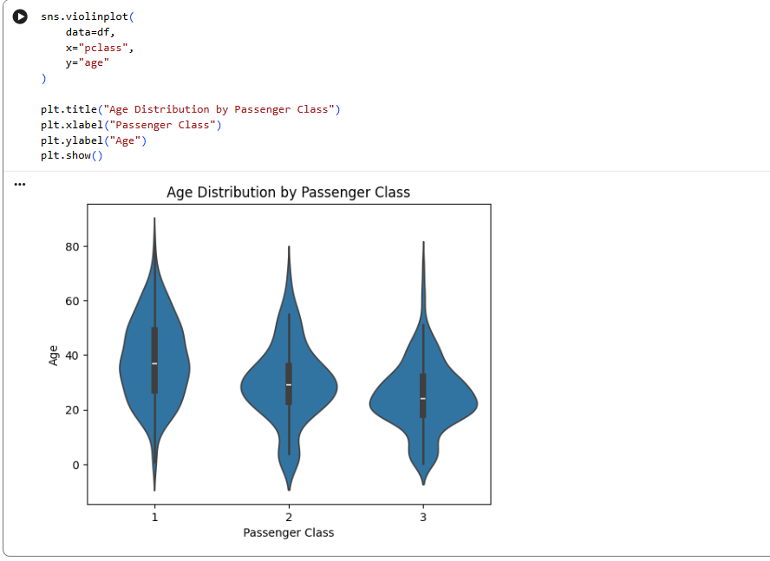
Description
A violin plot combines information about the distribution and density of data. Here, it shows age distribution within each passenger class.

6. Correlation Heatmap
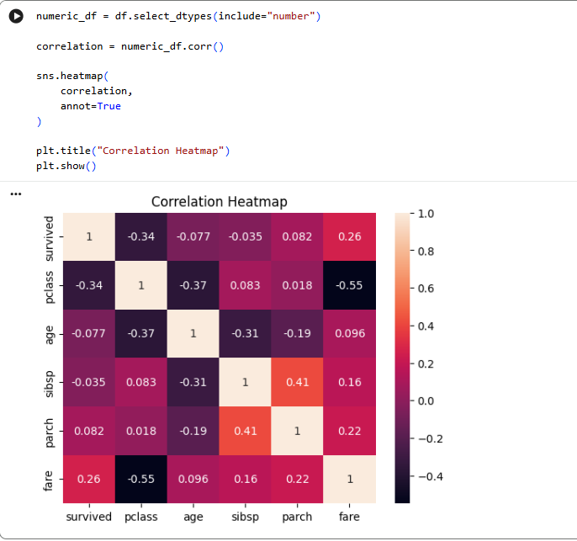
Description
The correlation heatmap displays the correlation between numerical variables in the dataset.

7. Pairplot
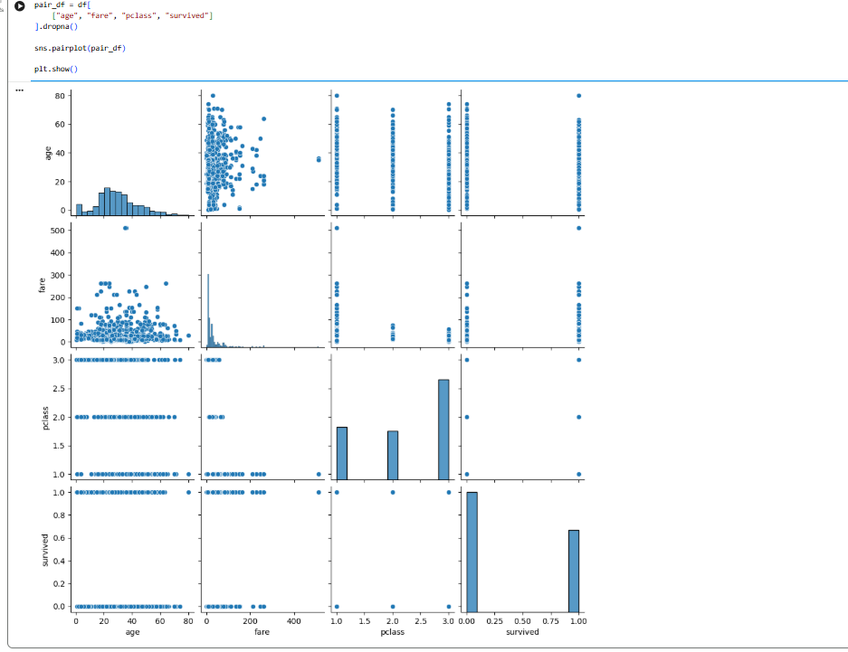
Description
A pairplot creates multiple plots showing relationships between numerical variables.

8. Distribution Analysis — Fare
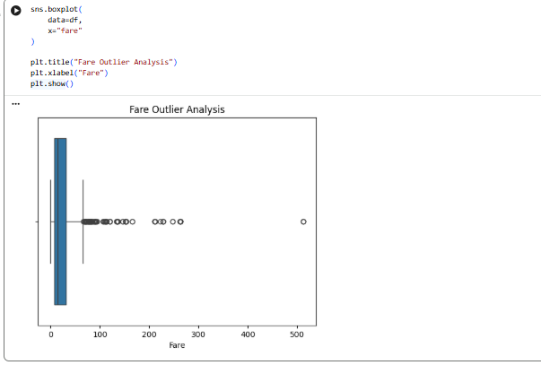
Description
This plot shows the distribution of passenger fares and includes a KDE curve to represent the approximate distribution shape.

9. Outlier Analysis
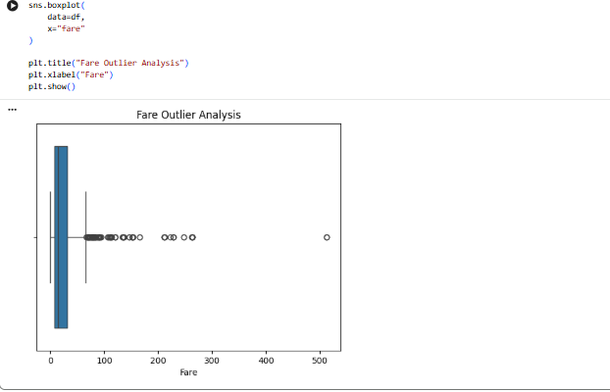
Description
The boxplot is used to identify unusually high or low fare observations.

10. Survival Analysis
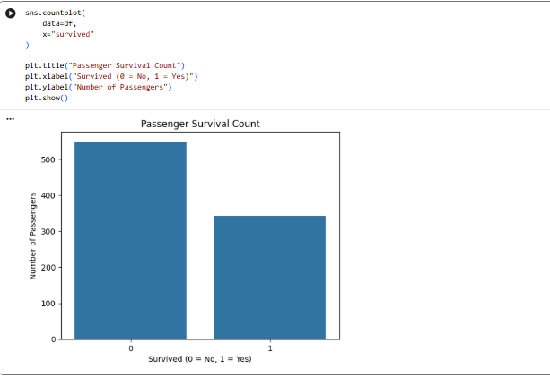
Description
This countplot compares passengers who did not survive with passengers who survived.

DAY 13— FUNCTIONS + ADVANCED PYTHON BASICS
Completed Assignment with Answers and Python Program

1. Task Day & Date
• Day: Friday
• Date:25/09/2026
2. Task Description

The objective of Day 13 is to learn Power BI and create a one-page Sales Dashboard. The task focuses on importing sales data, cleaning and transforming it, and presenting important business information using different Power BI visualizations.

3. Task Elaboration

Operations to Perform
- Import Data
Import the sales dataset into Power BI.
- Power Query
Open Power Query Editor and prepare the data for analysis.
- Transform Data
Perform required data-cleaning and transformation operations.
- Set Data Types
Make sure columns have the correct data types such as Text, Number, Date, etc.
- Apply Filters
Use filters to display specific portions of the sales data.
- Create Slicers
Add slicers to allow users to interactively filter the dashboard.
- Create Charts
Use charts to visually represent sales information.
- Create Cards
Create KPI cards for important totals.
- Create Tables
Display detailed sales information using a table.
- Create Matrix
Use a matrix to summarize sales information by different categories.

Dashboard Requirements
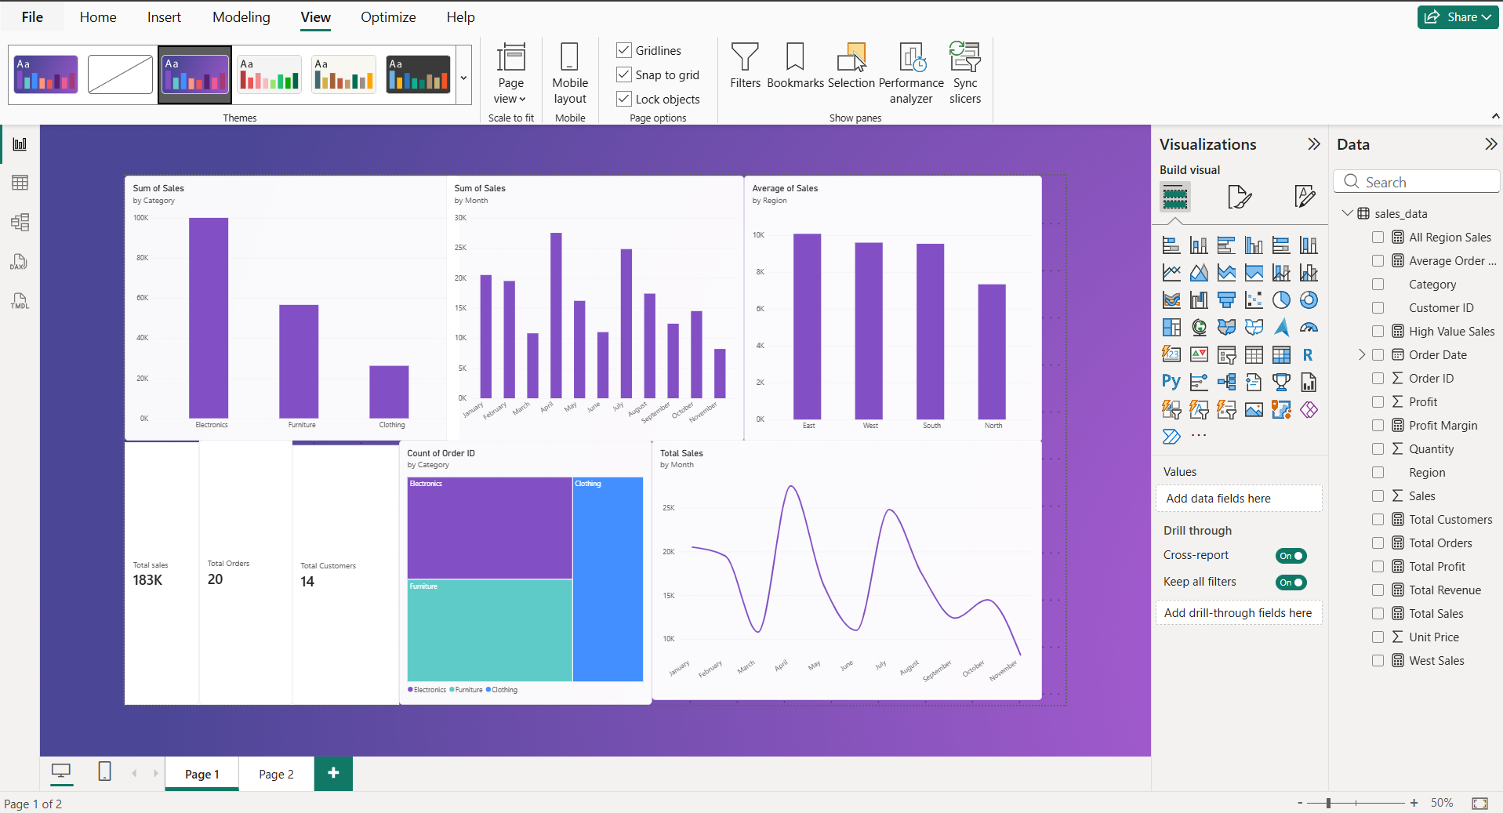

The one-page dashboard should contain:
- Total Sales - Create a Card visual showing total sales.
    - Operation: Select Card.
        - Add the Sales field.
        - Use Sum aggregation.

- Total Orders - Create another Card to display the total number of orders.
- Total Customers - Create a Card displaying the number of customers.
- Sales by Category - Create a chart showing sales for each product category.
    - Operation: Add Category to Axis.
        - Add Sales to Values.
        - Select a bar/column chart.

- Sales by Region - Create a chart showing sales according to region.
Operation:
- Add Region to Axis.
- Add Sales to Values.

- Monthly Sales- Create a line chart to analyze sales over time.
Operation:
        - Add Date/Month to Axis.
        - Add Sales to Values.

DAY 14— FUNCTIONS + ADVANCED PYTHON BASICS
Completed Assignment with Answers and Python Program

1. Task Day & Date
• Day: Friday
• Date:25/09/2026
2. Task Description

The Day 14 task focuses on learning DAX (Data Analysis Expressions) in Power BI for creating dynamic calculations. The task requires creating measures such as Total Revenue, Total Profit, Total Orders, Total Customers, Average Order Value, and Profit Margin. It also covers important DAX functions including CALCULATE, FILTER, ALL, SUMX, COUNTROWS, and DISTINCTCOUNT

3. Task Elaboration
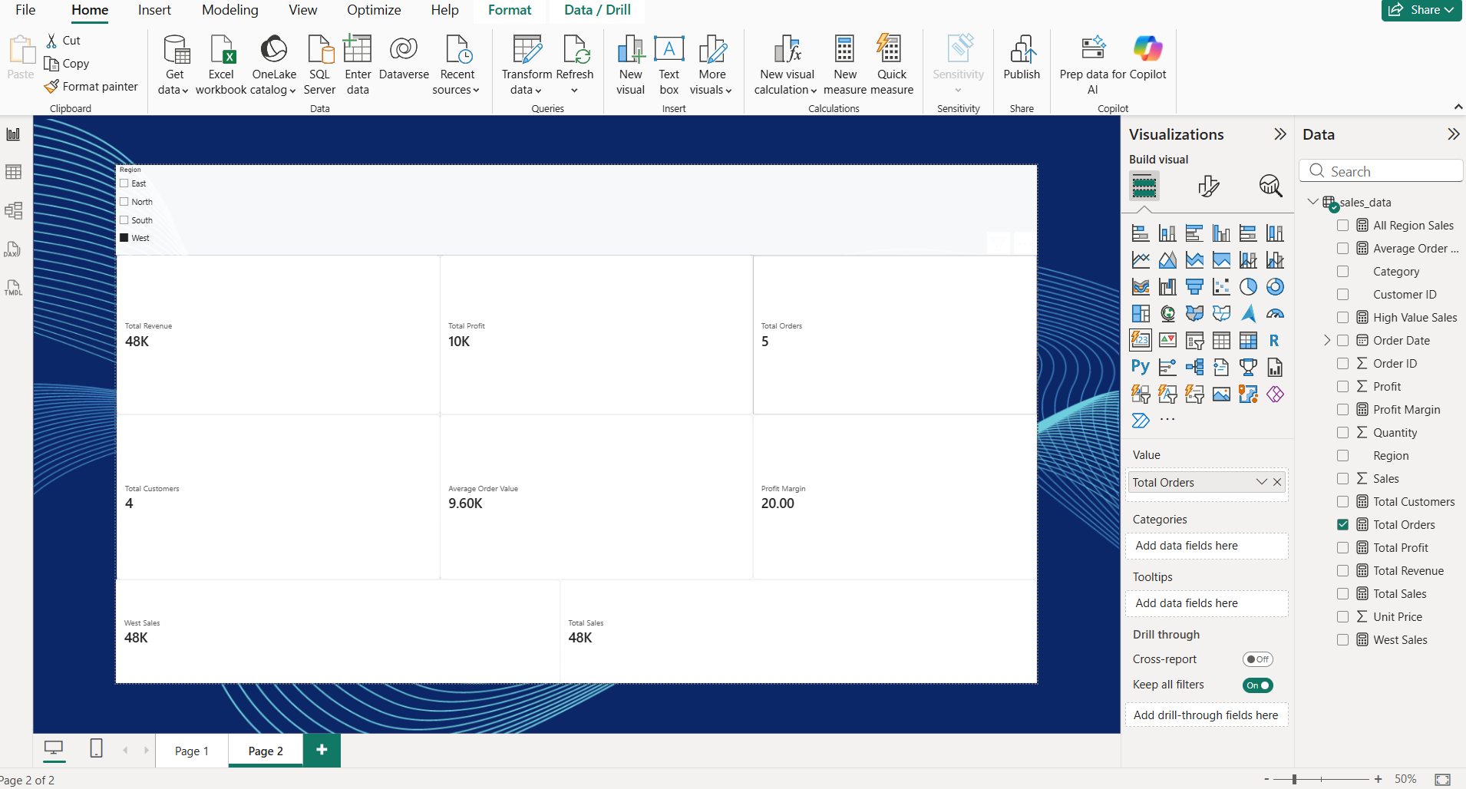

1. Region Slicer
At the top-left, a Region slicer is provided with:
- East
- North
- South
- West
The slicer allows the user to filter the dashboard according to the selected region.

2. Total Revenue
The Total Revenue card displays 48K.
It represents the total revenue generated from the available sales data.

3. Total Profit
The Total Profit card displays 10K.
It represents the total profit generated from the sales transactions.

4. Total Orders
The Total Orders card displays 5.
It represents the number of orders available in the dataset.

5. Total Customers
The Total Customers card displays 4.
It represents the number of unique customers in the sales data.

6. Average Order Value
The Average Order Value displays 9.60K.
It represents the average revenue generated per order.

7. Profit Margin
The Profit Margin displays 20.00.
This measure represents the relationship between profit and revenue.

8. West Sales
The West Sales card displays 48K.
It represents the sales value associated with the West region based on the current dashboard/filter context.

9. Total Sales
The Total Sales card displays 48K.
It represents the overall sales amount in the current data/filter context.

DAY 15— FUNCTIONS + ADVANCED PYTHON BASICS
Completed Assignment with Answers and Python Program

1. Task Day & Date
• Day: Saturday
• Date:26/09/2026
2. Task Description

Today's task was to learn the basics of Git and GitHub and understand how they are used to manage and store project files. I learned important Git and GitHub concepts such as Repository, Clone, Commit, Push, Pull, Branch, Merge, .gitignore, and README. I created a GitHub repository named Data-Science-Intern and uploaded my completed Day 1 to Day 14 Data Analytics tasks. This repository can be used to organize and present my internship work as a professional portfolio. The Day 15 deliverable is a GitHub repository.

3. Task Elaboration

1. Repository
A repository is a storage location used to maintain project files and track changes. I created a GitHub repository named Data-Science-Intern for storing my internship tasks.

2. Clone
Clone is used to create a local copy of a remote GitHub repository. It allows developers to work with repository files on their computer.

3. Commit
A commit saves changes made to files in Git. It creates a record of the changes made to the project.

4. Push
Push is used to upload local Git changes to a remote GitHub repository.

5. Pull
Pull is used to download the latest changes from a remote GitHub repository to the local project.

6. Branch
A branch is a separate line of development. It allows developers to work on changes without directly modifying the main branch.

7. Merge
Merge is used to combine changes from one branch into another branch.

8. .gitignore
The .gitignore file specifies files and folders that should not be tracked or uploaded by Git.

9. README
A README file provides information about the project, its purpose, contents, and instructions.

10. Upload Day 1–14 Tasks
I uploaded my completed Data Analytics work from Day 1 to Day 14 to the GitHub repository. This provides a centralized location for maintaining my internship work.

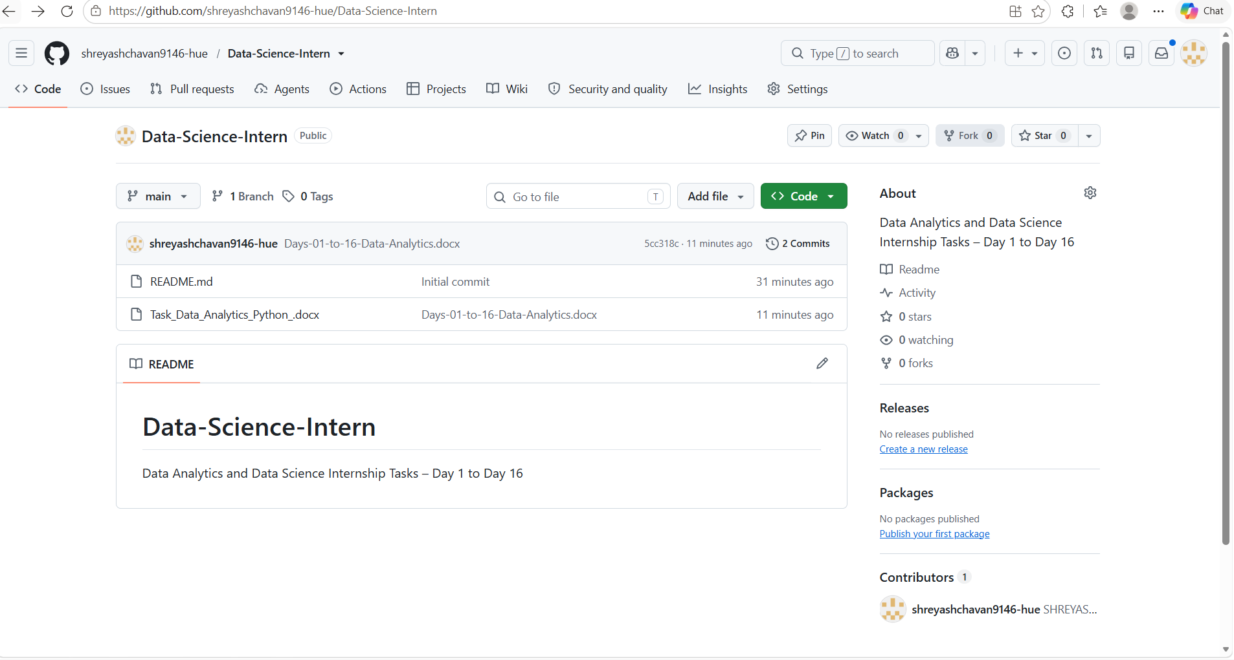

Steps Performed
- Opened the Data-Science-Intern GitHub repository.
- Selected Add file from the repository page.
- Selected Upload files.
- Selected the completed Data Analytics Word document from the computer.
- GitHub displayed the selected file before committing.
- Entered the commit information.
- Selected Commit directly to the main branch.
- Clicked Commit changes.
- The file was successfully added to the repository.
- Verified the uploaded file on the repository's Code page.
Uploaded File
File: Task_Data_Analytics_Python_.docx
The screenshot shows the file listed under the repository:
- README.md
- Task_Data_Analytics_Python_.docx

DAY 16— FUNCTIONS + ADVANCED PYTHON BASICS
Completed Assignment with Answers and Python Program

1. Task Day & Date
• Day: Saturday
• Date:26/09/2026
2. Task Description

Today's task was to understand the fundamentals of Artificial Intelligence, Machine Learning, Deep Learning, Supervised Learning, Unsupervised Learning, Regression, Classification, and Clustering. I also learned how to identify the appropriate Machine Learning technique for real-world problems. For 10 real-world problems, I identified the Problem, Type, Features, Target, and Possible Algorithm. The purpose of this task was to understand which Machine Learning technique can be applied to different types of problems and why. The deliverable is an ML Fundamentals document.

3. Task Elaboration

1. Artificial Intelligence (AI)
Artificial Intelligence is a field of technology that focuses on developing computer systems that can perform tasks that normally require human intelligence, such as decision-making, pattern recognition, and problem-solving.

2. Machine Learning
Machine Learning is a branch of Artificial Intelligence in which computers learn patterns from data and use those patterns to make predictions or decisions.

3. Deep Learning
Deep Learning is a subset of Machine Learning that uses multi-layer neural networks to learn complex patterns from large amounts of data.

4. Supervised Learning
Supervised Learning uses labeled data where the input features and target/output are known. The model learns the relationship between the input and target.
Examples: Regression and Classification.

5. Unsupervised Learning
Unsupervised Learning works with data where there is no predefined target. The model identifies patterns, relationships, or groups within the data.
Example: Clustering.

6. Regression
Regression is a Machine Learning technique used to predict a numerical value.
Example: Predicting house prices or employee salaries.

7. Classification
Classification is used to predict a category or class.
Example: Predicting whether an email is Spam or Not Spam.

8. Clustering
Clustering is an unsupervised learning technique that groups similar data points together.
Example: Grouping customers based on their purchasing behavior.

Real-world problems-
Problem 1 — House Price Prediction
Problem: Predict house price.
Type: Regression
Features: Area, bedrooms, location, house age
Target: House price
Possible Algorithm: Linear Regression
Description:
The objective is to predict the numerical price of a house using different property characteristics. Since the target is a numerical value, regression can be used.

Problem 2 — Student Result Prediction
Problem: Predict whether a student will pass or fail.
Type: Classification
Features: Attendance, marks, study hours
Target: Pass/Fail
Possible Algorithm: Decision Tree
Description:
The model uses student information to classify students into Pass or Fail categories.

Problem 3 — Customer Churn Prediction
Problem: Predict whether a customer will leave a service.
Type: Classification
Features: Usage, tenure, complaints, subscription plan
Target: Churn/Not Churn
Possible Algorithm: Logistic Regression
Description:
The model classifies customers according to whether they are likely to leave the service.

Problem 4 — Employee Salary Prediction
Problem: Predict employee salary.
Type: Regression
Features: Experience, education, department
Target: Salary
Possible Algorithm: Linear Regression
Description:
Salary is a numerical value, so regression can be used to predict salary based on employee information.

Problem 5 — Customer Grouping
Problem: Group customers according to their behavior.
Type: Clustering
Features: Income, spending, purchase frequency
Target: No predefined target
Possible Algorithm: K-Means
Description:
Customers can be grouped according to similarities in their income and purchasing behavior without predefined categories.

Problem 6 — Spam Email Detection
Problem: Identify whether an email is spam.
Type: Classification
Features: Email words, links, sender information
Target: Spam/Not Spam
Possible Algorithm: Naive Bayes
Description:
The model classifies emails into Spam and Not Spam categories using information extracted from the emails.

Problem 7 — Sales Prediction
Problem: Predict future sales.
Type: Regression
Features: Previous sales, price, promotions
Target: Sales amount
Possible Algorithm: Linear Regression
Description:
The model predicts a numerical sales amount using previous sales and other relevant factors.

Problem 8 — Fraud Detection
Problem: Identify fraudulent transactions.
Type: Classification
Features: Transaction amount, location, time, transaction history
Target: Fraud/Not Fraud
Possible Algorithm: Random Forest
Description:
The model classifies transactions into fraudulent and legitimate categories using transaction-related information.

Problem 9 — Product Grouping
Problem: Group similar products.
Type: Clustering
Features: Price, category, ratings, product characteristics
Target: No predefined target
Possible Algorithm: K-Means
Description:
Products with similar characteristics can be grouped together using an unsupervised clustering technique.

Problem 10 — Loan Approval Prediction
Problem: Predict whether a loan application will be approved.
Type: Classification
Features: Income, credit score, loan amount, employment
Target: Approved/Rejected
Possible Algorithm: Decision Tree
Description:
The model classifies loan applications into Approved or Rejected categories using applicant and loan information.

