Data Management Example – Processing a Healthcare Survey

Dr. Bergen, Director of the Statistical Consulting Center at WSU, needs you to prepare the attached data for analysis. Note that health_survey.csv contains the responses to a series of health-related questions that we want to recode on a numeric scale and then aggregate. Dr. Bergen had a follow-up meeting with his client, and it turns out that some of the columns need a reverse coding, see the Needs Reverse Coding? column in ReverseCodingItems.csv. Please perform the following steps to prepare the required csv file.

Old Label | New Coded Value | Reverse Coding
“Strongly Disagree” | 1 | 5
“Somewhat Disagree” | 2 | 4
“Neither Agree nor Disagree” | 3 | 3
“Somewhat Agree” | 4 | 2
“Strongly Agree” | 5 | 1

- Look at the questions that need reverse coding and explain why it makes sense to reverse the coding on these items.

- Create a data repository for this project. Make sure that notebook is in the root of the repository and the data files are stored in a data folder.

- You will need to redo the file construction, but now need to take the reverse coding into account.
  - Stack the columns.
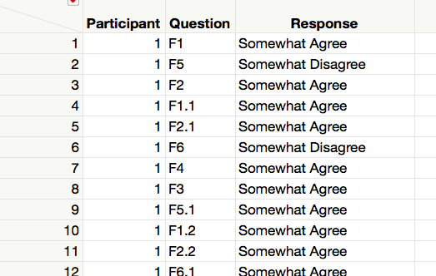

  - Make a new column called Needs Reverse by Recoding the Question Identifier to “Yes” or “No” per the Needs Reverse Coding? column in ReverseCodingItems.csv.
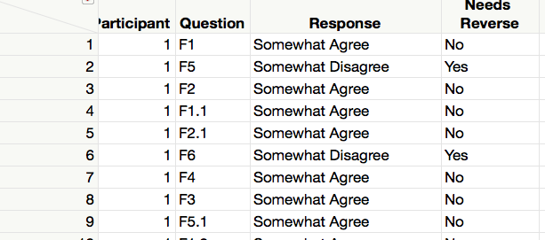

  - Make a new column called Temp Coded Value by Recoding the Questions Responses to the New Coded Values.
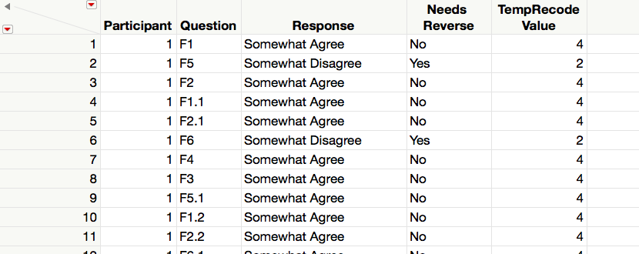

  - Make a new column called Temp Coded Value by Recoding the Questions Responses to the Reversed Coded Values.
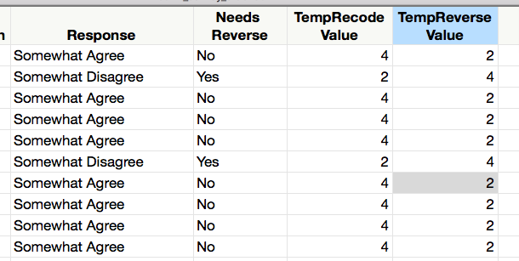
  - Make a new column called Recoded Value that holds the correct value for each question. You will want to use an case-when statement and use Needs Reverse to decide which temporary value to use.
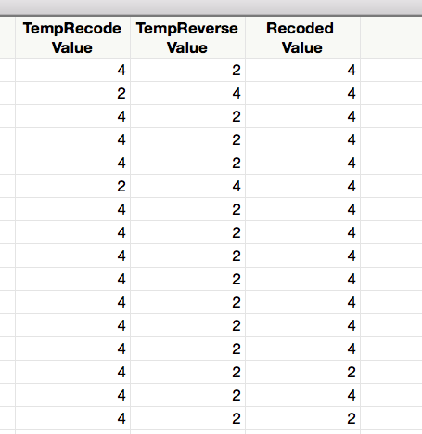

  - Make a new column by Recoding the Question Types to F1, F2, …, F6.
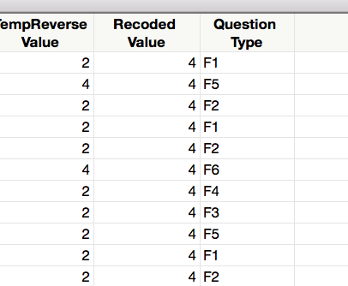

  - Aggregate and Split.
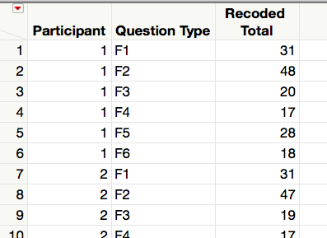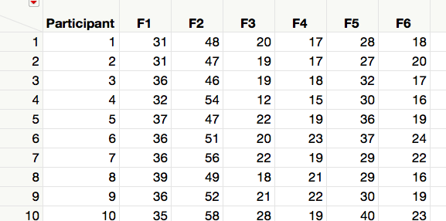

- Write the resulting table to a CSV file named health_survey_summary.csv in the data folder.

Deliverables. Submit this document with your answer to question 1, a link to your data repository, and a csv file with your final table.

