**Credits -** [**https://www.youtube.com/watch?v=YwWfKitB8aA**](https://www.youtube.com/watch?v=YwWfKitB8aA)

**Socket Communication in Python**

Server.py

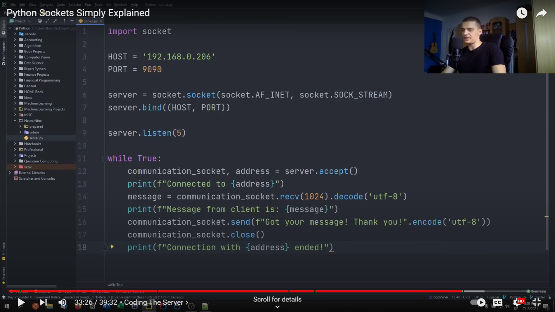

Client.py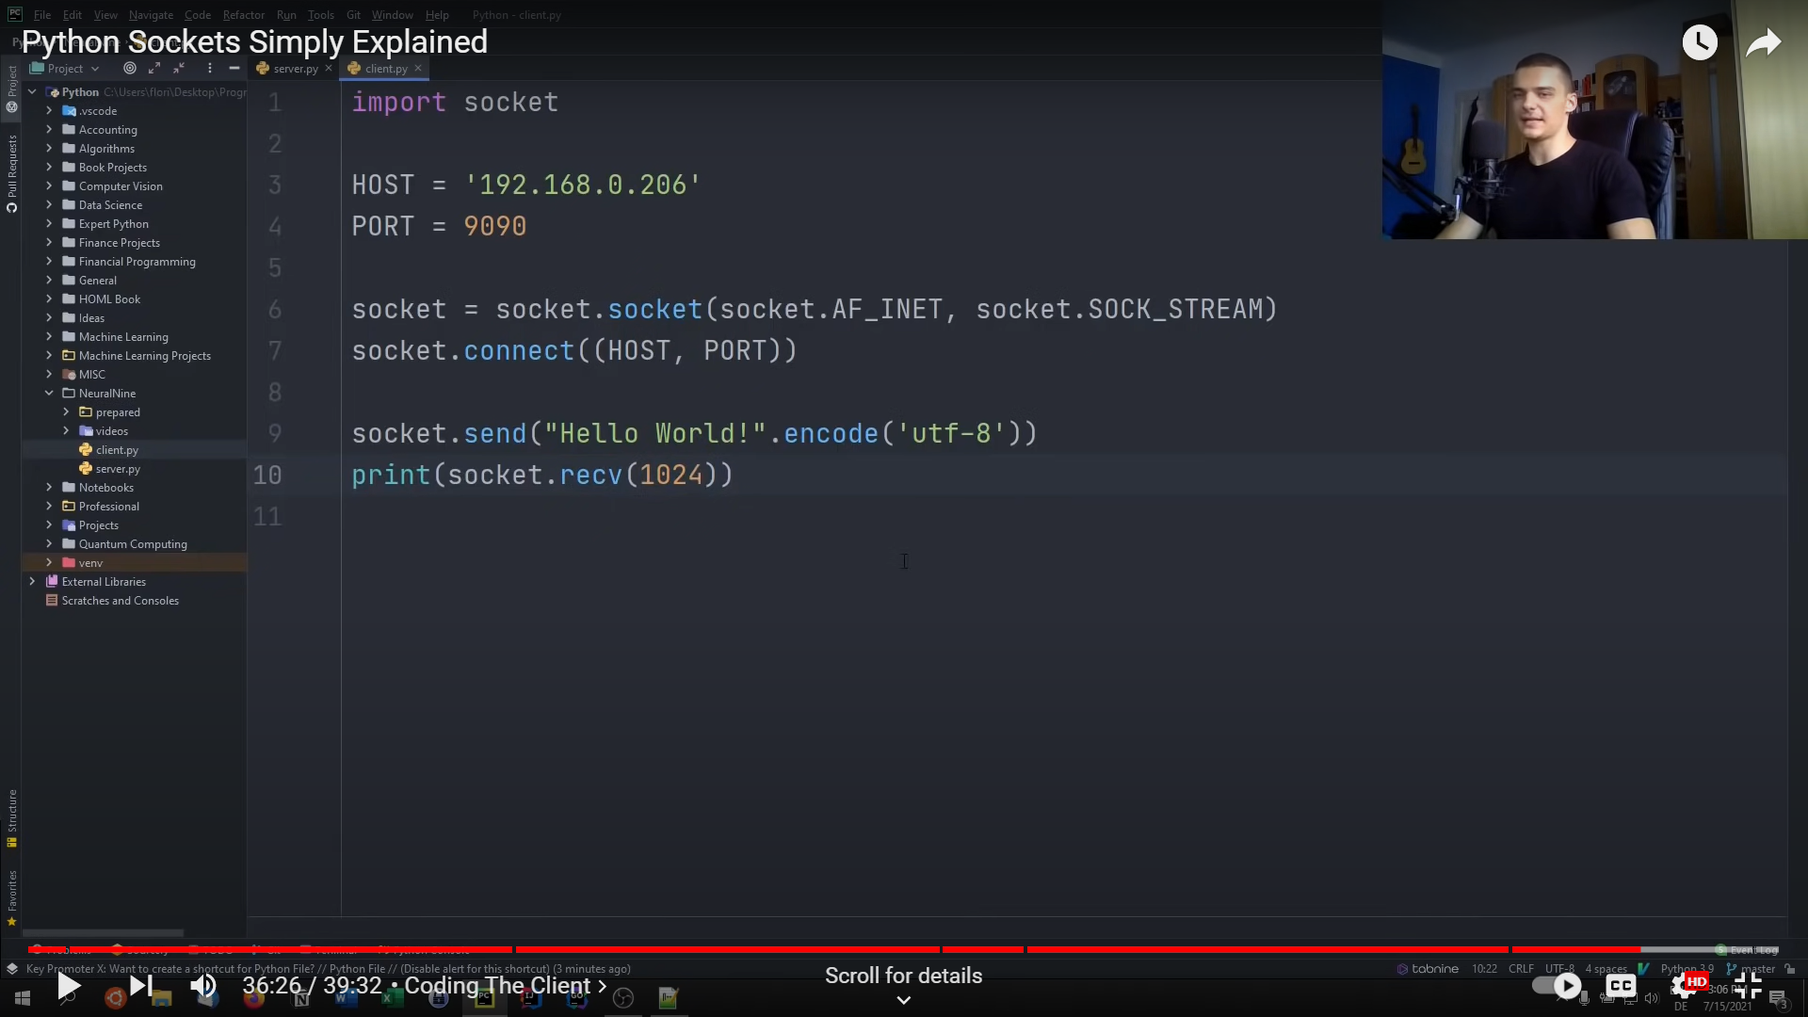

**File Transfer via Sockets in Python**

Sender.py

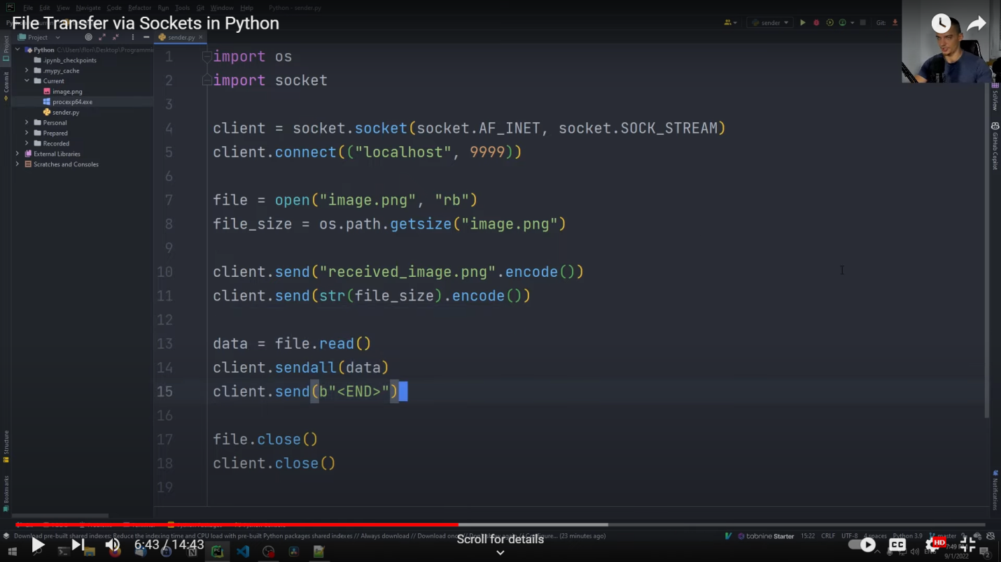

Reciever.py

