BRACT’s

Vishwakarma Institute of Technology, Pune

Practical Implementation Sheet

Department: CSE-AI Semester: 5 Academic Year: 2026-27

Division: C Batch: 3 Practical No: 4

Roll no: 25 PRN No: 12410917 Name of Student: Shreyash Kamble

Subject Name : Deep Learning

Problem Statement: Design and implement a Convolutional Neural Network (CNN) for image classification using the Tomato or Soybean disease dataset.

Algorithm:
- Import required libraries such as TensorFlow, Keras, NumPy, Matplotlib, Seaborn, and Scikit-learn.
- Import the PlantVillage dataset directly from Kaggle using kagglehub.
- Select only the Tomato disease classes from the dataset.
- Select a limited and balanced number of images from each class for faster training.
- Resize images to 96 × 96 pixels and normalize pixel values.
- Shuffle and divide the dataset into training, validation, and testing sets.
- Create a TensorFlow data pipeline using batching, prefetching, and AUTOTUNE.
- Apply data augmentation using random flipping, rotation, and zooming.
- Build a CNN using convolutional, ReLU, max-pooling, flatten, dense, and dropout layers.
- Compile the model using the Adam optimizer and sparse categorical cross-entropy loss.
- Train the CNN using the training dataset and validate it using the validation dataset.
- Plot training and validation accuracy and loss.
- Evaluate the model on the test dataset.
- Generate a classification report and confusion matrix.
- Display actual and predicted disease classes with prediction confidence.
- Save the trained CNN model.

Code :

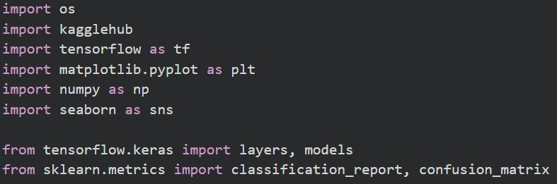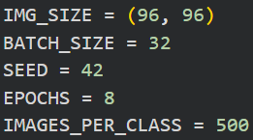
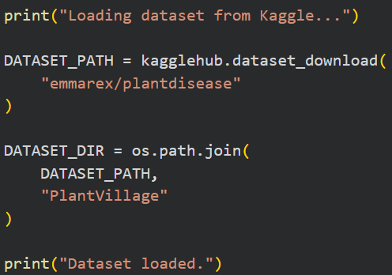
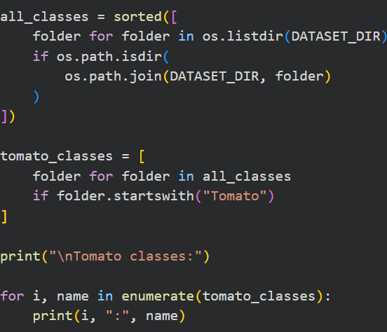
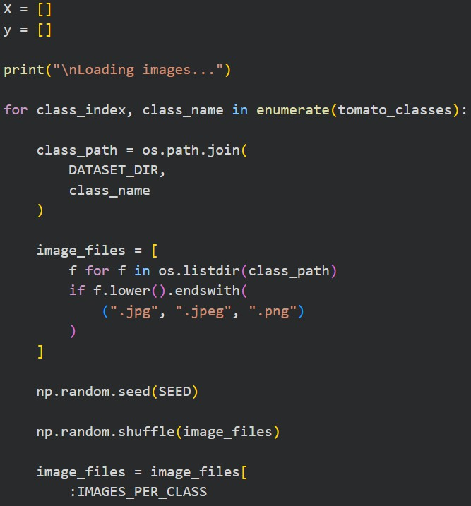
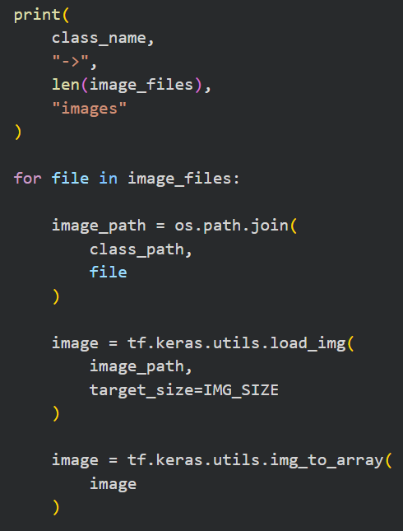

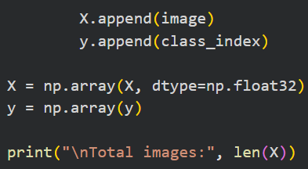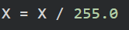

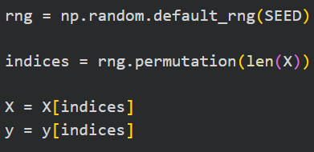
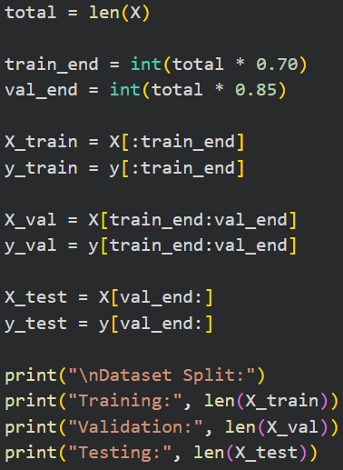
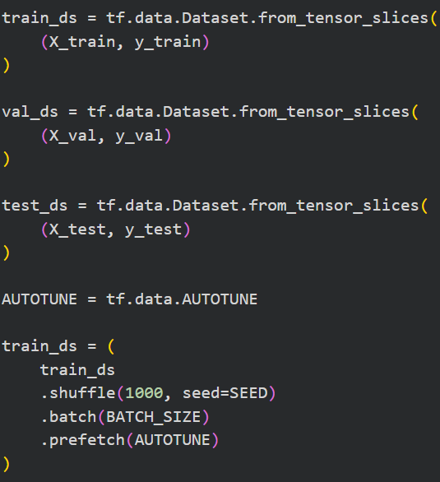

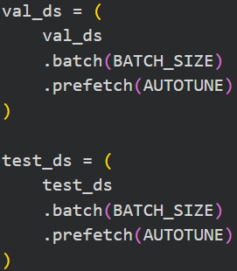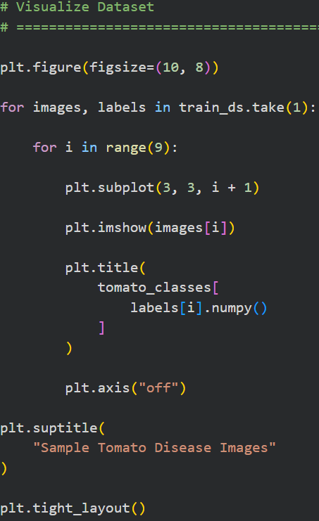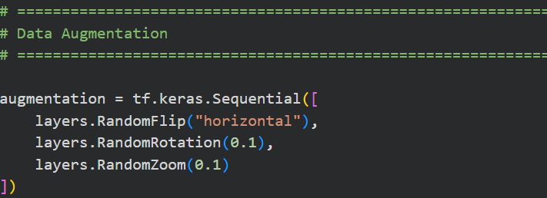

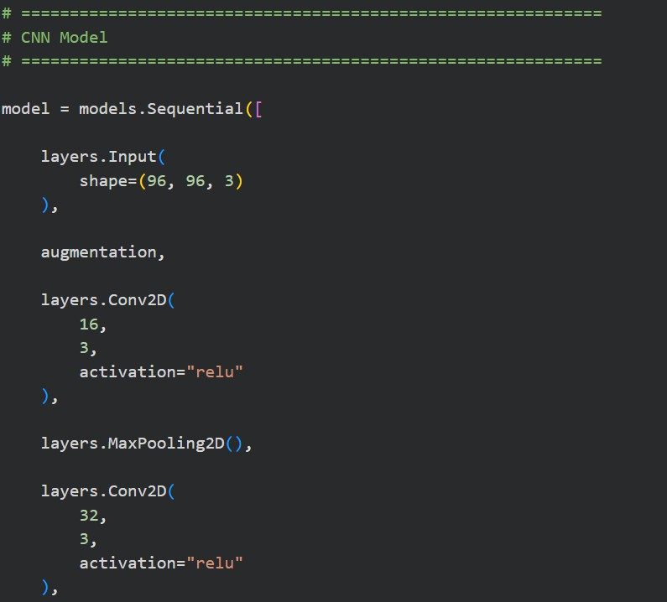
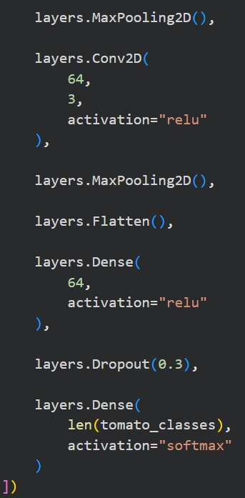
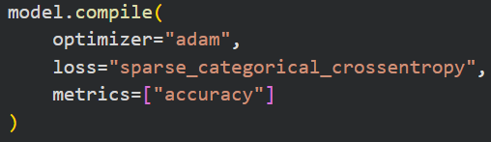

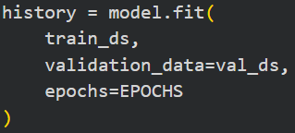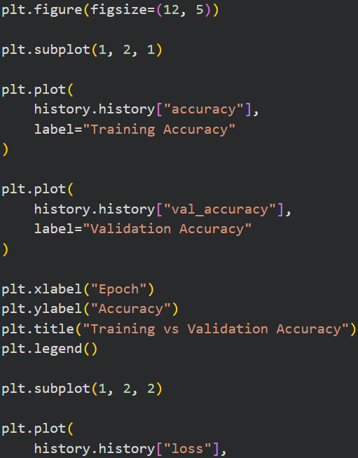
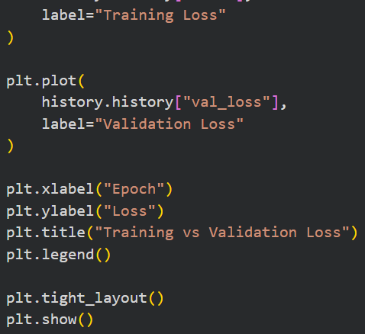
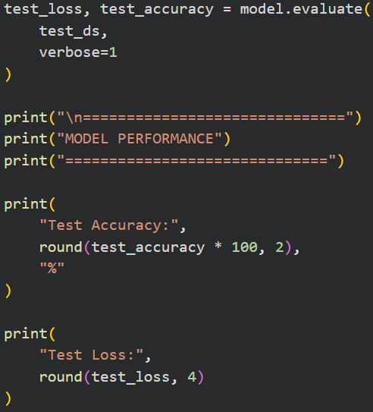

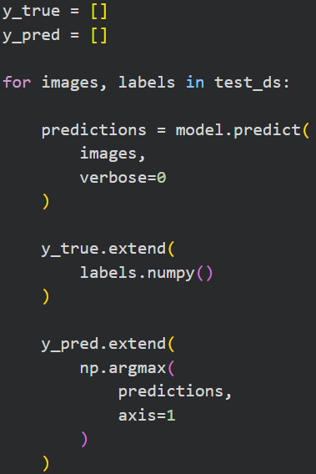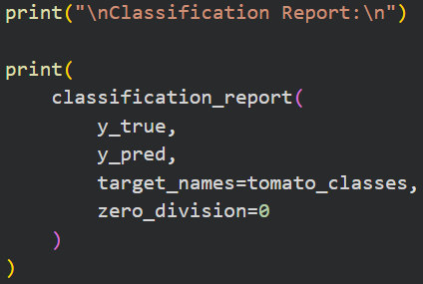
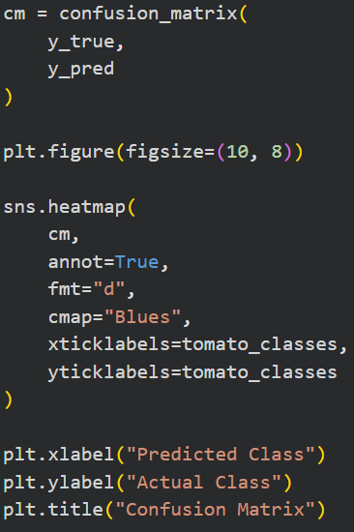
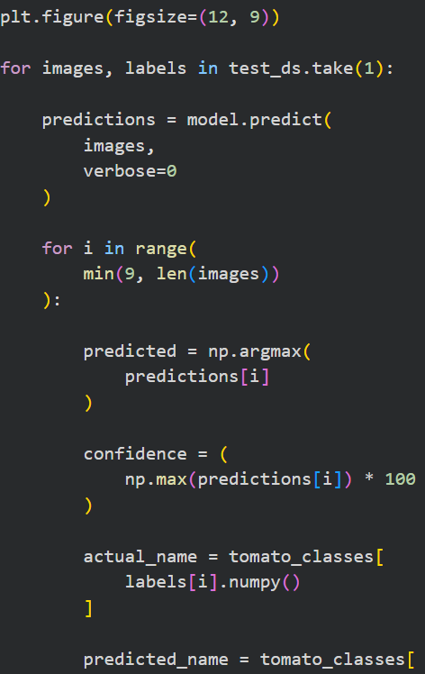

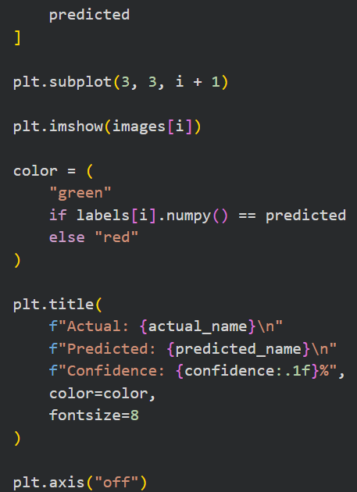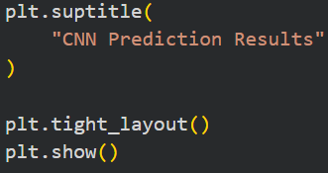
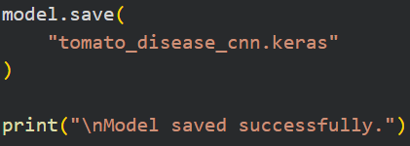

Output :
