DAY 6: FUNCTIONS, CODE BLOCKS & WHILE LOOPS
- Have to solve all the 4 hurdles and 1 maze of Reeborg’s World.
- All four problems consists of different conditions.
- Attaching the problem image and solution code snapshot alongside with it.
- Link for the website: https://reeborg.ca/reeborg.html?lang=en&mode=python&menu=worlds%2Fmenus%2Freeborg_intro_en.json&name=Hurdle%201&url=worlds%2Ftutorial_en%2Fhurdle1.json
(this will be the documentation for day 6 of 100 days of code)
- First Problem:
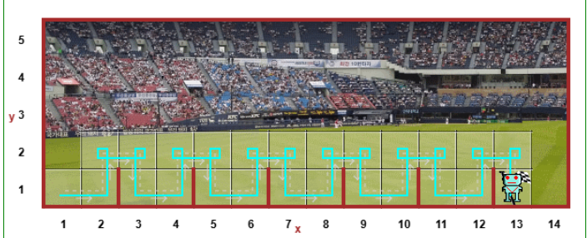
Code:
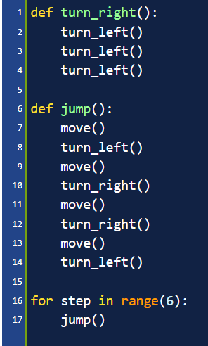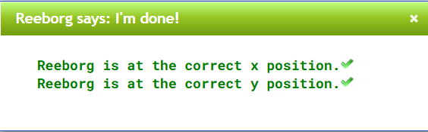
- Second Problem:
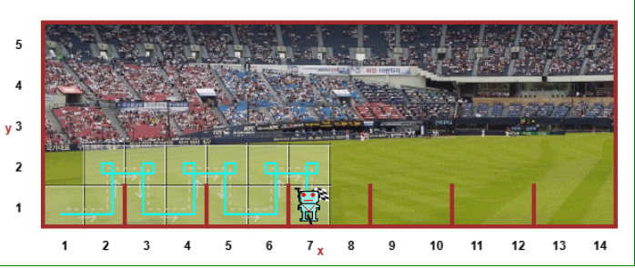
Code:
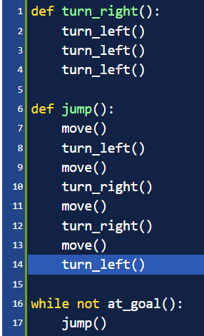



- Third Problem:
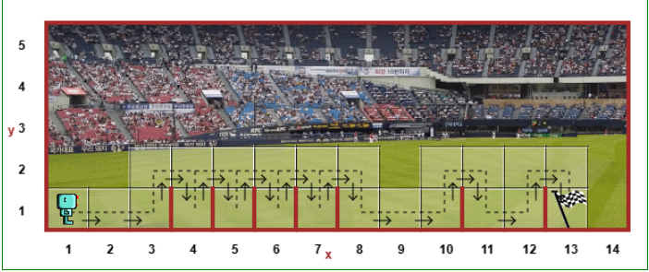
Code:
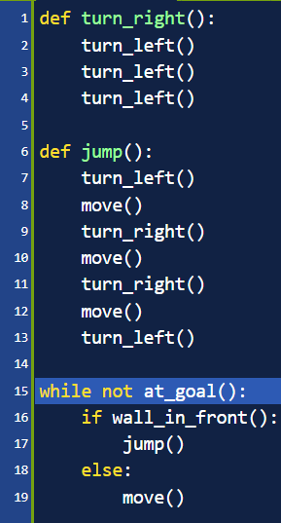

- Fourth Problem:
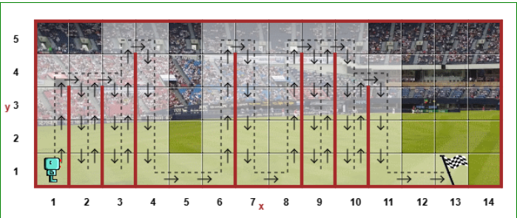
Code:
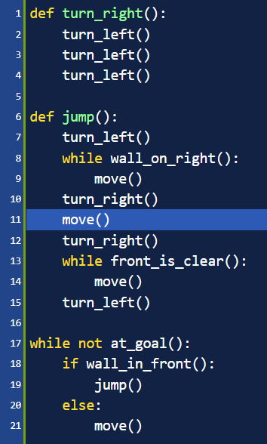

- The Escape Maze Problem (universal correct solution code):
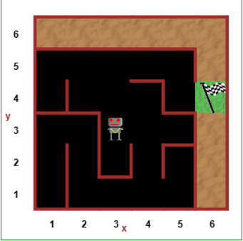
Code:
