Please mention the below details before attempting the assignment.

|  |  |
| --- | --- |
| Name of the Candidate | Shreyash Kirtikumar Kanhed |
| Contact Number & Alternate Contact No | 7249197251  8999912958 |
| Current Location | Hadapsar, Pune |
| Institute / College Name | Symbiosis |

**Manual testing:**

1. What is a test case, and what are the essential components of a test case?

Ans- Test case means the set of operations we perform on the test scenarios(Functionalities of the software) to check the software. Components of the Test case are Test case ID, Test Scenario, Test case name, Pre-condition, Steps-to-follow, Test data, Expected result, Actual result, Priority, Result/status, and Comments.

1. What is the difference between positive and negative testing?

Ans- Positive Testing means testing the application by entering positive data and Negative testing means Testing the application by entering negative or invalid data to find defects or to break the application.

1. What is exploratory testing, and when should it be used?

Ans- Exploratory testing means testing the application without any test plan or test script to understand the application and its behavior. If a new member joins the team then sometimes the company gave that member an application to do exploratory testing.

1. How do you perform smoke testing, and what is its purpose?

Ans- When we get a new software or product to test, the first testing we do on that is Smoke testing to check whether the given build is stable or not.

1. Write test cases for testing a website's search functionality.

**Acceptance criteria:**

* 1. The search functionality should allow users to search for content on the website using keywords or phrases related to the content.
  2. The search results should be relevant to the keywords or phrases entered by the user, and should include all relevant content that matches the search criteria.
  3. The search results should be displayed in a clear and concise manner, with relevant information such as the brand name, description, and cost of each search result.
  4. The search functionality should allow users to sort the search results by different criteria, such as recommended, popularity, or customer rating.
  5. Search should limit to 100 Characters
  6. If there is no result for searched data message “No result for your search” should display

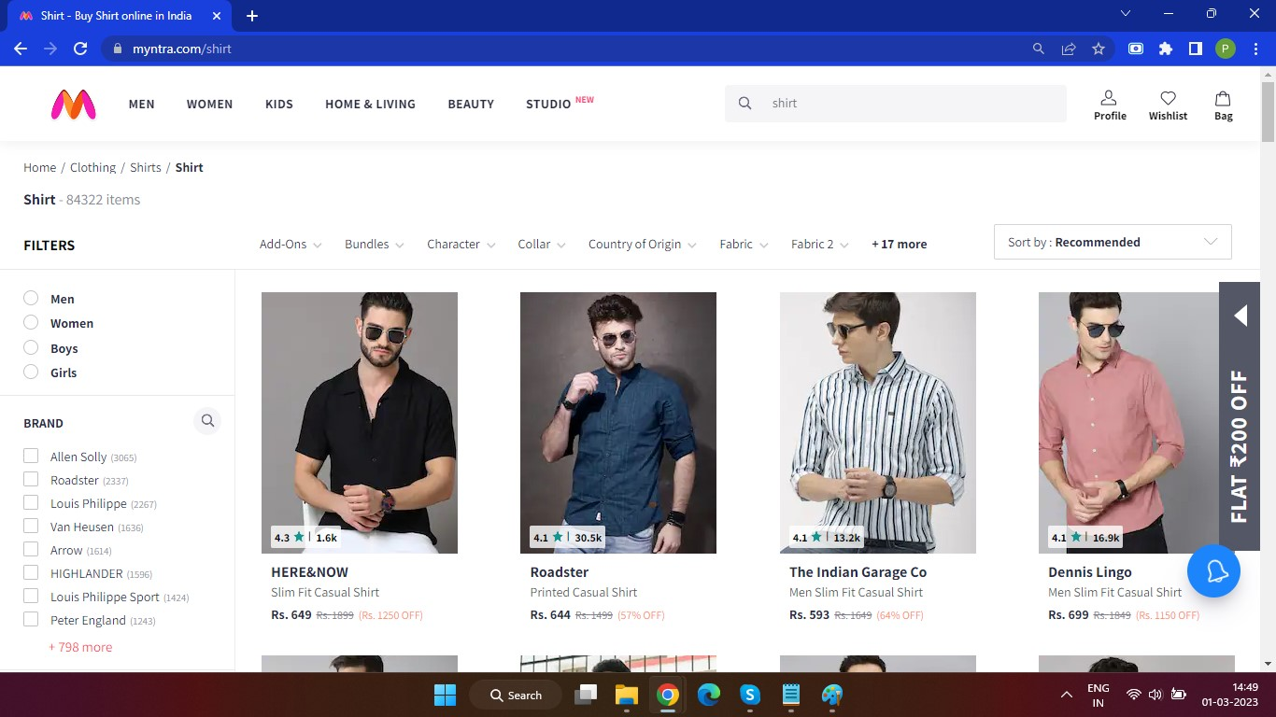

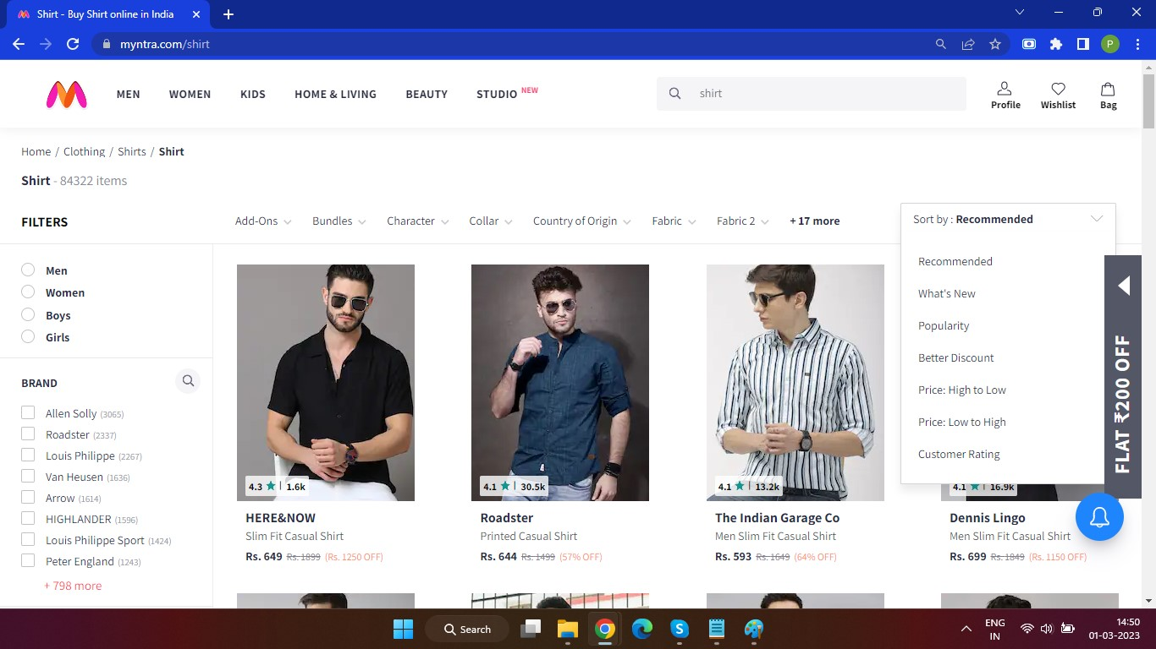

**Automation testing questions:**

1. What are the different types of locators that can be used in Selenium?

Ans- Id, name, className, tagName, xpath, cssSelector, linkText, Partial linkText.

1. How to handle dynamic elements in Selenium?

Ans- We can handle dynamic elements by using xpath axes.

1. What are the different types of waits?

Ans- there are 2 types of waits- 1) implicit- it is defined in the script and applicable for the whole session duration of that script execution. 2) explicit - it is particularly used for specific web elements.

1. What is TestNG and its annotations?

Ans- TestNG is a testing framework and annotations in testNG are used to control the next method to be executed. Annotations always start with @. For example- @Test, @BeforeTest, @AfterTest, @BeforeMethod, @AfterMethod.

1. Write an automation script for below acceptance criteria:

**Acceptance criteria:**

* + 1. Open the site “<https://demowebshop.tricentis.com/>”
    2. Register as a new user
    3. Login
    4. Search jeans and select Blue Jeans from the drop down
    5. Select Add to cart
    6. Go to shopping cart
    7. Check the terms and condition check box
    8. Click on checkout
    9. Enter the mandatory fields in Billing address and click on Continue
    10. Click on Continue for Shipping address
    11. Select Next Day Air option from Shipping Method and click on

Continue

* + 1. Select Cash on delivery option from Payment Method and click on

Continue

* + 1. Click on Continue for Payment information
    2. Click on Confirm for Confirm order
    3. Click on Continue

**Communications**

* 1. Provide a brief explanation of why you believe that education is crucial in developing nations.

Ans- I think Education is very important because nowadays all the things are getting upgraded with high technology. Education is very important they not just secure our lives but also learn how to live practically, and confidently, how to deal with logical situations and how to tackle that situation mentally. Education is a need. If we have that enough knowledge then we survive in every path of our life and go higher and higher. Thats why I think education is very important.

* 1. What is your definition of effective communication?

Ans- Effective communication means not what we are talking about. It is what the other person understands by our talking. It is the process of exchanging thoughts, ideas, knowledge and opinions so that the message is properly received by the receiver with clarity and our purpose of it In Communication Feedback Loop is very important. We can also maintain our tone of voice while speaking and very importantly maintain eye contact with our partner. It will help you to get their attention while talking to people.

* 1. Can you share your view for this assignment, which question you find most challenging and why?

Ans- It was a great experience working on this project. I felt like I was working for a company so it was an excellent feeling. It helped me practice all the things that I have learned. I don’t find anything that challenging and My attitude is always like if I don’t know anything I will learn that thing.

* 1. Explain with an example whether written or verbal communication is preferable?

Ans- Verbal communication means sharing our thoughts and idea in such a way that the other person is understanding what we are saying and in which you listen to a person to understand their meaning also. Verbal communication Examples are: 1. Face-to-face meeting 2.Phone call. Written communication is mostly used in Companies to write emails, blogs, and text messages.

* 1. Share your experience in your own words when you convince someone of your idea of work.

Ans- We convince someone for our own good, so convincing them makes us feel happy about it. I mostly convinced my parents to buy me something that I need. Also I convinced my friends to do something that I wanted it makes me good and happy. Convincing someone is a skill. And how you use that skills is your smartness.