**RESUME**

**Shreyash Yashwant Musale**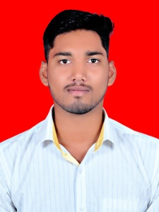

[musaleshreyash@gmail.co](mailto:musaleshreyash@gmail.co)m

9623065529

**CAREER OBJECTIVE**

To be the part of an enthusiastic work environment, where I can use my technical skills to accomplish organizational goals. Also do my best with full dedication and adding value to organization growth.

**SKILLS**

**Technical skills:** Python, Django, C, Core java, SQL, HTML, CSS, Networking basics, Arbor, Fortigate firewall

**Operating Systems:** Widows, Linux

**EDUATIONAL QUALIFICATION:**

|  |  |  |  |  |
| --- | --- | --- | --- | --- |
| **Qualification** | **Institution** | **Board/ University** | **Year of Passing** | **Percentage (%)** |
| B.E(Computer  Engineering) | Dr. D.Y Patil School of Engineering | Pune University | 2018 | **65.69%**  **(aggregate)** |
| 12th | Modern College of Arts, Science and Commerce, Shivaji Nagar | Pune University | 2014 | **66.00%** |
| 10th | Shivraj Vidya Mandir, Somnath Nagar, Wadgaon Sheri | State Board | 2012 | **84.36%** |

**STRENGTHS**

Strong programming skills, Good learner, Self-Motivated, Dedicated to work, Having good Patience

**PROJECTS**

**Project Name:** Portable Water Quality Monitoring System

**Project Details:** The proposed system will be dipped into the water and will automatically check the water quality on various factors like PH value, dissolved nitrogen, dissolved oxygen etc. and will give notification to the user/users on android application and through GSM module.

**EXTRA CURRICULAR**

Member of cultural group in college

Have done automation project in python

**Hobbies**

Trekking, Playing ground sports like Kabaddi, Cricket, and indoor games like Chess, Carom

**PERSONAL DETAILS**

**Address:** Ganesh Nagar,Wadgaon Sheri, Pune -411014, Maharashtra

**Date of birth:** 18/12/1996

**Gender:** Male

**Languages Known:** Marathi, Hindi and English

**Declaration**

I hereby declare that the information given above is true to the best of my Information knowledge belief.

DATE: Shreyash Y Musale